The Impact of gender diversity on scientific research teams: A need to broaden and accelerate future research

Hannah B. Love ^{1, 3*}, Alyssa Stephens ^{2, 3}, Bailey K. Fosdick ³, Elizabeth Tofany ³, Ellen R. Fisher^{1, 3, ,4}
¹ Divergent Science LLC, United States
² Cactus Consulting LLC, United States
³ Colorado State University, United States
⁴ University of New Mexico
*Corresponding Author: E-mail: Hannah.love15@alumni.colostate.edu

Appendix Table 1: Terms and Definitions
Term | Definition
Social Network or Network | Data collected from the social network survey in Appendix Table 1.
Scaled | The indegree or average degree was divided by the number of team members who completed the survey to obtain the scaled indegree or scaled average degree. For example, if a team member has a scaled mentor indegree of 0.10, then about 10% of the team considers them to be a mentor.
Average Degree | Average number of immediate connections (i.e., indegree plus outdegree) for a person in a network (Giuffre, 2013; Hanneman & Riddle, 2005).
Indegree | Measure of how many other team members reported receiving advice, or mentorship, from that person.
Outdegree | Measure of how many team members a given individual reported getting advice, or mentorship, from.
Senior  Woman | Woman PI or a woman on the leadership team.
Faculty | An assistant, associate, and full professor.
Non-faculty Team Member | An undergraduate student, graduate student, postdoc, research associate, community partner, or project manager.

Appendix Table 2:

Survey Terms and Associated Questions
Term used in Manuscript | Definition
Collaboration | Participants were asked questions about their scientific collaborations. These measures were combined to create a measure called collaboration. The combined measures were: worked on research, collaborations, tech projects, or consulting projects; worked on joint publications presentations, or conference proceeding; worked on or submitted a grant proposal.
Social | Participants were asked questions about their social relationships. These measures were combined to create a measure called social. The combined measures were: I hang out with [this person] for fun and [this person] is a friend were combined.
Professional Support | Participants were asked questions about their professional support. These measures were combined to create a measure called professional support. The combined measures were: I seek advice from [this person], [this person] is a mentor to me, and sat on a student’s committee together (or is a member of your thesis/dissertation committee) were combined.
New Research | Since joining your team, please tell us about interactions with members: who have you talked about possible joint research/ ideas/ concepts/ connections.
Research | Since joining your team, please tell us about interactions with members with who you have worked on research, collaborations, tech projects, or consulting projects.
Publications | Since joining your team, please tell us about interactions with members who you have worked with on joint publications presentations or conference proceeding.
Grants | Since joining your team, please tell us about interactions with members who you have you worked with on or submitted a grant proposal.
Student Committees | Since joining your team, please tell us about interactions with members who have you sat on a student’s committee together (or are members of your thesis/dissertation committee).
Learn | Since joining your team, please indicate which relationships you have had with the following people: I learn from [this person].
Advice | Since joining your team, please indicate which relationships you have had with the following people: I seek advice from [this person].
Fun | Since joining your team, please indicate which relationships you have had with the following people: I hang out with [this person] for fun.
Leader | Since joining your team, please indicate which relationships you have had with the following people: [this person] is a leader on the team.
Mentor | Since joining your team, please indicate which relationships you have had with the following people: [this person] is a mentor to me.
Friend | Since joining your team, please indicate which relationships you have had with the following people: [this person] is a friend.
Energizes | Since joining your team, please indicate which relationships you have had with the following people: and [this person] energizes me.

Since joining your team, please tell us about interactions with members:
 | Talked about possible joint research/ ideas/ concepts/ connections | Worked on research, collaborations, tech projects, or consulting projects | Worked on joint publications presentations, or conference proceeding | Worked on or submitted a grant proposal | Sat on a student’s committee together (or is a member of your thesis/dissertation committee)
Example Name 1
Example Name 2
Example Name 3
Example Name 4

2. Since joining your team, please indicate which relationships you have had with the following people (i.e., consider each statement with the individual’s name inserted in the blank.)
Please check all that apply

 | I learn from ______ | I seek advice from ______ | I hang out with ______ for fun | _____ is a leader on the team | _____ is a mentor to me | _____ is a friend | _____ energizes me
Example Name 1
Example Name 2
Example Name 3
Example Name 4

Appendix Figure 1: Social Network Survey

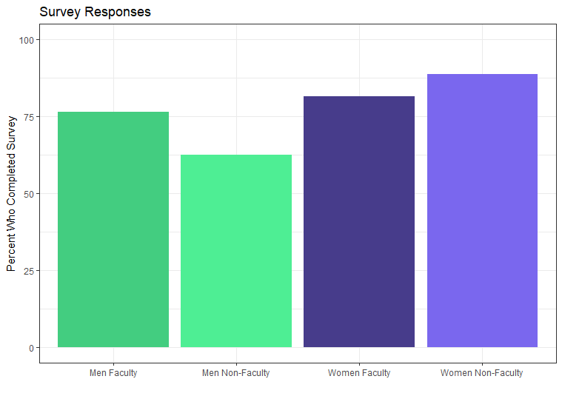
Appendix Figure 2: Response rate for women and men faculty and nonfaculty
78.5% of faculty and 77.6% of non-faculty completed the survey. A higher percentage of women completed the survey than men.

