Supplementary Materials

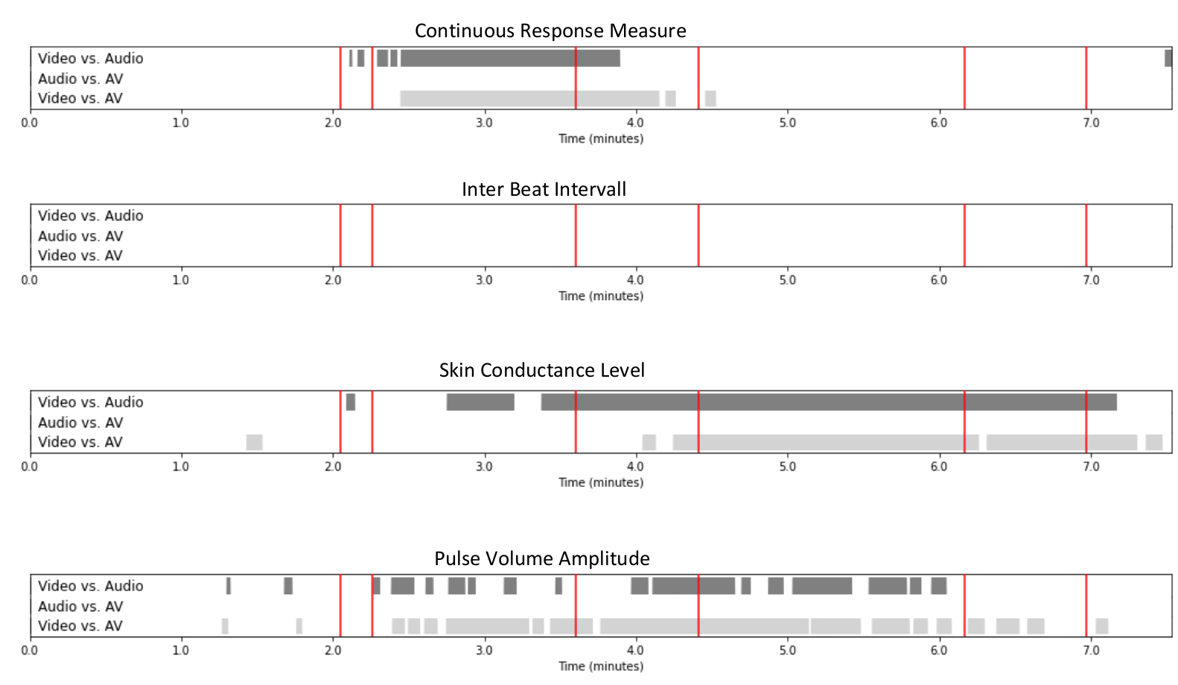

Supplementary Figure S1: Replication of Figure 2 but statistical testing is FDR corrected.

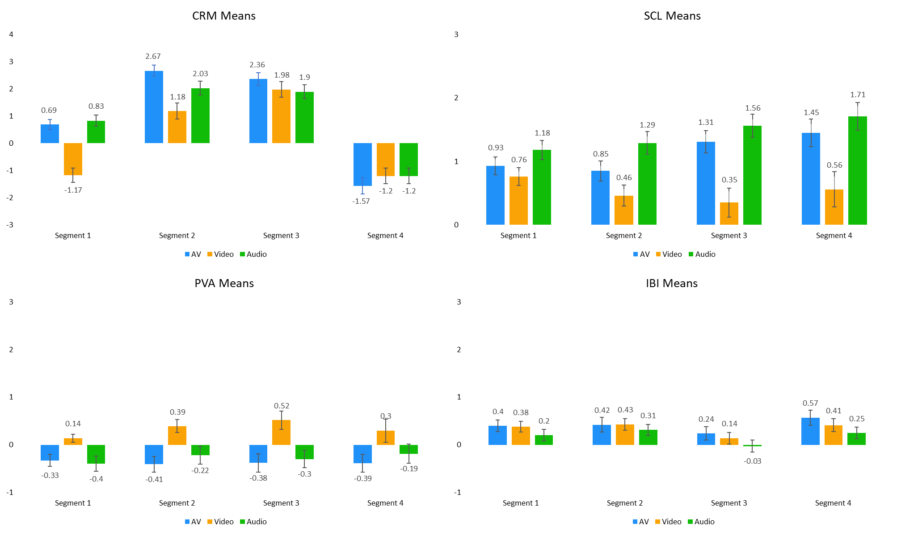

Supplementary Figure S2: Means and standard errors for all four measurements across conditions and segments.

Supplementary Text:
Description of the movie’s soundtrack:

The short film Lovefield begins with a three-note phrase that sets the stage. The last note of this phrase is the fifth note of a C major scale. In traditional western harmonic progression, it is expected that the fifth of a chord will resolve to one, also known as the dominant of the chord. Dominant feels like home base to our ear. It is where every harmonic piece is expected to lead, so the listener is already unsettled as the movie opens to hear the fifth linger without its resolution.

What takes place next is what we will call tension music. This music is characterized by musical gestures, comprising a chain of dissonant intervals that grow steadily louder with each entrance, and then abruptly cut off into silence. Then the process repeats. Musical gestures are used to build a specific musical texture, rather than progress through the use of melody or harmony.

These gestures are effective in building tension for three key reasons. First, the instruments are building dissonant intervals. Dissonance, in western music, is characterized as sounding uncomfortable and harsh to the ear, as if the notes are being squeezed tight together, rather than being given room to breathe.

Secondly, the violin is the primary instrument building these dissonant gestures. It is a common claim by composers that the violin is the instrument which most closely resembles the human voice. When these clashing chords are played on the violin, while steadily building to a loud dynamic, it can eerily register as screaming to our ears.

Lastly, many of these musical gestures build only to suddenly cut off and leave the listener in silence. Silence in music has similar implications to how silence acts in nature; if all of the birds were to abruptly stop chirping and you are left in silence, that is an indication that there is danger close by. In that same way, silence in music tells our brain to stay alert. Silence tells us to wait and see what is coming, and it is used in this short film to build the anticipation for what will happen next.

In the moment when it becomes clear to the observer that they have misinterpreted what is happening in this short film, there is a change in the musical mood, which we will call, “cheerful music.” The cheerful music is a stark contrast to the tone which it precedes. This music is melodic, and includes soft, open chords characterized by consonance rather than dissonance. We are now back in the realm of the expected, so the listener is more at ease. This music follows the rules of traditional western harmonic progression, so our ears are now enjoying the pleasing intervals that lead to predictable conclusions. As the movie fades out, we hear the entrance of the strings, which are no longer screaming within the texture, they are singing.

