Supplementary Information: Researchers attitudes towards sharing have improved, but they still lack needed resources, skills and rewards

Joshua Borycz* [1], Robert Olendorf [2], Alison Specht [3], Bruce Grant [4], Kevin Crowston [5], Carol Tenopir [6], Suzie Allard [7], Natalie M. Rice [8], Rachael Hu [9], Robert J. Sandusky [10]

[1] Vanderbilt University (joshua.borycz@vanderbilt.edu)
[2] North Carolina State University (rkolendo@ncsu.edu)
[3] University of Queensland, Australia (a.specht@uq.edu.au)
[4] Widener University (bwgrant999@gmail.com)
[5] Syracuse University (crowston@g.syr.edu)
[6] University of Tennessee, Knoxville (ctenopir@utk.edu)
[7] University of Tennessee, Knoxville (sallard@utk.edu)
[8] University of Tennessee, Knoxville (natalie.manaeva@gmail.com)
[9] California Digital Library (Rachael.Hu@ucop.edu)
[10] University of Illinois at Chicago (deceased) (sandusky@uic.edu)

*Corresponding author

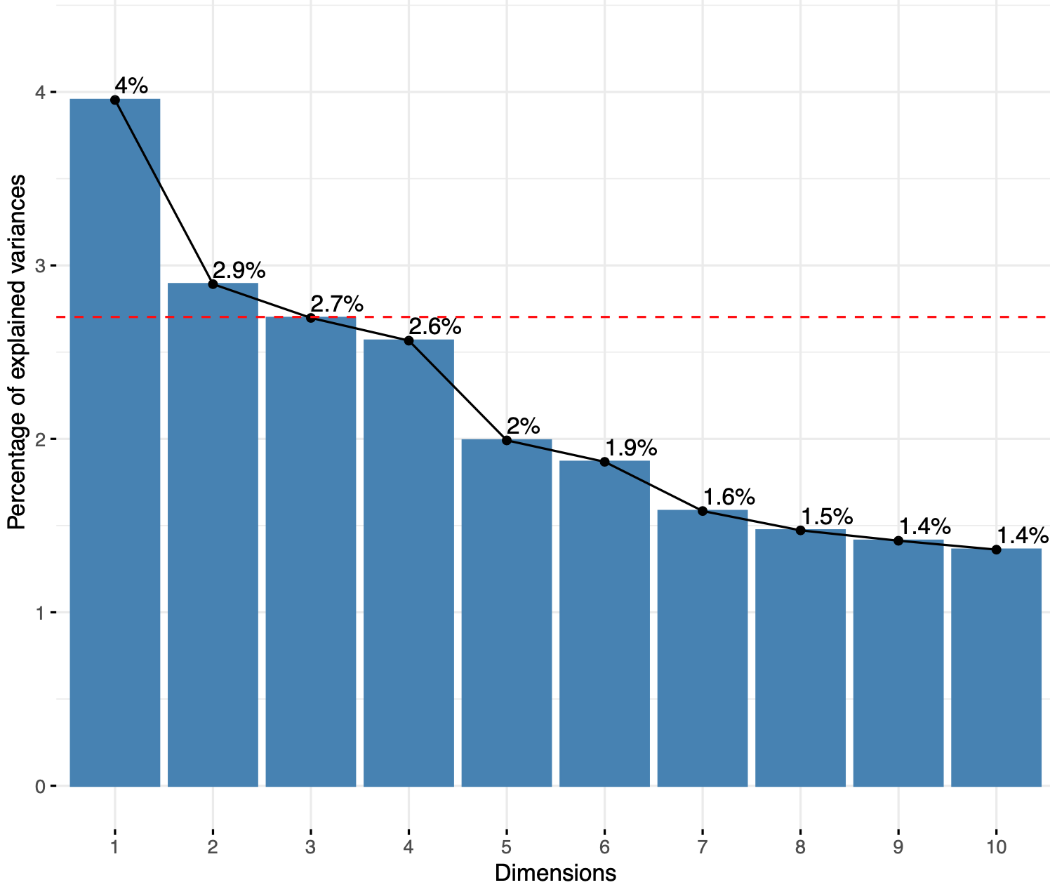

Figure S1: Proportion of variance explained by the dimensions derived from the MFA. The first two dimensions were used to interpret the dataset as they lie above the average percentage of explained variance shown by the red dotted line.

Table S1: Countries included in the regions category compared with the International Union for Conservation of Nature (IUCN) regions.

Region | Countries | IUCN Regions | Countries
AfricaMENA | Algeria, Bahrain, Botswana, Cameroon, Cape Verde, Chad, Congo, Democratic Republic of the Congo, Egypt, Ethiopia, Ghana, Iran, Iraq, Israel, Kenya, Kuwait, Libya, Morocco, Mozambique, Nigeria, Oman, Qatar, Saudi Arabia, South Africa, Sudan, Swaziland, Tunisia, Turkey, Uganda, United Arab Emirates, United Republic of Tanzania, Zambia, Zimbabwe | Eastern and Southern Africa | Botswana, Ethiopia, Kenya, Mozambique, South Africa, South Sudan, Sudan, United Republic of Tanzania, Zambia, Zimbabwe
 |  | Mediterranean | Algeria, Egypt, Israel, Monaco, Morocco, Libya, Tunisia, Turkey
 |  | West and Central Africa | Cameroon, Cape Verde, Chad, Congo Democratic Republic of the Congo, Ghana
 |  | West Asia | Bahrain, Iran, Iraq, Kuwait, Oman, Qatar, Saudi Arabia, United Arab Emirates
AsiaSEAsia | Afghanistan, Bangladesh, Bhutan, China, India, Indonesia, Japan, Kazakhstan, Malaysia, Nepal, Pakistan, Philippines, Republic of Korea, Singapore, Taiwan, Thailand, Uzbekistan, Vietnam | Asia | Afghanistan, Bangladesh, Bhutan, China, India, Indonesia, Japan, Malaysia, Nepal, Pakistan, Philippines, Republic of Korea, Singapore, Sri Lanka, Taiwan, Thailand, Vietnam
 |  | Eastern Europe and Central Asia | Uzbekistan, Kazakhstan
AustraliaNZ | Australia, New Zealand | Oceania | Australia, New Zealand
EuroRussia | Austria, Belgium, Bosnia and Herzegovina, Bulgaria, Croatia, Cyprus, Czech Republic, Denmark, Estonia, Finland, France, Germany, Greece, Hungary, Iceland, Ireland, Italy, Luxembourg, Netherlands, Norway, Poland, Portugal, Romania, Russian Federation, Serbia, Slovakia, Slovenia, Spain, Sweden, Switzerland, Ukraine, United Kingdom | Europe | Austria, Belgium, Bulgaria, Croatia, Cyprus, Czech Republic, Denmark, Estonia, Finland, France, Germany, Greece, Hungary, Iceland, Ireland, Italy, Luxembourg, Norway, Poland, Portugal, Romania, Slovakia, Slovenia, Spain, Sweden, Switzerland, Netherlands, United Kingdom
 |  | Eastern Europe and Central Asia | Bosnia and Herzegovina, Russian Federation, Serbia, Ukraine
LatinAmerica | Antigua and Barbuda, Argentina, Bolivia, Brazil, Chile, Colombia, Costa Rica, Dominican Republic, Ecuador, Mexico, Panama, Peru, Uruguay, Venezuela | Mexico/Central America and the Caribbean | Antigua and Barbuda, Costa Rica, Dominican Republic, Mexico, Panama
 |  | South America | Argentina, Bolivia, Brazil, Chile, Colombia, Peru, Uruguay, Venezuela
USACanada | Canada, United States of America | Washington D.C. Office | Canada, United States of America

Table S2: Professions included in each domain category. Survey respondents entered a wide array of answers for their professions, when possible these were included in the main four domain categories, but many were not easily defined and had to be placed in other.
Domain | Professions
Natural science | Agriculture, Biology, Ecology, Environmental Science, Forestry, Geography, Health Sciences, Medicine, Natural Resources
Physical science | Atmospheric Science, Chemistry, Engineering, Geology, Hydrology, Marine, Science, Mathematics, Physical Sciences, Space and Planetary Science
Information science | Computer science, Information Science, Library Science
Social science | Business, Education, Psychology, Social Sciences
Other | Law, Sport, Urbanist Landscape, etc.

Table S3: All questions with above average contributions for dimension 1 of the MFA. This dimension was interpreted as willingness to share.
Question | Subquestion | Answer type | Coordinates | Contribution | Correlation | Framework element
1 | I would be willing to place at least some of my data into a central data repository with no restrictions. | Likert (1-5) | 0.40 | 7.94 | -0.54*** | Social
2 | The data provider is given and agrees to a statement of uses to which the data will be put. | yes, no | 0.39 | 7.83 | 0.63*** | Individual  risk
2 | Results based (at least in part) on the data could not be disseminated in any format without the data provider's approval | yes, no | 0.38 | 7.57 | 0.63***​​ | Individual benefit
2 | Mutual agreement on reciprocal sharing of data | yes, no | 0.35 | 7.03 | 0.60*** | Individual benefit
1 | I would be willing to share data across a broad group of researchers who use data in different ways. | Likert (1-5) | 0.35 | 6.90 | -0.54*** | Social
2 | Co-authorship on publications resulting from use of the data | yes, no | 0.33 | 6.67 | 0.59*** | Individual benefit
1 | I would be willing to place all of my data into a central data repository with no restrictions. | Likert (1-5) | 0.32 | 6.29 | -0.53*** | Social
2 | Legal permission for data use is obtained. | yes, no | 0.31 | 6.25 | 0.58*** | Individual  risk
2 | The data provider is given a complete list of all products that make use of the data, including | yes, no | 0.27 | 5.30 | 0.54*** | Individual  risk
2 | Results based (at least in part) on the data could not be disseminated without the data provider having the opportunity to review the results and make suggestions or comments, but approval not required. | yes, no | 0.24 | 4.82 | 0.50*** | Individual  risk
2 | The opportunity to collaborate on the project (including, for example, consultation on analytic methods, interpretation of results, dissemination of research results, etc.) | yes, no | 0.24 | 4.76 | 0.51*** | Individual  benefit
2 | Reprints of articles that make use of the data must be provided to the data provider. | yes, no | 0.21 | 4.25 | 0.50*** | Individual  risk
1 | I would be more likely to make my data available if I could place conditions on access | Likert (1-5) | 0.21 | 4.10 | 0.38*** | Individual  risk
1 | I would use other researchers' datasets if their datasets were easily accessible. | Likert (1-5) | 0.20 | 4.08 | -0.43*** | Individual  effort
1 | It is appropriate to create new datasets from shared data. | Likert (1-5) | 0.14 | 2.78 | -0.35*** | Social
p*<0.05,**<0.01,***<0.001
1 The following group of statements relates to data sharing. Tell us how much you agree with each using the following scale:
2 Is each of the following conditions a fair exchange for the use of your data or a fair exchange for the use of other people's data?

Table S4: All questions with above average contributions for the 2nd dimension of the MFA. This dimension was interpreted as satisfaction with resources.
Question | Subquestion | Answer type | Coordinates | Contribution | Correlation | Framework elements
1 | I am satisfied with the process strong my data beyond the life of the project (long-term) | Likert (1-5) | 0.25 | 6.85 | -0.46*** | Organizational
2 | I would be willing to place at least some of my data into a central data repository with no restrictions. | Likert (1-5) | 0.23 | 6.20 | 0.16*** | Organizational
2 | I would be willing to share data across a broad group of researchers who use data in different ways. | Likert (1-5) | 0.21 | 5.64 | 0.06** | Social
3 | Lack of access to data generated by other researchers or institutions is a major impediment to progress in science. | Likert (1-5) | 0.20 | 5.42 | 0.11*** | Social
3 | Data may be misinterpreted due to complexity of the data. | Likert (1-5) | 0.19 | 5.04 | 0.14*** | Individual  risk
3 | Data may be misinterpreted due to poor quality of the data. | Likert (1-5) | 0.18 | 4.96 | 0.13*** | Individual  risk
3 | Lack of access to data generated by other researchers or institutions has restricted my ability to answer scientific questions. | Likert (1-5) | 0.17 | 4.76 | 0.15*** | Social
3 | Data may be used in other ways than intended. | Likert (1-5) | 0.17 | 4.70 | 0.12*** | Individual  risk
2 | It is appropriate to create new datasets from shared data. | Likert (1-5) | 0.17 | 4.60 | 0.03 | Social
2 | I would be willing to place all of my data into a central data repository with no restrictions. | Likert (1-5) | 0.17 | 4.54 | -0.03 | Social
2 | I would use other researchers' datasets if their datasets were easily accessible. | Likert (1-5) | 0.15 | 4.15 | 0.10*** | Individual effort
2 | I am satisfied with my ability to integrate data from disparate sources to address research questions. | Likert (1-5) | 0.15 | 4.14 | -0.26*** | Individual benefit
1 | I am satisfied with the process for storing my data during the life of the project (short-term). | Likert (1-5) | 0.15 | 4.05 | -0.29*** | Individual  benefit
4 | My organization or project provides training on best practices for data management. | Likert (1-5) | 0.14 | 3.92 | -0.35*** | Organizational
4 | My organization or project has a formal established process for storing data beyond the life of the project (long-term). | Likert (1-5) | 0.14 | 3.89 | -0.36*** | Organizational
4 | My organization or project has a formal established process for managing data during the life of the project (short-term). | Likert (1-5) | 0.14 | 3.69 | -0.32*** | Organizational
2 | I would be more likely to make my data available if I could place conditions on access | Likert (1-5) | 0.12 | 3.39 | 0.11*** | Individual  risk
2 | It is important that my data are cited when used by other researchers. | Likert (1-5) | 0.11 | 3.08 | -0.01 | Individual  benefit
p *<0.05,**<0.01,***<0.001
1 The following group of statements relates to how you collect and use research data. Tell us how much you agree with each statement using the following scale:
2 The following group of statements relates to data sharing. Tell us how much you agree with each using the following scale:
3 The following group of statements relates to your views on the use of data across your research field. Tell us how much you agree with each using the following scale:
4 The following group of statements relates to how your organization is involved with your data. Tell us how much you agree with each using the following scale:

Table S5: Dimensions 1 and 2 means with standard errors for all demographics in the three scientist surveys.
 |  | Dimension 1 |  |  | Dimension 2
 |  | 2011 | 2015 | 2020 | 2011 | 2015 | 2020
Region | Africa & Middle East | -0.821 (0.3) | -0.530 (0.3) | -1.152 (0.2) | 0.682 (0.5) | 0.774 (0.3) | 0.790 (0.2)
Region | Asia & Southeast Asia | -1.101 (0.2) | -1.090 (0.3) | -0.963 (0.2) | 0.818 (0.3) | 0.021 (0.4) | 0.614 (0.2)
Region | Australia & New Zealand | -0.468 (0.4) | 1.252 (0.7) | 0.371 (0.3) | -0.159 (0.4) | -0.686 (0.5) | 0.355 (0.3)
Region | Euro & Russia | -0.645 (0.1) | 0.034 (0.2) | 0.264 (0.1) | -0.327 (0.1) | 0.166 (0.3) | 0.021 (0.1)
Region | Latin America | -0.994 (0.3) | 0.029 (0.3) | -0.365 (0.2) | 0.739 (0.3) | 0.232 (0.3) | 0.502 (0.3)
 | USA & Canada | -0.446 (0.1) | 0.635 (0.1) | 0.908 (0.1) | -0.249 (0.1) | -0.067 (0.1) | -0.102 (0.1)
Domain | Natural science | -0.485 (0.1) | 0.179 (0.1) | 0.216 (0.1) | -0.112 (0.1) | -0.082 (0.1) | 0.222 (0.1)
Domain | Physical science | -0.566(0.1) | 0.462 (0.2) | 0.585 (0.1) | -0.092 (0.1) | 0.207 (0.2) | -0.037 (0.1)
Domain | Information science | -0.082 (0.3) | 1.213 (0.3) | 0.781 (0.3) | -0.518 (0.2) | 0.093 (0.2) | 0.198 (0.2)
Domain | Social science | -0.004 (0.1) | 0.034 (0.3) | -1.041 (0.5) | -0.259 (0.2) | 0.193 (0.3) | 1.026 (0.4)
 | Other | -0.853(0.3) | -0.218 (0.5) | -0.452 (0.2) | -0.416 (0.2) | 0.439 (0.6) | 0.320 (0.1)
Work sector | Academic | -0.604 (0.1) | 0.161 (0.1) | 0.155 (0.1) | -0.190 (0.1) | 0.001 (0.1) | 0.070 (0.1)
Work sector | Commercial | -1.159 (0.3) | -0.074 (0.6) | 0.269 (0.4) | 0.653 (0.4) | 0.838 (0.6) | 0.576 (0.3)
Work sector | Government | -0.197 (0.1) | 1.020 (0.2) | 1.249 (0.1) | -0.254 (0.1) | 0.016 (0.2) | 0.120 (0.1)
Work sector | Non-Profit | -0.178 (0.4) | 0.500 (0.4) | 0.038 (0.3) | 0.217 (0.3) | -0.051 (0.5) | 0.052 (0.3)
 | Other | 0.241 (0.5) | 0.306 (0.8) | -0.078 (0.4) | 0.815 (0.6) | 1.888 (1.3) | 0.597 (0.3)
Funding agency | Corporation | -1.305 (0.3) | -1.253 (0.6) | 0.318 (0.4) | -0.014 (0.3) | 0.860 (0.7) | 0.363 (0.3)
Funding agency | Federal & national government | -0.323 (0.1) | 0.605 (0.1) | 0.596 (0.1) | -0.235 (0.1) | -0.008 (0.1) | 0.047 (0.1)
Funding agency | Private foundation | -0.993 (0.2) | 0.285 (0.4) | 0.395 (0.4) | 0.103 (0.3) | 0.361 (0.4) | 0.341 (0.3)
Funding agency | State, regional & local government | -0.968 (0.1) | -0.308 (0.3) | -0.392 (0.2) | -0.090 (0.1) | 0.185 (0.3) | 0.255 (0.2)
 | Other | -0.886 (0.2) | -0.276 (0.2) | -0.592 (0.1) | 0.237 (0.2) | -0.136 (0.2) | 0.248 (0.1)

Total ANOVA & Tukey HSD Results
Table S6: Results of the effect of region of the world on willingness to share (Dimension 1) and satisfaction with resources (Dimension 2) across all three surveys using ANOVA with Tukey’s HSD post-hoc test. The diagonal provides the means for each region. Pairwise differences between Tukey’s HSD means of each region are shown with their significance values.
Dimension 1 | Africa & Middle East | Asia & Southeast Asia | Australia & New Zealand | Europe & Russia | Latin America | USA & Canada
Africa & Middle East | -0.940
Asia & Southeast Asia | 0.080 | -1.020
Australia & New Zealand | -1.227*** | -1.308*** | 0.288
Europe & Russia | -0.902*** | -0.983*** | 0.325 | -0.037
Latin America | -0.471 | -0.552 | 0.756 | 0.431 | -0.468
USA & Canada | -1.178*** | -1.258*** | 0.049 | -0.276 | -0.707** | 0.238
Dimension 2 | Africa & Middle East | Asia & Southeast Asia | Australia & New Zealand | Europe & Russia | Latin America | USA & Canada
Africa & Middle East | 0.770
Asia & Southeast Asia | 0.183 | 0.587
Australia & New Zealand | 0.631 | 0.448 | 0.138
Europe & Russia | 0.856*** | 0.673*** | 0.224 | -0.086
Latin America | 0.259 | 0.076 | -0.372 | -0.596** | 0.510
USA & Canada | 0.933*** | 0.750*** | 0.302 | 0.078 | 0.674*** | -0.163
p *<0.05,**<0.01,***<0.001
Table S7: Results of the effect of domain on willingness to share (Dimension 1) across all three surveys using ANOVA with Tukey’s HSD post-hoc test. Dimension 2 had no significant results. The diagonal provides the means for each domain. Pairwise differences between Tukey’s HSD means of each domain are shown with their significance values.
Dimension 1 | Natural science | Physical science | Information science | Social science | Other
Natural science | -0.128
Physical science | -0.420*** | 0.291
Information science | -0.791*** | -0.370 | 0.660
Social science | 0.461* | 0.883*** | 1.252*** | -0.592
Other | 0.400*** | 0.821*** | 1.191*** | -0.061 | -0.531
p *<0.05,**<0.01,***<0.001

Table S8: Results of the effect of work sector on willingness to share (Dimension 1) across all three surveys using ANOVA with Tukey’s HSD post-hoc test. The diagonal provides the means for each work sector. Pairwise differences between Tukey’s HSD means of each work sector are shown with their significance values.
Dimension 1 | Academic | Commercial | Government | Non-Profit | Other
Academic | -0.148
Commercial | 0.117 | -0.264
Government | -0.904*** | -1.020*** | 0.756
Non-Profit | -0.158 | -0.274 | 0.746* | 0.010
Other | -0.210 | -0.327 | 0.694 | -0.052 | 0.062
Dimension 2 | Academic | Commercial | Government | Non-Profit | Other
Academic | -0.046
Commercial | -0.691** | 0.645
Government | -0.030 | 0.661* | -0.015
Non-Profit | -0.129 | 0.562 | -0.099 | 0.084
Other | -0.838** | -0.147 | -0.808* | -0.709 | 0.792
p *<0.05,**<0.01,***<0.001
Table S9: Results of the effect of funding agency on willingness to share (Dimension 1) across all three surveys using ANOVA with Tukey’s HSD post-hoc test. Dimension 2 had no significant results. The diagonal provides the means for each funding agency Pairwise differences between Tukey’s HSD means of each funding agency are shown with their significance values.
Dimension 1 | Corporation | Federal & national government | Private foundation | State, regional & local government | Other
Corporation | -0.555
Federal & national government | -0.812** | 0.257
Private foundation | -0.244 | 0.569* | -0.312
State, regional & local government | 0.120 | 0.933*** | 0.364 | -0.676
Other | 0.035 | 0.847*** | 0.278 | -0.086 | -0.590
p *<0.05,**<0.01,***<0.001

ANOVA & Tukey HSD Results by Survey
Table S10: Results of the effect of region of the world on willingness to share (Dimension 1) and satisfaction with resources (Dimension 2) ANOVA with Tukey’s HSD post-hoc test for each survey. The diagonal provides the means for each region. Pairwise differences between Tukey’s HSD means of each region are shown with their significance values.
Dimension 1 |  | Africa & Middle East |  |  | Asia & Southeast Asia |  |  | Australia & New Zealand |  |  | Europe & Russia |  |  | Latin America |  |  | USA & Canada
 |  | 2011 | 2015 | 2020 | 2011 | 2015 | 2020 | 2011 | 2015 | 2020 | 2011 | 2015 | 2020 | 2011 | 2015 | 2020 | 2011 | 2015 | 2020
Africa & Middle East | 2011 | -0.821
Africa & Middle East | 2015 | -0.290 | -0.530
Africa & Middle East | 2020 | 0.331 | 0.622 | -1.152
Asia & Southeast Asia | 2011 | 0.281 | 0.571 | -0.051 | -1.101
Asia & Southeast Asia | 2015 | 0.269 | 0.560 | -0.062 | -0.011 | -1.090
Asia & Southeast Asia | 2020 | 0.143 | 0.433 | -0.189 | -0.138 | -0.127 | -0.963
Australia & New Zealand | 2011 | -0.353 | -0.062 | -0.684 | -0.633 | -0.622 | -0.495 | -0.468
Australia & New Zealand | 2015 | -2.073 | -1.782 | -2.404* | -2.354 | -2.342 | -2.216 | -1.720 | 1.252
Australia & New Zealand | 2020 | -1.192 | -0.901 | -1.523*** | -1.472** | -1.461 | -1.334** | -0.839 | 0.881 | 0.371
Europe & Russia | 2011 | -0.176 | 0.114 | -0.508 | -0.457 | -0.445 | -0.319 | 0.177 | 1.897 | 1.015 | -0.645
Europe & Russia | 2015 | -0.787 | -0.496 | -1.118 | -1.067 | -1.056 | -0.930 | -0.434 | 1.286 | 0.405 | -0.611 | -0.034
Europe & Russia | 2020 | -1.084 | -0.794 | -1.416*** | -1.365*** | -1.354 | -1.227*** | -0.732 | 0.989 | 0.107 | -0.908*** | -0.297 | 0.264
Latin America | 2011 | 0.173 | 0.464 | -0.158 | -0.107 | -0.096 | 0.030 | 0.526 | 2.246 | 1.365 | 0.349 | 0.960 | 1.257* | -0.994
Latin America | 2015 | -0.792 | -0.501 | -1.123 | -1.073 | -1.061 | -0.935 | -0.439 | 1.281 | 0.400 | -0.616 | -0.005 | 0.292 | -0.965 | -0.029
Latin America | 2020 | -0.456 | -0.165 | -0.787 | -0.736 | -0.725 | -0.599 | -0.103 | 1.617 | 0.736 | -0.280 | 0.331 | 0.628 | -0.629 | 0.336 | -0.365
USA & Canada | 2011 | -0.374 | -0.084 | -0.706 | -0.655 | -0.644 | -0.517 | -0.022 | 1.699 | 0.817 | -0.198 | 0.412 | 0.71*** | -0.548 | 0.418 | 0.081 | -0.446
USA & Canada | 2015 | -1.456 | -1.165 | -1.787*** | -1.737*** | -1.725** | -1.599*** | -1.103 | 0.617 | -0.264 | -1.280*** | -0.669 | -0.372 | -1.629*** | -0.664 | -1.000* | -1.082*** | 0.635
USA & Canada | 2020 | -1.729** | -1.439** | -2.061*** | -2.010*** | -1.998*** | -1.872*** | -1.376 | 0.344 | -0.537 | -1.553*** | -0.942* | -0.645*** | -1.902*** | -0.937 | -1.273*** | -1.355*** | -0.273 | 0.908

Dimension 2 |  | Africa & Middle East |  |  | Asia & Southeast Asia |  |  | Australia & New Zealand |  |  | Europe & Russia |  |  | Latin America |  |  | USA & Canada
 |  | 2011 | 2015 | 2020 | 2011 | 2015 | 2020 | 2011 | 2015 | 2020 | 2011 | 2015 | 2020 | 2011 | 2015 | 2020 | 2011 | 2015 | 2020
Africa & Middle East | 2011 | 0.682
Africa & Middle East | 2015 | -1.595 | 0.774
Africa & Middle East | 2020 | -0.108 | -0.016 | 0.790
Asia & Southeast Asia | 2011 | -0.136 | -0.044 | -0.028 | 0.818
Asia & Southeast Asia | 2015 | 0.661 | 0.753 | 0.769 | 0.797 | 0.021
Asia & Southeast Asia | 2020 | 0.068 | 0.160 | 0.176 | 0.204 | -0.593 | 0.614
Australia & New Zealand | 2011 | 0.841 | 0.933 | 0.949 | 0.977 | 0.180 | 0.773 | -0.159
Australia & New Zealand | 2015 | 1.368 | 1.460 | 1.476 | 1.504 | 0.707 | 1.300 | 0.527 | -0.686
Australia & New Zealand | 2020 | 0.327 | 0.419 | 0.435 | 0.463 | -0.334 | 0.259 | -0.514 | -1.041 | 0.355
Europe & Russia | 2011 | 1.010 | 1.102 | 1.117*** | 1.145** | 0.348 | 0.941** | 0.169 | -0.359 | 0.682 | -0.327
Europe & Russia | 2015 | 0.516 | 0.608 | 0.624 | 0.652 | -0.145 | 0.448 | -0.325 | -0.852 | 0.189 | -0.494 | 0.166
Europe & Russia | 2020 | 0.703 | 0.795 | 0.811* | 0.839 | 0.042 | 0.635 | -0.138 | -0.665 | 0.376 | -0.306 | 0.187 | -0.021
Latin America | 2011 | -0.056 | 0.036 | 0.051 | 0.079 | -0.718 | -0.125 | -0.897 | -1.424 | -0.384 | -1.066 | -0.572 | -0.759 | 0.739
Latin America | 2015 | 0.450 | 0.542 | 0.558 | 0.586 | -0.211 | 0.382 | -0.391 | -0.918 | 0.123 | -0.559 | -0.066 | -0.253 | 0.506 | 0.232
Latin America | 2020 | 0.181 | 0.273 | 0.288 | 0.316 | -0.481 | 0.112 | -0.660 | -1.188 | -0.147 | -0.829 | -0.335 | -0.522 | 0.237 | -0.269 | 0.502
USA & Canada | 2011 | 0.932 | 1.024* | 1.039*** | 1.067** | 0.270 | 0.863*** | 0.091 | -0.436 | 0.604 | -0.078 | 0.416 | 0.229 | 0.988 | 0.482 | 0.751 | -0.249
USA & Canada | 2015 | 0.750 | 0.842 | 0.857** | 0.885 | 0.088 | 0.681* | -0.091 | -0.619 | 0.422 | -0.260 | 0.234 | 0.046 | 0.806 | 0.299 | 0.569 | -0.182 | -0.067
USA & Canada | 2020 | 0.784 | 0.876 | 0.892** | 0.92* | 0.123 | 0.716** | -0.057 | -0.584 | 0.457 | -0.225 | 0.268 | 0.081 | 0.841 | 0.334 | 0.604 | -0.148 | 0.035 | -0.102
p *<0.05,**<0.01,***<0.001
Table S11: Results of the effect of domain on willingness to share (Dimension 1) and satisfaction with resources (Dimension 2) ANOVA with Tukey’s HSD post-hoc test for each survey. The diagonal provides the means for each domain. Pairwise differences between Tukey’s HSD means of each domain are shown with their significance values.

Dimension 1 |  | Natural Science |  |  | Physical Science |  |  | Information Science |  |  | Social Science |  |  | Other
 |  | 2011 | 2015 | 2020 | 2011 | 2015 | 2020 | 2011 | 2015 | 2020 | 2011 | 2015 | 2020 | 2011 | 2015 | 2020
Natural Science | 2011 | -0.483
Natural Science | 2015 | -0.664** | 0.179
Natural Science | 2020 | -0.701*** | -0.037 | 0.216
Physical Science | 2011 | 0.082*** | 0.746** | 0.783*** | -0.566
Physical Science | 2015 | -0.947** | -0.283 | -0.246 | -1.028** | 0.462
Physical Science | 2020 | -1.070*** | -0.405 | -0.368 | -1.151*** | -0.123 | 0.585
Information Science | 2011 | -0.403 | 0.262 | 0.298 | -0.484 | 0.544 | 0.667 | -0.082
Information Science | 2015 | -1.698*** | -1.034 | -0.997 | -1.779*** | -0.751 | -0.628 | -1.295 | 1.213
Information Science | 2020 | -1.266** | -0.602 | -0.565 | -1.348 | -0.319 | -0.197 | -0.864 | 0.432 | 0.781
Social Science | 2011 | -0.234 | 0.183** | 0.220*** | -0.563** | 0.466*** | 0.588*** | -0.078 | 1.217*** | 0.785** | -0.004
Social Science | 2015 | -0.451 | 0.213 | 0.250 | -0.532 | 0.496 | 0.619 | -0.048 | 1.247 | 0.815 | 0.030 | -0.034
Social Science | 2020 | 0.556 | 1.220 | 1.257 | 0.475 | 1.503* | 1.626** | 0.959 | 2.254*** | 1.822* | 1.037 | 1.007 | -1.041
Other | 2011 | 0.368 | 1.033 | 1.07* | 0.287 | 1.315* | 1.4380* | 0.771 | 2.066*** | 1.635*** | 0.849 | 0.819 | -0.188* | -0.853
Other | 2015 | -0.267 | 0.398 | 0.434 | -0.348 | 0.680 | 0.803 | 0.136 | 1.431 | 1.000 | 0.214 | 0.184 | -0.823 | -0.635 | -0.218
Other | 2020 | -0.032 | 0.632 | 0.669 | -0.114 | 0.914* | 1.037*** | 0.370 | 1.665*** | 1.234* | 0.449 | 0.419 | -0.588 | -0.401 | 0.234 | -0.452
Dimension 2 |  | Natural Science |  |  | Physical Science |  |  | Information Science |  |  | Social Science |  |  | Other
 |  | 2011 | 2015 | 2020 | 2011 | 2015 | 2020 | 2011 | 2015 | 2020 | 2011 | 2015 | 2020 | 2011 | 2015 | 2020
Natural Science | 2011 | -0.112
Natural Science | 2015 | -0.402 | -0.082
Natural Science | 2020 | -0.334 | -0.305 | 0.222
Physical Science | 2011 | -0.020 | 0.010 | 0.315 | -0.092
Physical Science | 2015 | -0.319 | -0.289 | 0.016 | -0.299 | 0.207
Physical Science | 2020 | -0.075 | -0.045 | 0.260 | -0.055 | 0.244 | -0.037
Information Science | 2011 | 0.406 | 0.435 | 0.740 | 0.426 | 0.725 | 0.481 | -0.518
Information Science | 2015 | -0.205 | -0.175 | 0.130 | -0.185 | 0.114 | -0.130 | -0.610 | 0.093
Information Science | 2020 | -0.310 | -0.281 | 0.024 | -0.291 | 0.008 | -0.236 | -0.716 | -0.106 | 0.198
Social Science | 2011 | 0.147 | 0.177 | 0.482 | 0.167 | 0.466 | 0.222 | -0.258 | 0.352 | 0.458 | -0.259
Social Science | 2015 | -0.305 | -0.276 | 0.029 | -0.285 | 0.014 | -0.230 | -0.711 | -0.101 | 0.005 | -0.453 | 0.193
Social Science | 2020 | -1.138* | -1.108 | -0.803 | -1.118 | -0.819 | -1.063 | -1.544* | -0.933 | -0.827 | -1.285* | -0.833 | 1.026
Other | 2011 | 0.304 | 0.334 | 0.639 | 0.324 | 0.623 | 0.379 | -0.102 | 0.509 | 0.615 | 0.157 | 0.609 | 1.442* | -0.416
Other | 2015 | -0.551 | -0.522 | -0.217 | -0.531 | -0.233 | -0.477 | -0.957 | -0.347 | -0.241 | -0.699 | -0.246 | 0.587 | -0.855 | 0.439
Other | 2020 | -0.432 | -0.402 | -0.097 | -0.412 | -0.113 | -0.357 | -0.838 | -0.227 | -0.121 | -0.579 | -0.127 | 0.706 | -0.736 | 0.120 | 0.320
p *<0.05,**<0.01,***<0.001

Table S12: Results of the effect of work sector on willingness to share (Dimension 1) ANOVA with Tukey’s HSD post-hoc test for each survey. Dimension 2 had no significant results. The diagonal provides the means for each work sector. Pairwise differences between Tukey’s HSD means of each work sector are shown with their significance values.
Dimension 1 |  | Academic |  |  | Commercial |  |  | Government |  |  | Non-Profit |  |  | Other
 |  | 2011 | 2015 | 2020 | 2011 | 2015 | 2020 | 2011 | 2015 | 2020 | 2011 | 2015 | 2020 | 2011 | 2015 | 2020
Academic | 2011 | -0.604
Academic | 2015 | -0.765*** | 0.161
Academic | 2020 | -0.759*** | 0.006 | 0.155
Commercial | 2011 | 0.555 | 1.320 | 1.315* | -1.159
Commercial | 2015 | -0.530 | 0.235 | 0.230 | -1.085 | -0.074
Commercial | 2020 | -0.873 | -0.108 | -0.114 | -1.428 | -0.343 | 0.269
Government | 2011 | -0.407 | 0.358 | 0.352 | -0.962 | 0.123 | 0.466 | -0.197
Government | 2015 | -1.624*** | -0.859* | -0.865* | -2.179*** | -1.094 | -0.751 | -1.217** | 1.020
Government | 2020 | -1.853*** | -1.088*** | -1.094*** | -2.408*** | -1.323 | -0.980 | -1.446*** | -0.229 | 1.249
Non-Profit | 2011 | -0.426 | 0.339 | 0.334 | -0.981 | 0.104 | 0.447 | -0.019 | 1.199 | 1.427* | -0.178
Non-Profit | 2015 | -1.104 | -0.339 | -0.345 | -1.659 | -0.574 | -0.231 | -0.697 | 0.520 | 0.749 | -0.678 | 0.500
Non-Profit | 2020 | -0.566 | 0.199 | 0.193 | -1.121 | -0.036 | 0.307 | -0.159 | 1.058 | 1.287** | -0.140 | 0.538 | -0.038
Other | 2011 | -0.845 | -0.080 | -0.086* | -1.401 | -0.316 | 0.028 | -0.438 | 0.779 | 1.008 | -0.420 | 0.259 | -0.279 | 0.241
Other | 2015 | -0.910 | -0.145 | -0.151 | -1.465 | -0.380 | -0.037 | -0.503 | 0.714 | 0.943 | -0.484 | 0.194 | -0.344 | -0.065 | 0.306
Other | 2020 | -0.526 | 0.239 | 0.233 | -1.081 | 0.004 | 0.347 | -0.119 | 1.098 | 1.327* | -0.100 | 0.578 | 0.040 | 0.319 | 0.384 | -0.078
p *<0.05,**<0.01,***<0.001
Table S13: Results of the effect of funding agency on willingness to share (Dimension 1) ANOVA with Tukey’s HSD post-hoc test for each survey. Dimension 2 had no significant results. The diagonal provides the means for each funding agency. Pairwise differences between Tukey’s HSD means of each funding agency are shown with their significance values.
Dimension 1 |  | Corporation |  |  | Federal & national government |  |  | Private foundation |  |  | State, regional & local government |  |  | Other
 |  | 2011 | 2015 | 2020 | 2011 | 2015 | 2020 | 2011 | 2015 | 2020 | 2011 | 2015 | 2020 | 2011 | 2015 | 2020
Corporation | 2011 | -1.305
Corporation | 2015 | -0.052 | -1.253
Corporation | 2020 | -1.622 | -1.570 | 0.318
Federal & national government | 2011 | -0.981 | -0.929 | 0.641 | -0.323
Federal & national government | 2015 | -1.910*** | -1.858 | -0.287 | -0.928*** | 0.605
Federal & national government | 2020 | -1.901*** | -1.848 | -0.278 | -0.919*** | 0.009 | 0.596
Private foundation | 2011 | -0.311 | -0.259 | 1.311 | 0.670 | 1.598*** | 1.589*** | -0.993
Private foundation | 2015 | -1.590 | -1.538 | 0.033 | -0.608 | 0.320 | 0.311 | -1.278 | 0.285
Private foundation | 2020 | -1.7* | -1.648 | -0.078 | -0.719 | 0.209 | 0.200 | -1.389 | -0.111 | 0.395
State, regional & local government | 2011 | -0.337 | -0.285 | 1.286* | 0.645* | 1.573*** | 1.564*** | -0.025 | 1.253 | 1.364* | -0.968
State, regional & local government | 2015 | -0.997 | -0.945 | 0.626 | -0.015 | 0.913 | 0.904 | -0.685 | 0.593 | 0.704 | -0.660 | -0.308
State, regional & local government | 2020 | -0.913 | -0.861 | 0.710 | 0.069 | 0.997*** | 0.988*** | -0.601 | 0.677 | 0.788 | -0.576 | 0.084 | -0.392
Other | 2011 | -0.419 | -0.367 | 1.203 | 0.562 | 1.49*** | 1.481*** | -0.108 | 1.170 | 1.281 | -0.083 | 0.577 | 0.493 | -0.886
Other | 2015 | -1.028 | -0.976 | 0.594 | -0.047 | 0.881 | 0.872* | -0.717 | 0.561 | 0.672 | -0.692 | -0.032 | -0.116 | -0.609 | -0.276
Other | 2020 | -0.713 | -0.661 | 0.909 | 0.268 | 1.197*** | 1.188*** | -0.401 | 0.877 | 0.987 | -0.376 | 0.284 | 0.200 | -0.294 | 0.316 | -0.592
p *<0.05,**<0.01,***<0.001

Table S14: Dimensions 1 and 2 degrees of freedom, sum of squares, mean square, F-value, and p-value for all ANOVAs computed in this work.
Dimension | Year | Variable | Degrees of Freedom | Sum of Squares | Mean Square | F-value | p-value
Dimension 1 | 2011, 2015, 2020 | Region | 5 | 533 | 106.5 | 21.9 | 0.000
Dimension 1 | 2011, 2015, 2020 | Domain | 4 | 357 | 89.1 | 18.1 | 0.000
Dimension 1 | 2011, 2015, 2020 | Work sector | 4 | 345 | 86.2 | 17.5 | 0.000
Dimension 1 | 2011, 2015, 2020 | Funding agency | 4 | 491 | 122.7 | 25.2 | 0.000
Dimension 1 | 2011 | Region | 5 | 40 | 8.0 | 2.1 | 0.061
Dimension 1 | 2015 | Region | 5 | 152 | 30.5 | 6.2 | 0.000
Dimension 1 | 2020 | Region | 5 | 705 | 141.0 | 27.3 | 0.000
Dimension 1 | 2011 | Domain | 4 | 23 | 5.7 | 1.5 | 0.198
Dimension 1 | 2015 | Domain | 4 | 62 | 15.5 | 3.1 | 0.017
Dimension 1 | 2020 | Domain | 4 | 253 | 63.2 | 11.6 | 0.000
Dimension 1 | 2011 | Work sector | 4 | 50 | 12.5 | 3.3 | 0.010
Dimension 1 | 2015 | Work sector | 4 | 57 | 14.2 | 2.8 | 0.026
Dimension 1 | 2020 | Work sector | 4 | 263 | 65.7 | 12.0 | 0.000
Dimension 1 | 2011 | Funding agency | 4 | 121 | 30.2 | 8.2 | 0.000
Dimension 1 | 2015 | Funding agency | 4 | 114 | 28.4 | 5.7 | 0.000
Dimension 1 | 2020 | Funding agency | 4 | 306 | 76.4 | 14.1 | 0.000
Dimension 2 | 2011, 2015, 2020 | Region | 5 | 266 | 53.3 | 14.8 | 0.000
Dimension 2 | 2011, 2015, 2020 | Domain | 4 | 7 | 1.8 | 0.5 | 0.738
Dimension 2 | 2011, 2015, 2020 | Work sector | 4 | 83 | 20.7 | 5.7 | 0.000
Dimension 2 | 2011, 2015, 2020 | Funding agency | 4 | 35 | 8.7 | 2.4 | 0.050
Dimension 2 | 2011 | Region | 5 | 121 | 24.3 | 6.5 | 0.000
Dimension 2 | 2015 | Region | 5 | 35 | 7.1 | 2.0 | 0.082
Dimension 2 | 2020 | Region | 5 | 129 | 25.7 | 7.4 | 0.000
Dimension 2 | 2011 | Domain | 4 | 14 | 3.4 | 0.9 | 0.467
Dimension 2 | 2015 | Domain | 4 | 14 | 3.4 | 1.0 | 0.434
Dimension 2 | 2020 | Domain | 4 | 51 | 12.7 | 3.6 | 0.006
Dimension 2 | 2011 | Work sector | 4 | 45 | 11.3 | 3.0 | 0.019
Dimension 2 | 2015 | Work sector | 4 | 31 | 7.8 | 2.2 | 0.072
Dimension 2 | 2020 | Work sector | 4 | 21 | 5.2 | 1.5 | 0.212
Dimension 2 | 2011 | Funding agency | 4 | 25 | 6.3 | 1.6 | 0.160
Dimension 2 | 2015 | Funding agency | 4 | 16 | 4.1 | 1.2 | 0.329
Dimension 2 | 2020 | Funding agency | 4 | 15 | 3.7 | 1.0 | 0.388

Table S15: Bartlett’s test for homogeneity of variance. The p-value with the Bonferonni correction is 0.0016 (0.05/32). P-values less than this value are shown in bold.
MFA | Division | Survey | Bartlett's K-squared | p-value
Dimension 1 | Region | all | 58.77 | 0.000
Dimension 1 | Domain | all | 5.66 | 0.226
Dimension 1 | Work sector | all | 2.21 | 0.697
Dimension 1 | Funding agency | all | 22.47 | 0.000
Dimension 2 | Region | all | 36.39 | 0.000
Dimension 2 | Domain | all | 15.42 | 0.004
Dimension 2 | Work sector | all | 14.86 | 0.005
Dimension 2 | Funding agency | all | 21.91 | 0.000
Dimension 1 | Region | 2011 | 17.43 | 0.004
Dimension 1 | Domain | 2011 | 1.03 | 0.906
Dimension 1 | Work sector | 2011 | 6.40 | 0.171
Dimension 1 | Funding agency | 2011 | 5.35 | 0.253
Dimension 2 | Region | 2011 | 8.45 | 0.133
Dimension 2 | Domain | 2011 | 17.60 | 0.001
Dimension 2 | Work sector | 2011 | 7.72 | 0.103
Dimension 2 | Funding agency | 2011 | 8.63 | 0.071
Dimension 1 | Region | 2015 | 17.05 | 0.004
Dimension 1 | Domain | 2015 | 2.86 | 0.582
Dimension 1 | Work sector | 2015 | 5.81 | 0.214
Dimension 1 | Funding agency | 2015 | 5.09 | 0.278
Dimension 2 | Region | 2015 | 10.16 | 0.071
Dimension 2 | Domain | 2015 | 10.29 | 0.036
Dimension 2 | Work sector | 2015 | 7.38 | 0.117
Dimension 2 | Funding agency | 2015 | 10.17 | 0.038
Dimension 1 | Region | 2020 | 26.38 | 0.000
Dimension 1 | Domain | 2020 | 7.00 | 0.136
Dimension 1 | Work sector | 2020 | 5.04 | 0.283
Dimension 1 | Funding agency | 2020 | 10.97 | 0.027
Dimension 2 | Region | 2020 | 53.84 | 0.000
Dimension 2 | Domain | 2020 | 8.35 | 0.080
Dimension 2 | Work sector | 2020 | 7.58 | 0.108
Dimension 2 | Funding agency | 2020 | 19.09 | 0.001

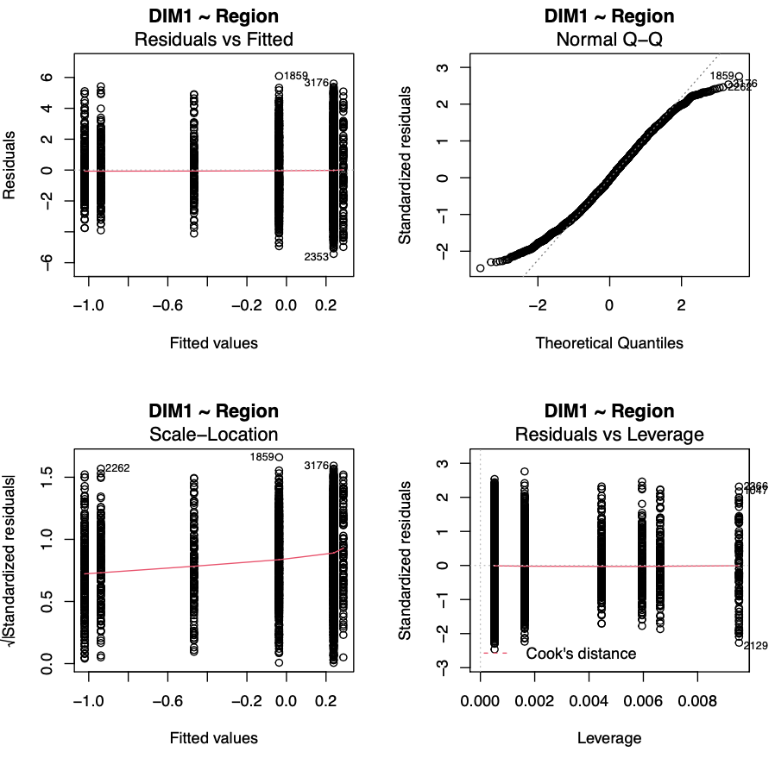
Figure S2: Standardized residual plots for dimension 1 and region for all surveys combined.

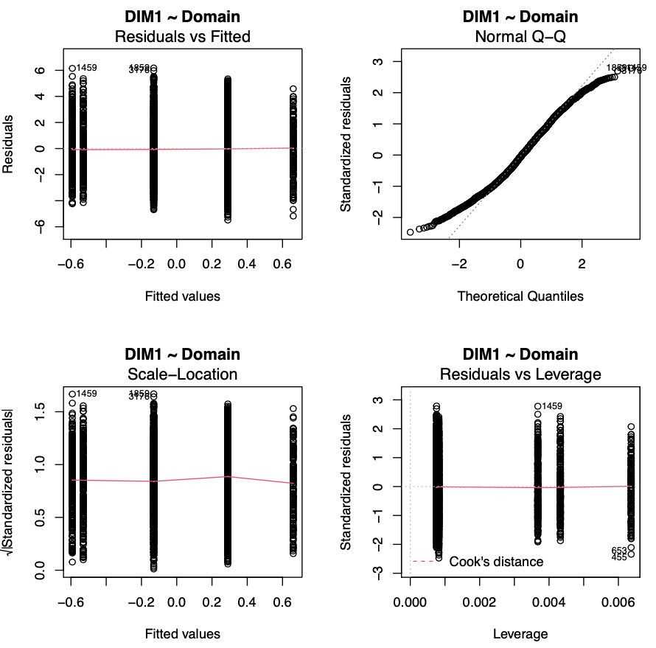
Figure S3: Standardized residual plots for dimension 1 and domain for all surveys combined.
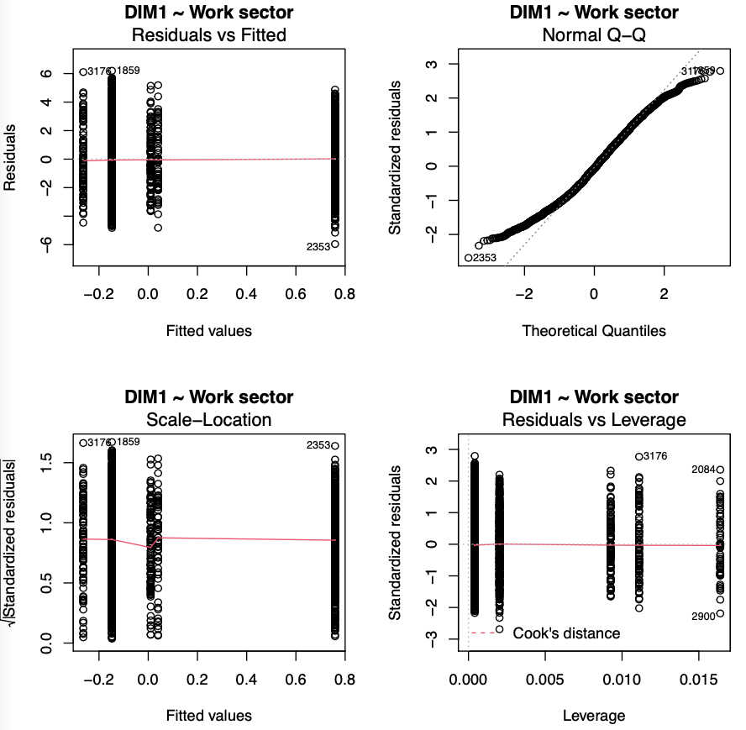
Figure S4: Standardized residual plots for dimension 1 and work sector for all surveys combined.

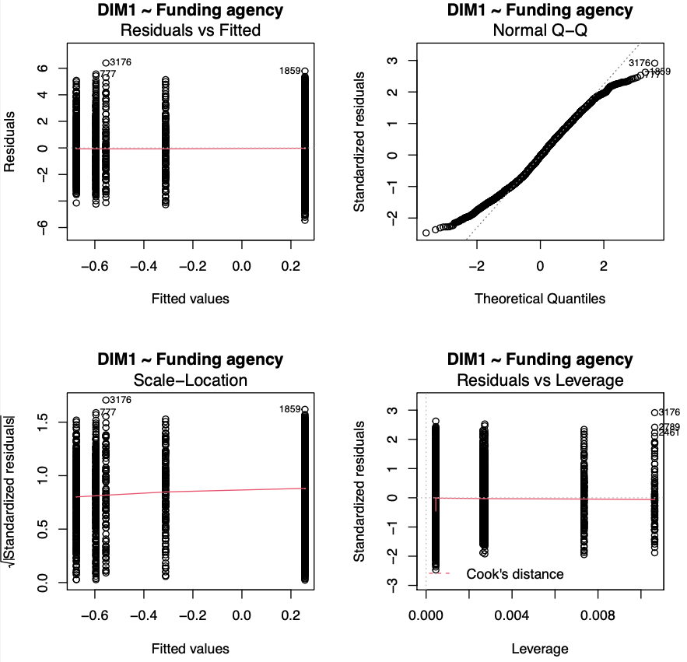
Figure S5: Standardized residual plots for dimension 1 and funding agency for all surveys combined.

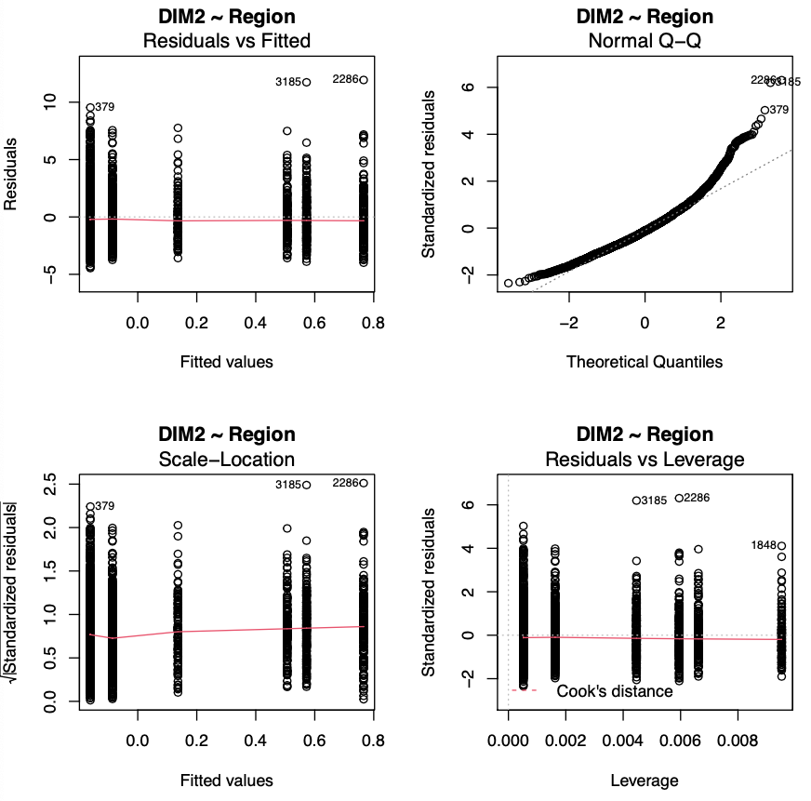
Figure S6: Standardized residual plots for dimension 2 and region for all surveys combined.

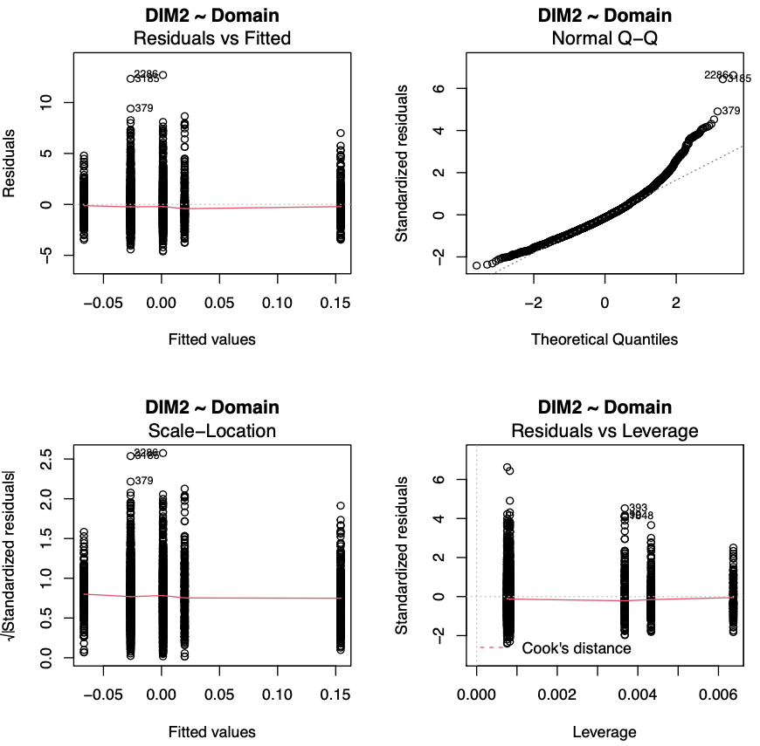
Figure S7: Standardized residual plots for dimension 2 and domain for all surveys combined.

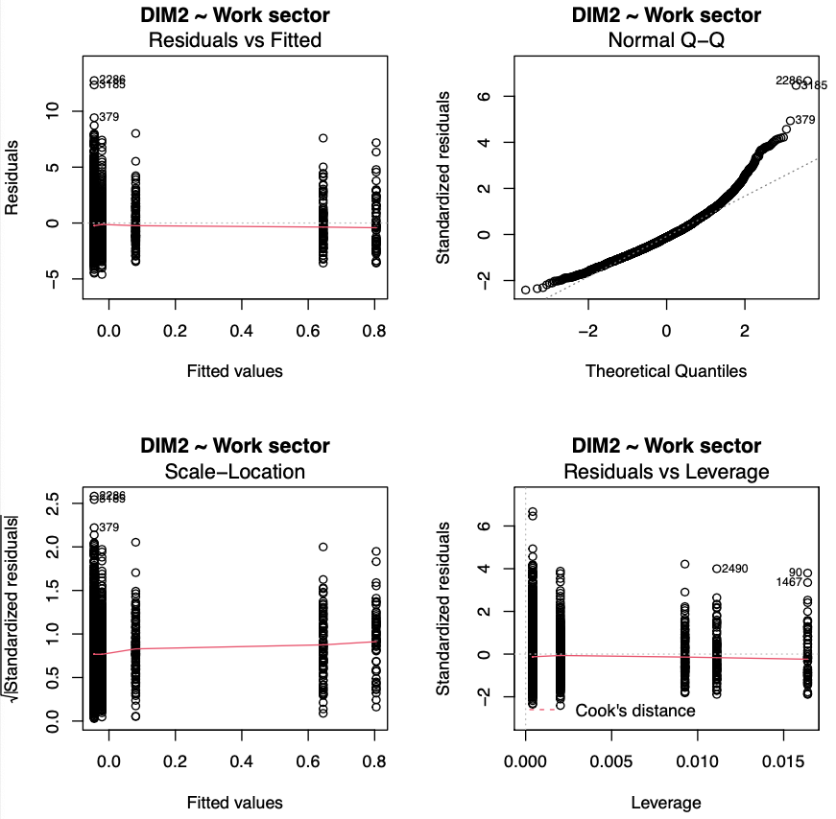
Figure S8: Standardized residual plots for dimension 2 and work sector for all surveys combined.

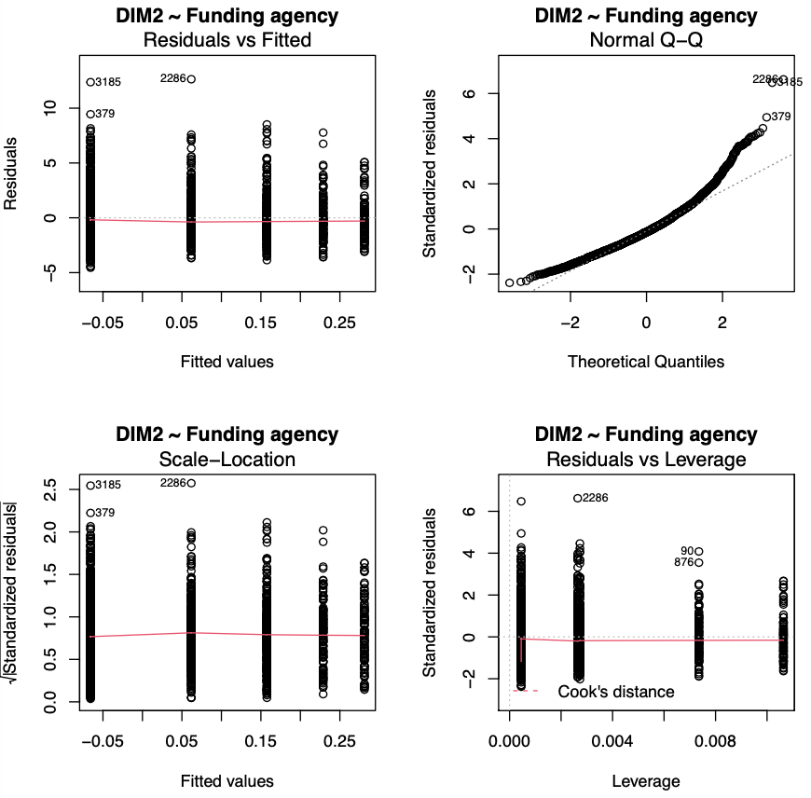
Figure S9: Standardized residual plots for dimension 2 and funding agency for all surveys combined.

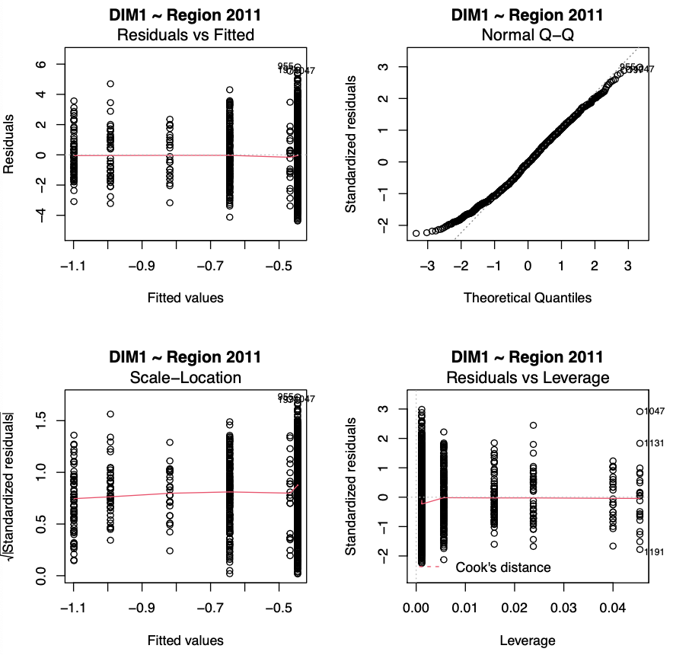
Figure S10: Standardized residual plots for dimension 1 and region in the 2011 survey.

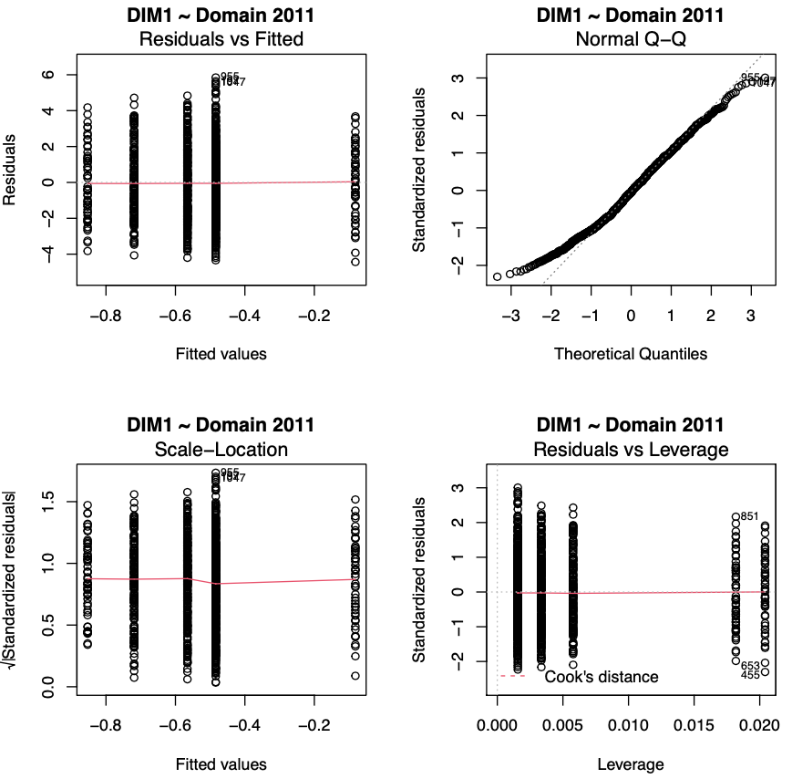
Figure S11: Standardized residual plots for dimension 1 and domain in the 2011 survey.

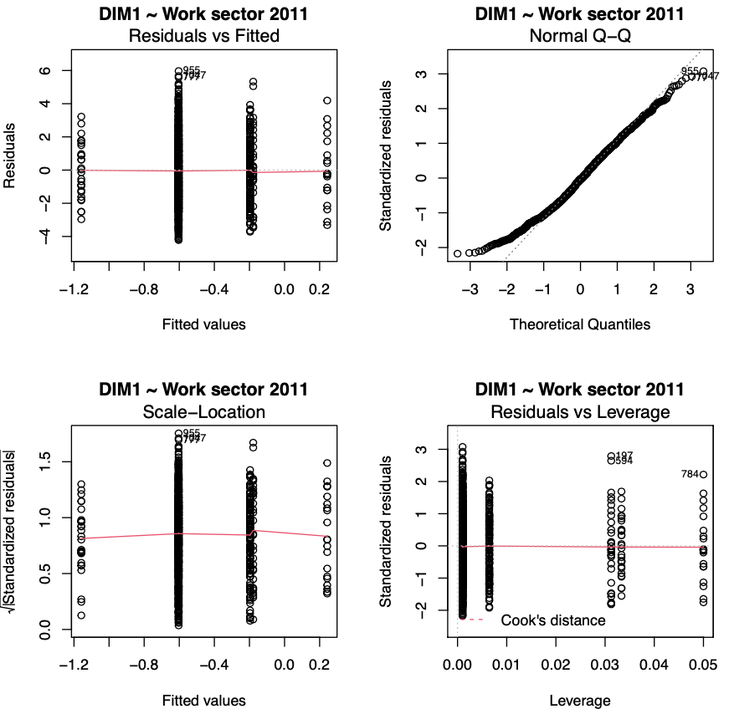
Figure S12: Standardized residual plots for dimension 1 and work sector in the 2011 survey.

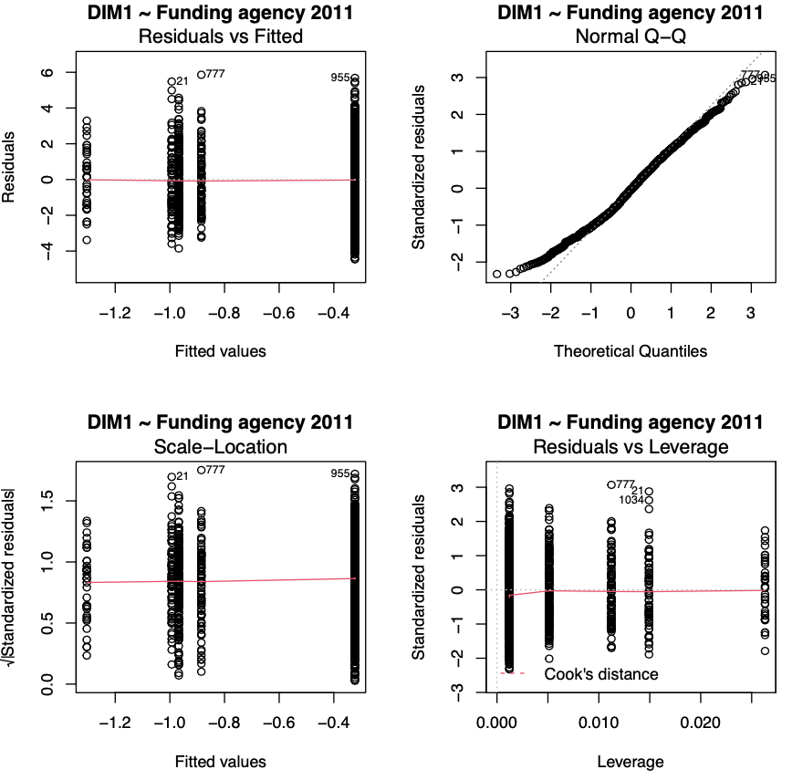
Figure S13: Standardized residual plots for dimension 1 and funding agency in the 2011 survey.

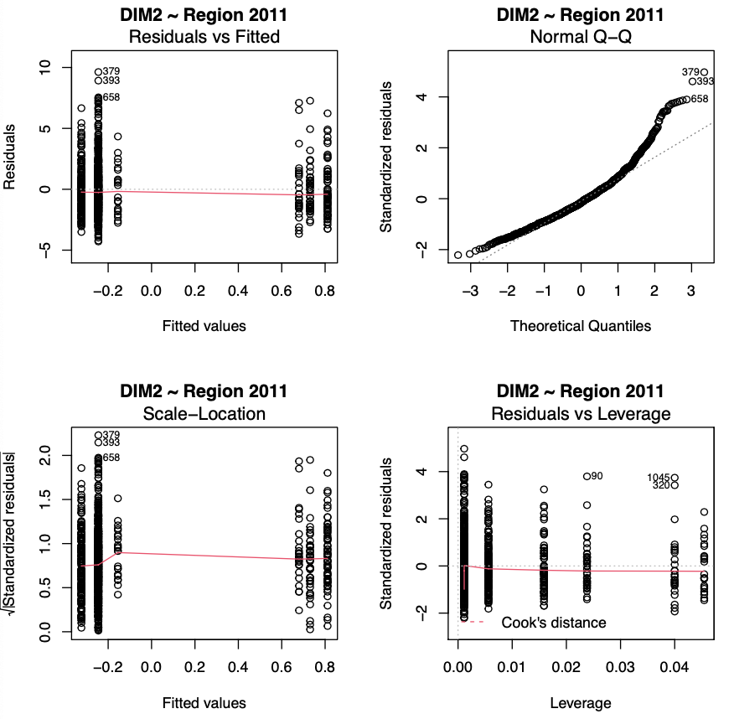
Figure S14: Standardized residual plots for dimension 2 and region in the 2011 survey.

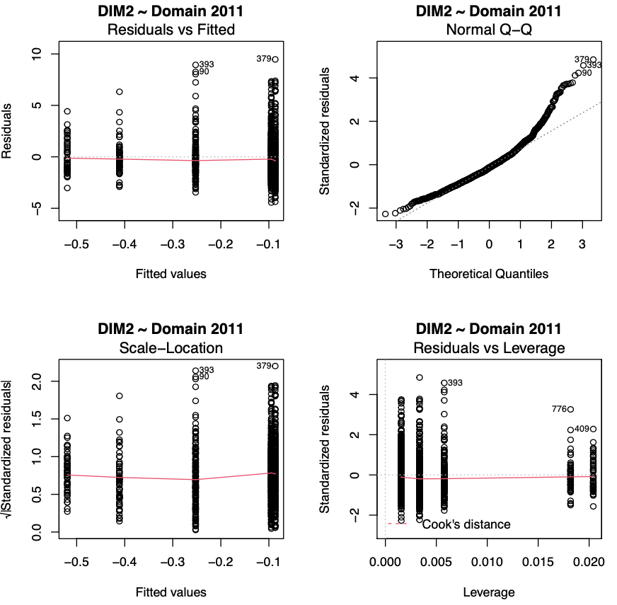
Figure S15: Standardized residual plots for dimension 2 and domain in the 2011 survey.

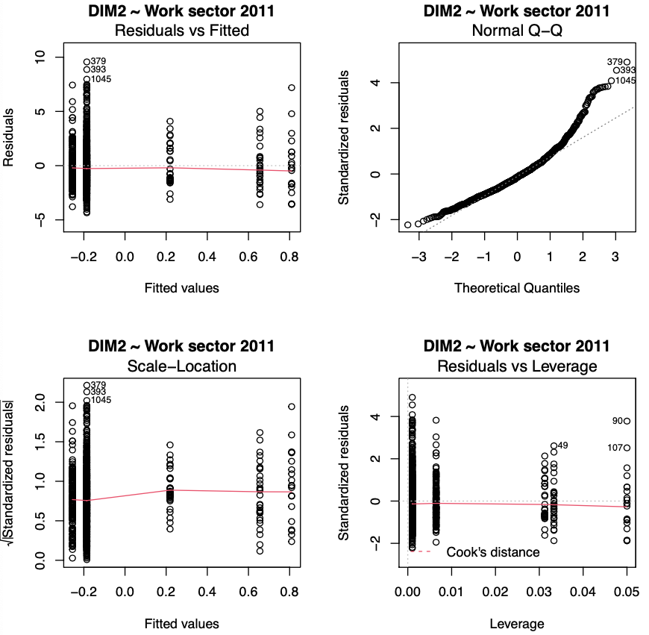
Figure S16: Standardized residual plots for dimension 2 and work sector in the 2011 survey.

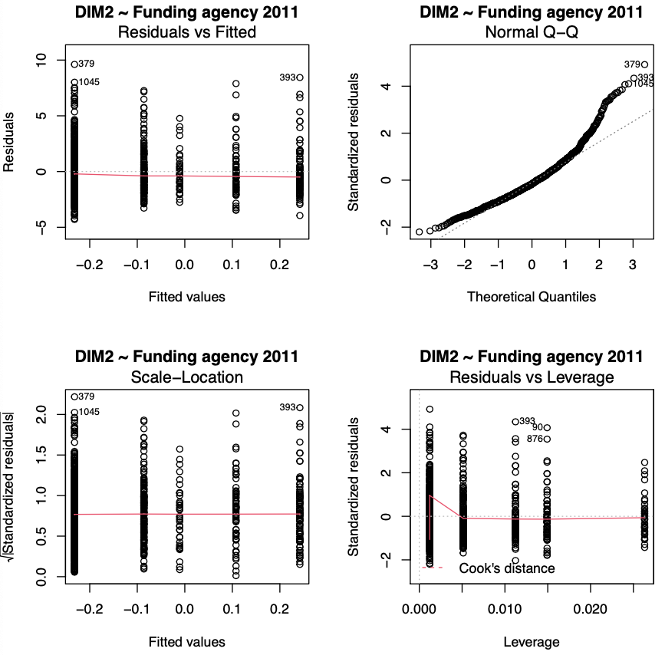
Figure S17: Standardized residual plots for dimension 2 and funding agency in the 2011 survey.

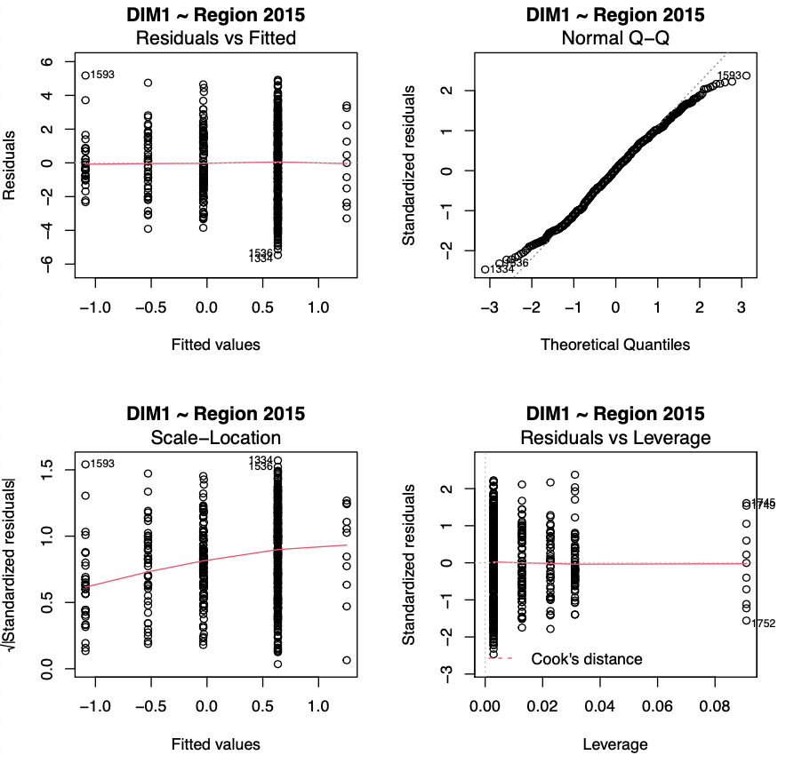
Figure S18: Standardized residual plots for dimension 1 and region in the 2015 survey.

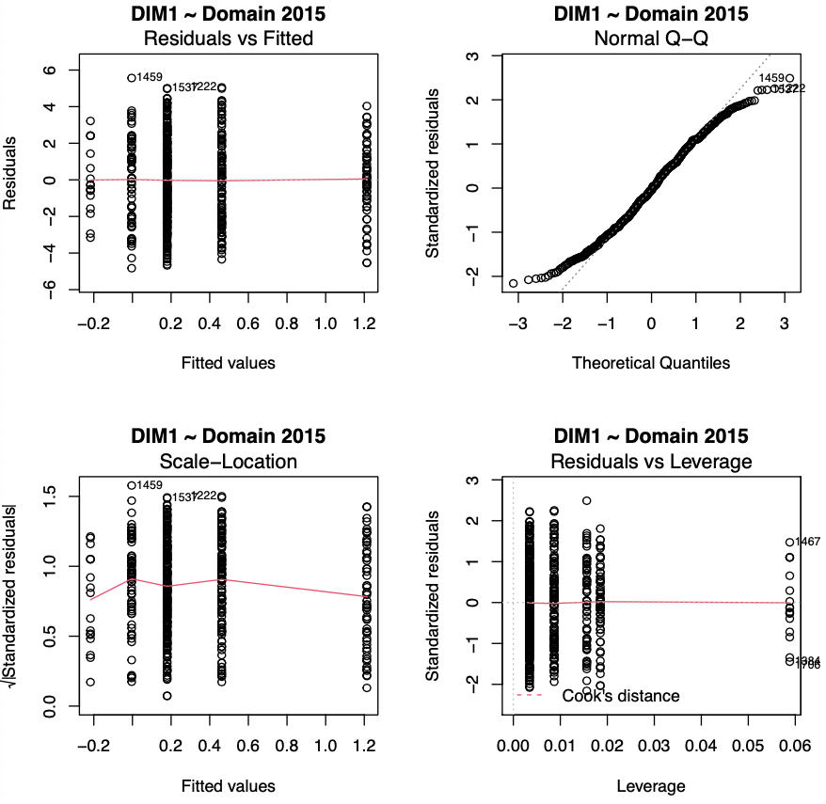
Figure S19: Standardized residual plots for dimension 1 and domain in the 2015 survey.

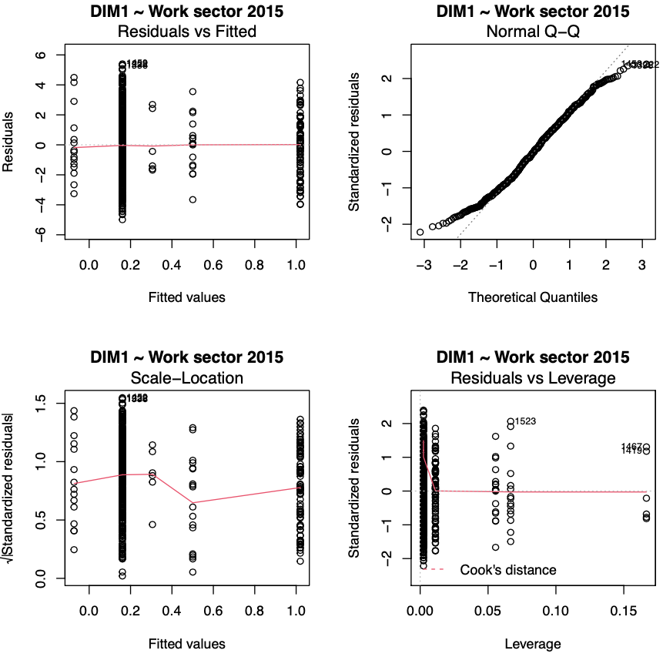
Figure S20: Standardized residual plots for dimension 1 and work sector in the 2015 survey.

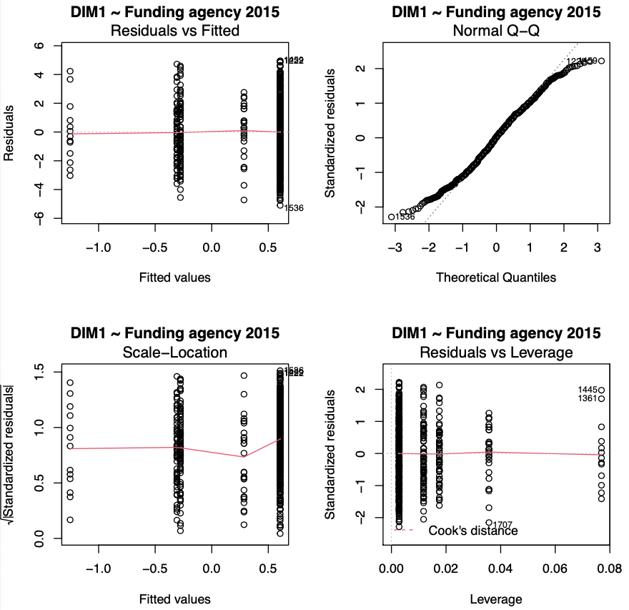
Figure S21: Standardized residual plots for dimension 1 and funding agency in the 2015 survey.

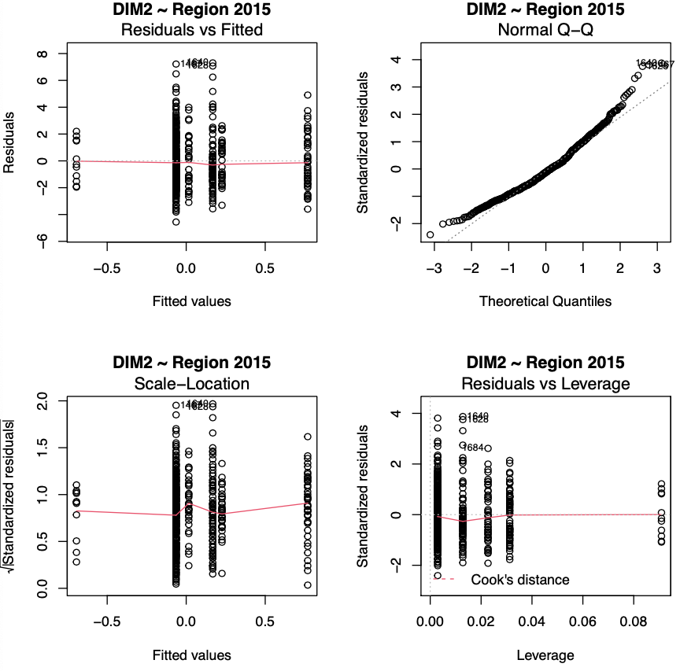
Figure S22: Standardized residual plots for dimension 2 and region in the 2015 survey.

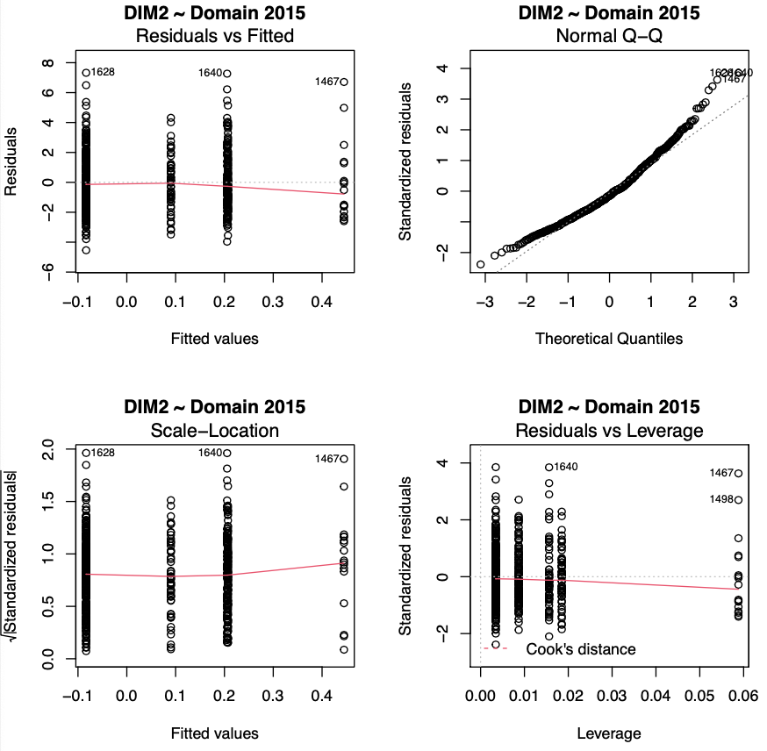
Figure S23: Standardized residual plots for dimension 2 and domain in the 2015 survey.

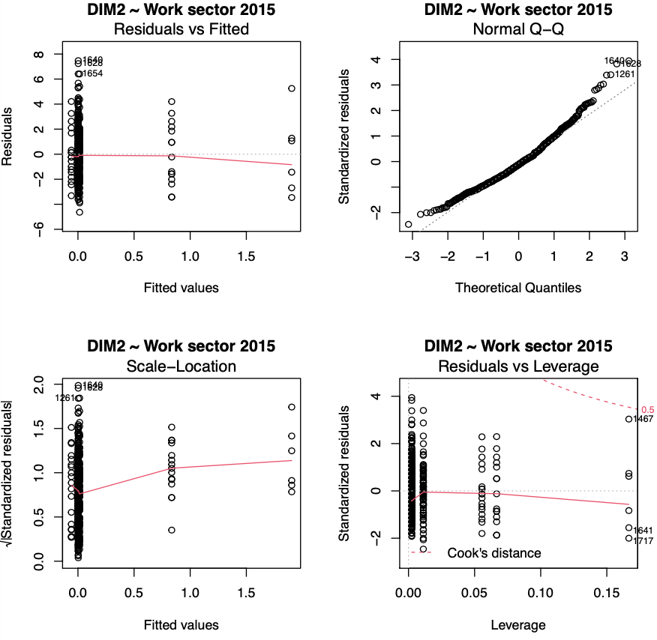
Figure S24: Standardized residual plots for dimension 2 and work sector in the 2015 survey.

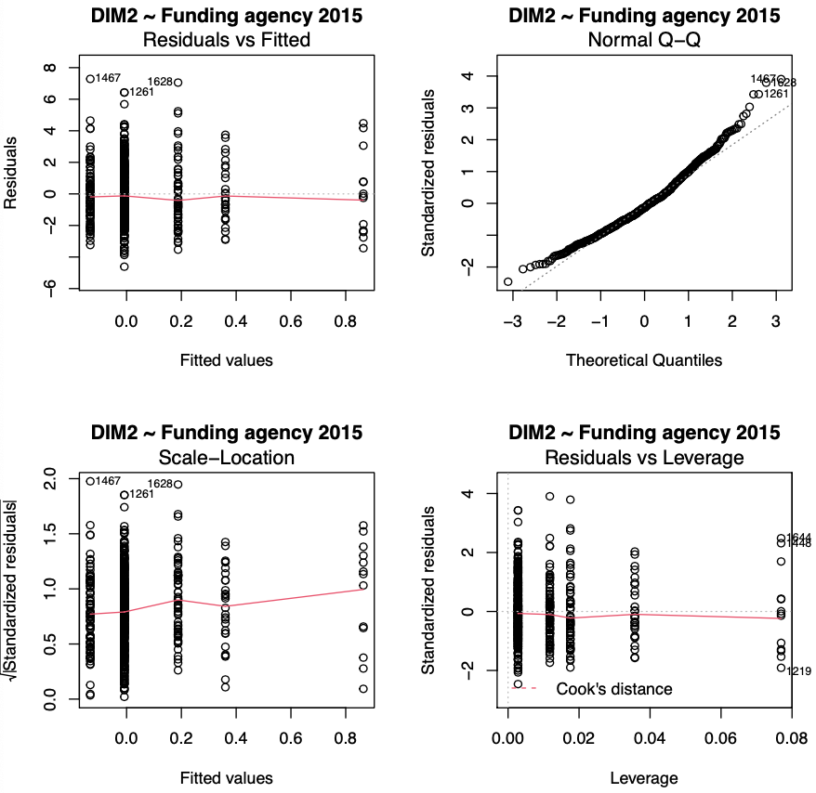
Figure S25: Standardized residual plots for dimension 2 and funding agency in the 2015 survey.

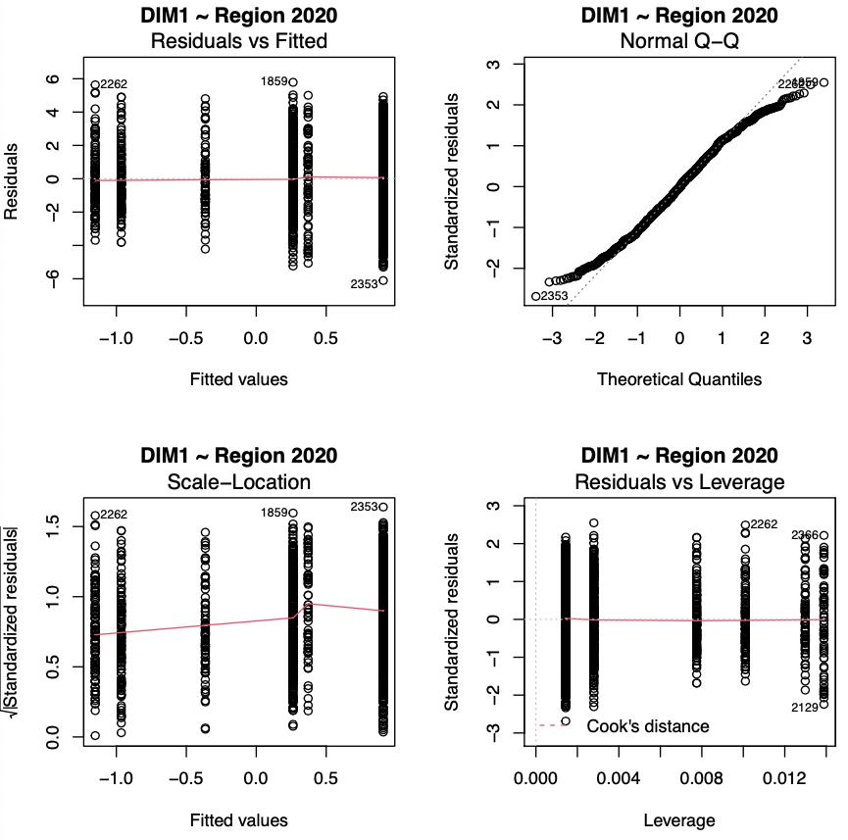
Figure S26: Standardized residual plots for dimension 1 and region in the 2020 survey.

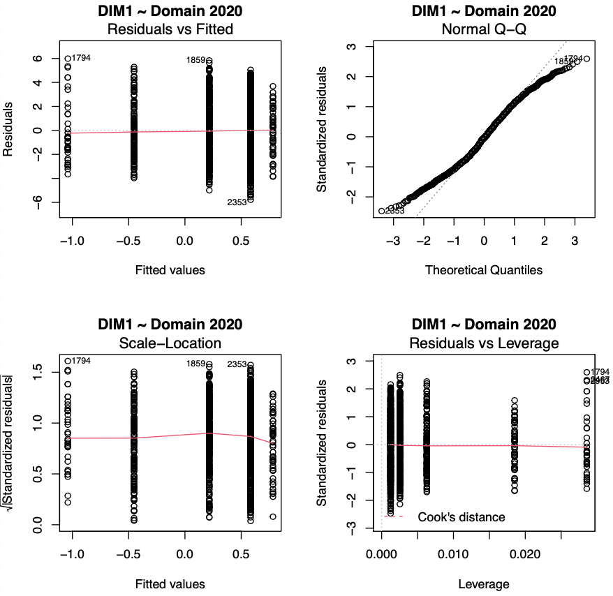
Figure S27: Standardized residual plots for dimension 1 and domain in the 2020 survey.

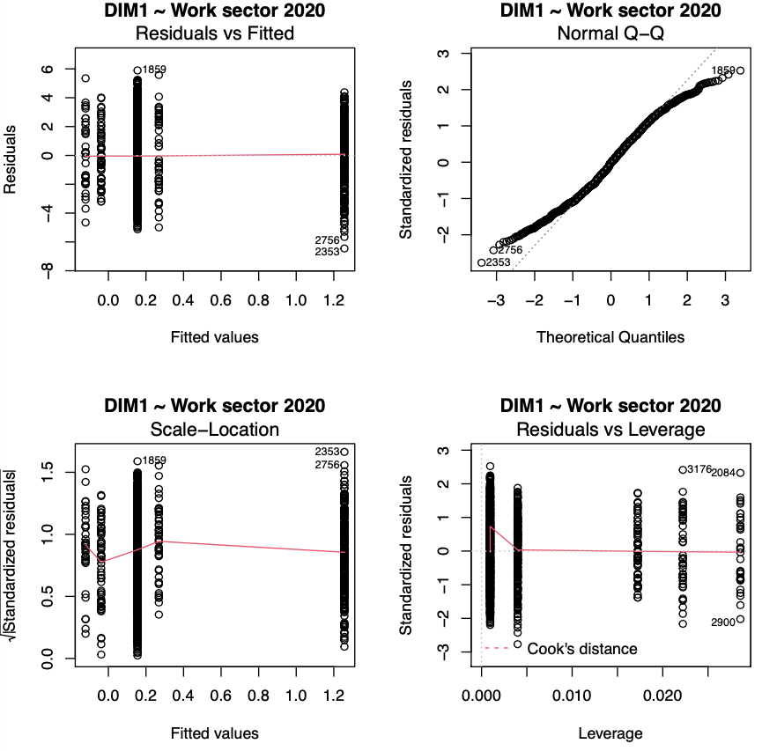
Figure S28: Standardized residual plots for dimension 1 and work sector in the 2020 survey.

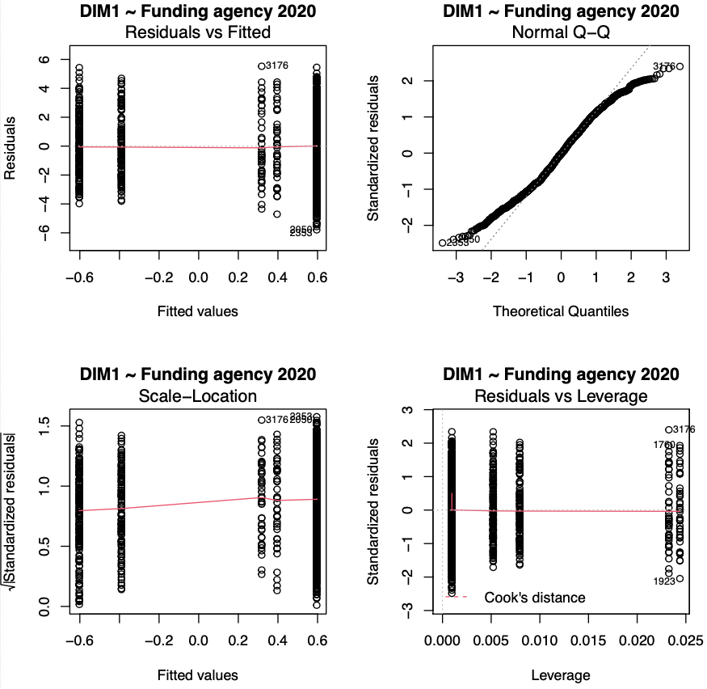
Figure S29: Standardized residual plots for dimension 1 and funding agency in the 2020 survey.

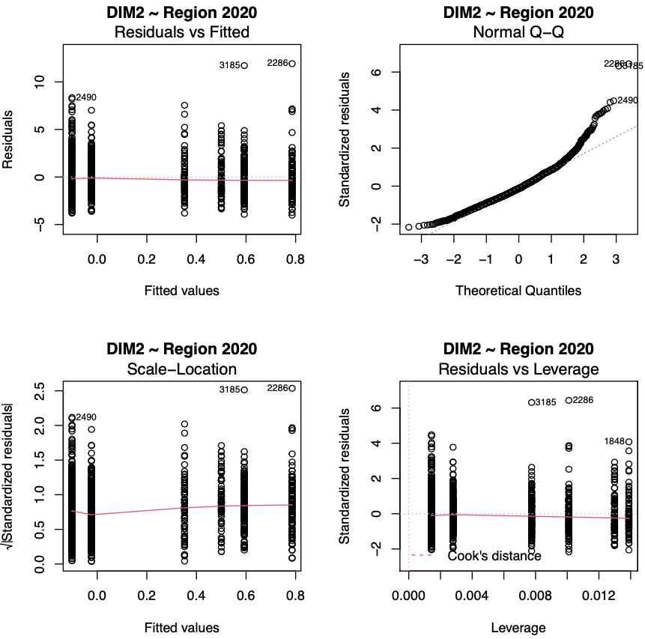
Figure S30: Standardized residual plots for dimension 2 and region in the 2020 survey.

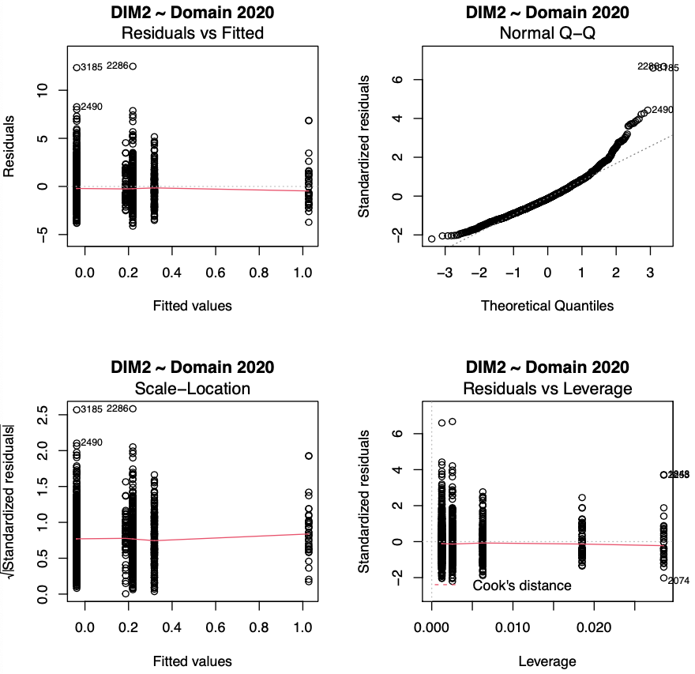
Figure S31: Standardized residual plots for dimension 2 and domain in the 2020 survey.

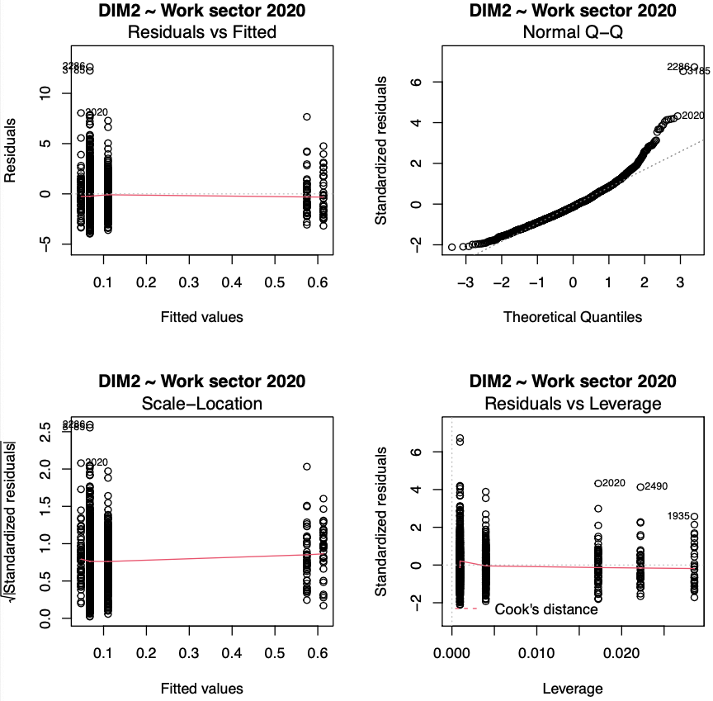
Figure S32: Standardized residual plots for dimension 2 and work sector in the 2020 survey.

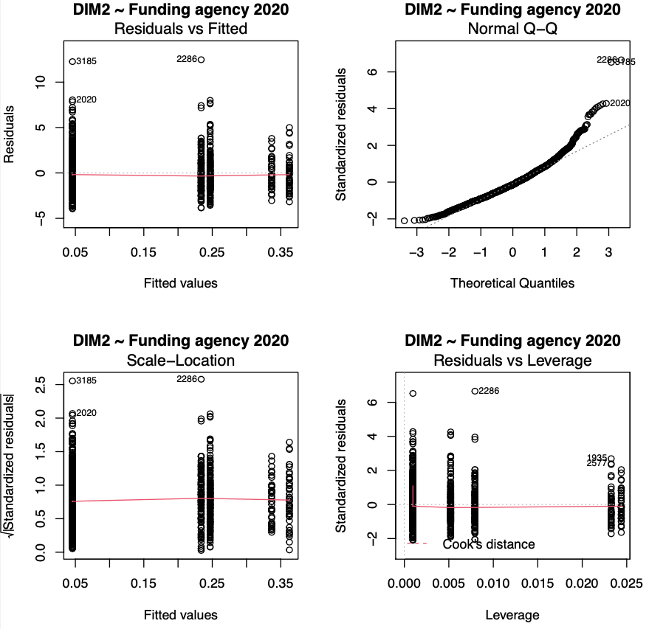
Figure S33: Standardized residual plots for dimension 2 and funding agency in the 2020 survey.

