Mental health of children with gender and sexual minority parents: a review and future directions
By Deni Mazrekaj and Yuxuan Jin
Supplementary Information
Risk of bias assessment
We assessed the risk of bias in the studies included in our review using the Risk of Bias in Non-randomised Studies of Interventions (ROBINS-I) tool (Sterne et al., 2016). We assessed seven specific bias domains: (1) bias due to confounding; (2) bias in the selection of participants into the study; (3) bias in the classification of interventions; (4) bias due to deviations from intended interventions; (5) bias due to missing data; (6) bias in measurement outcomes; (7) bias in the selection of the reported result. Two authors independently applied the tool to assess each study and recorded judgements of risk of bias for each domain, including low, moderate, serious, critical, and no information. In line with other systematic reviews (e.g., Betthäuser, Bach-Mortensen, & Engzell, 2023), the overall judgement of risk of bias for each study was determined by the highest level of risk of bias in any of the domains that were assessed.
Supplementary Figure 1 and Figure 2 show the results of the risk of bias assessment, which were created by the robvis tool (McGuinness & Higgins, 2021). Supplementary Figure 1 is a summary plot of the judgement of risks for all 17 articles included in our review. Supplementary Figure 2 is the traffic light plot of the judgement of risk of bias for each study, including the overall risk and seven risks of bias domains separately. As shown in Supplementary Figure 1, the most common and severe bias for the studies in our review is due to confounding. Another common bias is from the selection of participants for the study as many studies used convenience samples and cross-sectional data. In the main text of the discussion part, we provided suggestions for future studies on how to reduce the risk of bias.
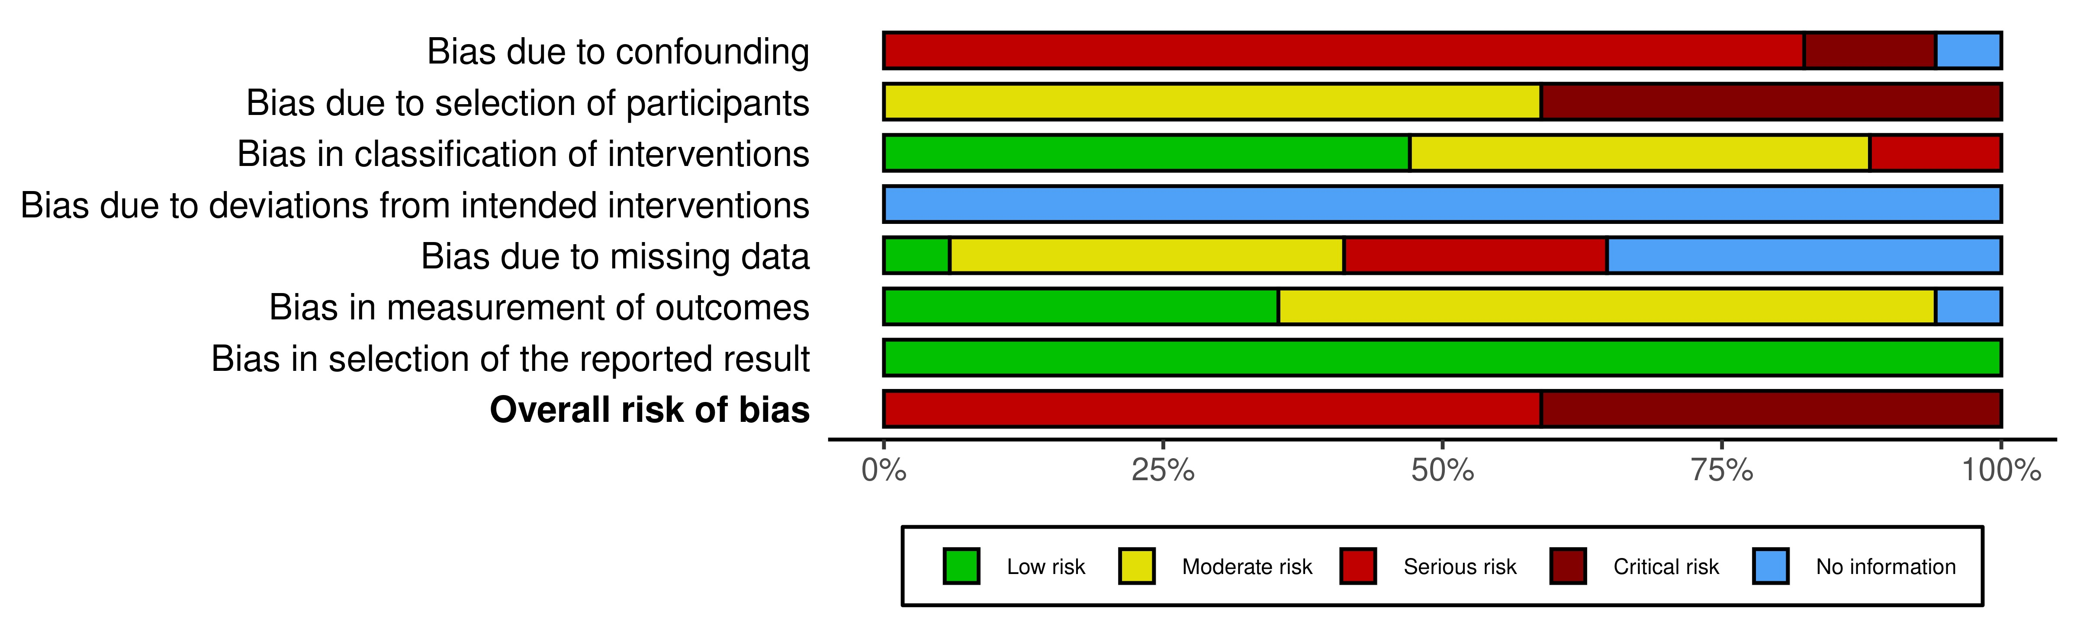
Supplementary Figure 1. Summary plot of judgement for the risk of bias separated by the risk of bias domain.

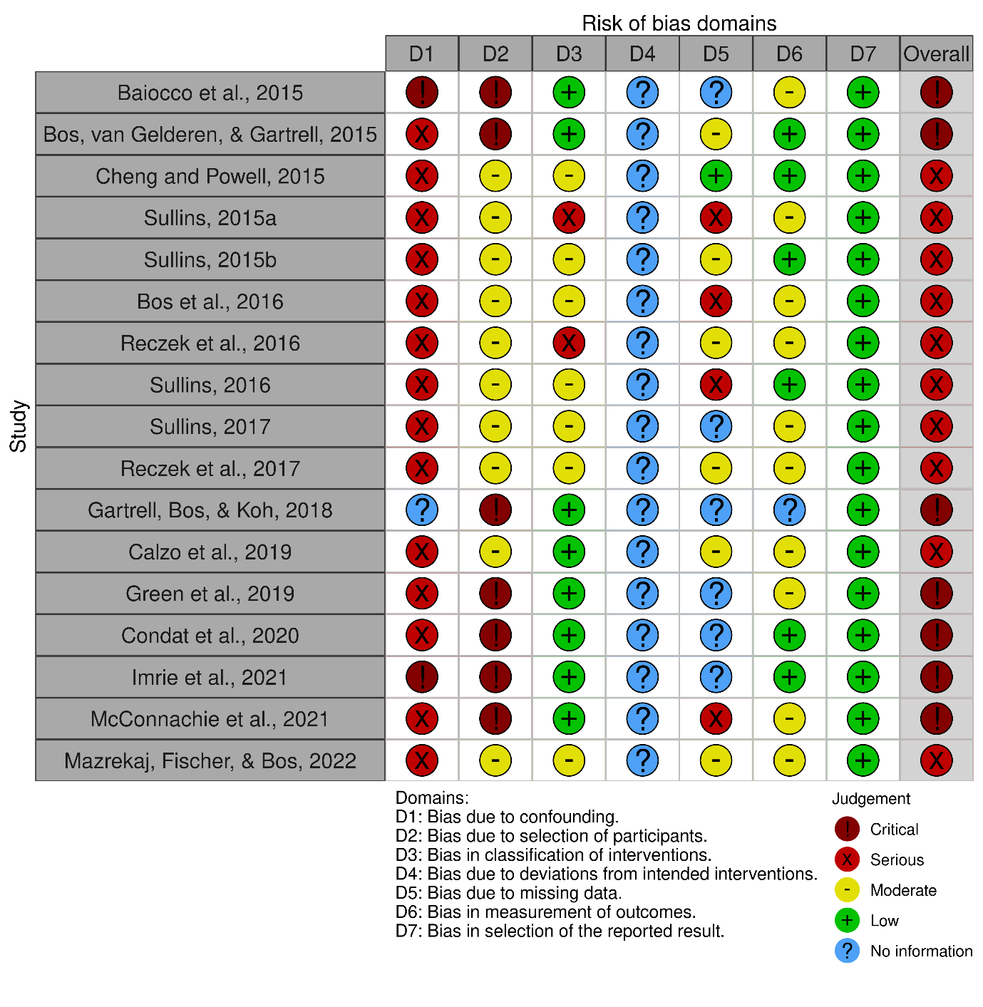
Supplementary Figure 2. Traffic light plot of judgement of the risk of bias, separated by each study and risk of bias domain.

References
Betthäuser, B. A., Bach-Mortensen, A. M. & Engzell, P. (2023). A systematic review and meta-analysis of the evidence on learning during the COVID-19 pandemic. Nature Human Behaviour, 7, 375–385. https://doi.org/10.1038/s41562-022-01506-4
McGuinness, L. A., & Higgins, J. P. (2021). Risk-of-bias VISualization (robvis): An R package and Shiny web app for visualizing risk-of-bias assessments. Research Synthesis Methods, 12(1), 55–61. https://doi.org/10.1002/jrsm.1411
Sterne, J. A., Hernán, M. A., Reeves, B. C., Savović, J., Berkman, N. D., Viswanathan, M., Henry, D., Altman, D. G., Ansari, M. T., Boutron, I., Carpenter, J. R., Chan, A.-W., Churchill, R., Deeks, J. J., Hróbjartsson, A., Kirkham, J., Jüni, P., Loke, Y. K., Pigott, T. D., … Higgins, J. P. (2016). ROBINS-I: A tool for assessing risk of bias in non-randomised studies of interventions. BMJ, 355, i4919. https://doi.org/10.1136/bmj.i4919

