Appendix

Conversation with ChatGPT (in German): Prompts & answers
Requests made: between 03 and 09 May 2023

Prompt:
Answer as a researcher: In which activities within their studies can ChatGPT support engineering students?

Answer
As an AI model, ChatGPT can support engineering students in various activities within their studies. Some examples are:

1. research and literature study: ChatGPT can help in finding relevant research papers, articles or books to enhance students' knowledge.
2. concept development and design: ChatGPT can help in developing ideas and concepts for projects, design of experiments, prototypes or products by providing feedback and suggestions.
3. data analysis and modelling: ChatGPT can assist in analysing data or creating models to solve technical problems.
4. programming and simulation: ChatGPT can assist in writing code or running simulations to optimise specific technologies or processes.
5. problem solving and decision making: ChatGPT can help in problem identification or decision making by suggesting alternative solutions or performing decision tree analysis.

Overall, ChatGPT can be used as a tool to support engineering students in many aspects of their studies, from literature review to practical application of technologies and concepts.

Prompt:
Answer as a researcher: In what activities within their studies can ChatGPT support science students?

Answer
As an artificial intelligence, ChatGPT can support students of science in various areas. Some examples are:

1. research: ChatGPT can help in searching for scientific articles and publications by suggesting relevant keywords and search terms and recommending appropriate sources.
2. data analysis: ChatGPT can help with data analysis and interpretation by suggesting statistical methods and models tailored to students' specific research questions.
3. word processing: ChatGPT can help with the writing of scientific articles and reports by providing feedback and suggestions for grammar, spelling and writing style.
4. research design: ChatGPT can help in planning research projects by giving suggestions for the selection of variables, methods and instruments, and advice on how to optimise the research design.
5. literature review: ChatGPT can help in conducting literature reviews by identifying relevant publications and providing summaries and analyses of these articles.

However, it is important to note that while ChatGPT as an artificial intelligence can provide useful support, it is not a substitute for students' critical thinking and intellectual work. It is always important to review and validate the results proposed by ChatGPT to ensure that they meet scientific standards.

Prompt:
Answer as a researcher: In what activities in their studies can ChatGPT support students of mathematics?

Answer
As a researcher in the field of artificial intelligence, I can tell you that ChatGPT can support students of mathematics in a variety of activities. Here are some examples:

1. explaining mathematical concepts: ChatGPT can help students understand complex mathematical concepts by explaining them in understandable language and giving examples.
2. solving mathematical problems: ChatGPT can help students solve mathematical problems by guiding them through the solution process or even suggesting possible solutions.
3. providing practice problems: ChatGPT can provide students with practice problems and examples to improve their understanding of mathematics.
4. answering questions: ChatGPT can help students with questions about mathematical concepts and problems by providing instant answers.
5. generation of mathematical formulas: ChatGPT can help students generate mathematical formulae and equations relevant to their research work or studies.
6. connecting mathematics with other disciplines: ChatGPT can help students connect mathematical concepts with other disciplines to better understand their applicability.

These are just a few examples of activities where ChatGPT can help students of mathematics. Ultimately, ChatGPT can help improve students' understanding and performance in mathematics.

Prompt:
Answer as a researcher: In which activities in the context of their studies can ChatGPT support medical students?

Answer
As a language model, I can support medical students with various tasks within their studies, such as:

1. literature research: I can help with searching for scientific articles and publications in medical databases such as PubMed, Medline or Cochrane Library.
2. understanding medical concepts: I can help students understand and explain complex medical concepts. By using natural language and adding context, I can make difficult medical topics more understandable.
3. exam preparation: I can help students prepare for medical exams by answering questions on different topics and helping students prepare for oral or written exams.
4. case discussions: I can help students analyse and discuss clinical cases by providing additional information on diseases, treatment options and diagnostic possibilities.
5. medical terminology: I can assist students in learning medical terminology by providing definitions and examples of medical terms.

Prompt:
Answer as a researcher: In what activities within their studies can ChatGPT support healthcare students?

Answer
As an AI model, ChatGPT can support healthcare students in various activities within their studies, including:

1. literature search: ChatGPT can help find relevant research papers, studies or other scientific articles in the field of healthcare. It can also assist in obtaining information on medical conditions, symptoms, treatments and medical procedures.
2. case studies: ChatGPT can help in case study preparation and interpretation by providing relevant information on medical cases, diagnoses and treatment options.
3. exam preparation: ChatGPT can help students prepare for healthcare exams by answering questions and helping with content revision.
4. ethics discussions: ChatGPT can help discuss ethical issues and decisions in the field of healthcare by offering different perspectives and arguments.
5. translations: ChatGPT can also help in translating medical terms and texts into different languages to meet the needs of patients from different countries and cultures.
6. clinical decision-making: ChatGPT can help with clinical decision-making by collating studies and evidence-based practices to help identify diagnoses and treatments.

However, it is important to note that ChatGPT is an AI model and should not be considered a substitute for human medical professionals. Students should always seek professional medical advice and help from experienced doctors or other medical experts for more complex medical problems.

Prompt:
Answer as a researcher: In what activities in their studies can ChatGPT assist students of social sciences? (in German: “Gesellschaftswissenschaften”)

Answer
As a researcher in the field of artificial intelligence, I can say that ChatGPT can assist students in many areas of social sciences. Some examples are:

1. researching and summarising information: ChatGPT can help students find relevant information and summarise it in a clear way. This can be particularly useful when preparing assignments or other written work.
2. text analysis and processing: ChatGPT can help students to analyse texts and extract important information from them. This can be helpful both in preparing term papers and in conducting research projects.
Language processing and translation: ChatGPT can help students to translate and understand texts in different languages. This can be particularly beneficial when students need to read materials in another language.
4. data analysis and visualisation: ChatGPT can help students analyse data and help them present this data in a visual way. This can be particularly beneficial when conducting empirical studies or analysing statistics.
5. generating texts: ChatGPT can help students to generate texts, for example when creating summaries or abstracts. However, it should be noted that the texts generated by ChatGPT are not always perfect and should be checked by students.

These are just a few examples of how ChatGPT can support students of social sciences. However, it is important to emphasise that ChatGPT should not be used as a substitute for human support, but as a complementary tool for students.

Prompt:
Answer as a researcher: In what activities in their studies can ChatGPT support students of social sciences? (in German: “Sozialwissenschaften”)

Answer
As a researcher in the field of artificial intelligence, I can offer many different ways to help students in the social sciences. Here are some concrete examples:
1. research: ChatGPT can help students find relevant research articles and databases relevant to their work.
2. data analysis: ChatGPT can help students analyse data, for example by performing statistical analysis or assisting in the development of machine learning models.
3. writing process: ChatGPT can help students with writing by, for example, offering suggestions for better wording or revised structure of the text.
4. answering questions: ChatGPT can help students by answering questions about certain concepts or theories and thus help to clarify ambiguities.
5. automated summaries: ChatGPT can help students by creating automated summaries of long texts to save them time and effort.
6. language translation: ChatGPT can help students by automatically translating texts into different languages, which can help them read and understand relevant literature in another language.

These are just a few examples of how ChatGPT can help students of social sciences. With its ability to hold human-like conversations and respond to natural language, ChatGPT can also provide customised support to meet students' needs and requirements.

Prompt:
Answer as a researcher: In what activities within their studies can ChatGPT support law students?

Answer
As an artificial intelligence with a strong language processing capability, I can assist law students in a variety of areas. Here are some possible activities I can help with:

1. research: I can help find relevant legal sources such as legal texts, court decisions, case law or specialised literature.
2. summaries and analyses: based on the sources found, I can help to prepare summaries and analyses that help students to better understand the content.
3. spelling and grammar check: I can help identify and correct spelling and grammar errors in legal writing.
4. legal tech applications: I can help develop legal-tech applications that facilitate legal work, such as automated contract generation or legal case analysis.
5. answering questions: I can answer questions on legal topics by drawing on my knowledge of laws, case law and other legal sources.

However, it is important to note that as an artificial intelligence, I am not able to provide legal advice or answer complex legal questions that require individual assessment. In such cases, it is advisable to consult a qualified lawyer or legal adviser

Prompt:
Answer as a researcher: In what activities as part of their studies can ChatGPT assist students of economics?

Answer
As an artificial intelligence, I can support students of economics in a variety of ways. Here are some examples:
1. research: I can help students find relevant research papers, literature and other sources they need for their papers.
2. data analysis: I can help students perform statistical analyses and interpret data.
3. writing support: I can help students improve their writing skills by providing feedback on their grammar, spelling and expression.
4. decision-making: I can help students make complex decisions by showing them different scenarios and possible outcomes.
5. tutoring: I can help students better understand their course materials by answering questions and giving them explanations of different concepts and theories.

However, it is important to note that my answers are always based on the data and information I have access to. Students should therefore consider my answers as a form of support and not as a substitute for their own intellectual work.

Prompt:
Answer as a researcher: In what activities within their studies can ChatGPT support students of linguistics?

Answer
As a language model, I can support linguistics students in a number of ways, particularly with:

1. text analysis and language processing: as a language model, I can help analyse texts and solve complex language problems. For example, I can help identify linguistic patterns and peculiarities in a text.
2. translation: I can also assist in the translation of texts and documents by helping to translate the meaning and nuances of texts into different languages.
3. language learning and teaching: As I am able to communicate in different languages, I can also assist with language learning and teaching. For example, I can act as a virtual language teacher and help students improve their language skills.
4. language research: Finally, I can also assist in conducting language-related research projects and analysing language data. I can help collect, analyse and interpret data to gain relevant insights.

Prompt:
Answer as a researcher: In which activities within their studies can ChatGPT support students of cultural studies?

Answer
As an AI-based language model, ChatGPT can support students of cultural studies in various activities, including:

1. research: ChatGPT can assist in researching literature, articles and other sources by retrieving and providing relevant information from a variety of databases and online resources.
2. writing process: ChatGPT can help with the writing process by generating ideas, assisting with structuring texts and helping with the use of correct grammar and syntax.
3. analysis: ChatGPT can help with the analysis of texts and other media by identifying relevant information and contexts and providing summaries and conclusions.
4. translation: ChatGPT can help translate texts between different languages by translating automatically and ensuring high accuracy.
5. proofreading: ChatGPT can help proofread texts by identifying and correcting errors in grammar, syntax and spelling.
However, it is important to note that ChatGPT, as an AI-based model, cannot replace the expertise and critical thinking of a human cultural scholar. ChatGPT's support should therefore always be seen as complementary to the student's own work and collaboration with other students and lecturers.

Prompt:
Answer as a researcher: in what activities within their studies can ChatGPT support students of the arts?

Answer
As an artificial intelligence, I can help with various activities within an arts degree. Here are some examples:

1. research: when students need information on specific artists, art movements or art movements, I can help find relevant information from a variety of sources.
2. creativity support: I can help students overcome creative blocks and develop new ideas for their artwork by providing them with a variety of suggestions and sources of inspiration.
3. feedback: students can send their artwork to me for constructive feedback and suggestions for improvement.
4. analysis: I can help students to analyse and interpret artworks by providing them with information about the history, techniques and meaning of artworks.
5. translation: If students need to analyse artworks in a foreign language, I can help by providing them with a translation of texts or descriptions.
6. technical help: if students have technical problems, e.g. using image editing programmes or other tools to create artworks, I can help solve these problems.

There are many ways in which I, as an artificial intelligence, can support students in their art studies. However, ultimately, how I can best help students depends on their specific needs and requirements.

Prompt:
Answer as a researcher: In what activities within their studies can ChatGPT support students of design?

Answer
As a researcher, I would say that ChatGPT can support students of design in a variety of activities within their studies. Here are some examples:

1. ideation and concept development: students can use ChatGPT to generate ideas for projects or to develop ideas they already have. ChatGPT can also help develop concepts for projects by suggesting designs, colours, layouts and other design elements.
2. research: ChatGPT can help design students with research by answering search queries and providing relevant information and sources for a specific topic.
3. text and content design: ChatGPT can help students write text for projects such as websites, social media posts or print materials. It can also help shape the content of projects such as infographics or videos.
4. feedback and critique: ChatGPT can help students receive feedback and critique for their projects by allowing them to present their work to a virtual audience and receive feedback from ChatGPT and other students.
5. technical support: ChatGPT can help design students with technical issues by assisting them in using software and tools or solving technical problems.

There are many more activities where ChatGPT can support design students, but these examples give an overview of how ChatGPT can be used in the context of design studies.

Prompt:
Answer as a researcher: In what activities within their studies can ChatGPT support students of music?

Answer
As an artificial intelligence based on natural language processing, ChatGPT can support students of music in various ways. Here are some examples:

1. writing assistance: ChatGPT can help students to manage writing projects as part of their music studies. ChatGPT can help generate ideas for essays, plan the structure of writing assignments, solve writing problems and provide feedback to improve students' writing skills.
2. music theory: ChatGPT can help music students better understand music theory. The artificial intelligence can answer questions about harmony, rhythm, notation and other aspects of music theory.
3. music history: ChatGPT can also help with researching and understanding music history. It can help students understand and interpret historical facts and events related to music.
4. music practice: ChatGPT can also help with the practical application of music. It can help students analyse pieces of music, identify and correct mistakes in their performances, and provide feedback and tips to improve musical skills.
5. career guidance: ChatGPT can help students explore their career options in music. It can help them find and understand information about career paths, job opportunities and requirements in different areas of the music industry.

There are many more ways in which ChatGPT can help students of music as part of their studies. However, the type of support provided will depend on the individual needs of the student

Prompt:
Answer as a researcher: In what activities as part of their studies can ChatGPT support students of agricultural sciences?

Answer
As an artificial intelligence, I can support students of agricultural sciences in various ways. Here are some of the activities I can help with:

1. literature research: I can help find and collect relevant literature on a specific topic by searching scientific databases.
2. data analysis: I can assist in the analysis of data, be it data collection, data cleaning or the application of statistical methods.
3. writing research questions: I can help formulate research questions and hypotheses by gathering relevant data and information from the literature.
4. simulation of experiments: I can help run simulations of agricultural science experiments to predict outcomes.
5. automated text generation: I can assist in writing scientific texts such as reports, articles or theses by automatically generating texts based on the research results.

These are just a few examples of activities that I, as an artificial intelligence, can help students of agricultural sciences with. However, it depends on the specific requirements and needs of the students how I can best be used.

Prompt:
Answer as a researcher: In which activities within their studies can ChatGPT support forestry students?

Answer
As an artificial intelligence trained on a variety of texts and data, ChatGPT can support forestry students in a variety of ways. Some of the possible applications include:

1. research: ChatGPT can help students research information and articles relevant to their coursework or projects. Students can ask questions and ChatGPT will try to provide the best answers based on its knowledge and experience.
2. text analysis: ChatGPT can help analyse texts by, for example, automatically extracting keywords, generating summaries or classifying texts into different categories.
3. prediction and forecasting: ChatGPT can also help predict events or trends relevant to forest science. For example, it can use machine learning techniques to generate weather forecasts that can help plan forestry operations or fight forest fires.
4. speech processing: ChatGPT can also help process spoken language, for example, automatically transcribing lectures or discussions.

There are many other ways in which ChatGPT can support forestry students, depending on the specific requirements and needs of the students.

Prompt:
Answer as a researcher: In what activities within their studies can ChatGPT support students in teaching degree programmes?

Answer
As an artificial intelligence and language model, ChatGPT can support students in teacher education programmes in several ways, such as:

1. providing teaching materials: ChatGPT can provide teaching materials such as articles, books and videos on various topics in the field of education. Students can ask ChatGPT for recommendations for relevant learning materials and in this way expand their knowledge.
2. answering questions: ChatGPT can help students answer questions on various topics in pedagogy, didactics and other areas of education. Students can ask questions about specific concepts, theories or methods and ChatGPT will provide relevant answers.
3. support in planning lessons: ChatGPT can support students in planning lessons by providing suggestions for activities and methods based on the learning objectives at hand and the needs of the students.
4. teaching feedback: ChatGPT can provide students with teaching feedback by analysing their teaching materials and methods and making recommendations for improvement. In this way, students can improve their teaching effectiveness and enhance their pedagogical expertise.
5. creating exam questions: ChatGPT can help students create exam questions by identifying relevant concepts and theories and providing suggestions for questions that test students' understanding.

However, it is important to note that ChatGPT is not a substitute for human interaction and the expertise of experienced teachers. However, it can be used as a valuable tool to support the learning process.

Answer as a researcher: In what activities in their studies can ChatGPT support students in civil service programmes?

As an artificial intelligence, I am able to provide information on various topics that can help students in civil service programmes. For example, I could help with researching laws, regulations and other relevant documents or serve as a reference for technical terms and definitions.
In addition, I could also assist with the preparation of term papers and other written work by providing information on various topics or helping to structure and organise texts. I could also help prepare for exams and papers by, for example, providing practice exercises and questions on various topics.
However, it is important to note that as an artificial intelligence, I cannot provide personal advice or individual support like a tutor or lecturer. My strengths lie in providing information and assistance with various study activities.

Prompt:
Answer as a researcher: How can ChatGPT assist in programming?

Answer
As a researcher, I can say that ChatGPT can provide excellent support in programming, especially in developing software applications or algorithms. ChatGPT is able to understand complex code syntax and structures and can therefore help in debugging and optimising code.
In addition, ChatGPT can serve as a creative partner that assists in the development of new programming solutions and approaches. The model can also help in generating automated tests by identifying potential bugs or vulnerabilities in the code.
Another advantage of ChatGPT is its ability to quickly analyse and understand large amounts of code and documentation. This can help identify patterns and trends in the code, which in turn can help improve the quality and efficiency of applications.
Overall, ChatGPT can be a valuable addition for any developer who wants to code quickly and efficiently. However, it is important to note that there is still a human component and developers still need to make their own decisions based on their expertise and experience.

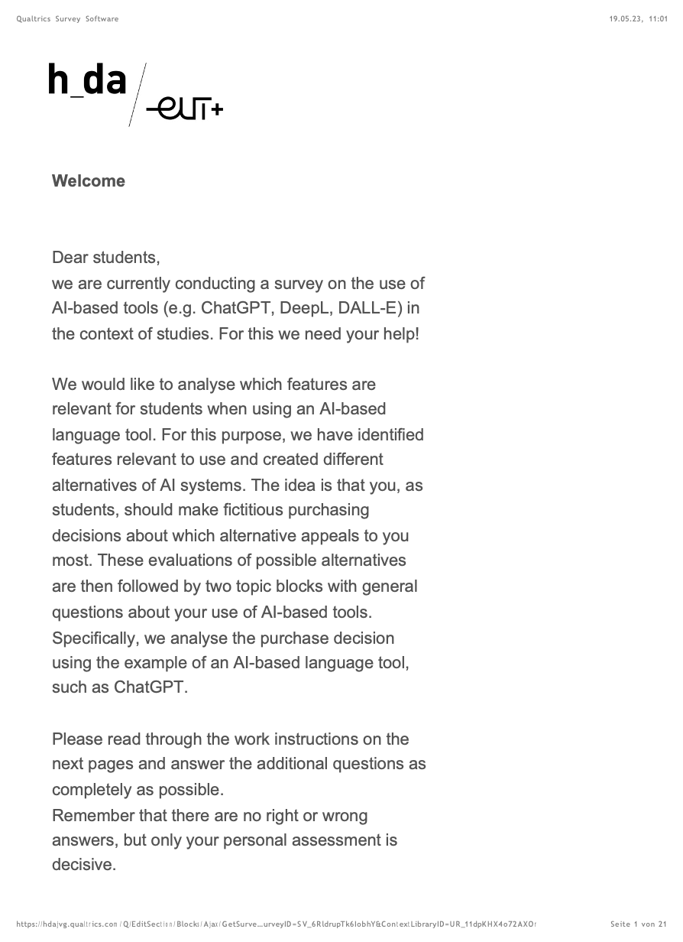
Questionaire (in German originally)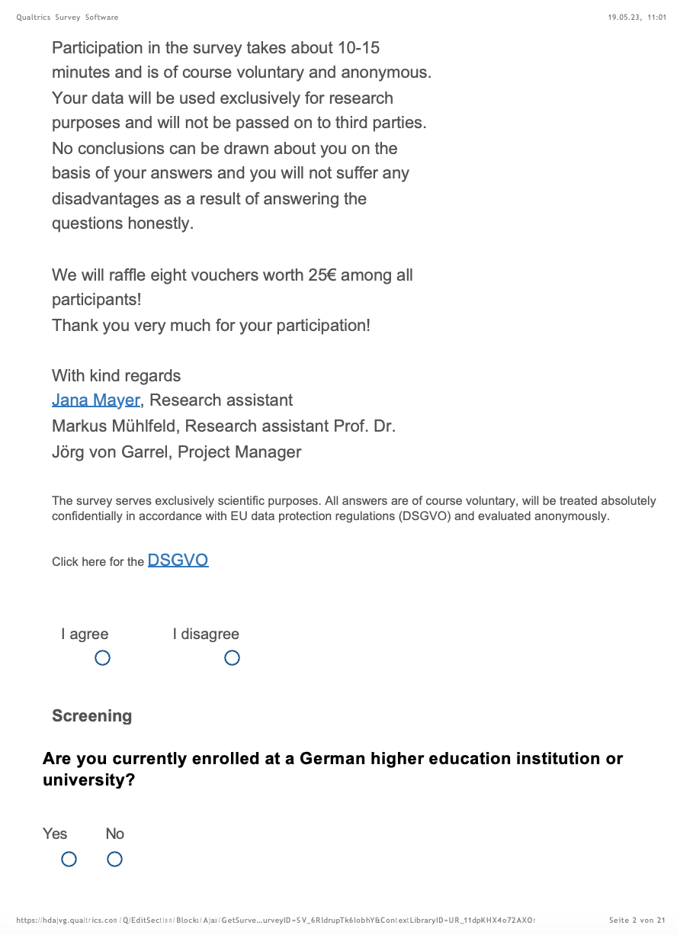 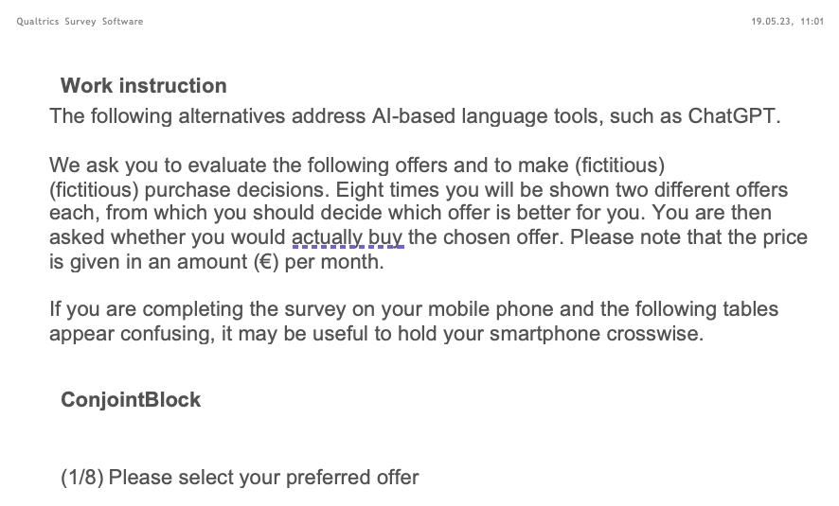

Characteristic | Expression 1 | Expression 2 | Expression3 | Expression 4 | Price share
Error prevention during output | No susceptibility to errors (no hallucinations) | Erroneous answers of the AI are possible (hallucinations) |  |  | 8€
 | 8€ | 0€ |  |  | 17%
Degree of scientificity | Citation of purely scientific sources | Citation of reliable/ truthful sources | Citation of invented sources possible | No citation | 12€
 | 8€ | 4€ | 0€ | 0€ | 26%
Logical reasoning | extensive and detailed formulation of the output (logically comprehensible) | short and concise wording of the output (possibly no logical comprehensibility) |  |  | 6€
 | 4€ | 2€ |  |  | 13%
Explainability of the decision | Transparency of the data basis (White-Box) | Lack of transparency of the data basis (Black-Box) |  |  | 16€
 | 16€ | 0€ |  |  | 35%
Error detection/correction during output | Error detection and correction during output | Errors in entered texts are not recognised or corrected by the AI |  |  | 4€
 | 4€ | 0€ |  |  | 9%
46€
