Supplementary information for “Female early-career scientists have conducted less interdisciplinary research in the past six decades: Evidence from doctoral theses” by Meijun Liu, Sijie Yang, Yi Bu, Ning Zhang

This file includes supplementary tables 1 to 8, and supplementary figures 1 to 4.

Table S1. Statistics of the original dataset.
Type of information | Number of observations
Doctoral theses | 920,619
Years | 1950-2016
Advisors | 217,143
Universities | 759
Number of states | 48

Table S2. Distribution of scientific domains of theses in PQDT.
Domain | Freq. | Percent | Cum.
Mathematical and Physical Sciences | 243,829 | 21.98 | 21.98
Engineering | 206,485 | 18.61 | 40.59
Biological Sciences | 201,018 | 18.12 | 58.71
Behavioral Sciences | 158,358 | 14.27 | 72.98
Health and Medical Sciences | 110,929 | 10 | 82.98
Agriculture | 38,397 | 3.46 | 86.44
Geosciences | 35,270 | 3.18 | 89.62
Education | 26,781 | 2.41 | 92.03
Social Sciences | 19,081 | 1.72 | 93.75
Ecosystem Sciences | 14,712 | 1.33 | 95.08
Interdisciplinary | 13,393 | 1.21 | 96.28
Business | 10,668 | 0.96 | 97.24
Environmental Sciences | 10,312 | 0.93 | 98.17
Area, Ethnic, and Gender Studies | 6,764 | 0.61 | 98.78
Philosophy and Religion | 4,332 | 0.39 | 99.17
Communications and Information Sciences | 3,085 | 0.28 | 99.45
Language & Literature | 2,316 | 0.21 | 99.66
History | 1,298 | 0.12 | 99.78
Fine and Performing Arts | 1,174 | 0.11 | 99.88
Law and Legal Studies | 713 | 0.06 | 99.95
Architecture | 573 | 0.05 | 100
Language and Literature | 3 | 0 | 100
Total | 1,109,491 | 100

Table S3. The prediction of students’ gender using Genderize.io.
Domain | Male student | Female student | Female student (%) | Total
Behavioral Sciences | 69,705 | 77,539 | 52.66% | 147,244
Biological Sciences | 110,788 | 61,534 | 35.71% | 172,322
Engineering | 142,349 | 19,586 | 12.09% | 161,935
Health and Medical Sciences | 46,412 | 51,152 | 52.43% | 97,564
Mathematical and Physical Sciences | 172,916 | 32,210 | 15.70% | 205,126
Total | 542,170 | 242,021 | 30.86% | 784,191

Table S4. The prediction of advisors’ gender using Genderize.io.
Domain | Male advisor | Female advisor | Female advisor(%) | Total
Behavioral Sciences | 50,220 | 29,121 | 36.70% | 79,341
Biological Sciences | 87,125 | 23,009 | 20.89% | 110,134
Engineering | 104,740 | 10,681 | 9.25% | 115,421
Health and Medical Sciences | 37,502 | 26,319 | 41.24% | 63,821
Mathematical and Physical Sciences | 97,566 | 9,460 | 8.84% | 107,026
Total | 377,153 | 98,590 | 20.72% | 475,743

Table S5. The estimated relationship between students’ gender, advisors’ gender, and the interdisciplinarity indicator of doctoral theses using Genderize.io to infer gender.
 | (1) | (2) | (3) | (4) | (5) | (6)
Variable | All periods |  | Period 1: 1950-1999 |  | Period 2: 2000-2016
Female student | -0.014*** | -0.012*** | -0.006*** | -0.007*** | -0.017*** | -0.016***
 | (0.001) | (0.001) | (0.002) | (0.002) | (0.001) | (0.002)
Female advisor | -0.000 | 0.003 | 0.001 | -0.000 | 0.001 | 0.003
 | (0.001) | (0.002) | (0.002) | (0.004) | (0.001) | (0.002)
Female student$×$female advisor |  | -0.014*** |  | -0.004 |  | -0.017***
 |  | (0.002) |  | (0.003) |  | (0.002)
Year FE | Yes | Yes | Yes | Yes | Yes | Yes
University FE | Yes | Yes | Yes | Yes | Yes | Yes
Domain FE | Yes | Yes | Yes | Yes | Yes | Yes
Observations | 304,722 | 304,722 | 96,831 | 96,831 | 207,862 | 207,862
Adjusted $R^{2}$ | 0.0673 | 0.0673 | 0.114 | 0.114 | 0.0518 | 0.0518
Notes: robust standard errors are in parentheses; ***, **, and * represent significance at the 1%, 5%, and 10 % level, respectively.

Table S6. The estimated relationship between students’ gender, advisors’ gender, and the interdisciplinarity indicator of doctoral theses when including data on observations with the gender prediction of “mostly female” and “mostly male”.
 | (1) | (2) | (3) | (4) | (5) | (6)
Variable | All periods |  | Period 1: 1950-1999 |  | Period 2: 2000-2016
Female student | -0.010*** | -0.009*** | -0.005*** | -0.005*** | -0.013*** | -0.011***
 | (0.001) | (0.001) | (0.002) | (0.002) | (0.001) | (0.002)
Female advisor | -0.001 | 0.003* | 0.002 | 0.000 | -0.001 | 0.003
 | (0.001) | (0.002) | (0.002) | (0.004) | (0.001) | (0.002)
Female student$×$female advisor |  | -0.012*** |  | -0.003 |  | -0.015***
 |  | (0.002) |  | (0.003) |  | (0.002)
Year FE | Yes | Yes | Yes | Yes | Yes | Yes
University FE | Yes | Yes | Yes | Yes | Yes | Yes
Domain FE | Yes | Yes | Yes | Yes | Yes | Yes
Observations | 291,758 | 291,758 | 95,143 | 95,143 | 196,589 | 196,589
Adjusted $R^{2}$ | 0.0695 | 0.0696 | 0.113 | 0.113 | 0.0542 | 0.0543
Notes: robust standard errors are in parentheses; ***, **, and * represent significance at the 1%, 5%, and 10 % level, respectively.

Table S7. The estimated relationship about between students’ gender, advisors’ gender, and the interdisciplinarity indicator of doctoral theses when using the doc2vec model to measure interdisciplinarity.
 | (1) | (2) | (3) | (4) | (5) | (6)
Variable | All periods |  | 1950-1999 |  | 2000-2016
Female student | -0.001*** | -0.002*** | -0.001*** | -0.002*** | -0.001** | -0.002***
 | (0.000) | (0.000) | (0.000) | (0.001) | (0.000) | (0.001)
Female advisor | -0.000 | -0.001*** | -0.001 | -0.001* | -0.000 | -0.001**
 | (0.000) | (0.000) | (0.000) | (0.001) | (0.000) | (0.000)
Female student$×$female advisor |  | -0.001*** |  | -0.002*** |  | -0.001**
 |  | (0.000) |  | (0.001) |  | (0.000)
Year FE | Yes | Yes | Yes | Yes | Yes | Yes
University FE | Yes | Yes | Yes | Yes | Yes | Yes
Domain FE | Yes | Yes | Yes | Yes | Yes | Yes
Observations | 382,058 | 382,058 | 148,259 | 148,259 | 233,768 | 233,768
Adjusted $R^{2}$ | 0.009 | 0.009 | 0.014 | 0.014 | 0.01 | 0.01
Notes: robust standard errors are in parentheses; ***, **, and * represent significance at the 1%, 5%, and 10 % level, respectively.

Table S8. The estimated relationship about between students’ gender, advisors’ gender, and the interdisciplinarity indicator of doctoral theses by including fixed effects regarding advisors.
 | (1) | (2) | (3)
 | All periods | Period 1: 1950-1999 | Period 2: 2000-2016
Female student | -0.008*** | -0.007*** | -0.009***
 | (0.001) | (0.002) | (0.002)
Year FE | Yes | Yes | Yes
University FE | Yes | Yes | Yes
Advisor FE | Yes | Yes | Yes
Observations | 268,937 | 84,318 | 167,247
Adjusted $R^{2}$ | 0.207 | 0.249 | 0.196
Notes: robust standard errors are in parentheses; ***, **, and * represent significance at the 1%, 5%, and 10 % level, respectively.

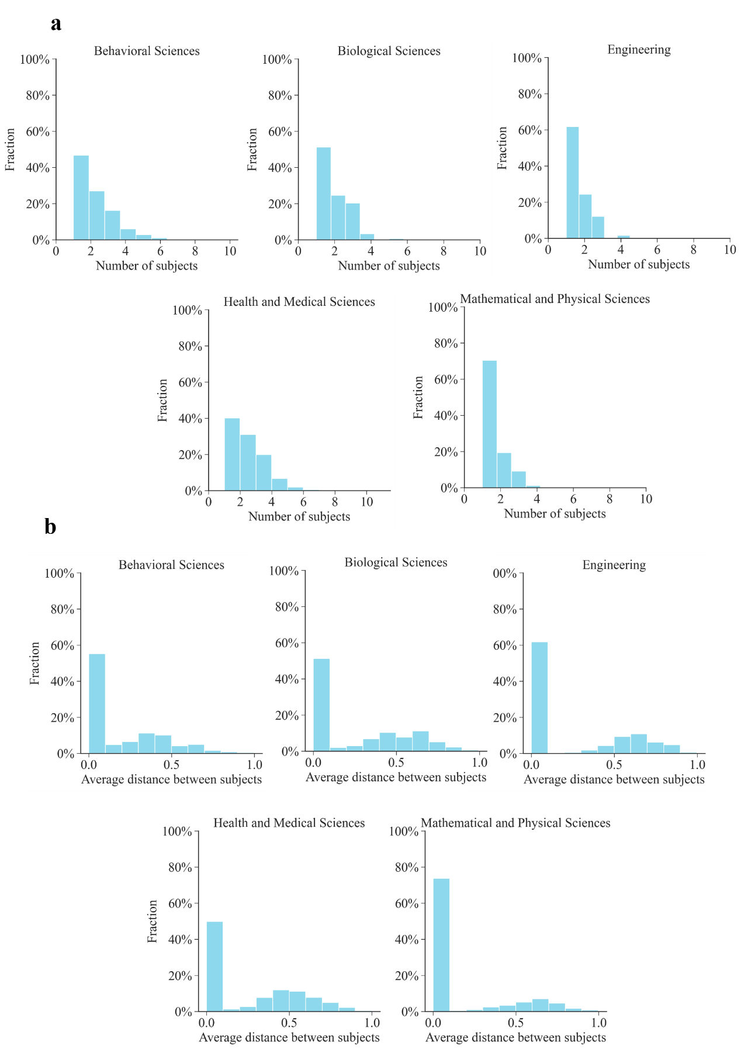
Fig S1. The distribution of the number of subjects and the average distance between subjects by scientific
domain. (a) indicates the distribution of subjects that are assigned to doctoral theses, and (b) shows the average
distance between subjects for doctoral theses.

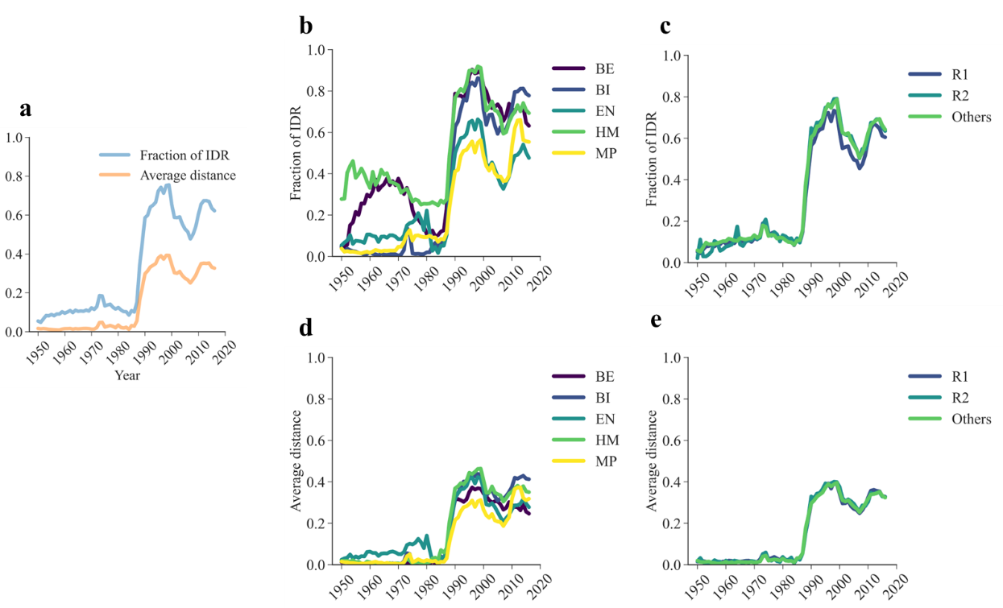
Fig S2. The evolution of the fraction of IDR and the interdisciplinarity indicator over time. (a) displays the fraction of IDR and the average distance between subjects; (b) and (c) indicate the fraction of IDR by scientific domain and university of differing research intensity, respectively; (d) and (e) show the average distance between subjects by scientific domain and university of differing research intensity, respectively. The overall trend toward a greater level of interdisciplinarity in doctoral theses has experienced some fluctuations since the beginning of the 21st century. Specifically, both the proportion of IDR and the average distance between subjects decreased from 2000 to 2010, but began to rise again after 2010. Upon consulting the PQDT database, a possible explanation for this observation is that the subject of “interdisciplinary” was added to the subject categories of PQDT following the release of CIP2000. As a result, interdisciplinary theses that were published after 2000 (i.e., theses assigned more than one subject based on our definition), and those that show high average distances between subjects, might have been categorized under the subject of “interdisciplinary”, rather than the five scientific domains we investigate. Because of the addition of the new subject category of “interdisciplinary” in PQDT, the proportion of IDR and the average distance between subjects may have been underestimated after 2000, leading to a downward curve between 2000 and 2010. As interdisciplinary doctoral theses continue to develop, the two variables we use to measure interdisciplinarity have increased again since 2010. Since no evidence suggests that this addition affects male and female students differently regarding their selection of subject categories for their work, we believe that it will not introduce any bias into the gender disparities observed in interdisciplinary doctoral theses.

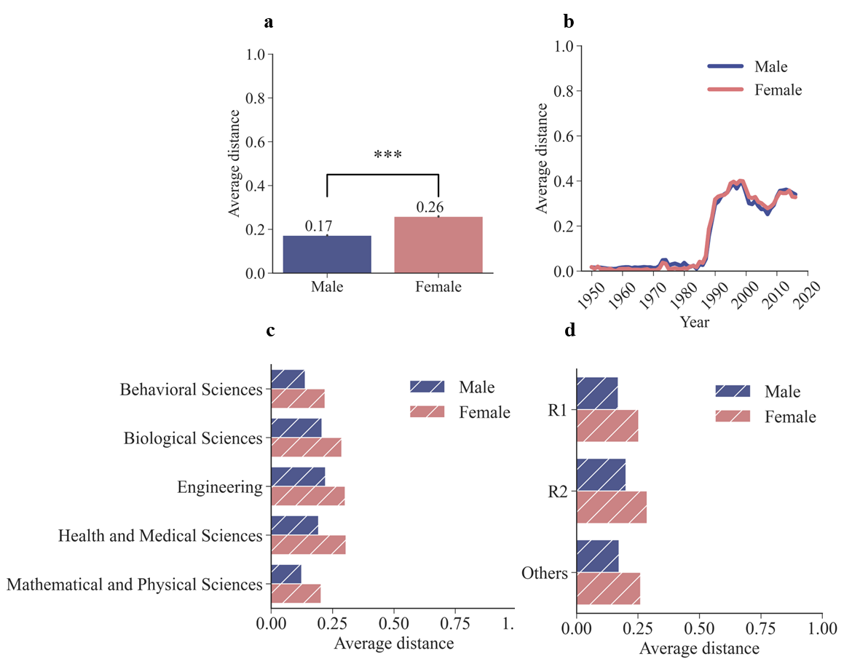

Fig S3. The simple comparison of the average distance between subjects of doctoral theses by female and
male students. The Welch’s t-tests are performed in (a). ***, **, and * represent significance at the 1%, 5%, and
10 % level, respectively. (a) indicates the average distance between subjects for male and female students. (b)
shows the average distance between subjects for male and female students by year. (c) shows the average distance
between subjects for male and female students by scientific domain. (d) displays the average distance between subjects for male and female students by university of varying research intensity.

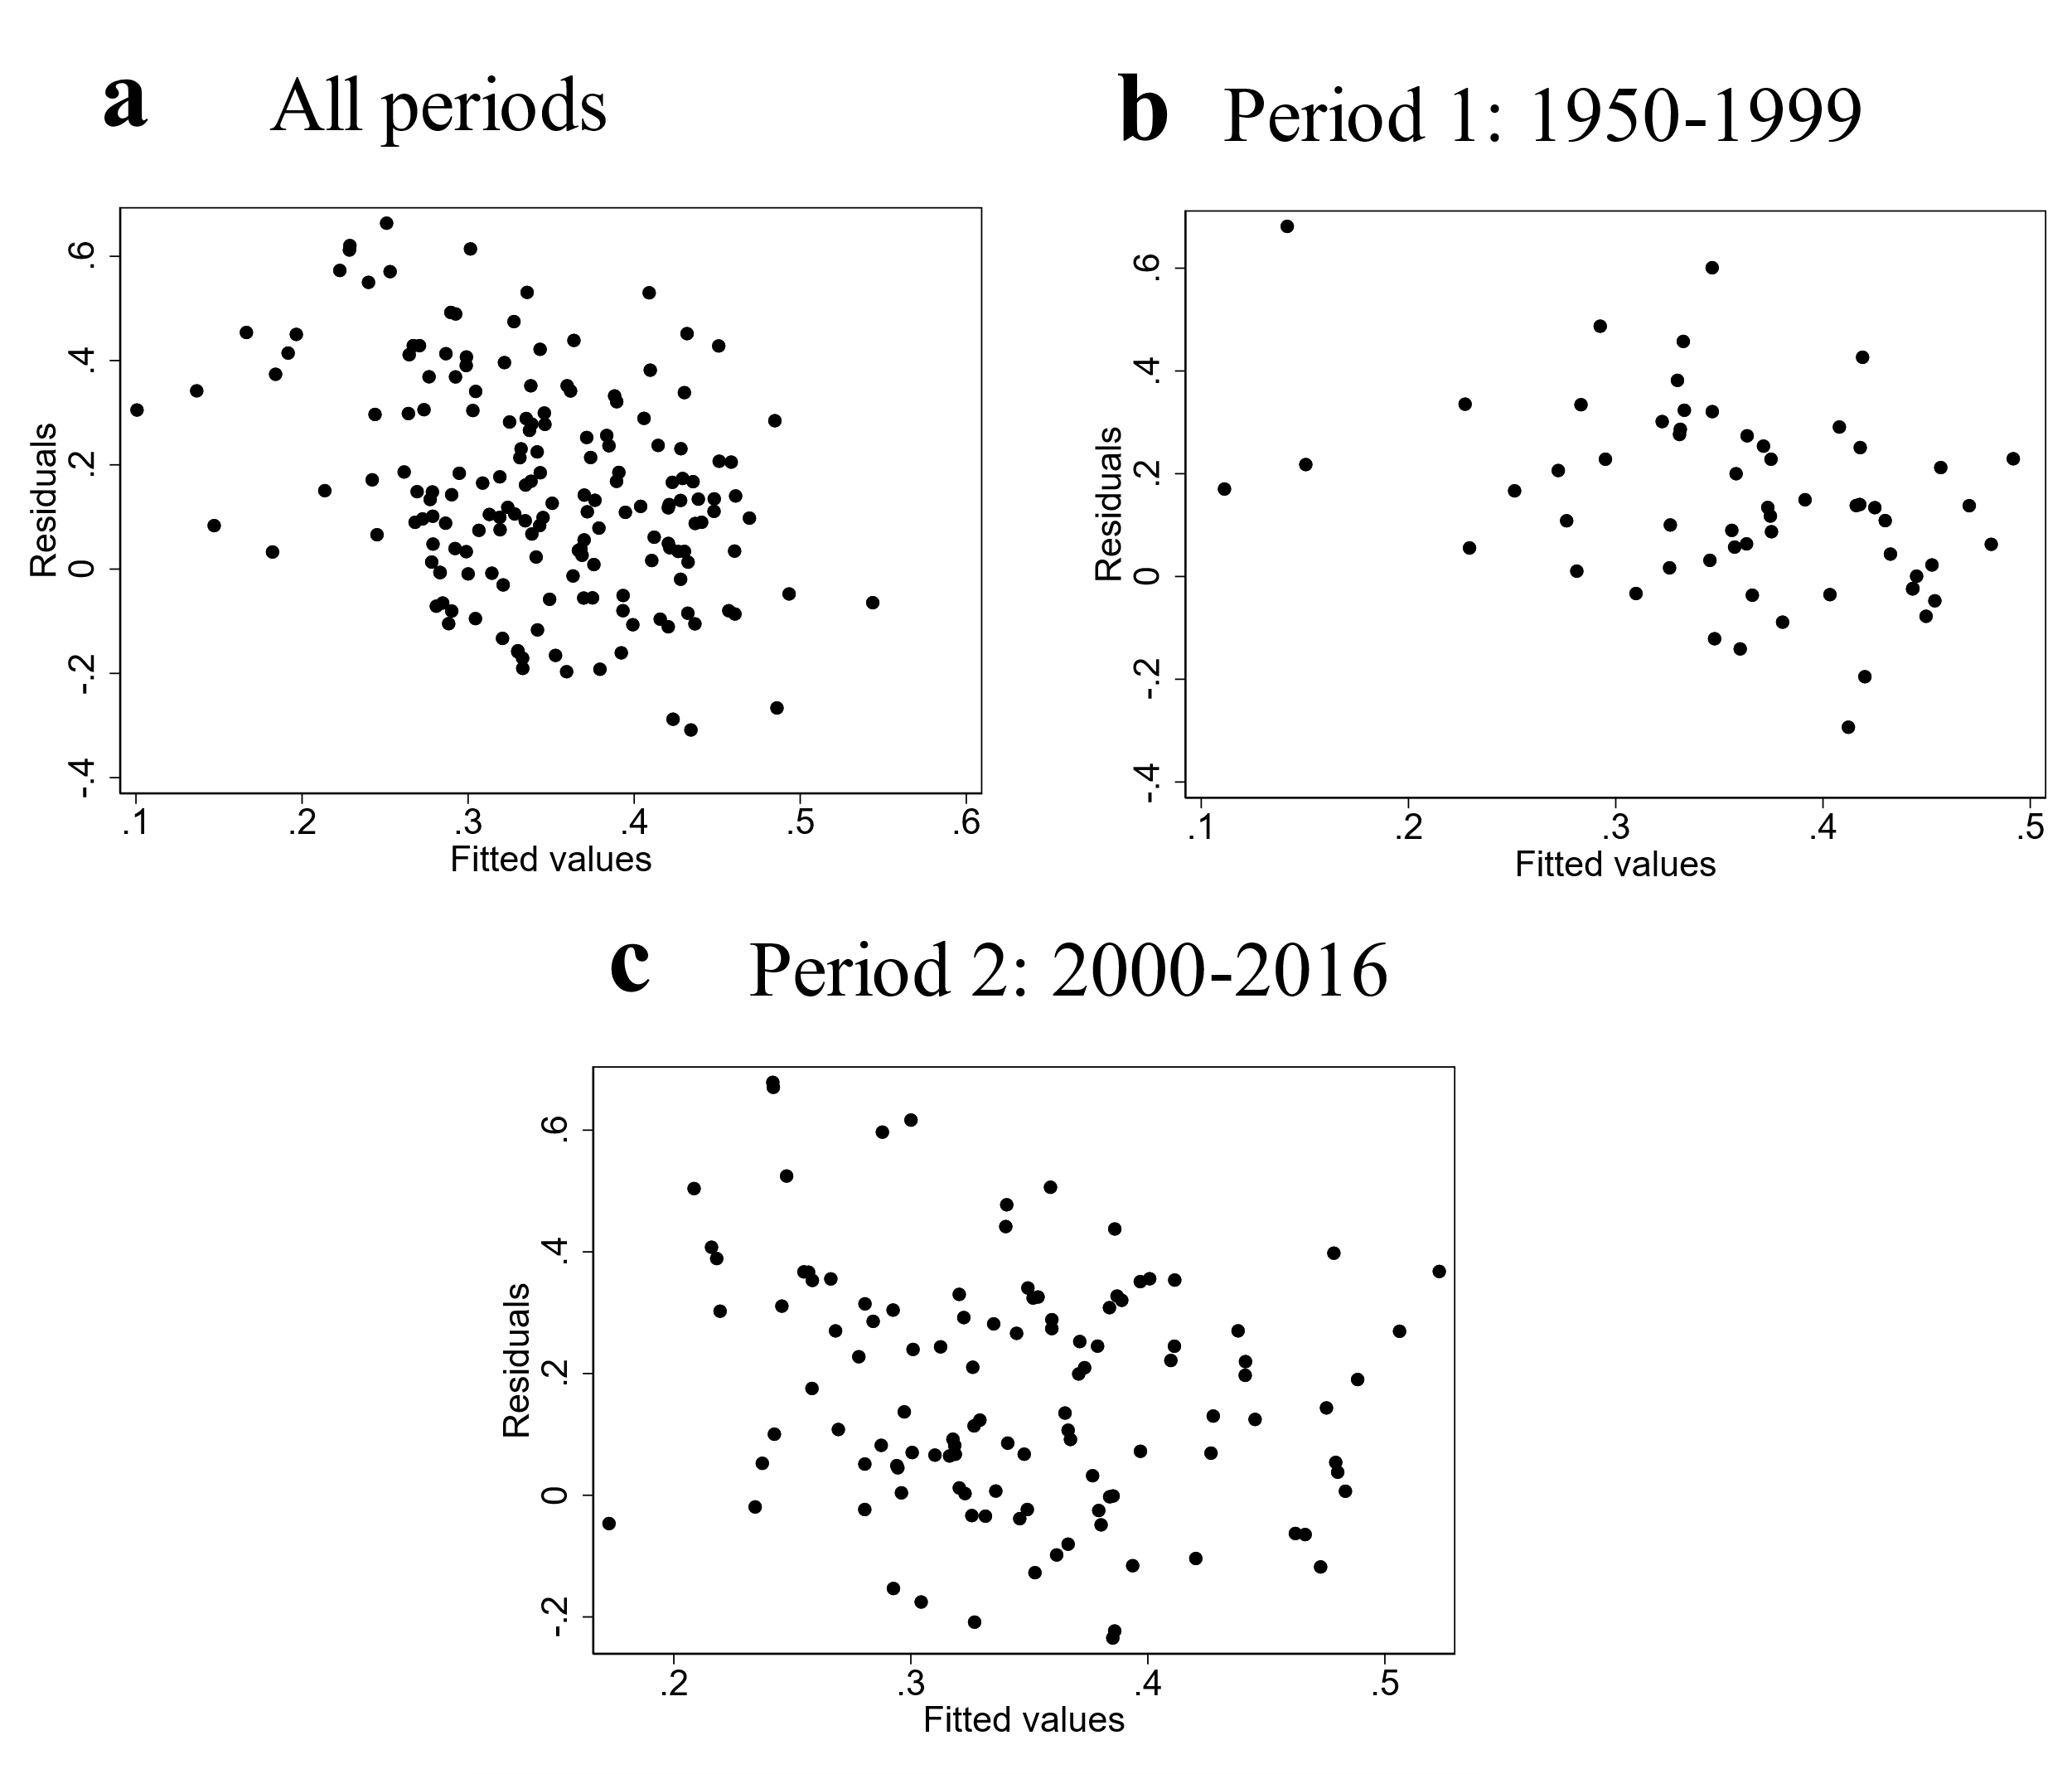

Fig S4. Residual analyses of regression models. We provide residual plots for regression models that are in columns
1, 3 and 5 in Table 3. The x-axis represents the predicted values, while the y-axis represents the residuals. The residual plots demonstrate a symmetric and random distribution of residuals, with a tendency to cluster around the
central region of the plot. No discernible pattern is observed in the residual plots, indicating the absence of any relationship between the residuals and the fitted values. Based on these findings, it can be concluded that the linear
regression models employed in this study are suitable and appropriate.

