The Poverty Alleviation Effect of Transfer Payments：Evidence from China

Yan Miao ª, Zheng Li ^{b}*
ª School of Economics, Tianjin Normal University, Tianjin, China;
ORCID: 0000-0003-4534-6980 E-mail address: 10281329@qq.com

^{b} School of Statistics, Tianjin University of Finance and Economics, Tianjin, China
ORCID: 0000-0002-7537-2509 E-mail address: 503647543@qq.com

* Corresponding author: Zheng Li.
E-mail address: 503647543@qq.com

Appendix
The CLDS 2018 data is used here. Table A1 presents the definitions and descriptive statistics of the variables (Same as selected variables in Variables and data sources).
Table A1 Definition of variables and descriptive statistics (CLDS 2018)
 | Variables | Definition | Mean  (All sample, n=4643) |  | Mean (Treatment group, n=409) | Mean (Control group, n=4234)
Covariates | Age | The age of household head | 49.859 | 53.787 |  | 49.479
Covariates | Marriage | Marital status of household head (1=married, 0=unmarried) | 0.868 | 0.775 |  | 0.877
Covariates | Educ | The highest educational attainment of household head (1= high school or above, 0=below high school) | 0.173 | 0.078 |  | 0.183
Covariates | F_size | Number of family members | 1.820 | 1.848 |  | 1.817
Covariates | Tap_water | Tap-water accessed at home  (1=yes, 0=no) | 0.880 | 0.828 |  | 0.885
Covariates | Unpol | The drinking water source is not contaminated  (1=yes, 0=no) | 0.290 | 0.213 |  | 0.354
Covariates | Natgas | Natural gas accessed at home  (1=yes, 0=no) | 0.892 | 0.807 |  | 0.948
Covariates | Intter | Frequent power interruptions  (1=yes, 0=no) | 0.033 | 0.044 |  | 0.032
Covariates | P_elec | Productive electricity accessed at home  (1=yes, 0=no) | 0.034 | 0.031 |  | 0.035
Covariates | Internet | Internet accessed at home  (1=yes, 0=no) | 0.702 | 0.501 |  | 0.721
Covariates | Phone | Phone accessed at home  (1=yes, 0=no) | 0.990 | 0.977 |  | 0.992
Covariates | Car | The household own a car  (1=yes, 0=no) | 0.241 | 0.078 |  | 0.257
Covariates | Tractors | The household own a tractor  (1=yes, 0=no) | 0.154 | 0.139 |  | 0.156
Covariates | Implements | The household own large-scale agricultural implements  (1=yes, 0=no) | 0.025 | 0.025 |  | 0.026
Covariates | Livestock | The household own livestock for production  (1=yes, 0=no) | 0.081 | 0.134 |  | 0.075
Covariates | Debt | The household is in debt  (1=yes, 0=no) | 0.326 | 0.419 |  | 0.317
Covariates | A_cost | Cost of the farm | 11659.970 | 5245.813 |  | 12393.641
Covariates | A_sub | Access to agricultural subsidies  (1=yes, 0=no) | 0.590 | 0.694 |  | 0.579
Outcome variables describing income | In | Total income | 52619.020 | 24229.944 |  | 55361.371
Outcome variables describing income | In1 | Gross income from agriculture, forestry, animal husbandry and fishery | 10846.692 | 7718.455 |  | 11148.877
Outcome variables describing income | In2 | Wage income | 27842.200 | 12149.303 |  | 29358.121
Outcome variables describing income | In3 | Operating income | 8890.917 | 1210.024 |  | 6932.884
Outcome variables describing income | In4 | Property income | 1050.333 | 235.207 |  | 1129.073
Outcome variables describing consumption | Ex | Total consumption expenditure | 43314.580 | 33279.808 |  | 44283.932
Outcome variables describing consumption | Ex1 | Food expenditure | 11719.281 | 6405.966 |  | 12232.544
Outcome variables describing consumption | Ex2 | Healthcare expenditure | 6727.254 | 8831.907 |  | 6523.947
Outcome variables describing consumption | Ex3 | Education expenditure | 5480.979 | 3881.443 |  | 5635.493
Treatment variable | Treat | Accept transfer payments or not (1=yes, 0=no)

The graphical balance diagnostic test of the model and comparison of propensity scores between treatment and control groups are presented in the Figure A1-A2. It ensures that the control group individuals are comprehensive for the analysis.
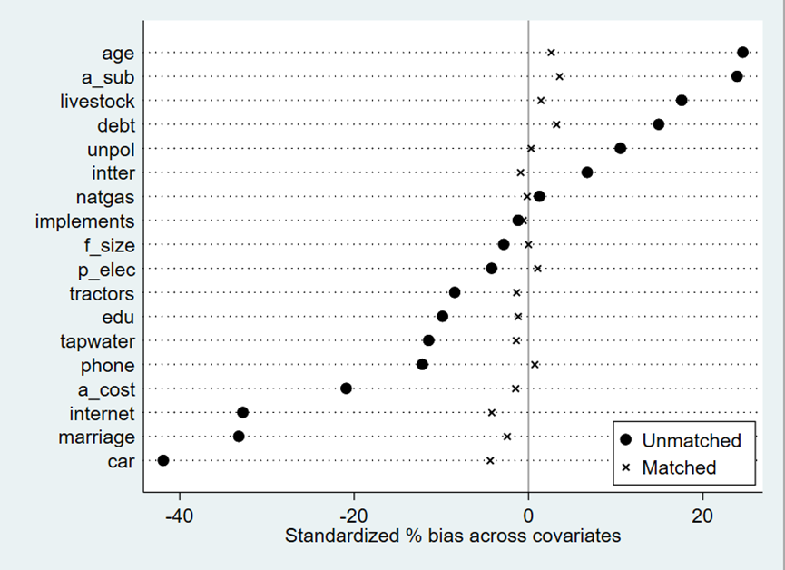
Fig. A1: Graphical balance diagnostic test (CLDS 2018)

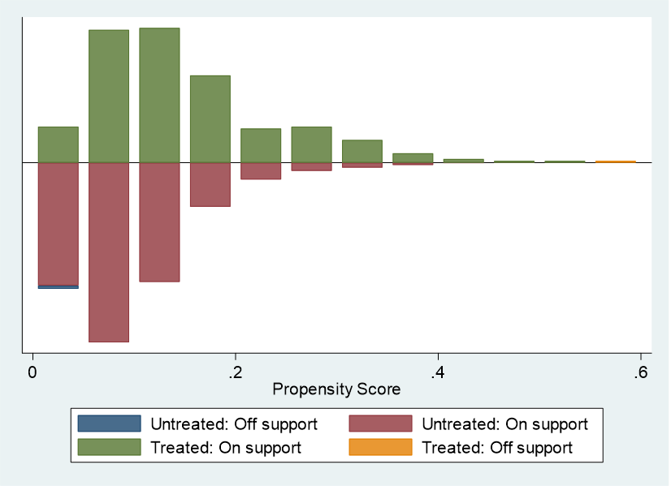
Fig.A2: Comparison of propensity score between treatment group and control group (CLDS 2018)

The results of Radius and Kernel methods are shown in Table A2-A3. It can be found that different methods give similar results, which support the conclusions of this paper.
Table A2 Results of Radius matching
Variables and definitions | Mean (Treatment group) | Mean  (Control Group) | Average treatment effect on the treated (ATT) | Standard error
In (Total income) | 22077.482 | 37150.413 | -15072.931*** | 4232.669
In1(Gross income from agriculture, forestry, animal husbandry and fishery) | 10622.897 | 14594.021 | -3971.124 | 2541.255
In2 (Wage income) | 9884.477 | 17761.361 | -7876.884*** | 2952.618
In3(Operating income) | 1144.327 | 2977.458 | -1833.131 | 1411.659
In4(Property income) | 348.451 | 445.775 | -97.324 | 538.362
Ex (Total consumption expenditure) | 28509.407 | 38817.802 | -10308.395 | 8314.315
Ex1(Food expenditure) | 7689.619 | 11412.189 | -3722.570*** | 1561.954
Ex2(Healthcare expenditure) | 7793.335 | 6788.876 | 1004.459* | 552.518
Ex3(Education expenditure) | 4548.521 | 4906.250 | -357.729 | 1129.380

Table A3 Results of Kernel matching
Variables and definitions | Mean (Treatment group) | Mean  (Control Group) | Average treatment effect on the treated (ATT) | Standard error
In (Total income) | 22077.482 | 30534.335 | -8456.853* | 4582.481
In1(Gross income from agriculture, forestry, animal husbandry and fishery) | 10622.897 | 11962.233 | -1339.337 | 1589.216
In2 (Wage income) | 9884.477 | 14872.307 | -4987.830*** | 1830.677
In3(Operating income) | 1144.327 | 2118.713 | -974.385 | 997.494
In4(Property income) | 348.451 | 290.413 | 58.037 | 289.100
Ex (Total consumption expenditure) | 28509.407 | 33849.669 | -5340.261 | 3618.902
Ex1(Food expenditure) | 7689.619 | 10067.623 | -2378.005* | 1249.089
Ex2(Healthcare expenditure) | 7793.335 | 6506.953 | 1286.382* | 699.204
Ex3(Education expenditure) | 4548.521 | 4183.427 | 365.093 | 928.579

