Conceiving of and politically responding to NEETs in Europe: a scoping review
Online Appendix
Claudia Petrescu, Bogdan Voicu, Christin Heinz-Fischer, Jale Tosun

Contents
A1: Publications referring to NEETs in Europe and indexed by the WoS database, 2002-2022* 1
A2: Distribution of main 25 academic fields in which the ‘NEETs’ papers can be retrieved in the WoS database* 2
A3: PRISMA 2020 flow diagram for systematic review 3
A4: Short description of papers 4
Papers included in the scoping review 4
Papers excluded from the scoping review 20
Papers that were not retrieved 24
A5: Network analysis 25
A6: Proportional wordcloud of all keywords in the selected papers 26
A7: Proportional wordcloud of most frequent keywords in the selected papers, excluding the keyword "NEET(s)" 27
A8: Network of keywords in the articles included in the review (bigram count network, threshold: 1) 28
A9: Network of keywords in the articles included in the review (bigram count network, threshold: 3) 29
A10: Reading grid for the selected papers 30
A11: Incidence of NEETs across Europe 32
Dynamics of NEET rates across Europe: 2013-2022 32
Distribution of NEETs across European societies: 2013 33
Distribution of NEETs across European societies: 2022 34
Distribution of NEETs across European societies: selected years, gender differences 35
References 36

A1: Publications referring to NEETs in Europe and indexed by the WoS database, 2002-2022*
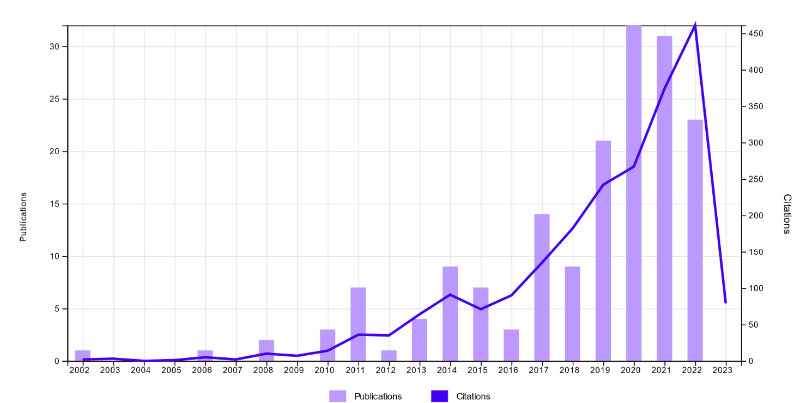
*according to the extraction on November 28th, 2022. Graph generated by WoS.

A2: Distribution of main 25 academic fields in which the ‘NEETs’ papers can be retrieved in the WoS database*
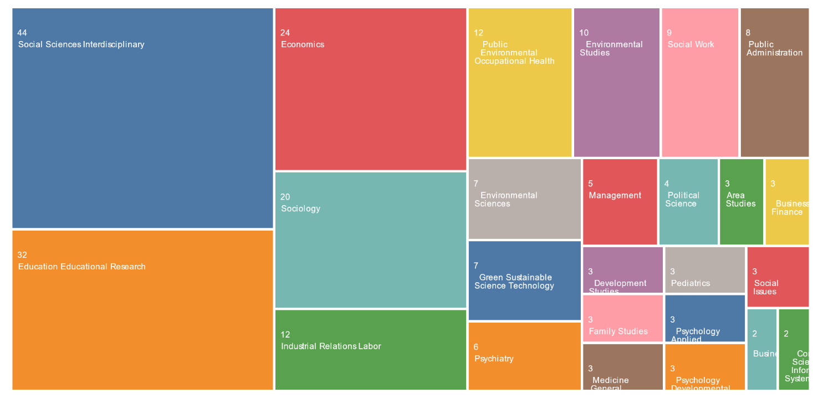
*according to the extraction on 28th November 2022. Graph generated by WoS.

A3: PRISMA 2020 flow diagram for systematic review

Records identified from*: WoS
Databases (n = 1)
Registers (n = 1)
Records removed before screening:
Duplicate records removed (n = 0)
Records marked as ineligible by automation tools (n =0)
Records removed for other reasons (n = 0)
Records screened
(n = 121)
Records excluded**
(n = 0)
Records sought for retrieval
(n = 121)
Records not retrieved
(n = 1)
Records assessed for eligibility
(n = 120)
Records excluded:
Not relevant due to geographical constraint or not being related to NEETs (n = 37)
Studies included in review
(n = 83)
Reports of included studies
(n = 83)
Identification of studies via databases and registers
Identification
Screening

Included

Template adapted from: Page MJ, McKenzie JE, Bossuyt PM, Boutron I, Hoffmann TC, Mulrow CD, et al. The PRISMA 2020 statement: an updated guideline for reporting systematic reviews. BMJ 2021;372:n71. doi: 10.1136/bmj.n71

A4: Short description of papers

Papers included in the scoping review
André and Crosby (2022) conduct an ethnographic study of 42 NEETs living in lower-class neighbourhoods in Brussels. The authors generate a NEET typology based on individual trajectories to deconstruct the statistical NEET category. With their approach they distinguish between NEETs in “discontinuous” situations, which refer to unstable work situations, and NEETs “outside the system”, who do not seek aid from service institutions. The trajectory of both groups is influenced by urban, educational, and job market segregation. Based on the narratives of impacted youths, they show that withdrawing from society and its institutions is not an expression of lacking will but a way to confront mechanisms of exclusion.
Basta et al. (2019) analyse the associations connecting substance abuse and symptoms of anxiety and depression with the NEET status. The analysis is based on a randomised population-based sample of 2771 young Greeks aged 15-24 years. The results of the multivariate analysis revealed that older and long-term NEETs present a higher risk to have anxiety/ depression symptoms and the status of older NEETs is more likely to be associated with severe symptoms of anxiety and moderate/severe symptoms of depression. The article does not refer to policy implications or youth policy.
Berlin, Kaariala, Lausten, Andersson, and Brannstrom (2021) analyse the risk of being a NEET at the ages of 21-23 (due to data restrictions) among young adults with experience in out-of-home care (OHC) across Denmark, Finland, and Sweden during the great recession (2008-2010). Their study is based on register data for the entire birth cohort from 1987. The Nordic states are classified as universal welfare regimes and share relatively similar systems promoting the school-to-work transition. In all countries a higher share of NEETs was from OHC compared to peers without such experience, which indicates that the welfare systems in the three Nordic countries could not compensate for childhood disadvantages. Furthermore, those with both OHC experience and poor school performance had an exacerbated risk of being NEET. The paper briefly discusses implications for policies targeting children in care.
Bradley and Crouchley (2020) analyse the relationship between test scores, truancy, and the risk of unemployment or becoming NEET using the Youth Cohort Study for England and Wales. The authors use an econometric approach to examine the interdependence and direction of causation between truancy and test scores in the teenage age group and the risk of entering the NEET status a few months after leaving school. Higher levels of truancy have an indirect effect on the likelihood of unemployment and being NEET via test scores, but also a direct effect on labour market outcomes, insofar as truancy and labour market outcomes are positively correlated. Test scores have a direct effect on the risk of unemployment and becoming NEET.
Bradley, Migali, and Paniagua (2020) examine the determinants of youth unemployment and NEET rates for regional differences in Italy, Spain, and the UK using Labour Force Survey Data for the period 1993-2018. They also assess for the teenage (16-19) and young adult population (20-24) whether there is a spatial neighbourhood effect of related youth unemployment and NEET rates. The results suggest that there are several common factors that increase youth unemployment and NEET rates. Regional youth unemployment rates tend to increase when adult unemployment increases and there is evidence that a larger share of immigrants in a region increases youth employment rates. A mix of industries and the share of small and medium-sized enterprises in a region similarly help to reduce youth unemployment rates for all age groups. There is also evidence of positive and statistically significant spatial interdependence in regional unemployment for all countries.
Brown, Douthwaite, Costas Batlle, and Savvides (2022) use an ecological framework of five risk categories (personal challenges, familial circumstances, social relationships, institutional features of school/work and structural factors of policy, economic disadvantage and the educational system) for NEEThood to analyse the data of 39 interviews with young people who are early leavers or at-risk of early leaving and 51 interviews with educators supporting them. While educators focused on structural factors, limited funding or alternative options for weak students and personal challenges, young people concentrated on structural factors and their effects on schooling and personal challenges. The authors went on to identify three systemic generative mechanisms: the pressure of performative benchmarks in schooling, the inability of mainstream schooling to meet young people’s diverse needs, and the difficult relationships in school.
Burlina, Crociata, and Odoardi (2021) focus on the role of cultural capital (CC) on the rate of NEETs in Centre-North and South Italy. Using 2001-2018 regional NUTS2 data, they apply a panel vector autoregression. As the results show, cultural capital has a positive effect on reducing the NEET risk, with a higher impact for southern regions. GDP per capita is a significant determinant, while the role of family - observed through proxies of the human capital and the average income – have a partial influence. The role of tertiary education does not have a significant effect. Hence, increasing access to cultural experiences and social interventions could help to cope with NEET lock-in effects and to reduce the North-South divide.
Bynner (2012), in a paper that also reviews his own career, proposes a retrospective view of academic and (mainly UK) societal debates around youth and labour markets, as can also be seen through the author’s own works from the 1960s to the 2010s. John Bynner observs that NEETs enter into discussion in the mid 1990s, but phenomena in the 1980s preceeded the debate, with the major societal change being the postponment of entry into the labour markets. In the 1970s, the social norm was that teenagers started to work around the age of 16. Already in the 1980s, the labour markets were set in train to be deserted of those younger than 20, in particular due to ‘the collapse of unskilled empolyment’ (page 40). Bynner argues that the solution identified by the Thatcher government was to focus on youth training, looking for causes of youth unemployment in the lack of skills of the unemployed and less in the repeated global economic recessions that occurred in early the 1980s and early 1990s. Since simple provison of training schemes did not attract youths, the NEET category came into being.
Bynner and Parsons (2002) analysed longitudinal data from a subsample of the 1970 British Birth Cohort Study collected at age 21 to exmine the relationship between NEET status and prior educational achievement and circumstance, and the difficulties being NEET poses in the context of building adult identity capital. They find that NEET status negatively affects outcomes in adulthood that are associated with the formation of identity capital, especially among young women, while among young men, the effects of the NEET status in the late teenage years are mainly manifested in poor labour market performance.
Campbell et al. (2020) explore a British sample of youngsters aged 18 and consider their exposure to risky behaviours in mid-adolescence, including sexual health, substance abuse, self-harm, vehicle related injury risk, criminal and antisocial behaviour, and physical inactivity. Being NEET is used as one of the seven negative outcomes and it is shown to be a consequence of such exposure.
Cefalo, Scandurra, and Kazepov (2020) consider regional differences in youth employment in the EU. They propose an index of youth labour market integration that combines various indicators at NUS2 level, including NEET rates. NEET rates are mentioned as an example of territorial differentiation and are used as a specific indicator for exclusion from the labour market.
Cornish (2021) adopts a case study approach to examine exclusion by the design and allocation of physical space at a college in England’s East Region. The analysis shows a territorial exclusion by design (the employability course was delivered in a Q-Block building out of sight and that was used mainly for programmes for marginalised people) and enforces the spatial dimension of exclusion. Delivering the employability course and programmes for NEETs in this Q-Block created a spatial exclusion that led to the stigmatisation of these students. Also, NEETs and disengaged youths were treated like a homogenous group in this space.
Dayioglu, Kucukbayrak, and Tumen (2022) apply a regression discontinuity analysis and find that an increase of the age-specific minimum wage initially increases the likelihood of youth males entering the NEET status in Turkey. This is because when teens become more expensive, they get replaced by more experienced workers. However, in the medium term, school enrollment increases and the NEET effect vanishes.
De Luca, Mazzocchi, Quintano, and Rocca (2020) analyse determinants of NEETS and Early School Leavers (ESLs) in Italy and Spain between 2007 and 2017. In Spain, the NEET status is mainly connected to unemployment and more influenced by economic cycles, while in Italy inactivity is an important and more persistent factor. Based on regression models and time-varying correlation models, they find a greater ESL influence on becoming NEET in Italy and in particular for men.
Dorsett and Lucchino (2014) examine the school-to-work transition in the UK through optimal matching and cluster analysis using data from 1991 to 2008. They aim to deepen their understanding of individuals’ trajectories in the five years after reaching the school leaving age and of the main factors that impact these trajectories. The analysis shows that nine of ten young people have a successful school-to-work transition and the key ‘risk factors’ that impact youth trajectories after 16 years are: early pregnancy, low educational attainment and self-confidence, and coming from a disadvantaged family background. The authors deem it essential for policymakers to take into account the heterogeneity among young people who do not appear to manage a successful school-to-work transition. An effective policy must be sensitive to this fact and have a more holistic and joined-up approach spanning the relevant youth services if it is to bring young people back into the labour market. Also, effective career advice and vocational counselling are important in minimising the risk of ‘fractured transitions’.
Dumouilla et al. (2021) attempt to explore the social representations of NEETs in the Paris region (France). Small samples of NEETs and matched students are interviewed. Semantic analysis of free evocations considers the lexical repertoires associated with the French label for NEET. The authors note more diverse repertoires in the statements of NEETs as compared to their peers, with more negative terms being coined by non-NEETs. The common trait in the social representations of NEETs and non-NEETs is the importance given to the social context. Non-NEETs tend to define NEETs as non-active, slacker, sometimes ‘dependent’. NEETs define themselves as rather active and with more positive motivations.
Erdogan, Flynn, Nasya, Paabort, and Lendzhova (2021) propose an EU-wide analysis of 51 social interventions under the Youth Guarantee Programme, identified within the European Commission webpage, and considers them through a set of lenses that includes urban-rural differentiations, the type of intervention, the geographical focus and scale of the projects, the top-down vs. participative approach, and their social inclusiveness.
Finlay, Sheridan, McKay, and Nudzor (2010) explore the daily life of Scottish NEETs based on qualitative research. The authors spent three full days in four small groups of NEETs. One group focused on work ethic and included members that had known each other for at least a few weeks prior to being observed; the second sought to identify social networks that had brought the NEETs together for this research; the third was mixed (some of the members knew each other prior to the research, others were newcomers), and the interest of the researchers was related to group dynamics; the forth group included people supported by the local council and people living in homeless units. The findings offer NEET profiles and recount NEET school experiences, challenges of the school-to-work transition, their aspirations, and the support they received from various providers. The main conclusion is that the observed NEETs have normal aspirations, but low expectations, which were actually adjusted to opportunities. The tailored provision of opportunities to reach aspirations is advocated as policy implication, with education, employment and training as simultaneous areas of intervention.
Focacci (2020) considers the ALMP (explain acronym) part of the Youth Guarantee programme and tests whether ALMPs are relevant for increasing employability. They employ a difference-in-difference model using longitudinal data from the province of Trento (Italy), collected by the agency for unemployment from its solicitors. The authors inspect the effect of participating in a programme that includes first orientation and formation, and second on-job training/internship, and observes that it increases by 7% the probability of being employed.
Furlong (2006) uses the Scottish School Leavers Survey (SSLS) and the wave of 2003 to discuss the policy implications of different NEET conceptualisations and examines the characteristics of NEETs. The author argues that for effective youth representation, politicians should either use a narrower definition of NEET than the current one or replace it with a broader definition to enable more far-reaching measures.
García-Fuentes and Martínez García (2020) consider Spanish NEETs and attempt to estimate the incidence of the phenomena between 2007 and 2017 using survey data from Encuesta de Población Activa. They observe an increasing trend that peaks at 23% in 2013 and thereafter decreases, sinking to nearly 16% in 2017. They also assess reasons for being NEET, which are based on self-reporting by NEETs themselves. The paper provides exclusively descriptive statistics and lacks any discussion on policy implications.
Goldman-Mellor et al. (2016) contrast outcomes of NEETs and their peers with respect to work-related behaviours and attitudes, skills, mental health, and substance abuse. To this end, they inspect a British longitudinal survey of twins, observing participants at the ages of 4, 7, 12, and 18. The authors find lower mental health outcomes among NEETs, more substance abuse, the same commitment to work, a higher interest in searching for jobs, and no relation between these measures. Soft skills and professional skills are also reported to be less present in NEETs.
Görlich and Katznelson (2015) use qualitative research on 20 early school leavers, aged 17-24 years, who are part of a local project of reintegration into education in Denmark. The authors push for policies focused on youngsters at the margin of educational system and for consideration of their relationship with the social environment. The focus on education is somehow natural in a society that aimed for a minimum of 95% of each cohort to graduate upper-secondary education by 2020. The paper starts from post-structuralist/constructivist conceptions of self, as a relational or narrative one, and explores attitudes towards education as a package.
Haikkola (2021) uses ethnographic research in employment services in Helsinki, Finland, to investigate the role of youth activation in reproducing classed and gendered youth transitions. The author considers that there is a powerful institutional pattern that structures and restricts youths’ transition paths. This is due to the institutional structure of youth activation that provides supportive practices that channel young people towards a limited number of occupational tracks at the lower end of the labour market. The analysis shows that the institutional structure of youth activation perpetuates existing class, gender, and racialised divisions. There are inequalities in how the growth and future development of different categories of young people are considered in the Finnish youth policies and labour market policies. The NEETs are considered as risky and in need of assistance and their future potential is as working hands and bodies.
Hale and Viner (2018) examine the relationship between health status in early adolescence and academic and employment outcomes in order to identify potential mediators of these associations. Based on data from the Longitudinal Study of Young People in England, the authors analyse the association between adolescents’ health and their educational (educational attainment at 16 years) and occupational (being NEET at 19 years) outcomes. The mediators included in the analysis of cases where significant associations were identified were attendance and truancy, classroom behaviour, substance abuse, and psychological distress. The analysis shows that: 1) the health status of early adolescents predicts poor education and employment results; 2) there is no association between the NEET status and its long-term chronic status; 3) social exclusion is the most important mediating variable; 4) the mediators for mental health are school behaviour, truancy, and substance abuse. There is an association between poorer health in early adolescence and low attainments or being NEET at the end of secondary school.
Hazenberg, Seddon, and Denny (2014) analyse the added value provided by work integration social enterprise (WISE) to NEETs. Through a comparative analysis between a WISE and a for-profit work integration organisation that provides employment enhancement programmes to NEETs, the authors show that the WISE’s ‘added value’ came from the different induction policy for NEETs. The analysis shows no significant difference between the outcome performance of the NEETs from WISEs and non-WISEs. The open access induction process provided by WISE, the focus on socially excluded young people, the capacity to tackle their problems, and the support services for NEETs with socio-economic integration are elements that make WISEs a better work integration place. WISEs developed a supportive and structured environment for NEETs characterised by the use of mentors who were role-models and advisors for NEETs and by the creation of small-size classes to encourage interaction. In this way, WISEs focus more on developing the individuals’ confidence, motivation, and self-belief.
Holmes, Murphy, and Mayhew (2021) propose a dynamic approach for young people aged 16-29 in the UK between 1975 and 2015. The authors use the Labour Force Survey for their estimations and observe the factors associated with the likelihood to be a NEET. The paper is centred around the changes in these factors, drawing implications for policy intervention in its conclusive part.
Juberg and Skjefstad (2019) explore discourses in central Norwegian policy documents addressing young NEETs aged 18-30 who have exhibited drug or alcohol problems. With the help of textual analysis inspired by Foucault and Fairclough they find three prevalent discourses – the ‘Medicalisation Discourse’, the ‘Stigma Discourse’, and the ‘Social Investment Discourse’ – which relate to the neoliberal trend of individualising and medicalising social problems, even though little evidence in research shows a direct link between alcohol and drug use and the NEET status. Implications for NEETs are briefly discussed; concrete alternative policies are not subject of the article.
Karaoglan, Begen, and Tat (2022) consider the associations between being NEET and several risky health factors: mental health, obesity, smoking, alcohol consumption. They use three rounds of the cross-sectional Turkey Health Survey, bringing into attention data from 2014, 2016, and 2019. Except for cigarette smoking, all these outcomes prove to be related to being NEET.
Kelly and McGuinness (2015) document the changes in the profiles of NEETs and (other) unemployed and prime-aged people by contrasting data from before and after the recession at the end of the 2000s. The authors analyse data from Ireland’s Labour Force Survey for 2006.Q2 and 2011.Q4.
Klug, Drobnic, and Brockmann (2019) explore the level of employment insecurity over 6 years after leaving the education system. Employment insecurity is seen as a dynamic phenomenon that depicts the employment-course over a longer period, instead of the static view of employment status at a certain point in time. Using a sample of German youngsters (the German Socio-Economic Panel – SOEF – waves 1995-2014), the authors use latent class analysis (growth models) to estimate at 10% the share of permanent NEETs who experience persistent exclusion, and at 3% those who have repeated spells of unemployment. Being long-term NEET is shown to be associated with low education, a history of migrations, lower health, and lower life satisfaction.
Lawy, Quinn, and Diment (2010) explore the results of a year’s research on a group of marginalised and socially disadvantaged young Britons who were in ‘jobs without training’. Jobs without training is “a policy construct and has been defined as being employed for 16 hours a week or over; not being engaged in formal training and not having level 2 qualifications” (p. 335). The ‘problem’ of young people in ‘jobs without training’ is due to the various inequalities they face and represents rather a manifestation of other structural and cultural problems in the community and society. The relevance of the paper for our review is that the JWT status proves to precede becoming a NEET.
Leavey et al. (2019) examine the determinants for successful transitions from childhood and adolescence to adult mental health services in Northern Ireland based on a retrospective analysis of 373 service users. They found that NEETs were more likely to be referred to adult services.
Lőrinc, Ryan, D'Angelo, and Kaye (2020) explore how interactions of ecological systems shape and mediate young people’s school-to-work transitions. The case study conducts semi-structured interviews and focus groups with 53 NEETs in London between May 2015 and October 2016. While participants presented challenges as personal struggles at the micro-level, the authors reject the individualisation of the NEET situation and highlight that cutbacks in education systems and services in the context of the UK government’s austerity programme are likely the reason for the lack of support and career guidance in schools.
MacDonald (2011) analyses the changes and continuities in young people’s trajectories to work over 30 years (between 1980 and 2010) in the UK. The concepts of underemployment and the ‘myth of the skills economy’ are key issues for the paper. The author discusses the evolution and implications of NEET policy in UK, showing that the key problems are the overlooking of the heterogeneity within the NEET population, the consideration of unemployment as a problem of the youth, and the appreciation of NEETs as static policy categories unable to capture the dynamism of youth transitions.
MacIntyre (2014) follows a case study approach with a cohort of 20 young people with a moderate learning disability aged 18 to 21. The period of analysis for each person was between six and nine months and contained two interviews, one at the start and one at the end of this period. Young people with learning disabilities have available opportunities for further education, training, and employment; however, those do not always fulfil their purpose of strengthening social networks and promoting social inclusion. She calls for a more holistic approach with policies promoting active citizenship and the visible inclusion of youths with learning disabilities into society, for example through voluntary work.
Madia, Obsuth, Thompson, Daniels, and Murray (2022) discuss the mid- to long-term impacts of school exclusion (permanent exclusion) on labour market (employment, quality of labour force) and economic outcomes. Using the counterfactual approach, the authors estimate the causal effects of school exclusion. The results of their quantitative analysis (on ‘Longitudinal Study of Young People in England’ – LSYPE) show that school exclusion has negative effects in adulthood, increasing the risk of becoming NEET at the age of 19/20 and remaining economically inactive at the age of 25/26. At the same time, the counterfactual analysis reveals students expelled from school when aged 13-16 display a higher risk to remain trapped in precarious jobs and have lower wages when aged 25. The main factors that lead to school exclusion are related to gender (more boys than girls), socio-economic background, family vulnerabilities, and ethnic minority background. Considering this, the policy measures should focus on re-integrating excluded individuals into education or vocational training.
Maguire (2010) starts from Britain’s policy to raise the participation age and builds an argument based on young school leavers that enter the labour market via ‘jobs without training’, which typically include low-skilled jobs but do not reduce to such positions. The argument is that focusing policy on NEETs creates a circular process, and that policies to address the problem are actually creating the problem by pushing school leavers into jobs without training.
Maguire (2015) gives an overview of the size, characteristics, and geographical distribution of the NEET population in England. Furthermore, she discusses policy interventions to tackle this problem. The Government’s ‘Building Engagement, Building Futures’ (2011) policy seeks to reduce youth unemployment, for example, through launching a national Careers Service and reforming the apprenticeship programme. The ‘Youth Contract’ (YC) policy launched in 2012 focuses on assisting NEETs aged 16-24 through instruments such as wage incentive payments for employers. Other programmes promote apprenticeships and/or traineeships. The author raises concerns about the effectiveness of such policy interventions because of the absence of a clear definition of the NEETs group in England and problems of recording precise numbers for the younger NEETs. Together, these result in a large number of people with ‘unknown’ post-education destinations and the stereotyping of young NEETs’ behaviours and attitudes.
Malo, Mussida, Cueto, and Baussola (2021) consider the persistence of being NEET and document the phenomena using the Labour Force Survey 2000-2019 and the EU-SILC 2004-2007 and 2013-2016, from which they extract Southern Europeans (Greece, Spain, Portugal, Italy). Short-term and long-term persistence are distinguished. The findings reveal that short-term persistence is more likely to be present as compared to long-term persistence.
Manhica, Lundin, and Danielsson (2019) use a large sample of Swedish youths (panel data) to understand the effects of four different categories on alcohol use disorder (AUD). They observe that being in education reduces the risk of AUD as compared to being in a core workforce, while being NEET or in insecure employment increases the risk by a similar degree.
Mauro and Mitra (2020) discuss youth idleness (NEETs) in Eastern Europe and Central Asia (ECA) before and after the 2009 economic crisis. By analysing micro-level data from the 2000s to 2011 from 20 countries in the ECA region, the authors aim to fill some knowledge gaps (1. Who are the NEETs in ECA? 2. What are their characteristics? 3. What are their families like?) and inform future policies on youth idleness (out-of-work or out-of-school young people). One of the main problems in ECA countries related to NEETs is related to data availability and comparability. The analysis includes NEETs from 15 to 24 years old and makes comparisons between ECA countries and regions as well as between age categories (15 – 24 y.o, 15 – 19 y.o, and 20 – 24 y.o). The data analysis reveals that after the 2009 economic crisis, the NEET rates increased in ECA countries and the NEET rate for 20 – 24 y.o is two-three times higher than for 15 -19 y.o. This is due to the fact that many young people between 15 – 19 y.o. are included in the compulsory education system. Other characteristics of the NEET population in the ECA region are: 56% of all NEETs live in rural areas, 18% are married, and most of them have lower or upper secondary education. There is a great heterogeneity across ECA countries related to the characteristics of NEETs due to the varying demographics, labour market conditions, and education policies.
Mawn et al. (2017) review the effectiveness of interventions targeting NEETs based on 18 English language study trials since 1990, which analysed between 122,488 and 131,337 participants. The main finding is that high-intensity multi-component interventions, including classroom and job-based training, increased the employment rate of NEETs by four percent.
Maynou, Ordonez, and Silva (2022) conduct an analysis of the convergence and determinants for NEETs across the 274 European regions from 2000 to 2019. Based on the club convergence methodology, they identify four clusters with different trends in NEET rates. The first two clusters exhibit an increasing NEET rate and mostly contain Southern and Eastern European regions as well as some in the UK and France. The third cluster, containing mainly regions in the UK, Belgium, and Portugal, stays close to the panel average, while the fourth cluster, consisting of mostly Central and North European regions, shows a decreasing NEET trend. Key determinants for NEET rates in all clusters are the unemployment rate and the share of early leavers from school and training. Understanding regional commonalities in NEET rates can support policymakers to implement a common EU strategy.
Mellberg, Minas, Korpi, and Andersson (2022) analyse how municipal variation in NEET rates in Sweden relates to local governance. The theoretical framework is based on interactive governance and includes network theory and the collective action approach. As a basis for semi-structured interviews with NEETs in 20 selected municipalities, they conduct a multilevel regression analysis including all 290 Swedish municipalities. The qualitative interview data are evaluated by a fuzzy-set qualitative comparative analysis (fs-QCA). Municipalities with local governance which identify NEET subgroups and share perceptions of problems and solutions showed lower NEET shares.
Mujčinović et al. (2021) examine the determinants and regional development policies for rural NEETs in Bosnia and Herzegovina, North Macedonia, Serbia, and Ireland compared to the EU-28 countries in the period of 2009 to 2019. They find a strong positive correlation between the rural NEET and the unemployment rate and a negative relationship between rural NEETs and macro-economic conditions, such as the GDP and rural employment. Within agricultural and rural development policies there are limited measures that directly support youth in Bosnia and Herzegovina, North Macedonia, and Serbia since most focus mainly on supporting agricultural producers. In contrast, Ireland’s comprehensive policies proactively support rural youth NEETs.
Odoardi (2020) looks at parental education and its influence on young Italians to become NEETs. More precisely, the author uses a panel data analysis to compare the effects of the regional educational level of the adult population, using this as a proxy for the influence of parental education on the NEET rate. The author controls for spatial effects and their focus period is 2007-2016 Odoardi’s results show that an increase in the population with secondary or higher education levels has positive effects on decreasing NEET rates. An explanation for this is that parents with higher educational attainments can support their children better by providing knowledge and skills, assisting them in finding a job, and integrating them into society. These findings highlight the need to strengthen human capital through structural change that improves school quality and promotes the attainment of higher education levels. Another suggestion is to increase the intraregional mobility of the young workforce as a short-term solution. Additionally, other interventions, such as career guidance programmes, should help to smoothen the transition from school to work by preventing early school leaving and by combating unemployment.
Palmer and Small (2021) explore how government responses to the COVID-19 pandemic affected disconnected youths and young adults (YYA) in NEET situations in four OECD countries: Turkey, South Korea, the United States, and the United Kingdom. In the UK, the YYA in NEET situations only experienced a small increase during the pandemic in 2020, very likely due to the Coronavirus Job Retention Scheme (CJRS), which reimbursed employers up to 80 % of employees’ wages. In July 2020 the UK introduced a Kickstart Scheme targeting subsidised employment for YYA aged 16 to 24 years who receive Universal Credit.
Pascual and Martín (2017) analyse employability in the Spanish Youth Guarantee Implementation Plan based on local practices in three Spanish cities: Seville, Madrid, and Valencia. The concept of employability entails administrative reforms and redefines social interventions with the intention of increasing personalised interventions and individualising labour market responses, stressing the willingness to work. Jobseekers’ guidance services by six non-profit associations contracted under the regional employment services were analysed. The authors criticise that these new youth employability policies actively reproduce the problem they allegedly seek to solve.
Pemberton (2008) assesses the influence of intergenerational factors (family circumstances, parents’ education level, parents’ interest in children’s education and aspirations, place of residence, early educational attainment of children) on the NEET status for young people. The diversity of factors influencing the NEET status makes it difficult to implement an efficient intervention. Focusing on activities that address intergenerational factors (positive parenting, raising aspirations, solving family breakdowns, etc), in addition to on ones responding to education and employment issues, could have a positive impact.
Pereira, Li, and Power (2017) explore the association between child maltreatment (abuse and neglect) and outcomes of adult economic circumstances (not in employment, education or training, long-term sickness absence, poor qualifications, low incomes, etc.). By analysing 1958 British birth cohort data (N = 8076), the authors show that 21% of people experienced at least one type of maltreatment, and the low income is explained also by abuse or neglect during childhood.
Pesquera Alonso, Muñoz Sánchez, and Iniesta Martínez (2021) develop an evaluation of the youth Guarantee based on the data collected through the Indicator Framework for Monitoring the Youth Guarantee. The article presents a comparative evaluation of the Youth Guarantee implementation in four countries from Southern Europe: Cyprus, Greece, Italy, and Spain. The evaluation proposes to see if the Youth Guarantee is a successful programme or not and to make suggestions for improvements of the future programmes dedicated to NEETs. The authors analyse policy data and uncover flaws, errors, and biases within the published datasets on the Youth Guarantee. The data analysis reveals the following: 1) there is a negative association between policy performance and the number/percent of NEETs covered due to time and resource limitations; 2) the subsidising offers did not contribute to a better policy performance; 3) there are differences between the countries in the data collected and the percentage of people covered in the Youth Guarantee dataset; 4) the timeframe is very important for achieving the desired policy results and for acquiring a high-quality overview of the policy achievements and impact.
Petrescu, Ellena, Fernandes-Jesus, and Marta (2022) use a policy narrative framework to examine whether the development of rural NEET policies are based on evidence. The European Youth Guarantee (YG) (2014-2020) and the development of YG plans in Romania, Italy, and Portugal lie at the centre of this study. The authors conduct 27 interviews with policymakers and NGO leaders. The Portuguese YG plan was positively evaluated by interviewees, whereas the Italian and Romanian narrative was more focused on inefficiencies. However, neither of the plans considered measures for rural NEETs. This paper has highlighted that evidence was scarcely used for the development of national YG plans in all three countries. Due to insufficient capacity and the lack of other empirical data sources at the national level, evidence was drawn from Eurostat or national institutes of statistics.
Piqué, Veà, and Strecker (2016) evaluate the European Council’s Youth Guarantee and its implementation in Spain. The EU’s general recommendations comprise cooperation between all stakeholders, early intervention measures to prevent the NEET phenomenon, support measures to facilitate labour market integration, and the allocation of EU structural funds. For Spain, the specific implementation includes, for example, monitoring the effectiveness of its Entrepreneurship and Employment Strategy measures and strengthening the importance of education and training for the labour market by expanding the dual vocational training system. The main concern that the authors raise is the insufficient and retroactive funding as well as the difficulty of reaching the whole target group. In Spain, young people must demonstrate that they have been in a NEET situation for a certain amount of time; they must also know that such a program exists and apply for it. Therefore, the authors recommend revising the Youth Guarantee and combining supply-side and demand-side measures, such as by creating quality employment instead of promoting precarious jobs. They also emphasise the importance of considering the heterogeneous and dynamic nature of the young people subsumed under the NEET category when designing education and training measures. The implementation in Spain should entail a recruitment stage to inform and reach young people as well as to promote their participation.
Pitkänen, Remes, Moustgaard, and Martikainen (2021) assess the childhood determinants of becoming a NEET using logistic regression models. Their sample consists of 99,137 children born between 1986 and 1993, obtained from Finish longitudinal register data, and follows the cohort from birth to age 18. The authors show that having parents with fewer socio-economic resources is strongly associated with the NEET risk, whereas the link between adverse childhood experiences and becoming NEET is more moderate and mostly explained by socio-economic factors. These findings have some policy implications: first, it is crucial to increase targeted interventions, such as financial assistance for parents; second, raising the mandatory age for leaving school and for receiving gratis secondary education could also help to reduce the NEET rates.
Quinn (2013) explores the significance of nature in the learning lives of marginalised young people. The article is focus on young people in jobs without training. The author finds that nature could provide some opportunities for practical learning to young people in jobs without training.
Raghupathi and Raghupathi (2020) focus on covariations between indicators of education and indicators of health. They focus on the 26 OECD countries over a period of 20 years: 1995-2015. Even though the relationships are treated as causal, the paper makes use of bivariate correlations only, for indicators that are treated in cross-sectional perspective, despite the data being longitudinal by nature. NEET rates, both at ages 15-19 and 20-24, prove to be positively correlated to the infant mortality rate, and negatively with life expectancy at birth. Lower death rates from cancer are noted in societies where the NEET rate is higher. The authors advance the hypothesis that this is probably due to higher work stress in countries with lower NEET rates. However, one may also hypothesise that in countries with higher NEET rates, it is more likely that other death causes reduce the number of people that live long. Other correlations are also noted: lower NEET rates are associated with higher health expenditures and higher vaccination rates.
Răileanu-Szeles and Simionescu (2022) provide a comparative analysis of NEETs in EU regions and of the influence of the digital divide, education, and sectoral growth. Linear dynamic panel regression models using Eurostat data identify factors affecting regional NEET youth rates. The paper reveals that bridging the digital divide, for example, through extending internet usage activities, reduces the NEET risk and has a positive impact on education and sectoral growth. Advanced digital skills especially have a significant influence on NEETs’ reintegration. Moreover, the growth of employment in certain economic sectors, such as Information and Communication, can lower the number of youths who are NEET. A low level of regional digital divide can diminish the negative impact of deprivation and low educational attainments on the NEET risk. In a similar way, higher R&D expenditures are needed to compensate for the negative effect of the digital divide on NEET rates in EU regions. The authors derive a set of policy recommendations from their findings; for example, it is necessary to bridge the digital divide through education and sectoral economic development.
Rambla and Scandurra (2021) consider early-school leavers at the NUTS2 level, between 2003 and 2015, and ask whether one could find catch-up effects within countries on the regional level. The authors also search for covariates of the decreasing NEET rates in the same period. Their tables show GDP levels as the most consistent predictor across welfare regimes. In post-socialist and in liberal countries, population density also plays a role, with higher density being associated with lower NEET rates.
Rasalingam, Brekke, Dahl, and Helseth (2021) explore the educational and employment outcomes of young adults with long-term health challenges. Their longitudinal study contains a sample of all young adults born in Norway between 1990-1996 at the age of 21 from the time period 2011-2017. Their data come from public registers in Statistics Norway and the Norwegian Patient Registry, the Historical Event Database, and the National Education Database. Their results show that young adults with long-term health challenges generally have a higher risk of becoming NEET than those without any health concerns. For certain diagnoses, the NEET risk was higher than for others. For example, young adults with sensory impairment had 1.78 times higher odds, those with epilepsy 3.41 times higher odds, and young people with spinal muscular atrophy, spina bifida, or cerebral palsy faced 9.14 times higher odds in comparison to healthy youths. The conclusion for policymakers from this study is that parents need more support, and active collaboration between parents and service providers could facilitate the transition from school to work.
Rodriguez-Modroño (2019) conducts an intersectional analysis on the impact of structural factors on the NEET risk in Spain in 2013, when youth unemployment reached its peak, and in 2016, after several reforms were introduced. A probit model based on data from the Spanish Survey on Income and Living Conditions (SILC) shows that for men the NEET probability increased with age and was lower for those with a higher level of education. Age had no effect on women, but the risk of being NEET increased for females with a university degree. Both young men and women were more likely to be NEETs if they lived as a couple in 2013. Work experience decreased the NEET likelihood across genders and years. Being unemployed for six months or less increased the NEET odds. Longer unemployment periods for more than six months were especially hard on women in 2013 and on both sexes in 2016.
Saczyńska-Sokół (2018) explores the challenges in supporting NEETs that labour market institutions and public employment services in particular are facing in Poland. The analysis is based on a quantitative and qualitative analysis of the data from a project implemented in Bialystok Podlasie province and identifies some necessary actions to support NEETs, including: prevent entering NEETs groups, comprehensive identification of NEET youth groups at the level of municipalities and counties, reaching out to young people in the NEET group to reintegrate them into the labour market and education, and the creation of a culture of cooperation for the benefit of young people that is based on local partnerships between public institutions and other organisations.
Salva-Mut, Thomas-Vanrell, and Quintana-Murci (2016) examine the transition from school to work in Spain, focusing on the pathways followed by early school leavers which is the reason why a part of the population aged 26-28 lack any qualification, and has ISCED0-1 certificates. In this group, 77% of the total NEET group are women and 41% are men (p. 15).
Scandurra, Cefalo, and Kazepov (2021a) investigate the associations between gender inequality and violence between intimate partners, across Spanish regions, from 2006 to 2014. Among the several bivariate analyses, the paper shows that the NEET rate is positively associated to the adolescent fertility rate.
Scandurra, Cefalo, and Kazepov (2021b) study the outcomes of school-to-work-transitions in European regions before and after the Great Recession. The data stems from Eurostat for 2005-2016; for NEETs, the reference age group is 18-24. The authors show that the employment and NEET rates strongly persisted over time, hinting at path-dependent effects, which are strongest for the poorest regions. Hence, regions with better economic conditions, in combination with easier labour market access and performance, can facilitate smoother school-to-work transitions, while worse-off economic regions stay behind. In particular, Mediterranean, East European, and liberal countries have institutional configurations in which, for example, the relevance of vocational training is lower. This in turn is related to worse transition processes than continental and universal countries. Not only cross-national variances exist but also regional differences within countries. Regional disparities in the labour markets in divided countries such as Italy, France, and Spain risk re-producing or even exacerbating existent inequalities. To equalise labour market opportunities, the authors recommend the devolution of regulatory powers within youth labour market policies, the consideration of regional disparities, and the provision of resources.
Sergi, Cefalo, and Kazepov (2018) start from the assumption that entering the labour market has become more difficult for young people in recent years, both in terms of access and post-access conditions. They focus on Italy, trying to determine whether the NEET category is useful for understanding the process of labour market integration. The paper proposes a different conceptualisation of the NEET term, based on its history and intended uses, discusses the aggregate figures of youth participation in the labour market and education in Italy, and approaches the structural characteristics of the Italian education system, with a focus on vocational education and training (VET). The discussion on age limits and on what the NEET concept covers (unemployed, not in education, and training) is complemented with criticism of the excessively negative connotations of the acronym and the fact it ignores social stratification, country-level specificities, and more general period effects such as transformations of the labour market. The authors raise concerns with respect to people in precarious employment situations or underemployment (a demographic that does not typically fall under the NEET umbrella). The authors also note that the NEET concept ignores flexibilisation of life-course trajectories, including the alternation of (under)employment and NEETs spells, even though these can still lead to the precarisation of working conditions and the prospect of a happy life. Their argument is illustrated through figures drawn mainly from Eurostat and ISTAT (Italian Statistical Office), aggregated at the Italian level or at the level of the Italian NUTS2 regions, which show higher unemployment and poverty among young people, but lower NEET numbers. Overall, the authors claim that ‘in Italy, young people belong to a secondary labour market that cannot be depicted simply by looking at the share of young people out of work and out of education’ (p. 51).
Serracant (2014) works on the conceptualisation of the NEET social construction. Based on common criticisms of it – including its failure to acknowledge the group’s heterogeneity, individualisation within it, the completion of defective policies, the existence of other risk groups, and the exclusion of adults from this category – the author proposes an alternative ‘NEET-restricted’ indicator. It refers to ‘inactive non-studying people aged 16 to 64 years who are not ill or disabled and who do not have family commitments as their main activity’ (p. 410). Serracant’s definition therefore refers to the population ‘who do not work or study and do not wish to do so’ (p. 407). Using this new indicator, the article analyses the NEET-restricted situation in Catalonia (2005-2010) and shows that the phenomenon of being a NEET affects all age groups and that most people who are initially considered to be in a NEET situation have a positive attitude to work or studying. The findings from the redefined indicator also suggest a link between the NEET rate and the economic cycle, which highlights the structural factors affecting a NEET’s situation. The author briefly discusses implications for policymakers and recommends shifting from individualising the NEET problem to contextualising structural constraints.
Signorelli and Choudhry (2015) summarise the impacts of labour market policies and of the Great Recession on NEETs. They also look at how the sovereign debt crisis has affected this group in certain European countries. One paper in this symposium proposes that passive labour market policies, such as guaranteeing unemployment benefits, or active labour market policies, such as rehabilitation and training incentives, can mollify the effects of a crisis. Another study promotes regional or local labour market policies, which can have spatial spillover effects. The last paper advocates the implementation of the EU Youth Guarantee and highlights the need to improve education systems and to develop new policies targeting NEETs.
Silva, Silva, Cortés-González, and Brazienė (2021) summarise the results of research on 38 Portuguese municipalities, covering those at the country’s peripheries to inland ones, that investigates how structural inequalities in these regions (social, educational, low mobility/remoteness, and economic inequalities) are impacting young people’s lives and driving local educational and youth policies/practices. They also aim to understand the youth’ sense of belonging to the regions. The article analyses how mobility is incorporated into the lives of young people growing up in these regions and how municipalities are dealing with the imperative of mobility and its consequences. Mobility is perceived by young people as a value necessary for success and for gaining access to better opportunities, which very much aligns with the model of human capital.
Simões et al. (2021) focus on the youth mobility issue and the brain drain phenomenon by analysing the structural and subjective factors that affect university students’ intentions of returning. They base their study on a tri-wave survey involving students from a rural, remote region of Portugal (The Azores Islands). The analysis shows that the impact of structural factors on rural students’ intentions of returning is shaped by local, cultural, and familial conditions that create emotional bonds to the place of origin.
Simões, Meneses, Luís, and Drumonde (2017) develop an analysis for rural NEETs in the Azores Islands (Portugal). Their theoretical argument combines the risk intrinsic to the NEET status with that of residing in a disadvantaged area (rural) in a peripheral region (Azores), in a country where the NEET rate is high. The cumulative disadvantage makes NEETs adjust their expectations and aspirations to what seems feasible. Dropping-out of the school or labour market has consequences on occupational aspirations, and perceptions of self-efficacy decrease. The study uses a sample of 137 people aged 18-30 who are registered with a local public employment agency and could be labelled as NEET since they were not in education, employment, or training at the time of data collection. The findings reveal that long unemployment spells are associated with lower self-perceptions of efficacy and with perceiving the presence of more difficult barriers to achieving a good life.
Smoter (2022) approaches the topic of NEETs through the lens of Public Employment Services (PES), assessing the coverage of PES on young NEETs in Poland and trying to ascertain which ones receive insufficient public provision. The author investigates administrative and Labour Force Survey data and uses an original dataset obtained by applying an online survey completed by the PES offices. The paper has two foci. One of these is the NEETs as individuals. Smoter considers age, gender, place of residence (rurality), and education and shows that they trigger different likelihoods of becoming NEET; being female, rurality, lack of a secondary education (as compared to primary), and higher age are the most significant risk factors. The other focus is actions initiated by the public authorities. The author estimates that two-thirds of the NEETs are not in the PES registries – a phenomenon more common in urban areas and among NEETs with a disability or health problem. The main barrier to helping NEETs is to the difficulty of finding data on them as well as using these data to register and reach NEETs through dedicated programs. The paper also reports on the actions initiated by PES offices: job or educational fairs and presence at local events are the most frequent, with no observable difference between urban and rural areas. Stationary contact points, mobile units, and info-kiosks are far less frequent, again with no rural-urban difference. The author finds a low level of cooperation between PES offices and local authorities, even though the overwhelming majority of PES report common action with schools and other local institutions (including social welfare centres, NGOs, and sports centres).
Szpakowicz (2022) uses qualitative research, based on interviews with 22 Scottish NEETs, to understand how technology affects their career chances. Despite the dominant societal discourse that young generations master technology, the findings reveal that technology plays a minor role in their transitions from school to work and in social mobility. The digital skills cannot override the deficit in qualifications that forbids access to labour markets; nor do they change personal attitudes towards career, education, life.
Tamesberger and Bacher (2014) analyse the risk factors behind entering and remaining in a NEET situation for young Austrians aged between 16 and 24 years. Their study is based on 1,317 NEETs and their data come from the Austrian Labour Force Survey for the period 2008–2010, which were times of financial crisis. Socio-economic factors reveal the heterogeneity of the NEET youth in Austria. They are mostly female, have a migration background, live in urban areas, have low educational attainment, and are more likely to be with a partner and/or child. The risk of becoming a NEET is higher for early school leavers. One third are permanently affected NEETs; being female, having a migration background, being aged 20-24, not living with parents, having a child, leaving school early, and not looking for a job pose the highest risk of being in a permanent NEET situation. Other reasons for being in a permanent NEET situation are termination of a temporary contract, care responsibilities, personal or family circumstances, and illness or disability. Implications for labour market policies are to create enough professional or educational opportunities, for example, by extending the secondary labour market or investing in more experimental polices.
Tanton et al. (2021) compare the sexual, physical, and mental health of 738 young NEETs with that of workers and students. Their study is based on data on individuals aged 16-24 years who were interviewed in 2010–12 for Britain’s third National Survey of Sexual Attitudes and Lifestyles. With the help of multivariable logistic regression models and a cluster analysis, they find that young men who were NEET were more likely to self-report smoking or use drug abuse. In sexual health there were fewer differences, even though NEETs were more likely to report condomless sex, and NEET women, unplanned pregnancy. In general, risk behaviours were more clustered within and across domains for NEET men, while poor health outcomes were more clustered across the mental, physical, and sexual health domains among NEET women.
Thompson (2011) proposes an alternative conceptualisation of NEETs, starting from the premise that at time of writing the paper, the concept had already been a point of interest for the UK Government for more than a decade. The author defines NEET as a form of social exclusion that is addressed through policy and actions for the sake of increasing the participation of the target group. The essay situates the NEET conundrum within the framework of individualisation, of both taking actions and risks, typical to late modernity. The argument is that while stressing the importance of individual empowerment, NEET policy should also address the inequalities of access to education and the labour market.
Thompson (2017) conducts a three-year (2010-2013) ethnographic study in northern England on 24 young people who are either NEET or at risk of entering this situation. The analysis stresses that social background and educational attainment are very important factors in the opportunity structure. Even though most participants of this study did not become NEET immediately after finishing school, restricted labour market opportunities and the lack of high-quality education and training posed significant challenges. Over the course of time, most participants became restricted to marginal forms of education. Opportunity structures and educational marginality should be of concern to policymakers.
Van Parys and Struyven (2013) focus on NEETs who do not register for or who withdraw early from public employment services (PES). They argue based on non-compliance and non-take-up theory that neither calculations of risks, costs, and benefits nor attitudes can explain this phenomenon alone, but that organisational factors must also play a role. In the end of 2008 and the beginning of 2009, the Flemish public employment service (VDAB) launched nine pilots in eight Flemish cities for ‘the young hard-to-reach unemployed’. Between July 2009 and February 2010, VDAB collected data in the form of administrative client data and conducted open interviews with unemployed participants in the pilots. It also carried out surveys with the job coaches. The authors found evidence that non-compliance certainly is an issue and that the opportunity costs are estimated higher than the penalty costs. However, most NEETs did not exercise their rights because they faced obstacles at the individual level, including missing awareness that such services existed or unstable personal situations. At the organisational level, high caseloads of counsellors and self-help policies increase the difficulties for accessing these services. The authors propose tailored service delivery as one approach as well as increased diversification of service delivery.
van Vugt, Levels, and van der Velden (2022) examine the extent to which the likelihood of young people being long-term NEET can be explained by low literacy skills, how this varies across advanced countries, and how this cross-national variation can be explained by education and social policies. Their study analyses 34,000 young adults aged 20-30 years from 25 OECD countries. The authors find the risk of being a long-term NEET is higher for low-literate young people. The NEET risks are also connected to a country’s institutional features. While high numbers of (enabling) ALMPs in general reduce the risk of being NEET, they are not as effective for low-literate young people. Besides, young people from social-democratic welfare states are less likely to be NEET, but low-literate young people seem to profit less from this. As implications for policy interventions, the authors argue that most social policies are aimed at NEETs with higher literacy skills and thus fail to reach the most vulnerable group of young adults with low literacy skills.
Wilson, Cunningham-Burley, Bancroft, and Backett-Milburn (2008) analyse how parental drug and alcohol abuse affect NEETs’ experiences of transitions. Their qualitative study is based on semi-structured interviews with 38 young people aged 15-27 in Scotland and focuses on 7 of those who were described as ‘unsupported’ or likely to be ‘fast-track’. Young people whose parents’ substance abuse problems were not known or not existent when they were children are essentially invisible to the system and may not even be eligible for child-protection services because they pass age limits. These findings reveal weaknesses in policy responses, especially since the policies are mostly targeting young children and consequently letting adolescents and other young people fall under the radar. For this reason, they suggest a more holistic approach, broadening the target group of unsupported people and entitled age groups.
Yates, Harris, Sabates, and Staff (2011) explore the link between uncertain occupational aspirations or misaligned educational expectations and the risk of being a NEET by age 18. Longitudinal data from the British Youth Cohort Study (BCS70) comprise over 17,000 individuals born in Britain in April 1970 and include occupational aspirations and educational expectations at age 16 as well as the NEET status between ages 16 and 18 (3,163 women and 2,202 men). Employing a logistic regression analysis, the authors show that both uncertainty and misalignment increase the probability of becoming a NEET. Overall, the risk is higher for young women than for men. Furthermore, a low socio-economic background has a negative effect for men with misaligned aspirations and an even worse impact for those with uncertain aspirations. No significant effects regarding socio-economic background could be found for women, possibly due to the very high significance of teenage pregnancy. Policy implications are discussed very briefly; with the authors stating that it is not enough simply to raise the aspirations of young people and that it is most important to re-engage them in education, training, and employment.
Yeung and Yang (2020) introduce the findings of a special issue on the international perspective on the determinants, patterns, and consequences of labour market uncertainties for youths and young adults. The special issue reveals enormous labour market inequalities among young people in Europe, Latin/South America, the United States, and Asia. The proportion of the youth population who are in NEET situations is estimated to be highest in the emerging economies; those with the lowest skills and education level, women, and a low socio-economic status are the most vulnerable among them, as are migrants and people belonging to ethnic minorities.
Zuccotti and O'Reilly (2019) use the approach of intersectionality to examine the link between ethnicity, gender, and the employment status of one’s parental household as well as their effect on the probabilities of becoming NEET in the UK. Using data from the survey Understanding Society – the United Kingdom Household Longitudinal Study (UKHLS), specifically Wave 1 (2009–2010) and waves 2 to 5 (2011–2014), which provide additional household information, the study applies descriptive statistics and multivariate logistic regression analysis to determine risk factors for becoming NEET. The authors show that on average, youths with workless parents are more at risk of becoming NEET compared to those from households with at least one employed parent, except for men from single-parent-earner households, who do not seem to benefit from the working parent. However, these results do not apply equally to all ethnic minority groups and genders. For second-generation Indian and African men with unemployed parents as well as Bangladeshi men and women with jobless parents, the NEET risk is much lower than for white British men and women with workless parents. The article analysed the intersectionality of inequalities between and within categories but did not discuss implications for public policy.

Papers excluded from the scoping review
There were three core reasons for why we excluded several papers from our analysis: some did not refer to NEETs other than mentioning them as background information; others referred or even had NEETs as their main focus but placed the empirical argument outside of Europe; and one paper was ideological, not to mention that it used highly questionable methodologies that might have distorted its results. In the following, we briefly explain the content of the excluded papers.
Abayasekara and Gunasekara (2019) examine NEET-related risk factors in Sri Lanka using binomial and multinomial logistic regression models based on the Sri Lankan Labour Force Survey data for 2016. The study identifies the main risk factors of becoming a NEET in this study as gender, ethnic and religious minorities, the age group 20-24, illiteracy in English, a low‐income or male-headed household, and living in more remote areas. Gender sometimes has the opposite effect: for example, being married or living with children aged under five raises the NEET risk for females but lowers it for males. Also, having a high eduction increases the risk of becoming a NEET for men but reduces the likelihood for women. Policy implications to decrease the NEET rate entail promoting women by relieving them from household responsibilities through the provision of childcare. Highly educated males could be helped with vocational education, apprenticeships, internships, and the creation of more white-collar jobs. Locational disadvantages, such as living in a remote area, could be addressed through financial and mobility assistance, following EU schemes already in place.
Alcázar, Balarin, Glave, and Rodriguez (2020) conduct a mixed-methods study of ‘urban vulnerable’ youths, a construct which includes NEETs as well as precarious young workers in Peru. Using original primary qualitative data and household survey data the authors show that the degree of vulnerability of young people is determined by different life trajectories, meaning different life events or shocks, and family support. Risk factors for becoming a NEET include being female, having a lower socio-economic status, and having experienced a health shock in the last four weeks or suffering from a chronic illness, while a higher number of educational years serves as a protecting factor. These findings suggest that policies addressing youth labour market vulnerability in the Global South should follow a more integrated and targeted approach for the different subgroups. To tackle the various vulnerabilities, programmes should not only focus on developing specific skills but also mobilise family support, strengthen neighbourhoods, and empower individuals to develop their social capital.
Barbachyn, Devine, Thrall, and Kurama (2017) analyse construction engineering and do not refer to youth policy at all.
Bray, Depro, McMahon, Siegle, and Mobley (2016) discuss only South India.
Chen (2011) focuses on Taiwan.
Craig, Powell, and Brown (2015) examine the NEETs in Australia and explore domestic work patterns among families in which parents co-reside with young adults (15-34 years).
Crisp and Powell (2017) critically analyse the UK labour market policy tackling youth unemployment. They detect a shift towards a more punitive approach in the wake of the financial crisis and regard the concept of employability as a tool of urban governance as a useless analytical device. Since the study does not exclusively focus on NEETs, we excluded the article from our review.
Dias and Vasconcelos (2020) identify the socioeconomic heterogeneity in the NEETs aged 15–29 in Brazil. Using data from the 2014 National Household Sample Survey, the authors carry out descriptive analysis and multiple correspondence analysis (MCA). Their descriptive results reveal that women (20.8%) have a much higher share of NEETs than men (7.1%). The rural-urban divide also shows gendered effects: while more male NEETs live in urban areas, the biggest share of female NEETs live in rural areas. Having children and being non-white also plays a major role for the NEET risk, as do marriage and, for women, domestic and care responsibilities. These results suggest that policies are needed that promote access to the labour market and permanence in it.
Dulloo (2021) focuses on India.
Garman et al. (2022) use the Global Multidimensional Poverty Index (MPI) to explore the link between poverty dimensions and depressive symptoms among young people in South Africa. We chose not to include this study because it does not analyse NEETs and has a different regional focus.
Görlich (2019) constructs young people’s narratives with the help of with the poetic inquiry method and examines how these narratives co-constitute their educational and working opportunities. Distance is a key concept used in the young people’s narratives and it impacts their subjectification processes.
Gutiérrez-García, Benjet, Borges, Ríos, and Medina-Mora (2017) develop their argument for the case of Mexico.
Haikkola (2019) conducts ethnographic research on youth services in the Public Employment Services (PES) in Helsinki, Finland. This paper shows that even though the policy focus is on active citizenship, the policy implementation and street-level practice encompass not only liberal concepts of self-responsible individuals but also authoritarian measures. Since NEETs are not at the core of this article and only briefly mentioned, this paper is not considered for the scoping review.
Hill, Rezaei, and Rocha (2018) discuss only the MENA region.
Huddleston (2016) assesses the role of vocational education in the 2010s, in the UK. She notes the lack of prestige associated with the vocational route, connects it to public interventions, including official declarations and regulations, and then investigates the matches between the UK proposed study programmes and the vocational expectations. The only references to NEETs are in the list of references.
Iacobuță and Ifrim (2020) propose an ideologised stance towards development, starting from the ‘perils of welfare mentality’s proliferation’ and arguing that increased individual responsibility is key to development. They use aggregate country level data for European countries to determine covariates that they then interpretate in a causal way. The paper is cluttered with disputable methodological decisions. For instance, the country-level percentage of people who agree that ‘Government should take more responsibility to ensure that everybody is provided for’ (the Eurobarometer question) is interpreted as ‘welfare mentality’. This would classify Netherlands, Denmark, and the UK as the most liberal countries in Europe, with Sweden and Finland a close fourth and fifth respectively (see graph at page 10). The correlational analysis indicates that the percentage of NEETs positively correlates with ‘welfare mentality’ and risk of poverty, and there are significant negative correlations with the impact of social transfers, economic freedom, government effectiveness, and quality of education system. No significant association is reported in the bivariate analyses on the quality of primary education or the size of social expenditures. Based on such correlations, the authors conclude that ‘the NEET category individuals perceive the welfare state as a convenient solution to the problems they face’ (page 14). Given the debatable methodology, the ideological positioning, the strange interpretation of findings, and the endogeneity embedded in the models, we have not included the paper in our analysis.
Hodgson (2019) proposes an argument on the circularity of education policy and its role in producing and maintaining NEETs. However, his/her paper is structured around the Australian case.
Irwin (2021) focuses on young people in the ‘middle’ group, that is, those between the NEETs and the highly educated. NEETs are mentioned only as a more frequent object for study than this mid-category.
Jeong, Park, Hyun, and Kim (2021) explore the situation in South Korea. The paper aims to analyse how the emotions and pro-active behaviours of Korean NEETs in respect of finding jobs are influenced by their daily activities and community participation. The article reveals that social participation and emotional comfort increase a NEET’s chances of achieving labour market integration.
Kanagasabapathy and Raj (2017) discuss only South India.
Kerr, Minh, Siddiqi, Muntaner, and O'Campo (2019) focus on the US and Canada and analyse the relationship between NEETs and alcohol, tobacco, and marijuana use.
Kiss, Fotheringhame, and Quilan-Davidson (2022) investigate the geographical links between socio-economic risk factors and NEET rates by age groups (adolescents (15-17) and youths (18-24)). The authors conduct an exploratory ecological correlation analysis using the most recent Brazilian National Census (2010) data from the Brazilian Institute of Geography and Statistics (IBGE). No factor showed significant correlations for the age group 15-17 due to low variance; however, the Gini index, an indicator for social inequality and youth homicides, is strongly positively correlated with becoming a NEET between the ages of 18 and 24. In contrast, employment rate measures were anti-correlated with a high share of NEETs. The authors warn that policies which ‘only address individual drivers of marginalisation also neglect important trends in the labour market’ (p. 1400). For this reason, they suggest investing in education and employment opportunities for the youth and in general interventions that address social exclusion.
Lin and Chiao (2022) find a positive correlation between adverse childhood experiences (measured at age 14) and becoming NEET by age 20, as well as one between being NEET and heavy smoking. However, the paper is geographically located in Taiwan, not in Europe.
Matli and Ngoepe (2021) carried out semi-structured interviews with 24 NEETs in South Africa in 2018 to examine their life situations and experiences and to see how social structures feed into these. The study shows that the NEET respondents were still actively searching for work or other developmental opportunities, and since there are few available jobs, they are not choosy. Coming from different families with different socio-economic backgrounds means the experiences and challenges differ. Very few participants were interested in entrepreneurship and most preferred to work for someone else. To combating social inequality in South Africa, the government should inform young people about their options at the basic education stage and empower them to consider entrepreneurship.
Nestic and Tomic (2018) look at the characteristics of the NEET population aged 20-64 years in all 28-EU countries and especially in Croatia. The main results are that compared to the employed workfore, NEETs are younger, less educated, and more often live in rural areas. Job prospects for NEETs are best for single, prime-age men with good relations. Due to the broad age group of NEETs and the focus on adults, we excluded this paper from our literature review.
Park et al. (2020) evaluate the effectiveness of the Vision Plan Program, a youth employment support programme in South Korea which was implemented in 11 community social welfare centres nationwide from 2016-2018. Since there are no alternative state programs, it is a pilot program developed by a non-government agency. Using the difference-in-difference method, the authors evaluate the effectiveness of the programme and control with treatment and comparison groups. They show that the intention to find a job increased to 8.3% among participants of the programme compared to that of non-participants. Moreover, the risk of becoming a NEET decreased to 6.6% through participation in the programme. In light of their positive assessment of the Vision Plan Program, the authors suggest expanding youth employment programmes but also point to country specific conditions. South Korea, for example, has a high college entrance rate, and NEETs with higher levels of education might be more responsive to employment programmes. Furthermore, its Vision Plan Program focused on individual-family-community levels and considered personal characteristics of the NEETs and their family system. Therefore, the structural context of the community level must be taken into account when elements of specific policies are implemented in other countries.
Roberts (2011) analyses young people in ‘jobs without training’ (JWT). He/She finds they usually hold low-level positions, acting as ‘missing middles’ between the ‘NEET’ and ‘tidy’ pathways.
Shon, Cho, Byon, and Lee (2022) and Shon and Lee (2021) are papers in engineering that entered into our selection since they are funded by the KAI-NEET Education Research Center.
Stain et al. (2019) examine the efficacy of telephonic psychological intervention in improving the social wellbeing of disengaged NEETs. However, the article is only a study protocol explaining the study design; the analysis will be conducted at a later point in time.
Stavrou and Achniotis (2021) analyses the relation to work in the context of economic crisis and the employment precarity of university graduates in Cyprus. It does not exclusively focus on NEETs since all young people in the interview sample are engaged in informal paid freelance work.
Thornham (2014) explores practices and discourses of creativity during a project for NEETs in the UK. It does not focus on the NEETs but more on constructing meaning within and the process of creativity.
To, Victor, Daniel, Lau, and Su (2021) look at NEETs in Hong Kong.
Toivonen, Norasakkunkit, and Uchida (2011) discuss the situation of Japanese NEETS.
Yang (2020) investigates the characteristics of young people aged 16 to 35 in China who are NEETs as well as their risk factors. By applying a multilevel logistic regression model based on the 2012 China Labor-Force Dynamics Survey, the author shows that 8 percent were NEETs and that being a (married) woman or female migrant was a risk factor for becoming a NEET. For men, migration did not pose a significant risk factor. Age has a nonlinear effect for individuals aged 22 to 25, who have the highest risk of being NEET. Protective factors against being NEET include having a higher education and living in a city, where people have higher average education levels. These findings stress the importance of education, in particular tertiary education, in empowering women and supporting 22- to 25-year-olds especially, including with their entrance into the labour market.

Papers that were not retrieved
Only one paper could not be retrieved through our subscriptions since it is not in the public space (open access), and the authors did not answer our requests for support: Pullman and Krejcik (2021).

A5: Network analysis
Our network analysis revealed that the body of literature is fragmented, as the individual articles focus on quite different aspects related to the NEET concept. As Figure 7 illustrates, the keyword “NEET” is located at the centre of the network because of how we selected the articles for inclusion in the analysis. Then several different terms appear in the figure, of which only a few are connected to terms different from NEET. Education, (un)employment, work, school, and social exclusion are such keywords that are interrelated; they are also connected to the literature on the school-to-work transition. A few studies additionally assess the health status of NEETs, focusing on mental health and depression.
For our scoping review, the findings entail that the topical space is notably spread over different terms. We can identify one cluster of keywords that shape the literature on the school-to-work transition. However, with the exception of that literature, we could not observe other topical clusters. It follows that the corpus on which this analysis is based comprises many different themes which are not connected to each other in a systematic fashion. We conclude that the academic literature is generous in addressing the field and the field is quite complex and deserves attention as a whole. Focusing on the literature on the school-to-work-transition would allow for drawing conclusions that could be generalised to the rest of the corpus.

Figure 4. Most frequent keywords in the selected papers
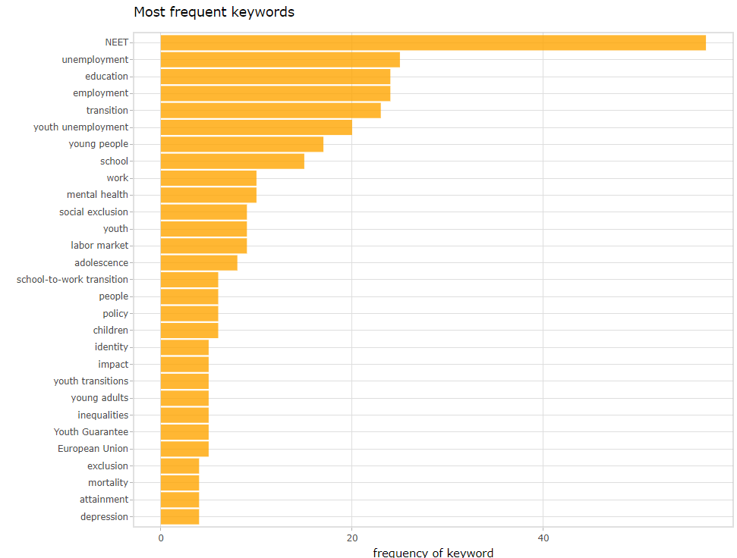

A6: Proportional wordcloud of all keywords in the selected papers

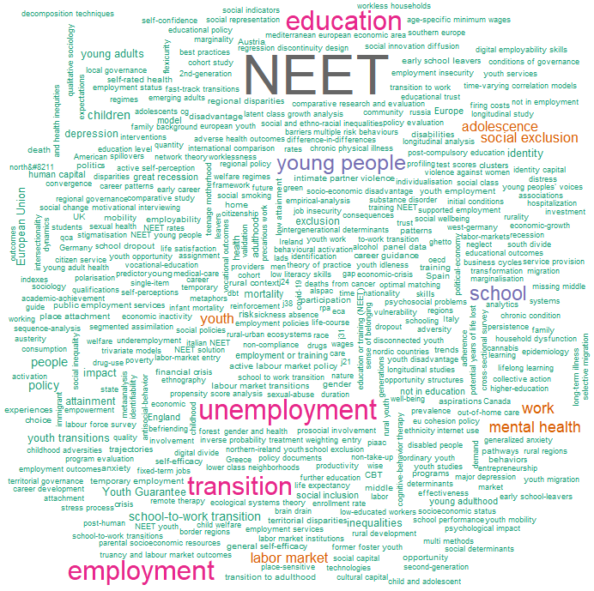

A7: Proportional wordcloud of most frequent keywords in the selected papers, excluding the keyword "NEET(s)"



A8: Network of keywords in the articles included in the review (bigram count network, threshold: 1)

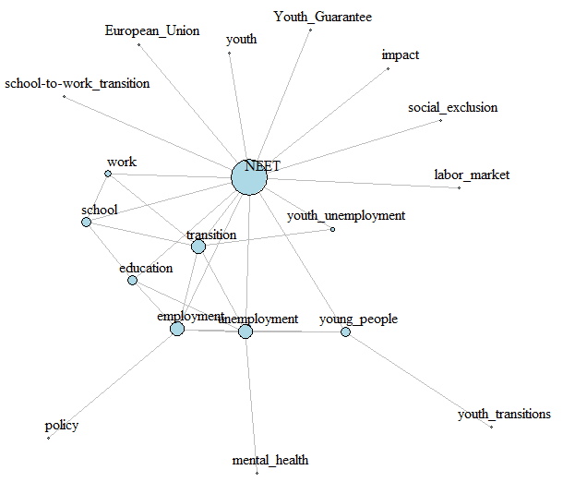

A9: Network of keywords in the articles included in the review (bigram count network, threshold: 3)

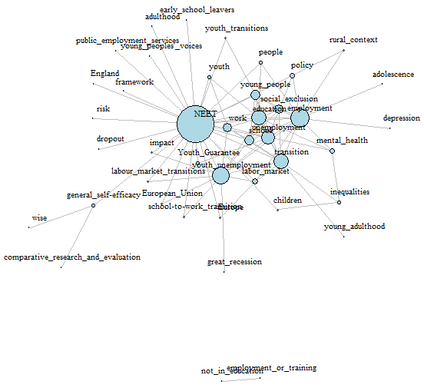

A10: Reading grid for the selected papers
Dimension | (variable) | categories
Regulator | Level of government | local: municipality, subregional: county, regional, country-level, EU-level
Regulator | Type of policy | Sectorial  overall
Youth as target | Targets youth as main goal
Youth as target | Targets youth – marginally
Rurality considered | Rural as target
Rurality considered | Distinction rural-urban in the policy
Target areas | Disadvantaged regions
Specific groups of NEETS | The 7 categories from Eurofound: | Re-entrants  Long-term unemployed  Short-term unemployed  Illness, disability  Family responsibilities  Discouraged  Other NEETs
Policy goals | Equality of access
Policy goals | Targeting unemployment
Policy goals | Incentive reinforcement
Policy goals | Regional focus
Policy instruments | Information
Policy instruments | Financial Support
Policy instruments | Regulation
Policy instruments | Direct Provision by the state
Types of active labour market policies (Bonoli, 2010) | Incentive reinforcement
Types of active labour market policies (Bonoli, 2010) | Employment assistance
Types of active labour market policies (Bonoli, 2010) | Occupation | e.g. apprenticeship, internship, paid short-term employment
Types of active labour market policies (Bonoli, 2010) | Human capital investment/ upskilling | Human capital investment (training, education, etc) – transversal (e.g. increasing ITC skills, language programmes, etc.)
Timeline | Year
Timeline | Expected duration
Timeline | Year when it was renewed
Timeline | Termination year
Timeline | When the effects are expected to be observed

Details:
Bonoli (2010, pp. 441-443) – types of ALMPs:
- “incentive reinforcement” – measures that aim to strengthen work incentives for the recipients of benefits (e.g. tax credits, in-work benefits, benefit conditionality)
- “employment assistance” – measures aiming to remove obstacles to labour-market participation (e.g. placement services, job-search programmes, counselling, job subsidies, help in finding and paying for a suitable daycare service for employee’s children, job rotation schemes, and start-up incentives)
- “occupation” – measures to keep jobless people busy, to prevent the depletion of human capital associated with a spell of unemployment (e.g. job creation and work experience programmes in the public or nonprofit sector, such as apprenticeships, internships, short-term employment)
- “human capital investment/ upskilling” – training for general competences/soft skills or specific skills/vocational training
Eurostat categories of labour market policies were extracted from Eurostat’s classifications related to labour market policy statistics. They include:
- LMP services cover all services and activities of the Public Employment Services (PES) together with any other publicly funded services for jobseekers.
1. Labour market services
- LMP measures cover interventions that provide temporary support to groups disadvantaged in the labour market as well as interventions which aim to activate the unemployed, helping people to move from involuntary inactivity into employment or maintaining the jobs of persons threatened by unemployment.
2. Training
4. Employment incentives
5. Supported employment and rehabilitation
6. Direct job creation
7. Start-up incentives
- LMP supports cover financial assistance that aims to compensate individuals for loss of wage or salary and support them during their job-search (i.e. mostly unemployment benefits). They also cover financial assistance which facilitates early retirement.
8. Out-of-work income maintenance and support
9. Early retirement
(the entire description is taken as such from Eurostat, https://ec.europa.eu/employment_social/employment_analysis/lmp/lmp_esms.htm)

A11: Incidence of NEETs across Europe

Dynamics of NEET rates across Europe: 2013-2022
TIME | 2013 | 2014 | 2015 | 2016 | 2017 | 2018 | 2019 | 2020 | 2021 | 2022
Austria | 8,6 | 9,3 | 8,7 | 8,9 | 8,4 | 8,4 | 8,3 | 9,5 | 9,4 | 9,1
Belgium | 14,9 | 14,1 | 14,4 | 13 | 12,6 | 12 | 11,8 | 12 | 10,1 | 9,2
Bulgaria | 25,7 | 24 | 22,2 | 22,4 | 18,9 | 18,1 | 16,7 | 18,1 | 17,6 | 15,1
Croatia | 22,3 | 21,8 | 19,9 | 19,5 | 17,9 | 15,6 | 14,2 | 14,6 | 14,9 | 13,3
Cyprus | 20,4 | 19,5 | 18,5 | 18 | 17,6 | 14,9 | 14,1 | 15,3 | 15,4 | 14,7
Czechia | 12,8 | 12,1 | 11,8 | 11,1 | 10 | 9,5 | 9,8 | 11 | 10,9 | 11,4
Denmark | 8,2 | 8 | 8,5 | 8,4 | 9,8 | 9,6 | 9,6 | 10,2 | 8,3 | 7,9
Estonia | 14,3 | 13,8 | 13,2 | 14,1 | 11,6 | 12,1 | 10,6 | 11,9 | 11,2 | 10,6
Finland | 10,9 | 11,8 | 12,4 | 11,7 | 10,9 | 10,1 | 9,5 | 10,3 | 9,3 | 9,5
France | 13,8 | 14,1 | 14,7 | 14,3 | 13,8 | 13,6 | 13 | 14 | 12,8 | 12
Germany | 8,7 | 8,7 | 8,5 | 8,9 | 8,5 | 7,9 | 7,6 | 9,1 | 9,5 | 8,6
Greece | 28,5 | 26,7 | 24,1 | 22,2 | 21,3 | 19,5 | 17,7 | 18,7 | 17,3 | 15,4
Hungary | 18,4 | 16,4 | 15,1 | 14,1 | 13,3 | 12,9 | 13,2 | 14,7 | 11,7 | 10,8
Iceland | 6,4 | 6,9 | 5,3 | 4,6 | 4,1 | 5,4 | 5,8 | 7,1 | 7,3 | 5,4
Ireland | 18,8 | 17,8 | 16,5 | 14,5 | 12,8 | 11,6 | 11,4 | 14,2 | 9,8 | 8,7
Italy | 26 | 26,2 | 25,7 | 24,3 | 24,1 | 23,4 | 22,2 | 23,3 | 23,1 | 19
Latvia | 15,6 | 15,2 | 13,8 | 13,3 | 12,3 | 11,6 | 10,3 | 11,9 | 12,1 | 11,3
Lithuania | 13,7 | 12,9 | 11,8 | 10,7 | 10,2 | 9,3 | 10,9 | 13 | 12,7 | 10,7
Luxembourg | 7,2 | 6,5 | 7,6 | 6,8 | 6,6 | 7,5 | 6,5 | 7,7 | 8,8 | 7,4
Malta | 10,9 | 11,6 | 11,8 | 9,4 | 8,8 | 7,3 | 7,9 | 9,5 | 9,5 | 7,2
Montenegro | 23,6 | 22,5 | 23,4 | 22,3 | 21,4 | 21 | 21,3 | 26,6 | n.a. | n.a.
Netherlands | 7,5 | 7,6 | 6,7 | 6,3 | 5,9 | 5,7 | 5,7 | 5,7 | 3,9 | 4,2
North Macedonia | 31,3 | 31,9 | 32,5 | 31,3 | 31,1 | 29,8 | 24,5 | 26,2 | n.a. | n.a.
Norway | 7 | 7,1 | 7 | 7,1 | 6,4 | 6,5 | 6,4 | 6,6 | 7,4 | 6,8
Poland | 16,2 | 15,5 | 14,6 | 13,8 | 12,9 | 12,1 | 12 | 12,9 | 13,4 | 10,9
Portugal | 16,4 | 14,6 | 13,2 | 12,8 | 10,6 | 9,6 | 9,2 | 11 | 9,5 | 8,4
Romania | 19,6 | 19,9 | 20,9 | 20,2 | 17,8 | 17 | 16,8 | 16,6 | 20,3 | 19,8
Serbia | 25,5 | 25,5 | 24,6 | 22,3 | 21,7 | 20,1 | 19 | 20 | 18,8 | 15,1
Slovakia | 19 | 18,2 | 17,2 | 15,9 | 16 | 14,6 | 14,5 | 15,2 | 14,2 | 12,3
Slovenia | 12,9 | 12,9 | 12,3 | 10,9 | 9,3 | 8,8 | 8,8 | 9,2 | 7,3 | 8,5
Spain | 22,5 | 20,7 | 19,4 | 18,1 | 16,4 | 15,3 | 14,9 | 17,3 | 14,1 | 12,7
Sweden | 7,9 | 7,8 | 7,4 | 7,1 | 6,8 | 6,9 | 6,3 | 7,2 | 6 | 5,7
Switzerland | 8 | 7,7 | 7,3 | 7,5 | 7,2 | 6,6 | 6,2 | 6,3 | n.a. | n.a.
Türkiye | 29,3 | 28,4 | 27,9 | 27,8 | 27,5 | 27,6 | 29,5 | 32 | n.a. | n.a.
United Kingdom | 14,6 | 13,4 | 12,7 | 12,3 | 11,4 | 11,7 | 11,4 | n.a. | n.a. | n.a.
*NEET rates as percentage of total youths aged 15-29, according to Eurostat data derived from Labour Force Surveys (LFS) (https://ec.europa.eu/eurostat/databrowser/view/edat_lfse_18/)

Distribution of NEETs across European societies: 2013
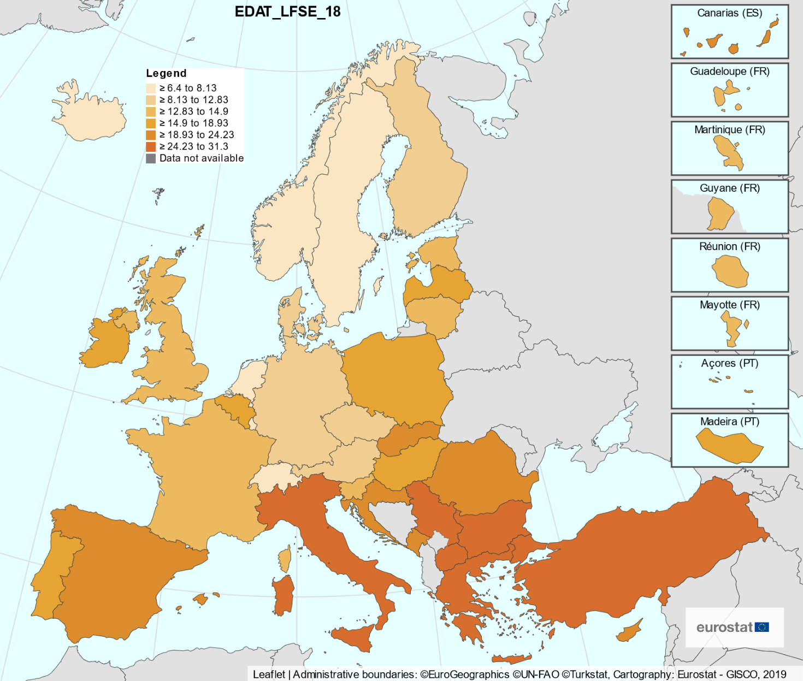
*NEET rates as percentage of total youths aged 15-29, according to Eurostat data derived from Labour Force Surveys (LFS) (https://ec.europa.eu/eurostat/databrowser/view/edat_lfse_18/)

Distribution of NEETs across European societies: 2022
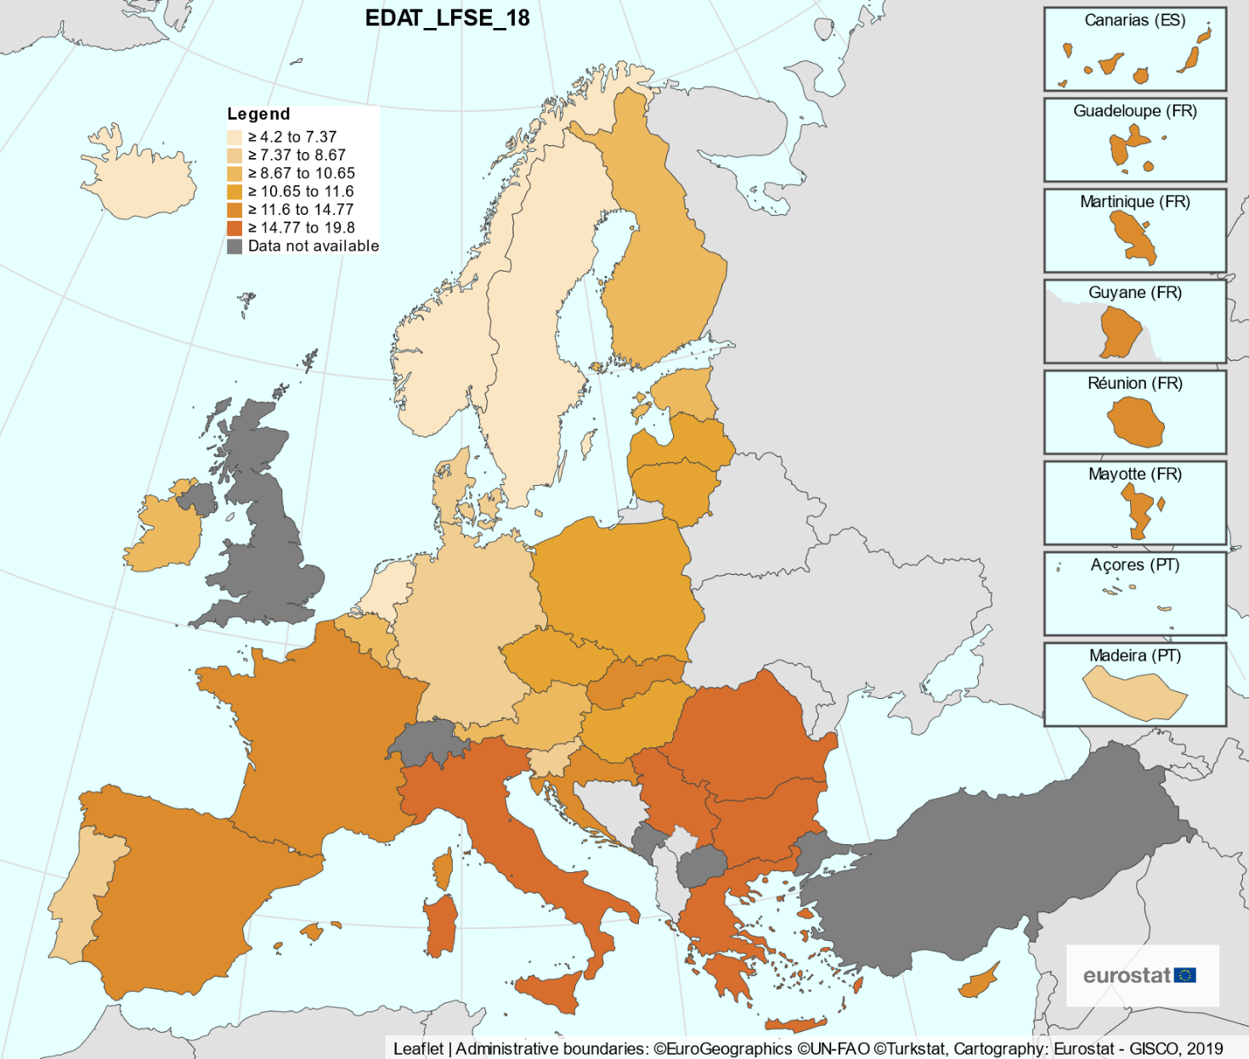
*NEET rates as percentage of total youths aged 15-29, according to Eurostat data derived from Labour Force Surveys (LFS) (https://ec.europa.eu/eurostat/databrowser/view/edat_lfse_18/)

Distribution of NEETs across European societies: selected years, gender differences
TIME | 2013 |  | 2016 |  | 2019 |  | 2022
GENDER | Males | Females | Males | Females | Males | Females | Males | Females
Belgium | 14,1 | 15,7 | 12,0 | 14,0 | 11,2 | 12,5 | 9,3 | 9,1
Bulgaria | 23,8 | 27,8 | 19,1 | 25,8 | 13,2 | 20,3 | 12,9 | 17,4
Czechia | 8,2 | 17,7 | 5,6 | 16,8 | 4,0 | 15,9 | 6,1 | 17,1
Denmark | 7,8 | 8,7 | 8,2 | 8,7 | 9,5 | 9,6 | 7,6 | 8,3
Germany | 6,7 | 10,8 | 7,0 | 10,9 | 5,9 | 9,5 | 7,1 | 10,2
Estonia | 11,1 | 17,5 | 9,0 | 19,5 | 7,3 | 14,1 | 11,9 | 9,2
Ireland | 19,0 | 18,5 | 14,4 | 14,7 | 10,5 | 12,4 | 7,8 | 9,7
Greece | 26,8 | 30,3 | 19,8 | 24,8 | 16,4 | 19,1 | 14,1 | 16,6
Spain | 22,8 | 22,1 | 17,4 | 18,7 | 14,4 | 15,4 | 12,1 | 13,3
France | 12,3 | 15,3 | 13,1 | 15,6 | 12,1 | 13,8 | 11,9 | 12,1
Croatia | 22,5 | 22,1 | 19,5 | 19,4 | 12,2 | 16,3 | 11,5 | 15,1
Italy | 24,5 | 27,5 | 22,4 | 26,3 | 20,2 | 24,3 | 17,7 | 20,5
Cyprus | 20,7 | 20,1 | 16,4 | 19,5 | 12,2 | 15,9 | 12,3 | 17,0
Latvia | 13,9 | 17,3 | 12,9 | 13,6 | 10,0 | 10,6 | 11,0 | 11,6
Lithuania | 13,2 | 14,3 | 10,8 | 10,7 | 10,9 | 11,0 | 9,6 | 11,8
Luxembourg | 6,7 | 7,8 | 5,4 | 8,3 | 7,1 | 5,9 | 7,9 | 6,9
Hungary | 14,5 | 22,6 | 9,6 | 18,8 | 8,7 | 17,9 | 8,3 | 13,3
Malta | 9,1 | 12,7 | 6,9 | 12,1 | 6,3 | 9,6 | 7,0 | 7,3
Netherlands | 6,9 | 8,2 | 5,7 | 6,9 | 5,6 | 5,8 | 3,8 | 4,6
Austria | 7,6 | 9,7 | 8,4 | 9,4 | 6,8 | 9,8 | 8,5 | 9,6
Poland | 13,4 | 19,1 | 10,7 | 17,1 | 7,6 | 16,6 | 8,2 | 13,6
Portugal | 16,0 | 16,9 | 12,4 | 13,2 | 8,3 | 10,1 | 8,2 | 8,6
Romania | 16,2 | 23,2 | 15,2 | 25,5 | 11,8 | 22,1 | 14,5 | 25,4
Slovenia | 11,7 | 14,1 | 10,6 | 11,3 | 6,6 | 11,2 | 7,3 | 9,9
Slovakia | 16,2 | 21,9 | 11,1 | 20,9 | 9,7 | 19,5 | 10,8 | 13,9
Finland | 10,4 | 11,4 | 11,2 | 12,3 | 8,6 | 10,4 | 10,3 | 8,8
Sweden | 7,5 | 8,3 | 6,8 | 7,3 | 6,0 | 6,6 | 5,4 | 5,9
Iceland | 6,9 | 5,9 | 4,3 | 5,0 | 6,6 | 4,8 | 5,5 | 5,2
Norway | 6,5 | 7,5 | 7,1 | 7,2 | 5,8 | 7,0 | 6,8 | 6,8
Switzerland | 7,4 | 8,6 | 7,3 | 7,8 | 6,5 | 6,0 | n.a. | n.a.
United Kingdom | 11,9 | 17,4 | 9,8 | 14,9 | 9,8 | 13,1 | n.a. | n.a.
Montenegro | 23,9 | 23,3 | 21,6 | 23,1 | 21,0 | 21,5 | n.a. | n.a.
North Macedonia | 28,1 | 34,6 | 28,7 | 34,0 | 20,9 | 28,3 | n.a. | n.a.
Serbia | 23,8 | 27,5 | 20,3 | 24,5 | 17,1 | 20,9 | 13,6 | 16,8
Türkiye | 14,8 | 43,8 | 14,8 | 40,9 | 18,3 | 40,8 | n.a. | n.a.
*NEET rates as percentage of total youths aged 15-29, by gender, according to Eurostat data derived from Labour Force Surveys (LFS) (https://ec.europa.eu/eurostat/databrowser/view/edat_lfse_18/)

References
Abayasekara, A., & Gunasekara, N. (2019). Determinants of youth not in education, employment or training: Evidence from Sri Lanka. Review of Development Economics, 23(4), 1840-1862. doi:10.1111/rode.12615
Alcázar, L., Balarin, M., Glave, C., & Rodriguez, M. F. (2020). Fractured lives: understanding urban youth vulnerability in Peru. Journal of Youth Studies, 23(2), 140-159. doi:10.1080/13676261.2019.1587154
André, G., & Crosby, A. (2022). The “NEET” category from the perspective of inequalities: toward a typology of school-to-work transitions among youth from lower class neighborhoods in the Brussels region (Belgium). Journal of Youth Studies, 1-15. doi:10.1080/13676261.2022.2098707
Barbachyn, S. M., Devine, R. D., Thrall, A. P., & Kurama, Y. C. (2017). Economic Evaluation of High-Strength Materials in Stocky Reinforced Concrete Shear Walls. Journal of Construction Engineering and Management, 143(10), 14. doi:10.1061/(asce)co.1943-7862.0001377
Basta, M., Karakonstantis, S., Koutra, K., Dafermos, V., Papargiris, A., Drakaki, M., . . . Papadakis, N. (2019). NEET status among young Greeks: Association with mental health and substance use. Journal of Affective Disorders, 253, 210-217. doi:10.1016/j.jad.2019.04.095
Berlin, M., Kaariala, A., Lausten, M., Andersson, G., & Brannstrom, L. (2021). Long-term NEET among young adults with experience of out-of-home care: A comparative study of three Nordic countries. International Journal of Social Welfare, 30(3), 266-279. doi:10.1111/ijsw.12463
Bonoli, G. (2010). The political economy of active labor-market policy. Politics & Society, 38(4), 435-457.
Bradley, S., & Crouchley, R. (2020). The effects of test scores and truancy on youth unemployment and inactivity: a simultaneous equations approach. Empirical Economics, 59(4), 1799-1831. doi:10.1007/s00181-019-01691-8
Bradley, S., Migali, G., & Paniagua, M. N. (2020). Spatial variations and clustering in the rates of youth unemployment and NEET: A comparative analysis of Italy, Spain, and the UK. Journal of Regional Science, 60(5), 1074-1107. doi:10.1111/jors.12501
Bray, J. W., Depro, B., McMahon, D., Siegle, M., & Mobley, L. (2016). Disconnected geography: A spatial analysis of disconnected youth in the United States. Journal of Labor Research, 37, 317-342.
Brown, C., Douthwaite, A., Costas Batlle, I., & Savvides, N. (2022). A multi-stakeholder analysis of the risks to early school leaving: comparing young peoples’ and educators’ perspectives on five categories of risk. Journal of Youth Studies, 1-25. doi:10.1080/13676261.2022.2132139
Burlina, C., Crociata, A., & Odoardi, I. (2021). Can culture save young Italians? The role of cultural capital on Italian NEETs behaviour. Economia Politica, 38(3), 943-969. doi:10.1007/s40888-021-00219-7
Bynner, J. (2012). Policy reflections guided by longitudinal study, youth training, social exclusion, and more recently NEET. British Journal of Educational Studies, 60(1), 39-52.
Bynner, J., & Parsons, S. (2002). Social exclusion and the transition from school to work: The case of young people not in education, employment, or training (NEET). Journal of Vocational Behavior, 60(2), 289-309. doi:10.1006/jvbe.2001.1868
Campbell, R., Wright, C., Hickman, M., Kipping, R. R., Smith, M., Pouliou, T., & Heron, J. (2020). Multiple risk behaviour in adolescence is associated with substantial adverse health and social outcomes in early adulthood: Findings from a prospective birth cohort study. Preventive Medicine, 138, 7. doi:10.1016/j.ypmed.2020.106157
Cefalo, R., Scandurra, R., & Kazepov, Y. (2020). Youth Labor Market Integration in European Regions. Sustainability, 12(9), 18. doi:10.3390/su12093813
Chen, Y. W. (2011). Once a NEET always a NEET? Experiences of employment and unemployment among youth in a job training programme in Taiwan. International Journal of Social Welfare, 20(1), 33-42. doi:10.1111/j.1468-2397.2009.00711.x
Cornish, C. (2021). Exclusion by design: uncovering systems of segregation and ‘ghettoization’ of so-called NEET and ‘disengaged’ youth on an employability course in a further education (FE) college. Journal of Youth Studies, 26(4), 456-472. doi:10.1080/13676261.2021.2010690
Craig, L., Powell, A., & Brown, J. E. (2015). Co-resident Parents and Young People Aged 15-34: Who Does What Housework? Social Indicators Research, 121(2), 569-588. doi:10.1007/s11205-014-0643-5
Crisp, R., & Powell, R. (2017). Young people and UK labour market policy: A critique of 'employability' as a tool for understanding youth unemployment. Urban Studies, 54(8), 1784-1807. doi:10.1177/0042098016637567
Dayioglu, M., Kucukbayrak, M., & Tumen, S. (2022). The impact of age-specific minimum wages on youth employment and education: a regression discontinuity analysis. International Journal of Manpower, 43(6), 1352-1377. doi:10.1108/ijm-02-2021-0079
De Luca, G., Mazzocchi, P., Quintano, C., & Rocca, A. (2020). Going Behind the High Rates of NEETs in Italy and Spain: The Role of Early School Leavers. Social Indicators Research, 151(1), 345-363. doi:10.1007/s11205-020-02370-3
Dias, T. S., & Vasconcelos, A. M. N. (2020). Heterogeneity among Young People Neither in Employment Nor in Education in Brazil. Annals of the American Academy of Political and Social Science, 688(1), 208-224. doi:10.1177/0002716220913234
Dorsett, R., & Lucchino, P. (2014). Explaining patterns in the school-to-work transition: An analysis using optimal matching. Advances in Life Course Research, 22, 1-14. doi:10.1016/j.alcr.2014.07.002
Dulloo, P. (2021). Selection Approach for Indian Medical Residency Program: Perspective of Interns and Residents. Journal of Clinical & Diagnostic Research, 15(6).
Dumouilla, A., Botella, M., Gillet, M., Joncheray, H., Guegan, J. M., Robieux, L., . . . Zenasni, F. (2021). Comparison of social representations of NEETs in active young French adults and NEETs themselves. British Journal of Guidance & Counselling, 49(3), 333-346. doi:10.1080/03069885.2021.1900776
Erdogan, E., Flynn, P., Nasya, B., Paabort, H., & Lendzhova, V. (2021). NEET Rural-Urban Ecosystems: The Role of Urban Social Innovation Diffusion in Supporting Sustainable Rural Pathways to Education, Employment, and Training. Sustainability, 13(21), 15. doi:10.3390/su132112053
Finlay, I., Sheridan, M., McKay, J., & Nudzor, H. (2010). Young people on the margins: in need of more choices and more chances in twenty-first century Scotland. British Educational Research Journal, 36(5), 851-867. doi:10.1080/01411920903168532
Focacci, C. N. (2020). "You reap what you sow": Do active labour market policies always increase job security? Evidence from the Youth Guarantee. European Journal of Law and Economics, 49(3), 373-429. doi:10.1007/s10657-020-09654-6
Furlong, A. (2006). Not a very NEET solution: representing problematic labour market transitions among early school-leavers. Work Employment and Society, 20(3), 553-569. doi:10.1177/0950017006067001
García-Fuentes, J., & Martínez García, J. S. (2020). Los jóvenes “Ni-Ni”: Un estigma que invisibiliza los problemas sociales de la juventud. Education Policy Analysis Archives, 28, 20. doi:10.14507/epaa.28.4652
Garman, E. C., Avendano, M., Araya, R., Evans-Lacko, S., McDaid, D., Zimmerman, A., & Lund, C. (2022). Understanding the complex relationship between multidimensional poverty and depressive symptoms among young South Africans: A cross-sectional study. Journal of Affective Disorders, 319, 352-360. doi:10.1016/j.jad.2022.09.101
Goldman-Mellor, S., Caspi, A., Arseneault, L., Ajala, N., Ambler, A., Danese, A., . . . Moffitt, T. E. (2016). Committed to work but vulnerable: self-perceptions and mental health in NEET 18-year olds from a contemporary British cohort. Journal of Child Psychology and Psychiatry, 57(2), 196-203. doi:10.1111/jcpp.12459
Görlich, A. (2019). Distance and mastery: poetic inquiry of young people's subjectification processes. Journal of Youth Studies, 22(3), 401-419. doi:10.1080/13676261.2018.1510175
Görlich, A., & Katznelson, N. (2015). Educational trust: relational and structural perspectives on young people on the margins of the education system. Educational Research, 57(2), 201-215. doi:10.1080/00131881.2015.1030857
Gutierrez-Garcia, R. A., Benjet, C., Borges, G., Rios, E. M., & Medina-Mora, M. E. (2017). NEET adolescents grown up: eight-year longitudinal follow-up of education, employment and mental health from adolescence to early adulthood in Mexico City. European Child & Adolescent Psychiatry, 26(12), 1459-1469. doi:10.1007/s00787-017-1004-0
Haikkola, L. (2019). Shaping activation policy at the street level: Governing inactivity in youth employment services. Acta Sociologica, 62(3), 334-348. doi:10.1177/0001699318784341
Haikkola, L. (2021). Classed and gendered transitions in youth activation: the case of Finnish youth employment services. Journal of Youth Studies, 24(2), 250-266. doi:10.1080/13676261.2020.1715358
Hale, D. R., & Viner, R. M. (2018). How adolescent health influences education and employment: investigating longitudinal associations and mechanisms. Journal of Epidemiology and Community Health, 72(6), 465-470. doi:10.1136/jech-2017-209605
Hazenberg, R., Seddon, F., & Denny, S. (2014). INVESTIGATING THE OUTCOME PERFORMANCE OF WORK-INTEGRATION SOCIAL ENTERPRISES (WISES) Do WISEs offer 'added value' to NEETs? Public Management Review, 16(6), 876-899. doi:10.1080/14719037.2012.759670
Hill, V., Rezaei, S., & Rocha, S. C. L. (2018). Increasing entrepreneurial impact in the MENA Region. Entrepreneurship Ecosystem in the Middle East and North Africa (MENA) Dynamics in Trends, Policy and Business Environment, 113-165.
Hodgson, D. (2019). Conceptualising the compulsory education policy apparatus: producing and reproducing risky subjectivities. Journal of Education Policy, 34(1), 117-132. doi:10.1080/02680939.2017.1410578
Holmes, C., Murphy, E., & Mayhew, K. (2021). What accounts for changes in the chances of being NEET in the UK? Journal of Education and Work, 34(4), 389-413. doi:10.1080/13639080.2021.1943330
Huddleston, P. (2016). A question of identity: Does it do what it says on the tin? In Vocationalism in Further and Higher Education (pp. 53-64): Routledge.
Iacobuță, A. O., & Ifrim, M. (2020). Welfare Mentality as a Challenge to European Sustainable Development. What Role for Youth Inclusion and Institutions? Sustainability, 12(9), 25. doi:10.3390/su12093549
Irwin, S. (2021). Young people in the middle: pathways, prospects, policies and a new agenda for youth research. Journal of Youth Studies, 24(8), 1033-1051. doi:10.1080/13676261.2020.1792864
Jeong, J., Park, K., Hyun, Y., & Kim, D. (2021). Measuring Psychological Support for the Unemployed: The Case of Kakao NEET Project. Ksii Transactions on Internet and Information Systems, 15(4), 1502-1520. doi:10.3837/tiis.2021.04.017
Juberg, A., & Skjefstad, N. S. (2019). 'NEET' to work? - substance use disorder and youth unemployment in Norwegian public documents. European Journal of Social Work, 22(2), 252-263. doi:10.1080/13691457.2018.1531829
Kanagasabapathy, S., & Raj, S. (2017). Depression, anxiety and stress--a cross-sectional study in a cohort of school students from South India. Journal of Evolution of Medical and Dental Sciences, 6(42), 3205-3209.
Karaoglan, D., Begen, N., & Tat, P. I. N. (2022). Mental Health Problems and Risky Health Behaviors among Young Individuals in Turkey: The Case of Being NEET. Journal of Mental Health Policy and Economics, 25(3), 105-117. Retrieved from <Go to ISI>://WOS:000882156400004
Kelly, E., & McGuinness, S. (2015). Impact of the Great Recession on unemployed and NEET individuals' labour market transitions in Ireland. Economic Systems, 39(1), 59-71. doi:10.1016/j.ecosys.2014.06.004
Kerr, J., Minh, A., Siddiqi, A., Muntaner, C., & O'Campo, P. (2019). A cross-country comparison of alcohol, tobacco, and marijuana use among youth who are employed, in school or out of the labor force and school (OLFS). Journal of Youth Studies, 22(5), 623-641. doi:10.1080/13676261.2018.1529862
Kiss, L., Fotheringhame, D., & Quilan-Davidson, M. (2022). Latin American young NEETs: Brazil as a case study for systemic risks of youth social exclusion. Journal of Youth Studies, 25. doi:10.1080/13676261.2021.1965107
Klug, K., Drobnic, S., & Brockmann, H. (2019). Trajectories of insecurity: Young adults' employment entry, health and well-being. Journal of Vocational Behavior, 115, 16. doi:10.1016/j.jvb.2019.05.005
Lawy, R., Quinn, J., & Diment, K. (2010). Responding to the 'needs' of young people in jobs without training (JWT): some policy suggestions and recommendations. Journal of Youth Studies, 13(3), 335-352. doi:10.1080/13676260903447544
Leavey, G., McGrellis, S., Forbes, T., Thampi, A., Davidson, G., Rosato, M., . . . Singh, S. P. (2019). Improving mental health pathways and care for adolescents in transition to adult services (IMPACT): a retrospective case note review of social and clinical determinants of transition. Social Psychiatry and Psychiatric Epidemiology, 54(8), 955-963. doi:10.1007/s00127-019-01684-z
Lin, W. H., & Chiao, C. (2022). The Relationship Between Adverse Childhood Experience and Heavy Smoking in Emerging Adulthood: The Role of Not in Education, Employment, or Training Status. Journal of Adolescent Health, 70(1), 155-162. doi:10.1016/j.jadohealth.2021.07.022
Lőrinc, M., Ryan, L., D'Angelo, A., & Kaye, N. (2020). De-individualising the 'NEET problem': An ecological systems analysis. European Educational Research Journal, 19(5), 412-427. doi:10.1177/1474904119880402
MacDonald, R. (2011). Youth transitions, unemployment and underemployment. Journal of Sociology, 47(4), 427-444. doi:10.1177/1440783311420794
MacIntyre, G. (2014). The potential for inclusion: young people with learning disabilities experiences of social inclusion as they make the transition from childhood to adulthood. Journal of Youth Studies, 17(7), 857-871. doi:10.1080/13676261.2013.878794
Madia, J. E., Obsuth, I., Thompson, I., Daniels, H., & Murray, A. L. (2022). Long-term labour market and economic consequences of school exclusions in England: Evidence from two counterfactual approaches. British Journal of Educational Psychology, 92(3), 801-816. doi:10.1111/bjep.12487
Maguire, S. (2010). 'I just want a job' - what do we really know about young people in jobs without training? Journal of Youth Studies, 13(3), 317-333. doi:10.1080/13676260903447551
Maguire, S. (2015). NEET, unemployed, inactive or unknown - why does it matter? Educational Research, 57(2), 121-132. doi:10.1080/00131881.2015.1030850
Malo, M. Á., Mussida, C., Cueto, B., & Baussola, M. (2021). Being a NEET before and after the Great Recession: persistence by gender in Southern Europe. Socio-Economic Review, 21. doi:10.1093/ser/mwab043
Manhica, H., Lundin, A., & Danielsson, A. K. (2019). Not in education, employment, or training (NEET) and risk of alcohol use disorder: a nationwide register-linkage study with 485 839 Swedish youths. Bmj Open, 9(10), 6. doi:10.1136/bmjopen-2019-032888
Matli, W., & Ngoepe, M. (2021). Life situations and lived experiences of young people who are not in education, employment, or training in South Africa. Education and Training, 63(9), 1242-1257. doi:10.1108/et-10-2019-0231
Mauro, J. A., & Mitra, S. (2020). Youth idleness in Eastern Europe and Central Asia before and after the 2009 crisis. Applied Economics, 52(15), 1634-1655. doi:10.1080/00036846.2019.1677848
Mawn, L., Oliver, E. J., Akhter, N., Bambra, C. L., Torgerson, C., Bridle, C., & Stain, H. J. (2017). Are we failing young people not in employment, education or training (NEETs)? A systematic review and meta-analysis of re-engagement interventions. Systematic Reviews, 6, 17. doi:10.1186/s13643-016-0394-2
Maynou, L., Ordonez, J., & Silva, J. I. (2022). Convergence and determinants of young people not in employment, education or training: An European regional analysis. Economic Modelling, 110, 11. doi:10.1016/j.econmod.2022.105808
Mellberg, C., Minas, R., Korpi, T., & Andersson, L. (2022). Effective local governance assisting vulnerable groups: The case of youth not in employment, education or training (NEETs) in Sweden. International Journal of Social Welfare, 32(1), 20-31. doi:10.1111/ijsw.12527
Mujčinović, A., Nikolić, A., Tuna, E., Stamenkovska, I. J., Radović, V., Flynn, P., & McCauley, V. (2021). Is It Possible to Tackle Youth Needs with Agricultural and Rural Development Policies? Sustainability, 13(15), 15. doi:10.3390/su13158410
Nestic, D., & Tomic, I. (2018). Jobless Population and Employment Flows in Recession. Journal of Balkan and near Eastern Studies, 20(3), 273-292. doi:10.1080/19448953.2018.1385271
Odoardi, I. (2020). Can parents' education lay the foundation for reducing the inactivity of young people? A regional analysis of Italian NEETs. Economia Politica, 37(1), 307-336. doi:10.1007/s40888-019-00162-8
Palmer, A. N., & Small, E. (2021). COVID-19 and disconnected youth: Lessons and opportunities from OECD countries. Scandinavian Journal of Public Health, 49(7), 779-789. doi:10.1177/14034948211017017
Park, M., Lee, S., Nam, K. C., Noh, H., Lee, S., & Lee, B. J. (2020). An evaluation of the youth employment support program in South Korea: Focusing on the outcome of preventing NEET. Children and Youth Services Review, 110, 11. doi:10.1016/j.childyouth.2020.104747
Pascual, A. S., & Martín, P. M. (2017). From 'Employab-ility' to 'Entrepreneurial-ity' in Spain: youth in the spotlight in times of crisis. Journal of Youth Studies, 20(7), 798-821. doi:10.1080/13676261.2016.1273513
Pemberton, S. (2008). Tackling the NEET generation and the ability of policy to generate a 'NEET' solution - evidence from the UK. Environment and Planning C-Government and Policy, 26(1), 243-259. doi:10.1068/c0654
Pereira, S. M. P., Li, L., & Power, C. (2017). Child Maltreatment and Adult Living Standards at 50 Years. Pediatrics, 139(1), 10. doi:10.1542/peds.2016-1595
Pesquera Alonso, C., Muñoz Sánchez, P., & Iniesta Martínez, A. (2021). Youth Guarantee: Looking for Explanations. Sustainability, 13(10), 13. doi:10.3390/su13105561
Petrescu, C., Ellena, A. M., Fernandes-Jesus, M., & Marta, E. (2022). Using Evidence in Policies Addressing Rural NEETs: Common Patterns and Differences in Various EU Countries. Youth & Society, 54(2_SUPPL), 69S-88S. doi:10.1177/0044118x211056361
Piqué, M. A. C., Veà, A. P., & Strecker, T. (2016). The EU youth guarantee - a critical analysis of its implementation in Spain. Journal of Youth Studies, 19(5), 684-704. doi:10.1080/13676261.2015.1098777
Pitkänen, J., Remes, H., Moustgaard, H., & Martikainen, P. (2021). Parental socioeconomic resources and adverse childhood experiences as predictors of not in education, employment, or training: a Finnish register-based longitudinal study. Journal of Youth Studies, 24(1), 1-18. doi:10.1080/13676261.2019.1679745
Pullman, A., & Krejcik, L. (2021). Literacy, Numeracy, and Digital Practices at Home Among NEET Individuals in Germany How are they Associated with Future Work and School? Zeitschrift Fur Padagogik, 133-152. Retrieved from <Go to ISI>://WOS:000639570900008
Quinn, J. (2013). New learning worlds: the significance of nature in the lives of marginalised young people. Discourse-Studies in the Cultural Politics of Education, 34(5), 716-730. doi:10.1080/01596306.2013.728366
Raghupathi, V., & Raghupathi, W. (2020). The influence of education on health: an empirical assessment of OECD countries for the period 1995-2015. Archives of Public Health, 78(1), 18. doi:10.1186/s13690-020-00402-5
Rambla, X., & Scandurra, R. (2021). Is the distribution of NEETs and early leavers from education and training converging across the regions of the European Union? European Societies, 23(5), 563-589. doi:10.1080/14616696.2020.1869282
Rasalingam, A., Brekke, I., Dahl, E., & Helseth, S. (2021). Impact of growing up with somatic long-term health challenges on school completion, NEET status and disability pension: a population-based longitudinal study. BMC Public Health, 21(1), 12. doi:10.1186/s12889-021-10538-w
Răileanu-Szeles, M., & Simionescu, M. (2022). Improving the school-to-work transition for young people by closing the digital divide: evidence from the EU regions. International Journal of Manpower, 43(7), 1540-1555. doi:10.1108/ijm-03-2021-0190
Roberts, S. (2011). Beyond 'NEET' and 'tidy' pathways: considering the 'missing middle' of youth transition studies. Journal of Youth Studies, 14(1), 21-39. doi:10.1080/13676261.2010.489604
Rodriguez-Modroño, P. (2019). Youth unemployment, NEETs and structural inequality in Spain. International Journal of Manpower, 40(3), 433-448. doi:10.1108/ijm-03-2018-0098
Saczyńska-Sokół, S. (2018). Supporting NEETs - challenges facing labor market institutions in Poland. Oeconomia Copernicana, 9(1), 159-173. doi:10.24136/oc.2018.009
Salva-Mut, F., Thomas-Vanrell, C., & Quintana-Murci, E. (2016). School-to-work transitions in times of crisis: the case of Spanish youth without qualifications. Journal of Youth Studies, 19(5), 593-611. doi:10.1080/13676261.2015.1098768
Scandurra, R., Cefalo, R., & Kazepov, Y. (2021a). Drivers of Youth Labour Market Integration Across European Regions. Social Indicators Research, 154(3), 835-856. doi:10.1007/s11205-020-02549-8
Scandurra, R., Cefalo, R., & Kazepov, Y. (2021b). School to work outcomes during the Great Recession, is the regional scale relevant for young people's life chances? Journal of Youth Studies, 24(4), 441-465. doi:10.1080/13676261.2020.1742299
Sergi, V., Cefalo, R., & Kazepov, Y. (2018). Young people's disadvantages on the labour market in Italy: reframing the NEET category. Journal of Modern Italian Studies, 23(1), 41-60. doi:10.1080/1354571x.2017.1409529
Serracant, P. (2014). A Brute Indicator for a NEET Case: Genesis and Evolution of a Problematic Concept and Results from an Alternative Indicator. Social Indicators Research, 117(2), 401-419. doi:10.1007/s11205-013-0352-5
Shon, H., Cho, C.-S., Byon, Y.-J., & Lee, J. (2022). Autonomous condition monitoring-based pavement management system. Automation in Construction, 138, 104222.
Shon, H., & Lee, J. (2021). Integrating multi-scale inspection, maintenance, rehabilitation, and reconstruction decisions into system-level pavement management systems. Transportation Research Part C: Emerging Technologies, 131, 103328.
Signorelli, M., & Choudhry, M. T. (2015). Symposium: Youth labour market and the "Great Recession". Economic Systems, 39(1), 1-2. doi:10.1016/j.ecosys.2014.06.005
Silva, S. M. d., Silva, A. M., Cortés-González, P., & Brazienė, R. (2021). Learning to Leave and to Return: Mobility, Place, and Sense of Belonging amongst Young People Growing up in Border and Rural Regions of Mainland Portugal. Sustainability, 13(16), 21. doi:10.3390/su13169432
Simões, F., Meneses, A., Luís, R., & Drumonde, R. (2017). NEETs in a rural region of Southern Europe: perceived self-efficacy, perceived barriers, educational expectations, and vocational expectations. Journal of Youth Studies, 20(9), 1109-1126. doi:10.1080/13676261.2017.1311403
Simões, F., Rocca, A., Rocha, R., Mateus, C., Marta, E., & Tosun, J. (2021). Time to Get Emotional: Determinants of University Students’ Intention to Return to Rural Areas. Sustainability, 13(9), 12. doi:10.3390/su13095135
Smoter, M. (2022). Outreach Practices of Public Employment Services Targeted at NEET Youth in Poland. Youth & Society, 54(2_SUPPL), 89S-108S. doi:10.1177/0044118x211058224
Stain, H. J., Baker, A. L., Jackson, C., Lenroot, R., Paulik, G., Attia, J., . . . Hides, L. (2019). Study protocol: a randomised controlled trial of a telephone delivered social wellbeing and engaged living (SWEL) psychological intervention for disengaged youth. Bmc Psychiatry, 19, 9. doi:10.1186/s12888-019-2116-5
Stavrou, S., & Achniotis, P. (2021). Towards a revaluation of work in post-Fordist societies? Critical reconversions of highly skilled youth and negotiations of fluid relationships with work. Journal of Youth Studies, 26(2), 250-268. doi:10.1080/13676261.2021.2010685
Szpakowicz, D. (2022). Problematising engagement with technologies in transitions of young people identified as ‘Not in Education, Employment or Training’ (NEET) in Scotland. Journal of Youth Studies, 1-19. doi:10.1080/13676261.2022.2080538
Tamesberger, D., & Bacher, J. (2014). NEET youth in Austria: a typology including socio-demography, labour market behaviour and permanence. Journal of Youth Studies, 17(9), 1239-1259. doi:10.1080/13676261.2014.901492
Tanton, C., McDonagh, L., Cabecinha, M., Clifton, S., Geary, R., Rait, G., . . . Mercer, C. H. (2021). How does the sexual, physical and mental health of young adults not in education, employment or training (NEET) compare to workers and students? BMC Public Health, 21(1), 17. doi:10.1186/s12889-021-10229-6
Thompson, R. (2011). Individualisation and social exclusion: the case of young people not in education, employment or training. Oxford Review of Education, 37(6), 785-802. doi:10.1080/03054985.2011.636507
Thompson, R. (2017). Opportunity structures and educational marginality: the post-16 transitions of young people outside education and employment. Oxford Review of Education, 43(6), 749-766. doi:10.1080/03054985.2017.1352502
Thornham, H. (2014). Claiming 'creativity': discourse, 'doctrine' or participatory practice? International Journal of Cultural Policy, 20(5), 536-552. doi:10.1080/10286632.2013.865729
To, S. M., Victor, C. W. W., Daniel, D. M. L., Lau, C. D., & Su, X. B. (2021). Navigating Risk Discourses: a Narrative Analysis of Parental Experiences in the Career and Life Development of Youth not in Education, Employment, or Training. Applied Research in Quality of Life, 16(5), 2039-2058. doi:10.1007/s11482-020-09855-w
Toivonen, T., Norasakkunkit, V., & Uchida, Y. (2011). Unable to conform, unwilling to rebel? Youth, culture, and motivation in globalizing Japan. Frontiers in Psychology, 2, 9. doi:10.3389/fpsyg.2011.00207
Van Parys, L., & Struyven, L. (2013). Withdrawal from the public employment service by young unemployed: a matter of non-take-up or of non-compliance? How non-profit social work initiatives may inspire public services. European Journal of Social Work, 16(4), 451-469. doi:10.1080/13691457.2012.724387
van Vugt, L., Levels, M., & van der Velden, R. (2022). The low skills trap: the failure of education and social policies in preventing low-literate young people from being long-term NEET. Journal of Youth Studies, 1-35. doi:10.1080/13676261.2022.2118036
Wilson, S., Cunningham-Burley, S., Bancroft, A., & Backett-Milburn, K. (2008). 'Joined up' thinking? Unsupported 'fast-track' transitions in the context of parental substance use. Journal of Youth Studies, 11(3), 283-312. doi:10.1080/13676260801946423
Yang, Y. (2020). China's Youth in NEET (Not in Education, Employment, or Training): Evidence from a National Survey. Annals of the American Academy of Political and Social Science, 688(1), 171-189. doi:10.1177/0002716220909807
Yates, S., Harris, A., Sabates, R., & Staff, J. (2011). Early Occupational Aspirations and Fractured Transitions: A Study of Entry into 'NEET' Status in the UK. Journal of Social Policy, 40, 513-534. doi:10.1017/s0047279410000656
Yeung, W. J. J., & Yang, Y. (2020). Labor Market Uncertainties for Youth and Young Adults: An International Perspective. Annals of the American Academy of Political and Social Science, 688(1), 7-19. doi:10.1177/0002716220913487
Zuccotti, C. V., & O'Reilly, J. (2019). Ethnicity, Gender and Household Effects on Becoming NEET: An Intersectional Analysis. Work Employment and Society, 33(3), 351-373. doi:10.1177/0950017017738945

