Supplementary information for
The environmental impacts and sustainable pathways of the global diamond industry

Yutong Sun^{1,2}, Shangrong Jiang³, Shouyang Wang^{1,2,4*}
¹ Academy of Mathematics and Systems Science, Chinese Academy of Sciences, Beijing, China
² School of Economics and Management, University of Chinese Academy of Sciences, Beijing, China
³ HKU Business School, The University of Hong Kong, Hong Kong, China
⁴ School of Entrepreneurship and Management, ShanghaiTech University, Shanghai, China
*Corresponding author(s). E-mail(s): sywang@amss.ac.cn;
Contributing authors: sunyutong@amss.ac.cn; srjiang@hku.hk;

Supplementary Table 1 | DEIE regions dataset
Year | Australia | Russia | Botswana | DR Congo | South Africa | Others
1970 | -- | -- | 463595 | -- | 8111533 | 18508443
1971 | -- | -- | 871765 | -- | 7031249 | 19659485
1972 | -- | -- | 2402936 | -- | 7394974 | 33028798
1973 | -- | -- | 2416460 | -- | 7565374 | 31519672
1974 | -- | -- | 2718000 | -- | 7510075 | 33620001
1975 | -- | -- | 2413839 | -- | 7295133 | 31407641
1976 | -- | -- | 2361000 | -- | 7022770 | 29376725
1977 | -- | -- | 2691000 | -- | 7643291 | 28891702
1978 | -- | -- | 2799000 | -- | 7726605 | 28928008
1979 | -- | -- | 4369000 | -- | 8384332 | 26499207
1980 | -- | -- | 5146000 | -- | 8520328 | 29244460
1981 | -- | -- | 4960000 | -- | 9525876 | 25095450
1982 | 457000 | -- | 7562000 | -- | 9152886 | 23066946
1983 | 6200227 | -- | 10897000 | -- | 10311778 | 27890721
1984 | 5692193 | -- | 12904000 | -- | 10120712 | 34747165
1985 | 7070062 | -- | 12608000 | -- | 10205936 | 35967656
1986 | 29232453 | -- | 13138000 | -- | 10226963 | 43101726
1987 | 30331701 | -- | 13225344 | -- | 9050992 | 39927698
1988 | 35221000 | -- | 15229000 | -- | 8504016 | 38127468
1989 | 35079000 | -- | 15252000 | -- | 9115880 | 37975552
1990 | 34662000 | -- | 17351000 | -- | 8708231 | 49902429
1991 | 35956000 | -- | 16506000 | -- | 8431389 | 45148391
1992 | 40172000 | 18000000 | 15946000 | 13501450 | 10177283 | 24395621
1993 | 41883000 | 16000000 | 14730000 | 15626000 | 10177283 | 15230882
1994 | 43789000 | 16300000 | 15550000 | 16259000 | 10853653 | 20872404
1995 | 40692000 | 16900000 | 16802438 | 22024000 | 9682744 | 23277570
Year | Australia | Russia | Botswana | DR Congo | South Africa | Others
1996 | 41993000 | 19200000 | 17707000 | 22240000 | 9946750 | 24806923
1997 | 40175000 | 19400000 | 20111000 | 20977000 | 10041380 | 24064251
1998 | 40843000 | 19800000 | 19639000 | 21362000 | 10704628 | 25103789
1999 | 29784000 | 16200000 | 21263000 | 22000000 | 10014815 | 29437326
2000 | 26647000 | 20500000 | 24635000 | 16500000 | 10789976 | 30007743
2001 | 26176000 | 20500000 | 26190000 | 18198000 | 11162630 | 33184785
2002 | 33648000 | 20000000 | 28368000 | 22503000 | 10882614 | 17259594
2003 | 31013000 | 33020000 | 30412155 | 26981000 | 12673379 | 23682128
2004 | 20620000 | 38865770 | 31125000 | 29503000 | 14294662 | 26245622
2005 | 30702786 | 38000990 | 31889771 | 33054998 | 15775720 | 26257704
2006 | 29308284 | 38360810 | 34293401 | 28990241 | 15152801 | 30461728
2007 | 19231451 | 38291200 | 33639000 | 28452496 | 15247122 | 34740080
2008 | 15670576 | 36925150 | 32595000 | 33401928 | 12901018 | 32407359
2009 | 10794724 | 34759400 | 17734000 | 21298459 | 6118974 | 29061580
2010 | 9997752 | 34856600 | 22019000 | 16964000 | 8870967 | 32218416
2011 | 7561487 | 35139800 | 22903000 | 19249057 | 7046644 | 30673190
2012 | 8625996 | 34927650 | 20478000 | 19154000 | 7245403 | 34784766
2013 | 11481749 | 37884140 | 22597000 | 16653000 | 8168113 | 33172231
2014 | 9288118 | 38303500 | 24658000 | 14689000 | 8060373 | 29469579
2015 | 13560795 | 41912390 | 20824000 | 14284000 | 8232627 | 28135705
2016 | 13958000 | 40322030 | 20954000 | 15523000 | 8450758 | 25642028
2017 | 17135000 | 42614780 | 22900000 | 18891800 | 9685235 | 39461514
2018 | 14008054 | 43161058 | 27373000 | 15131210 | 9911460 | 39804881
2019 | 12154544 | 45271212 | 23278000 | 13469699 | 7177435 | 34465771
2020 | 9980000 | 31186551 | 16868000 | 10782600 | 8478398 | 28663664
Total | 9170795952 | 886603031 | 846175704 | 587663938 | 485485168 | 1371957508

Supplementary Table 2| Environmental indicators of mined diamonds and lab-grown diamonds
Name of indicators | Mined diamonds (per carat) | Lab-grown diamonds (per carat)
GHG emissions | 57000 grams | 0.028 grams
Mineral waste | 2.63 tonnes | 0.0006 tonnes
Water usage | 0.48 m³ | 0.07 m³

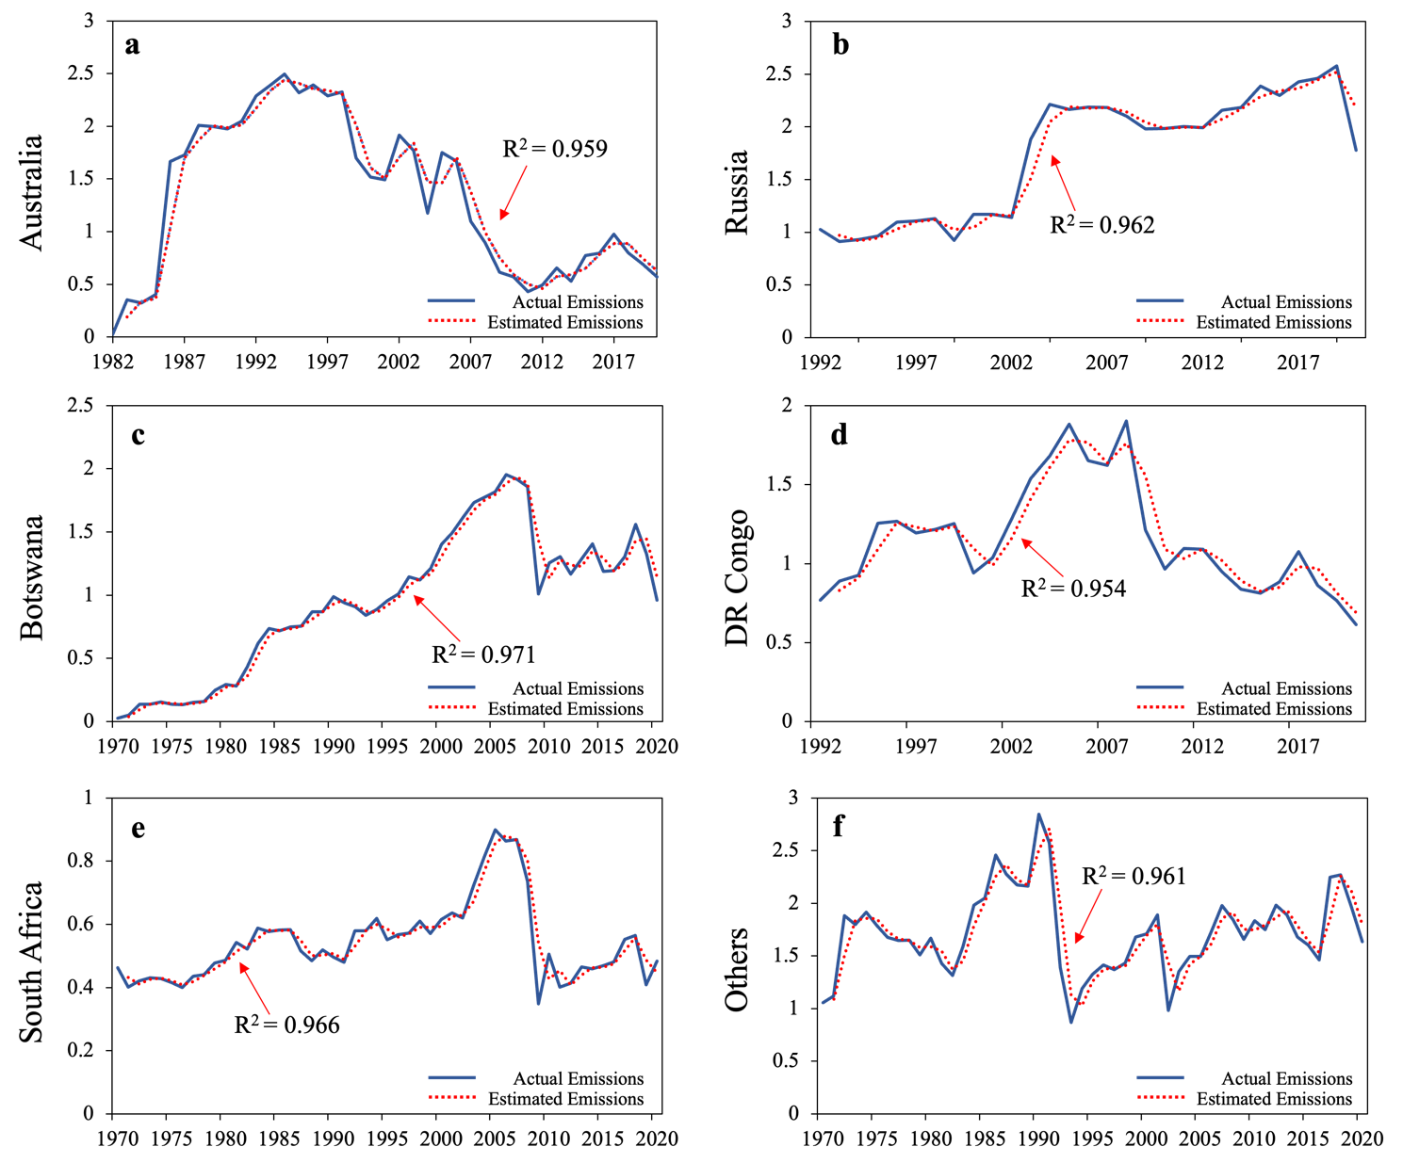
Supplementary Fig. 1 | Reality and statistical test results. This Figure illustrates the historical and projected annual carbon emission of mined diamond industry (Million Tons) based on the World Mineral Statistics (WMS) archive data (https://www2.bgs.ac.uk/mineralsUk/statistics/). The blue line represents the actual emissions. The dotted red line shows the estimated emissions based on DEIE modeling. We introduce R² to interpret the goodness of fit and parameter consistencies of DEIE modelling.

