Are migrants a threat? Migrant children and human capital investments among local households in urban China

Xiaodong Zheng^{1,2,3}, Yanran Zhou^{1,2}*
¹ KRI-Modern Business Research Center of Zhejiang Gongshang University, Hangzhou, China
² School of Economics, Zhejiang Gongshang University, Hangzhou, China
³ School of Economics, Fudan University, Shanghai, China
*Correspondence: Yanran Zhou, KRI-Modern Business Research Center of Zhejiang Gongshang University, No.18 Xuezheng Street, Qiantang District, Hangzhou, Zhejiang 310018, P.R. China. Email: zhouyanran@zjgsu.edu.cn

Supplementary materials
S1. Details about the sampling design of the CEPS
The China Education Panel Survey (CEPS) in 2014 adopted a multi-stage probability proportional to size (PPS) sampling method, which is divided into four stages of sampling.
In the first stage of sampling, administrative units at the county level are selected as Primary Sampling Units (PSUs). Based on the data from the 6th National Census conducted in 2010, a total of 2,870 county-level administrative units with a permanent resident population in the 31 provinces, autonomous regions, and municipalities directly under the central government (excluding Hong Kong, Macau, and Taiwan) are grouped into three sampling frames. From these sampling frames, 28 counties (or districts) are sampled, including 15 core samples and 13 supplementary samples.
In the second stage of sampling, schools are selected as Secondary Sampling Units (SSUs). Local cooperating agencies collect the latest statistics of school lists, school types, and school sizes for the academic year 2013-2014 from the education departments of the sampled counties (districts). Based on this information, the research team constructs the second-stage sampling frame and adopts a Probability Proportional to Size (PPS) sampling method. Four schools are selected from each of the sampled counties (districts).
In the third stage of sampling, classes are selected as Tertiary Sampling Units (TSUs). This stage of sampling is completed by local cooperating agencies before the field investigation begins. If the surveyed grade in the sampled school has only one or two classes, all of them are included in the sample. However, if the grade has three or more classes, two classes are randomly selected using the random number table provided for class sampling.
After completing the class sampling in the third stage, all students in the selected classes are included in the sample. There is no further sampling within the selected classes, and all students and their parents and main teachers within those classes are surveyed.

Table S1. Summary statistics by migrant status
Variables | Migrant status (Yes=1)
Variables | All | No | Yes | Mean Diff. | Sig.
Variables | (1) | (2) | (3) | (4) | (5)
Household human capital investments
Total education expenditure (log) | 7.615 | 5.490 | 5.865 | -0.375 | ***
In-school expenditure (log) | 6.444 | 3.637 | 4.146 | -0.508 | ***
Out-of-school expenditure (log) | 3.663 | 3.705 | 3.647 | 0.058 | NS
Parental time investment (log) | 1.273 | 1.291 | 1.221 | 0.071 | ***
Student characteristics
Migrant status | 0.185 | — | — | — | —
Gender (male=1) | 0.499 | 0.500 | 0.494 | 0.006 | NS
Age (in years) | 14.354 | 14.353 | 14.391 | -0.039 | NS
Only child (yes=1) | 0.614 | 0.659 | 0.457 | 0.202 | ***
Ethnic minority (yes=1) | 0.106 | 0.111 | 0.076 | 0.035 | ***
Academic record rank in grade six | 15.175 | 15.285 | 14.423 | 0.862 | *
Family characteristics
Father’s education (in years) | 11.568 | 11.802 | 10.804 | 0.998 | ***
Mother’s education (in years) | 10.851 | 11.154 | 9.870 | 1.283 | ***
Family economic status (very poor=1, very rich=5) | 3.100 | 3.107 | 3.101 | 0.005 | NS
Class characteristics
Class size (log) | 3.920 | 3.949 | 3.797 | 0.152 | ***
Gender of head teacher (male=1) | 0.339 | 0.346 | 0.300 | 0.046 | ***
Age of head teacher (in years) | 2.431 | 38.833 | 39.554 | -0.721 | ***
Working experience of head teacher (in years) | 2.230 | 17.383 | 17.595 | -0.212 | NS
Education level of head teacher (college or above=1) | 0.482 | 0.459 | 0.562 | -0.102 | ***
Notes: Descriptive statistics (mean characteristics) are shown for the total sample, as well as migrant students and their local peers. Column (4) and column (5) report the mean differences of the variables between the two groups and the corresponding statistical significance levels from t-tests, respectively. “NS” denotes not statistically significant. * p < 0.1, ** p < 0.05, *** p < 0.01.

Table S2. Balancing test: multiple regression (F test)
Dependent variable: | Coefficient | Robust standard error
Panel A: Student characteristics | 0.001 | (0.002)
Gender | 0.002 | (0.002)
Age | -0.002 | (0.002)
Only child | -0.000 | (0.004)
Ethnic minority | -0.000 | (0.000)
Academic record rank in grade 6 | 0.001 | (0.002)
Panel B: Family characteristics
Father’s education | -0.002 | (0.002)
Mother’s education | 0.002 | (0.002)
Family economic status | -0.002 | (0.003)
Panel C: Class characteristics
Class size | -0.080 | (0.062)
Gender of head teacher | -0.022 | (0.015)
Age of head teacher | 0.024 | (0.020)
Working experience of head teacher | -0.017 | (0.015)
Education level of head teacher | -0.008 | (0.011)
F-statistics | 1.36
Prob > F | 0.191
Observations | 4560
Notes: Standard errors in parentheses are clustered at the class level. * p < 0.1, ** p < 0.05, *** p < 0.01

Table S3. Description of dependent variables for mechanism analysis
Variables | Description of Questions | Answers to the questions
Panel A: Parental beliefs about their children
Education expectation | What is the highest level of education you expect this child to receive? | From 1 (drop out now) to 9 (get a doctor degree)
Confidence in the child’s future | Are you confident in the future of this child? | Not confident at all=1, Not so confident=2, Somewhat confident=3, Very confident=4
Biased belief about the child’s academic achievement | Biased parental belief in child achievement is measured by comparing their beliefs regarding academic achievement with their child’s true performance in three subjects: Chinese, English, and mathematics. Parents are asked to report their beliefs about their child’s academic rank in their class (1=very low, 5=very high). Students’ actual academic achievement is measured by Chinese, English, and mathematics test scores in the mid-term examination in the autumn of 2013. We group the average test scores of the three subjects within the class into five categories based on equal percentiles. Parental biased belief is measured by the gap between the perceived and actual student academic performance. | Ranging from -4 (downward bias, underestimated) to 4 (upward bias, overestimated)
Underestimate the child’s academic achievement | Based on the variable regarding parents’ biased belief in their child’s academic achievement, we further generate two dummy variables indicating whether parents underestimate and overestimate their child’s academic performance, respectively. | Yes=1, No=0
Overestimate the child’s academic achievement |  | Yes=1, No=0
Panel B: Parental beliefs about children’ peers and private tutoring
Friends are important for students’ grade | Do you think friends have important effects on students’ grade | Yes=1, No=0
Private tutoring is important for students’ grade | Do you think private tutoring has important effects on students’ grade | Yes=1, No=0
This child likes his/her schoolmates | Does this child like his/her schoolmates | Strongly dislike them=1, Somewhat dislike them=2,  Somewhat like them=3, Like them very much=4
Migrant children are harmful to educational quality | What kind of effect do you think will the increase of students from non-local county/district  have on the educational quality of the school? | Harmful=1, Others=0
Migrant children are harmful to school atmosphere | What kind of effect do you think will the increase of students from non-local county/district  have on the atmosphere of the school? | Harmful=1, Others=0
Panel C: Parental beliefs about school teachers
This child likes homeroom teacher | Does this child like his/her homeroom teacher? | Strongly dislike them=1, Somewhat dislike them=2,  Somewhat like them=3, Like them very much=4
This child likes other teachers at school | Does this child like other teachers at school?
Students with academic records above average benefit most from the teachers | In your opinion, which kind of the following students benefits most from the teaching method  of the teacher? | Students with academic records above average=1, Others=0
School teachers are responsible for this child | In your opinion, is the teacher responsible for this child? | Not responsible at all=1, Not so responsible=2, Moderate=3,  Somewhat responsible=4, Very responsible=5
School teachers are patient with this child | In your opinion, is the teacher patient to your child? | Not patient at all=1, Not so patient=2, Moderate=3,  Somewhat patient=4, Very patient=5
Panel D: Students’ quality of school life
How much do you agree with each of the following statements about your school life? | 1. Most of my classmates are nice to me | Strongly disagree=1, Somewhat disagree=2, Somewhat agree=3, Strongly agree=4
 | 2. I often take part in class activities.
 | 3. My class is in a good atmosphere.
 | 4. I feel close to the people in this school.
 | 5. I feel bored in this school.
Panel E: Students’ emotional well-being
Do you have the feeling in the last seven days? | 1. Feeling blue. | Never=1, Seldom=2, Sometimes=3, Often=4, Always=5
Do you have the feeling in the last seven days? | 2. Depressed. | Never=1, Seldom=2, Sometimes=3, Often=4, Always=5
Do you have the feeling in the last seven days? | 3. Unhappy. | Never=1, Seldom=2, Sometimes=3, Often=4, Always=5
Do you have the feeling in the last seven days? | 4. Not enjoying life. | Never=1, Seldom=2, Sometimes=3, Often=4, Always=5
Do you have the feeling in the last seven days? | 5. Sad. | Never=1, Seldom=2, Sometimes=3, Often=4, Always=5
Panel F: Students’ academic achievement
Chinese test score | The CEPS collected students’ midterm standardized test scores in Chinese, mathematics, and English in the fall semester of 2013-2014. These three subjects’ test scores are standardized to zero mean and unit variance to facilitate results interpretation. The average academic test score is the mean of the three subjects’ test scores and the variable is also standardized to zero mean and unit variance. | Standardized score (zero mean and unit variance)
Math test score |  | Standardized score (zero mean and unit variance)
English test score |  | Standardized score (zero mean and unit variance)
Average academic test score |  | Standardized score (zero mean and unit variance)
Cognitive test score | The cognitive test consisted of 20 items and the original test score ranged from 0 to 20. Based on the item response theory (IRT) with three parameters, including difficulty index, discriminative powder index, and guessing index, the CEPS performs a three-parameter logistic (3PL) model to standardize children’s cognitive test scores. It has been proved that the cognitive test of the CEPS was internationally comparable and nationally standardized. | Standardized score (zero mean and unit variance)
Panel G: Teachers’ view: pedagogical practices
Lecturing | Teachers of main subjects (including Chinese, Math, and English) were asked about their pedagogical practices. Specifically, teachers reported the frequency of teaching methods (lecturing, group discussion, and interaction with students) and teaching media (multi-media projectors and internet) they adopted. | Seldom=1, Sometimes=2,  Often=3, Always=4
Group discussion |  | Seldom=1, Sometimes=2,  Often=3, Always=4
Interaction with students |  | Seldom=1, Sometimes=2,  Often=3, Always=4
Multi-media projectors |  | Seldom=1, Sometimes=2,  Often=3, Always=4
Internet |  | Seldom=1, Sometimes=2,  Often=3, Always=4
Panel H: Teachers’ view: students’ learning environment
Class discipline | If one-third or more of the students in the class are migrant children from other counties (districts), how will the discipline in the class be? | Very Bad=1; Bad=2; Moderate=3; Good=4; Very good=5
Class management | What do you think is the impact of having migrant students with non-local (out-of-district) residency status on classroom management? | The class would become more difficult to handle=1; Nothing much would change=2; The class would become easier to handle =3
Student relationship | If one-third or more of the students in the class are migrant children from other counties (districts), how will the relationships among the students be? | Very Bad=1; Bad=2; Moderate=3; Good=4; Very good=5
Student academic ability | How does the curriculum foundation of migrant students with non-local (out-of-district) residency status compare to that of local students? (The students' proficiency in Chinese, mathematics, and English is assessed by their respective Chinese, mathematics, and English teachers.) | Far worse=1; About the same=2; Better=3
Teaching effectiveness | If one-third or more of the students in the class are migrant children from other counties (districts), how will the class teaching effectiveness be? | Very Bad=1; Bad=2; Moderate=3; Good=4; Very good=5
Notes: All variables are standardized to zero mean and unit variance besides dummy variables in the empirical analysis.

Table S4. Effects of migrant children on academic achievement of local children: accounting for household human capital investments
 | Panel A: Students’ academic achievement (controlling for human capital investments)
 | Chinese test score | Math test score | English test score | Average academic score | Cognitive test score
Proportion of migrant children | 0.015 | -0.424 | -0.498 | -0.297 | -0.397
Proportion of migrant children | (0.622) | (0.566) | (0.610) | (0.568) | (0.292)
Observations | 3461 | 3461 | 3463 | 3464 | 3515
R² | 0.522 | 0.408 | 0.471 | 0.502 | 0.316
 | Panel B: Students’ academic achievement (one year later)
 | Chinese test score | Math test score | English test score | Average academic score | Cognitive test score
Proportion of migrant children | -0.631 | -0.419 | -0.571 | -0.530 | -0.155
Proportion of migrant children | (0.410) | (0.407) | (0.446) | (0.394) | (0.529)
Observations | 1842 | 1842 | 1840 | 1842 | 1826
R² | 0.654 | 0.537 | 0.536 | 0.627 | 0.359
Notes: The dependent variable in each regression is standardized to zero mean and unit variance. Standard errors in parentheses are clustered at the class level. Each regression includes all control variables and controls for grade-by-school fixed effects. In addition, regressions in Panels A and B have controlled for total household education expenditure and parental time investment in 2014. * p < 0.1, ** p < 0.05, *** p < 0.01.

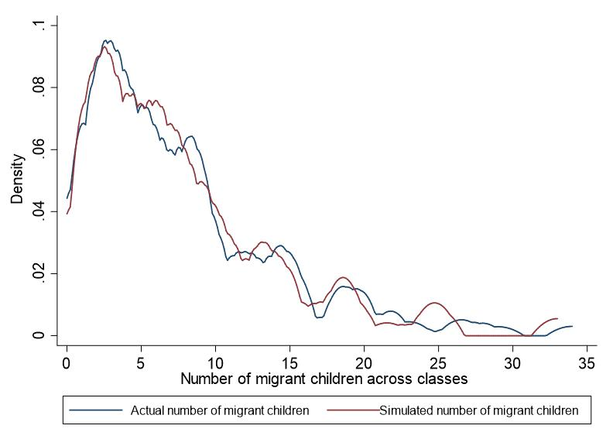
Fig. S1. Kernel density of the actual and simulated number of migrant children across classes

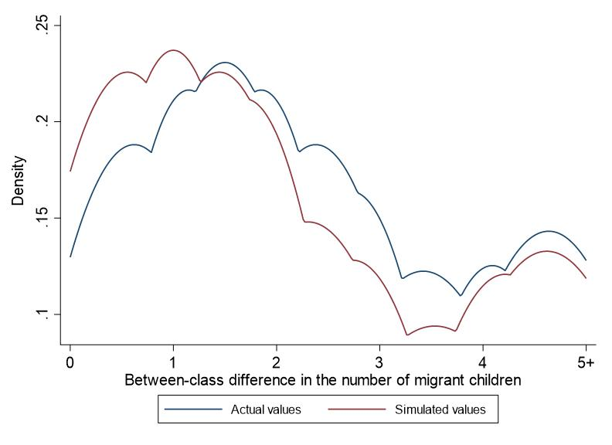
Fig. S2. Kernel density of actual and simulated between-class differences in the number of migrant children

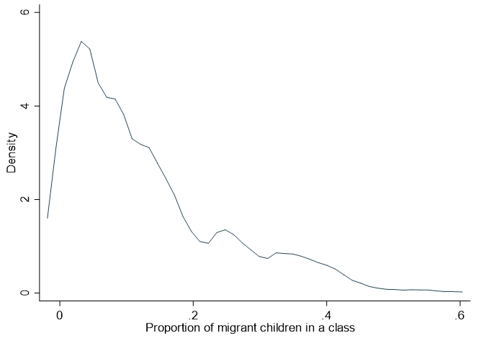
Fig. S3. Kernel distribution of the proportion of migrant children in a class

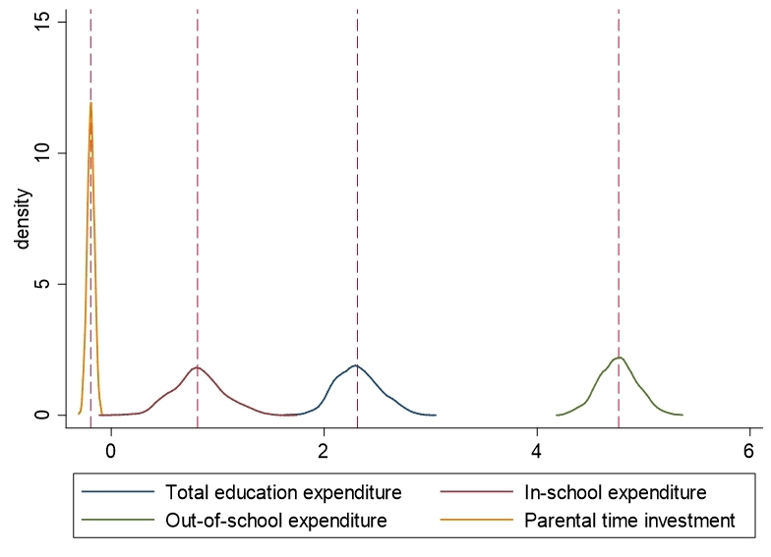
Fig. S4. Kernel distribution of the Beta for effects of migrant children on household human capital investments in local students in urban China

The manual of sampling design (written in Chinese) of the CEPS can be retrieved at: http://ceps.ruc.edu.cn/__local/B/2F/1C/3EB9F842184845AC685C3A250FF_870BE0DA_56B46.pdf?e=.pdf. For more information, please visit the CEPS website: http://ceps.ruc.edu.cn/English/Home.htm.
Sampling Frame 1: All 2,870 county-level administrative units in the entire country. From this frame, 15 districts (counties) are selected as the core samples. Sampling Frame 2: The 18 districts (counties) under Shanghai municipality. In order to fully reflect the unique characteristics of the mega-city Shanghai, this survey treats the 18 districts as a separate sampling frame. From this frame, 3 districts (counties) are selected as supplementary samples. Sampling Frame 3: The 120 districts (counties) nationwide with a significant number of migrant populations. In order to include more migrant children and children of migrant workers in the sample and thus better reflect the impact of the special characteristics of migrant populations on the educational process and educational inequalities, this survey selects 10 districts (counties) from the 120 districts (counties) with a large migrant population as supplementary samples.

