The sweet burden: does homeownership improve the economic status of households?
Manyi Luo, Shihu Zhong^{2,3,}* & Jie Chen⁴

Appendix A1: Common support test.
Efficiency of propensity score matching depends on the quality of matching results. If the matching quality is low, the results obtained from propensity score matching would also be inefficient. Therefore, it is necessary to test the efficiency of models. In empirical tests, matching results are considered valid when the matching process meets ‘common support condition’ and ‘balancing condition’. ‘Common support condition’ means that individuals from the treated group and the control group are comparable, and propensity score density distribution of both groups can be observed. Table 4 reveals that the vast majority of individuals from both groups are within the common support range during matching process, showcasing that ‘common support’ is met.

Table A1 Common support test.
 | Non-common value | Common value
Control group | 17 | 12,079
Treated group | 0 | 1,288

Appendix A2: Mean value tests on matching quality.
‘Balancing condition’ means that the distribution of control variables in the treated group and control group should be similar after matching, that is, treatment effects (home ownership in this study) is unrelated to observable individual characteristics. To examine whether the matching procedure meets ‘balancing condition’, this study tests the difference of control variables among the treated group and the control group after and before matching. Table 5 presents the mean value of control variables from the treated group and the control group. It is shown that the mean value difference of control variables between the treated group and control group substantially decreases after matching through nearest neighbor, radius, and kernel approaches. All mean value differences are insignificant after matching. Therefore, we basically demonstrate the results from propensity score matching meet ‘balancing condition’.

Table A2 Mean value tests on matching quality.
Panel A |  | Nearest neighbor matching
 |  | Treated group | Control group | t value | p>|t|
Married | Before matching | 0.859 | 0.886 | -2.940 | 0.003
 | After matching | 0.859 | 0.878 | -1.450 | 0.147
Age | Before matching | 46.789 | 47.660 | -2.210 | 0.027
 | After matching | 46.789 | 46.450 | 0.640 | 0.523
Female | Before matching | 0.540 | 0.541 | -0.120 | 0.905
 | After matching | 0.540 | 0.533 | 0.340 | 0.736
Urban hukou | Before matching | 0.677 | 0.565 | 7.730 | 0.000
 | After matching | 0.677 | 0.674 | 0.180 | 0.860
Member of the Communist Party of China | Before matching | 0.086 | 0.105 | -2.080 | 0.037
 | After matching | 0.086 | 0.076 | 0.980 | 0.327
Middle school | Before matching | 0.372 | 0.321 | 3.720 | 0.000
 | After matching | 0.372 | 0.365 | 0.360 | 0.722
High school | Before matching | 0.240 | 0.204 | 2.980 | 0.003
 | After matching | 0.240 | 0.253 | -0.780 | 0.436
University | Before matching | 0.115 | 0.123 | -0.890 | 0.375
 | After matching | 0.115 | 0.108 | 0.560 | 0.578
Panel B |  | Radius matching
 |  | Treated group | Control group | t value | p>|t|
Married | Before matching | 0.859 | 0.886 | -2.940 | 0.003
 | After matching | 0.859 | 0.887 | -2.170 | 0.030
Age | Before matching | 46.789 | 47.660 | -2.210 | 0.027
 | After matching | 46.789 | 47.421 | -1.190 | 0.236
Female | Before matching | 0.540 | 0.541 | -0.120 | 0.905
 | After matching | 0.540 | 0.538 | 0.060 | 0.953
Urban hukou | Before matching | 0.677 | 0.565 | 7.730 | 0.000
 | After matching | 0.677 | 0.622 | 2.930 | 0.003
Member of the Communist Part of China | Before matching | 0.086 | 0.105 | -2.080 | 0.037
 | After matching | 0.086 | 0.103 | -1.430 | 0.154
Middle school | Before matching | 0.372 | 0.321 | 3.720 | 0.000
 | After matching | 0.372 | 0.344 | 1.460 | 0.145
High school | Before matching | 0.240 | 0.204 | 2.980 | 0.003
 | After matching | 0.240 | 0.219 | 1.260 | 0.209
University | Before matching | 0.115 | 0.123 | -0.890 | 0.375
 | After matching | 0.115 | 0.134 | -1.440 | 0.151
Panel C |  | Kernel matching
 |  | Treated group | Control group | t value | p>|t|
Married | Before matching | 0.859 | 0.886 | -2.940 | 0.003
 | After matching | 0.859 | 0.888 | -2.210 | 0.028
Age | Before matching | 46.789 | 47.660 | -2.210 | 0.027
 | After matching | 46.789 | 47.455 | -1.250 | 0.211
Female | Before matching | 0.540 | 0.541 | -0.120 | 0.905
 | After matching | 0.540 | 0.539 | 0.020 | 0.987
Urban hukou | Before matching | 0.677 | 0.565 | 7.730 | 0.000
 | After matching | 0.677 | 0.632 | 2.400 | 0.016
Member of the Communist Party of China | Before matching | 0.086 | 0.105 | -2.080 | 0.037
 | After matching | 0.086 | 0.100 | -1.230 | 0.217
Middle school | Before matching | 0.372 | 0.321 | 3.720 | 0.000
 | After matching | 0.372 | 0.340 | 1.690 | 0.091
High school | Before matching | 0.240 | 0.204 | 2.980 | 0.003
 | After matching | 0.240 | 0.224 | 0.960 | 0.336
University | Before matching | 0.115 | 0.123 | -0.890 | 0.375
 | After matching | 0.115 | 0.132 | -1.330 | 0.182

Appendix A3: Calculating the standardized bias of control variable.
Comparing the mean value difference of control variables in the treated group and the control group is an intuitive test approach. But direct mean value difference exerts huge impacts on econometric unit. To eliminate the impacts of variables’ econometric unit on difference comparison results, this study calculates the standardized bias of control variables before and after matching. Matching approaches include nearest neighbor matching, radius matching, and kernel matching. Fig. A1-A3 reports the standardized bias of control variables before and after nearest neighbor matching, radius matching, and kernel matching respectively. It is shown that nearly all standardized bias of control variables decreases significantly after matching and some even approach zero, demonstrating a satisfactory degree of balance on data through matching.
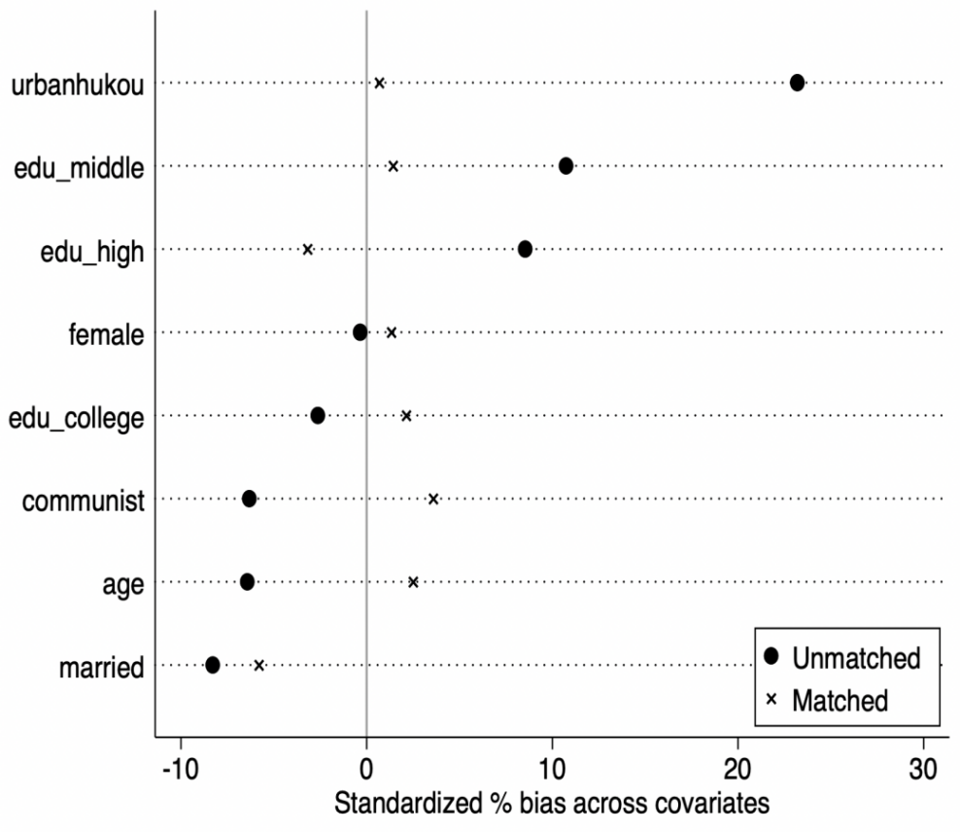
Fig. A1 Standardized bias of covariates before and after nearest neighbor matching
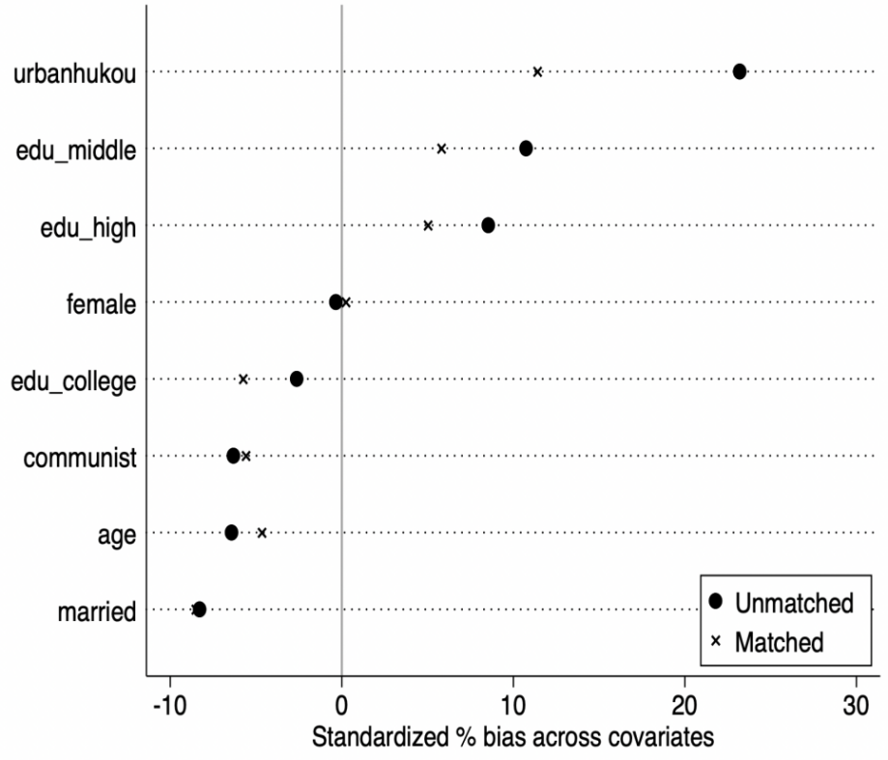
Fig. A2 Standardized bias of covariates before and after radius matching

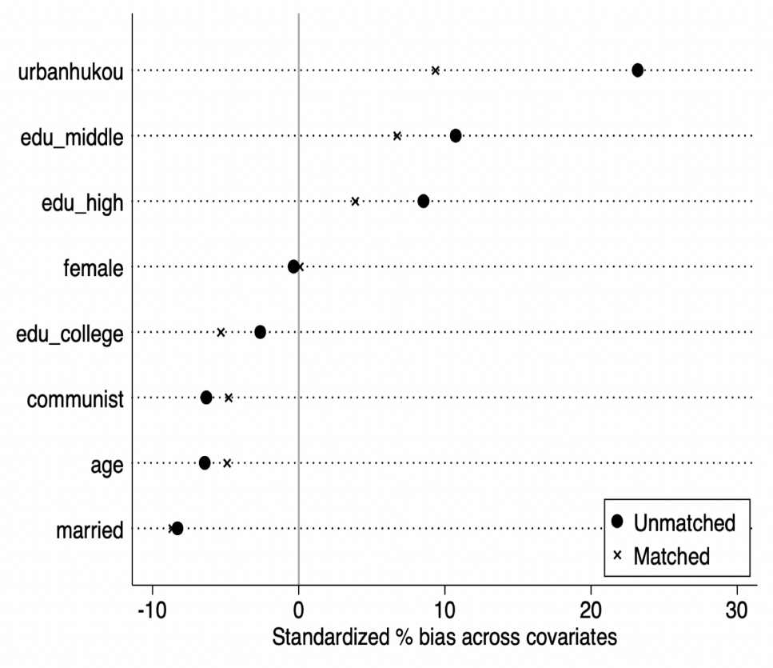
Fig. A3 Standardized bias of covariates before and after kernel matching

¹ College of Economics and Trade, Hunan University of Technology and Business, Changsha, China. ²Shanghai National Accounting Institute, Shanghai, China. *email: zhongshihu@163.sufe.edu.cn (S.Z.). ³Antai College of Economics and Management, Shanghai Jiao Tong University, Shanghai 200030, China. ⁴School of International and Public Affairs & Center for Housing and Urban–Rural Development, Shanghai Jiao Tong University, Shanghai, China. Shihu Zhong: https://orcid.org/0000-0001-6100-1750; Jie Chen http://orcid.org/0000-0002-9254-4413

