Table S1. Survey Instrument
Code | Items
EC1 | I am extremely concerned about the state of the world’s environment and what this will mean for my future.
EC2 | If all of us individually contributed to environmental protection, it would have a significant effect.
EC3 | Everyone is responsible for protecting the environment in their everyday life.
EC4 | Preserving and protecting the environment should be one of our priorities.
EC5 | We should take responsibility for environmental issues, as we are the cause of environmental damage.
EV1 | I consider the potential environmental impact of my actions when making many of my decisions.
EV2 | I would describe myself as environmentally responsible.
EV3 | I am willing to take actions that are more environmentally friendly.
EV4 | Regardless of what other people do, because of my own values/principles, I feel that I should behave in an environmentally friendly way.
EV5 | I feel that it is important to be environmentally friendly, reducing the harm to community and its environment.
HC1 | I’m very self-conscious about my health.
HC2 | I chose food carefully to ensure good health.
HC3 | I’m alert to changes in my health.
HC4 | I’m constantly examining my health.
HC5 | I take responsibility for the state of my health.
VP1 | Organic food offer value for money.
VP2 | Organic food has consistent quality.
VP3 | Buying organic food would make a good impression on other people.
VP4 | Organic food is something that I would enjoy.
VP5 | Buying organic food instead of conventional food would feel like making a personal contribution to something better.
PS1 | I value the price of organic food.
PS2 | I used to collect a lot of price-related information to have the best buy.
PS3 | I always compare prices before making the organic food purchase.
PS4 | It is worth to move in different stores to have control over price.
PS5 | I commonly detect every fluctuation in organic food prices.
GP1 | Through campaigns and the promotion of organic food, I became aware of the health benefits of organic food.
GP2 | Through campaigns and the promotion of organic food, I became aware of the environmental performance of organic food.
GP3 | I tend to pay attention to campaigns focused on a healthy lifestyle.
GP4 | I tend to pay attention to advertising messages about organic food in public.
GP5 | Green customers’ recommendations are probable to boost me to change my decision making.
AOF1 | I feel that organic food’s environmental reputation is generally reliable.
AOF2 | I feel that organic food’s environmental performance is generally dependable.
AOF3 | I feel that organic food’s environmental claims are generally trustworthy.
AOF4 | Organic food’s environmental concern meets my expectations.
AOF5 | Organic food’s keep promises and responsibilities for environmental protection.
IOF1 | I will consume organic food in the near future.
IOF2 | I plan to consume organic food on a regular basis.
IOF3 | I intend to buy organic food for my long term health benefits.
IOF4 | I intend to buy organic food because I am more concerned about food safety.
IOF5 | I intend to buy organic food because they are more environmentally friendly.
GPB1 | By choosing organic food, I have the feeling of contributing to the well-being of humanity and nature.
GPB2 | Choosing organic food can make me feel better because I don't harm the environment.
GPB3 | Choosing organic food can express my environmental concern.
GPB4 | Choosing organic food can demonstrate to myself and my friends that I care about environmental conservation.
GPB5 | Choosing organic food can make me feel closer to nature.
WPOF1 | It is acceptable for me to pay more money for organic food in an environmentally friendly way.
WPOF2 | I feel proud to have organic food in my house, though they are more costly than conventional food.
WPOF3 | I would be willing to spend more money in order to buy less environmentally harmful food.
WPOF4 | To me, it deserves to consume organic food despite their premium pricing.
WPOF5 | I am willing to buy organic food at a higher price for their environmental benefits.
Note: Environmental Concern (EC); Environmental Values (EV); Health Consciousness (HC); Value Perception (VP); Price Sensitivity (PS); Green Promotion (GP); Attitude towards Organic Food (AOF); Intention to Consume Organic Food (IOF); Green Psychological Benefits (GPB); Willingness to pay premium price for Organic Food (WPOF).
Source: Author's data analysis

Table S2. Demographic Details
 | N | Percent |  | N | Percent
Gender |  |  | Occupation
Male | 212 | 47 | Employed Full-Time | 209 | 46.3
Female | 239 | 53 | Employed Part-Time | 134 | 29.7
Total | 451 | 100 | Seeking opportunities | 47 | 10.4
 |  |  | Student | 61 | 13.5
Age |  |  | Total | 451 | 100
18-20 | 22 | 4.9
21-25 | 168 | 37.3 | Monthly food expenditure (RMB)
26-30 | 210 | 46.6 | ≤ 1000 | 76 | 16.9
31-35 | 51 | 11.3 | 1001-2000 | 147 | 32.6
Total | 451 | 100 | 2001-3000 | 146 | 32.4
 |  |  | 3001-4000 | 56 | 12.4
Marital status |  |  | > 4000 | 26 | 5.8
Single | 111 | 24.6 | Total | 451 | 100
Married | 300 | 66.5
Divorced | 24 | 5.3 | Weight
Widowed | 16 | 3.5 | Obese | 107 | 23.7
Total | 451 | 100 | Very overweight | 161 | 35.7
 |  |  | Slightly overweight | 96 | 21.3
Education background |  |  | Healthy weight range | 87 | 19.3
College and below | 115 | 25.5 | Total | 451 | 100
Bachelor degree | 237 | 52.5
Master degree or above | 87 | 19.3 | Perceived physically fitness
Doctoral degree and above | 12 | 2.7 | Fit | 357 | 79.2
Total | 451 | 100 | Unfit | 94 | 20.8
 |  |  | Total | 451 | 100
Monthly income (RMB)
≤ 3000 | 94 | 20.8 | Frequency of exercise per week
3001-6000 | 159 | 35.3 | Never or Rarely | 86 | 19.1
6001-9000 | 115 | 25.5 | 1-2 days | 240 | 53.2
9001-12000 | 61 | 13.5 | 3-5 days | 110 | 24.4
12001-15000 | 14 | 3.1 | More than 5 days | 15 | 3.3
> 15000 | 8 | 1.8 | Total | 451 | 100
Total | 451 | 100
Note: RMB (Chinese Currency): 1RMB = 0.14USD

Table S3. Full Collinearity Test
Variables | EC | EV | HC | VP | PS | GP | AOF | IOF | GPB | WPOF
VIF | 1.405 | 1.498 | 1.391 | 1.678 | 1.443 | 1.867 | 1.582 | 1.570 | 1.563 | 2.399
Note: Environmental Concern (EC); Environmental Values (EV); Health Consciousness (HC); Value Perception (VP); Price Sensitivity (PS); Green Promotion (GP); Attitude towards Organic Food (AOF); Intention to Consume Organic Food (IOF); Green Psychological Benefits (GPB); Willingness to pay premium price for Organic Food (WPOF).
Source: Author's data analysis

Table S4. Collinearity Statistics
 | AOF | IOF | WPOF
EC | 1.388 | 1.398 | -
EV | 1.443 | 1.476 | -
HC | 1.359 | 1.365 | -
VP | 1.461 | 1.516 | -
PS | 1.411 | 1.423 | -
GP | 1.630 | 1.704 | -
AOF | - | 1.548 | 1.288
IOF | - | - | 1.261
GPB | 1.491 | 1.496 | 1.228
WPOF | - | - | -
Note: Environmental Concern (EC); Environmental Values (EV); Health Consciousness (HC); Value Perception (VP); Price Sensitivity (PS); Green Promotion (GP); Attitude towards Organic Food (AOF); Intention to Consume Organic Food (IOF); Green Psychological Benefits (GPB); Willingness to pay premium price for Organic Food (WPOF).
Source: Author's data analysis

Table S5. Discriminant Validity
 | EC | EV | HC | VP | PS | GP | AOF | IOF | GPB | WPOF
Fornell-Larcker Criterion
EC | 0.849
EV | 0.380 | 0.861
HC | 0.375 | 0.333 | 0.820
VP | 0.352 | 0.364 | 0.347 | 0.846
PS | 0.357 | 0.341 | 0.353 | 0.415 | 0.810
GP | 0.397 | 0.453 | 0.388 | 0.445 | 0.397 | 0.854
AOF | 0.363 | 0.417 | 0.342 | 0.446 | 0.374 | 0.484 | 0.840
IOF | 0.322 | 0.302 | 0.378 | 0.465 | 0.396 | 0.431 | 0.402 | 0.849
GPB | 0.348 | 0.412 | 0.360 | 0.398 | 0.383 | 0.465 | 0.373 | 0.348 | 0.865
WPOF | 0.433 | 0.475 | 0.414 | 0.572 | 0.445 | 0.614 | 0.512 | 0.529 | 0.533 | 0.874
Heterotrait-monotrait ratio (HTMT)
EC | -
EV | 0.418 | -
HC | 0.421 | 0.372 | -
VP | 0.387 | 0.401 | 0.385 | -
PS | 0.404 | 0.385 | 0.401 | 0.461 | -
GP | 0.436 | 0.497 | 0.433 | 0.490 | 0.445 | -
AOF | 0.400 | 0.461 | 0.384 | 0.494 | 0.419 | 0.534 | -
IOF | 0.354 | 0.331 | 0.419 | 0.514 | 0.440 | 0.473 | 0.445 | -
GPB | 0.379 | 0.452 | 0.399 | 0.436 | 0.424 | 0.510 | 0.411 | 0.381 | -
WPOF | 0.470 | 0.518 | 0.455 | 0.626 | 0.490 | 0.671 | 0.562 | 0.578 | 0.579 | -
Note: Environmental Concern (EC); Environmental Values (EV); Health Consciousness (HC); Value Perception (VP); Price Sensitivity (PS); Green Promotion (GP); Attitude towards Organic Food (AOF); Intention to Consume Organic Food (IOF); Green Psychological Benefits (GPB); Willingness to pay premium price for Organic Food (WPOF).
Source: Author's data analysis

Table S6. Loading and Cross Loadings
 | EC | EV | HC | VP | PS | GP | AOF | IOF | GPB | WPOF
EC1 | 0.839 | 0.326 | 0.351 | 0.353 | 0.372 | 0.394 | 0.339 | 0.303 | 0.343 | 0.462
EC2 | 0.856 | 0.339 | 0.336 | 0.258 | 0.273 | 0.348 | 0.303 | 0.234 | 0.274 | 0.340
EC3 | 0.841 | 0.314 | 0.275 | 0.260 | 0.292 | 0.333 | 0.275 | 0.250 | 0.246 | 0.321
EC4 | 0.851 | 0.321 | 0.258 | 0.282 | 0.275 | 0.289 | 0.316 | 0.277 | 0.304 | 0.327
EC5 | 0.859 | 0.313 | 0.367 | 0.328 | 0.293 | 0.319 | 0.300 | 0.295 | 0.301 | 0.373
EV1 | 0.320 | 0.872 | 0.298 | 0.364 | 0.298 | 0.377 | 0.371 | 0.285 | 0.350 | 0.423
EV2 | 0.343 | 0.860 | 0.286 | 0.292 | 0.312 | 0.436 | 0.380 | 0.240 | 0.381 | 0.440
EV3 | 0.323 | 0.850 | 0.318 | 0.315 | 0.304 | 0.391 | 0.350 | 0.253 | 0.361 | 0.381
EV4 | 0.308 | 0.848 | 0.251 | 0.284 | 0.270 | 0.376 | 0.322 | 0.258 | 0.364 | 0.410
EV5 | 0.341 | 0.872 | 0.276 | 0.309 | 0.285 | 0.368 | 0.366 | 0.263 | 0.318 | 0.390
HC1 | 0.376 | 0.301 | 0.802 | 0.239 | 0.334 | 0.293 | 0.304 | 0.264 | 0.268 | 0.286
HC2 | 0.314 | 0.242 | 0.847 | 0.273 | 0.258 | 0.319 | 0.246 | 0.321 | 0.293 | 0.311
HC3 | 0.301 | 0.300 | 0.859 | 0.284 | 0.283 | 0.288 | 0.281 | 0.271 | 0.286 | 0.292
HC4 | 0.221 | 0.223 | 0.752 | 0.352 | 0.248 | 0.342 | 0.274 | 0.365 | 0.291 | 0.415
HC5 | 0.332 | 0.301 | 0.837 | 0.264 | 0.323 | 0.340 | 0.292 | 0.314 | 0.332 | 0.373
VP1 | 0.355 | 0.325 | 0.291 | 0.834 | 0.350 | 0.380 | 0.387 | 0.342 | 0.327 | 0.425
VP2 | 0.345 | 0.338 | 0.331 | 0.865 | 0.367 | 0.422 | 0.429 | 0.402 | 0.382 | 0.513
VP3 | 0.286 | 0.275 | 0.303 | 0.834 | 0.353 | 0.345 | 0.356 | 0.410 | 0.324 | 0.498
VP4 | 0.222 | 0.276 | 0.313 | 0.856 | 0.374 | 0.401 | 0.371 | 0.424 | 0.341 | 0.504
VP5 | 0.283 | 0.328 | 0.224 | 0.842 | 0.308 | 0.330 | 0.340 | 0.385 | 0.305 | 0.477
PS1 | 0.346 | 0.269 | 0.263 | 0.299 | 0.774 | 0.331 | 0.324 | 0.235 | 0.273 | 0.320
PS2 | 0.287 | 0.320 | 0.299 | 0.287 | 0.814 | 0.310 | 0.313 | 0.296 | 0.304 | 0.330
PS3 | 0.303 | 0.284 | 0.237 | 0.300 | 0.805 | 0.280 | 0.246 | 0.295 | 0.257 | 0.307
PS4 | 0.275 | 0.269 | 0.323 | 0.347 | 0.838 | 0.341 | 0.272 | 0.376 | 0.353 | 0.387
PS5 | 0.252 | 0.249 | 0.298 | 0.425 | 0.818 | 0.341 | 0.351 | 0.380 | 0.349 | 0.436
GP1 | 0.330 | 0.404 | 0.360 | 0.399 | 0.321 | 0.864 | 0.413 | 0.369 | 0.403 | 0.527
GP2 | 0.402 | 0.397 | 0.342 | 0.398 | 0.350 | 0.876 | 0.460 | 0.406 | 0.395 | 0.547
GP3 | 0.344 | 0.403 | 0.367 | 0.380 | 0.354 | 0.837 | 0.388 | 0.342 | 0.403 | 0.511
GP4 | 0.300 | 0.402 | 0.286 | 0.369 | 0.329 | 0.841 | 0.403 | 0.373 | 0.367 | 0.524
GP5 | 0.314 | 0.325 | 0.304 | 0.352 | 0.342 | 0.850 | 0.398 | 0.345 | 0.418 | 0.513
AOF1 | 0.340 | 0.351 | 0.307 | 0.411 | 0.320 | 0.416 | 0.845 | 0.347 | 0.312 | 0.473
AOF2 | 0.273 | 0.375 | 0.281 | 0.306 | 0.272 | 0.387 | 0.830 | 0.323 | 0.320 | 0.405
AOF3 | 0.307 | 0.335 | 0.248 | 0.382 | 0.280 | 0.344 | 0.836 | 0.326 | 0.302 | 0.411
AOF4 | 0.310 | 0.315 | 0.284 | 0.414 | 0.346 | 0.435 | 0.846 | 0.342 | 0.331 | 0.450
AOF5 | 0.292 | 0.377 | 0.312 | 0.356 | 0.348 | 0.448 | 0.845 | 0.349 | 0.302 | 0.407
IOF1 | 0.274 | 0.252 | 0.354 | 0.403 | 0.349 | 0.373 | 0.362 | 0.860 | 0.329 | 0.459
IOF2 | 0.231 | 0.237 | 0.286 | 0.416 | 0.363 | 0.355 | 0.335 | 0.850 | 0.260 | 0.455
IOF3 | 0.262 | 0.225 | 0.281 | 0.382 | 0.311 | 0.352 | 0.325 | 0.840 | 0.281 | 0.407
IOF4 | 0.318 | 0.257 | 0.315 | 0.390 | 0.320 | 0.335 | 0.319 | 0.845 | 0.304 | 0.434
IOF5 | 0.283 | 0.307 | 0.361 | 0.381 | 0.336 | 0.409 | 0.362 | 0.850 | 0.302 | 0.487
GPB1 | 0.294 | 0.399 | 0.287 | 0.325 | 0.324 | 0.412 | 0.297 | 0.278 | 0.874 | 0.449
GPB2 | 0.276 | 0.334 | 0.263 | 0.306 | 0.321 | 0.362 | 0.342 | 0.281 | 0.852 | 0.433
GPB3 | 0.324 | 0.352 | 0.346 | 0.357 | 0.361 | 0.375 | 0.308 | 0.306 | 0.879 | 0.484
GPB4 | 0.285 | 0.339 | 0.315 | 0.385 | 0.320 | 0.420 | 0.359 | 0.325 | 0.865 | 0.470
GPB5 | 0.326 | 0.361 | 0.343 | 0.345 | 0.332 | 0.440 | 0.306 | 0.313 | 0.857 | 0.470
WPOF3 | 0.383 | 0.423 | 0.366 | 0.519 | 0.417 | 0.521 | 0.410 | 0.476 | 0.479 | 0.868
WPOF4 | 0.390 | 0.405 | 0.381 | 0.522 | 0.410 | 0.583 | 0.431 | 0.470 | 0.470 | 0.877
WPOF5 | 0.394 | 0.409 | 0.363 | 0.436 | 0.350 | 0.516 | 0.453 | 0.441 | 0.450 | 0.870
Note: Environmental Concern (EC); Environmental Values (EV); Health Consciousness (HC); Value Perception (VP); Price Sensitivity (PS); Green Promotion (GP); Attitude towards Organic Food (AOF); Intention to Consume Organic Food (IOF); Green Psychological Benefits (GPB); Willingness to pay premium price for Organic Food (WPOF).
Source: Author's data analysis

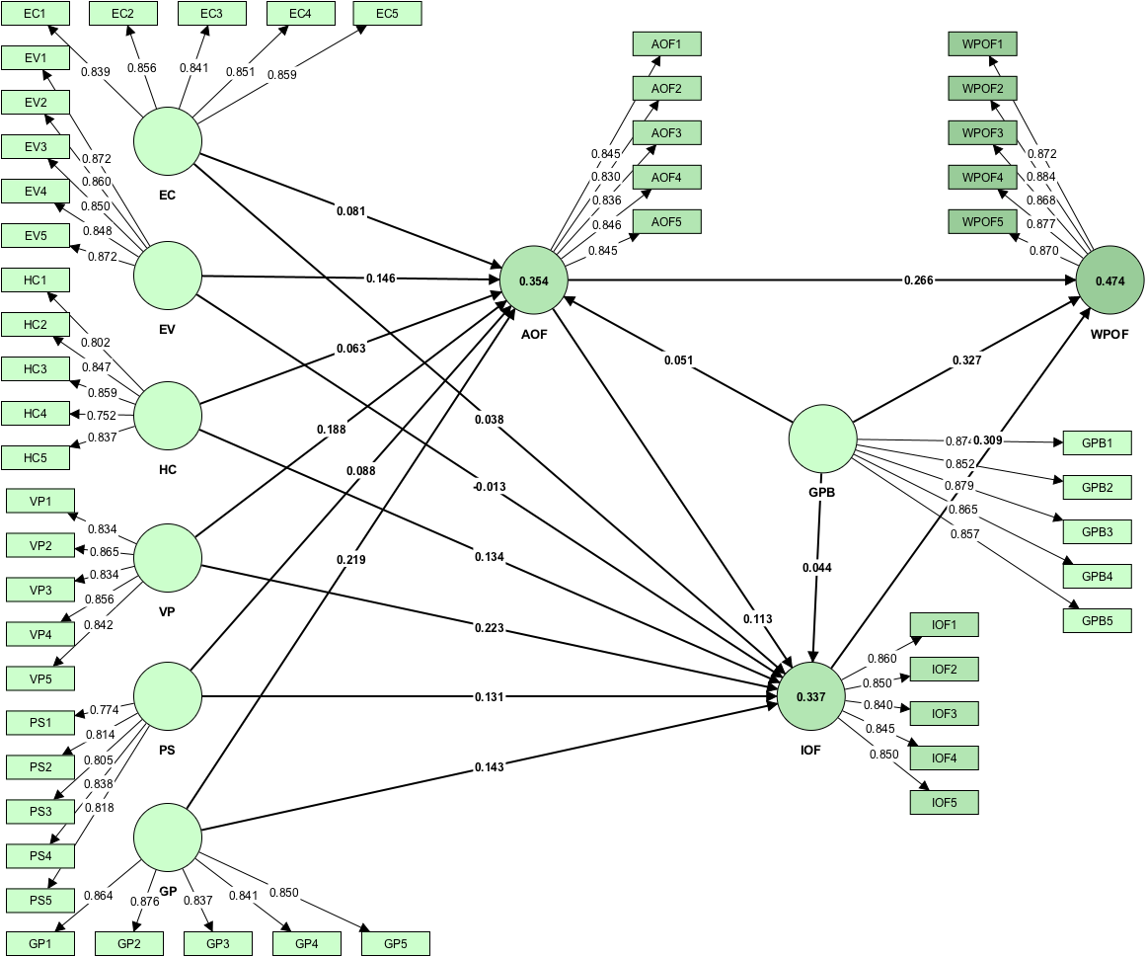

Fig. S1. Measurement Model

