Supplementary Information

Interpretable AI-driven causal inference uncovers the time-varying effects of PM_{2.5} and public health interventions on COVID-19 infection rates

Yang Han¹, Jacqueline CK Lam^{1, *}, Victor OK Li^{1, *}, and Jon Crowcroft²

¹Department of Electrical and Electronic Engineering, The University of Hong Kong, Hong Kong.
²Department of Computer Science and Technology, The University of Cambridge, Cambridge, UK.
*Corresponding authors. Emails: jcklam@eee.hku.hk; vli@eee.hku.hk

1. Baseline Selection
Stepwise ordinary least squares (OLS) regression adopted a two-stage procedure (forward and backward regression) that performed stepwise variable selection based on p-value (p < 0.05) (Han et al., 2021).
Panel OLS regression included random-effects and fixed-effects regression models for the panel data analysis (Yan et al., 2021). The fixed-effects model assumed that the LTLA-specific effects were correlated with the covariates, while the random-effects model assumed no correlation (dependence). The model selection (i.e., whether the random-effects or the fixed-effects model was used) was determined based on Hausman’s test (Baltagi and Liu, 2016). Demographic and comorbidity variables were excluded, given that those fixed effects were already addressed in the model.
Double lasso adopted a three-stage feature selection procedure using lasso (i.e., based on zero vs. non-zero coefficients) to further reduce confounding biases when estimating the causal effects (Torrats-Espinosa, 2021).
Linear Granger causality identified a causal graph using a Granger causality-based model that best fitted the corresponding time-series data for each LTLA (Shojaie and Michailidis, 2010). A final causal graph was constructed using a stability selection procedure that selected edges only when the probability of edge occurrence across all graphs was larger than 0.5 (Belyaeva et al., 2021).
Peter-Clark (PC) algorithm, a constraint-based model, identified a causal graph based on the conditional independence relationships inferred from the data (Spirtes et al., 2000). Fisher’s Z conditional independence test was adopted. Prior knowledge could correct the identified edges during constraint-based graph searching. The same prior knowledge used in the proposed model was incorporated.
Greedy equivalence search (GES), a score-based graph model, identified an optimal causal graph that best fitted the data using a score function (Chickering, 2002). The Bayesian Information Criterion (BIC) score function was adopted.
Greedy sparsest permutation (GSP), a permutation-based model, identified a sparse causal graph from every ordering of the variables (Lam et al., 2022). The BIC score function was adopted.
Linear non-Gaussian acyclic model (LiNGAM), a constraint-based functional model, identified the causal orderings of variables using a linear non-Gaussian acyclic model (a variant of structural equation model (SEM)) (Shimizu et al., 2011). The same prior knowledge used in the proposed model was incorporated into the model.
Causal GNN, the original causal GNN model, identified a causal graph structure based on time-series data (Löwe et al., 2022). The causal GNN model adopted the same hyperparameters and utilized the same encoder and decoder models in the proposed encoder-decoder framework, except that the decoder (RNN) did not account for the time-varying causal structure. No regularization was used in the causal GNN model.

Table S1.Variable definition
Variable Name | Description | Unit
Dependent Variable
COVID-19 Infection Rate | Confirmed COVID-19 cases per 100,000 population | NA
Independent Variables
COVID-19 Tests | COVID-19 tests (PCR and LFD) per 100,000 population | NA
COVID-19 Vaccination (First Dose) | First doses per 100,000 population | NA
COVID-19 Vaccination (Second Dose) | Second doses per 100,000 population | NA
COVID-19 Vaccination (Third Injection) | Third doses and booster doses per 100,000 population | NA
Short-term PM_{2.5} | Short-term outdoor PM_{2.5} concentration | ug/m³
Short-term PM₁₀ | Short-term outdoor PM₁₀ concentration | ug/m³
Short-term NO₂ | Short-term outdoor NO₂ concentration | ug/m³
Short-term O₃ | Short-term outdoor O₃ concentration | ug/m³
Long-term PM_{2.5} | Long-term outdoor PM_{2.5} concentration pre-pandemic | ug/m³
Long-term PM₁₀ | Long-term outdoor PM₁₀ concentration pre-pandemic | ug/m³
Long-term NO₂ | Long-term outdoor NO₂ concentration pre-pandemic | ug/m³
Long-term O₃ | Long-term outdoor O₃ concentration pre-pandemic | ug/m³
Temperature | Air temperature | deg C
Relative Humidity | Calculated relative humidity | %
Pressure | Mean sea level air pressure | hPa
Wind Speed | Wind speed | knot
Visibility | Visibility | dam
Sunshine | Sunshine duration | hour
Cloud Amount | Total cloud amount | okta
Precipitation | Precipitation amount | mm
UV Index | Ultraviolet radiation index | NA
Mobility (Retail & Recreation) | % change in retail and recreation from baseline | %
Mobility (Grocery & Pharmacy) | % change in grocery and pharmacy from baseline | %
Mobility (Parks) | % change in parks from baseline | %
Mobility (Transit Stations) | % change in transit stations from baseline | %
Mobility (Workplaces) | % change in workplaces from baseline | %
Mobility (Residential) | % change in residential from baseline | %
School Closure | 0: no measures, 1: recommend closure, 2: require closure for some categories, and 3: require closure | NA
Workplace Closure | 0: no measures, 1: recommend closure, 2: require closure for some categories, and 3: require closure | NA
Public Events Cancellation | 0: no measures, 1: recommend canceling, and 2: require canceling | NA
Gatherings Restrictions | 0: no restrictions, 1: restrictions on very large gatherings (> 1,000 people), 2: restrictions on gatherings between 101-1,000 people, 3: restrictions on gatherings between 11-100 people, and 4: restrictions on gatherings of 10 people or less | NA
Public Transport Closure | 0: no measures, 1: recommend closure, and 2: require closure | NA
Stay-at-home Requirements | 0: no measures, 1: recommend, 2: require with exceptions, and 3: require with minimal exceptions | NA
Internal Movement Restrictions | 0: no measures, 1: recommend restrictions, and 2: require restrictions | NA
International Travel Controls | 0: no measures, 1: screening arrivals, 2: quarantine arrivals, 3: ban arrivals from some regions, and 4: total border closure | NA
Contact Tracing | 0: no contact tracing, 1: limited contact tracing (not done for all cases), and 2: comprehensive contact tracing (done for all cases) | NA
Facial Coverings | 0: no policy, 1: recommend, 2: require in some specific public spaces or some situations when social distancing is impossible, 3: require in all public spaces or all situations when social distancing is impossible, and 4: require at all times | NA
% of Young | % of young people (0-19 years old) | %
% of Older | % of older people (≥ 65 years old) | %
Male/Female Ratio | The ratio of male and female | %
Population Density | Persons per hectare | ha⁻¹
% of Black Population | % of the black population | %
% of White Population | % of the white population | %
% of Low Education | % of the low education population (no qualifications) | %
Asthma Prevalence | Asthma prevalence | %
COPD Prevalence | COPD prevalence | %
Dementia Prevalence | Dementia prevalence | %
Diabetes Prevalence | Diabetes prevalence | %
Hypertension Prevalence | Hypertension prevalence | %
Obesity Prevalence | Obesity prevalence | %
Stroke Prevalence | Stroke prevalence | %
Smoking Prevalence | Smoking prevalence | %
HIV Prevalence | HIV prevalence (per 1,000 population) | %
Number of Available Hospital Beds | The number of available hospital beds | NA

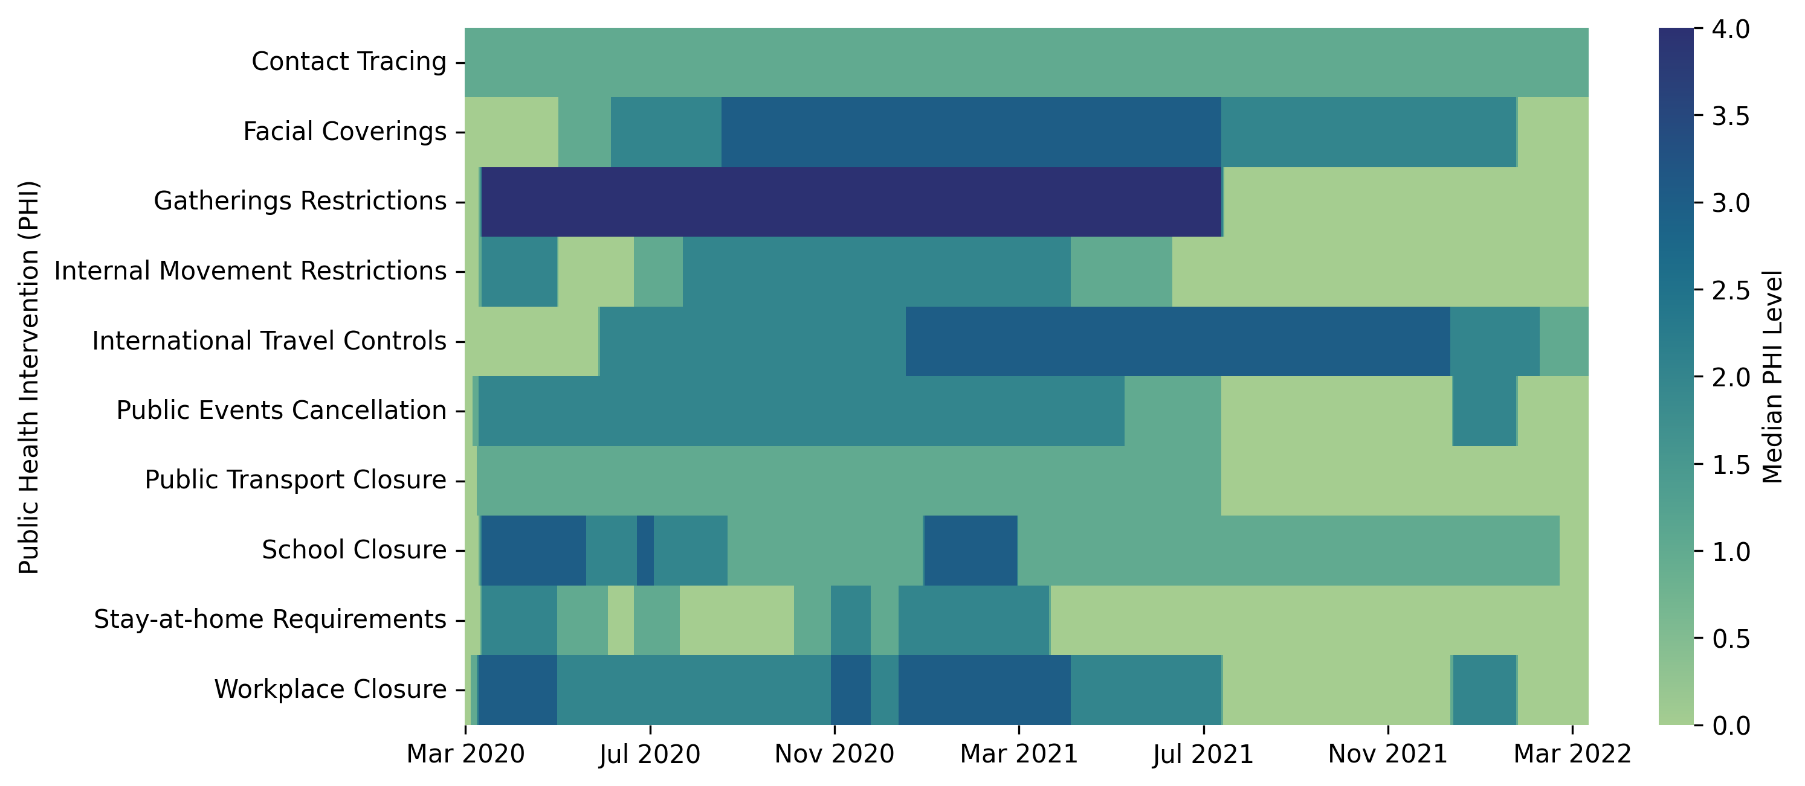
Figure S1. Daily median public health policy intervention level at the country level (including England, Wales, Scotland, and Northern Ireland) in the UK.

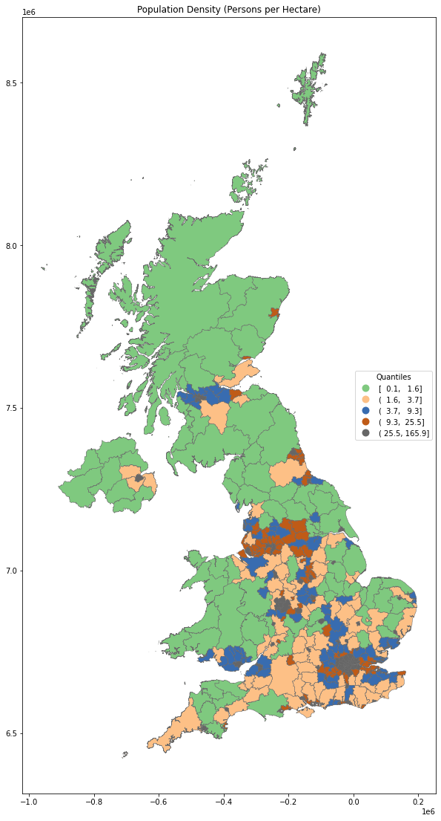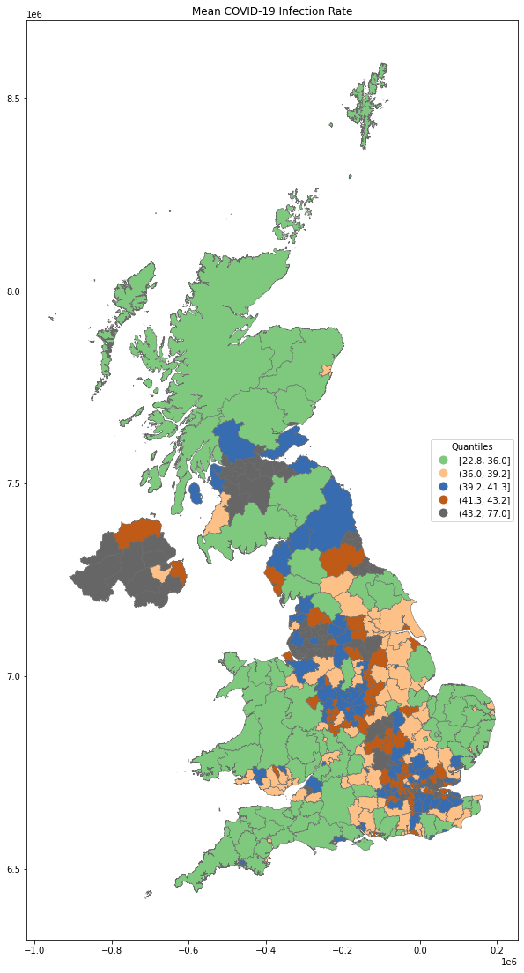
Figure S2. Population density and COVID-19 infection rate at the lower tier local authority (LTLA) level across the UK during the study period. Map visualizations were made using the EPSG:3857 Projected Coordinate System.
References
Baltagi BH, Liu L. (2016). Random effects, fixed effects and Hausman's test for the generalized mixed regressive spatial autoregressive panel data model. Econometric Reviews, 35(4): 638-658.
Belyaeva A, Cammarata L, Radhakrishnan A et al. (2021). Causal network models of SARS-CoV-2 expression and aging to identify candidates for drug repurposing. Nature Communications, 12(1): 1024.
Chickering DM. (2002). Optimal structure identification with greedy search. Journal of Machine Learning Research, 3(Nov): 507-554.
Han Y, Lam JCK, Li VOK et al. (2021). Outdoor PM2.5 concentration and rate of change in COVID-19 infection in provincial capital cities in China. Scientific Reports, 11(1): 23206.
Lam W-Y, Andrews B, Ramsey J. (2022). Greedy relaxations of the sparsest permutation algorithm. Uncertainty in Artificial Intelligence,
Löwe S, Madras D, Zemel R et al. (2022). Amortized causal discovery: Learning to infer causal graphs from time-series data. Conference on Causal Learning and Reasoning,
Shimizu S, Inazumi T, Sogawa Y et al. (2011). DirectLiNGAM: A direct method for learning a linear non-Gaussian structural equation model. Journal of Machine Learning Research, 12(Apr): 1225-1248.
Shojaie A, Michailidis G. (2010). Discovering graphical Granger causality using the truncating lasso penalty. Bioinformatics, 26(18): i517-i523.
Spirtes P, Glymour CN, Scheines R et al. (2000). Causation, prediction, and search. MIT Press. Cambridge, MA
Torrats-Espinosa G. (2021). Using machine learning to estimate the effect of racial segregation on COVID-19 mortality in the United States. Proceedings of the National Academy of Sciences, 118(7): e2015577118.
Yan Y, Malik AA, Bayham J et al. (2021). Measuring voluntary and policy-induced social distancing behavior during the COVID-19 pandemic. Proceedings of the National Academy of Sciences, 118(16): e2008814118.

