Description of Pictures
Picture 1. This drawing depicts a field where children are playing. There is a green slide in the drawing and three girls are jumping rope. There is a purple swing and a black cat in the background of the picture. The picture has a playful atmosphere and reflects a social play environment.
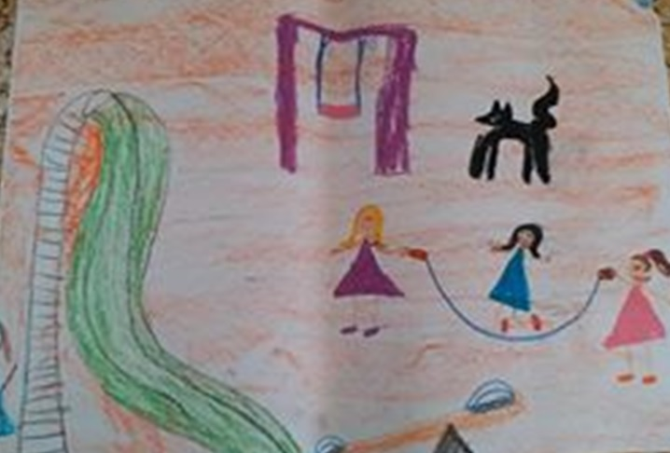
Picture 2. In the picture, there is a big green tree with red fruits. Behind the tree, two big butterflies in blue and yellow are seen flying. A colorful nature is depicted in the picture. Under the tree, two flowers are drawn, the smiling child in the picture reflects the existence of a cheerful and lively environment.
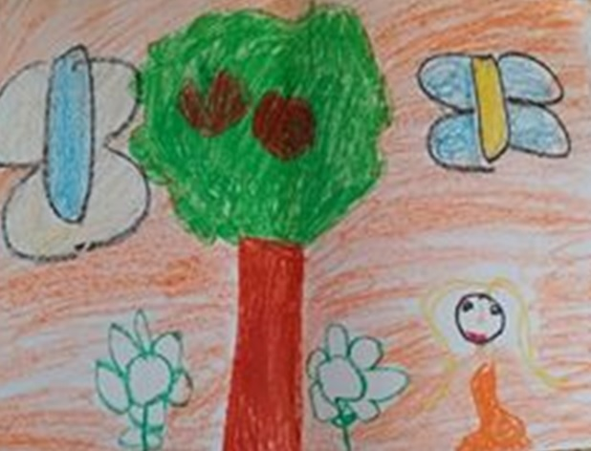

Picture 3. In this drawing, children are seen performing various activities. The playground is visualized in a beautiful environment of nature. A lively space is reflected with details such as a large tree, swing, hopscotch area, butterfly, slide, ladybug, birds and the sun. An energetic and cheerful area is seen in the picture.
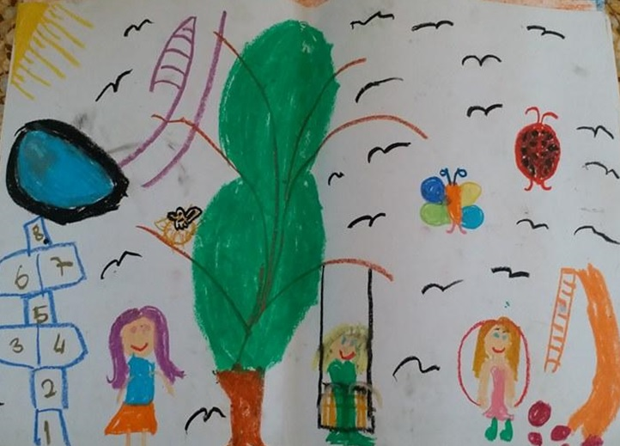
Picture 4. In this drawing, there is a child sliding down a long purple slide on the playground. On one side of the slide, there are two swings, and on the other side, there is a seesaw. Near the slide, there is a small cat and a flower. There is a garbage can on the playground. Birds are flying in the air and the sun is shining brightly.
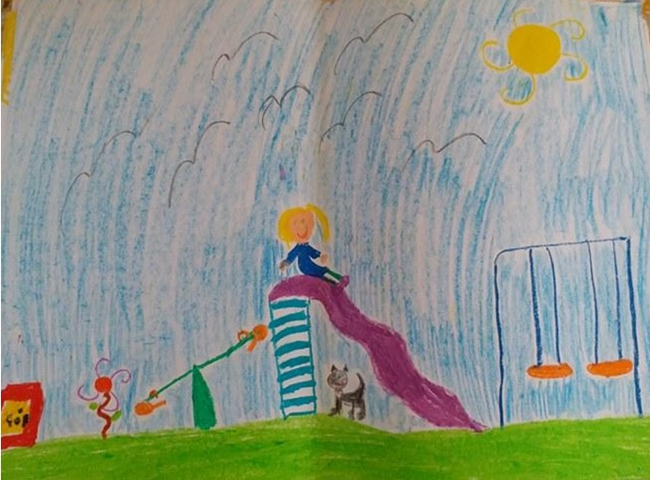
Picture 5. A playground with a slide and a swing is drawn. A group of girls are seen under a blue sky. The girls, wearing colorful clothes, may be waiting for their turn to play. The children seem to be happily waiting for their turn to play. A bee and a butterfly add a natural look to the playground.
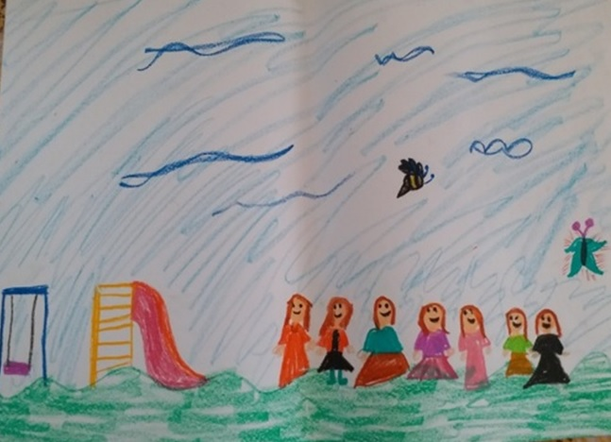
Picture 6. In this picture, there are many children doing different activities. There were children playing football, swinging, seeing-sawing and sliding down the slide. The presence of sunny weather makes the environment lively and fun. The tree and some greenery also added liveliness to the picture.
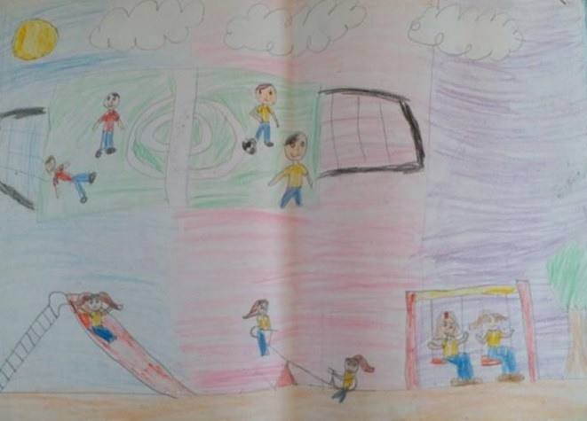

Picture 7. There is a large football field in front of the school building and players can be seen on the field. The football field is in a grassy area. The abbreviations of the Turkish football teams Fenerbahçe and Galatasaray are written on the field. There are swings and a slide next to the football field. In the picture, it can be seen that the playtime at school is enjoyable.
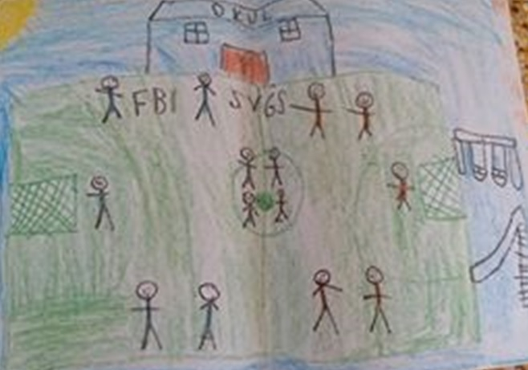
Picture 8. In the picture, there is a girl jumping rope, and right next to her is another girl holding a kite. A hopscotch area is also drawn. There is a structure that looks like a house decorated with bright colors. There are many birds in the sky, and a beautiful atmosphere is created with flowers, clouds and the sun around.
