Supplementary information
Appendix A. Data
This appendix provides the details of data used in this study in Table A1, A2, A3 and A4.
Table A1. Cost data for battery manufacturing in the UAE
Parameter (unit) | Value | Reference
Building cost ($/m²) | 3000 | EverBatt default value
Direct labor cost ($/h) | 5.1900 | Calculated based on information from ^{30,31}
Electricity cost ($/kWh) | 0.0820 | Calculated based on information from ³²
Water cost ($/L) | 0.0021 | ³²
Landfill cost ($/ton) | 61.260 | ³³
Wastewater discharge cost ($/L) | 0.0007 | ³⁴
Natural gas cost ($/MJ) | 0.0022 | ³⁵

Table A2. Information used for truck transportation cost calculations for the UAE
Parameter | Heavy-duty truck | Medium-duty truck | Reference
List price | $350,000 | $300,000 | ³⁶
Consumption | 2.08 km/L | 2.68 km/L | ³⁶
Capacity | 23 ton | 10 ton | ³⁶
Lifetime | 10 years |  | Assumed
Driver cost | $7.62/h |  | ³⁷
Fuel cost | $0.87/L |  | ³⁸
Average speed | 80 km/h |  | ³⁹

Table A3. Environmental impacts on electricity and energy mix of the UAE in 2019 and 2022
Item |  |  | Year
 |  |  | 2019 | 2022
Energy  Mix  Input | Energy  Sources | Petroleum | 0.6% | 43.3%
Energy  Mix  Input | Energy  Sources | NG | 96.7% | 49.8%
Energy  Mix  Input | Energy  Sources | Coal | 0.0% | 2.0%
Energy  Mix  Input | Energy  Sources | Biomass | 0.0% | 0.0%
Energy  Mix  Input | Energy  Sources | Nuclear | 0.0% | 3.6%
Energy  Mix  Input | Energy  Sources | Hydro | 0.0% | 0.0%
Energy  Mix  Input | Energy  Sources | Others | 2.7% | 1.3%
Energy  Mix  Input | T&D Loss |  | 2.0% | 2.2%
Environmental  Impact | Energy consumption  (btu) | Total energy | 2336610.7 | 2865857.6
Environmental  Impact | Energy consumption  (btu) | Fossil fuels | 2307586.1 | 2808016.6
Environmental  Impact | Energy consumption  (btu) | Coal | 1978.0 | 71960.5
Environmental  Impact | Energy consumption  (btu) | Natural gas | 2285341.2 | 1290623.1
Environmental  Impact | Energy consumption  (btu) | Petroleum | 20267.0 | 1445433.0
Environmental  Impact | Water consumption (gal) |  | 54.3 | 104.7
Environmental  Impact | Emissions  (g) | VOC (g) | 22.0 | 32.0
Environmental  Impact | Emissions  (g) | CO | 74.7 | 120.8
Environmental  Impact | Emissions  (g) | NOx | 103.2 | 561.4
Environmental  Impact | Emissions  (g) | PM10 | 7.3 | 38.0
Environmental  Impact | Emissions  (g) | PM2.5 | 7.0 | 33.7
Environmental  Impact | Emissions  (g) | SOx | 29.2 | 325.5
Environmental  Impact | Emissions  (g) | BC | 0.5 | 3.2
Environmental  Impact | Emissions  (g) | OC | 4.2 | 7.6
Environmental  Impact | Emissions  (g) | CH4 | 388.3 | 355.6
Environmental  Impact | Emissions  (g) | N2O | 2.1 | 3.1
Environmental  Impact | Emissions  (g) | CO2 | 137649.5 | 208037.5
Environmental  Impact | Emissions  (g) | CO2 (w/ C in VOC & CO) | 194340.4 | 208327.1
Environmental  Impact | Emissions  (g) | GHGs | 205178.2 | 219770.3

Table A4. Environmental impacts of electricity in the UAE
Environmental impacts of electricity  at the wall outlet |  | Value_EB  (per mmBtu electricity) | Value_SI  (per MJ electricity)
Energy consumption  (btu, J) | Total energy | 2865857.6 | 2860008.9
Energy consumption  (btu, J) | Fossil fuels | 2808016.6 | 2802285.9
Energy consumption  (btu, J) | Coal | 71960.5 | 71813.7
Energy consumption  (btu, J) | Natural gas | 1290623.1 | 1287989.1
Energy consumption  (btu, J) | Petroleum | 1445433.0 | 1442483.1
Water consumption (gal, L) |  | 104.7 | 0.400
Emissions  (g, g) | VOC | 32.0 | 0.030
Emissions  (g, g) | CO | 120.8 | 0.114
Emissions  (g, g) | NOx | 561.4 | 0.532
Emissions  (g, g) | PM10 | 38.0 | 0.036
Emissions  (g, g) | PM2.5 | 33.7 | 0.032
Emissions  (g, g) | Sox | 325.5 | 0.308
Emissions  (g, g) | BC | 3.2 | 0.003
Emissions  (g, g) | OC | 7.6 | 0.007
Emissions  (g, g) | CH₄ | 355.6 | 0.337
Emissions  (g, g) | N₂O | 3.1 | 0.003
Emissions  (g, g) | CO₂ | 208037 | 197.181
Emissions  (g, g) | CO₂ (w/C in VOC & CO) | 208327 | 197.456
Emissions  (g, g) | GHG | 219770 | 208.302

Appendix B. EvetBatt 2023
This appendix provides the structure of EverBatt 2023 worksheets used in this study in Table B1 and reports a minor bug in the Everbatt2023 module.
Table B1. Description of EverBatt worksheets
No. | Worksheet Name | Description | Category
1 | ReadMe | generic information | Description
2 | Input | business scenario input | High-level  input-output data
3 | Output | detailed output | High-level  input-output data
4 | Report | visualized output | High-level  input-output data
5 | Man Par. | maufacturing info | Detailed  input-output data  for each life-cycle stage
6 | Col&Trans Par. | collection, transportation parameters | Detailed  input-output data  for each life-cycle stage
7 | Disassembly | recycling: disassembly parameters | Detailed  input-output data  for each life-cycle stage
8 | Preproc. Par. | recycling: preprocessing parameters | Detailed  input-output data  for each life-cycle stage
9 | CM Rec Par. | recycling: critical material recovery parameters | Detailed  input-output data  for each life-cycle stage
10 | Cath. Prod. Par. | recycling: cathode powder production parameters | Detailed  input-output data  for each life-cycle stage
11 | Man Rec Par. | manufacturing with recycled materials parameters | Detailed  input-output data  for each life-cycle stage
12 | Mat. Conv Par. | material conversion calculation | Detailed  input-output data  for each life-cycle stage
13 | Unit Ops | unit operations info (cost, power) | Detailed  input-output data  for each life-cycle stage
14 | Materials | price of materials | Detailed  input-output data  for each life-cycle stage
15 | Geographic Par. | Geographic parameters (capital, labor costs) | Background data
16 | BatPaC IO | economic factors from BatPaC | Background data
17 | GREET IO | environmental factors from GREET | Background data

B2. Fixing a bug in Everbatt 2023
Here we are reporting a minor bug in the Everbatt2023 module, which incorrectly displays the feedstock payment on the 'Output' sheet of Everbatt2023. The feedstock payment in Everbatt 2023 is defined as follows: “Positive values mean recyclers pay to get the materials; negative values mean recyclers get paid for taking the materials”, as outlined in Cell B87 of the ‘CM Rec Par.’ sheet. When its value is positive, it signifies that feedstock payment is considered as a cost because paying to obtain the materials incurs a feedstock purchase expense. However, in the ‘Output’ sheet, for instance, in Cell L210, the feedstock payment of Pyro is calculated using the formula ‘IF(L211<0,L211,0)’, where Cell L211 contains the feedstock payment value. Accordingly, Everbatt 2023 erroneously displays it as zero in the chart as depicted in Figure B1. Thus, the formula in Cell L210 has been fixed from ‘IF(L211<0,L211,0)’ to ‘IF(L211>0,L211,0)’. The same correction has been applied to Cells M~O210 for the feedstock payment of Hydro, Direct and Custom.
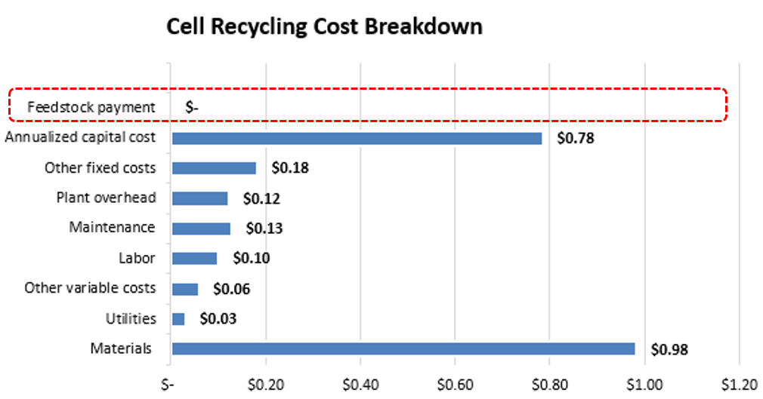
Figure B1. Erroneous display of the feedstock payment in Everbatt2023

