Appendix

ESG ratings, executive pay-for-performance sensitivity
and within-firm pay gap
Xinze Li¹, Xi Wang^{1,2}, Zuoxiang Zhao³ & Qiuyun Zhao⁴
¹Center for Economic Research, Shandong University, Jinan, China.
²Qingdao Finance Research Institute, Dongbei University of Finance and Economics, Qingdao, China. (Current Address) Email: 202020044@mail.sdu.edu.cn.
³School of Management and Economics, Beijing University of Chemical Technology, Beijing, China.
⁴Institute of New Structural Economics, Peking University, Beijing, China.

Table A1
Variable definitions.
Variable | Definitions
Fpg | The ratio of average executive salary to average ordinary employees’ salary.
ESG | The values range from 1 to 7 and are from the Wind database.
Size | The natural logarithm of net fixed assets.
Lev | The ratio of the firm’s total liabilities to total assets.
Roa | The ratio of net profit to total assets.
Cashflow | The ratio of net cash flow from operations to total assets.
Top10 | The proportion of top 10 shareholders.
Dual | 1 if the chairman of the firm’s board and CEO are the same individual, otherwise 0.
Indep | The ratio of independent directors on the board.
Firmage | The natural logarithm of the number of years since the firm’s establishment.
Soe | 1 for stated-owned firms, otherwise 0.
Growth | The ratio of current year’s operating income to the previous year’s minus 1.
Pro_gdp | The logarithm of per capita GDP at the provincial level.
Notes: ESG data are from Wind; GDP data are from the Statistical Yearbook of China, and other data are all from CSMAR.

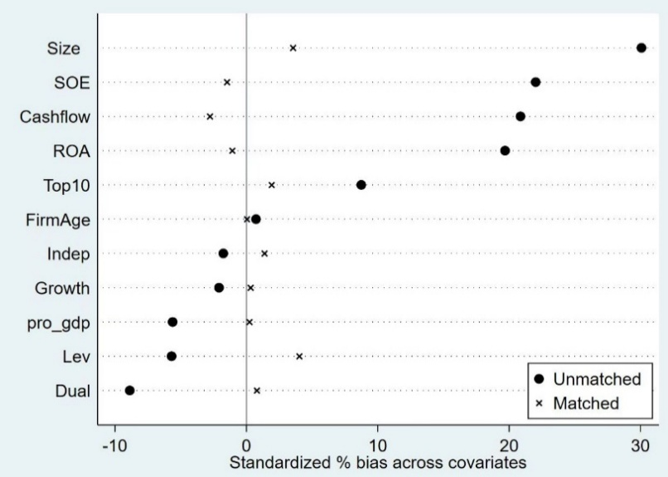
Appendix Figure A1
Balance test.

