More information, better diet?―Regression-discontinuity evidence from hypertension diagnoses in China

Qihui Chen*
Beijing Food Safety Policy & Strategy Research Base,
China Agricultural University, P. R. China
chenqihui2002@126.com; qhchen2013@cau.edu.cn

Juerong Huang
College of Economics and Management
Northwest A&F University, Yangling, P. R. China
jrhuang0@163.com

Yue Hu
College of Economics and Management
China Agricultural University, Beijing, P. R. China
hymoon1@163.com

Jiale Bao
College of Economics and Management
China Agricultural University, Beijing, P. R. China
baojiale1999@163.com

*Corresponding author: Qihui Chen, chenqihui2002@126.com; qhchen2013@cau.edu.cn. Room 302, Economical Building, No.17 Qinghua East Road, Haidian District, China Agricultural University, P. R. China. 100083.

Appendix
Table A1: Scoring criteria for a male whose recommended energy intake is 2000 kcal/day in the definition of the Diet Balance Index
Components | Sub-  components | Score  range | Score
Components | Sub-  components | Score  range | -12 | -10 | -8 | -6 | -4 | -3 | -2 | -1 | 0 | 1 | 2 | 3 | 4 | 6 | 8 | 10 | 12
DBI1: Diet variety | Diet variety | -12~0 | The score = 0 if a person consumes no less than 25g (5g for soybean and products) for a given food item included in the DDS; = -1 otherwise
DBI2: Grains | Grains | -12~12 | < 25 | [25,  75) | [75,  125) | [125,  175) | [175,  225) |  | [225,  275) |  | [275,  325) |  | [325,  375) |  | [375,  425) | [425,  475) | [475,  525) | [525,  575) | ≥ 575
DBI3: Vegetables and fruits | Vegetables | -6~0 |  |  |  | < 1 | [1, 175) |  | [175,  350) |  | ≥ 350
DBI3: Vegetables and fruits | Fruits | -6~0 |  |  |  | < 1 | [1, 150) |  | [150, 300) |  | ≥ 300
DBI4: Soybean and dairy products | Dairy | -6~0 |  |  |  | [1,100) | [100,  200) |  | [200, 300) |  | ≥ 300
DBI4: Soybean and dairy products | Soybean | -6~0 |  |  |  | < 1 | [1, 20) |  | [20, 40) |  | ≥ 40
DBI5: Animal protein | Meat | -4~4 |  |  |  |  | < 1 |  | [1, 25) |  | [25, 75) |  | [75,  125) |  | ≥ 125
DBI5: Animal protein | Fish | -4~0 |  |  |  |  | < 30 | [30,45) | [45, 60) | [60,  75) | ≥ 75
DBI5: Animal protein | Eggs | -4~4 |  |  |  |  | < 1 |  | [1, 25) |  | [35, 50) |  | [50,75) |  | ≥ 75
DBI6: Cooking oil, salt, and alcoholic beverages | Cooking oil | 0~4 |  |  |  |  |  |  |  |  | ≤ 25 |  | (25,50] |  | > 50
DBI6: Cooking oil, salt, and alcoholic beverages | Salt | 0~4 |  |  |  |  |  |  |  |  | ≤ 6 |  | (6,12] |  | > 12
DBI6: Cooking oil, salt, and alcoholic beverages | Alcohol | 0~4 |  |  |  |  |  |  |  |  | ≤ 25 | (25,50] | (50,75] | (75,100] | > 100
Notes: The complete scoring system for all seven energy intake groups can be found in He et al. (2009).
Table A2: Non-parametric RD estimates with different bandwidths
 | (1) | (2) |  | (3) | (4)
Estimator | RD estimates  based on SBP readings  (cut-off: SBP = 140) |  |  | RD estimates  based on DBP readings  (cut-off: DBP = 90)
Bandwidth | Half the  optimal  bandwidth | Twice the  optimal  bandwidth |  | Half the  optimal  bandwidth | Twice the  optimal  bandwidth
A. Diet diversity score (DDS) | -0.542*** | -0.357** |  | 0.153 | -0.094
 | (0.175) | (0.150) |  | (0.228) | (0.172)
Bandwidth | 5.82 | 23.30 |  | 2.43 | 9/71
N | 15704 | 15704 |  | 16081 | 16081
B. Diet balance index (DBI) | -1.921* | -1.294 |  | -0.927 | -0.570
 | (1.140) | (0.951) |  | (1.676) | (1.095)
Bandwidth | 6.05 | 24.21 |  | 2.58 | 10.34
N | 15074 | 15074 |  | 15444 | 15444
C. DBI: over-consumption | 0.136 | 0.364 |  | -1.286 | -0.402
 | (0.544) | (0.453) |  | (0.909) | (0.562)
Bandwidth | 7.23 | 28.94 |  | 2.65 | 10.60
N | 15074 | 15074 |  | 15444 | 15444
D. DBI: under-consumption | -2.059*** | -1.450** |  | 0.354 | -0.172
 | (0.791) | (0.686) |  | (1.103) | (0.829)
Bandwidth | 6.16 | 24.62 |  | 2.34 | 9.37
N | 15432 | 15432 |  | 15804 | 15804
Notes: Data were drawn from the China Health and Nutrition Survey (1997, 2000, 2004, 2006, 2009, 2011). Analytical samples are restricted to observations within ±40 mmHg intervals of the respective cut-offs. The actual sample size is determined by the optimal bandwidth chosen by minimizing the mean squared error to produce a lower bias (Calonico et al., 2014). Non-parametric RD estimates using the triangular kernel and the associated optimal bandwidth are reported. Standard errors are reported in parentheses, clustered at the community level.
*** p<0.01, ** p<0.05, * p<0.1.
Table A3: Non-parametric RD estimates on diet structure with alternative definitions of assignment variables
 | (1) | (2) | (3) | (4) |  | (5) | (6) | (7) | (8)
Estimator | RD estimates based on SBP readings (cut-off: SBP=140) |  |  |  |  | RD estimates based on DBP readings (cut-off: DBP=90)
Definitions of assignment variables: | Original  estimates  (mean of 3 SBP readings) | Mean of  2nd & 3rd  SBP readings | Mean of  lowest two  readings | Median readings |  | Original  estimates  (mean of 3 SBP readings) | Mean of  2nd & 3rd  DBP readings | Mean of  lowest two  readings | Median readings
A. Diet diversity score (DDS) | -0.610*** | -0.746*** | -0.834*** | -0.799*** |  | 0.159 | -0.026 | 0.156 | 0.105
 | (0.179) | (0.196) | (0.192) | (0.221) |  | (0.241) | (0.244) | (0.260) | (0.398)
Bandwidth | 11.65 | 10.40 | 10.89 | 12.81 |  | 4.86 | 5.42 | 5.36 | 6.03
N | 15,704 | 15,624 | 15,767 | 15,341 |  | 16,081 | 16,048 | 16,123 | 15,911
B. Diet balance index (DBI) | -2.542** | -4.000*** | -3.756*** | -5.432*** |  | -0.801 | -1.055 | -1.303 | 0.461
 | (1.150) | (1.328) | (1.197) | (1.745) |  | (1.730) | (1.889) | (1.641) | (2.409)
Bandwidth | 12.11 | 10.22 | 11.59 | 11.87 |  | 5.17 | 5.68 | 6.62 | 6.24
N | 15,074 | 14,996 | 15,137 | 14,716 |  | 15,444 | 15,411 | 15,486 | 15,277
C. DBI: over-consumption | -0.029 | -0.029 | -0.464 | -1.629* |  | -1.125 | -0.960 | -1.616* | -0.269
 | (0.543) | (0.653) | (0.627) | (0.893) |  | (0.918) | (0.892) | (0.862) | (0.888)
Bandwidth | 14.47 | 11.8 | 12.62 | 12.21 |  | 5.3 | 6.40 | 7.02 | 9.12
N | 15,074 | 14,996 | 15,137 | 14,716 |  | 15,444 | 15,411 | 15,486 | 15,277
D. DBI: under-consumption | -2.278*** | -3.552*** | -3.124*** | -3.359*** |  | 0.521 | 0.028 | 1.017 | 4.038
 | (0.805) | (0.911) | (0.874) | (1.032) |  | (1.188) | (1.166) | (1.168) | (4.292)
Bandwidth | 12.31 | 10.48 | 11.96 | 13.06 |  | 4.68 | 5.49 | 5.30 | 5.03
N | 15,432 | 15,352 | 15,495 | 15,071 |  | 15,804 | 15,771 | 15,846 | 15,634
Notes: Data were drawn from the China Health and Nutrition Survey (1997, 2000, 2004, 2006, 2009, 2011). Analytical samples are restricted to observations within ±40 mmHg intervals of the respective cut-offs. The actual sample size is determined by the optimal bandwidth chosen by minimizing the mean squared error to produce a lower bias (Calonico et al., 2014). Non-parametric RD estimates using the triangular kernel and the associated optimal bandwidth are reported. Standard errors are reported in parentheses, clustered at the community level.
*** p<0.01, ** p<0.05, * p<0.1.

Table A4: Difference-in-differences estimates of the effects of SBP-based hypertension diagnoses on diet structure
 | (1) | (2) | (3) | (4) |  | (5) | (6) | (7) | (8)
Model specification: | Diet diversity  score (DDS) | Diet balance  index (DBI) | DBI: over-  consumption | DBI: under-  consumption |  | Diet diversity  score (DDS) | Diet balance  index (DBI) | DBI: over-  consumption | DBI: under-  consumption
Sample | Diastolic-normal (DBP<90) |  |  |  |  | RD analytic sample (diastolic-normal and blood  pressure readings within the ±40 mmHg intervals)
Hypertension diagnoses × Post (t+1) | -0.178 | -1.129 | -0.507 | -0.567 |  | -0.168 | -1.007 | -0.446 | -0.513
 | (0.116) | (0.870) | (0.529) | (0.478) |  | (0.115) | (0.885) | (0.540) | (0.483)
Hypertension diagnoses (t) | 0.065 | 0.626 | 0.154 | 0.427 |  | 0.057 | 0.505 | 0.104 | 0.361
 | (0.105) | (0.831) | (0.491) | (0.446) |  | (0.106) | (0.849) | (0.504) | (0.455)
Post (t+1) | 0.083** | 0.819*** | 0.429*** | 0.406** |  | 0.078* | 0.788*** | 0.434*** | 0.375**
 | (0.039) | (0.276) | (0.150) | (0.172) |  | (0.041) | (0.286) | (0.155) | (0.179)
Age (year) | -0.001 | -0.010 | -0.012*** | 0.003 |  | -0.002* | -0.011 | -0.012*** | 0.002
 | (0.001) | (0.007) | (0.004) | (0.004) |  | (0.001) | (0.007) | (0.005) | (0.005)
Male (=1 if yes) | -0.018 | -1.621*** | -0.382*** | -1.256*** |  | -0.020 | -1.633*** | -0.367*** | -1.280***
 | (0.016) | (0.125) | (0.081) | (0.077) |  | (0.017) | (0.130) | (0.083) | (0.080)
Education (years) | 0.024*** | 0.110*** | 0.009 | 0.104*** |  | 0.023*** | 0.101*** | 0.003 | 0.103***
 | (0.004) | (0.025) | (0.016) | (0.015) |  | (0.004) | (0.027) | (0.017) | (0.016)
Rural residents (1=yes) | -1.754*** | -6.547*** | 0.347 | -7.022*** |  | -1.806*** | -6.122*** | 0.606*** | -6.850***
 | (0.049) | (0.349) | (0.229) | (0.212) |  | (0.049) | (0.349) | (0.226) | (0.214)
Household income per capita | 0.060*** | 0.275*** | 0.041 | 0.232*** |  | 0.061*** | 0.272*** | 0.039 | 0.231***
 | (0.011) | (0.081) | (0.048) | (0.050) |  | (0.011) | (0.081) | (0.048) | (0.051)
Household size | 0.025** | -0.129* | -0.167*** | 0.032 |  | 0.020** | -0.126* | -0.154*** | 0.022
 | (0.010) | (0.066) | (0.038) | (0.041) |  | (0.010) | (0.067) | (0.038) | (0.042)
Working (1=yes) | 0.021 | 0.140 | 0.184 | -0.022 |  | 0.015 | 0.101 | 0.189 | -0.072
 | (0.028) | (0.199) | (0.116) | (0.118) |  | (0.030) | (0.212) | (0.124) | (0.123)
Married (1=yes) | 0.132*** | 0.763*** | 0.291** | 0.470*** |  | 0.143*** | 0.752*** | 0.234* | 0.519***
 | (0.026) | (0.216) | (0.135) | (0.124) |  | (0.027) | (0.218) | (0.136) | (0.129)
Han (1=yes) | 0.028 | -0.330 | -0.181 | -0.157 |  | 0.039 | -0.491 | -0.343 | -0.139
 | (0.045) | (0.381) | (0.245) | (0.235) |  | (0.047) | (0.399) | (0.255) | (0.247)
Constant | 4.722*** | -17.619*** | 14.653*** | -32.190*** |  | 4.755*** | -17.043*** | 15.044*** | -32.036***
 | (0.172) | (1.188) | (0.704) | (0.714) |  | (0.171) | (1.207) | (0.722) | (0.717)
Survey year fixed effects | yes | yes | yes | yes |  | yes | yes | yes | yes
N | 16,116 | 15,480 | 15,480 | 15,849 |  | 14,674 | 14,092 | 14,092 | 14,432
R² | 0.385 | 0.321 | 0.249 | 0.390 |  | 0.387 | 0.324 | 0.253 | 0.390
Notes: Data were drawn from the China Health and Nutrition Survey (1997, 2000, 2004, 2006, 2009, 2011). Standard errors are reported in parentheses, clustered at the community level. *** p<0.01, ** p<0.05, * p<0.1.

Table A5: Difference-in-differences estimates of the effects of DBP-based hypertension diagnoses on diet structure
 | (1) | (2) | (3) | (4) |  | (5) | (6) | (7) | (8)
Model specification: | Diet diversity  score (DDS) | Diet balance  index (DBI) | DBI: over-  consumption | DBI: under-  consumption |  | Diet diversity  score (DDS) | Diet balance  index (DBI) | DBI: over-  consumption | DBI: under-  consumption
Sample | Systolic normal (SBP<140) |  |  |  |  | RD analytic sample (systolic-normal and blood  pressure readings within the ±40 mmHg intervals)
Hypertension diagnoses × Post (t+1) | 0.078 | 0.025 | -0.203 | 0.207 |  | 0.087 | 0.151 | -0.127 | 0.249
 | (0.094) | (0.751) | (0.443) | (0.405) |  | (0.094) | (0.744) | (0.439) | (0.404)
Hypertension diagnoses (t) | -0.040 | 0.010 | 0.154 | -0.114 |  | -0.050 | -0.147 | 0.061 | -0.173
 | (0.084) | (0.690) | (0.407) | (0.356) |  | (0.084) | (0.685) | (0.405) | (0.354)
Post (t+1) | 0.082** | 0.864*** | 0.453*** | 0.428** |  | 0.077* | 0.834*** | 0.458*** | 0.400**
 | (0.039) | (0.273) | (0.150) | (0.172) |  | (0.041) | (0.282) | (0.156) | (0.177)
Age (year) | -0.001 | -0.007 | -0.010** | 0.005 |  | -0.001 | -0.008 | -0.011** | 0.004
 | (0.001) | (0.007) | (0.004) | (0.004) |  | (0.001) | (0.007) | (0.004) | (0.004)
Male (=1 if yes) | -0.021 | -1.583*** | -0.357*** | -1.242*** |  | -0.024 | -1.593*** | -0.341*** | -1.265***
 | (0.016) | (0.124) | (0.082) | (0.076) |  | (0.017) | (0.128) | (0.084) | (0.078)
Education (years) | 0.023*** | 0.114*** | 0.015 | 0.102*** |  | 0.022*** | 0.106*** | 0.009 | 0.101***
 | (0.004) | (0.025) | (0.015) | (0.015) |  | (0.004) | (0.026) | (0.016) | (0.016)
Rural residents (1=yes) | -1.829*** | -7.008*** | 0.354 | -7.501*** |  | -1.881*** | -6.590*** | 0.615*** | -7.341***
 | (0.047) | (0.345) | (0.228) | (0.211) |  | (0.048) | (0.342) | (0.223) | (0.213)
Household income per capita | 0.062*** | 0.305*** | 0.059 | 0.247*** |  | 0.064*** | 0.304*** | 0.058 | 0.246***
 | (0.011) | (0.079) | (0.048) | (0.050) |  | (0.011) | (0.079) | (0.047) | (0.051)
Household size | 0.031*** | -0.091 | -0.151*** | 0.056 |  | 0.027** | -0.084 | -0.138*** | 0.049
 | (0.011) | (0.067) | (0.039) | (0.041) |  | (0.011) | (0.068) | (0.040) | (0.042)
Working (1=yes) | 0.030 | 0.197 | 0.213* | 0.009 |  | 0.025 | 0.158 | 0.217* | -0.039
 | (0.028) | (0.194) | (0.112) | (0.119) |  | (0.029) | (0.204) | (0.119) | (0.122)
Married (1=yes) | 0.139*** | 0.843*** | 0.368*** | 0.470*** |  | 0.150*** | 0.846*** | 0.323** | 0.521***
 | (0.026) | (0.217) | (0.129) | (0.128) |  | (0.027) | (0.220) | (0.131) | (0.133)
Han (1=yes) | 0.031 | -0.094 | -0.068 | -0.054 |  | 0.044 | -0.214 | -0.211 | -0.019
 | (0.045) | (0.374) | (0.227) | (0.226) |  | (0.047) | (0.383) | (0.233) | (0.231)
Constant | 4.737*** | -18.224*** | 14.045*** | -32.181*** |  | 4.763*** | -17.743*** | 14.384*** | -32.069***
 | (0.172) | (1.186) | (0.701) | (0.718) |  | (0.171) | (1.197) | (0.717) | (0.720)
Survey year fixed effects | yes | yes | yes | yes |  | yes | yes | yes | yes
N | 16,419 | 15,778 | 15,778 | 16,147 |  | 14,984 | 14,397 | 14,397 | 14,737
R² | 0.384 | 0.319 | 0.250 | 0.386 |  | 0.387 | 0.323 | 0.254 | 0.387
Notes: Data were drawn from the China Health and Nutrition Survey (1997, 2000, 2004, 2006, 2009, 2011). Standard errors are reported in parentheses, clustered at the community level. *** p<0.01, ** p<0.05, * p<0.1.
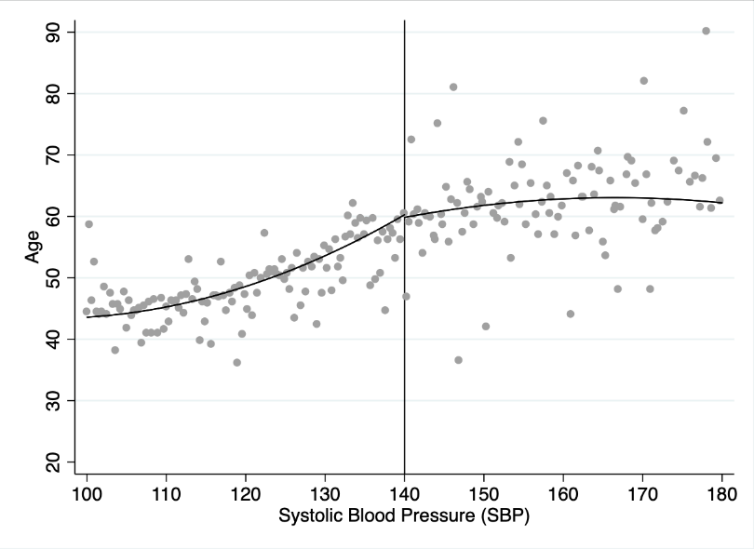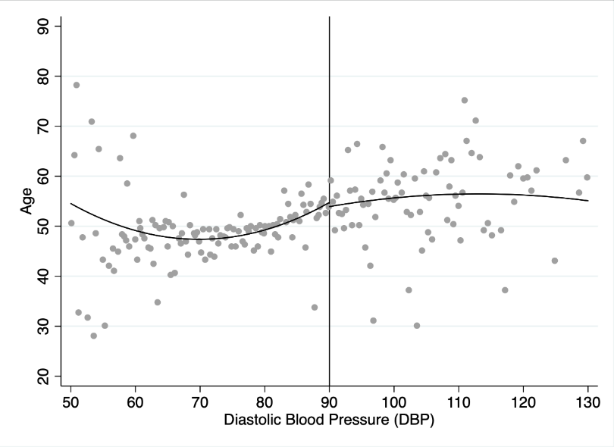
(a) Age and systolic blood pressure (b) Age and diastolic blood pressure
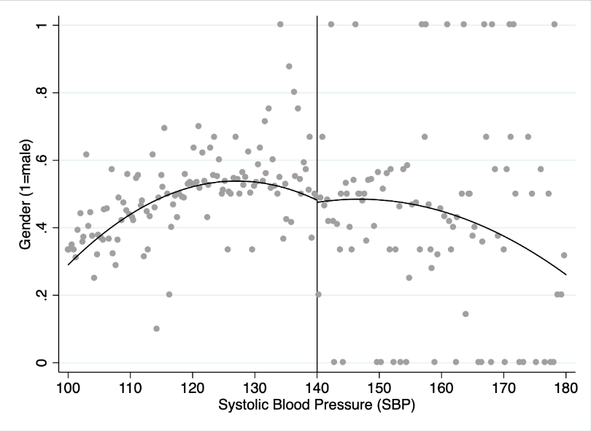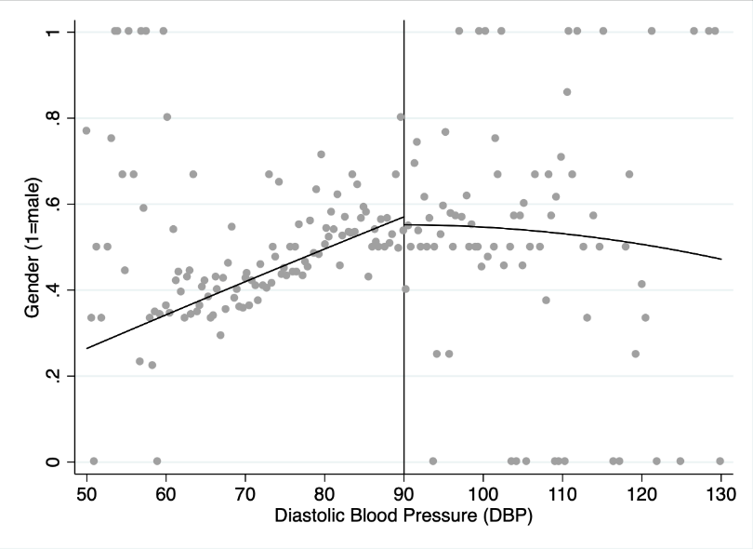
(c) Gender (1=male) and systolic pressure (d) Gender (1=male) and diastolic pressure
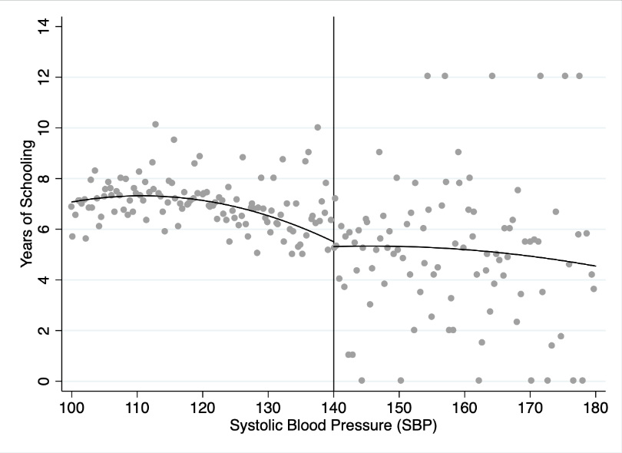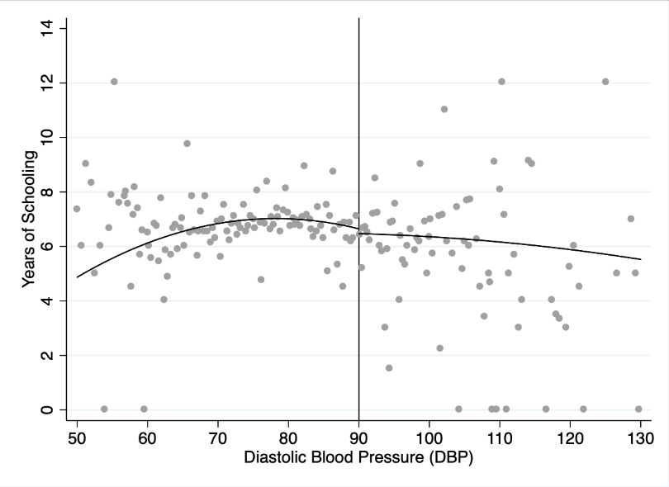
(e) Years of schooling and systolic pressure (f) Years of schooling and diastolic pressure
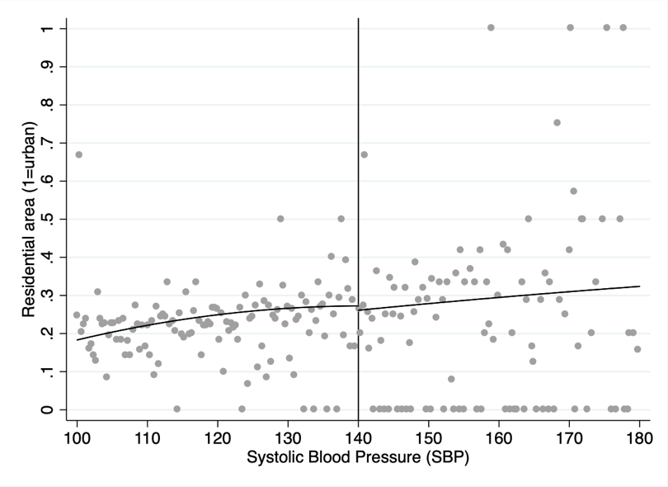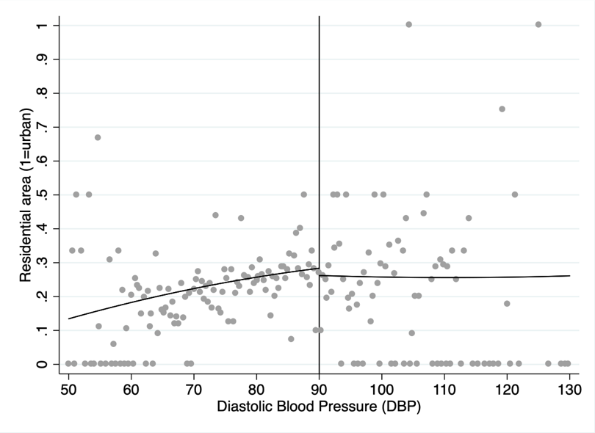
(g) Residential area (1=urban) and systolic pressure (h) Residential area (1=urban) and diastolic pressure
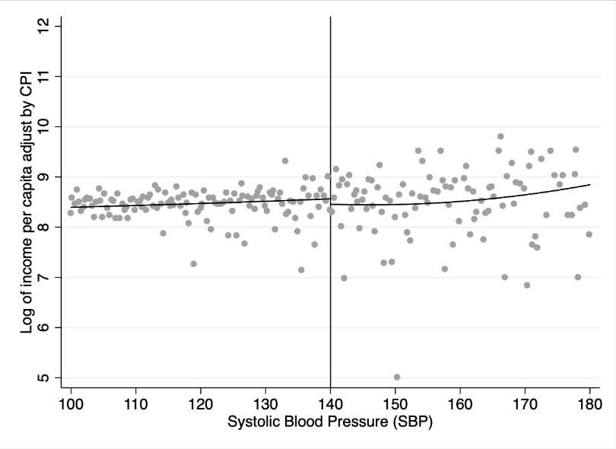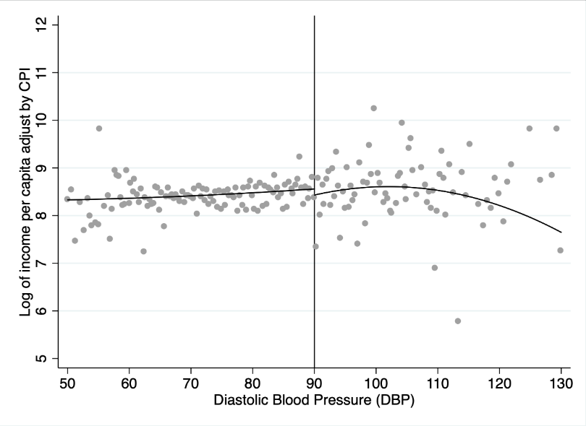
(i) Household income per capita and systolic pressure (j) Household income per capita and diastolic pressure
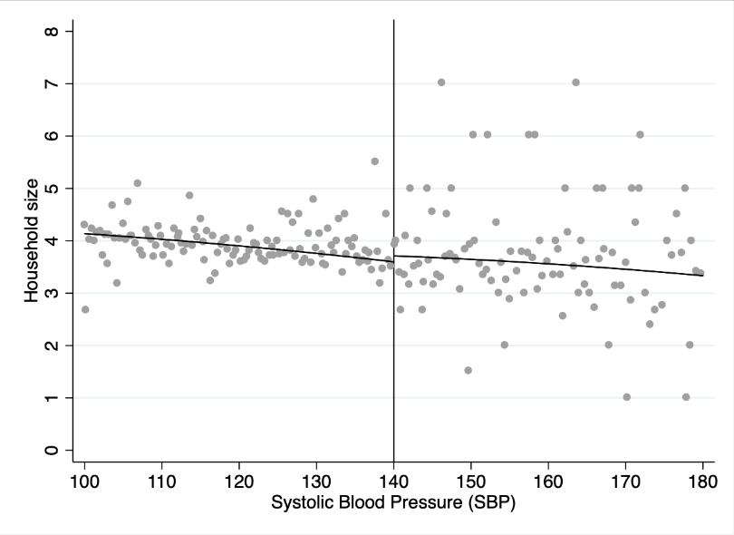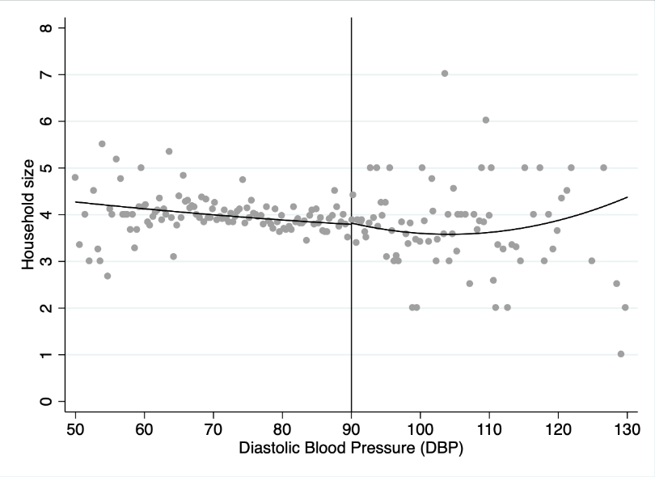
(k) Household size and systolic pressure (l) Household size and diastolic pressure

Figure A1. Continuity in pre-determined characteristics at hypertension diagnosis cut-offs

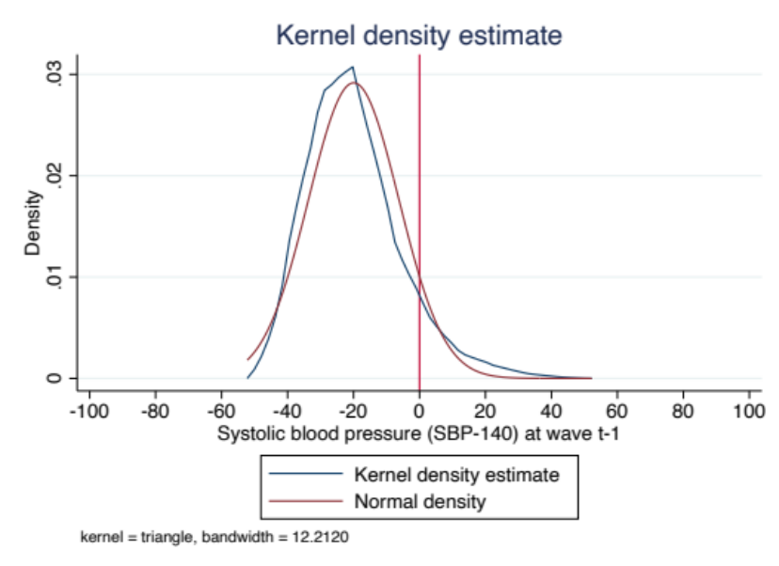
(A) Density of systolic blood pressure readings
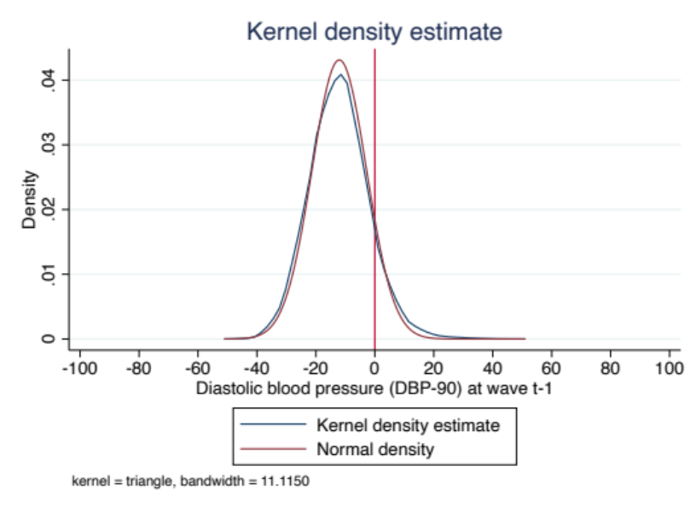
(B) Density of diastolic blood pressure readings
Figure A2. Densities of systolic and diastolic blood pressure readings

