Supplementary material for
Gender disparities in the STEM research enterprise of China
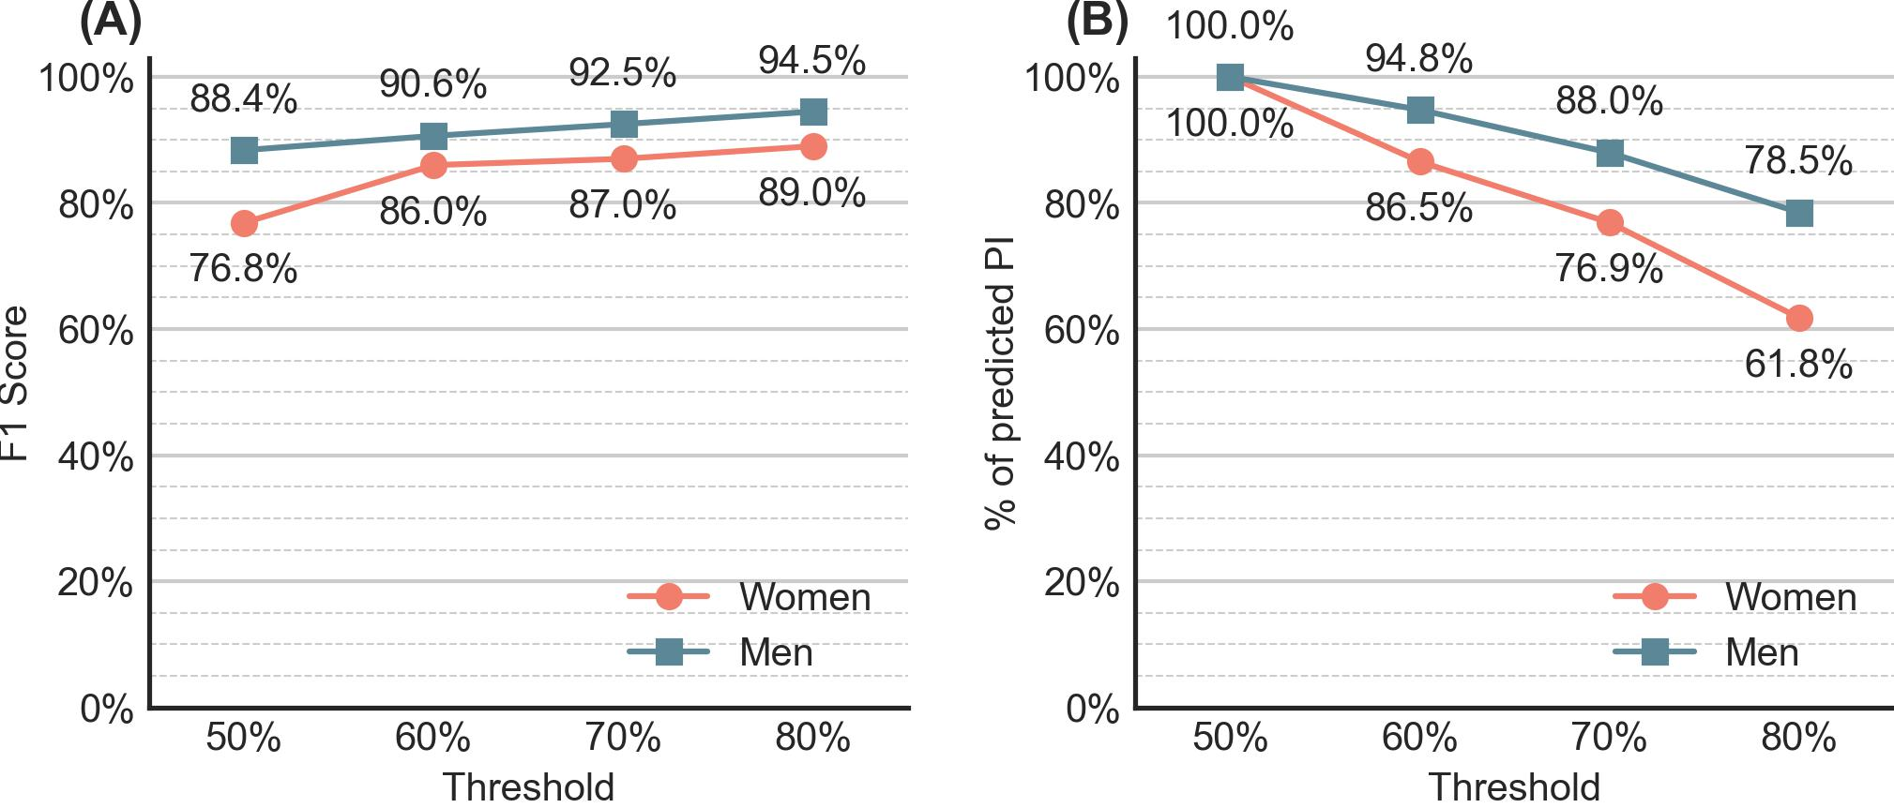

Fig. S1. Evaluation of ngender for gender prediction. (A) F1 scores by threshold based on evaluations using master and doctoral graduates' self-reported gender; (B) Percentage of PIs predicted with gender information by threshold.
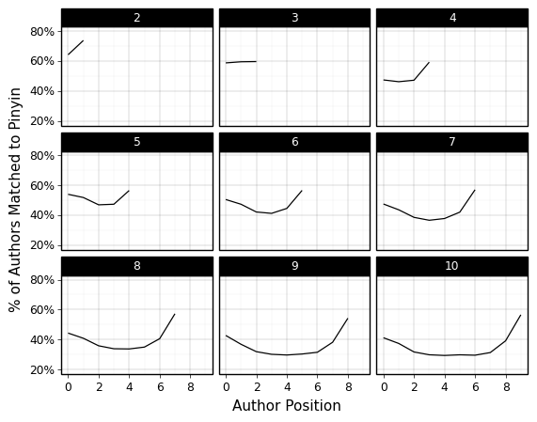

Fig. S2. The percentage of names in Pinyin matched to names in Chinese characters by their positions in publications bylines and the number of authors. The numbers at the top of each panel show the number of authors.

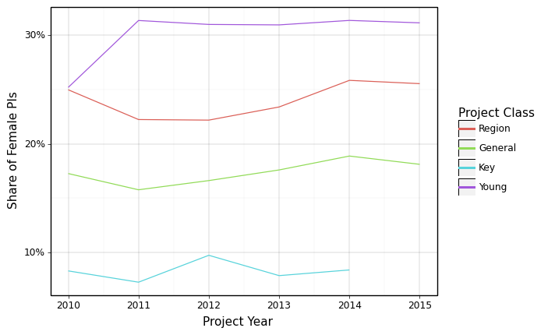
Fig. S3. Share of women PIs among NSFC projects by project type.

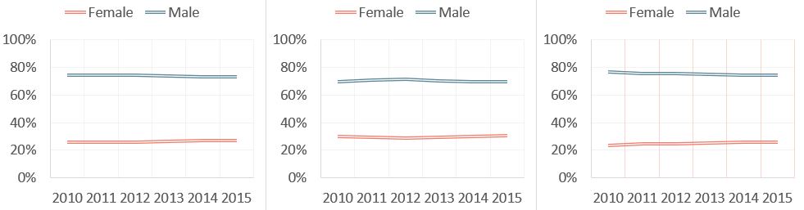

Fig. S4. Share of women among All authors (left), first authors (middle), and last authors (right) by time.

Table S1. NSFC projects by project field and type (2010-2015).

 | General |  | Young |  | Key |  | Region |  | Total
 | # | % | # | % | # | % | # | % | Total
Chem | 8739 | 49.9% | 7362 | 42.0% | 279 | 1.6% | 1140 | 6.5% | 17520
Earth | 8568 | 48.5% | 7921 | 44.8% | 350 | 2.0% | 842 | 4.8% | 17681
EMS | 15162 | 47.6% | 14680 | 46.1% | 381 | 1.2% | 1649 | 5.2% | 31872
Health | 21700 | 51.5% | 16382 | 38.8% | 426 | 1.0% | 3662 | 8.7% | 42170
Info | 9691 | 46.1% | 9871 | 46.9% | 356 | 1.7% | 1124 | 5.3% | 21042
Life | 14200 | 49.1% | 10871 | 37.6% | 384 | 1.3% | 3452 | 11.9% | 28907
MPS | 8360 | 46.1% | 8574 | 47.3% | 294 | 1.6% | 900 | 5.0% | 18128
MS | 3983 | 48.9% | 3417 | 42.0% | 123 | 1.5% | 622 | 7.6% | 8145
Total | 90403 | 48.7% | 79078 | 42.6% | 2593 | 1.4% | 13391 | 7.2% | 185465

Table S2. Analytical ample data description.

 | #Projects | # Publications | Chinese Publications |  | English Publications
 | #Projects | # Publications | # | % | # | %
Chem | 17,094 | 236,708 | 40,077 | 16.9% | 196,622 | 83.1%
Earth | 20,636 | 362,975 | 98,848 | 27.2% | 264,110 | 72.8%
EMS | 17,347 | 180,879 | 95,658 | 52.9% | 85,220 | 47.1%
Health | 31,543 | 435,703 | 183,523 | 42.1% | 252,228 | 57.9%
Info | 40,516 | 293,218 | 124,267 | 42.4% | 168,939 | 57.6%
Life | 27,747 | 204,220 | 85,661 | 41.9% | 118,554 | 58.1%
MPS | 17,569 | 214,746 | 49,356 | 23.0% | 165,387 | 77.0%
MS | 8,082 | 120,888 | 80,618 | 66.7% | 40,269 | 33.3%
Total | 180,534 | 2,049,337 | 758,008 | 37.0% | 1,291,329 | 63.0%

Table S3. Percentage of women authors among all, first, and last authors of NSFC teams.

Language | % all authors | % first authors | % last authors
Chinese | 27.4% | 31.0% | 26.2%
English | 24.8% | 26.8% | 23.1%
All | 27.1% | 30.5% | 25.6%

