The dual nature of arrogance: From an approach-avoidance perspective (authors: Yinghua Xu, Heming Gong)
Appendix A: Arrogant expressions of actors
 | Approach-oriented arrogance | Avoidance-oriented arrogance | Neutral state
Male actor | 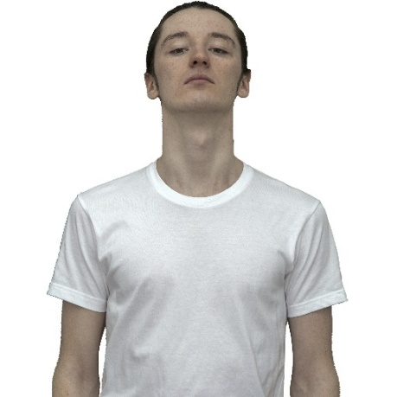 | 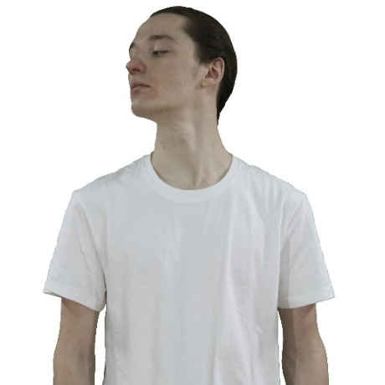 | 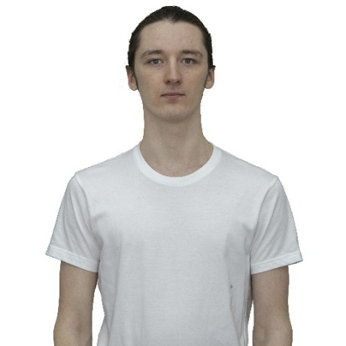
Female actor | 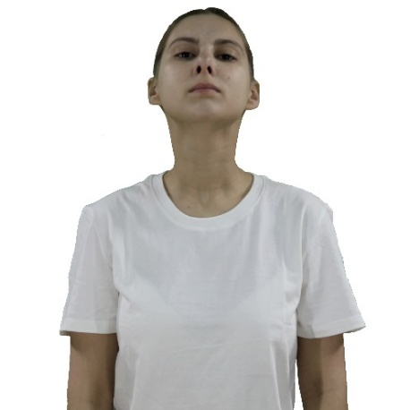 | 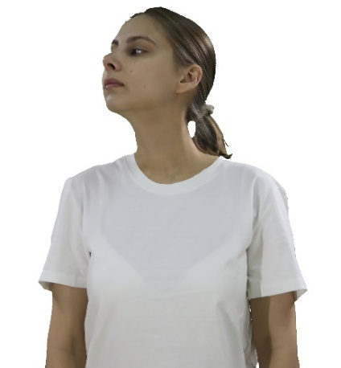 | 