Title
Economic development benefits or social inequality hinders? Intergenerational educational mobility in 49 countries

Author names and affiliations
Jiyue Li* (First author and Corresponding author)
jiyue.li@wustl.edu
Institute for Empirical Social Science Research, Xi’an Jiaotong University, China
Department of Sociology, School of Humanties and Social Science, Xi’an Jiaotong University, China

Qian Zhang
qzhang1123@qq.com
Institute for Empirical Social Science Research, Xi’an Jiaotong University, China
Department of Sociology, School of Humanties and Social Science, Xi’an Jiaotong University, China

Appendix
Table A1 Number of cases and fieldwork period in countries.
Countries | ISO 3166 | No. of Cases | Fieldwork period | Countries | ISO 3166 | No. of Cases | Fieldwork period
Argentina | AR | 660 | 2017 | Iran | IR | 1133 | 2020
Azerbaijan | AZ | 1340 | 2018 | Peru | PE | 1038 | 2018
Australia | AU | 1162 | 2018 | Japan | JP | 761 | 2019
Austria | AT | 993 | 2018 | Kazakhstan | KZ | 1037 | 2018
Bangladesh | BD | 951 | 2018 | South Korea | KR | 1040 | 2017.12-2018.1
Brazil | BR | 1174 | 2018 | Malaysia | MY | 1089 | 2018
Bulgaria | BG | 911 | 2017.11-2018.1 | Italy | IT | 1068 | 2018.9-2019.1
Belarus | BY | 1034 | 2018 | Mexico | MX | 1261 | 2018
Canada | CA | 2930 | 2020 | Netherlands | NL | 2483 | 2017.8-2018.2
Chile | CL | 760 | 2018 | New Zealand | NZ | 576 | 2019.7-2020.2
China | CN | 2437 | 2018 | Norway | NO | 775 | 2018
Colombia | CO | 1053 | 2018 | Pakistan | PK | 1551 | 2018
Croatia | HR | 923 | 2017.10-2018.2 | Poland | PL | 750 | 2017.11-2018.2
Czechia | CZ | 1798 | 2017 | Russia | RU | 2452 | 2017
Denmark | DK | 2103 | 2017.9-2018.1 | Singapore | SG | 1485 | 2019.11-2020.3
Ecuador | EC | 870 | 2018 | Serbia | RS | 1635 | 2017
Estonia | EE | 690 | 2018 | Vietnam | VN | 984 | 2019.12-2020.1
France | FR | 1133 | 2018 | Spain | ES | 649 | 2017.11-2018.1
Finland | FI | 663 | 2017.11-2018.7 | Sweden | SE | 736 | 2017.9-2018.6
Georgia | GE | 1383 | 2018 | Ukraine | UA | 2066 | 2020
Germany | DE | 2354 | 2017.10-2018.3 | Switzerland | CH | 2083 | 2017.9-2018.2
Greece | GR | 792 | 2017 | Zimbabwe | ZW | 833 | 2020
Hungary | HU | 760 | 2018 | Great Britain | GB | 2491 | 2018
Iceland | IS | 1064 | 2017.6-2018.4 | United States | US | 1968 | 2017
Indonesia | ID | 2632 | 2018
Notes. 1. Fieldwork period are dated as year.month.
2. ISO 3166 is a standard published by the International Organization for Standardization (ISO) that defines codes for the names of countries, territories, and their subdivisions.
Table A2. Descriptive statistics of key variables in countries.
Countries | ISO 3166 |  | Mean
Countries | ISO 3166 | Personal education | Parental education | Education gap | Gender | Age
Low economic and low inequality
Bangladesh | BD | 7.72 | 4.87 | 2.86 | 0.52 | 39.88
Pakistan | PK | 8.78 | 5.46 | 3.36 | 0.53 | 37.94
Azerbaijan | AZ | 13.07 | 12.45 | 0.73 | 0.50 | 42.65
Poland | PL | 13.12 | 10.23 | 2.77 | 0.46 | 46.44
Croatia | HR | 13.46 | 11.53 | 1.93 | 0.41 | 45.67
Kazakhstan | KZ | 14.76 | 11.60 | 3.10 | 0.45 | 41.84
Belarus | BY | 15.36 | 12.48 | 2.89 | 0.42 | 44.27
Ukraine | UA | 15.38 | 12.81 | 2.51 | 0.39 | 44.35
Low economic and high inequality
Indonesia | ID | 9.19 | 6.18 | 3.01 | 0.45 | 41.66
China | CN | 10.16 | 6.24 | 3.93 | 0.45 | 45.37
Zimbabwe | ZW | 10.16 | 6.96 | 3.19 | 0.49 | 40.52
Brazil | BR | 10.60 | 6.31 | 4.24 | 0.45 | 11.65
Argentina | AR | 10.95 | 8.19 | 2.79 | 0.49 | 43.51
Colombia | CO | 11.18 | 7.09 | 4.10 | 0.49 | 42.00
Ecuador | EC | 11.37 | 7.56 | 3.79 | 0.45 | 42.22
Mexico | MX | 11.50 | 7.35 | 4.13 | 0.50 | 43.00
Vietnam | VN | 11.54 | 6.97 | 4.57 | 0.44 | 40.65
Peru | PE | 11.67 | 7.99 | 3.69 | 0.49 | 42.29
Malaysia | MY | 11.95 | 10.22 | 1.73 | 0.50 | 40.55
Iran | IR | 13.28 | 6.70 | 6.55 | 0.51 | 41.63
Bulgaria | BG | 13.37 | 11.35 | 1.94 | 0.40 | 47.42
Georgia | GE | 13.73 | 12.56 | 1.14 | 0.37 | 46.35
Russia | RU | 15.45 | 13.11 | 2.29 | 0.43 | 43.46
Serbia | RS | 15.55 | 11.80 | 2.90 | 0.46 | 43.89
High economic and low inequality
Greece | GR | 12.36 | 8.14 | 4.14 | 0.46 | 45.82
France | FR | 13.09 | 9.59 | 3.46 | 0.46 | 45.89
Austria | AT | 13.29 | 11.94 | 1.26 | 0.46 | 45.48
Hungary | HU | 13.36 | 11.91 | 1.54 | 0.43 | 45.69
Czechia | CZ | 13.64 | 12.95 | 0.69 | 0.40 | 45.69
Netherlands | NL | 13.69 | 10.22 | 3.29 | 0.47 | 46.94
Great Britain | GB | 13.74 | 8.46 | 9.94 | 0.43 | 46.63
Germany | DE | 13.97 | 12.59 | 1.31 | 0.49 | 46.43
Norway | NO | 14.00 | 12.85 | 1.14 | 0.48 | 44.98
Denmark | DK | 14.06 | 12.30 | 1.79 | 0.49 | 47.26
Estonia | EE | 14.08 | 12.20 | 1.86 | 0.44 | 49.38
Switzerland | CH | 14.10 | 12.33 | 1.72 | 0.47 | 45.60
Iceland | IS | 14.24 | 12.71 | 1.52 | 0.47 | 46.01
New Zealand | NZ | 14.42 | 11.57 | 2.78 | 0.40 | 49.75
Finland | FI | 14.68 | 11.13 | 3.53 | 0.48 | 48.12
Sweden | SE | 14.82 | 11.91 | 2.86 | 0.49 | 46.41
Canada | CA | 15.18 | 12.29 | 2.89 | 0.52 | 44.36
High economic and high inequality
Spain | ES | 11.81 | 7.80 | 3.82 | 0.47 | 45.17
Italy | IT | 12.19 | 8.74 | 3.53 | 0.50 | 46.51
Chile | CL | 13.63 | 10.63 | 3.02 | 0.46 | 44.49
South Korea | KR | 13.78 | 9.46 | 4.32 | 0.48 | 46.31
Singapore | SG | 14.14 | 8.55 | 5.54 | 0.45 | 45.07
Japan | JP | 14.18 | 11.94 | 2.20 | 0.43 | 46.97
Australia | AU | 14.96 | 12.49 | 2.48 | 0.35 | 47.37
United States | US | 15.24 | 13.64 | 1.59 | 0.53 | 42.19
Note. Countries are sorted by the children’s educational attainment in ascending order in each category.
Table A3. Multilevel linear models with standard errors clustering in the country level.
 | Model A1a | Model A1b | Model A1c | Model A1d | Model A1e | Model A1f
Fixed effects
Individual
Parental education | 0.263***  (0.015) | 0.262***  (0.015) | 0.589***  (0.137) | 0.415***  (0.054) | 0.196***  (0.028) | 0.438**  (0.148)
Male | 0.068  (0.101) | 0.068  (0.101) | 0.068  (0.101) | 0.068  (0.101) | 0.068  (0.101) | 0.068  (0.101)
Age | -0.024***  (0.005) | -0.024***  (0.005) | -0.024***  (0.005) | -0.024***  (0.005) | -0.024***  (0.005) | -0.024***  (0.005)
Household income | 0.334***  (0.019) | 0.334***  (0.019) | 0.334***  (0.019) | 0.334***  (0.019) | 0.334***  (0.019) | 0.334***  (0.019)
Immigrant | 0.287*  (0.125) | 0.285*  (0.125) | 0.285*  (0.125) | 0.285*  (0.125) | 0.285*  (0.125) | 0.285*  (0.125)
Religious | 0.007  (0.093) | 0.007  (0.093) | 0.007  (0.093) | 0.007  (0.093) | 0.008  (0.093) | 0.007  (0.093)
Father’s job (rf. Elite)
Routine nonmanual | -0.125  (0.088) | -0.127  (0.089) | -0.128  (0.088) | -0.128  (0.088) | -0.128  (0.088) | -0.129  (0.088)
Working-class | -0.740***  (0.072) | -0.741***  (0.072) | -0.742***  (0.072) | -0.742***  (0.072) | -0.742***  (0.072) | -0.743***  (0.072)
Macro
Log of GDP-per-capita |  | 0.468  (0.329) | 0.482  (0.332) | 0.467  (0.328) | 0.468  (0.328) | 0.472  (0.333)
Inequality ratio |  | -0.116⁺  (0.069) | -0.116⁺  (0.069) | -0.116⁺  (0.069) | -0.120⁺  (0.071) | -0.119⁺  (0.070)
Public spending on education |  | 0.279  (0.235) | 0.279  (0.234) | 0.296  (0.238) | 0.278  (0.234) | 0.294  (0.239)
Interaction
Log of GDP-per-capita×Parental education |  |  | -0.034*  (0.013) |  |  | -0.011  (0.015)
Public spending on education×Parental education |  |  |  | -0.032**  (0.010) |  | -0.026*  (0.012)
Inequality ratio×Parental education |  |  |  |  | 0.010**  (0.003) | 0.008*  (0.003)
Intercept | 10.329***  (0.284) | 5.288  (3.306) | 5.160  (3.337) | 5.218  (3.299) | 5.318  (3.306) | 5.207  (3.344)
Random effects
Parental education - slope variance | 0.010***  (0.002) | 0.010***  (0.002) | 0.009***  (0.002) | 0.009***  (0.002) | 0.009***  (0.002) | 0.008***  (0.002)
Within-country variance | 3.567***  (0.745) | 2.677***  (0.469) | 2.657***  (0.467) | 2.651***  (0.465) | 2.664***  (0.470) | 2.643***  (0.466)
Between-country variance | 10.238***  (0.506) | 10.238***  (0.502) | 10.238***  (0.502) | 10.238***  (0.502) | 10.238***  (0.502) | 10.239***  (0.502)
ICC | 0.258 | 0.207 | 0.206 | 0.206 | 0.206 | 0.205
AIC | 333630.2 | 333622.5 | 333617.6 | 333615.1 | 333619.7 | 333613.8
BIC | 333739.1 | 333758.6 | 333762.8 | 333760.3 | 333764.9 | 333677.2
Note: ⁺p <0.1, *p < 0.05; **p < 0.01; ***p < 0.001 (two-tailed tests).
Table A4. Multilevel linear models of IEM results (N=27071).
 | Model A2a | Model  A2b | Model A2c | Model A2d
Fixed effects
Parental education | 0.834***  (0.036) | 0.432***  (0.013) | 0.273***  (0.003) | 0.778***  (0.038)
Other variables | controlled | controlled | controlled | controlled
Log of GDP-per-capita×Parental education | -0.058***  (0.004) |  |  | -0.043***  (0.005)
Public spending on education×Parental education |  | -0.036***  (0.003) |  | -0.017***  (0.003)
Inequality ratio×Parental education |  |  | 0.002**  (0.001) | 0.001  (0.000)
Intercept | -0.816  (0.385) | 2.670⁺  (1.374) | 4.285**  (1.445) | -0.360  (1.379)
Random effects
Variance-country | 0.914***  (0.201) | 0.950***  (0.210) | 1.102***  (0.241) | 0.892***  (0.197)
Variance-year | 0.248***  (0.021) | 0.260***  (0.021) | 0.261***  (0.021) | 0.250***  (0.021)
Variance-residuals | 10.452***  (0.063) | 10.457***  (0.063) | 10.490***  (0.063) | 10.445***  (0.063)
Note: ⁺p <0.1, *p < 0.05; **p < 0.01; ***p < 0.001 (two-tailed tests). Table A4 only shows the main results relevant to the study.
Table A5. OLS regression models with standard errors clustering in the country level (N=27071).
 | Model A3a | Model  A3b | Model A3c | Model A3d
Parental education | 0.826***  (0.189) | 0.419***  (0.078) | 0.264***  (0.042) | 0.774***  (0.185)
Other variables | controlled | controlled | controlled | controlled
Log of GDP-per-capita×Parental education | -0.058**  (0.019) |  |  | -0.044*  (0.021)
Public spending on education×Parental education |  | -0.036*  (0.015) |  | -0.016  (0.016)
Inequality ratio×Parental education |  |  | 0.002  (0.004) | 0.000  (0.004)
Intercept | 1.687  (2.680) | 6.040**  (1.618) | 7.820***  (1.469) | 2.133  (2.514)
Note: ⁺p <0.1, *p < 0.05; **p < 0.01; ***p < 0.001 (two-tailed tests). Table A5 only shows the main results relevant to the study.
Table A6 The heterogeneous effects among genders of macro variables on IEM.
 | Female | Male | Female | Male | Female | Male
 | Model A4a | Model A4b | Model A4c | Model A4d | Model A4e | Model A4f
Fixed effects
Other variables | Controlled | Controlled | Controlled | Controlled | Controlled | Controlled
Parental education | 0.272***  (0.005) | 0.253***  (0.005) | 0.271***  (0.005) | 0.251***  (0.005) | 0.268***  (0.005) | 0.249***  (0.05)
Interaction
Log of GDP-per-capita×Parental education | -0.068***  (0.005) | -0.048***  (0.005)
Public spending on education×Parental education |  |  | -0.043***  (0.003) | -0.029***  (0.004)
Inequality ratio×Parental education |  |  |  |  | 0.001  (0.001) | 0.002*  (0.001)
Observed difference | 0.020 |  | 0.014 |  | 0.001
No. of observations | 16403 | 10667 | 16403 | 10667 | 16403 | 10667
Note: ⁺p <0.1, *p < 0.05; **p < 0.01; ***p < 0.001 (two-tailed tests). Table A6 only shows the main results relevant to the study.
Table A7 The heterogeneous effects among cohort groups of macro variables on IEM.
 | Younger cohort | Older cohort | Younger cohort | Older cohort | Younger cohort | Older cohort
 | Model A5a | Model A5b | Model A5c | Model A5d | Model A5e | Model A5f
Fixed effects
Other variables | Controlled | Controlled | Controlled | Controlled | Controlled | Controlled
Parental education | 0.240***  (0.005) | 0.262***  (0.006) | 0.241***  (0.005) | 0.257***  (0.005) | 0.245***  (0.006) | 0.249***  (0.005)
Interaction
Log of GDP-per-capita×Parental education | -0.055***  (0.005) | -0.056***  (0.007)
Public spending on education×Parental education |  |  | -0.046***  (0.004) | -0.033***  (0.004)
Inequality ratio×Parental education |  |  |  |  | 0.003**  (0.001) | 0.001  (0.001)
Observed difference | 0.001 |  | 0.013 |  | 0.002
No. of observations | 15336 | 11735 | 15336 | 11735 | 15336 | 11735
Note: ⁺p <0.1, *p < 0.05; **p < 0.01; ***p < 0.001 (two-tailed tests). Table A7 only shows the main results relevant to the study. Considering the scope of observations, the younger cohort refers to individuals born after 1980 and the older cohort refers to individuals born before 1969.
Figure A1. The correlation matrix of key variables.
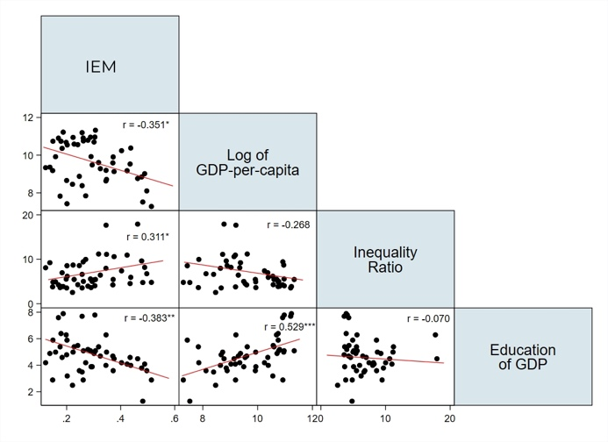
Figure A2. Gender and cohort differences in IEM across countries (standardized).
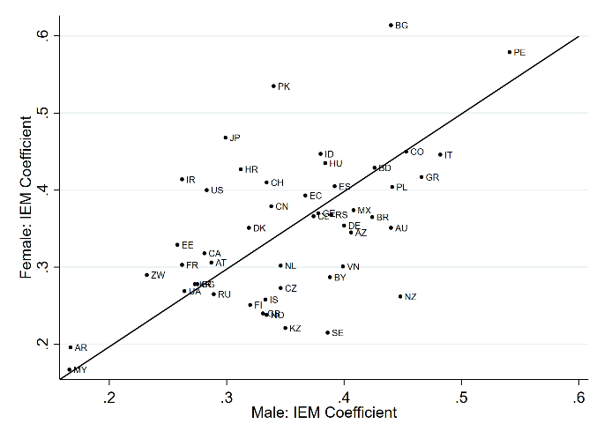
  - IEM coefficients in countries by genders

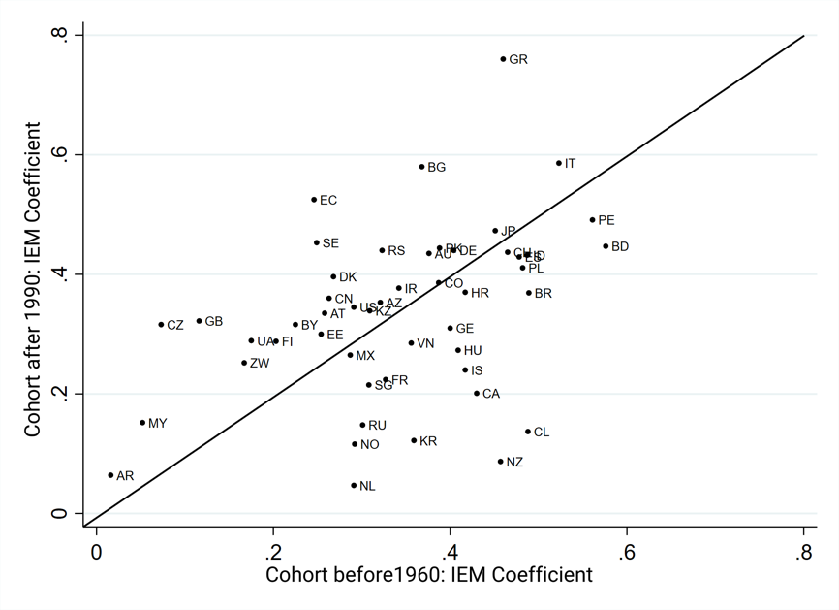
1-2 IEM coefficients in countries by cohorts
Notes. 1. The countries are labeled as the standard country abbreviation (ISO3166-1 Alpha-2code).
2. All the coefficients are statistically significant at the 5% level (two-tailed test).
3. Female and Cohort 25-30 are the reference groups when we calculate gender and cohort differences.

