Appendix S5: Diagrams based on predicted values to evaluate the trend of U5MR
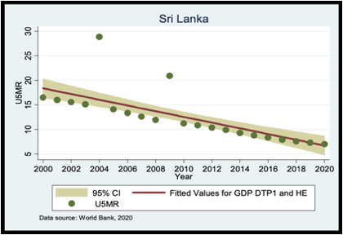
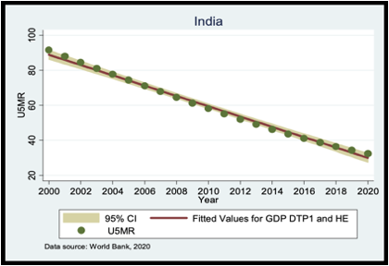
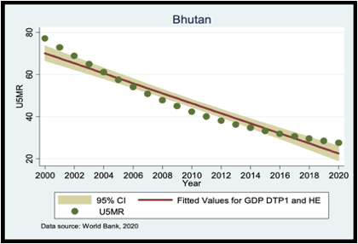
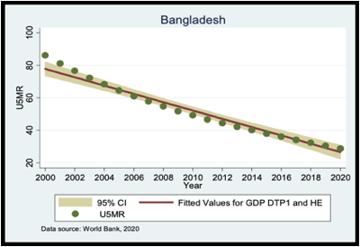

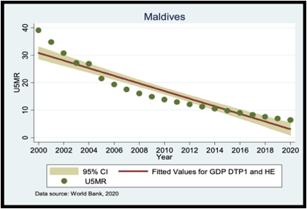
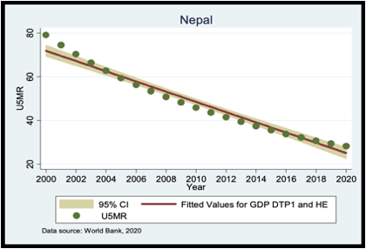

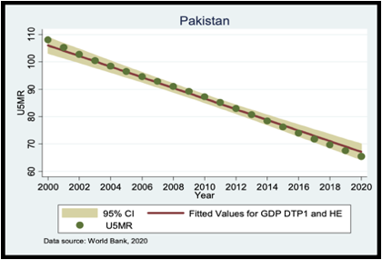

Note: Graphs showing projected Under-5 Mortality Rate (U5MR) trends from 2000 to 2020 for SAARC countries. Each graph includes actual mean U5MR values with standard errors, fitted values based on PGDP, GHE, and DTP1.

