Appendix for:
Repeat collaboration and scientific innovation:
Evidence from dynamic ego networks of Nobel laureates

Appendix
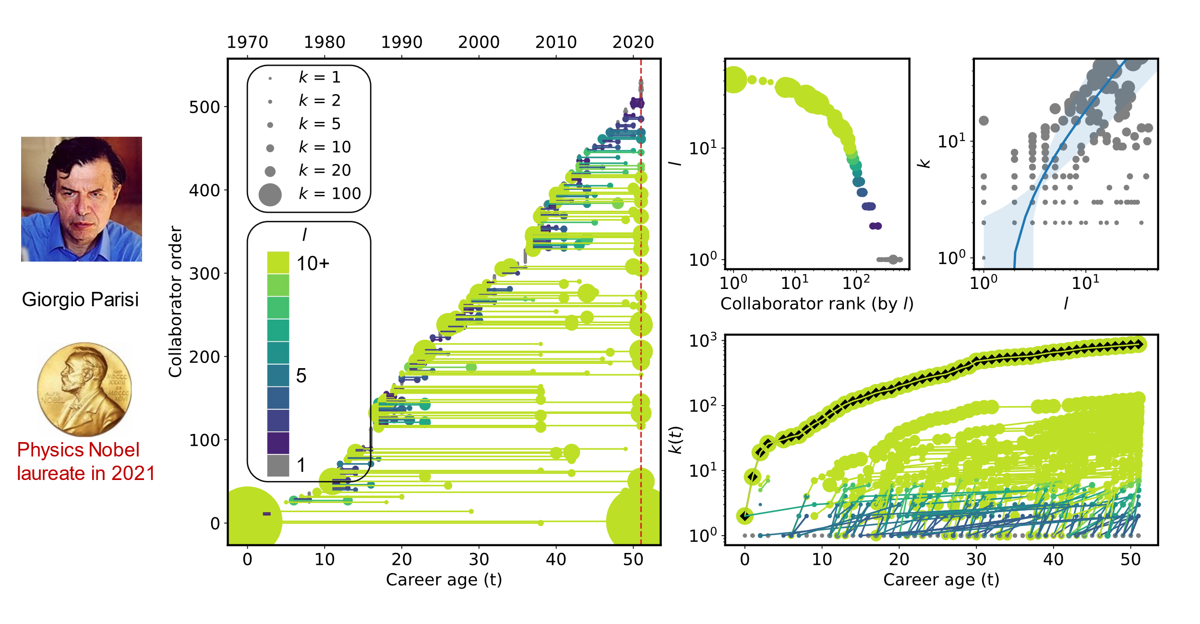
Figure A1. Illustration of repeat collaboration throughout Nobel laureates’ careers by Giorgio Parisi.
Table A1 Relationship between repeat collaboration and scientific innovation (Physics).
Models | (1) | (2) | (3) | (4)
 | Citation (pct) | Disruption (pct) | Novelty (pct) | Interdisciplinarity (pct)
ln ($k(t)$+1) | -0.0331*** (0.0010) | -0.0025*** (0.0003) | -0.0076*** (0.0002) | -0.0024*** (8.15e-5)
ln (Team size) | 0.4043*** (0.0025) | -0.0299*** (0.0007) | -0.0404*** (0.0007) | -0.0028*** (0.0002)
ln ($t$+1) | 1.103*** (0.0138) | 0.1261*** (0.0043) | 0.3919*** (0.0043) | 0.0870*** (0.0016)
ln (Focal author productivity+1) | 0.2075*** (0.0093) | -0.1068*** (0.0032) | -0.0735*** (0.0029) | -0.0077*** (0.0011)
ln (Focal author citations+1) | -0.5507*** (0.0062) | 0.0028* (0.0014) | -0.0443*** (0.0013) | 0.0026*** (0.0005)
Focal author FE | Yes | Yes | Yes | Yes
Year FE | Yes | Yes | Yes | Yes
Obs. | 892,857 | 661,208 | 509,554 | 503,682
R² | 0.25640 | 0.05913 | 0.20217 | 0.16667
Note: All models are estimated using OLS regression. Standard errors, clustered at the focal author level, are reported in parentheses. Statistical significance is indicated as follows: * p < 0.05, ** p < 0.01, *** p < 0.001.

Table A2 Relationship between repeat collaboration and scientific innovation (Chemistry).
Models | (1) | (2) | (3) | (4)
 | Citation (pct) | Disruption (pct) | Novelty (pct) | Interdisciplinarity (pct)
ln ($k(t)$+1) | -0.0046** (0.0016) | -0.0008* (0.0004) | -0.0031*** (0.0005) | -0.0002. (9.73e-5)
ln (Team size) | 0.3179*** (0.0042) | -0.0102*** (0.0011) | 0.0682*** (0.0009) | 0.0037*** (0.0002)
ln ($t$+1) | 0.5208*** (0.0222) | -0.0521*** (0.0065) | 0.0381*** (0.0079) | 0.0177*** (0.0020)
ln (Focal author productivity+1) | -0.4156*** (0.0150) | -0.0057 (0.0046) | -0.0151** (0.0054) | -0.0330*** (0.0014)
ln (Focal author citations+1) | 0.1184*** (0.0078) | 0.0056* (0.0025) | -0.0172*** (0.0030) | 0.0213*** (0.0007)
Focal author FE | Yes | Yes | Yes | Yes
Year FE | Yes | Yes | Yes | Yes
Obs. | 167,674 | 124,524 | 109,328 | 107,374
R² | 0.30571 | 0.11787 | 0.17103 | 0.28190
Note: All models are estimated using OLS regression. Standard errors, clustered at the focal author level, are reported in parentheses. Statistical significance is indicated as follows: * p < 0.05, ** p < 0.01, *** p < 0.001.

Table A3 Relationship between repeat collaboration and scientific innovation (Medicine).
Models | (1) | (2) | (3) | (4)
 | Citation (pct) | Disruption (pct) | Novelty (pct) | Interdisciplinarity (pct)
ln ($k(t)$+1) | -0.0061** (0.0019) | -0.0015*** (0.0004) | -0.0016** (0.0005) | -0.0014*** (9.88e-5)
ln (Team size) | 0.2067*** (0.0037) | -0.0401*** (0.0008) | 0.0539*** (0.0010) | -0.0020*** (0.0001)
ln ($t$+1) | -0.0473* (0.0195) | 0.0301*** (0.0050) | 0.0192** (0.0059) | 0.0275*** (0.0013)
ln (Focal author productivity+1) | 0.0963*** (0.0192) | -0.0671*** (0.0054) | 0.0352*** (0.0060) | 0.0107*** (0.0013)
ln (Focal author citations+1) | -0.0532*** (0.0110) | 0.0200*** (0.0030) | -0.0315*** (0.0033) | -0.0059*** (0.0007)
Focal author FE | Yes | Yes | Yes | Yes
Year FE | Yes | Yes | Yes | Yes
Obs. | 155,989 | 116,368 | 107,982 | 108,085
R² | 0.30406 | 0.17025 | 0.19853 | 0.23769
Note: All models are estimated using OLS regression. Standard errors, clustered at the focal author level, are reported in parentheses. Statistical significance is indicated as follows: * p < 0.05, ** p < 0.01, *** p < 0.001.

