Supplementary Information
Soft disempowerment dynamics in the 2022 FIFA World Cup

Table of Contents
Supplementary Methods 4
Qatar stance detection 4
Identifying actors 4
Supplementary Figures 6
Topic models of Qatar-related tweets 6
Figure S1. Topic distribution of tweets mentioning Qatar with location 7
Figure S2. Topic distribution of tweets mentioning Qatar during the first 4 weeks of the 2022 FIFA World Cup (November 20 - December 18, 2022) 8
Identifying retweet count and the most retweeted tweets 9
Figure S3. Distribution of Qatar stance of the top 100 most retweeted World Cup tweets mentioning Qatar 9
Analysis of association of URLs to criticism towards Qatar 10
Figure S4. Chi-squared test of association between frequency of URL domains and criticism towards Qatar 11
Supplementary Tables 12
Summary of statistics of regression models 12
Table S1. Description of the explanatory variables used in the determinants model 12
Table S2. Descriptive statistics of the variables used in the determinants model 13
Table S3. Description of the explanatory variables used in the size (HNB) and survival (Log-normal AFT) models 14
Table S4. Descriptive statistics of the variables used in the size and survival models 15
regression estimates 16
Table S5. Multilevel mixed-effects logistic regression estimates analyzing the determinants of criticisms towards Qatar 16
Table S6. Regression estimates explaining the size and survival of retweets 17
Assumption checks 18
Table S7. Stationarity tests for time series * 18
Table S8. Multicollinearity tests for the determinants model 19
Table S9. Multicollinearity tests for the size and survival model 20
Table S10. Test for proportional hazards assumption 21
Model comparison 22
Table S11. Comparison of survival models 22
Sample distribution by country 24
Table S12. Valid sample sizes per country and ISO 3166-1 (International Organization for Standardization, 2024) country code 24
Supplementary Section S1 25
Morocco’s qualification in the FIFA World Cup semifinals 25
Figure S5. Daily proportion of critical tweets about Qatar during the 2022 FIFA World Cup 25
Table S13. Parallel trends assessment 26
Table S14. Difference-in-difference estimates explaining the impact of Morocco’s qualification to the FIFA World Cup semifinals on the critical tweets about Qatar 27
Supplementary Section S2 28
Efforts to improve Qatar’s image 28
Table S15. Examples of supportive tweets from selected users 30
References 38

Supplementary Methods

Qatar stance detection
For our stance detection, we had to classify 2,974,570 unique tweet texts. We used the ChatGPT model gpt-4o-mini-2024-07-18 for the stance detection with a temperature of 0, frequency penalty of 0, presence penalty of 0, and max token of 1. The tweet text was classified by directly accessing the API from within R. We minimally preprocessed the text by removing all URLs. We used the following prompt and role description:
Prompt: “Analyze the following tweet and determine if it explicitly mentions criticism or expresses negative sentiment about Qatar or the World Cup in Qatar. Criticism includes, but is not limited to, allegations of corruption, human rights violations, discrimination against LGBT individuals, treatment of journalists, their national team, or negative impacts on the environment. If the tweet criticizes the criticism of Qatar or the World Cup (e.g., mentions hypocrisy of the critics), it should not be classified as negative sentiment towards Qatar or the World Cup. Similarly, if the tweet criticizes Iran without explicitly connecting the criticism to Qatar, it should not be classified as negative sentiment towards Qatar. Reply with 1 if it does, and with 0 if it does not. Reply only with a number. Here is the tweet: [Tweet text]”
Role: “You are a helpful research assistant who classifies the stance of tweets towards the 2022 World Cup in Qatar.”
We then checked and counted the responses that mentioned ‘1’, all other responses were coded as 0. The Cohen’s Kappa was calculated based on 1000 randomly selected tweets that were manually labeled together by the co-authors. Overall, we achieved a Kappa of 0.7212 (Precision=0.962, Recall=0.980) and an accuracy of 0.948.

Identifying actors
We used specific classifiers to identify accounts affiliated with media organizations, NGOs, and Western politicians. Media-affiliated actors were identified by scanning profile descriptions for keywords such as “journalist,” “periodist,” “reporter,” “correspondent,” “anchor,” and “newspaper.” We supplemented this with a curated list of Twitter handles comprising major U.S. new agencies (ercexpo, 2021). In total, we identified 9,111 unique media-affiliated users, achieving 88.91% accuracy based on manual validation. For NGOs and their affiliates, we relied on the United Nations Global Database of Civil Society Organizations (United Nations Department of Economic and Social Affairs, n.d.) and identified accounts who referenced the NGO URLs in their profile descriptions. Western politicians were identified by cross-referencing user accounts with the 2021 Twitter Parliamentarian Database (Van Vliet et al., 2020). We identified 183 unique NGO-affiliated accounts and 258 accounts belonging to Western politicians.

Supplementary Figures

Topic models of Qatar-related tweets
We generated topic models based on the Structural Topic Model framework, using the stm package (Roberts et al., 2019) in R, specifying K = 50 topics. The generated topic models for the entire tweet corpus mentioning Qatar is shown in Figure S1 together with country-specific topic models. Temporal changes in the topics are shown in Figure S2.
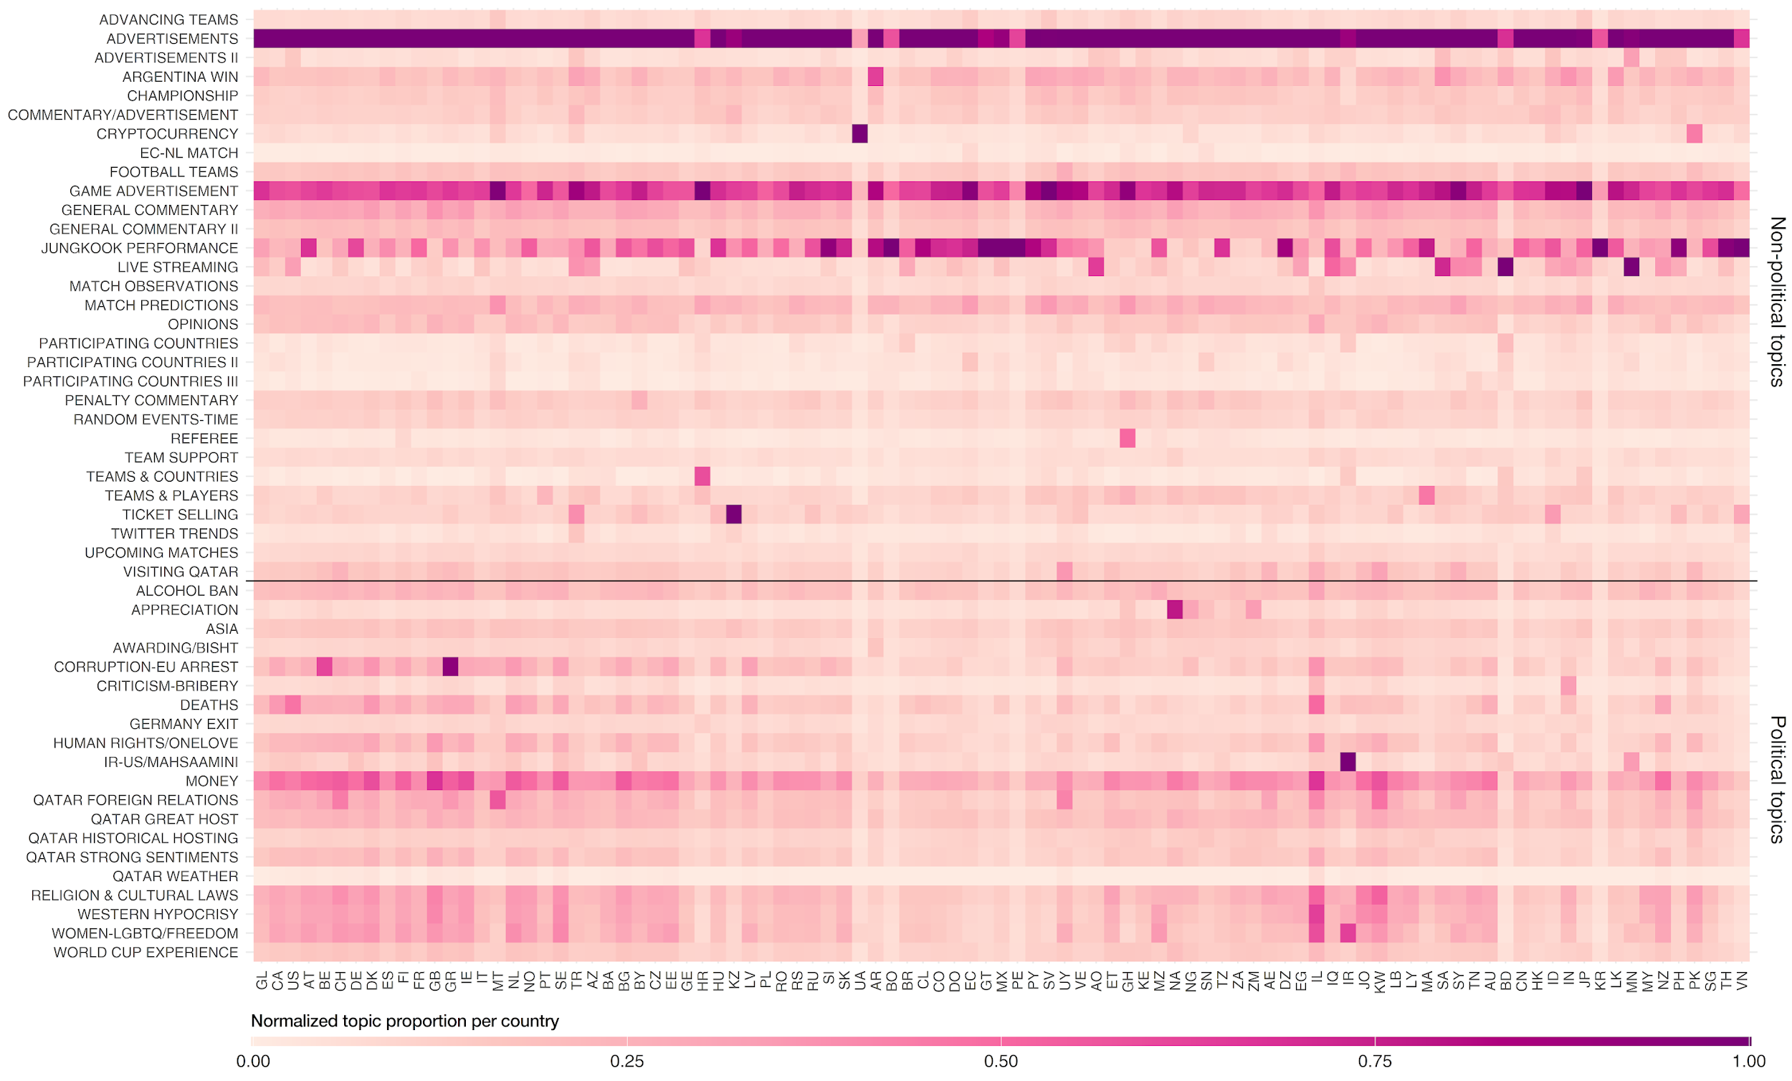

Figure S1. Topic distribution of tweets mentioning Qatar with location

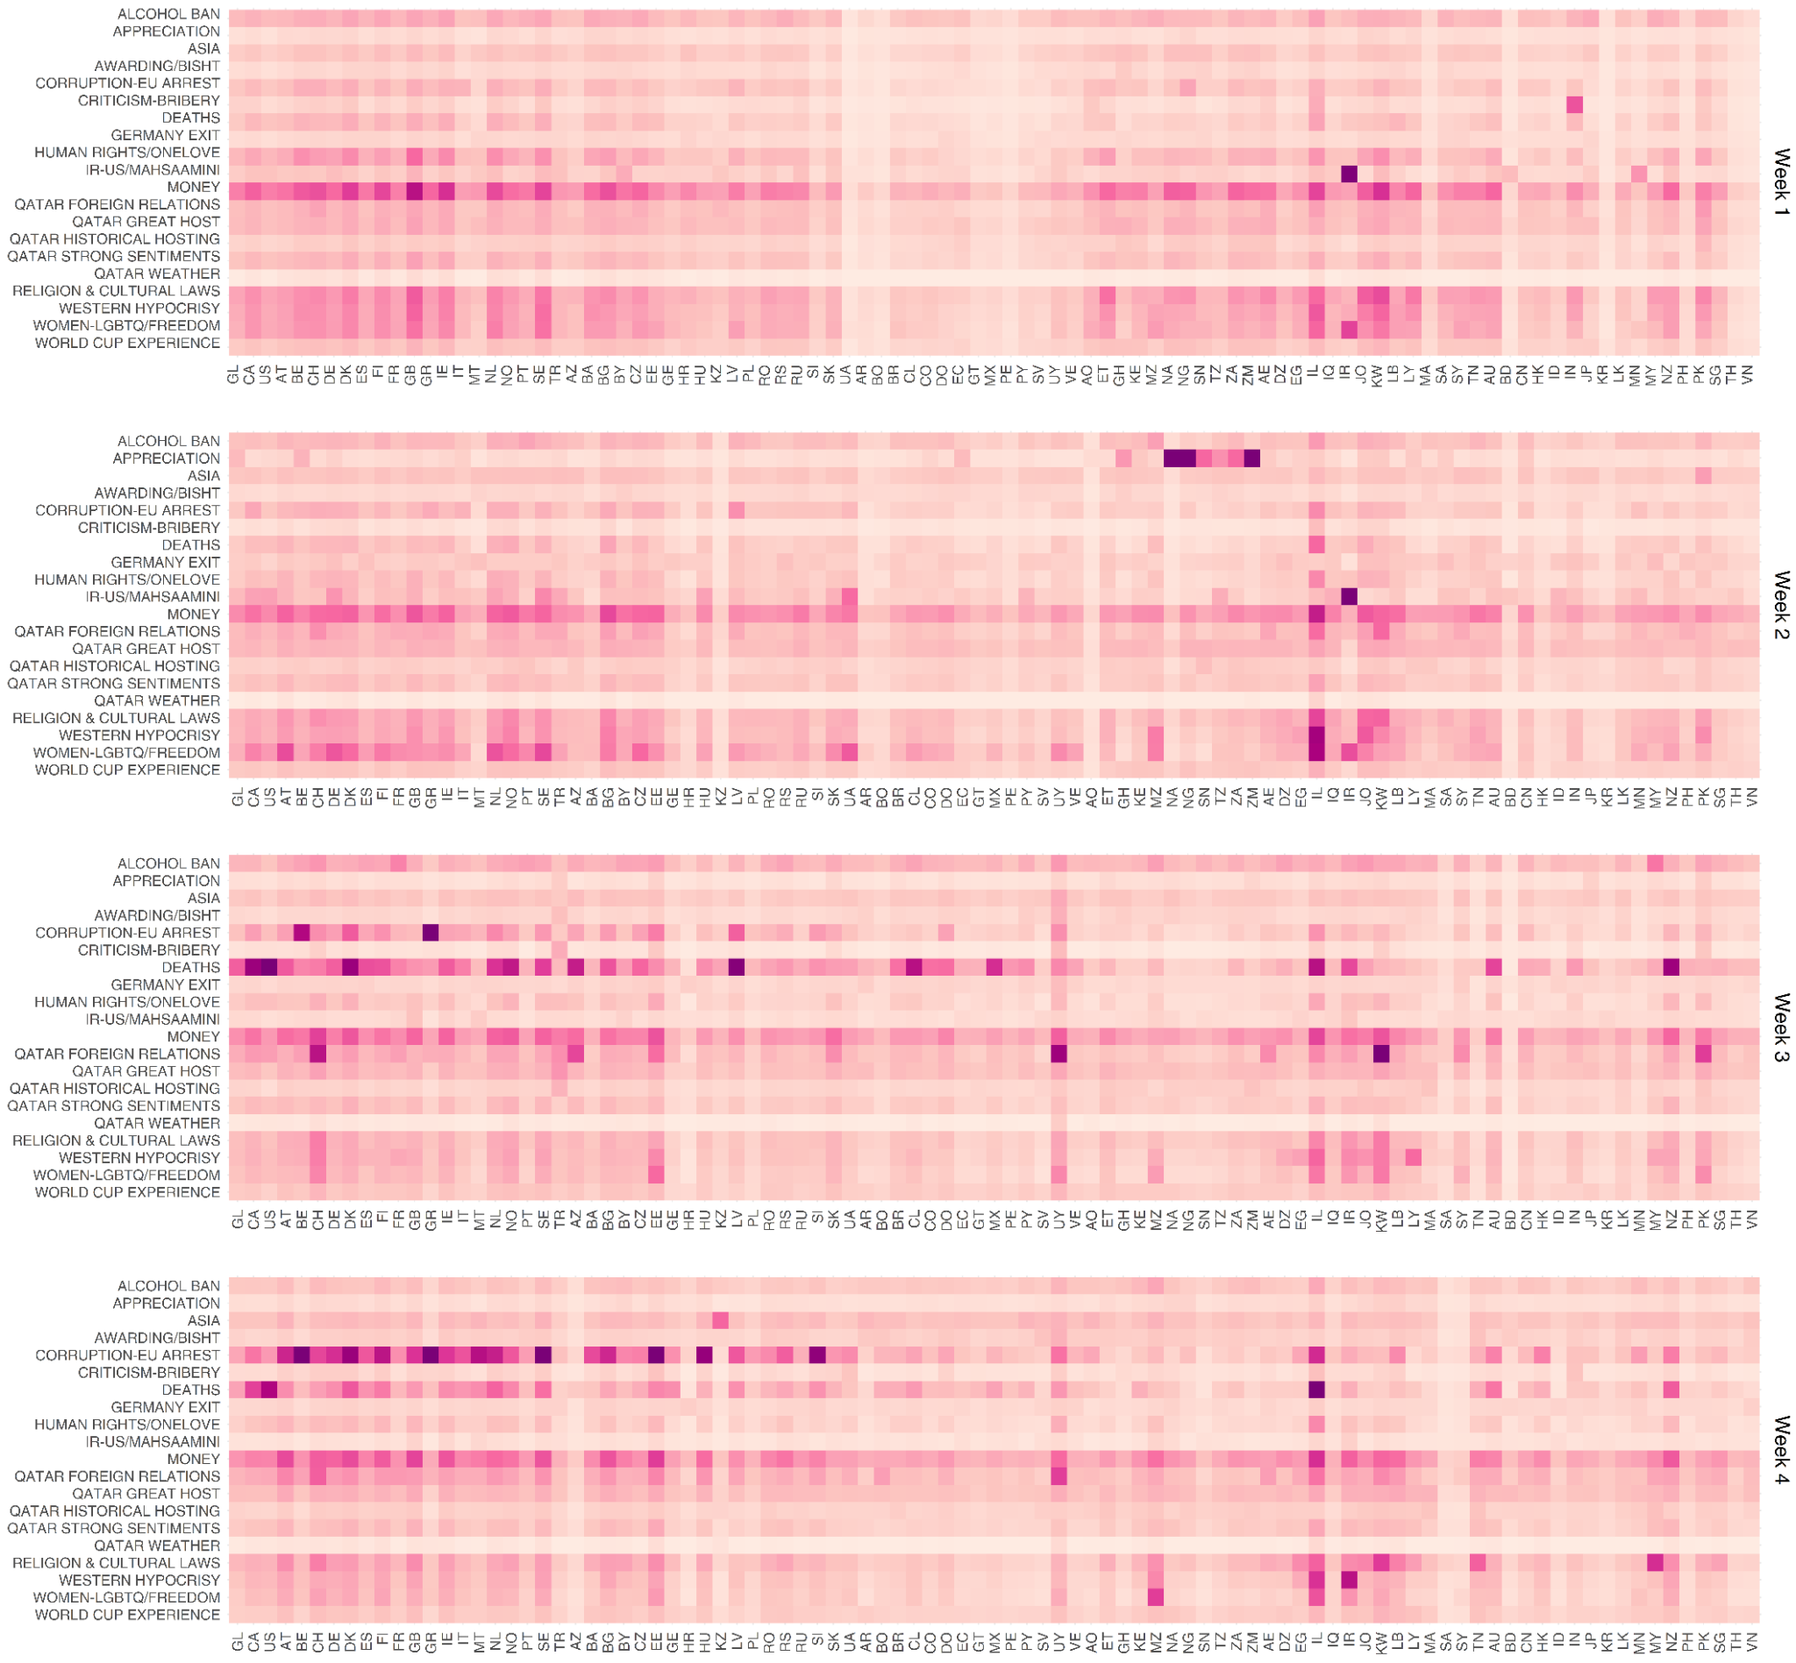

Figure S2. Topic distribution of tweets mentioning Qatar during the first 4 weeks of the 2022 FIFA World Cup (November 20 - December 18, 2022)

Identifying retweet count and the most retweeted tweets
Original tweets and retweets in the World Cup dataset were initially separated. We then matched the id_str column of the original tweets to the retweeted_status.id_str column of the retweets. Since we are limited with data that we were only able to download, we measure the retweet count of each of the original tweets based on the maximum retweet_count among the retweets that matched with a corresponding original tweet id_str. We identified the top 100 most retweeted tweets which mentioned Qatar. Figure S3 shows the Qatar stance of the most retweeted tweets which are ordered most retweeted from top left (number 1) to least retweeted at the bottom right (number 100). Sample tweets are also shown to provide examples. By mapping the stance of the most retweeted tweets with regards to criticisms towards Qatar, we are able to provide an overview of the two-sided debate on Twitter. We see that there are tweets criticizing Qatar for its anti-LGBTQ policies and human rights violations which globally resonated with thousands of users; on the other hand, there are also those who sided with the host country such as by retweeting the message of @binnahar85 who raised the issue on Western hypocrisy to staunchly defend Qatar.
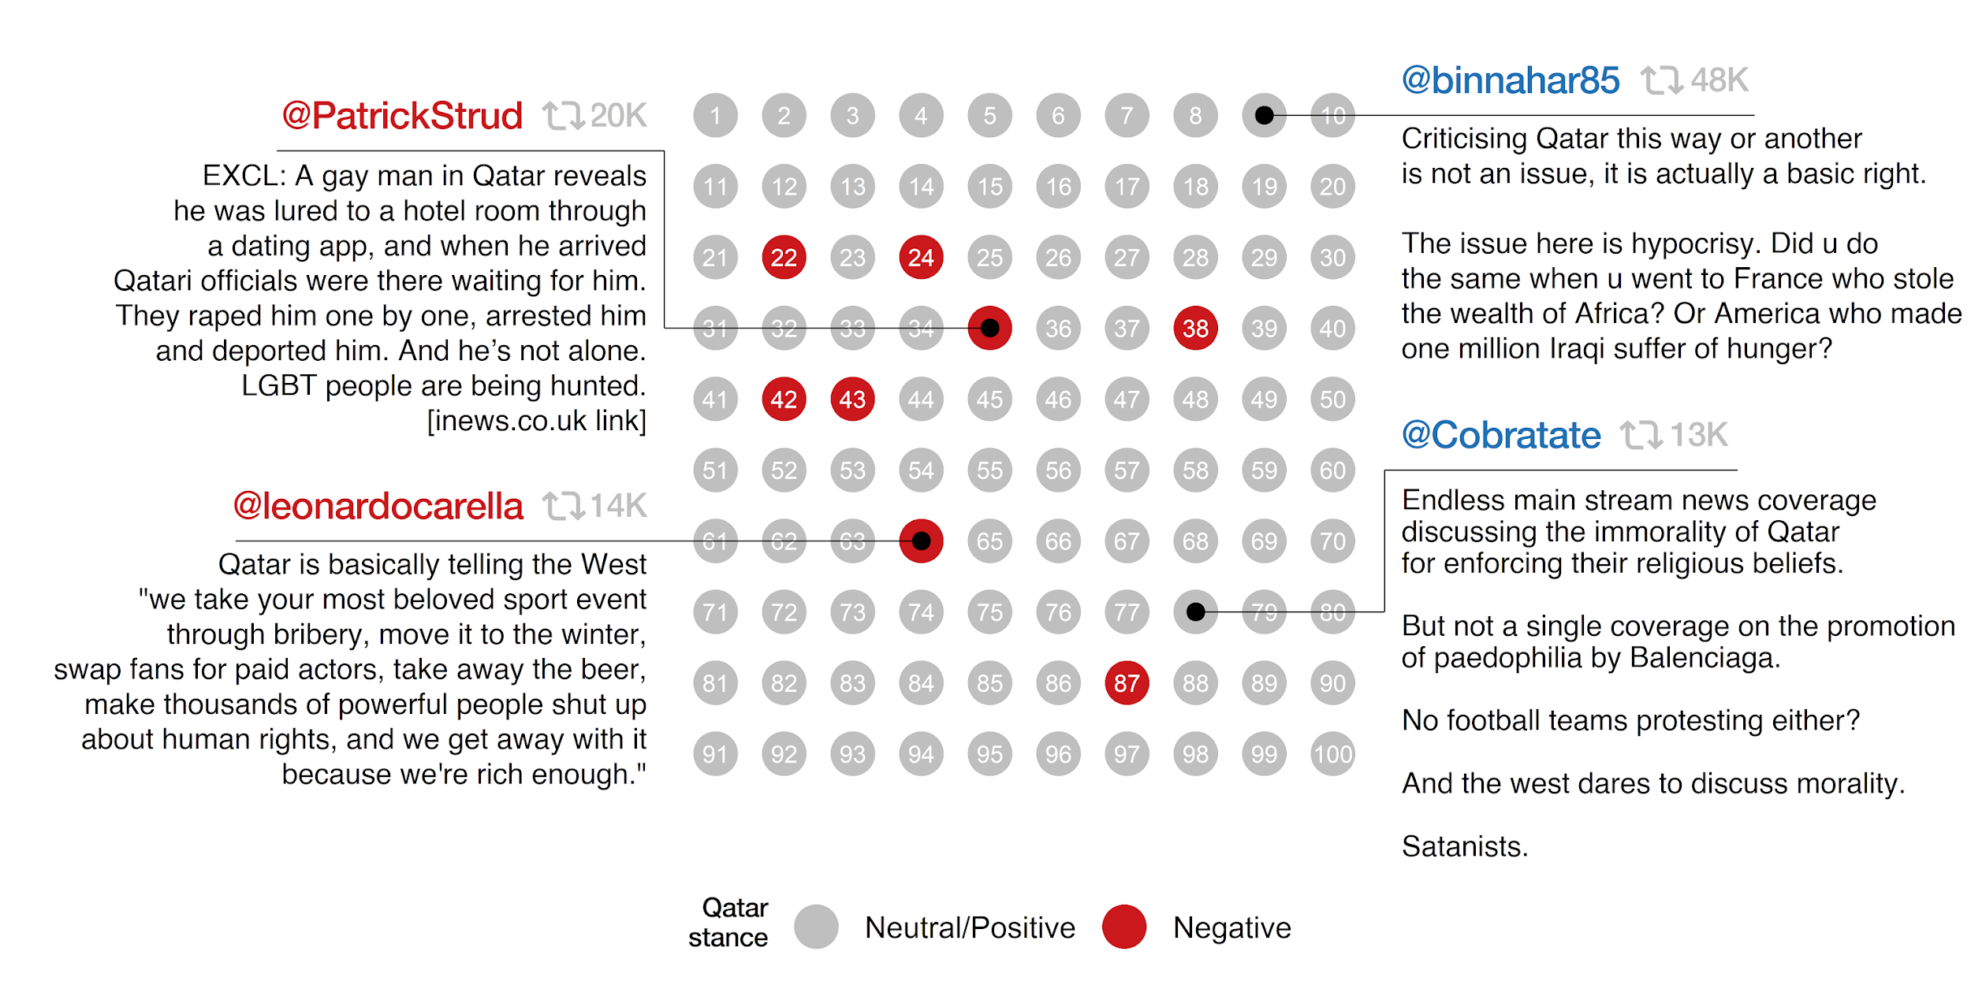

Figure S3. Distribution of Qatar stance of the top 100 most retweeted World Cup tweets mentioning Qatar

Analysis of association of URLs to criticism towards Qatar
There are 1,618,947 non-“twitter.com” URLs retrieved from the original tweets mentioning Qatar. These URLs underwent preprocessing for domain categorization, and their association with Qatar criticism was quantified using chi-squared statistics, analyzing the Qatar stance of the tweet where a URL has been mentioned and the number of retweets of that tweet. Figure S4 illustrates the chi-squared scores and the number of retweets of the top 25 domains most associated with negative criticisms and the top 25 domains associated with positive or neutral tones towards Qatar. Here, we reveal that domains linked to negative criticisms predominantly consist of U.S. or Western European media agencies and non-governmental organizations such as Human Rights Watch and Amnesty International. Domains marketed to gender minority groups are notably among the top domains associated with negative criticisms. Two US government domains were also among this list. On the other hand, domains associated with positive or neutral tone tweets primarily belong to streaming and advertising platforms (online gaming, gambling, marketing, online selling). This alignment is expected, given that promotional statements characterize tweets from these domains. The variation in number of retweets or sample size between criticism and positive or neutral categories is anticipated, considering marketing strategies involving bundled URLs or tweet repetitions.
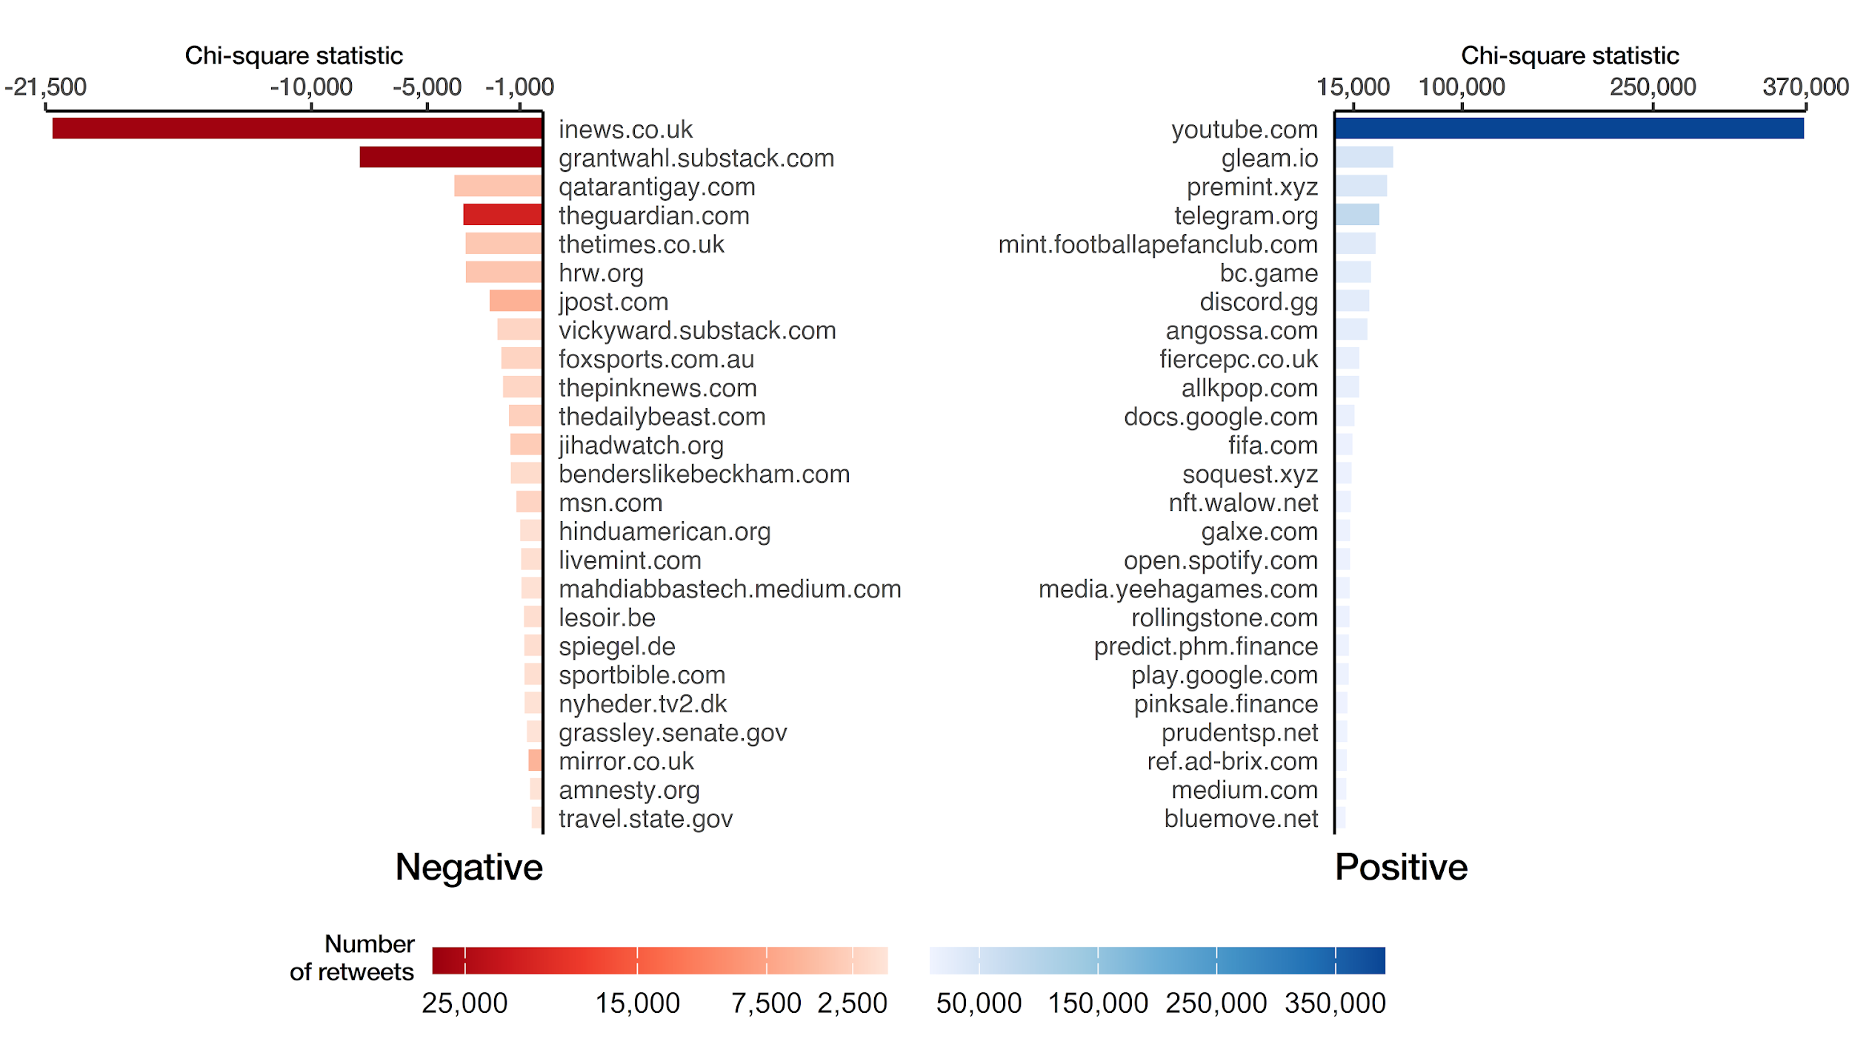

Figure S4. Chi-squared test of association between frequency of URL domains and criticism towards Qatar

Supplementary Tables

Summary of statistics of regression models

Table S1. Description of the explanatory variables used in the determinants model
Variable | Description
Content features
Retweet | 1 if the tweet is a retweet; 0 otherwise
Political | 1 if the tweet was classified as political; 0 otherwise
Hashtag freq. | Number of hashtags contained in the tweet
Mention freq. | Number of users mentioned in the tweet
URL freq. | Number of URLs contained in the tweet
Photo/video | 1 if the tweet contains a photo or video; 0 otherwise
Temporal features
Knockout stage | 1 if the tweet was posted during the knockout stage; 0 otherwise
Post-World Cup | 1 if the tweet was posted after the World Cup; 0 otherwise
During game | 1 if the tweet was posted during a match; 0 otherwise
User handle features
Media | 1 if the user is identified as affiliated with media; 0 otherwise
NGO | 1 if the user is identified as or in affiliation with NGO; 0 otherwise
Western politician | 1 if the user is identified as a Western politician; 0 otherwise
Country-level variable
Democracy index | Democracy index score of the country (Economist Intelligence Unit, 2022)
Muslim population | Percentage of the country’s population that is Muslim, retrieved from Pew Research (2010) (Pew Research Center, 2011)
Cultural distance | Standardized Euclidean cultural distance (Hofstede et al., 2010; The Culture Factor Group, 2023) of the country from Qatar
% Imports | Percentage of Qatar’s share in a country’s total imports, retrieved from World Integrated Trade Solution (WITS) database of the World Bank (World Bank, 2024)
Note: Notation: D = dummy variable; C = continuous variable.

Table S2. Descriptive statistics of the variables used in the Determinants model
 | Mean | Std. Dev. | Min | Max | Skewness | Kurtosis
Dependent Variable
Critical | 0.13 | 0.34 | 0.00 | 0.00 | 1.00 | 1.00
Independent Variables
Retweet | 0.74 | 0.44 | 0.00 | 1.00 | -1.07 | -0.85
Political | 0.28 | 0.45 | 0.00 | 1.00 | 0.98 | -1.04
Hashtag freq. | 1.72 | 2.59 | 0.00 | 48.00 | 2.96 | 14.38
Mention freq. | 1.13 | 1.13 | 0.00 | 51.00 | 11.85 | 402.26
URL freq. | 0.21 | 0.47 | 0.00 | 6.00 | 2.58 | 8.50
Photo/video | 0.55 | 0.50 | 0.00 | 1.00 | -0.20 | -1.96
Knockout stage | 0.32 | 0.47 | 0.00 | 1.00 | 0.76 | -1.42
Post-World Cup | 0.09 | 0.28 | 0.00 | 1.00 | 2.95 | 6.73
During game | 0.25 | 0.43 | 0.00 | 1.00 | 1.19 | -0.60
Media | 0.02 | 0.13 | 0.00 | 1.00 | 7.45 | 53.46
NGO | 0.00 | 0.02 | 0.00 | 1.00 | 57.96 | 3357.61
Western politician | 0.00 | 0.01 | 0.00 | 1.00 | 89.65 | 8034.87
Democracy index | 6.85 | 1.71 | 1.43 | 9.81 | -1.04 | 0.31
Muslim population | 20.47 | 30.73 | 0.01 | 99.90 | 1.61 | 1.10
Cultural distance | 3.17 | 1.26 | 0.87 | 6.29 | 0.10 | -1.31
% imports | 0.46 | 0.80 | 0.00 | 3.24 | 2.19 | 3.56

Table S3. Description of the explanatory variables used in the Size (HNB) and Survival (Log-normal AFT) models
Variable | Description
Content features
Critical | 1 if the content of the tweet is critical towards Qatar; 0 otherwise
Hashtag freq. | Number of hashtags contained in the tweet
Mention freq. | Number of users mentioned in the tweet
URL freq. | Number of URLs contained in the tweet
Photo/video | 1 if the tweet contains a photo or video; 0 otherwise
User handle features
Log (followers) | Number of users following the handle (log-transformed)
Log (friends) | Number of users followed by the handle (log-transformed)
Log (status) | Number of tweets posted by the handle prior to the tweet (log-transformed)
Media | 1 if the user is identified as or in affiliation with media; 0 otherwise
NGO | 1 if the user is identified as or in affiliation with NGO; 0 otherwise
Western politician | 1 if the user is identified as a Western politician; 0 otherwise
Temporal features
Knockout stage | 1 if the tweet was posted during the knockout stage; 0 otherwise
Post-World Cup | 1 if the tweet was posted after the World Cup; 0 otherwise
During game | 1 if the tweet was posted during a match; 0 otherwise
Note: Log-transformation was applied using the formula log(x+1) to address instances where followers, friends or statuses recorded 0 values.

Table S4. Descriptive statistics of the variables used in the Size and Survival models
 | Mean | Std. Dev. | Min | Max | Skewness | Kurtosis
Size model (N = 2,974,570)
Dependent Variable
Retweet count | 2.59 | 211.62 | 0.00 | 196720.00 | 610.90 | 464073.45
Independent Variables
Critical | 0.11 | 0.31 | 0.00 | 1.00 | 2.49 | 4.22
Hashtag freq. | 2.60 | 3.44 | 0.00 | 48.00 | 1.88 | 5.23
Mention freq. | 0.66 | 1.62 | 0.00 | 51.00 | 8.91 | 184.40
URL freq. | 0.55 | 0.71 | 0.00 | 8.00 | 1.40 | 2.52
Photo/video | 0.32 | 0.47 | 0.00 | 1.00 | 0.75 | -1.43
Log (followers) | 4.42 | 3.11 | 0.00 | 18.58 | 0.49 | -0.09
Log (friends) | 4.79 | 2.25 | 0.00 | 14.65 | -0.23 | -0.69
Log (status) | 7.83 | 2.43 | 0.69 | 15.35 | -0.25 | -0.11
Media | 0.02 | 0.13 | 0.00 | 1.00 | 7.17 | 49.43
NGO | 0.00 | 0.02 | 0.00 | 1.00 | 65.12 | 4238.32
Western politician | 0.00 | 0.01 | 0.00 | 1.00 | 105.54 | 11135.70
Knockout stage | 0.29 | 0.45 | 0.00 | 1.00 | 0.92 | -1.15
Post-World Cup | 0.06 | 0.24 | 0.00 | 1.00 | 3.56 | 10.70
During game | 0.40 | 0.49 | 0.00 | 1.00 | 0.40 | -1.84
Survival model (N = 323,554)
Dependent Variable
Time interval | 74748.91 | 226484.75 | 1.00 | 3502264.00 | 6.57 | 56.92
Independent Variables
Critical | 0.13 | 0.34 | 0.00 | 1.00 | 2.18 | 2.77
Hashtag freq. | 2.43 | 3.58 | 0.00 | 38.00 | 2.75 | 10.53
Mention freq. | 0.62 | 1.79 | 0.00 | 50.00 | 14.04 | 330.48
URL freq. | 0.28 | 0.50 | 0.00 | 5.00 | 1.84 | 4.71
Photo/video | 0.55 | 0.50 | 0.00 | 1.00 | -0.20 | -1.96
Log (followers) | 7.77 | 3.27 | 0.00 | 18.58 | 0.11 | -0.19
Log (friends) | 5.99 | 1.98 | 0.00 | 14.65 | -0.54 | 0.56
Log (status) | 9.06 | 2.45 | 0.69 | 15.24 | -0.68 | 0.23
Media | 0.06 | 0.24 | 0.00 | 1.00 | 3.70 | 11.70
NGO | 0.00 | 0.03 | 0.00 | 1.00 | 29.89 | 891.27
Western politician | 0.00 | 0.03 | 0.00 | 1.00 | 39.50 | 1558.05
Knockout stage | 0.32 | 0.47 | 0.00 | 1.00 | 0.75 | -1.43
Post-World Cup | 0.08 | 0.27 | 0.00 | 1.00 | 3.17 | 8.02
During game | 0.26 | 0.44 | 0.00 | 1.00 | 1.08 | -0.84

Regression estimates

Table S5. Multilevel mixed-effects logistic regression estimates analyzing the determinants of criticisms towards Qatar
Predictors | Coef. | [95% CrI]
Fixed effects
(Intercept) | -3.359 | [-3.449, -3.264]
Country-level features
Democracy index | 0.113 | [0.025, 0.201]
Muslim population | -0.090 | [-0.174, -0.010]
Cultural distance | 0.168 | [0.072, 0.268]
% Imports | -0.261 | [-0.393, -0.120]
Actor features
Media | 0.062 | [0.037, 0.085]
NGO | 1.522 | [1.383, 1.659]
Western politician | 0.770 | [0.564, 0.974]
Content features
Retweet | 0.058 | [0.050, 0.066]
Political | 2.740 | [2.731, 2.748]
Hashtag freq. | -0.258 | [-0.264, -0.253]
Mention freq. | -0.007 | [-0.010, -0.004]
URL freq. | 0.065 | [0.061, 0.069]
Photo/Video | -0.401 | [-0.409, -0.394]
Temporal features
Knockout stage | -0.115 | [-0.123, -0.107]
Post-World Cup | -0.330 | [-0.342, -0.316]
During game | -0.090 | [-0.099, -0.082]
Random Effects
SD (intercept) | 0.383 | [0.333, 0.439]
Number of observations | 4,092,297
Number of clusters | 103
Note: Our analysis covers all tweets with valid locations, including countries with available values for all the country-level variables. Continuous variables are standardized prior to estimations.

Table S6. Regression estimates explaining the size and survival of retweets
 | Size |  | Survival
Predictors | Coef. | [95% CrI] | Coef. | [95% CrI]
(Intercept) | -1.227 | [-1.253, -1.202] | 7.606 | [7.560, 7.652]
Critical | 0.227 | [0.209, 0.244] | 0.729 | [0.699, 0.759]
Hashtag freq. | -0.021 | [-0.023, -0.019] | -0.036 | [-0.039, -0.033]
Mention freq. | 0.094 | [0.089, 0.099] | -0.027 | [-0.033, -0.022]
URL freq. | -0.757 | [-0.767, -0.748] | -0.539 | [-0.560, -0.518]
Photo/Video | 1.420 | [1.408, 1.432] | 0.271 | [0.250, 0.291]
Log (followers) | 0.689 | [0.686, 0.692] | 0.316 | [0.311, 0.320]
Log (friends) | -0.098 | [-0.102, -0.094] | 0.054 | [0.048, 0.060]
Log (status) | -0.345 | [-0.348, -0.342] | -0.185 | [-0.191, -0.179]
Media | 0.039 | [0.002, 0.076] | -0.104 | [0.147, -0.062]
NGO | 0.104 | [-0.200, 0.428] | 0.843 | [0.563, 1.125]
Western politician | 1.213 | [0.732, 1.754] | 1.115 | [0.727, 1.496]
Knockout stage | -0.223 | [-0.235, -0.210] | -0.010 | [-0.033, 0.012]
Post-World Cup | -0.192 | [-0.216, -0.169] | 0.480 | [0.442, 0.521]
During game | 0.127 | [0.113, 0.140] | -0.947 | [-0.970, -0.924]
Observations | 2,974,570 |  | 323,554
The Size Model panel shows the estimates of the negative binomial regression analyzing the number of retweets. The Survival Model panel shows the estimates of the log-normal AFT regression analyzing the duration between the original tweet and the last retweet.

Assumption checks

Table S7. Stationarity tests for time series *
 | Political | Critical
ADF test ª
Dickey-Fuller | -12.871 | -11.176
p-value | 0.01 | 0.01
Stationarity | Stationary | Stationary
KPSS test for Level Stationarity ^{b}
KPSS level | 0.0055518 | 0.0081975
p-value | 0.1 | 0.1
Stationarity | Stationary | Stationary
KPSS test for Trend Stationarity ^{c}
KPSS trend | 0.0054236 | 0.0082169
p-value | 0.1 | 0.1
Stationarity | Stationary | Stationary
ª The null hypothesis for the Augmented Dickey-Fuller (ADF) test is that the time-series contains a unit root, implying non-stationarity. A significant p-value suggests that we reject the null hypothesis in favor of stationarity.
^{b} The null hypothesis for the Kwiatkowski-Phillips-Schmidt-Shin (KPSS) test for level stationarity is that the time-series is stationary around a constant mean (level). A non-significant p-value suggests that we fail to reject the null hypothesis, implying that the time series is stationary around a constant mean.
^{c} The null hypothesis for the KPSS test for trend stationarity is that the time-series is stationary around a deterministic linear trend. A non-significant p-value suggests that we fail to reject the null hypothesis, implying that the time series is stationary around a linear trend.
* Both time series were differenced prior to estimation to account for initial non-stationarity.

Table S8. Multicollinearity tests for the determinants model
Predictors | VIF | 95% CrI
Retweet | 1.110 | [1.109, 1.111]
Political | 1.096 | [1.095, 1.097]
Hashtag freq. | 1.111 | [1.110, 1.112]
Mention freq. | 1.022 | [1.021, 1.023]
URL freq. | 1.076 | [1.075, 1.077]
Photo/video | 1.118 | [1.117, 1.119]
Knockout stage | 1.106 | [1.105, 1.107]
Post-World Cup | 1.082 | [1.080, 1.083]
During game | 1.071 | [1.070, 1.072]
Media | 1.012 | [1.011, 1.013]
NGO | 1.004 | [1.003, 1.005]
Western politician | 1.002 | [1.001, 1.003]
Democracy index | 2.236 | [2.232, 2.239]
Muslim population | 1.663 | [1.660, 1.665]
Cultural distance | 1.961 | [1.958, 1.963]
% Imports | 1.043 | [1.042, 1.044]
Note: The Variance Inflation Factor (VIF) values for all predictors were found to be below 5, indicating the absence of significant multicollinearity among the independent variables.

Table S9. Multicollinearity tests for the size and survival model
 | Size |  | Survival
Predictors | VIF | 95% CrI | VIF | 95% CrI
Critical | 1.057 | [1.056, 1.059] | 1.058 | [1.054, 1.062]
Hashtag freq. | 1.178 | [1.176, 1.179] | 1.113 | [1.108, 1.117]
Mention freq. | 1.188 | [1.187, 1.190] | 1.033 | [1.029, 1.037]
URL freq. | 1.144 | [1.142, 1.145] | 1.088 | [1.084, 1.092]
Photo/video | 1.145 | [1.143, 1.146] | 1.121 | [1.116, 1.125]
Log (followers) | 3.296 | [3.290, 3.303] | 2.231 | [2.219, 2.243]
Log (friends) | 2.445 | [2.440, 2.449] | 1.382 | [1.376, 1.388]
Log (status) | 2.643 | [2.638, 2.648] | 2.451 | [2.438, 2.465]
Media | 1.060 | [1.059, 1.061] | 1.066 | [1.062, 1.070]
NGO | 1.006 | [1.005, 1.007] | 1.014 | [1.011, 1.018]
Western politician | 1.003 | [1.002, 1.004] | 1.005 | [1.003, 1.010]
Knockout stage | 1.097 | [1.096, 1.099] | 1.111 | [1.107, 1.115]
Post-World Cup | 1.115 | [1.113, 1.116] | 1.091 | [1.087, 1.095]
During game | 1.242 | [1.241, 1.244] | 1.086 | [1.082, 1.090]
Note: The Variance Inflation Factor (VIF) values for all predictors were found to be below 5, indicating the absence of significant multicollinearity among the independent variables.

Table S10. Test for proportional hazards assumption
Parameter | Chi-squared | df | p
Critical | 1047.809 | 1 | < 0.001
Hashtag freq. | 3663.188 | 1 | < 0.001
Mention freq. | 263.134 | 1 | < 0.001
URL freq. | 887.214 | 1 | < 0.001
Photo/video | 283.712 | 1 | < 0.001
Log (followers) | 10049.945 | 1 | < 0.001
Log (friends) | 4065.649 | 1 | < 0.001
Log (status) | 8228.196 | 1 | < 0.001
Media | 497.888 | 1 | < 0.001
NGO | 39.555 | 1 | < 0.001
Western politician | 39.383 | 1 | < 0.001
Knockout stage | 281.239 | 1 | < 0.001
Post-World Cup | 1117.247 | 1 | < 0.001
During game | 4447.311 | 1 | < 0.001
Global | 19468.674 | 14 | < 0.001
Note: We detected significant deviation from the proportional hazards assumption across all our covariates. Similarly, the global test is also significant, further confirming the presence of non-proportional hazards.

Model comparison

Table S11. Comparison of survival models
 | Cox’s Proportional Hazards | Exponential AFT | Weibull AFT | Log-normal AFT
Predictors | Coef.  [95% CrI] | Coef.  [95% CrI] | Coef.  [95% CrI] | Coef.  [95% CrI]
(Intercept) | 2.685  [2.659, 2.71] | 11.281  [11.264, 11.298] | 10.784  [10.743, 10.826] | 7.606  [7.560, 7.652]
Critical | -0.251  [-0.261, -0.240] | 0.355  [0.344, 0.366] | 0.535  [0.509, 0.561] | 0.729  [0.699, 0.759]
Hashtag freq. | -0.002  [-0.003, -0.001] | 0.017  [0.016, 0.018] | -0.005  [-0.008, -0.003] | -0.036  [-0.039, -0.033]
Mention freq. | 0.003  [0.002, 0.005] | 0.001  [-0.001, 0.002] | -0.009  [-0.013, -0.004] | -0.027  [-0.033, -0.022]
URL freq. | 0.127  [0.12, 0.134] | -0.125  [-0.132, -0.118] | -0.297  [-0.313, -0.28] | -0.539  [-0.560, -0.518]
Photo/video | -0.181  [-0.188, -0.173] | 0.35  [0.342, 0.358] | 0.334  [0.316, 0.352] | 0.271  [0.250, 0.291]
Log (followers) | -0.113  [-0.115, -0.112] | 0.165  [0.164, 0.167] | 0.236  [0.232, 0.239] | 0.316  [0.311, 0.320]
Log (friends) | -0.017  [-0.019, -0.015] | 0.024  [0.022, 0.026] | 0.04  [0.035, 0.045] | 0.054  [0.048, 0.060]
Log (status) | 0.107  [0.105, 0.109] | -0.19  [-0.192, -0.188] | -0.2  [-0.205, -0.194] | -0.185  [-0.191, -0.179]
Media | 0.051  [0.036, 0.065] | -0.074  [-0.089, -0.059] | -0.098  [-0.136, -0.060] | -0.104  [-0.147, -0.062]
NGO | -0.31  [-0.412, -0.208] | 0.388  [0.287, 0.493] | 0.682  [0.432, 0.939] | 0.843  [0.563, 1.125]
Western politician | -0.385  [-0.528, -0.246] | 0.488  [0.355, 0.625] | 0.810  [0.477, 1.15] | 1.115  [0.727, 1.496]
Knockout stage | 0.044  [0.036, 0.052] | -0.152  [-0.160, -0.144] | -0.048  [-0.068, -0.029] | -0.010  [-0.033, 0.012]
Post-World Cup | -0.066  [-0.081, -0.052] | -0.122  [-0.135, -0.108] | 0.28  [0.245, 0.315] | 0.480  [0.442, 0.521]
During game | 0.257  [0.248, 0.265] | -0.286  [-0.294, -0.278] | -0.579  [-0.599, -0.559] | -0.947  [-0.970, -0.924]
LOOIC | 7,180,241 | 7,787,830 | 7,037,406 | 7,032,991
Observations | 323,554
Note: We tested several AFT models in addition to the PH model. The log-normal AFT model demonstrated superior fit in terms of LOOIC, as well as frequentist metrics such as AIC, BIC and log-likelihood. Due to computational constraints, we computed LOOIC using 3,000 draws. Other distributions for AFT (e.g., Gaussian, Logistic, Rayleigh) were also tested, but yielded worse performance.
It is important to note that Cox’s model assesses proportional hazards, where a positive coefficient is associated with higher hazards and shorter survival. In contrast, for AFT models, coefficients are expressed as logarithms of ratios of survival times, with a positive coefficient indicating longer survival.
Notations: PH = Proportional Hazards, AFT = Accelerated Failure Time, LOOIC = leave-one-out cross-validation information criterion

Sample distribution by country

Table S12. Valid sample sizes per country and ISO 3166-1 (International Organization for Standardization, 2024) country code

 | Country | N_{i} | A-2 code
1 | Albania | 987 | AL
2 | Algeria | 6775 | DZ
3 | Angola | 1092 | AO
4 | Argentina | 39210 | AR
5 | Armenia | 753 | AM
6 | Australia | 66427 | AU
7 | Austria | 7616 | AT
8 | Azerbaijan | 1425 | AZ
9 | Bangladesh | 52361 | BD
10 | Belarus | 2325 | BY
11 | Belgium | 17333 | BE
12 | Bolivia | 2130 | BO
13 | Bosnia and Herzegovina | 1105 | BA
14 | Brazil | 55478 | BR
15 | Bulgaria | 2965 | BG
16 | Burkina Faso | 943 | BF
17 | Canada | 119063 | CA
18 | Cape Verde | 44 | CV
19 | Chile | 9546 | CL
20 | China | 14724 | CN
21 | Colombia | 16879 | CO
22 | Croatia | 5507 | HR
23 | Czech Republic | 3988 | CZ
24 | Denmark | 4006 | DK
25 | Dominican Republic | 2190 | DO
26 | Ecuador | 12806 | EC
27 | Egypt | 18475 | EG
28 | El Salvador | 4159 | SV
29 | Estonia | 1207 | EE
30 | Ethiopia | 4106 | ET
31 | Finland | 8987 | FI
32 | France | 81102 | FR
33 | Georgia | 1081 | GE
34 | Germany | 63609 | DE
35 | Ghana | 220478 | GH
36 | Greece | 8008 | GR
37 | Guatemala | 3743 | GT
38 | Hong Kong | 8559 | HK
39 | Hungary | 3383 | HU
40 | Iceland | 871 | IS
41 | India | 365163 | IN
42 | Indonesia | 133103 | ID
43 | Iran | 30585 | IR
44 | Iraq | 4527 | IQ
45 | Ireland | 27738 | IE
46 | Israel | 6936 | IL
47 | Italy | 31737 | IT
48 | Japan | 74016 | JP
49 | Jordan | 3627 | JO
50 | Kazakhstan | 2773 | KZ
51 | Kenya | 109448 | KE
52 | Kuwait | 7057 | KW
53 | Latvia | 1227 | LV
54 | Lebanon | 3185 | LB
55 | Libya | 1871 | LY
56 | Lithuania | 772 | LT
57 | Luxembourg | 863 | LU
58 | Malaysia | 64857 | MY
59 | Malta | 1507 | MT
60 | Mexico | 36365 | MX
61 | Moldova | 524 | MD
62 | Mongolia | 1614 | MN
63 | Montenegro | 331 | ME
64 | Morocco | 16655 | MA
65 | Mozambique | 1648 | MZ
66 | Namibia | 5460 | NA
67 | Netherlands | 22375 | NL
68 | New Zealand | 8222 | NZ
69 | Nigeria | 326505 | NG
70 | Norway | 8370 | NO
71 | Pakistan | 129702 | PK
72 | Paraguay | 3977 | PY
73 | Peru | 14042 | PE
74 | Philippines | 44714 | PH
75 | Poland | 11926 | PL
76 | Portugal | 12831 | PT
77 | Romania | 6566 | RO
78 | Russia | 13784 | RU
79 | Saudi Arabia | 36946 | SA
80 | Senegal | 6243 | SN
81 | Serbia | 2966 | RS
82 | Singapore | 13258 | SG
83 | Slovakia | 1834 | SK
84 | Slovenia | 1684 | SI
85 | South Africa | 104885 | ZA
86 | South Korea | 29712 | KR
87 | Spain | 39926 | ES
88 | Sri Lanka | 7817 | LK
89 | Sweden | 10750 | SE
90 | Switzerland | 11680 | CH
91 | Syria | 2302 | SY
92 | Tanzania | 17734 | TZ
93 | Thailand | 26752 | TH
94 | Tunisia | 2283 | TN
95 | Turkey | 20436 | TR
96 | UK | 518248 | GB
97 | Ukraine | 8860 | UA
98 | United Arab Emirates | 31221 | AE
99 | Uruguay | 3771 | UY
100 | USA | 756484 | US
101 | Venezuela | 9830 | VE
102 | Vietnam | 9187 | VN
103 | Zambia | 5439 | ZM
N_{i} = valid number of tweets per country i in the determinants regression models

Supplementary Section S1

Morocco’s Qualification in the FIFA World Cup Semifinals
We aim to capture the effects of the qualification of Morocco to the semifinals on the proportion of critical tweets about Qatar among Twitter users. Figure S5 shows the timeline of the matches of Morocco, as well as the daily proportion of critical tweets about Qatar, including those written by users from Arab nations (Algeria, Bahrain, Comoros, Djibouti, Egypt, Iraq, Jordan, Kuwait, Lebanon, Libya, Mauritania, Morocco, Oman, Palestine, Qatar, Saudi Arabia, Somalia, Sudan, Syria, Tunisia, the United Arab Emirates, and Yemen).
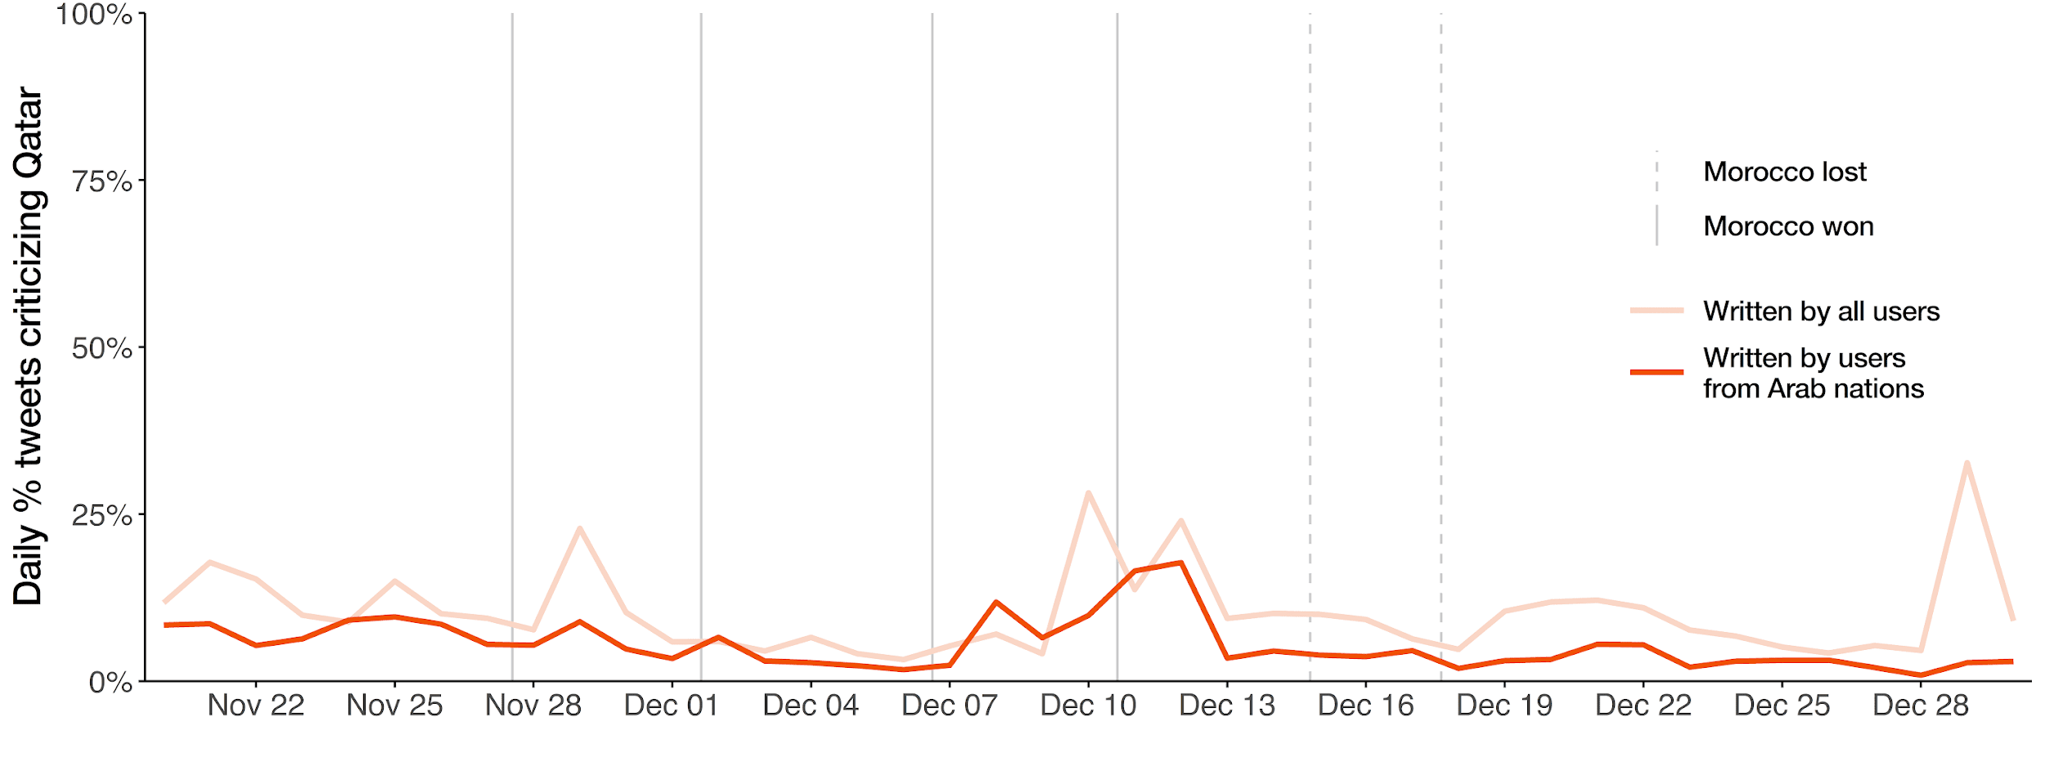

Figure S5. Daily proportion of critical tweets about Qatar during the 2022 FIFA World Cup
Note: From December 10 to December 13, there is an increase to the proportion of critical tweets. Upon manual checking, these included discussions about the arrest of Eva Kaili over the European Parliament corruption scandal or Qatargate scandal, as news about this issue coincided with the qualification of Morocco to the semifinals.

We conducted a difference-in-difference (DiD) analysis, using the aggregated daily proportion of critical tweets about Qatar as the outcome variable. The tweets were written from November 20 to December 30, 2022 and the analysis was structured based on two groups: Arab countries (treatment group) and non-Arab countries (control group). Morocco secured its place in the semifinals on December 10, 2022, making history as the first African and Arab nation to reach this stage of the tournament. To assess potential changes in the sentiment, we set the intervention date as December 11, 2022 (the first full day after the event) to capture both immediate and short-term behavioral lags in social media responses.
To support the validity of our DiD approach, we first assessed the parallel trends assumption using pre-intervention data only. We estimated a Bayesian linear regression of the daily proportion of critical tweets about Qatar (daily percentage) on group membership (arab), time (time), and their interaction (arab:time). Results (median estimates and 95% credible intervals) are reported in Table S13. The interaction term (arab:time) is not credibly different from zero, indicating no significant difference in pre-intervention trends between Arab and Non-Arab groups. This provides support for the parallel trends assumption required for a valid DiD estimation.

Table S13. Parallel trends assessment
Predictors | Coef. | [95% CrI]
(Intercept) | 0.131 | [0.082, 0.178]
arab | -0.055 | [-0.122, 0.015]
time | -0.003 | [-0.006, 0.001]
arab:time | 0.001 | [-0.004, 0.007]
Observations | 42
We then implemented a Bayesian DiD model to estimate the impact of Morocco’s qualification to the FIFA World Cup semifinals on the daily proportion of critical tweets about Qatar. The model included terms for group (arab), post-intervention (post-intervention), and the interaction (did, i.e., DiD estimator). Table S14 reports the result.
The DiD estimator is negative (β = -0.019, 95% CrI [-0.067, 0.030]), indicating that, if anything, Morocco’s qualification may have contributed to a reduction in critical sentiment about Qatar in the Arab group relative to the Non-Arab group. However, as the 95% credible interval includes zero, this effect is not statistically significant and the effect remains uncertain.

Table S14. Difference-in-difference estimates explaining the impact of Morocco’s qualification to the FIFA World Cup semifinals on the critical tweets about Qatar
Predictors | Coef. | [95% CrI]
(Intercept) | 0.103 | [0.079, 0.127]
arab | -0.040 | [-0.074, -0.006]
post-intervention | 0.003 | [-0.030, 0.036]
did | -0.019 | [-0.067, 0.030]
Observations | 82
In summary, our supplementary analyses suggest that there is no clear indication that Morocco’s historic achievement was associated with a credible change in critical messages about Qatar among Arab users on Twitter, relative to the trend in non-Arab countries. The evidence points towards a possible reduction, but uncertainty remains regarding the existence and magnitude of this effect.
It is important to note that our period of analysis coincided with other major events, such as the Qatargate scandal, which may have influenced online discourse and potentially introduced confounding effects. While our DiD approach accounts for broad temporal trends, we acknowledge that disentangling the specific impact of Morocco’s progression from concurrent events remains challenging. Future research using event-study methodologies or high-resolution data could help isolate these overlapping influences.
Additionally, while our Arab/non-Arab grouping reflects meaningful geopolitical and cultural distinctions relevant to Qatar’s soft power dynamics, we recognize two limitations: (1) the non-Arab category encompasses heterogeneous regions (e.g., Western vs. Asian audiences) that may respond differently to Qatar’s narratives, and (2) our binary classification may obscure nuanced variations within the Arab world itself (e.g., Gulf vs. North African perspectives). Future research may thus look into these dynamics further.

Supplementary Section S2

Efforts to improve Qatar’s image
We manually reviewed tweets from selected accounts that are either affiliated with or sympathetic to Qatar, to provide readers an overview of the efforts made to promote a positive image during the 2022 FIFA World Cup. We include the following: (a) official government-affiliated accounts such as Qatar’s Government Communication Office, (b) state-sponsored media such as Al Jazeera and Qatar News Agency, (c) major English-language newspapers based in Qatar, such as Gulf Times, The Peninsula, and Qatar Tribune, and (d) highly influential accounts who authored some of the top 100 most retweeted English-language tweets mentioning Qatar (see Figure S3). We list examples of supportive tweets in Table S15.
We found that tweets from highly influential users mainly focused on two key messages: praising Qatar’s World Cup as the best ever, and criticizing Western media or Western countries for double standards against Qatar. On the other hand, government-affiliated accounts and state-sponsored media typically did not respond directly to criticism. Instead, they broadcasted quotes or interviews from international dignitaries, visitors or observers who defended or sympathized with Qatar on various issues, such as the ban on alcohol, improvements in labor conditions, and negative portrayals from Western media.
We also noted some observable shifts in messaging over the course of the tournament. In the early stages, posts emphasized support for cultural aspects (e.g., alcohol ban), visitor impressions, and labor reform. As the tournament progressed, attention shifted toward highlighting logistical success, infrastructure quality, and the World Cup’s role in promoting Islam and Arab identity. Toward the final stages, accounts increasingly framed the event as a historic success, and cited international praise (e.g., BBC survey labeling it the “best World Cup ever”) and promoted Qatar’s strong security record. These evolving themes suggest some responsiveness to the tournament’s timeline and public discourse, although we cannot confirm with certainty whether they reflect a centrally coordinated strategy.
In summary, the messages from these official accounts and state media mostly emphasized three positive narratives:
- Qatar’s ability to host a large global event successfully, especially in terms of safety, infrastructure quality, smooth logistics, and inclusive measures for people with disabilities;
- Portraying the 2022 FIFA World Cup as a major achievement not only for Qatar but also for the broader Arab and Muslim community, and increasingly highlighting international praise of it as the best World Cup ever held, particularly during the final stages;
- Celebrating historic records set by the tournament, such as Qatar becoming the first Arab and Muslim country to host the World Cup (prior to the opening match), as well as breaking records related to viewership and attendance (after the final match).
We also observed tweets that clarified or defended cultural practices, such as the wearing of the bisht during the trophy ceremony, explaining it as a gesture of respect. In a way, these observations are consistent with the findings of Toula and Broussard (2025), who found that compared to other international media outlets, Al-Jazeera generally produced news content that favored the Qatari government.
Note, however, that this only provides a limited view of how positive messaging about Qatar was broadcasted on Twitter. It does not confirm with certainty the existence of a systematic and coordinated campaign by the state. While there are recent reports of PR firms being sued by migrant workers for allegedly helping Qatar cover up labor abuses (Strauss, 2025), such cases remain under investigation and beyond the scope of our study. Similarly, while we observed changes in messaging focus over time, establishing conclusive evidence of a deliberate and evolving communication strategy lies beyond the scope of our analyses. Future research could address these limitations by examining more direct evidence, such as interviews, internal records, or broader network analyses, and by assessing the actual impacts of these efforts.

Table S15. Examples of supportive tweets from selected users
Date posted | Screen name | Tweet
11/23/2022 | binnahar85 | Criticising Qatar this way or another is not an issue, it is actually a basic right. The issue here is hypocrisy. Did u do the same when u went to France who stole the wealth of Africa? Or America who made one million Iraqi suffer of hunger?
12/1/2022 | binnahar85 | In my BBC-interview, I was asked about Tony Blair‘s statement ,”it is not sensible to disrespect Qatar since they invest a lot in UK.” I said: the problem is linking respect with investment. All cultures should be respected regardless of how much they invest in your country.
12/19/2022 | binnahar85 | Qatar World Cup was a golden occasion to promote multiculturalism in a country with different cultures. But some in the West arrogantly chose to turn it into a clash of identities, starting with imposing the rainbow flag and ending with the anger at Messi wearing an Arabic cloak.
11/24/2022 | Qatari | Bayern players (7 of the german national team) come to Doha every December for a training camp during Bundesliga winter break. Only because their sponsor is Qatar airways and HIA airport, and they are getting paid. hypocrisy?
11/29/2022 | Qatari | After the signing of the gas agreement between Qatar and Germany, will we see Germany's national team support LGBT?
12/2/2022 | Qatari | Best world cup ever !!!!
12/4/2022 | Qatari | Rishi Sunak (British PM): We congratulate Qatar on a wonderful World Cup until now. The group stages is going to be remembered as one of the best of all times
12/18/2022 | Qatari | Welcome @elonmusk to the best version of the World Cup finals #Qatar2022
12/18/2022 | Qatari | For those who doubted Qatar and the Arabs, here is World cup 2022 ♥️
12/21/2022 | Qatari | I was told by one of the reporters working in one of the biggest agencies, that they do not authorize the reports to have any positive feedback about the 2022 World Cup that was held in Qatar. 1
11/20/2022 | AJEnglish | Kickoff is just hours away! Hosts Qatar will face Ecuador in the opening match at 7pm (16:00 GMT), marking the start of the first-ever #FIFAWorldCup held in the Middle East. ?? Follow our World Cup LIVE blog:
11/21/2022 | AJEnglish | The Qatar World Cup is about to shatter colonial myths. — #AJOpinion by @larbi_sadiki ⤵️
11/22/2022 | AJEnglish | FIFA president slams Western ‘hypocrisy’ over Qatar criticism
11/23/2022 | AJEnglish | FIFA’s decision sparked criticism from some visiting fans but many including families back the move
11/23/2022 | AJEnglish | FIFA’s no alcohol decision sparked criticism from some visiting fans but many Qatar based fans including families back the move
11/24/2022 | AJEnglish | “If FIFA were to ban alcohol when Qatar was announced the host, it would have been different.” FIFA’s decision to ban alcohol sparked criticism from some visitors, but many Qatar-based fans back the move
12/23/2022 | AJEnglish | The Arab cloak was a sign of respect for Messi after his World Cup win. But ignorant newsrooms won’t understand that. — #AJOpinion by @twaiji ⤵️
12/24/2022 | AJEnglish | What’s a bisht and why was Messi wearing it last night?
11/20/2022 | QNAEnglish | #QNA_Infographic Qatar National Team ...a march full of achievements and sports championships.#QNA #QNA_Sports #Qatar2022 #WorldCup2022
11/20/2022 | QNAEnglish | #WorldCupQatar2022 Oman Foreign Ministry congratulated the State of #Qatar on the opening of the World Cup, wishing success for all participating teams in the tournament. #QNA #QATAR2022 #FIFAWorldCup
11/20/2022 | QNAEnglish | #World_Cup_Qatar_2022 An unprecedented display of a magnificent World Cup trophy model at the opening ceremony of the World Cup. #QNA #QATAR2022 #FIFAWorldCup
11/20/2022 | QNAEnglish | #QNA_Infographic | #World_Cup_Qatar_2022 The opening ceremony of the FIFA World Cup Qatar 2022 is designed to leave behind a deep-rooted legacy for Qatar, the region and the whole world. #QNA #QATAR2022 #FIFAWorldCup
11/20/2022 | QNAEnglish | #QNA_Infographic | #World_Cup_Qatar_2022 The opening ceremony presented a contemporary global show that carried an important message from Arabs to the world. #QNA #QATAR2022 #FIFAWorldCup
11/20/2022 | QNAEnglish | #QNA_Infographic | #World_Cup_Qatar_2022 Dreamers: A song about a nation that dared to dream and made the dream a reality. #QNA #QATAR2022 #FIFAWorldCup
11/20/2022 | QNAEnglish | #World_Cup_Qatar_2022 Ecuador Coach: Beating Qatar Wasn't Easy. #QNA #QATAR2022 #FIFAWorldCup
11/20/2022 | QNAEnglish | #World_Cup_Qatar_2022 Nasser Al Khater: Satisfied with World Cup Preparations. #QNA #QATAR2022 #FIFAWorldCup
11/21/2022 | QNAEnglish | Qatari newspapers highlight the amazing opening of the World Cup in Qatar and publish some Live Photo’s of the events that have amazed the world.#QNA #QatarWorldCup2022 #FIFAWorldCup
11/21/2022 | QNAEnglish | Gulf newspapers report with admiration the legendary opening of the #World_Cup_Qatar_2022 , and praise the Qatari success that amazed the world.#QNA #QATAR2022 #FIFAWorldCup
11/23/2022 | QNAEnglish | #European_Union: #Qatar Has Made Remarkable Progress in Workers' Rights Over Past Years. #QNA #QATAR2022
11/24/2022 | QNAEnglish | #Doha Metro, Lusail Tram transported 2.4 million passengers during the first four days of the FIFA World Cup tournament. #QNA #WorldCupQatar2022 #QATAR2022 #FIFAWorldCup
11/24/2022 | QNAEnglish | International Media Professionals Praise Amazing World Cup Media Facilities. #QNA #WorldCupQatar2022 #QATAR2022 #FIFAWorldCup
12/1/2022 | QNAEnglish | beIN Sports’ MENA viewership exceeds 1 billion for World Cup opening ceremony and the first round, beIN Sports says. #QNA #FIFAWorldCup #Qatar2022. #QNA_Sport
12/4/2022 | QNAEnglish | Ahmed Bin Ali Stadium bid farewell to the tournament with the highest attendance of 45,032 fans in #Argentina vs. #Australia match that was held yesterday. #QNA #QNA_Sport #Qatar2022 #FIFAWorldCup
12/5/2022 | QNAEnglish | The number of fans attending the round of 16 match between Japan and Croatia at Al Janoub Stadium reached 42,523 fans. #QNA #WorldCupQatar2022 #QATAR2022 #FIFAWorldCup #QNA_Sport
12/7/2022 | QNAEnglish | #FIFA President has hailed the opening stages of FIFA #WorldCupQatar2022 as the ‘best ever’, following dramatic matches across all eight groups, record-breaking attendances and television figures across the world.#QNA #QATAR2022 #FIFAWorldCup #QNA_Sport
12/7/2022 | QNAEnglish | Gianni Infantino #FIFA Fan Festival in Doha proving hugely popular with fans supporting nations from every corner of the world. We hope that the tournament will continue and end as it began with unparalleled success. #QNA #Qatar2022
12/7/2022 | QNAEnglish | (SSOC) : We have succeeded in providing the highest levels of security and safety since the start of the tournament, and we have not recorded any crimes that threaten the security since the tournament started. #QNA #QATAR2022 #FIFAWorldCup
12/7/2022 | QNAEnglish | The Safety &amp; Security Operations Committee of Security Committee of FIFA World Cup Qatar 2022: There is full cooperation from the fans during the matches. We hope that this collaboration will continue through the rest of the tournament.#QNA #QATAR2022 #FIFAWorldCup
12/7/2022 | QNAEnglish | The Safety &amp; Security Operations Committee of Security Committee of FIFA World Cup Qatar 2022: we have received more than 585,000 calls of questions and inquiries since the start of the tournament until now. And they were all responded to.#QNA
12/7/2022 | QNAEnglish | #QNA_Infographic #FIFA President: FIFA World Cup Qatar 2022 Group Stage "Best Ever". #QNA #QATAR2022 #FIFAWorldCup #QNA_Sport
12/9/2022 | QNAEnglish | The 43rd GCC Summit Final Communique Praises Qatar's World Cup Hosting Success and Denounces the Malicious Media Campaigns Against Qatar. #QNA #Riyadh #WorldCupQatar2022 #Gulf_Summit
12/10/2022 | QNAEnglish | Qatar Proves Arab Countries Worthy of Hosting Major International Events. #QNA #WorldCupQatar2022 #QATAR2022 #FIFAWorldCup
12/11/2022 | QNAEnglish | Yemeni Minister of Youth and Sport to QNA: #Qatar dazzled the world with the impressive organization of the World Cup and the excellent facilities, infrastructure and services provided, especially the transportation. #QNA #WorldCupQatar2022 #Qatar2022 #QNA_Sports #FIFAWorldCup
12/11/2022 | QNAEnglish | Yemeni Minister of Youth and Sports to #QNA: false media campaigns that questioned Qatar's ability to host the World Cup failed miserably in front this impressive tournament. #QNA #WorldCupQatar2022 #Qatar2022 #QNA_Sports #FIFAWorldCup
12/11/2022 | QNAEnglish | Yemeni Minister of Youth and Sports to QNA: Qatar hosting the World Cup for the first time in the Arab region and Middle East was a dream come true, and it will have a positive impact to change the way world sees Arab nation. #QNA #WorldCupQatar2022 #Qatar2022 #QNA_Sports
12/14/2022 | QNAEnglish | FIFA Player App Proving Huge Success at FIFA World Cup 2022. #QNA #WorldCupQatar2022 #Qatar_2022 #QNA_Sport #FIFAWorldCup
12/14/2022 | QNAEnglish | #QNA_Video | Moroccan fans at #Katara praise the impressive organization of the FIFA World Cup Qatar 2022. #QNA #WorldCupQatar2022 #Qatar_2022 #QNA_Sport #FIFAWorldCup #France_Morocco
12/14/2022 | QNAEnglish | #QNA_Video | Moroccan and Arab fans ' statements ahead of the #Morocco vs #France match amid celebration vibes in front of Al Bayt Stadium. #QNA #WorldCupQatar2022 #Qatar_2022 #QNA_Sport #FIFAWorldCup #France_Morocco
12/15/2022 | QNAEnglish | #WorldCupQatar2022 breaks records again | 20.7 million viewers watched France and Morocco match in the World Cup semi-finals on the French channel TF1. #QNA_Sport #Qatar2022
12/16/2022 | QNAEnglish | #QNA_Infographic | #Qatar_National_Day Ambassador of Kuwait to QNA: QND Coinciding with World Cup is Opportunity for World to be Part of Celebrations. #QNA #Our_Unity_Source_of_Our_Strength
12/16/2022 | QNAEnglish | #QNA_Infographic | #Qatar_National_Day PSA President to QNA: National Day Holds Great Importance Where Founder Laid Foundations for Modern Qatar. #QNA #Our_Unity_Source_of_Our_Strength
12/16/2022 | QNAEnglish | Fans with disabilities praise the experience.. The World Cup allowed them to accompany the teams' players for the first time in the tournament's history, which reflected its exceptional and historical success. #QNA #WorldCupQatar2022 #QATAR2022 #FIFAWorldCup #QNA_Sport
12/17/2022 | QNAEnglish | #QNA_Infographic | #Qatar_National_Day French Ambassador to QNA: Qatar a Leading Regional Force; National Day Celebrations Marks World Cup. #QNA #Our_Unity_Source_of_Our_Strength
12/17/2022 | QNAEnglish | Qatar World Cup Offered New Aspect of Arabic Culture. #QNA #WorldCupQatar2022 #QATAR2022 #FIFAWorldCup #QNA_Sport
12/17/2022 | QNAEnglish | #QNA_Infographic | Great World Cup in a Great Country. #QNA #WorldCupQatar2022 #QATAR2022 #FIFAWorldCup #QNA_Sport
12/18/2022 | QNAEnglish | Qatar welcomed more than 1,400,000 visitors from all over the world during the #FIFAWorldCup, fans enjoyed the proximity and distinctive family atmosphere, while around 530,000 people attended the various entertainment events organized daily. #QNA #WorldCupQatar2022 #QATAR2022
12/18/2022 | QNAEnglish | Record-Breaking Fan Attendance Registered in FIFA World Cup Qatar 2022. #QNA #ArgentinaVsFrance #WorldCupQatar2022 #QATAR2022 #FIFAWorldCup #QNA_Sport
12/18/2022 | QNAEnglish | Nasser Al Khelaifi Proud of FIFA World Cup Qatar 2022 Dazzling Success. #QNA #ArgentinaVsFrance #WorldCupQatar2022 #QATAR2022 #FIFAWorldCup #QNA_Sport
12/19/2022 | QNAEnglish | #QNA_Infographic | Qatar News Agency: 29 Unforgettable Days of Enjoyment, Got #Qatar into Timeless History Record. #QNA #FIFAWorldCup #QATAR2022
12/19/2022 | QNAEnglish | National Human Rights Committee (NHRC) Hails #Qatar's Success in Organizing Distinguished FIFA World Cup Qatar 2022. #QNA #QATAR2022 #FIFAWorldCup #QNA_Sport
12/19/2022 | QNAEnglish | HE Sheikh Mohammed bin Hamad bin Khalifa Al Thani, Managing Director of Supreme Committee for Delivery &amp; Legacy (SC), to Al Kass TV: Qatar's success in organizing FIFA World Cup Qatar 2022 is a result of hard, long work over 12 years. #QNA #WorldCupQatar2022 #QATAR2022 #QNA_Sport
12/19/2022 | QNAEnglish | HE Sheikh Mohammed bin Hamad bin Khalifa Al Thani: We expected criticism from the first day we won the bid to host the World Cup and focused on working and achieving success. #QNA #WorldCupQatar2022 #QATAR2022 #QNA_Sport
12/19/2022 | QNAEnglish | HE Sheikh Mohammed bin Hamad bin Khalifa Al Thani: The Security Committee have done a great job in hosting and organizing the World Cup, and we thank them for their efforts. #QNA #WorldCupQatar2022 #QATAR2022 #QNA_Sport
12/19/2022 | QNAEnglish | HE Sheikh Mohammed bin Hamad bin Khalifa Al Thani: We went through difficult phases during the past 12 years, but we had full confidence in our ability to host the World Cup successfully. #QNA #WorldCupQatar2022 #QATAR2022 #QNA_Sport
12/19/2022 | QNAEnglish | HE Sheikh Mohammed bin Hamad bin Khalifa Al Thani: The medical staff made a great effort during the World Cup, and the civil team managed the organizational work with high professionalism. #QNA #WorldCupQatar2022 #QATAR2022 #QNA_Sport
12/19/2022 | QNAEnglish | Secretary General of Supreme Committee for Delivery and Legacy (SC) to Al Kass TV: World Cup #Qatar2022 is the best tournament and sporting event in the world. The Qatari organization will not be repeated in any tournament in the future. #QNA #WorldCupQatar2022 #QNA_Sport
12/19/2022 | QNAEnglish | Secretary General of Supreme Committee for Delivery and Legacy (SC): Organizing the World Cup in #Qatar opened horizons for many fans to realize their dream of attending the World Cup matches. #QNA #WorldCupQatar2022 #QNA_Sport
12/19/2022 | QNAEnglish | SC Secretary General: We managed to turn the challenges faced by #Qatar's bid to host the World Cup into positive ones. Since December 3, 2010, campaigns against Qatar have begun, only one day after winning the bid. #QNA #WorldCupQatar2022 #QATAR2022 #QNA_Sport
12/19/2022 | QNAEnglish | FIFA World Cup Qatar 2022 CEO to Al Kass TV: The World Cup didn't witness any security obstacles thanks to security authorities' plans. It was a crossroads of cultures in the world &amp; was distinguished by being a safe, family-friendly tournament.#QNA #WorldCupQatar2022 #QNA_Sport
12/19/2022 | QNAEnglish | Sheikh Mohammed bin Hamad Al-Thani Highlights Reasons for Qatar's Impressive Success in Organizing World Cup. #QNA #WorldCupQatar2022 #QNA_Sport
12/19/2022 | QNAEnglish | HE Sheikh Mohammed bin Hamad Al-Thani Highlights Reasons for Qatar's Impressive Success in Organizing World Cup. #QNA #WorldCupQatar2022 #QNA_Sport
12/20/2022 | QNAEnglish | Qatar Civil Aviation Authority: Aircraft movements until the end of the #FIFAWorldCup #Qatar2022 reached 26,425 movements. #QNA
12/20/2022 | QNAEnglish | The author Charlie Brooks, in an article published by "The Telegraph": Hats off to #Qatar's efforts in organizing the World Cup and its impressive success despite the media campaigns that preceded the tournament. #QNA #Qatar2022 #Britain
12/20/2022 | QNAEnglish | Author Charlie Brooks: Perhaps we should be asking Qatar for advice on how to run sporting events. Everyone who attended the tournament confirmed that it was very safe and brilliantly organized. #QNA #Qatar2022
12/21/2022 | QNAEnglish | 18.2 Million Passengers Used Doha Metro &amp; Lusail Tram Networks during #WorldCupQatar2022. #QNA #QATAR2022 #FIFAWorldCup
12/22/2022 | QNAEnglish | Qatari Designer Tamader Al Sultan Highlights to QNA World Cup's Role in Boosting Cultural Exchange. #QNA #FIFAWorldCup #QATAR2022
12/23/2022 | QNAEnglish | Yes, we can #Qatar believed in it; #FIFAWorldCupQatar2022 dazzled the world and inspired everyone on many levels. #QNA #FIFAWorldCup #Qatar2022 #QNA_Sport
12/26/2022 | QNAEnglish | A poll by #BBC shows that #Qatar_2022 gains the majority of votes with over 74% as the best World Cup in the century. #QNA #FIFAWorldCup #QATAR2022
12/26/2022 | QNAEnglish | beIN MEDIA GROUP Makes Record-Breaking 5.4 Billion World Cup Viewership. #QNA #FIFAWorldCup #QATAR2022 #QNA_Sport
12/28/2022 | QNAEnglish | SC Secretary-General and FIFA President: The volunteers of #Qatar2022 were the beating heart of the tournament and contributed to the success of the exceptional and historic World Cup edition. #QNA #FIFAWorldCup
12/28/2022 | QNAEnglish | SC Secretary-General and President of FIFA World Cup Qatar 2022: The volunteers of #Qatar2022 were the beating heart of the tournament and contributed to the success of the exceptional and historic World Cup edition. #QNA #FIFAWorldCup
12/28/2022 | QNAEnglish | BBC Online Poll, FIFA World Cup Qatar 2022, Best World Cup 21st Century. #QNA #FIFAWorldCup #Qatar2022 #QNA_Sport
12/28/2022 | QNAEnglish | Qatar Media Corporation Celebrates Success of World Cup Tournament, #National_Day Events. #QNA #FIFAWorldCup #Qatar2022
12/28/2022 | QNAEnglish | Qatar Media Corporation CEO Praises Media Coverage of FIFA World Cup Qatar 2022. #QNA #FIFAWorldCup #Qatar2022
12/28/2022 | QNAEnglish | #QNA_Video | Qatar Media Corporation Celebrates Success of World Cup Tournament, #National_Day Events. #QNA #FIFAWorldCup #Qatar2022
11/22/2022 | GulfTimes_QATAR | I attended the World Cup in Russia it was fantastic, but I think that the organisation by Qatar is amazing too.” Turki commented. #FIFAWorldCupQatar2022
11/22/2022 | GulfTimes_QATAR | A Polish family heaped praise on Qatar for the mellifluous handling of the World Cup, particularly for the Hayya Card system, and urged fans coming from across the world to take a deeper dive into Qatar’s nature and culture.
11/27/2022 | GulfTimes_QATAR | Dr. Mohamed Althaf, director of LuLu Group International, speaking to Gulf Times on the successful hosting of the FIFA World Cup in Qatar. ?? Peter Alagos #FIFA #FIFAWorldCup #Qatar2022 #Qatar #FIFAWorldCupQatar2022
11/27/2022 | GulfTimes_QATAR | Reporter of Brazilian Channel Jovem Pan News, Thiago Askar praises Qatar and it’s people for its hospitality, warmth, culture, safety and security. @jovempannews @opilhado #Qatar #FIFA2022
11/27/2022 | GulfTimes_QATAR | The attendance at Lusail Stadium for Saturday's Argentina-Mexico match is the second highest ever in the history of the men's football World Cup, FIFA has said.
11/28/2022 | GulfTimes_QATAR | Ronald de Boer speaks to Gulf Times about criticism against Qatar. ?? Joseph Varghese #FIFA #FIFAWorldCup #Qatar2022 #Qatar #FIFAWorldCupQatar2022
11/28/2022 | GulfTimes_QATAR | Italian legend, Alessandro Del Piero praises Qatar's football infrastructure, facilities ?? Joseph Varghese #FIFA #FIFAWorldCup #Qatar2022 #Qatar #FIFAWorldCupQatar2022
11/29/2022 | GulfTimes_QATAR | Hassan Ameera from Jordan hails Qatar’s arrangements for specially abled persons inside and outside the stadiums. “Every place and facility is easily accessible for persons with disabilities,” he said. ?? Shafeeq Alingal #FIFAWorldCup #Qatar2022 #Qatar #FIFAWorldCupQatar2022
11/29/2022 | GulfTimes_QATAR | The range of services and facilities in place to ensure connectivity and mobility for specially-abled fans from across the world at FIFA World Cup Qatar 2022 is winning praise for the country, especially for making the mega tournament an inclusive event.
11/30/2022 | GulfTimes_QATAR | While extending a warm welcome reflecting Qatar’s spirit of hospitality, many Qataris have opened their camps and majlises to the World Cup fans so as to enlighten them on Arab values, customs, traditions and cultural heritage.
11/30/2022 | GulfTimes_QATAR | The #FIFAWorldCupQatar2022 boasts the largest media coverage in World Cup history with thousands of media professionals and journalists covering the tournament events.
12/1/2022 | GulfTimes_QATAR | The Generation Amazing Foundation, a FIFA World Cup Qatar 2022 social and human legacy initiative, has successfully concluded its fourth annual youth festival and the second phase of its Goal 22 international school-exchange programme.
12/1/2022 | GulfTimes_QATAR | A historic event in World Cup Qatar. First all-women's referee team in the history of FIFA World Cup. #FIFA #FIFAWorldCup #Qatar2022 #Qatar #FIFAWorldCupQatar2022
12/3/2022 | GulfTimes_QATAR | After 13 days and 48 matches, the first edition of the #FIFAWorldCup to be hosted in the Middle East and Arab world has presented an array of facts and figures, starting with a cumulative stadium attendance of 2.45mn spectators.
12/4/2022 | GulfTimes_QATAR | Qatar, currently is a great manifestation of the FIFA slogan ‘Football unites the World’- truly and literally. The FIFA World Cup Qatar 2022 has brought together families, friends and acquaintances with tens of thousands visiting the country.
12/4/2022 | GulfTimes_QATAR | British PM Rishi Sunak Sunday praised Qatar for hosting an 'incredible World Cup' in a tweet. PM Sunak tweeted: “Hats off to Qatar for hosting an incredible World Cup so far.” He added: “The group stages will be remembered as one of the all-time greats.”
12/4/2022 | GulfTimes_QATAR | As the excitement fills up the air at Msheireb Downtown Doha (MDD) with the launch of World Cup activations, a number of fans from across the world have expressed admiration for the smart and sustainable city and the unique experience it offers them.
12/5/2022 | GulfTimes_QATAR | Qatar is hosting a wonderful edition of the World Cup- lao Rubert and Steve Schewel ?? Shafeeq Alingal #FIFAWorldCupQatar2022 #FIFAWorldCup #WorldCup2022 #Qatar2022 #Qatar
12/5/2022 | GulfTimes_QATAR | While many football fans continue to enjoy the wide variety of Arabic food in Qatar, the FIFA World Cup 2022 is also showcasing the diverse culinary scene across the country.
12/6/2022 | GulfTimes_QATAR | WELCOME TO QATAR! A Qatar resident offering some dates to greet and welcome incoming football fans just outside Stadium 974. ?? Joey Aguilar #FIFAWorldCupQatar2022 #FIFAWorldCup #WorldCup2022 #Qatar2022 #Qatar
12/6/2022 | GulfTimes_QATAR | Qatar’s metro is much nicer than most of the metros across the world. It’s a nice place to see people people and cheer for the teams- Abraham Schewel ?? Shafeeq Alingal #FIFAWorldCupQatar2022 #FIFAWorldCup #WorldCup2022 #Qatar2022 #Qatar
12/10/2022 | GulfTimes_QATAR | FIFA World Cup Qatar 2022: Qatar 2022 CEO, Nasser Al Khater Exclusive with Gulf Times. He says the number of visitors will cross one million and the tournament is going on as per the plans ?? Joseph Varghese #FIFAWorldCupQatar2022 #FIFAWorldCup #WorldCup2022 #Qatar2022
12/12/2022 | GulfTimes_QATAR | By staging a safe and well-organised tournament, Qatar has successfully dispelled “silly” FIFA World Cup-related propaganda, which had only exposed “racial and Islamophobic undertones,” according to Dr Mohamed Althaf, director of LuLu Group International.
12/12/2022 | GulfTimes_QATAR | World Cup: Qatar&amp;#039;s great efforts continue to receive accolades
12/12/2022 | GulfTimes_QATAR | The #FIFAWorldCupQatar2022 has achieved the unity of the Arab people, and proved that it is their meeting place," Qatar Press Center president Saad Mohamed al-Rumaihi said. #QatarPressCenter #QNA
12/12/2022 | GulfTimes_QATAR | Qatar has faced a vicious and unfair media campaign by some Western media ever since it won the #FIFAWorldCup bid, but such voices started to decline as soon as the first match kicked off, al-Mudahka said.
12/12/2022 | GulfTimes_QATAR | Qatar: From Mideast afterthought to shining World Cup host
12/13/2022 | GulfTimes_QATAR | Romanian Ambassador: Qatar's recent transformation made country one of world's fastest growing economies
12/13/2022 | GulfTimes_QATAR | Exposure to Qatar’s arts and cultural landscape has led to the #FIFAWorldCupQatar2022 fans rethinking misconceptions and stereotypes about the nation and Arab world, culture experts told an event organised Tuesday by Qatar Foundation.
12/14/2022 | GulfTimes_QATAR | #QatarWorldCup was a catalyst for the region's innovative and entrepreneurial spirit, participants highlighted at a panel discussion at the Host Country Media Centre Wednesday. #Qatar2002
12/16/2022 | GulfTimes_QATAR | The opportunity for small companies and startups to do business, secure deals, and participate in activities related to Qatar's hosting of the FIFA World Cup will create a positive impact on their operations, according t
12/16/2022 | GulfTimes_QATAR | While the compact nature of the FIFA World Cup Qatar 2022 was a great boon for the football fans to attend several matches on a single day, it has also been a great enabler of better cultural exchange and festivities across the country. Read:
12/16/2022 | GulfTimes_QATAR | Over 1mn fans have visited Qatar up to the semifinals of the ongoing #FIFAWorldCupQatar2022, a senior official announced Friday, confirming the fulfillment of the organiser's target for the mega sport event.
12/19/2022 | GulfTimes_QATAR | The closing ceremony of the #FIFAWorldCupQatar2022 received wide media attention, as #Qatar fulfilled its promise of making this World Cup an exceptional and historical edition whose impact and legacy will remain through
12/19/2022 | GulfTimes_QATAR | International news agencies and newspapers have highlighted the closing ceremony of the #FIFAWorldCupQatar2022, describing it as exceptional, majestic and most magnificent in the history of the tournament.
12/19/2022 | GulfTimes_QATAR | As the referee sounded the final whistle to signal the end of the final match at the iconic Lusail Stadium, the whole world said in unison- Qatar delivered the best ever World Cup in the tournament's history. #Qatar2022
12/20/2022 | GulfTimes_QATAR | Acclaim continues pouring in over Qatar's exceptional World Cup hosting
12/20/2022 | GulfTimes_QATAR | The resounding success of the #WorldCup lays a platform for the country to host major international events long into the future. The tournament will also significantly boost the development of business sectors across the country, including logistics.
12/20/2022 | GulfTimes_QATAR | #FIFA President Gianni Infantino reiterated his thanks to Qatar for hosting the #FIFAWorldCupQatar2022, describing the tournament as the best FIFA World Cup ever.
12/20/2022 | GulfTimes_QATAR | Giving the bisht (a traditional Arab cloak) to a guest is a sign of great honour in Arab culture. Bisht is viewed as a sign of appreciation and respect and is typically worn by top officials such as politicians, sheikhs and other high-status individuals.
12/20/2022 | GulfTimes_QATAR | A considerable number of fans who took part in the FIFA World Cup Qatar 2022 have expressed their thanks and appreciation to Qatar for the magnificent organisation of the mega sporting event. Read:
11/27/2022 | PeninsulaQatar | Politicians, sportsmen acclaim Qatar's impressive World Cup hosting #Qatar2022 #FIFAWorldCup
11/27/2022 | PeninsulaQatar | Qatar's excellence in hosting World Cup attracts world's attention, says former Kuwaiti striker Jassim Al Huwaidi #Qatar2022 #FIFAWorldCup
11/28/2022 | PeninsulaQatar | Qatar 2022 sends strong message, corrects misconceptions, say football legends #Qatar2022 #FIFAWorldCup
11/30/2022 | PeninsulaQatar | The FIFA World Cup in Qatar is an achievement for the entire Arab world, said Qatar Legacy Ambassadors #Qatar2022 #FIFAWorldCup
12/2/2022 | PeninsulaQatar | The FIFA World Cup Qatar 2022 is continuing to engage TV audiences around the world with record-breaking numbers across multiple markets #Qatar2022 #FIFAWorldCup #FIFAWorldCupQatar2022
12/12/2022 | PeninsulaQatar | Qatar responded to skeptics with deeds, not words, and through tireless efforts and continuous work, focusing on organizing an unprecedented tournament... #Qatar #FIFAWorldCup #Qatar2022
12/12/2022 | PeninsulaQatar | Minister of Foreign Affairs says Qatar has been subjected to unprecedented criticisms due to World Cup hosting, noting that the attack started since submitting its bid to host the event in the 2010. #Qatar2022 #FIFAWorldCup
12/12/2022 | PeninsulaQatar | "The attitude and the behaviour of some media toward Qatar was quite negative and disappointing from our perspective. They were trying to judge Qatar not based on facts, or not based on coming here and fact-checking."
12/12/2022 | PeninsulaQatar | "It's an achievement for a government system to change in 10 years. Europe and the United States didn't change in 10 years. We have accelerated these changes, and we are also thankful for the World Cup that helped us in accelerating these kinds of changes."
12/12/2022 | PeninsulaQatar | "In a very small country, people can go and attend four games in one day. And this made the World Cup affordable for a lot of people who never dreamed about coming to football, let alone attending multiple matches."
12/12/2022 | PeninsulaQatar | "We believe that all of us belong to each other. What you have seen in Qatar, the way that the people and the fans blended together, it's really something fascinating that I don't think that we have ever seen before."
12/15/2022 | PeninsulaQatar | The tournament has also offered the chance for many different people and groups to unite to discuss football and strategise how to further develop and grow the game globally. #Qatar #FIFA #football
12/16/2022 | PeninsulaQatar | The current edition of the World Cup was welcomed by everyone, especially at the level of fans: FIFA President #FIFA #Qatar2022 #FIFAWorldCup
12/16/2022 | PeninsulaQatar | What was achieved in the 2022 World Cup is unprecedented, and everyone who came to Qatar will carry beautiful memories: FIFA President #Qatar2022 #FIFAWorldCup #FIFAWorldCupQatar2022 #Qatar
12/18/2022 | PeninsulaQatar | Qatar presented honourable, civilised image of Arabs during World Cup: Jordanian Ambassador #Qatar #Qatar2022 #FIFAWorldCup
12/19/2022 | PeninsulaQatar | “With conclusion, we have fulfilled our promise to organise an exceptional championship from the Arab countries, which provided an opportunity for the peoples of the world to learn about the richness of our culture...” #Qatar #Qatar2022
12/19/2022 | PeninsulaQatar | “I thank Qatar for the way it has organised this tournament,” he said. “We have had a wonderful experience here, because everyone is safe – men, women, and children.” #Qatar #Qatar2022 #Fans #Tournament #WorldCup
12/20/2022 | PeninsulaQatar | The AFC President said: “The FIFA World Cup Qatar 2022 was a breathtaking spectacle which showcased once again the power of the beautiful game to inspire and unite people from all backgrounds..." #Qatar #AFC
12/20/2022 | PeninsulaQatar | After hosting the 2022 Qatar World Cup, Qatar has now become the most familiar and interesting country to Koreans, according to Park. #Qatar #Korea
11/20/2022 | Qatar_Tribune | Qatar is entering history as exceptional World Cup is kicking off
11/21/2022 | Qatar_Tribune | ‘Qatar has an ideal working environment’
11/21/2022 | Qatar_Tribune | The best way to clear up misconceptions about anything is to learn more about it. Many people now have a fantastic opportunity to learn more about #Qatar and #Islam, thanks to #FIFA #WorldCup #Qatar2022. This video by @Diplomaticqatar shows foreigners at a mosque in Qatar.
11/22/2022 | Qatar_Tribune | Congratulations pour in for dazzling Qatar 2022 opening show
11/24/2022 | Qatar_Tribune | "I am surprised by this attack on a country that showed its readiness to organize the World Cup five months before the start of the tournament, and despite that, there are still those who question Qatar's ability to organize." #Qatar2022 #FIFAWorldCup
11/24/2022 | Qatar_Tribune | Qatar has overcome all challenges to hold this exceptional World Cup: Tunisian sports minister READ: #Qatar2022 #FIFAWorldCup
11/24/2022 | Qatar_Tribune | Qatar’s resounding World Cup 2022 success receives worldwide acclaim
11/24/2022 | Qatar_Tribune | Opening match attracts more viewers than the same match four years ago, #FIFA figures show. #Qatar2022 #WorldCup2022
11/25/2022 | Qatar_Tribune | AFC president slams malicious campaigns against Qatar 2022
11/28/2022 | Qatar_Tribune | This South Korean duo had been afraid Qatar would not be safe — and they were pleasantly surprised! #BurstingMisconceptions #Qatar2022 #AllAreWelcome #FIFAWorldCup Via @hamadlahdan
11/28/2022 | Qatar_Tribune | WATCH A World Cup fan in Qatar is curious why a delivery worker is not afraid to leave his smartphone on his bike. Guess, someone will have to tell him that it's no big deal in #Qatar. After all, there is a reason why it's among the safest countries in he world Via @qatarmn
12/4/2022 | Qatar_Tribune | Safest World Cup by far, metro passengers say
12/5/2022 | Qatar_Tribune | ILO chief hails Qatar’s labour reforms
12/5/2022 | Qatar_Tribune | Qatar proved it is up to the challenge, say World Cup fans from across world
12/5/2022 | Qatar_Tribune | Enormous efforts by Qatar to host whole world: GCC chief
12/6/2022 | Qatar_Tribune | Qatar World Cup is impressive, says Ronaldo
12/6/2022 | Qatar_Tribune | ‘Hosting of FIFA WC Qatar 2022 confirms our ability to achieve the impossible’
12/6/2022 | Qatar_Tribune | “Thank you for the great atmosphere, we are grateful to you.” Japanese players have left a touching note in Arabic, complete with some brilliant origami, to hosts #Qatar as they leave after their #WorldCup exit. The Arabic may not be correct, but the intent sure is! #Qatar2022
12/7/2022 | Qatar_Tribune | Beckham praises Qatar Foundation's accessibility services to people with disabilities
12/9/2022 | Qatar_Tribune | Qatar's labour sector achievements improved work environment for expats: Minister
12/12/2022 | Qatar_Tribune | Qatar’s World Cup hosting highly efficient and wonderful: Kuwait envoy
12/12/2022 | Qatar_Tribune | So, how safe Qatar really is? Let's hear it from some women who have travelled all the way to Qatar for the World Cup. #Qatar2022
12/13/2022 | Qatar_Tribune | We’re seeing an incredible and passionate World Cup in Qatar: FIFA chief
12/14/2022 | Qatar_Tribune | Qatar 2022 ‘most sensational’ FIFAWorld Cup edition ever: UK minister
12/16/2022 | Qatar_Tribune | Fans praise ‘amazing’ accessibility experience at FIFA World Cup Qatar 2022
12/17/2022 | Qatar_Tribune | Qatar 2022 closing ceremony to amaze WC fans
12/17/2022 | Qatar_Tribune | "Priceless", "amazing", "unbelievable" and "completely blown away" — these are some of the words foreigners who have come to Qatar for the World Cup used to describe their experience and stay in the country. #Qatar2022 #FanExperience #FIFAWorldCup
12/21/2022 | Qatar_Tribune | Cabinet hails Amir for unprecedented success of Qatar 2022
12/25/2022 | Qatar_Tribune | ‘Qatar has created a cultural revolution through World Cup’
12/26/2022 | Qatar_Tribune | Qatar 2022 voted the best World Cup of this century
12/27/2022 | Qatar_Tribune | The Qatar Media Corporation has thanked the Qatar Tribune for its "outstanding work" during the #FIFAWorldCup #Qatar2022.
11/29/2022 | GCOQatar | Through @QF, the State of #Qatar has made great efforts to ensure that the @FIFAWorldCup Qatar 2022 is accessible to everyone, including those with disabilities. #VisiontoReality #NowisAll
12/6/2022 | GCOQatar | With a modern design that blends seamlessly with traditional Islamic architecture, the Education City Stadium, one of the #FIFAWorldCup Qatar 2022 stadiums, is a testament to what the State of #Qatar has achieved in accordance with the #QNV2030. #VisiontoReality #NowisAll
12/12/2022 | GCOQatar | Inspired by the Islamic architecture of our region, Lusail Stadium was designed and built as a hub through which @FIFAWorldCup Qatar 2022 fans and spectators can learn about distinctive aspects of the Arab World's heritage and culture. #VisiontoReality #NowisAll
12/16/2022 | GCOQatar | As part of its endeavour to make the @FIFAWorldCup Qatar 2022 an environmentally friendly tournament, the State of #Qatar spared no effort in properly managing and recycling waste generated during the tournament. #VisiontoReality #NowisAll
12/17/2022 | GCOQatar | The State of #Qatar takes great pride in being the first country to bring the @FIFAWorldCup to the Middle East. Learn more about Qatar's journey since being awarded the tournament.
12/21/2022 | GCOQatar | Through the advancement of various efficient facilities, including a modern healthcare system, the State of #Qatar has strived to ensure an excellent experience for fans and visitors throughout this edition of the @FIFAWorldCup
12/26/2022 | GCOQatar | The State of #Qatar has been a source of inspiration to people across the world throughout the FIFA World Cup Qatar 2022™️, particularly because of the State's ambitious post-World Cup plans which include building on the sustainable legacy of the tournament.
12/29/2022 | GCOQatar | Through strategic measures and initiatives with key partners, the State of #Qatar delivered a safe and secure @FIFAWorldCup Qatar 2022 for fans and visitors from across the globe. @SeCommittee2022

References
Economist Intelligence Unit (2022) Democracy Index 2022. Frontline democracy and the battle for Ukraine. Available at: https://pages.eiu.com/rs/753-RIQ-438/images/DI-final-version-report.pdf.
ercexpo (2021) US News Domains Twitter Dataset (v1.0.0). GitHub. Available at: https://github.com/ercexpo/us-news-domains/blob/main/us-news-twitter-v1.0.0.csv (accessed 2 August 2024).
Hofstede G, Hofstede GJ and Minkov M (2010) Cultures and Organizations: Software of the Mind, Third Edition. McGraw Hill Professional.
International Organization for Standardization (2024) Country Codes on the Online Browsing Platform (OBP). Available at: https://www.iso.org/obp (accessed 17 January 2024).
Pew Research Center (2011) Table: Muslim population by country. Available at: https://www.pewresearch.org/religion/2011/01/27/table-muslim-population-by-country/?fbclid=IwAR2qdftExIN_ksJUJWP7KG4qvOU1Tav-EJWKvW-9-5nN3XeqFag9Qp0eRGk (accessed 13 September 2024).
Roberts ME, Stewart BM and Tingley D (2019) Stm: An R package for structural topic models. Journal of Statistical Software 91: 1–40.
Strauss B (2025) Migrant workers accuse U.S. PR firms of helping Qatar hide World Cup abuses. The Washington Post, 24 April. Available at: https://www.washingtonpost.com/sports/2025/04/24/quarter-world-cup-migrant-lawsuit/ (accessed 18 July 2025).
The Culture Factor Group (2023) Country comparison tool. Available at: https://www.hofstede-insights.com/country-comparison-tool (accessed 11 April 2024).
Toula CM and Broussard R (2025) Soft power through soccer: how Al-Jazeera, and other international broadcasters, covered Qatar and the 2022 World Cup. International Journal of Sport Policy and Politics 17(2). Routledge: 221–236.
United Nations Department of Economic and Social Affairs (n.d.) Civil Society Participation (iCSO) database. Available at: https://esango.un.org/civilsociety/login.do (accessed 5 July 2024).
Van Vliet L, Törnberg P and Uitermark J (2020) The Twitter parliamentarian database: Analyzing Twitter politics across 26 countries. PLoS one 15(9). Public Library of Science San Francisco, CA USA: e0237073.
World Bank (2024) WITS - World Integrated Trade Solution Trade Statistics by Country. Available at: https://wits.worldbank.org/countrystats.aspx?lang=en (accessed 1 June 2024).

