Web Appendix
A Causal Explanation for Gender Differences in Investor Overconfidence

Supplementary Table 1
Causal Mediation Models with Auxiliary Variables
Causal Mediation | Overconfidence | Knowledge | Confidence
Variables | -----Coefficients-----
NIE | -0.081*** | -0.002 | -0.130***
 | (0.017) | (0.010) | (0.025)
NDE | -0.258*** | -0.260*** | -0.406***
 | (0.046) | (0.033) | (0.063)
TE | -0.339*** | -0.263*** | -0.536***
 | (0.045) | (0.031) | (0.061)
Outcome Model (DV Overconfidence)
Female | -0.150 | -0.351*** | -0.275**
 | (0.083) | (0.063) | (0.115)
Joint Decision-maker | -0.297*** | -0.163** | -0.543***
 | (0.055) | (0.047) | (0.076)
Female * Joint Decision-maker | -0.176 | 0.149* | -0.213
 | (0.098) | (0.072) | (0.135)
Married | 0.078 | -0.101** | 0.124
 | (0.050) | (0.037) | (0.069)
Aged 35-54 | -0.156* | 0.290*** | -0.296**
 | (0.068) | (0.050) | (0.095)
Aged 55+ | -0.307*** | 0.644*** | -0.511***
 | (0.065) | (0.046) | (0.091)
Income $50K-$100K | 0.173** | 0.085* | 0.241**
 | (0.062) | (0.042) | (0.086)
Income $100K+ | 0.331*** | 0.282*** | 0.490***
 | (0.067) | (0.048) | (0.093)
Bachelor’s degree or higher | -0.007 | 0.315*** | 0.011
 | (0.046) | (0.032) | (0.064)
Ethnic/Racial minority | 0.172** | -0.173*** | 0.230**
 | (0.054) | (0.040) | (0.075)
Constant | 0.269** | -0.434*** | 5.378***
 | (0.086) | (0.062) | (0.118)
Mediator Model (DV: Joint DM)
Female | 0.879*** | 0.885*** | 0.879***
 | (0.105) | (0.105) | (0.105)
Married | 0.518*** | 0.518*** | 0.518***
 | (0.115) | (0.115) | (0.115)
Aged 35-54 | 0.256 | 0.262 | 0.256
 | (0.152) | (0.151) | (0.152)
Aged 55+ | 0.816*** | 0.830*** | 0.816***
 | (0.145) | (0.144) | (0.145)
Income $50K-$100K | 0.132 | 0.115 | 0.132
 | (0.139) | (0.138) | (0.139)
Income $100K+ | 0.353* | 0.342* | 0.353*
 | (0.157) | (0.156) | (0.157)
Bachelor’s degree or higher | 0.080 | 0.080 | 0.080
 | (0.108) | (0.108) | (0.108)
Ethnic/Racial minority | -0.222 | -0.235 | -0.222
 | (0.127) | (0.126) | (0.127)
Constant | -0.562** | -0.560** | -0.562**
 | (0.172) | (0.172) | (0.172)
N | 1,987 | 2,000 | 1,987
Note: Results show natural indirect (NIE), natural direct (NDE), and total effects (TE) with linear outcome and logistic moderator models. Coefficients for overconfidence are expressed in standard deviations from the mean, knowledge in latent knowledge scores, and confidence in 7-point Likert scale points. Baseline categories for auxiliary variables are: male, not married, income of less than $50,000, less than bachelor’s degree, aged 18 – 34, and white/non-Hispanic. Robust standard errors in parentheses. *** p<0.001, ** p<0.01, * p<0.05

Supplementary Table 2
Full Descriptive Statistics
 |  |  |  | Quantiles
Variables | n | Mean  (SD) | Min | .25 | Mdn | .75 | Max
IRT Overconfidence | 1,987 | .00 | -3.46 | -.49 | .18 | .67 | 1.91
 |  | (1.00)
Confidence | 1,981 | 4.86 | 1.00 | 4.00 | 5.00 | 6.00 | 7.00
 |  | (1.39)
Latent Knowledge | 1,973 | .00 | -1.89 | -.55 | -.09 | .60 | 1.58
 |  | (.78)
Lone Female | 1,986 | .10 | .00 | .00 | .00 | .00 | 1.00
 |  | (.30)
Lone Male | 1,986 | .21 | .00 | .00 | .00 | .00 | 1.00
 |  | (.41)
Age 18-34 | 2,000 | .16 | .00 | .00 | .00 | .00 | 1.00
 |  | (.37)
Age 35-54 | 2,000 | .32 | .00 | .00 | .00 | 1.00 | 1.00
 |  | (.47)
Age 55+ | 2,000 | .52 | .00 | .00 | 1.00 | 1.00 | 1.00
 |  | (.50)
Bachelor+ | 2,000 | .61 | .00 | .00 | 1.00 | 1.00 | 1.00
 |  | (.49)
Married | 2,000 | .69 | .00 | .00 | 1.00 | 1.00 | 1.00
 |  | (.46)
Income less than $50,000 | 2,000 | .21 | .00 | .00 | .00 | .00 | 1.00
 |  | (.41)
Income $50,000 - $99,999 | 2,000 | .45 | .00 | .00 | .00 | 1.00 | 1.00
 |  | (.50)
Income $100,000+ | 2,000 | .34 | .00 | .00 | .00 | 1.00 | 1.00
 |  | (.47)
Minority | 2,000 | .20 | .00 | .00 | .00 | .00 | 1.00
 |  | (.40)

Supplementary Table 3
List of Investment Knowledge Items
Item ID in NFCS Dataset | Item Wording
G7 | In general, investments that are riskier tend to provide higher returns over time than investments with less risk.
G4 | If you buy a company's bond...
G8 | If you buy a company's stock...
G5 | If a company files for bankruptcy, which of the following securities is most at risk of becoming virtually worthless?
G6 | Over the last 20 years in the U.S., the best average returns have been generated by:
G11 | What has been the approximate average annual return of the S&P 500 stock index over the past 20 years (not adjusted for inflation)?
G13 | Which of the following best explains the distinction between nominal returns and real returns?
G12 | Which of the following best explains why many municipal bonds pay lower yields than other government bonds?
G9 | You invest $500 to buy $1,000 worth of stock on margin. The value of the stock drops by 50%. You sell it. Approximately how much of your original $500 investment are you left with in the end?
G10 | Which is the best definition of “selling short”?

Supplementary Table 4
Auxiliary Model for the Operationalization of Investor Overconfidence
Variables
Latent Knowledge | -0.05
 | (0.08)
Latent Knowledge² | 0.97***
 | (0.12)
Latent Knowledge³ | 0.00
 | (0.05)
Latent Knowledge⁴ | -0.20***
 | (0.05)
Constant | 4.44***
 | (0.05)
Observations | 1,987
R-squared | 0.08
Note: Model estimates confidence (dependent variable), controlling for knowledge in a fourth-order residuals model. Latent knowledge variables are Bayesian means of IRT latent trait (theta) indicators. Robust standard errors in parentheses. *** p<0.001, ** p<0.01, * p<0.05

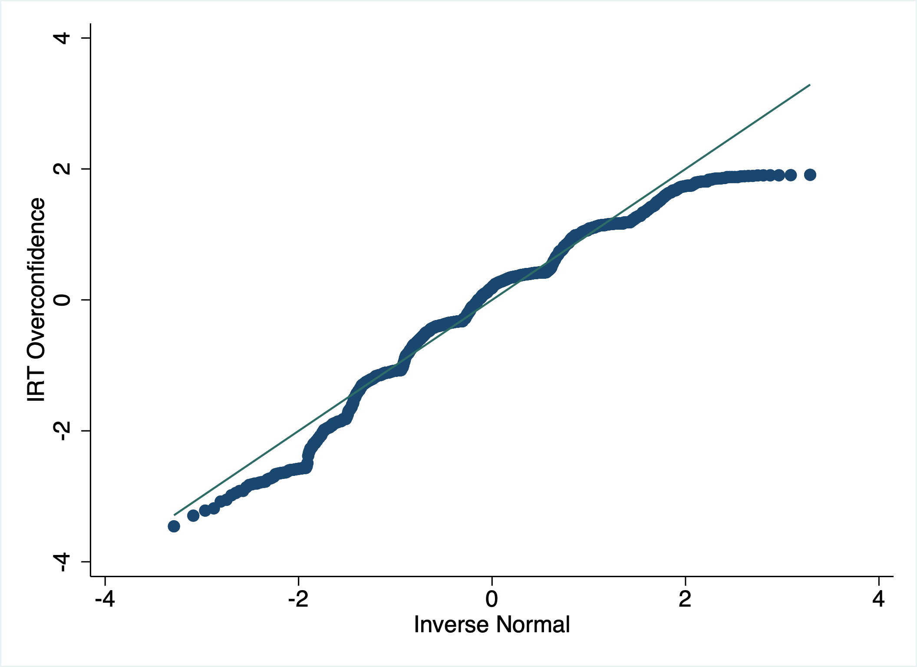
Supplementary Figure 1. Normal Quantile Plot for Overconfidence. The plot shows the observed sample quantile (dotted blue) for the dependent variable as well as the expected normal distribution (solid line). While there are minimal deviations throughout, the variable is sufficiently normally distributed to be used for causal mediation.

