Supplement to:
“Managing Trust Under Dynamic Information”

- Experimental Results (Table S1-S12)
Table S1. Bayesian Estimation of Trust Belief Updating in Experiment 1
Dependent Variable: $∆logit \left({\hat{μ}}_{it}\right)$ | Posterior Mean | Std. Dev. | 95% Credible Interval
$$β_{P}$$ | 1.087 | 0.089 | [0.911, 1.264]
$$β_{N}$$ | 0.984 | 0.078 | [0.827, 1.132]
Note: Posterior summaries are based on 10,000 MCMC iterations after a burn-in of 2,500.

Table S2. Trust Belief Updating in Experiment 1 with a Restricted Subsample
Dependent Variable: $∆logit \left({\hat{μ}}_{it}\right)$ | b | SE | t | p
$$β_{P}$$ | 0.835 | 0.113 | 7.36 | <0.001
$$β_{N}$$ | 0.911 | 0.088 | 10.33 | <0.001
Hypothesis | F-statistic | df | p
$$β_{P}=1$$ | 2.12 | 1 | 0.148
$$β_{N}=1$$ | 1.02 | 1 | 0.314
$$β_{P}=β_{N}$$ | 0.35 | 1 | 0.555
$$β_{P}=β_{N}=1$$ | 1.32 | 2 | 0.271
Observations | 370
Note: Standard errors are robust and clustered at the individual level.

Table S3. Trust Belief Updating in Experiment 1 with the Full Sample
Dependent Variable: $∆logit \left({\hat{μ}}_{it}\right)$ | b | SE | t | p
$$β_{P}$$ | 0.885 | 0.114 | 7.79 | <0.001
$$β_{N}$$ | 0.714 | 0.089 | 8.04 | <0.001
Hypothesis | F-statistic | df | p
$$β_{P}=1$$ | 1.02 | 1 | 0.314
$$β_{N}=1$$ | 10.38 | 1 | 0.002
$$β_{P}=β_{N}$$ | 1.83 | 1 | 0.178
$$β_{P}=β_{N}=1$$ | 5.22 | 2 | 0.006
Observations | 672
Note: Standard errors are robust and clustered at the individual level. To address potential misunderstandings of complex instructions, only participants reporting high comprehension in the post-experiment questionnaire were included.

Table S4. Round-by-Round Trust Belief Updating in Experiment 1
Panel A: Round 1
Dependent Variable: $∆logit \left({\hat{μ}}_{it}\right)$ |  | b |  | SE |  | t |  | p
$$β_{P}$$ |  | 1.313 |  | 0.209 |  | 6.27 |  | <0.001
$$β_{N}$$ |  | 0.980 |  | 0.157 |  | 6.24 |  | <0.001
Hypothesis |  | F-statistic |  | df |  | p
$$β_{P}=1$$ |  | 2.23 |  | 1 |  | 0.138
$$β_{N}=1$$ |  | 0.02 |  | 1 |  | 0.899
$$β_{P}=β_{N}$$ |  | 1.62 |  | 1 |  | 0.206
$$β_{P}=β_{N}=1$$ |  | 1.12 |  | 2 |  | 0.328
Observations |  | 140
Panel B: Round 2
Dependent Variable: $∆logit \left({\hat{μ}}_{it}\right)$ |  | b |  | SE |  | t |  | p
$$β_{P}$$ |  | 1.270 |  | 0.254 |  | 4.99 |  | <0.001
$$β_{N}$$ |  | 0.965 |  | 0.108 |  | 8.90 |  | <0.001
Hypothesis |  | F-statistic |  | df |  | p
$$β_{P}=1$$ |  | 1.13 |  | 1 |  | 0.290
$$β_{N}=1$$ |  | 0.10 |  | 1 |  | 0.747
$$β_{P}=β_{N}$$ |  | 1.22 |  | 1 |  | 0.271
$$β_{P}=β_{N}=1$$ |  | 0.62 |  | 2 |  | 0.541
Observations |  | 158
 | Panel C: Round 3
 | Dependent Variable: $∆logit \left({\hat{μ}}_{it}\right)$ |  | b |  | SE |  | t |  | p
 | $$β_{P}$$ |  | 0.787 |  | 0.162 |  | 4.86 |  | <0.001
 | $$β_{N}$$ |  | 1.018 |  | 0.174 |  | 5.85 |  | <0.001
 | Hypothesis |  | F-statistic |  | df |  | p
 | $$β_{P}=1$$ |  | 1.74 |  | 1 |  | 0.189
 | $$β_{N}=1$$ |  | 0.01 |  | 1 |  | 0.917
 | $$β_{P}=β_{N}$$ |  | 0.95 |  | 1 |  | 0.331
 | $$β_{P}=β_{N}=1$$ |  | 0.88 |  | 2 |  | 0.419
 | Observations |  | 160
 | Panel D: Round 4
 | Dependent Variable: $∆logit \left({\hat{μ}}_{it}\right)$ |  | b |  | SE |  | t |  | p
 | $$β_{P}$$ |  | 0.928 |  | 0.141 |  | 6.58 |  | <0.001
 | $$β_{N}$$ |  | 0.980 |  | 0.119 |  | 8.22 |  | <0.001
 | Hypothesis |  | F-statistic |  | df |  | p
 | $$β_{P}=1$$ |  | 0.26 |  | 1 |  | 0.610
 | $$β_{N}=1$$ |  | 0.03 |  | 1 |  | 0.866
 | $$β_{P}=β_{N}$$ |  | 0.08 |  | 1 |  | 0.779
 | $$β_{P}=β_{N}=1$$ |  | 0.15 |  | 2 |  | 0.865
 | Observations |  | 157
Note: Standard errors are robust and clustered at the individual level.
Table S5. Trust Belief Updating in Experiment 1 with Lagged Signals
Dependent Variable: $∆logit \left({\hat{μ}}_{it}\right)$ | b | SE | t | p
$$β_{P}$$ | 1.198 | 0.161 | 7.44 | <0.001
$$β_{N}$$ | 0.865 | 0.143 | 6.06 | <0.001
$$β_{P, -1}$$ | -0.141 | 0.177 | -0.80 | 0.427
$$β_{N, -1}$$ | 0.161 | 0.151 | 1.06 | 0.289
Hypothesis | F-statistic | df | p
$$β_{P}=1$$ | 1.51 | 1 | 0.221
$$β_{N}=1$$ | 0.89 | 1 | 0.346
$$β_{P}=β_{N}$$ | 1.61 | 1 | 0.206
$$β_{P}=β_{N}=1$$ | 0.83 | 2 | 0.436
Observations | 615
Note: Standard errors are robust and clustered at the individual level.

Table S6. Trust Belief Updating Across Initial Beliefs in Experiment 1
Panel A: Low-initial
Dependent Variable: $∆logit \left({\hat{μ}}_{it}\right)$ |  | b |  | SE |  | t |  | p
$$β_{P}$$ |  | 1.414 |  | 0.284 |  | 4.97 |  | <0.001
$$β_{N}$$ |  | 0.511 |  | 0.154 |  | 3.33 |  | 0.002
Hypothesis |  | F-statistic |  | df |  | p
$$β_{P}=1$$ |  | 2.12 |  | 1 |  | 0.152
$$β_{N}=1$$ |  | 10.11 |  | 1 |  | 0.003
$$β_{P}=β_{N}$$ |  | 13.70 |  | 1 |  | 0.001
$$β_{P}=β_{N}=1$$ |  | 11.57 |  | 2 |  | <0.001
Observations |  | 184
Panel B: Medium-initial
Dependent Variable: $∆logit \left({\hat{μ}}_{it}\right)$ |  | b |  | SE |  | t |  | p
$$β_{P}$$ |  | 1.076 |  | 0.117 |  | 9.20 |  | <0.001
$$β_{N}$$ |  | 1.158 |  | 0.109 |  | 10.64 |  | <0.001
Hypothesis |  | F-statistic |  | df |  | p
$$β_{P}=1$$ |  | 0.42 |  | 1 |  | 0.520
$$β_{N}=1$$ |  | 2.11 |  | 1 |  | 0.151
$$β_{P}=β_{N}$$ |  | 0.40 |  | 1 |  | 0.527
$$β_{P}=β_{N}=1$$ |  | 1.07 |  | 2 |  | 0.350
Observations |  | 235
 | Panel C: High-initial
 | Dependent Variable: $∆logit \left({\hat{μ}}_{it}\right)$ |  | b |  | SE |  | t |  | p
 | $$β_{P}$$ |  | 0.711 |  | 0.124 |  | 5.71 |  | <0.001
 | $$β_{N}$$ |  | 1.185 |  | 0.116 |  | 10.24 |  | <0.001
 | Hypothesis |  | F-statistic |  | df |  | p
 | $$β_{P}=1$$ |  | 5.39 |  | 1 |  | 0.024
 | $$β_{N}=1$$ |  | 2.55 |  | 1 |  | 0.116
 | $$β_{P}=β_{N}$$ |  | 10.14 |  | 1 |  | 0.002
 | $$β_{P}=β_{N}=1$$ |  | 5.12 |  | 2 |  | 0.009
 | Observations |  | 196
Note: Standard errors are robust and clustered at the individual level.

Table S7. Regression Analysis of Initial Trust Biases Across Experimental Conditions
Dependent Variable: Initial Trust Bias | b | SE | t | p
Identified | -0.321 | 2.617 | -0.12 | 0.903
Ingroup | 1.987 | 4.067 | 0.49 | 0.626
Identified × Ingroup | 8.284 | 3.710 | 2.23 | 0.027
University “CUFE” | -11.634 | 4.388 | -2.65 | 0.009
Female | 4.745 | 3.771 | 1.26 | 0.210
Undergraduate | -6.472 | 4.564 | -1.42 | 0.158
Only Child | -9.182 | 3.531 | -2.60 | 0.010
Observations | 336
Note: We estimated a two-way interaction model between treatment condition (anonymous vs. identified) and group membership (ingroup vs. outgroup). The model controls for university fixed effects, gender, undergraduate status, and only-child status.

Table S8 Adjusted Initial Trust Biases Across Experimental Conditions
Condition | Predicted Mean | SE | t | p
Anonymous-Outgroup | -2.41 | 2.81 | -0.86 | 0.393
Anonymous-Ingroup | -0.42 | 2.92 | -0.14 | 0.885
Identified-Outgroup | -2.73 | 2.72 | -1.00 | 0.317
Identified-Ingroup | 7.54 | 2.86 | 2.63 | 0.009
Comparison | Difference | SE | t | p
Anonymous-Ingroup vs. Anonymous-Outgroup | 1.99 | 4.07 | 0.49 | 0.626
Identified-Outgroup vs. Anonymous-Outgroup | -0.32 | 2.62 | -0.12 | 0.903
Identified-Ingroup vs. Anonymous-Outgroup | 9.95 | 4.02 | 2.48 | 0.014
Identified-Outgroup vs. Anonymous-Ingroup | -2.31 | 4.00 | -0.58 | 0.565
Identified-Ingroup vs. Anonymous-Ingroup | 7.96 | 2.63 | 3.03 | 0.003
Identified-Ingroup vs. Identified-Outgroup | 10.27 | 3.95 | 2.60 | 0.010
Note: Predicted means and standard errors are derived from a two-way interaction model between treatment condition (anonymous vs. identified) and group membership (ingroup vs. outgroup), controlling for university fixed effects, gender, undergraduate status, and only-child status. Detailed model results are reported in Table S7 above.
Table S9 Bayesian Estimation of Trust Belief Updating: Outgroup vs. Ingroup in Experiment 2
Panel A: Outgroup  Dependent Variable: $∆logit \left({\hat{μ}}_{it}\right)$ | Posterior Mean | Std. Dev. | 95% Credible Interval
$$β_{P}$$ | 1.085 | 0.137 | [0.810, 1.348]
$$β_{N}$$ | 0.861 | 0.120 | [0.631, 1.103]
Panel A: Ingroup  Dependent Variable: $∆logit \left({\hat{μ}}_{it}\right)$ | Posterior Mean | Std. Dev. | 95% Credible Interval
$$β_{P}$$ | 0.745 | 0.113 | [0.524, 0.967]
$$β_{N}$$ | 1.118 | 0.105 | [0.911, 1.328]
Note: Posterior summaries are based on 10,000 MCMC iterations after a burn-in of 2,500.

Table S10 Trust Belief Updating Across Initial Beliefs: Outgroup Treatment in Experiment 2
Panel A: Low-initial
Dependent Variable: $∆logit \left({\hat{μ}}_{it}\right)$ |  | b |  | SE |  | t |  | p
$$β_{P}$$ |  | 1.597 |  | 0.366 |  | 4.36 |  | <0.001
$$β_{N}$$ |  | 0.345 |  | 0.135 |  | 2.57 |  | 0.016
Hypothesis |  | F-statistic |  | df |  | p
$$β_{P}=1$$ |  | 2.66 |  | 1 |  | 0.114
$$β_{N}=1$$ |  | 23.65 |  | 1 |  | <0.001
$$β_{P}=β_{N}$$ |  | 10.88 |  | 1 |  | 0.003
$$β_{P}=β_{N}=1$$ |  | 13.90 |  | 2 |  | <0.001
Observations |  | 107
Panel B: Medium-initial
Dependent Variable: $∆logit \left({\hat{μ}}_{it}\right)$ |  | b |  | SE |  | t |  | p
$$β_{P}$$ |  | 0.910 |  | 0.139 |  | 6.53 |  | <0.001
$$β_{N}$$ |  | 0.991 |  | 0.113 |  | 8.81 |  | <0.001
Hypothesis |  | F-statistic |  | df |  | p
$$β_{P}=1$$ |  | 0.42 |  | 1 |  | 0.522
$$β_{N}=1$$ |  | 0.01 |  | 1 |  | 0.938
$$β_{P}=β_{N}$$ |  | 0.29 |  | 1 |  | 0.597
$$β_{P}=β_{N}=1$$ |  | 0.22 |  | 2 |  | 0.807
Observations |  | 129
 | Panel C: High-initial
 | Dependent Variable: $∆logit \left({\hat{μ}}_{it}\right)$ |  | b |  | SE |  | t |  | p
 | $$β_{P}$$ |  | 0.558 |  | 0.126 |  | 4.44 |  | <0.001
 | $$β_{N}$$ |  | 1.275 |  | 0.349 |  | 3.65 |  | 0.001
 | Hypothesis |  | F-statistic |  | df |  | p
 | $$β_{P}=1$$ |  | 12.42 |  | 1 |  | 0.002
 | $$β_{N}=1$$ |  | 0.62 |  | 1 |  | 0.439
 | $$β_{P}=β_{N}$$ |  | 5.16 |  | 1 |  | 0.033
 | $$β_{P}=β_{N}=1$$ |  | 9.50 |  | 2 |  | 0.001
 | Observations |  | 80
Note: Standard errors are robust and clustered at the individual level.
Table S11 Trust Belief Updating Across Initial Beliefs: Ingroup Treatment in Experiment 2
Panel A: Low-initial
Dependent Variable: $∆logit \left({\hat{μ}}_{it}\right)$ |  | b |  | SE |  | t |  | p
$$β_{P}$$ |  | 1.219 |  | 0.474 |  | 2.57 |  | 0.026
$$β_{N}$$ |  | 0.463 |  | 0.226 |  | 2.05 |  | 0.065
Hypothesis |  | F-statistic |  | df |  | p
$$β_{P}=1$$ |  | 0.21 |  | 1 |  | 0.653
$$β_{N}=1$$ |  | 5.63 |  | 1 |  | 0.037
$$β_{P}=β_{N}$$ |  | 3.00 |  | 1 |  | 0.111
$$β_{P}=β_{N}=1$$ |  | 3.99 |  | 2 |  | 0.050
Observations |  | 46
Panel B: Medium-initial
Dependent Variable: $∆logit \left({\hat{μ}}_{it}\right)$ |  | b |  | SE |  | t |  | p
$$β_{P}$$ |  | 0.814 |  | 0.173 |  | 4.70 |  | <0.001
$$β_{N}$$ |  | 1.118 |  | 0.191 |  | 5.85 |  | <0.001
Hypothesis |  | F-statistic |  | df |  | p
$$β_{P}=1$$ |  | 1.16 |  | 1 |  | 0.292
$$β_{N}=1$$ |  | 0.38 |  | 1 |  | 0.542
$$β_{P}=β_{N}$$ |  | 1.64 |  | 1 |  | 0.211
$$β_{P}=β_{N}=1$$ |  | 0.89 |  | 2 |  | 0.422
Observations |  | 94
 | Panel C: High-initial
 | Dependent Variable: $∆logit \left({\hat{μ}}_{it}\right)$ |  | b |  | SE |  | t |  | p
 | $$β_{P}$$ |  | 0.559 |  | 0.154 |  | 3.63 |  | 0.001
 | $$β_{N}$$ |  | 1.305 |  | 0.170 |  | 7.69 |  | <0.001
 | Hypothesis |  | F-statistic |  | df |  | p
 | $$β_{P}=1$$ |  | 8.25 |  | 1 |  | 0.006
 | $$β_{N}=1$$ |  | 3.23 |  | 1 |  | 0.080
 | $$β_{P}=β_{N}$$ |  | 27.41 |  | 1 |  | <0.001
 | $$β_{P}=β_{N}=1$$ |  | 14.35 |  | 2 |  | <0.001
 | Observations |  | 157
Note: Standard errors are robust and clustered at the individual level.

Table S12 Relationship Between Trust Beliefs and Trust Choices with Additional Covariates
Panel A: Pre-Feedback  Dependent Variable: Choice | dy/dx | SE | z | p
Belief | 0.007 | 0.001 | 10.32 | <0.001
Ingroup | 0.064 | 0.043 | 1.49 | 0.136
Outgroup | 0.038 | 0.050 | 0.76 | 0.449
University “CUFE” | -0.093 | 0.071 | -1.32 | 0.186
Female | -0.036 | 0.053 | -0.68 | 0.495
Undergraduate | -0.067 | 0.071 | -0.94 | 0.348
Only Child | 0.017 | 0.052 | 0.32 | 0.752
Observations | 336
Panel B: Post-Feedback
Dependent Variable: Choice | dy/dx | SE | z | p
Belief | 0.006 | 0.001 | 10.00 | <0.001
Ingroup | -0.005 | 0.047 | -0.10 | 0.921
Outgroup | 0.051 | 0.048 | 1.05 | 0.292
University “CUFE” | -0.106 | 0.069 | -1.53 | 0.127
Female | 0.017 | 0.047 | 0.35 | 0.728
Undergraduate | -0.082 | 0.070 | -1.17 | 0.243
Only Child | -0.027 | 0.048 | -0.57 | 0.572
Observations | 336
Note: dy/dx denotes average marginal effects estimated from the Probit regression.

2. Descriptive Model
We extend the trust game to a broader context by modeling it as a two-sided market with a continuum of agents on each side. On one side are trustors, indexed by $i∈[0,1]$, and on the other side are trustees, indexed by $j∈[0,1]$. Each trustor is paired with a trustee via a one-to-one mapping $i\left(j\right):\left[0,1\right]→[0,1]$.
Trustees are classified into two types: trustworthy ($φ_{j}=1$) and untrustworthy ($φ_{j}=0$). For example, in our experimental setup, Player B is considered trustworthy if they choose B1 and untrustworthy if they choose B2. Let $θ$ denote the proportion of trustworthy trustees in the population. The average trustworthiness of the population is $\overline{φ}=\int_{0}^{1}{φ_{j}dj}=θ$.
Each trustor has an initial belief $μ_{0}$ about their partner’s trustworthiness, which is private information known only to the trustees. Given random matching and the distribution of trustee types, the proportion of trustors paired with trustworthy partners should be equal to $θ$.
There are T discrete time periods, during which the trustor receives a binary signal $s_{t}∈\{P,N\}$ at each period $t=1, 2,…, T$. The trustor updates the trust belief to $μ_{t}$after receiving each signal. In our experiment, strategy B1 corresponds to a positive signal P, while strategy B2 corresponds to a negative signal N. These signals are noisy and follow independent and identically distributed properties. A trustworthy trustee provides a positive signal P with probability $p∈(0,1)$, whereas an untrustworthy trustee does so with probability $q∈(0,1)$, where $q<p$.
In the final period T, the trustor must decide between cooperation with the trustee and non-cooperation. Choosing non-cooperation results in a payoff of zero. In contrast, if the trustor chooses cooperation, they incur a cost $c∈(0,1)$but gain a benefit of 1 if the matched partner is trustworthy. We set $T=4$ to reflect the four feedback rounds in our experiment due to practical constraints, but the model allows T to be larger, potentially infinite, to capture long-term trust dynamics.
Therefore, a trustor will cooperate in the final period T if and only if the expected profit from cooperation is positive: $μ_{T}∙1+\left(1- μ_{T}\right)∙0-c>0$ . This implies that the trustor will cooperate only if they are sufficiently confident in the trustee's trustworthiness, i.e., $μ_{T}>c (or equivalently, logit\left( μ_{T}\right)>logit\left(c\right)$. Consequently, the success of cooperation hinges on the trustor's trust belief in the partner after receiving noisy feedback.
Based on Equation (6) in the main text, we have:
$$∆logit \left(μ_{t}\right)=β_{P}∙λ_{P}I\left(s_{t}=P\right)+β_{N}∙λ_{N}I\left(s_{t}=N\right) (S1)$$
Using this, we can formalize the information processing of a non-Bayesian as follows:
$logit\left(μ_{t}\right)=logit\left(μ_{t-1}\right)+β_{P}∙λ_{P}∙I\left(s_{t}=P\right)+β_{N}∙λ_{N}∙I\left(s_{t}=N\right)$ (S2)
where${ λ}_{p}=\ln{({\frac{p}{q}}})$ and ${ λ}_{N}=\ln{({\frac{1-p}{1-q}}})$denote the informativeness of positive and negative signals by Bayes’ rule. Meanwhile, $β_{P}$ and $β_{N}$ represent individual relative responsiveness to signals when utilizing Bayesian updating as the benchmark. For a standard Bayesian, $β_{P}=β_{N}=1.$
Consequently, it is straightforward to deduce that the posterior belief $μ^{t}$ of a biased updating satisfies:
$logit\left(μ_{t}\right)=logit\left(μ_{0}\right)+S_{Pt}{∙β}_{P}∙λ_{P}+S_{Nt}{∙β}_{N}∙λ_{N}$ (S3)
where $S_{Pt}\left(S_{Nt}\right)$denotes the number of positive (negative) signals the trustor has received by time t, which is a random variable dependent on the actual trustworthiness type of the trustee.
According to the characteristics of noisy signals drawn from a well-defined distribution, the ex-ante expectation of the trustor's logit-belief $μ_{t}$when paired with a trustworthy partner is:
$E\left[logit\left(μ_{t}\right) | trustworthy\right]= logit\left(μ_{0}\right)+t∙[pβ_{P}λ_{P}+\left(1-p\right)β_{N}λ_{N}$ (S4)
Similarly, the ex-ante expectation of trustor’s logit-belief $μ^{t}$when paired with an untrustworthy partner is:
$E\left[logit\left(μ_{t}\right) | untrustworthy\right]= logit\left(μ_{0}\right)+t∙\left[qβ_{P}λ_{P}+\left(1-q\right)β_{N}λ_{N}\right]$(S5)
Furthermore, the variances of the trustor’s logit-beliefs when encountering two types of trustees are derived, respectively:
$Var\left[logit\left(μ_{t}\right) | trustworthy\right]= t∙p(1-p)∙{(β_{P}λ_{P}-β_{N}λ_{N})}^{2}$ (S6)
$Var\left[logit\left(μ_{t}\right) | untrustworthy\right]= t∙q(1-q)∙{(β_{P}λ_{P}-β_{N}λ_{N})}^{2}$ (S7)
Let’s start with the benchmark Bayesian updating process, where $β_{P}=β_{N}=1$. Given the conditions $1>p>q>0$ and $p+q=1$, Equation (S4) indicates that the ex-ante expectation of $logit\left(μ_{t}\right)$ increases over time if the trustor is paired with a trustworthy partner. Conversely, Equation (S5) implies that the expectation decreases over time if the trustee is untrustworthy.
As illustrated in Figure S1, as the trustor receives more information, the mean logit-beliefs for a trustworthy partner (represented by the red line) and for an untrustworthy partner (represented by the blue line) converge to $+∞$ and $-∞$ respectively, at a rate of $\left(p-q\right)∙\left(\ln{p}-\ln{q}\right),$ while both variations increase at a rate of $pq∙{[2\left(\ln{p}-\ln{q}\right)]}^{2}$. Therefore, regardless of the initial logit-belief $logit\left(μ_{0}\right)$, the trustor will progressively become adept at distinguishing trustworthy partners from untrustworthy ones. The probability of updating the logit-belief in the correct direction approaches 1 for each state as $T→∞$.
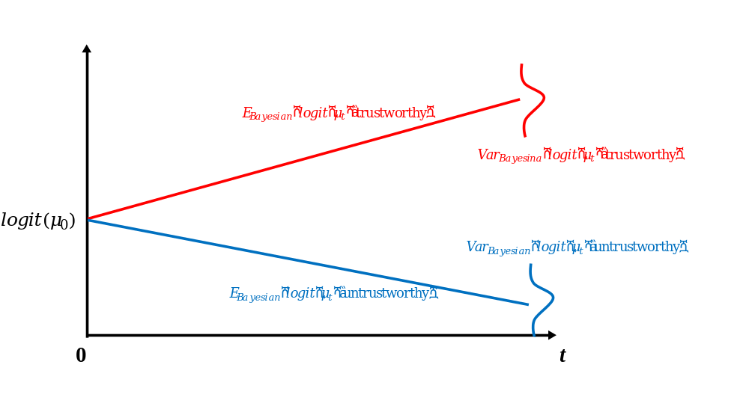
Figure S1 Evolution of Bayesian Logit-Beliefs
However, as illustrated in Figure S2, a trustor with a relatively high initial trust level is likely to consistently trust and cooperate with a trustee if there aren't enough feedback periods to update the trustor's belief. For instance, if paired with an untrustworthy partner and the signaling process stops before $τ_{a}$, the likely outcome for the trustor is a loss from trusting and cooperating with that untrustworthy individual. In our experiment, individuals tend to initially show over-trust when interacting with ingroup partners. Therefore, in Figure S2, we compare the Bayesian benchmark with biased belief updating.
Specifically, the dotted lines illustrate the evolution of mean logit-beliefs in an asymmetric manner, as observed in our trust experiment, where $β_{P}^{High}<β_{N}^{High}=1.$ In contrast to a standard Bayesian, who responds symmetrically to positive and negative signals, a non-Bayesian processes information asymmetrically, tending to underreact to positive signals. When such a non-Bayesian is paired with a trustworthy partner, the mean of her logit-beliefs converges to $+∞$ at a rate of $\left(β_{P}^{High}p-β_{N}^{High}q\right)∙(\ln{p}-\ln{q})$, while the variation increases at a rate of $pq∙{[2\left(β_{P}^{High}+β_{N}^{High}\right)\left(\ln{p}-\ln{q}\right)]}^{2}$. Conversely, when paired with an untrustworthy partner, the mean of her logit-beliefs converges to $-∞$ at a rate of $β_{N}^{High}∙(\ln{p}-\ln{q})$, while the variation increases at a rate of $pq∙{[2\left(β_{P}^{High}+β_{N}^{High}\right)\left(\ln{p}-\ln{q}\right)]}^{2}$.
Because we have $β_{P}^{High}p-β_{N}^{High}q=β_{P}^{High}p-q<p-q<p-β_{P}^{High}q=β_{N}^{High}p-β_{P}^{High}q$, the red dotted line has a flatter slope than the red solid line, whereas the blue dotted line has a steeper slope than the blue solid line. Moreover, the variations in both logit-beliefs are smaller compared to the case of Bayesian updating since $\left(β_{P}^{High}+β_{N}^{High}\right)<2$.
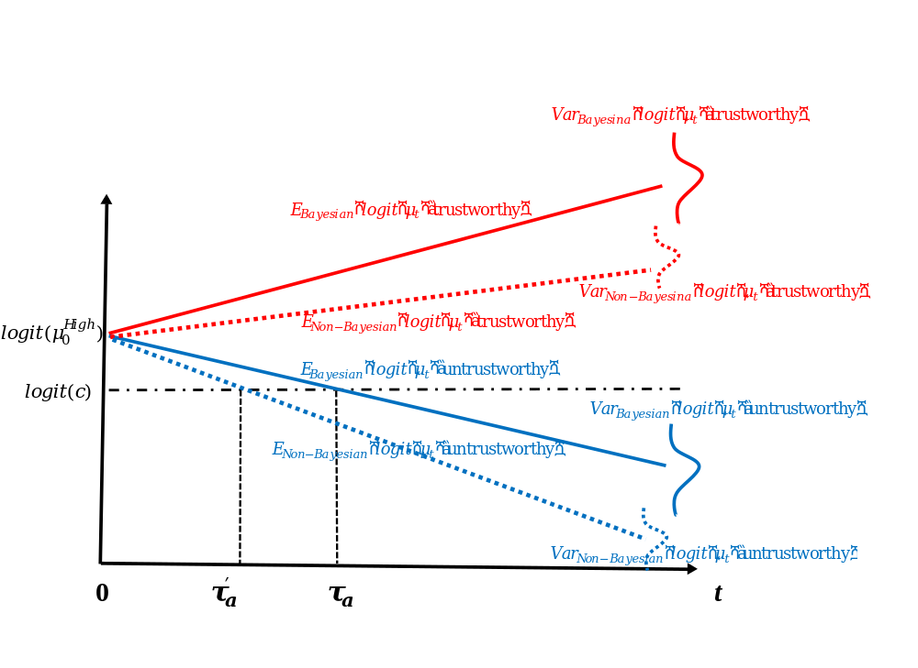
Figure S2 Bayesian Updating vs. Biased Updating with a High Initial Trust
Compared to a standard Bayesian, a non-Bayesian paired with a trustworthy partner tends to maintain logit-beliefs at their initial level for an extended period, regardless of how many positive signals are received. Consequently, it becomes challenging to gain additional trust from the trustor, even if matched with a trustworthy partner. However, since the trustor initially has a high belief in the ingroup partner, a relatively high trust level can be maintained toward the trustworthy partner after receiving more feedback.
On the contrary, if the trustee is untrustworthy, the trustor's logit-belief decreases significantly in response to negative signals from that trustee. The trustor rapidly loses trust in an untrustworthy partner, even if the initial belief was high. When the trustor's belief falls below a certain threshold, non-cooperation is chosen as the final decision.
As a result, this asymmetric updating process minimally impacts the trustor's opportunity to successfully cooperate with a trustworthy partner but effectively counterbalances the negative effect of a high initial belief level when dealing with untrustworthy partners. This significantly enhances the trustor's ability to identify untrustworthy partners and avoid being exploited.
On the other hand, as depicted in Figure S3, if the trustor initially has low trust in others, this low initial belief persists for an extended period, even when updated according to the Bayesian rule. This implies that a Bayesian trustor with a relatively low initial belief may consistently refuse to cooperate with a trustee if the number of feedback periods is fewer than $τ_{b}$, causing the trustor to miss out on the benefits of cooperating with a trustworthy partner. Our experiments have shown that people tend to initially display under-trust tendencies when interacting with their outgroup partners. Thus, we compare the Bayesian benchmark with the biased belief updating observed in our experiment.
Specifically, the dotted lines in Figure S3 illustrate the evolution of mean logit-beliefs in an asymmetric manner, with$β_{N}^{Low}<β_{P}^{Low}=1$. Compared to a standard Bayesian who responds symmetrically to positive and negative signals, a Bayesian processes information asymmetrically, underreacting to negative signals. When a non-Bayesian is paired with a trustworthy partner, the mean of their logit-beliefs converges to $+∞$ at a rate of $\left(β_{P}^{Low}p-β_{N}^{Low}q\right)∙(\ln{p}-\ln{q})$, while the variation increases at a rate of $pq∙{[2\left(β_{P}^{Low}+β_{N}^{Low}\right)\left(\ln{p}-\ln{q}\right)]}^{2}$. Conversely, when paired with an untrustworthy partner, the mean of their logit-beliefs converges to $-∞$ at a rate of $\left(β_{N}^{Low}p-β_{P}^{Low}q\right)∙(\ln{p}-\ln{q})$, with the variation increasing at a rate of $pq∙{[2\left(β_{P}^{Low}+β_{N}^{Low}\right)\left(\ln{p}-\ln{q}\right)]}^{2}$.
Because we have $β_{P}^{Low}p-β_{N}^{Low}q=p-β_{N}^{Low}q>p-q>β_{N}^{Low}p-q=β_{N}^{Low}p-β_{P}^{Low}q$, the red dotted line has a steeper slope than the red solid line, while the blue dotted line has a flatter slope than the blue solid line. Additionally, the variations in both logit-beliefs are smaller compared to Bayesian updating since$\left(β_{P}^{Low}+β_{N}^{Low}\right)<2$.
When a non-Bayesian is paired with a trustworthy partner, their logit-belief significantly increases in response to positive signals. This makes it easier to gain more trust from the non-Bayesian when matched with a trustworthy partner, even if the trustor initially held low beliefs. Once the trustor's belief surpasses a certain threshold, they will choose to cooperate.
By contrast, when the trustee is untrustworthy, the trustor's belief remains relatively stable around the initial level for an extended period, regardless of the number of negative signals received. Given the trustor's initial low beliefs about their outgroup partner, they are well-equipped to avoid being exploited with an untrustworthy partner after receiving more feedback.
Consequently, this asymmetric updating process minimally impacts the trustor's decision not to cooperate with an untrustworthy partner. Instead, it effectively counterbalances the negative effect of a low initial belief level when dealing with trustworthy partners, significantly enhancing the trustor's ability to identify the trustworthy type, facilitating successful cooperation.
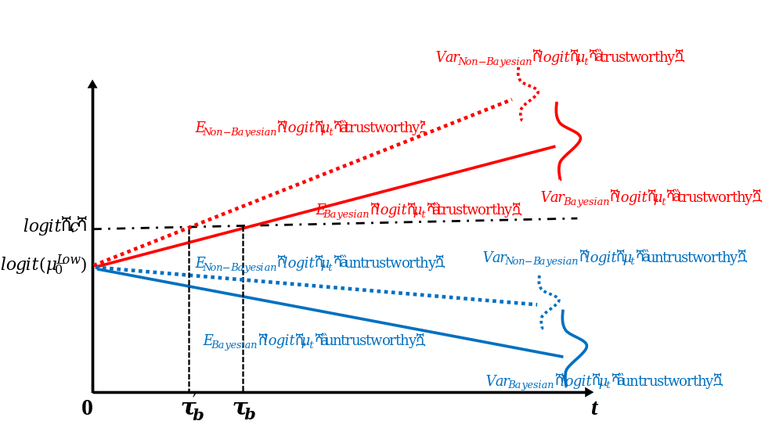
Figure S3 Bayesian Updating vs. Biased Updating with a Low Initial Trust
In summary, belief updating is crucial for differentiating between trustworthy and untrustworthy partners. Initially, individuals may have inherent biases due to limited information. Our descriptive model reveals that asymmetric belief updating can be more effective than symmetric Bayesian updating, particularly in time-constrained situations. This adaptive learning process enables individuals to overcome tendencies to either overly trust or distrust strangers, allowing them to selectively cooperate with trustworthy partners while avoiding the costly risks associated with untrustworthy ones.

3. Experiment Instructions

[New Screen]
Welcome to our experiment!

This experiment is exclusively for invited participants, including students from two different universities: Central University of Finance and Economics in Beijing and Hong Kong Baptist University in Hong Kong.

In this study, you'll be answering questions and making decisions in various environments. Your participation is expected to take approximately 30 minutes.

Participation in this study is completely voluntary, and your data will be kept strictly confidential. After the research is completed, the anonymous study results will be securely stored in a computer database.

You will receive 30 Yuan for your participation in this experiment. Additionally, you have an opportunity to increase your earnings by following the experiment instructions correctly. This experiment consists of four games, and the amount you earn depends on your decisions and the decisions of other participants. After completing all the games, one of them will be randomly selected to determine your final payment. So, your total earnings will be the 30 Yuan participation fee plus the earnings from the randomly selected task.

All payments will be made privately immediately after the experiment, and your earnings will be provided in tokens. At the end of the experiment, you will receive your payment IN CASH based on the exchange rate of 1 Yuan = 25 tokens. Depending on your performance, you can potentially earn up to a maximum of 60 Yuan.

If you'd like to participate in this study, please proceed to the next page.

[New Screen]
Let's begin the experiment. Over the course of this study, you'll be making decisions in four separate games. It's essential to understand that each decision and its outcome are entirely independent of your choices in the other games. This means that the decisions and outcomes in one game will not have any impact on the outcomes in any of the other games.

In every game, you will be anonymously paired with one other participant. Additionally, for each new game, you will be randomly matched with a different participant than in the previous game.

Each game involves two roles: Player A and Player B. The decisions will be made in alphabetical order, starting with Player A, followed by Player B. Keep in mind that your choices may influence the earnings of other participants, and the decisions made by your matched partner may also affect your earnings.

If you have a clear understanding of this introduction, please proceed to the first game.

[New Screen]
Game 1

In the first game, you will assume the role of Player B.

You will be paired anonymously with another participant, and Player A could be either from your own university or from the other university.

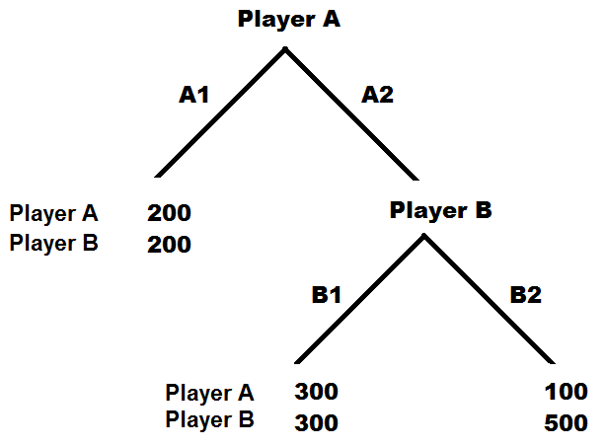

Suppose Player A has already made a choice. If Player A has selected option A1, both of you will receive 200 tokens.

Your decision will only have an impact if Player A has chosen A2. Therefore, you should base your choice on the assumption that Player A has opted for A2 rather than A1. If Player A has chosen A2 and you select B1, both of you will receive 300 tokens. On the other hand, if Player A has chosen A2 and you select B2, then Player A will receive 100 tokens, and you will receive 500 tokens.

Given that Player A has already chosen A2, as Player B, which option will you choose? [B1/B2]
[New Screen]
Game 2

In the second game, you will continue to be Player B.

The game structure remains identical to the previous game, but you will now be randomly paired with a different participant. It's important to note that, in this game, Player A will be limited to a student from your own university / from the other university.

Suppose Player A has already made a choice. If Player A has selected option A1, both of you will receive 200 tokens.

Your decision will only have an impact if Player A has chosen A2. Therefore, you should base your choice on the assumption that Player A has opted for A2 rather than A1. If Player A has chosen A2 and you select B1, both of you will receive 300 tokens. On the other hand, if Player A has chosen A2 and you select B2, then Player A will receive 100 tokens, and you will receive 500 tokens.

Given that Player A has already chosen A2, as Player B, which option will you choose? [B1/B2]

[New Screen]
Game 3

In the third game, you will switch to the role of Player A.

Once again, you will be anonymously matched with another participant, and Player B could be either from your own university or from the other university.
You have two choices: A1 or A2.

If you opt for A1, both you and Player B will receive 200 tokens.

If you opt for A2, the outcome depends on Player B's choice between B1 and B2. If you choose A2 and Player B selects B1, both of you will receive 300 tokens. However, if you choose A2 and Player B selects B2, you will receive 100 tokens, while Player B will receive 500 tokens.

Please note that Player B makes their choice without knowing your decision. Player B is aware that their choice will only impact the outcome if you've chosen A2, so they select B1 or B2 based on the assumption that you've chosen A2 instead of A1.

As Player A, which option will you choose? [A1/A2]

[New Screen]
Game 3: Please make your best estimate of your partner's choice

Regardless of the option you selected in Game 3, we are interested in your assessment of your matched partner's choice. Specifically, what probability do you think your partner, Player B, selected option B1 in that game? To encourage thoughtful consideration of this question, we are offering you an opportunity to potentially earn additional rewards by providing an accurate estimate.

To make it worthwhile for you to think a bit about this question, we give you a chance of winning additional reward by submitting a good estimate.

Our system has generated various robots, each programmed to choose B1 with a specific probability. For instance, "Robot 1" chooses option B1 with a 1% probability, "Robot 2" with a 2% probability, and so on, up to "Robot 99," which chooses B1 with a 99% probability. One of these robots has been randomly designated as a potential substitute for your actual matched partner.

You will receive an extra 100 tokens if either your real partner (Player B) or the substitute "Robot X" selects B1. However, it is crucial for you to inform us when we should apply your actual partner's choice and when we should use the substitute robot's choice. Consequently, if, and only if, "Robot X" has a higher likelihood of choosing B1 (i.e., the assigned probability X% is greater than your estimated probability of your actual partner selecting B1), we will implement the robot's choice instead of your partner's. Otherwise, we will stick with your partner's choice as usual.

In summary, you are most likely to earn the additional 100 tokens by simply reporting your true belief. Therefore, what is your estimate of the probability that your partner, Player B, has chosen B1 in Game 3? [1%, … ,99%]

[New Screen]
Game 3: Please update your estimate after feedback 1

You've provided an initial estimation of the probability that your partner, Player B, has chosen B1. Now, we will provide you with additional information to help you refine your estimate.

Imagine that Player B's strategy has been represented on a six-faced die. However, only four of these faces accurately reflect Player B's strategy, while the remaining two faces display an incorrect strategy. For instance, if Player B has selected B1, the die would have four faces showing B1 and two faces showing B2.

The computer will roll the dice once and provide one result to you. Since each of the six faces is equally likely to occur, the report of Player B1's strategy through this dice rolling mechanism should be accurate with a probability of 2/3.

After rolling the dice once, the result turns out to be (B1/B2).

Based on this feedback, we now ask you to update your estimate of the probability that Player B has chosen B1. You can either restate your initial probability or revise it based on this new information.

Just like before, "Robot X" is still a potential substitute for your actual matched partner. You must inform us when to use your actual partner's choice and when to use the substitute robot's choice. Consequently, if "Robot X" has a higher probability of choosing B1, we will employ the robot's choice instead of your partner's, and you will earn an additional 100 tokens if the choice is B1.

As with the previous estimation, your likelihood of earning the additional 100 tokens depends on the accuracy of your estimate. So, what is your updated estimate of the probability that your partner, Player B, has chosen B1 in Game 3? [1%, … ,99%]

[New Screen]
Game 3: Please update your estimate after feedback 2

In this period, the dice rolling mechanism, which correctly reports Player B1's choice with a probability of 2/3, has rolled for the second time.

Once again, the dice has been rolled, and the result turns out to be (B1/B2).

Considering this new feedback along with the previous one, we kindly request you to update your estimate of the probability that Player B has chosen B1.

Just as before, you can enhance your earnings by providing a precise estimate. Thus, you are most likely to earn the additional 100 tokens if your estimate is as accurate as possible. So, what is your updated estimate of the probability that your partner, Player B, has chosen B1 in Game 3? [1%, … ,99%]

[New Screen]
Game 3: Please update your estimate after feedback 3

In this period, the dice rolling mechanism, which correctly reports Player B1's choice with a probability of 2/3, has rolled for the third time.

Once again, the dice has been rolled, and the result turns out to be (B1/B2).

Considering this new feedback along with the previous two rounds, we kindly request you to update your estimate of the probability that Player B has chosen B1.

Just as before, you can enhance your earnings by providing a precise estimate. Thus, you are most likely to earn the additional 100 tokens if your estimate is as accurate as possible. So, what is your updated estimate of the probability that your partner, Player B, has chosen B1 in Game 3? [1%, … ,99%]

[New Screen]
Game 3: Please update your estimate after feedback 4

In this period, the dice rolling mechanism, which correctly reports Player B1's choice with a probability of 2/3, has rolled for the last time.

Once again, the dice has been rolled, and the result turns out to be (B1/B2).

Considering this new feedback along with the previous three rounds, we kindly request you to update your estimate of the probability that Player B has chosen B1.
Just as before, you can enhance your earnings by providing a precise estimate. Thus, you are most likely to earn the additional 100 tokens if your estimate is as accurate as possible. So, what is your updated estimate of the probability that your partner, Player B, has chosen B1 in Game 3? [1%, … ,99%]

[New Screen]
Game 3: Please rechoose your strategy as Player A

Up to this point, you've received four feedbacks and updated your estimate of the probability that your matched partner, Player B, has chosen B1 in Game 3.

Regardless of the strategy you initially chose as Player A in Game 3, you now have an opportunity to make a new decision. In this period, you can either restate the same choice or revise your choice in Game 3.

It's important to note that since your matched partner, Player B's strategy, is fixed, any changes in outcomes and payoffs will only be influenced by your new strategy as Player A. However, at the end of the experiment, we will randomly select one strategy from your previous one and this new one to calculate your payoff, as well as your partner's payoff in Game 3.

As Player A, which option would you like to rechoose? [A1/A2]

[New Screen]
Game 4

In this final game, you will continue to be Player A.

The game structure remains the same, but you will be randomly paired with a new participant who is distinct from the previous games. Unlike Game 3, where Player B could be from either your own university or the other university, in this game, your partner, Player B, will be limited to a student from your own university / from the other university.

You have two choices: A1 or A2.

If you opt for A1, both you and Player B will receive 200 tokens.

If you opt for A2, the outcome depends on Player B's choice between B1 and B2. If you choose A2 and Player B selects B1, both of you will receive 300 tokens. However, if you choose A2 and Player B selects B2, you will receive 100 tokens, while Player B will receive 500 tokens.

Please note that Player B makes their choice without knowing your decision. Player B is aware that their choice will only impact the outcome if you've chosen A2, so they select B1 or B2 based on the assumption that you've chosen A2 instead of A1.

As Player A, which option will you choose? [A1/A2]

[New Screen]
Game 4: Please make your best estimate of your partner's choice

In this period, similar to the estimation tasks in Game 3, we are interested in your assessment of your matched partner's strategy in Game 4. Specifically, what probability do you think your partner, Player B, selected option B1 in that game? It's important to note that unlike Game 3, where Player B could be anyone from either your own university or the other university, your partner in Game 4 is a student specifically student from your own university / from the other university.

As in the previous game, you have an opportunity to increase your earnings by providing an accurate estimate. "Robot X" remains a potential substitute for your actual matched partner, and you need to specify when to use your partner's choice and when to use the substitute robot's choice. Consequently, if "Robot X" has a higher probability of choosing B1, we will implement the robot's choice instead of your partner's, and you will earn an additional 100 tokens if the choice is B1.

Therefore, you are most likely to earn the additional 100 tokens by simply reporting your true belief. What is your estimate of the probability that your partner, Player B, has chosen B1 in Game 4? [1%, … ,99%]

[New Screen]
Game 4: Please update your estimate after feedback 1

You've provided an initial estimate of the probability that your partner, Player B, has chosen B1 in Game 4. Now, we will provide you with additional information to help you refine your estimate.

Similar to Game 3, we will employ the same dice rolling mechanism to report Player B's strategy in Game 4. Consequently, the feedback provided to you should be accurate with a probability of 2/3.

Now, after rolling the dice once, the result turns out to be (B1/B2).

Based on this feedback, we now ask you to update your estimate of the probability that Player B has chosen B1. You can either restate your initial probability or revise it based on this new information.

As with the previous estimation, your likelihood of earning the additional 100 tokens depends on the accuracy of your estimate. So, what is your updated estimate of the probability that your partner, Player B, has chosen B1 in Game 4? [1%, … ,99%]

[New Screen]
Game 4: Please update your estimate after feedback 2

In this period, the dice rolling mechanism, which correctly reports Player B1's choice with a probability of 2/3, has rolled for the second time.

Once again, the dice has been rolled, and the result turns out to be (B1/B2).
Considering this new feedback along with the previous one, we kindly request you to update your estimate of the probability that Player B has chosen B1.

Just as before, you can enhance your earnings by providing a precise estimate. Thus, you are most likely to earn the additional 100 tokens if your estimate is as accurate as possible. So, what is your updated estimate of the probability that your partner, Player B, has chosen B1 in Game 4? [1%, … ,99%]

[New Screen]
Game 4: Please update your estimate after feedback 3

In this period, the dice rolling mechanism, which correctly reports Player B1's choice with a probability of 2/3, has rolled for the third time.

Once again, the dice has been rolled, and the result turns out to be (B1/B2).

Considering this new feedback along with the previous two rounds, we kindly request you to update your estimate of the probability that Player B has chosen B1.

Just as before, you can enhance your earnings by providing a precise estimate. Thus, you are most likely to earn the additional 100 tokens if your estimate is as accurate as possible. So, what is your updated estimate of the probability that your partner, Player B, has chosen B1 in Game 4? [1%, … ,99%]
[New Screen]
Game 4: Please update your estimate after feedback 4

In this period, the dice rolling mechanism, which correctly reports Player B1's choice with a probability of 2/3, has rolled for the last time.

Once again, the dice has been rolled, and the result turns out to be (B1/B2).

Considering this new feedback along with the previous three rounds, we kindly request you to update your estimate of the probability that Player B has chosen B1.

Just as before, you can enhance your earnings by providing a precise estimate. Thus, you are most likely to earn the additional 100 tokens if your estimate is as accurate as possible. So, what is your updated estimate of the probability that your partner, Player B, has chosen B1 in Game 4? [1%, … ,99%]

[New Screen]
Game 4: Please rechoose your strategy as Player A

Up to this point, you've received four feedbacks and updated your estimate of the probability that your matched partner, Player B, has chosen B1 in Game 4.

Regardless of the strategy you initially chose as Player A in Game 4, you now have an opportunity to make a new decision. In this period, you can either restate the same choice or revise your choice in Game 4.

It's important to note that since your matched partner, Player B's strategy, is fixed, any changes in outcomes and payoffs will only be influenced by your new strategy as Player A. However, at the end of the experiment, we will randomly select one strategy from your previous one and this new one to calculate your payoff, as well as your partner's payoff in Game 4.

As Player A, which option would you like to rechoose? [A1/A2]
[New screen]
Post-experiment Survey

This is the last step to conclude the entire experiment. We are now nearing the end. Please take a moment to respond to a brief survey comprising a few questions.

1. What is your age? [16,…, 40]

2. What is your major at the university? [Please secify____]

3. Are you an undergraduate or graduate student? ［Undergraduate / Graduate］

4. In which year of your program are you currently enrolled? [1, … , 6]

5. What is your country of citizenship? [Please specify___ ]

6. How many siblings do you have? [0, 1, 2,…, 10]

7. In general, to what extent would you say that most people can be trusted? [Strongly Disagree / Disagree / Neutral / Agree / Strongly Agree]

8. To what extend do you think that “every person for themselves” is a good description of how people act in the community? [Strongly Disagree / Disagree / Neutral / Agree / Strongly Agree]

9. I always care what other people think of me. How accurately does this statement describe you? [Completely Untrue / Mostly Untrue / It Depends / Mostly True / Completely True]

10. Have you previously taken part in any experimental studies related to economics or psychology? [Yes/ No]

11. Do you find the experiment instructions easy to understand? [Yes / Somewhat / No]

12. Can you clearly distinguish the differences between the various games? [Yes / Somewhat / No]

[New screen]
The experiment has ended. Thank you very much for your participation! To protect your privacy, your earnings will be placed in a sealed envelope labeled only with your ID. Please collect your earnings from the adjacent room by presenting your ID.

