Supplementary information for:
Prioritizing Global Equity in Migration Research

Appendix

The following five sections correspond to supplementary material that complements the analysis in the main manuscript. Sections 1 and 2 present supplementary material to complement the description of the corpus creation presented in the Materials and Methods section. Sections 3-4 present complementary analysis of figures in the main text by presenting alternative measures. Figure S.2. presents the results for relative research representation as a complement of the absolute measure presented. Figure S.3A, S3.B, and S.4 are alternative geographic groupings to Figure 4. Section 5 shows the scores and ranking of country research representation based on the absolute measure for 1996-2022.

- Publications considered in the corpus.
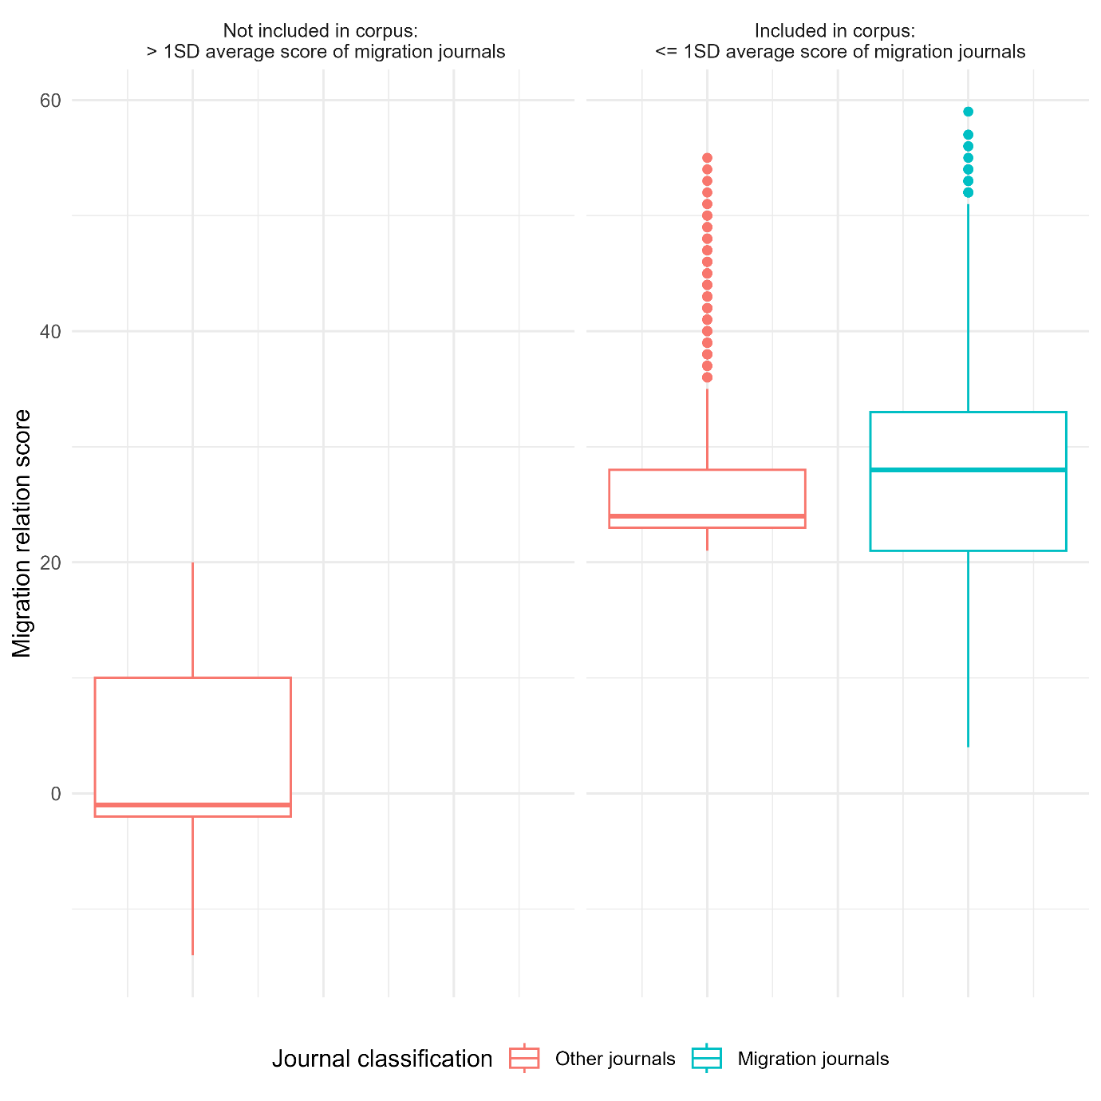
Figure S.1: We selected those publications having less than one standard deviation from the average score in publications in journals that publish mainly on migration topics. We use the distribution of scores in these journals to guide our selection of the generalist and non-social science journals. Nonetheless, we evaluated examples of publications scoring very high or very low to make sure the scores from migration journals do not distort our selection process in case specific terms and concepts are used disproportionately in these journals. Included and not included journals based on scoring system.

- Criteria used to score publications.
 | Criteria name | Description | Type
1 | basic | Presence of any term in list of basic terms | positive
2 | primary | Presence of any term in list of primary terms | positive
3 | migr | Presence of migr | positive
4 | mov | Presence of mov | positive
5 | mobil | Presence of mobil | positive
6 | specific | Any specific term | positive
7 | specific_exc | Presence of any term in list of exclusive specific terms | positive
8 | document type | Premium to article and review | positive
9 | mig_journal or previous studies | Item belong to journal with "migr" in title | positive
10 | count general unique terms | Premium for each additional general term | positive
11 | count specific unique terms | Premium for each additional specific term | positive
12 | item title premium | Premium if general primary OR specific exclusive in item title | positive
13 | pubyear >= 2010 | Premium to items from year 2010 and 2015 due to migration crises | positive
14 | presence anchor | Item has any anchor term | positive
15 | item title penalization |  | negative
16 | wrong item in item title |  | negative
17 | only mov and no specific term | Only mov and no specific term | negative
18 | only mobil and no specific term | Only mobil and no specific term | negative
Table S.1: Scoring of publications consisted of applying eighteen different criteria that gave summative positive or negative scoring. We scored all publications in Corpus B based on 18 criteria such as the sum of the unique count of specific and general terms.

- Research representation based on relative migration, period 1996-2020 aggregate.

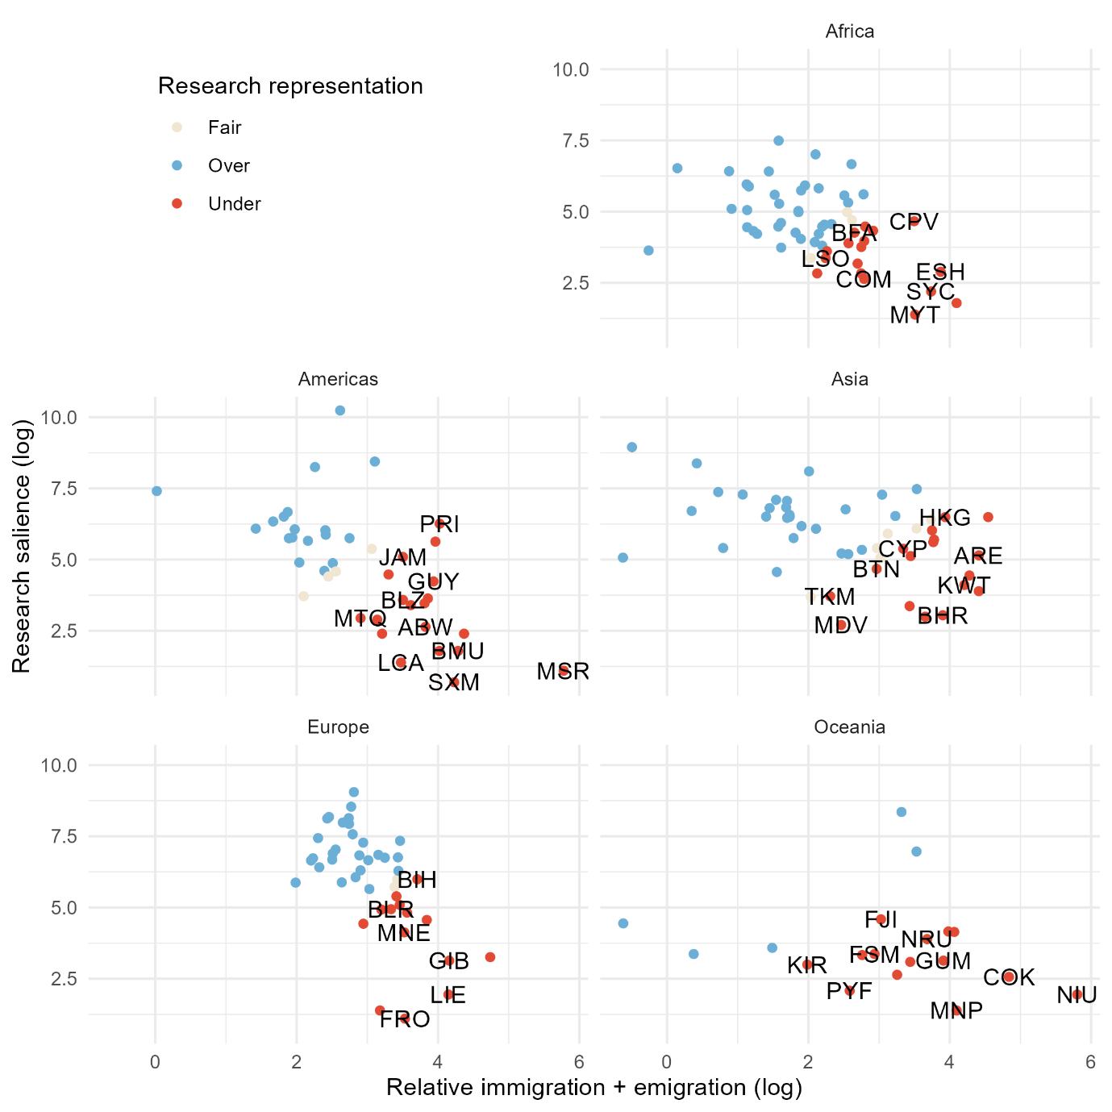
Figure S.2. Countries’ representation (circle colour) in contrast to the sum of relative emigration and immigration (X-axis) and the number of publications (Y-axis). Red countries are underrepresented. Fairly- and overrepresented countries in migration research are beige and blue, respectively.

- Authors’ country of affiliation.
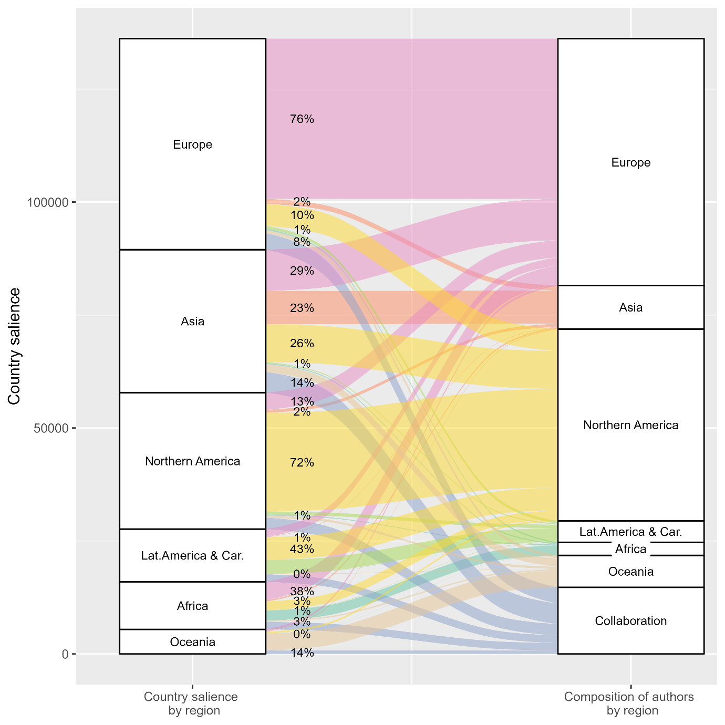
Figure S3.a: Country salience in contrast to authors’ country of affiliation, by continents. Axis 1 (left) shows counts of country salience grouped by continents. The Americas are separated into North America and Latin America and the Caribbean. Axis 2 (right) describes the authors’ affiliation composition grouped as all author(s) from each of the continents. Collaboration means that country mention was conducted by at least one author from a different location. Percentages correspond to authors' affiliation composition.
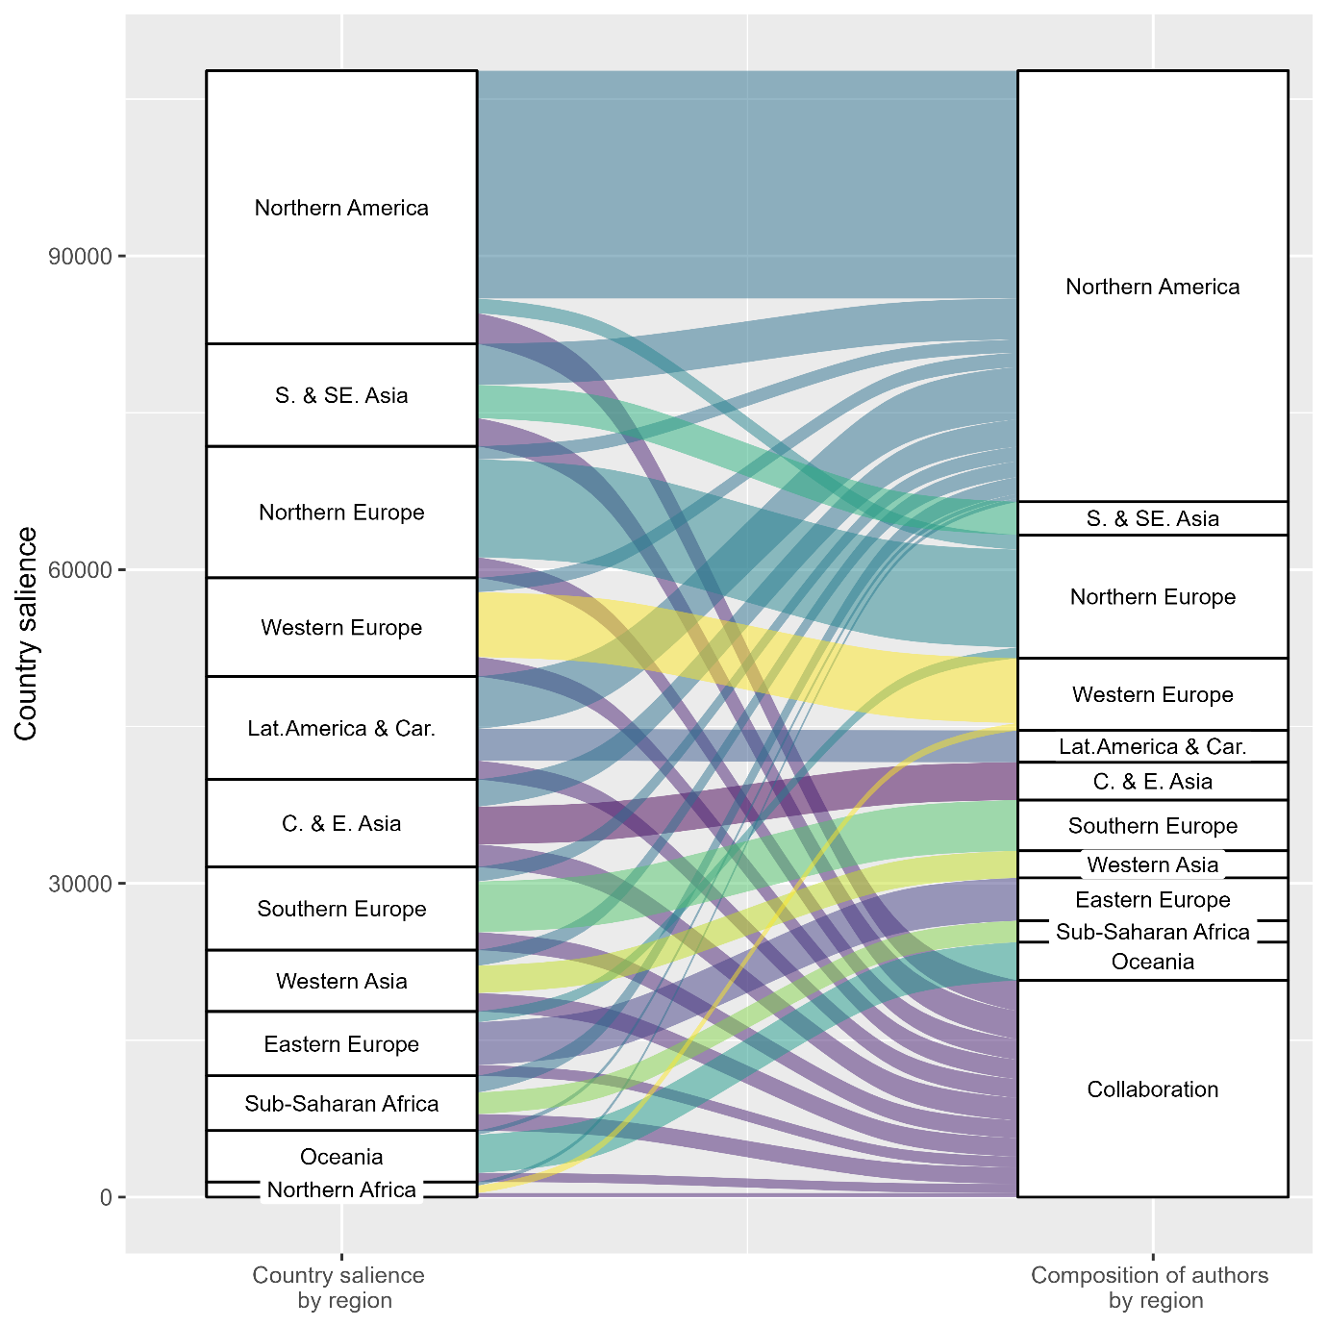
Figure S3.b: Country salience in contrast to authors’ country of affiliation, by United Nations subregional classification. Axis 1 (left) shows counts of country salience grouped by subregions. The top three flows are plotted for improved visualisation. Axis 2 (right) describes the authors’ affiliation composition grouped as all author(s) from each of the continents. Collaboration means that country mention was conducted by at least one author from a different location. Subregions have been grouped into broader groups to facilitate plotting. Abbreviations correspond to the following: S & SE Asia - South and South Eastern Asia; Lat. America & Car. - Latin America and the Caribbean; C & E. Asia - Central and Eastern Asia; Oceania - New Zealand and Australia, Micronesia, Polynesia, Melanesia.

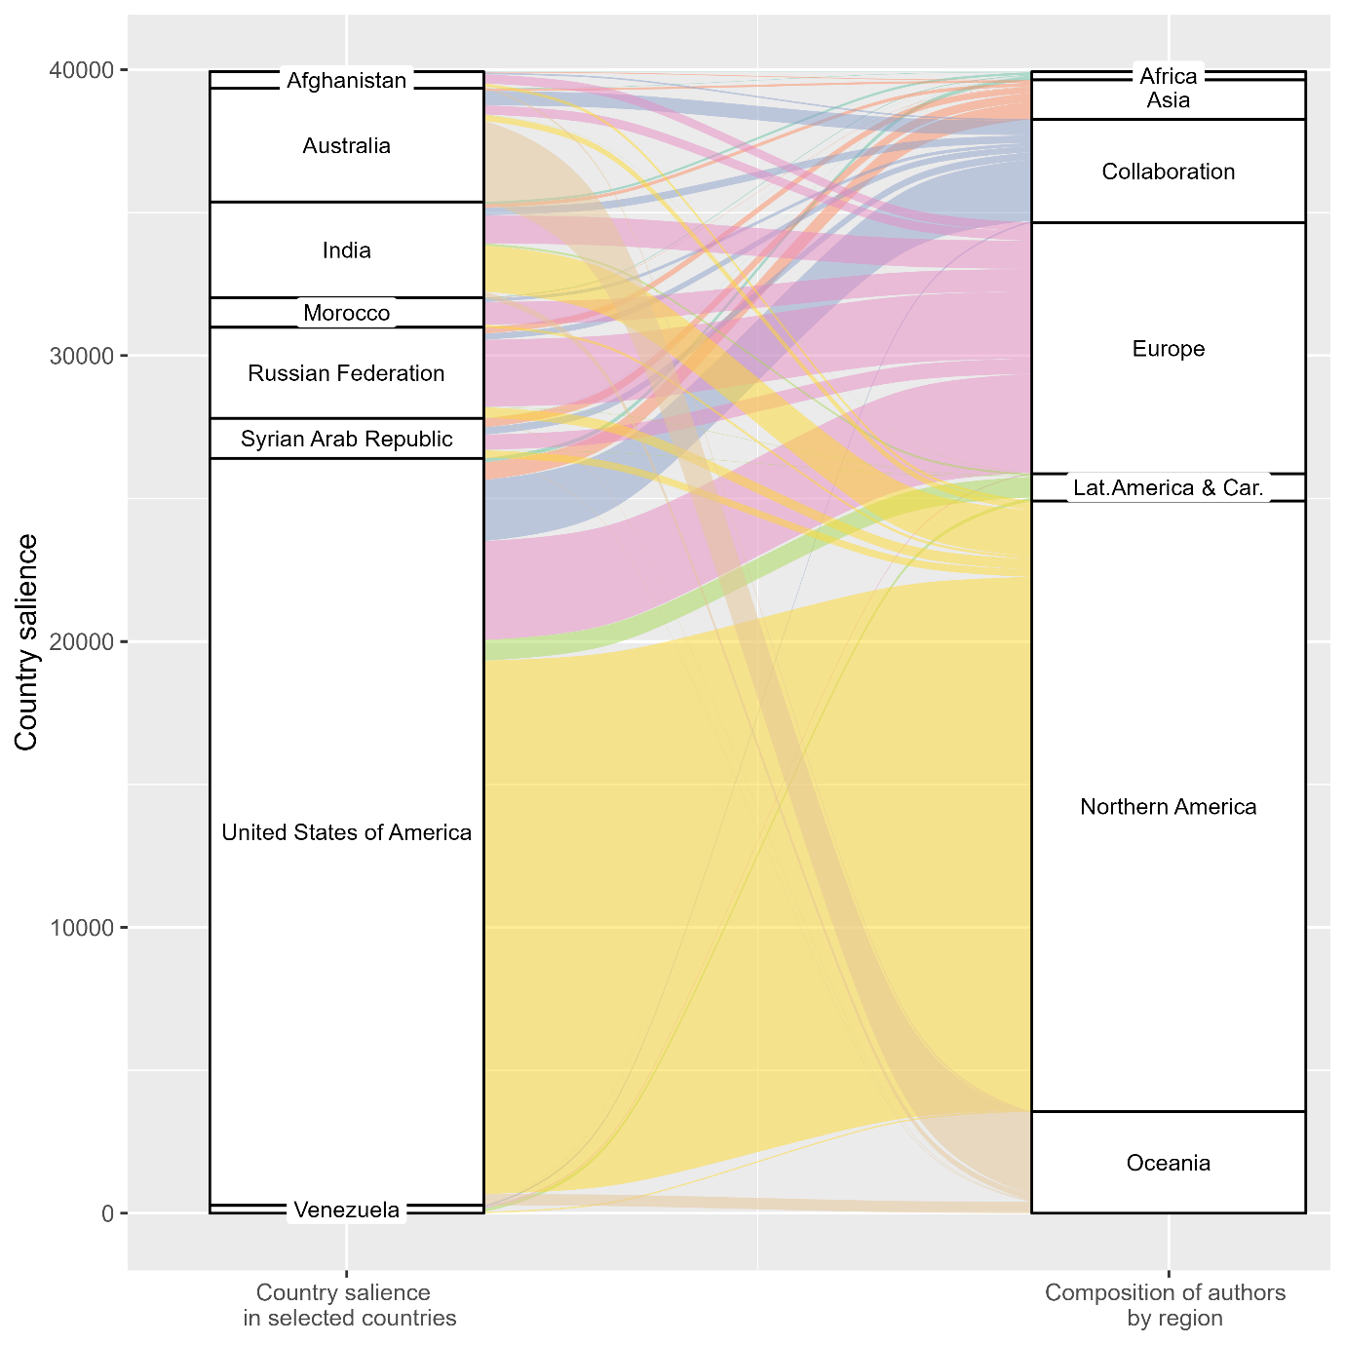
Figure S4. Country salience in selected countries in contrast to authors’ country of affiliation, by continents. Axis 1 (left) shows countries of country salience in a subset of countries. Country selection was guided by the highest levels of migration relevance within each continent, as well as recent migration or refugee crises (e.g., Afghanistan, Syria, and Venezuela). Axis 2 (right) describes the authors’ affiliation composition grouped as all author(s) from each of the continents. Collaboration means that country mention was conducted by at least one author from a different location.

- Research representation for 1996-2022. Table presents the absolute migration relevance and research salience, rescaled into 10 quantiles. Research representation is obtained by subtracting Absolute Migration Relevance from Research salience. The result is classified into positive (over), zero (fair), and negative (under).

Country | Absolute Migration Relevance (rescaled 1-10) | Research salience (rescaled 1-10) | Research Representation score | Research Representation
Finland | 5 | 9 | 4 | Over
Mongolia | 2 | 6 | 4 | Over
Norway | 5 | 9 | 4 | Over
Slovenia | 4 | 8 | 4 | Over
Denmark | 6 | 9 | 3 | Over
Hungary | 6 | 9 | 3 | Over
Ireland | 7 | 10 | 3 | Over
Nauru | 1 | 4 | 3 | Over
Democratic People's Republic of Korea | 3 | 6 | 3 | Over
Suriname | 4 | 7 | 3 | Over
Brazil | 8 | 10 | 2 | Over
Bhutan | 3 | 5 | 2 | Over
Cyprus | 4 | 6 | 2 | Over
Estonia | 5 | 7 | 2 | Over
Micronesia (Federated States of) | 1 | 3 | 2 | Over
Ghana | 6 | 8 | 2 | Over
Gibraltar | 1 | 3 | 2 | Over
Greenland | 1 | 3 | 2 | Over
Iceland | 2 | 4 | 2 | Over
Israel | 8 | 10 | 2 | Over
Lithuania | 5 | 7 | 2 | Over
Marshall Islands | 1 | 3 | 2 | Over
New Zealand | 7 | 9 | 2 | Over
Papua New Guinea | 2 | 4 | 2 | Over
Réunion | 3 | 5 | 2 | Over
Solomon Islands | 1 | 3 | 2 | Over
Somalia | 7 | 9 | 2 | Over
Slovakia | 5 | 7 | 2 | Over
Sweden | 8 | 10 | 2 | Over
Tonga | 2 | 4 | 2 | Over
Tuvalu | 1 | 3 | 2 | Over
Holy See | 1 | 3 | 2 | Over
Vanuatu | 1 | 3 | 2 | Over
Albania | 6 | 7 | 1 | Over
Austria | 8 | 9 | 1 | Over
Belgium | 8 | 9 | 1 | Over
Bolivia (Plurinational State of) | 6 | 7 | 1 | Over
Botswana | 3 | 4 | 1 | Over
Chile | 7 | 8 | 1 | Over
Cameroon | 5 | 6 | 1 | Over
Congo | 5 | 6 | 1 | Over
Cabo Verde | 4 | 5 | 1 | Over
Czechia | 7 | 8 | 1 | Over
Ecuador | 7 | 8 | 1 | Over
Eritrea | 5 | 6 | 1 | Over
Fiji | 4 | 5 | 1 | Over
Georgia | 6 | 7 | 1 | Over
Greece | 8 | 9 | 1 | Over
Guatemala | 6 | 7 | 1 | Over
Croatia | 7 | 8 | 1 | Over
Iraq | 8 | 9 | 1 | Over
Japan | 9 | 10 | 1 | Over
Cambodia | 6 | 7 | 1 | Over
Kiribati | 1 | 2 | 1 | Over
Sri Lanka | 7 | 8 | 1 | Over
Luxembourg | 4 | 5 | 1 | Over
North Macedonia | 5 | 6 | 1 | Over
Malta | 4 | 5 | 1 | Over
Niue | 1 | 2 | 1 | Over
Netherlands | 9 | 10 | 1 | Over
Peru | 7 | 8 | 1 | Over
Senegal | 6 | 7 | 1 | Over
Trinidad and Tobago | 4 | 5 | 1 | Over
British Virgin Islands | 1 | 2 | 1 | Over
Viet Nam | 9 | 10 | 1 | Over
Samoa | 3 | 4 | 1 | Over
South Africa | 9 | 10 | 1 | Over
Aruba | 2 | 2 | 0 | Fair
Argentina | 9 | 9 | 0 | Fair
Armenia | 7 | 7 | 0 | Fair
Australia | 10 | 10 | 0 | Fair
Bulgaria | 7 | 7 | 0 | Fair
Belize | 3 | 3 | 0 | Fair
Central African Republic | 4 | 4 | 0 | Fair
Canada | 10 | 10 | 0 | Fair
Switzerland | 9 | 9 | 0 | Fair
China | 10 | 10 | 0 | Fair
Cook Islands | 2 | 2 | 0 | Fair
Costa Rica | 5 | 5 | 0 | Fair
Cuba | 7 | 7 | 0 | Fair
Germany | 10 | 10 | 0 | Fair
Dominican Republic | 7 | 7 | 0 | Fair
Spain | 10 | 10 | 0 | Fair
Ethiopia | 8 | 8 | 0 | Fair
France | 10 | 10 | 0 | Fair
Faroe Islands | 1 | 1 | 0 | Fair
United Kingdom of Great Britain and Northern Ireland | 10 | 10 | 0 | Fair
Gambia | 4 | 4 | 0 | Fair
French Guiana | 3 | 3 | 0 | Fair
Guam | 3 | 3 | 0 | Fair
Honduras | 5 | 5 | 0 | Fair
Haiti | 7 | 7 | 0 | Fair
Indonesia | 9 | 9 | 0 | Fair
India | 10 | 10 | 0 | Fair
Italy | 10 | 10 | 0 | Fair
Jamaica | 6 | 6 | 0 | Fair
Kenya | 7 | 7 | 0 | Fair
Kyrgyzstan | 6 | 6 | 0 | Fair
Lao People's Democratic Republic | 6 | 6 | 0 | Fair
Lebanon | 8 | 8 | 0 | Fair
Liberia | 5 | 5 | 0 | Fair
Libya | 6 | 6 | 0 | Fair
Liechtenstein | 2 | 2 | 0 | Fair
Latvia | 6 | 6 | 0 | Fair
Morocco | 9 | 9 | 0 | Fair
Maldives | 2 | 2 | 0 | Fair
Mexico | 10 | 10 | 0 | Fair
Myanmar | 8 | 8 | 0 | Fair
Montenegro | 4 | 4 | 0 | Fair
Montserrat | 1 | 1 | 0 | Fair
Mauritius | 4 | 4 | 0 | Fair
Malawi | 5 | 5 | 0 | Fair
Malaysia | 9 | 9 | 0 | Fair
Namibia | 4 | 4 | 0 | Fair
Niger | 5 | 5 | 0 | Fair
Nigeria | 8 | 8 | 0 | Fair
Nicaragua | 5 | 5 | 0 | Fair
Nepal | 8 | 8 | 0 | Fair
Poland | 10 | 10 | 0 | Fair
Puerto Rico | 8 | 8 | 0 | Fair
Portugal | 9 | 9 | 0 | Fair
French Polynesia | 2 | 2 | 0 | Fair
Romania | 9 | 9 | 0 | Fair
Russian Federation | 10 | 10 | 0 | Fair
Singapore | 8 | 8 | 0 | Fair
Saint Helena | 1 | 1 | 0 | Fair
Sierra Leone | 4 | 4 | 0 | Fair
San Marino | 1 | 1 | 0 | Fair
Serbia | 8 | 8 | 0 | Fair
Seychelles | 2 | 2 | 0 | Fair
Syrian Arab Republic | 9 | 9 | 0 | Fair
Thailand | 9 | 9 | 0 | Fair
Tajikistan | 6 | 6 | 0 | Fair
Timor-Leste | 3 | 3 | 0 | Fair
Tunisia | 5 | 5 | 0 | Fair
Türkiye | 10 | 10 | 0 | Fair
United Republic of Tanzania | 6 | 6 | 0 | Fair
Uruguay | 4 | 4 | 0 | Fair
United States of America | 10 | 10 | 0 | Fair
Zimbabwe | 7 | 7 | 0 | Fair
Afghanistan | 10 | 9 | -1 | Under
Angola | 6 | 5 | -1 | Under
Burundi | 6 | 5 | -1 | Under
Bangladesh | 10 | 9 | -1 | Under
Bahamas | 3 | 2 | -1 | Under
Bosnia and Herzegovina | 8 | 7 | -1 | Under
Bermuda | 2 | 1 | -1 | Under
Barbados | 4 | 3 | -1 | Under
Colombia | 9 | 8 | -1 | Under
Comoros | 3 | 2 | -1 | Under
Djibouti | 3 | 2 | -1 | Under
Guinea | 6 | 5 | -1 | Under
Guadeloupe | 3 | 2 | -1 | Under
Equatorial Guinea | 4 | 3 | -1 | Under
Guyana | 5 | 4 | -1 | Under
China, Hong Kong Special Administrative Region | 9 | 8 | -1 | Under
Republic of Korea | 9 | 8 | -1 | Under
Saint Lucia | 2 | 1 | -1 | Under
Lesotho | 4 | 3 | -1 | Under
China, Macao Special Administrative Region | 5 | 4 | -1 | Under
Madagascar | 4 | 3 | -1 | Under
Northern Mariana Islands | 2 | 1 | -1 | Under
Mozambique | 7 | 6 | -1 | Under
Mauritania | 4 | 3 | -1 | Under
Martinique | 3 | 2 | -1 | Under
New Caledonia | 3 | 2 | -1 | Under
Pakistan | 10 | 9 | -1 | Under
Panama | 4 | 3 | -1 | Under
Philippines | 10 | 9 | -1 | Under
Paraguay | 6 | 5 | -1 | Under
State of Palestine | 9 | 8 | -1 | Under
Rwanda | 6 | 5 | -1 | Under
Sudan | 8 | 7 | -1 | Under
El Salvador | 7 | 6 | -1 | Under
Eswatini | 3 | 2 | -1 | Under
Sint Maarten (Dutch part) | 2 | 1 | -1 | Under
Uganda | 7 | 6 | -1 | Under
Ukraine | 10 | 9 | -1 | Under
United States Virgin Islands | 2 | 1 | -1 | Under
Yemen | 6 | 5 | -1 | Under
Zambia | 5 | 4 | -1 | Under
Azerbaijan | 8 | 6 | -2 | Under
Benin | 6 | 4 | -2 | Under
Brunei Darussalam | 4 | 2 | -2 | Under
Algeria | 8 | 6 | -2 | Under
Egypt | 9 | 7 | -2 | Under
Western Sahara | 4 | 2 | -2 | Under
Iran (Islamic Republic of) | 10 | 8 | -2 | Under
Jordan | 9 | 7 | -2 | Under
Republic of Moldova | 7 | 5 | -2 | Under
Mali | 7 | 5 | -2 | Under
Mayotte | 3 | 1 | -2 | Under
Chad | 5 | 3 | -2 | Under
Togo | 5 | 3 | -2 | Under
Turkmenistan | 5 | 3 | -2 | Under
Venezuela (Bolivarian Republic of) | 9 | 7 | -2 | Under
Bahrain | 5 | 2 | -3 | Under
Kazakhstan | 10 | 7 | -3 | Under
Qatar | 7 | 4 | -3 | Under
Uzbekistan | 9 | 6 | -3 | Under
United Arab Emirates | 10 | 6 | -4 | Under
Burkina Faso | 8 | 4 | -4 | Under
Belarus | 9 | 5 | -4 | Under
Democratic Republic of the Congo | 8 | 4 | -4 | Under
Kuwait | 8 | 4 | -4 | Under
Oman | 7 | 3 | -4 | Under
Saudi Arabia | 10 | 6 | -4 | Under
South Sudan | 8 | 4 | -4 | Under
Côte d’Ivoire | 9 | 4 | -5 | Under
Table S.2: Research representation for 1996-2022

