Appendix A
For the general solution of ${\hat{CI}}^{mass}$ and ${\hat{LI}}^{mass}$ under a mass-based scheme:
$Ω≡σ_{u}\left[θ_{Y,K}θ_{X,L}-θ_{Y,L}θ_{X,K}\right]\left[G\left(A-γ_{L}\left(1+γ_{K}\right)\right)-F\left(A-γ_{K}\left(1+γ_{L}\right)\right)\right]+σ_{X}\left[G\left(D+β_{L}\right)+F\left(β_{K}-D\right)\right]+Aθ_{X,L}θ_{Y,K}\left[Fe_{K,L}-Ge_{K,K}\right]-Aθ_{Y,L}θ_{X,K}\left[Fe_{L,L}-Ge_{K,L}\right]$>0 (A.1)
$γ_{L}≡\frac{λ_{L,Y}}{λ_{L,X}}=\frac{L_{Y}}{L_{X}}$>0 (A.2)
$γ_{K}≡\frac{λ_{K,Y}}{λ_{K,X}}=\frac{K_{Y}}{K_{X}}$>0 (A.3)
$β_{K}≡θ_{X,K}γ_{K}+θ_{Y,K}$>0 (A.4)
$β_{L}≡θ_{X,L}γ_{L}+θ_{Y,L}$>0 (A.5)
$A≡γ_{L}β_{K}+γ_{K}β_{L}$>0 (A.6)
$D≡β_{K}θ_{YL}-β_{L}θ_{YK}$ (A.7)
$F≡\left(\frac{γ_{L}\left(1-θ_{YK}\right)-γ_{K}θ_{YL}}{A}\right)+e_{KC}$ (A.8)
$G≡\left(\frac{γ_{K}\left(1-θ_{YL}\right)-γ_{L}θ_{YK}}{A}\right)+e_{LC}$ (A.9)
For the general solution of ${\hat{CI}}^{rate}$ and ${\hat{LI}}^{rate}$ under a rate-based scheme:
$Γ≡(1-v)σ_{u}\left(θ_{Y,K}θ_{X,L}-θ_{Y,L}θ_{X,K}\right)\left(γ_{K}-γ_{L}\right)+η\left[b_{w}+σ_{X}\left(θ_{X,L}γ_{L}+θ_{X,K}γ_{K}\right)\right]$>0
(A.10)
$η≡\left(θ_{Y,K}γ_{L}+θ_{Y,L}γ_{K}+1\right)(1-v)>0$ (A.11)

Appendix B
The impact of the carbon ETS on the welfare of different groups of households is shown in Figure B1, which is calculated under the RP, and LC scenarios.
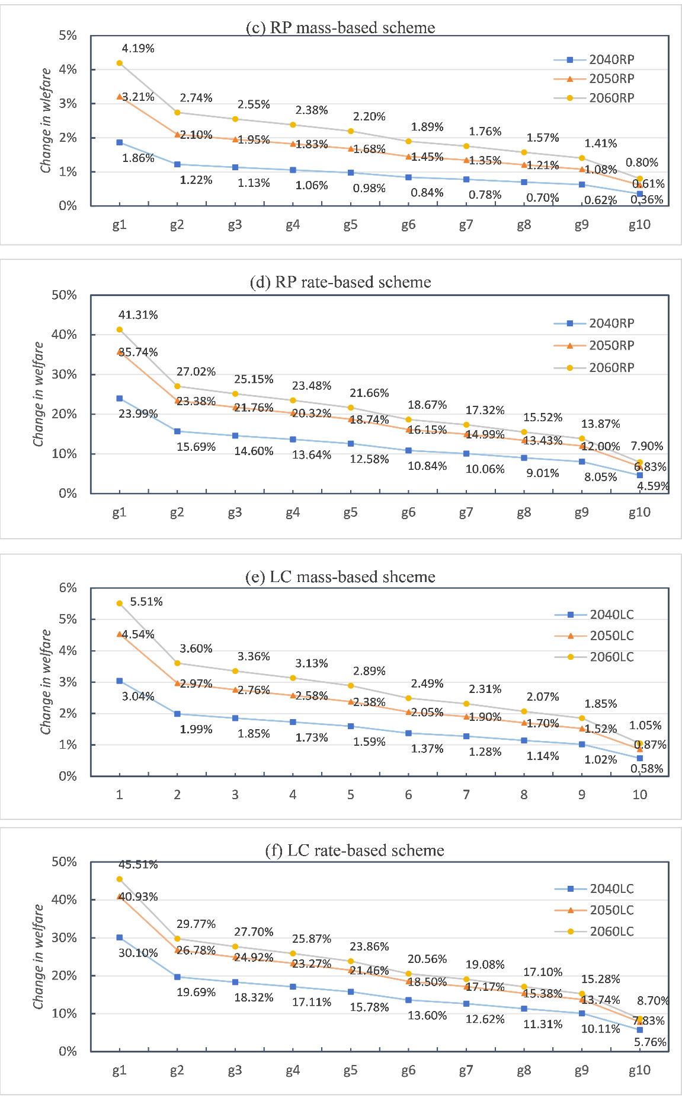
Figure B1 welfare analysis

