Supplementary information

Supplement 1: Supplementary Methods
- Survey instrument
- Non-response survey

Supplement 2: Respondent Demographics
Supplementary Table 1. Survey respondent demographics
Supplementary Figure 1. Respondent age and income distributions
Supplementary Figure 2. Histogram of respondent self-reported DEI prioritization
Supplementary Table 2. Comparison of respondent and non-respondent demographics

Supplement 3: Extended Quantitative Results
Supplementary Table 3. Mean effectiveness of DEI initiatives
Supplementary Figure 3. DEI initiative mean effectiveness by respondent disability and institution’s state politics
Supplementary Table 4. Summary of ‘Other’ initiatives provided by respondents as text entry related to DEI initiatives at the campus level
Supplementary Table 5. Summary of ‘Other’ initiatives provided by respondents as text entry related to fostering inclusive and safe classrooms in environmental courses
Supplementary Table 6. Summary of ‘Other’ initiatives provided by respondents as text entry related to advancing DEISJ in course content and materials

Supplement 4: Extended Qualitative Results
Supplementary Table 7. Codes, code descriptions, code frequency, and Cohen's kappa statistic from open-ended responses to question about what makes DEI initiatives effective
Supplementary Table 8. Codes, code descriptions, code frequency, and Cohen's kappa statistic from open-ended responses to question about what makes DEI initiatives ineffective

Data

Supplement 1: Supplementary Methods

1. Qualtrics survey instrument

Survey: Assessing the Impact of Diversity, Equity & Inclusion Practices in Ecological & Environmental Course
Description and definitions
This survey evaluates your perceptions of DEISJ initiatives in higher education, both on your campus and in your classrooms. We define the following terms relevant to DEISJ as:
- DEISJ: Diversity, Equity, Inclusion, Social Justice.
- Diversity: The presence of differences among people in a given setting including, but not limited to, differences in race, ethnicity, socioeconomic status, gender, sexual orientation, age, physical and mental ability, religious beliefs, political beliefs, or ideologies.
- Equity: Ensuring that everyone can develop their potential by identifying and addressing barriers to desirable outcomes, and by providing resources and support tailored to people’s unique needs.
- Inclusion: Fostering safe, respectful, and nurturing environments that bring traditionally excluded individuals and/or communities into processes, activities, and decision-making in a way that shares power and actively welcomes unique perspectives.
- Social Justice: Examining practices to identify and dismantle embedded systems of oppression, systemic barriers, inequitable power sharing, and unjust practices.
Main survey
- What is your current academic role?
Selection options: Student (selection prompts question 2a);
Faculty / Staff (selection prompts question 2b)
- a. What year/level are you in your academic program?
Selection options: Freshman; Sophomore; Junior; Senior; Masters; PhD;
Other (text entry)
b. What is your academic role (may select more than one)?
Selection options: Research Faculty; Lecturer/Instructor; Assistant Professor;
Associate Professor; Full Professor; Other (text entry)

- Which initiatives do you think are, or could be, effective at improving any aspect of DEISJ on your campus (excluding classes, which are covered later in this survey)?
Response type: 5-factor Likert scale (Not effective; slightly effective; moderately effective; very effective; extremely effective; NA/I don’t know)
Initiative as displayed in survey | Abbreviation used in text
Established expectations for communication/community norms | Community norms
Affinity networks (e.g., cultural centers, women’s leadership groups, BIPOC groups) | Affinity networks
Mentorship programs (peer-to-peer or mentor-mentee) | Mentorship programs
Diversity in leadership | Diverse leadership
Analysis to determine gaps in pay, graduation rates, grades, etc. (*only shown to faculty/staff respondents) | Pay analysis
Social engagement opportunities | Social engagement
DEISJ Training | DEISJ Training
DEISJ Committees | DEISJ Committees
Rewards DEISJ work in tenure and promotion (*only shown to faculty/staff respondents) | Tenure incentive
Institutional messaging on the value of DEISJ | Institutional messaging
Survey to assess the climate of DEISJ in the campus community | Climate survey
Policies and advocacy to promote equity in advancement (e.g., admissions, grades, hiring, promotion, salary, benefits) (*only shown to faculty/staff respondents) | Equity in advancement
DEISJ initiatives sufficiently funded | Sufficient funding
Accessibility of resources (e.g., accessible building design, websites, etc.) | Accessibility
Bias & harassment reporting systems | Bias reporting
Other anonymous feedback systems | Anonymous feedback
Family care support (e.g. daycare, family insurance plans, basic needs assistance) | Family care
Other (please describe)
- Student respondent question stem: The following initiatives are related to fostering inclusive, safe classroom environments that intentionally support a diversity of experiences, identities, and learning styles. Which of these initiatives have you experienced in your environmental courses, and how effective were they at increasing your sense of belonging or improving learning outcomes in the classroom?
Faculty/staff respondent question stem: The following initiatives are related to fostering inclusive, safe classroom environments that intentionally support a diversity of experiences, identities, and learning styles. Which of these initiatives have you included in your environmental courses, and how effective do you think they were at increasing students’ sense of belonging or learning outcomes in the classroom?
Response type: 5-factor Likert scale (Not effective; slightly effective; moderately effective; very effective; extremely effective; Not experienced/I don’t know)
Initiative as displayed in survey | Abbreviation used in text
Establishing expectations for engagement (community norms) | Community norms
Anonymous classroom feedback at the beginning or midpoint of a course leading to adaptations | Anonymous feedback
Instructors sharing relevant lived experiences and acknowledging their own privilege | Instructor lived experience
Discussions are structured or facilitated to be inclusive and center multiple perspectives | Facilitated discussion
Supporting peer-to-peer mentoring | Peer to peer mentoring
Flexible assignments and assessments | Flexible assignments
Flexibility for attendance options and office hours that accommodates diverse needs and unexpected life events | Attendance flexibility
If relevant, opportunities to engage with the outdoors are accessible and support diverse student identities | Outdoor accessibility
Syllabus is comprehensive and includes course objectives & expectations, the importance of DEISJ, and campus resource information (e.g., technology, health & safety) | Syllabus
Improving accessibility of resources (e.g., free course materials, screen-reader ready content, low-bandwidth content) | Resource Accessibility
Facilitates learning by providing slides in advance, multiple examples of worked problems, practice exams, etc | Comprehensive materials
Instructors share their pronouns, and consistently use students’ pronouns and names | Instructor pronouns
Other (please describe)
- Student respondent question stem: The following initiatives are related to advancing DEISJ in course content and materials. Which of these initiatives have you experienced in your environmental courses, and how effective were they at increasing your sense of belonging or learning outcomes in the classroom?
Faculty respondent question stem: The following initiatives are related to advancing DEISJ in course content and materials. Which of these initiatives have you included in your environmental courses, and how effective do you think they were at increasing students’ sense of belonging or learning outcomes in the classroom?
Response type: 5-factor Likert scale (Not effective; slightly effective; moderately effective; very effective; extremely effective; Not experienced/I don’t know)
Initiative as displayed in survey | Abbreviation used in text
Representation and discussion of diverse leaders, figures, and contributors to the field (e.g., content, guest lectures) | Diverse representation
Diverse content sources (e.g., storytelling, content from other disciplines, social media, etc.) | Diverse sources
Content designed to build skills related to critical thinking, discernment, and having uncomfortable conversations | Critical thinking
Content reflects students’ interests, feedback, and lived experiences/current events | Student relevant
Discussion of intersectional cultural and societal points of view on course topics (across diverse ethnicities, genders, races, etc.) | Intersectional perspectives
Discussion of the relationship between eugenics and science, past and present | Acknowledge eugenics
Discussion of discriminatory viewpoints held by “founders of the field” (e.g., John Muir, Gifford Pinchot) | Acknowledge discriminatory views
Discuss the appropriate use of Indigenous Knowledge in conservation and accountability to Indigenous communities | Appropriate use of TEK
Discussion of binary and heteronormative gender perspectives as a social construct, often reinforced in course content | Acknowledge heteronormativity
Critique of history of displacement and genocide of Indigenous peoples for conservation | Critique history
Promotes modern and accurate portrayal of all demographic groups, highlighting their strengths, contributions, & challenges, while avoiding stereotypes | Accurate portrayals
Other (please describe)

- How highly do you prioritize efforts (like those in this survey) to create equitable, inclusive, and diverse course content and learning environments?
Low Priority |  |  |  |  |  |  |  | High Priority
0 | 1 | 2 | 3 | 4 | 5 | 6 | 7 | 8 | 9 | 10

- In your opinion, what makes a DEISJ initiative (on campus or in the classroom) particularly effective? (Text response)
- In your opinion, what makes a DEISJ initiative (on campus or in the classroom) particularly ineffective? (Text response)
- Rate your familiarity with DEISJ concepts and initiatives.
Unfamiliar |  |  |  |  |  |  |  | Very familiar
0 | 1 | 2 | 3 | 4 | 5 | 6 | 7 | 8 | 9 | 10

- Demographics
Anonymous demographic data will be aggregated - no individual will be identifiable.
- To which racial or ethnic group(s) do you identify? (Select all that apply)
Selection options: American Indian/Native American/Alaska Native/First Nations; Asian; Black/African American; Hispanic/LatinX; Middle Eastern/North African; Native Hawaiian/Pacific Islander; White/Caucasian; Prefer not to answer; Prefer to self-describe (text entry)
- With which gender(s) do you identify? (Select all that apply)
Selection options: Agender; Cisgender Female, Feminine, or Woman; Cisgender Male, Masculine, or Man; Genderfluid; Genderqueer or Non-binary; Gender non-conforming; Intersex; Not cisgender, but I don’t identify with a specific identity; Questioning or figuring it out; Transgender Female, Feminine, or Woman; Transgender Male, Masculine, or Man; Two-spirit or other Traditional or Indigenous genders; Prefer not to answer; I don’t understand the question; Prefer to self-identify (text entry)
- With which sexual orientation(s) do you identify? Do you consider yourself to be… (Select all that apply)
Selection options: Asexual or Ace spectrum; Bisexual; Gay; Lesbian; Not heterosexual, but don’t identify with a specific identity; Pansexual or Omnisexual; Questioning or figuring it out; Straight or heterosexual; Queer; Prefer not to answer; I don’t understand the question; Prefer to self-identify (text entry)
- Do you self-identify as having or being affected by a disability? (select all that apply):
Selection options: Mental impairment/disability; Physical impairment/disability; None; Prefer not to answer; Other (text entry)
- What is your age? (Response type: numeric slider from 1-100)
- Were/are you the first generation in your family to pursue higher education?
Selection options: Yes; No; Prefer not to answer
- What is your expected annual income this year?
(Response type: dropdown with options: <$10,000; $10,000-$20,000; $20,000-$30,000; $30,000-$40,000; $40,000-$50,000; $50,000-$60,000; $60,000-$70,000; $70,000-$80,000; $80,000-$90,000; $90,000-$100,000; >$100,000)
- Do you identify as a non-traditional student or faculty/staff member?
Selection options: Yes; No; Prefer not to answer
- How does the state in which your institution is located lean politically?
Selection options: Conservative; Moderate; Liberal; Don't know; Prefer not to answer
- Is your institution a Minority Serving Institution?
Selection options: Yes; I don’t know; No
- Are there other marginalized communities with which you identify? (text entry)

Thank you for giving your time and effort to this work. Please press the forward arrow to submit your answers. Note that you will not be able to make further changes after submission.
2. Non-response survey

- What is your current academic role?
Selection options: Student (selection prompts question 2a);
Faculty / Staff (selection prompts question 2b)
- a. What year/level are you in your academic program?
Selection options: Freshman; Sophomore; Junior; Senior; Masters; PhD;
Other (text entry)
b. What is your academic role (may select more than one)?
Selection options: Research Faculty; Lecturer/Instructor; Assistant Professor;
Associate Professor; Full Professor; Other (text entry)
- Is there a reason why you did not take the full DEISJ survey?
Selection options: Too Busy; Other (text entry)
- How highly do you prioritize efforts to create equitable, inclusive, and diverse course content and learning environments?
Low Priority |  |  |  |  |  |  |  | High Priority
0 | 1 | 2 | 3 | 4 | 5 | 6 | 7 | 8 | 9 | 10

- Demographics (see survey above for demographic questions)

Supplement 2: Survey respondent demographics

Supplementary Table 1: Survey respondent demographics

Demographic |  | Faculty | Student
Race | BIPOC | 46 | 40
 | White | 192 | 95
 | Abstain (NA) | 11 (79) | 7 (127)
Gender | Cis Female | 92 | 86
 | Cis Male | 137 | 21
 | Transgender/gender expansive | 11 | 24
 | Abstain (NA) | 11 (77) | 12 (126)
Sexual orientation | Queer | 35 | 71
 | Heterosexual | 192 | 61
 | Abstain (NA) | 18 (83) | 9 (128)
Disability | Yes | 38 | 39
 | No | 203 | 87
 | Abstain (NA) | 7 (80) | 14 (129)
Non-traditional | Yes | 48 | 46
 | No | 193 | 92
 | Abstain (NA) | 7 (80) | 4 (127)
First-generation | Yes | 63 | 30
 | No | 185 | 111
 | Abstain (NA) | 3 (77) | 2 (126)
MSI | Yes | 40 | 17
 | No | 205 | 74
 | I don't know (NA) | 6 (77) | 52 (126)
State politics | Conservative | 88 | 51
 | Moderate | 65 | 22
 | Liberal | 91 | 64
 | Don't know | 3 | 6
 | Abstain (NA) | 4 (36) | 0 (46)
 | Complete | 254 | 143
 | Incomplete | 74 | 126
Total |  | 328 | 269

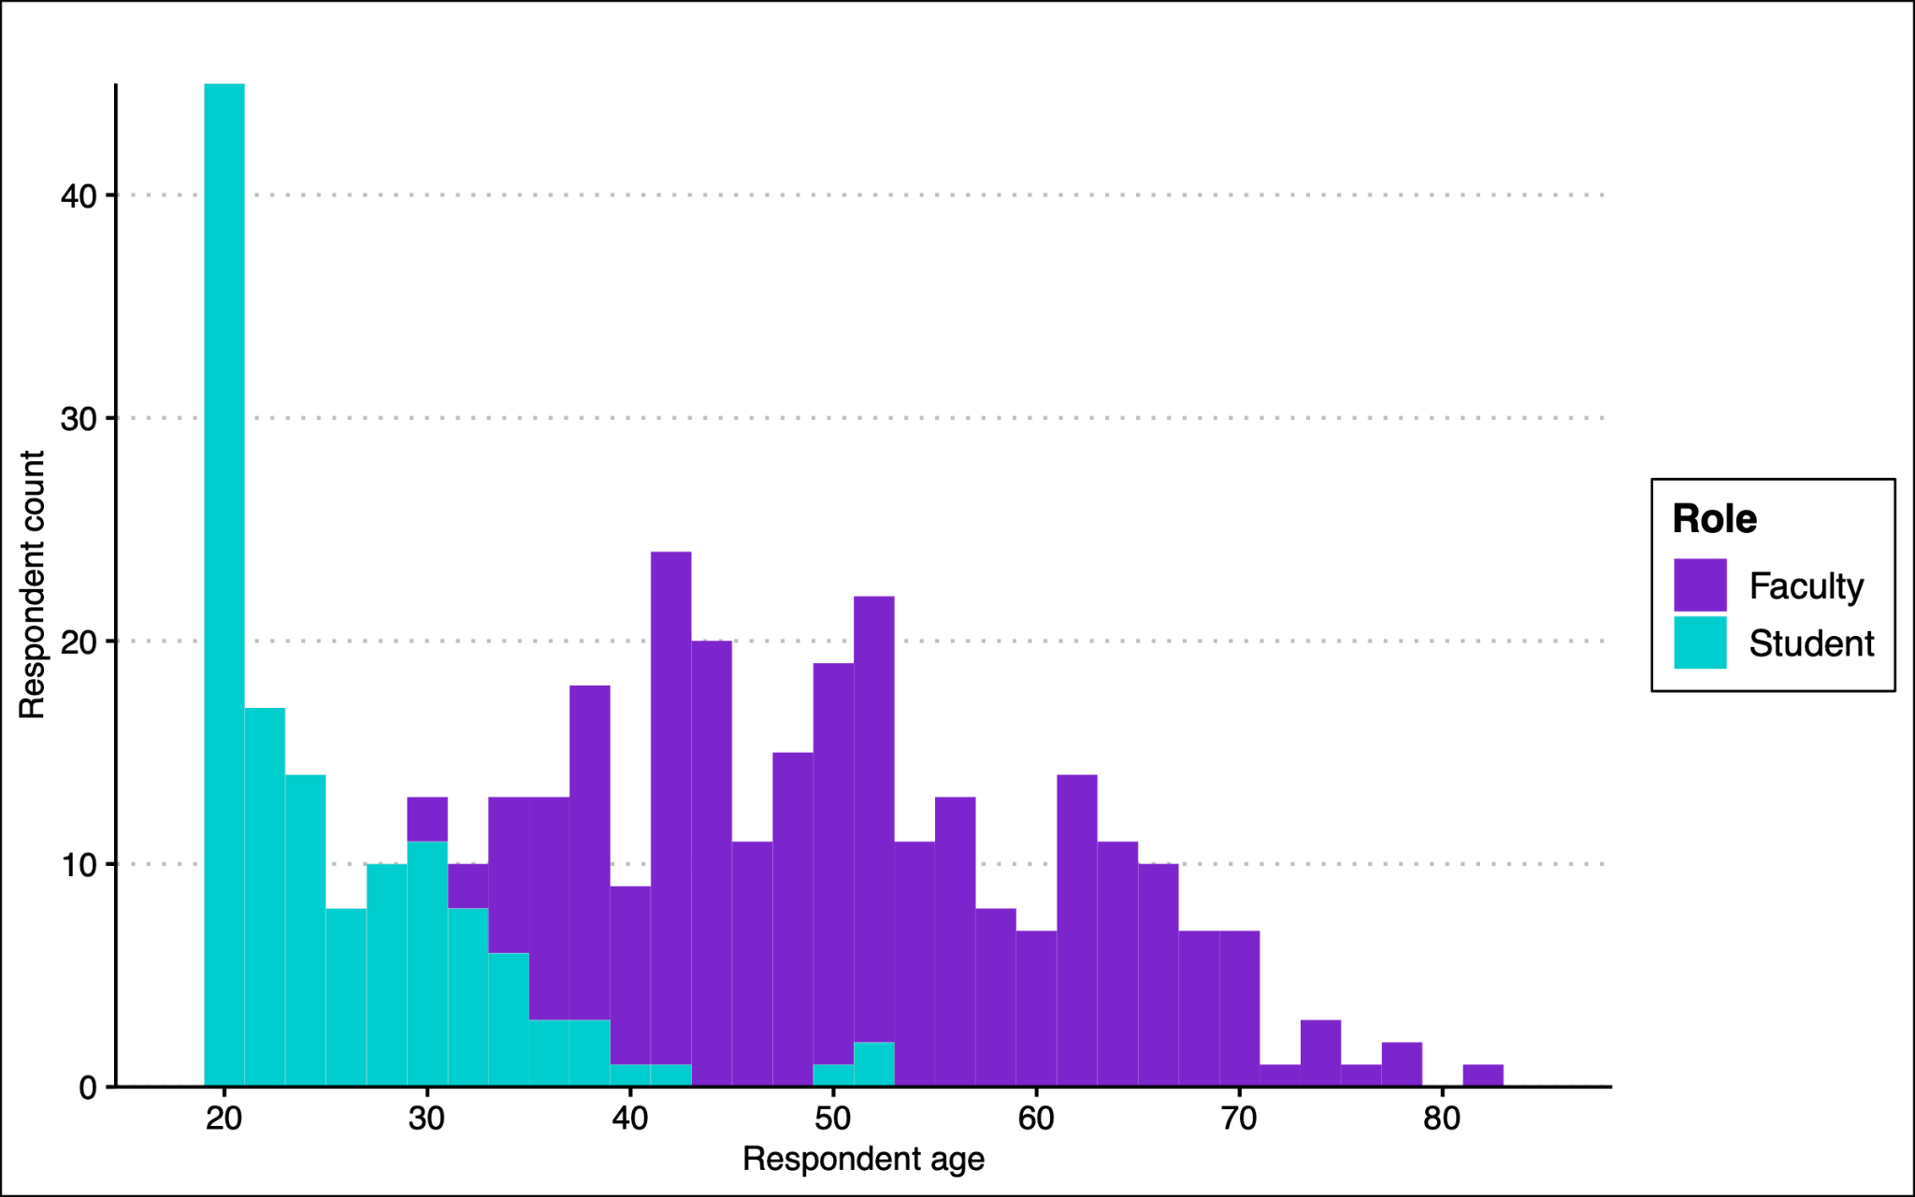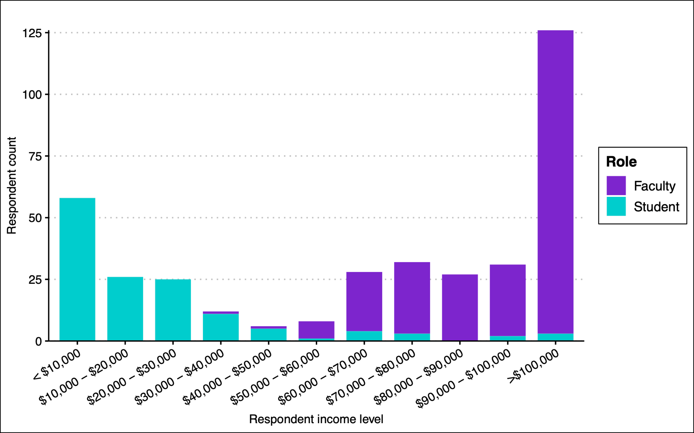
(b)
(a)
Supplementary Figure 1: Respondent (a) age and (b) income distributions. Median age across all respondents was 42 (range 18-83) and median income across respondents was $70,000-$80,000.

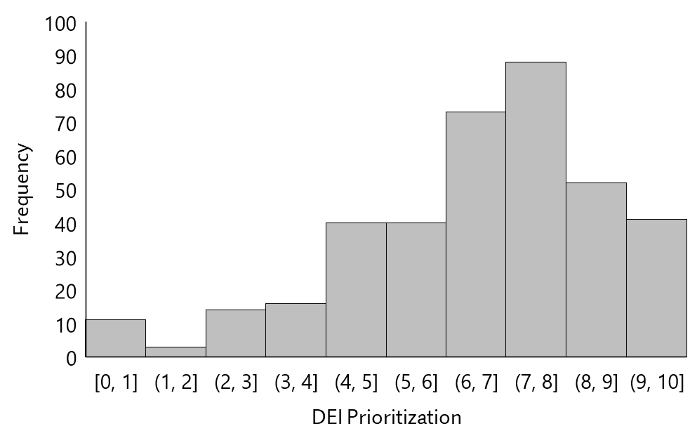
Supplementary Figure 2: Histogram of self-reported DEI prioritization for all available respondents (n = 378).

Supplementary Table 2: Comparison of demographics and DEI prioritization between survey respondents (n = 476) and non-respondents (n = 74).
Profile | Categories | Respondent Percentage (%) | Non-Respondent Percentage (%)
Academic Rank | Faculty / Staff | 60.29 | 90.54
 | Student | 39.7 | 9.46
Race/Ethnicity | BIPOC | 19.24 | 11.29
 | White | 75.19 | 79.03
 | Not Answering | 5.57 | 9.68
Gender | Cisgender Female | 44.92 | 39.34
 | Cisgender Male | 40.1 | 40.98
 | Gender Expansive | 7.87 | 6.56
 | Not Answering | 7.11 | 13.11
Sexual Orientation | Heterosexual/Straight | 65.54 | 73.33
 | Queer | 26.68 | 13.33
 | Not Answering | 7.77 | 13.33
Disability | Abled | 74.74 | 71.43
 | Disabled | 19.33 | 14.29
 | Not Answering | 5.93 | 14.29
First Generation Student | Yes | 23.6 | --
 | No | 75.13 | --
 | Prefer not to answer | 1.27 | --
Non-Traditional Student | Yes | 24.1 | --
 | No | 73.08 | --
 | Prefer not to answer | 2.82 | --
DEI Prioritization | Mean | 7.01 (sd 2.20) | 7.77 (sd 2.31)

Supplement 2: Expanded quantitative results

Supplementary Table 3. Mean effectiveness of DEI initiatives, grouped by initiative type/survey question (campus; inclusive classrooms; course content).

Included as Supplementary_Table_3.xlsx

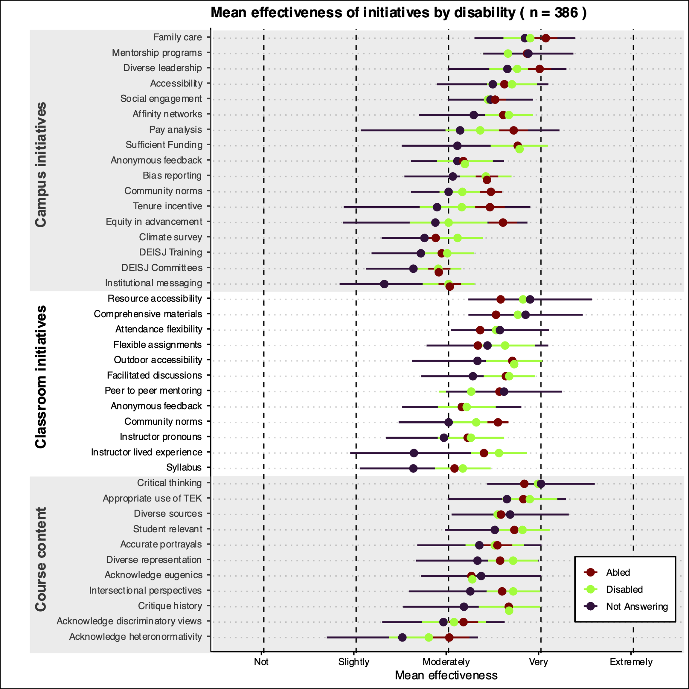
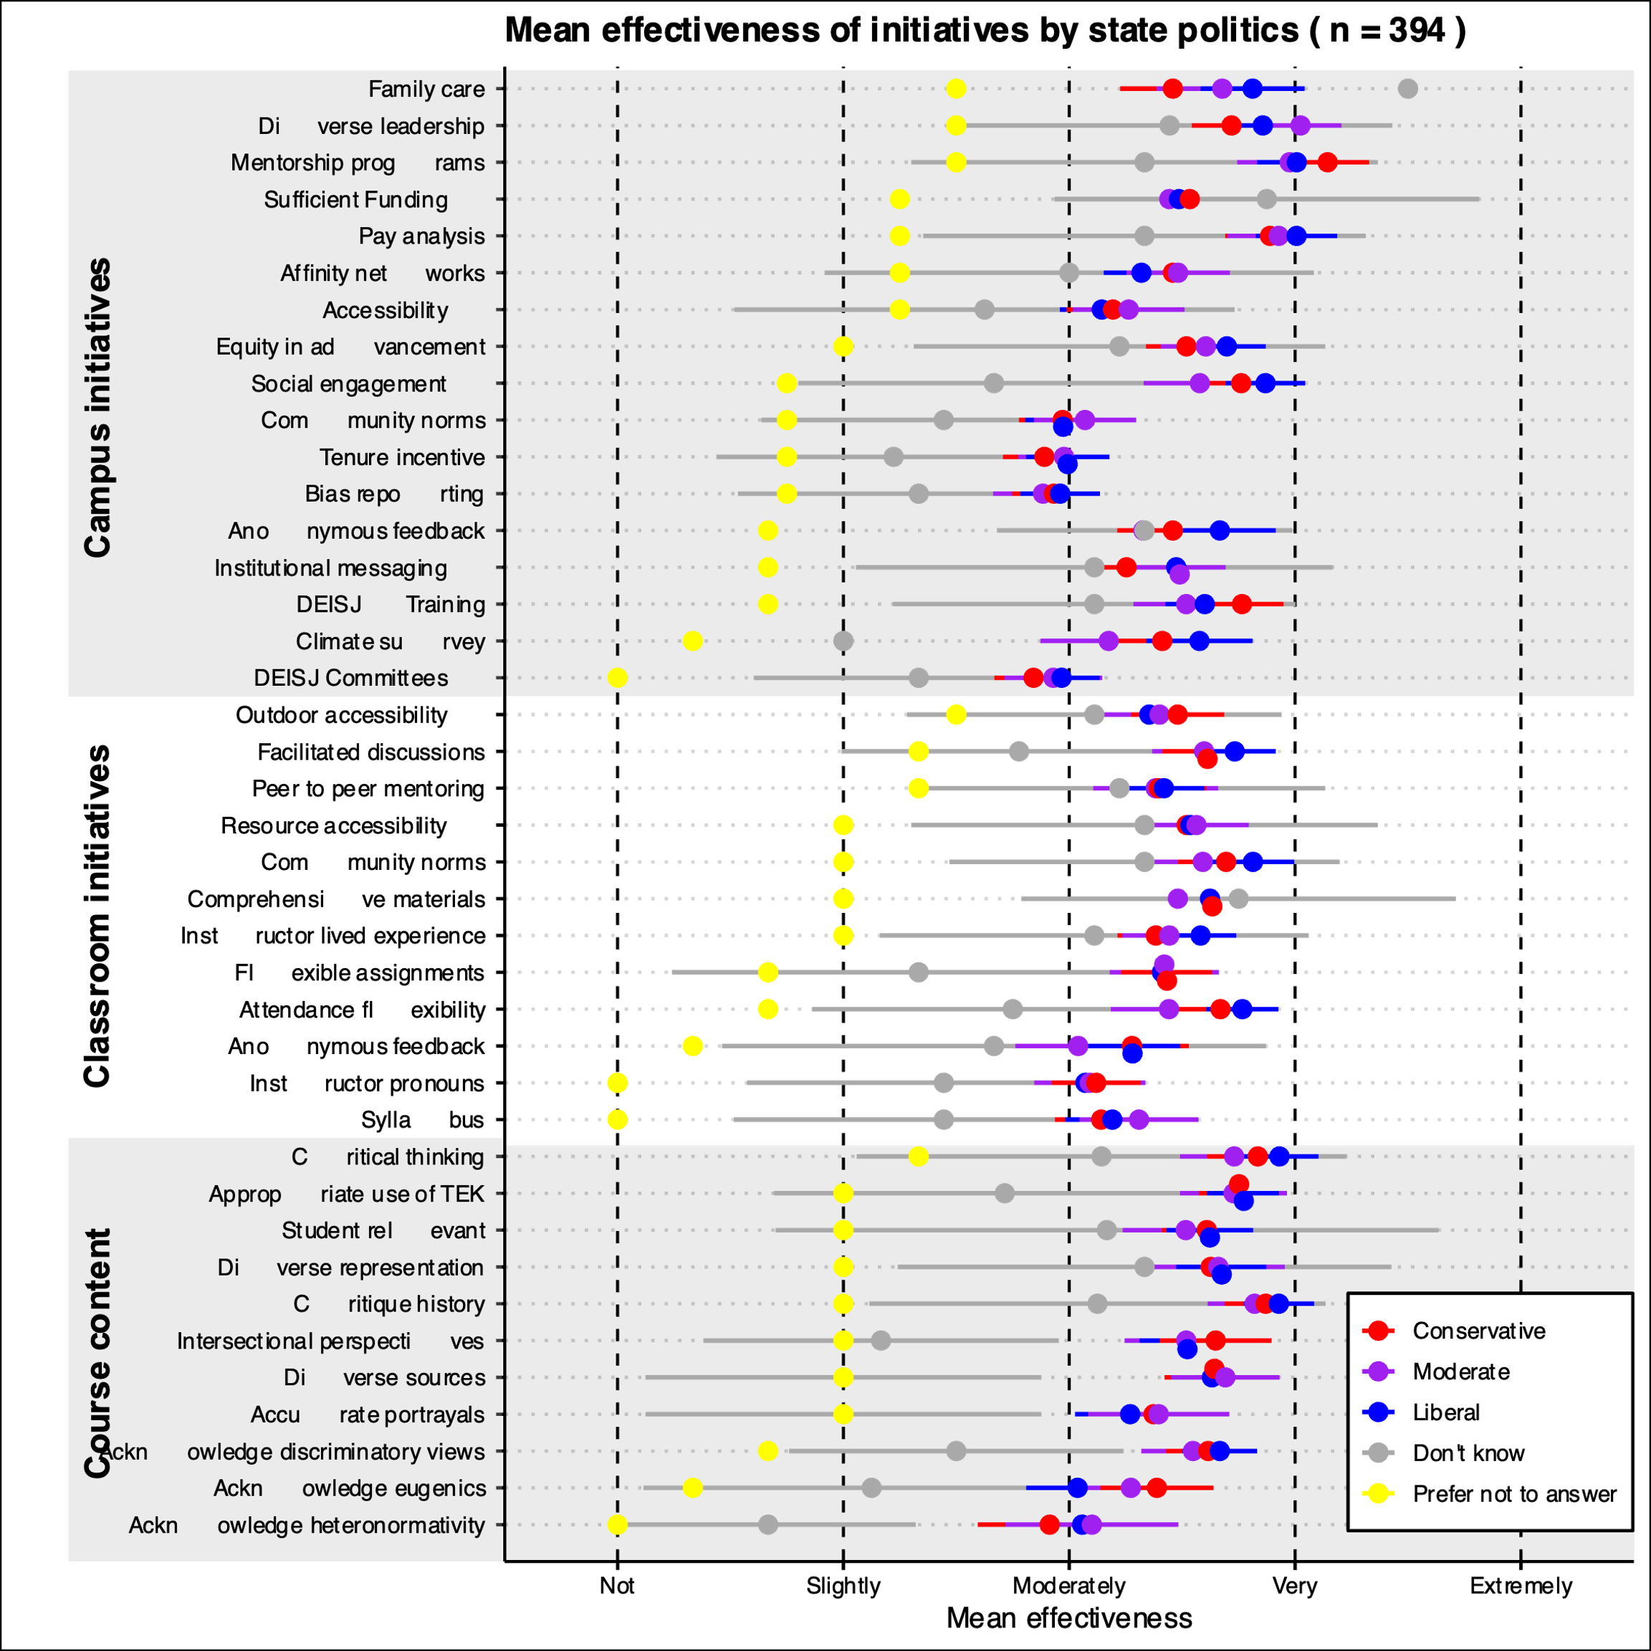
(b)
(a)

Supplementary Figure 3. Mean effectiveness of 40 DEI initiatives by respondent demographics: (a) institution’s state politics (n=394); and (b) disability (n=386). Initiatives are grouped by area (campus, classroom, content), corresponding to the three main survey questions. Dots represent group mean effectiveness and bars show corresponding 95% confidence intervals (CIs). The first row in each section shows the overall mean and 95% CI for all initiatives in that section, for both student and faculty respondents. Within each section, initiatives are shown from highest to lowest mean effectiveness. We interpreted that one group of respondents found initiatives “much more effective” than another if the 95% CIs for the two groups did not overlap. Full initiative descriptions (as they appeared in the survey) corresponding to each abbreviated name on the y-axis can be found in the survey (Supplement 1).
Supplementary Table 4. Summary of ‘Other’ initiatives provided by respondents as text entry related to DEI initiatives at the campus level.

Topic | Number of responses
Complaints and issues with DEI | 7
Increase wages, scholarships, funding, and other incentives | 5
Hire individuals with diverse backgrounds and/or DEI experience in faculty, admin, etc | 5
Evaluate, foster, and support current DEI programs and work | 4
Complaints about survey design | 5
Increase interdisciplinarity | 2
Targeted initiatives and programs | 2
Training | 1
Discriminatory remarks | 1
Non-judgmental mentorship | 1
Increased action | 1
Host open forums and listening sessions | 1
Teach Golden Rule | 1
Mental health resources | 1
Bottom-up solutions | 1

Supplementary Table 5. Summary of ‘Other’ initiatives provided by respondents as text entry related to fostering inclusive and safe classrooms in environmental courses.

Topic | Number of responses
Accurate historical representation | 6
"I don't know" selected because had not experienced the strategy/few strategies experienced | 4
Complaints about survey design & DEI, and transphobic complaints | 5
Foster mutual respect | 2
Discuss biases of Western science & decolonize syllabi | 2
Transparency and consistency in course policy | 1
Repriman racist behaviors | 1
Encourage students to communicate their needs | 1
Students appreciate authenticity | 1
Gap programs | 1
Student Disability Centers need better communication with professors | 1
Class participation in DEI social media campaigns | 1
Non-judgmental, nonpartisan learning | 1
Explicit consideration of DEI in course materials | 1
Inclusion should be modeled | 1
Flipped classroom approach | 1

Supplementary Table 6. Summary of ‘Other’ initiatives provided by respondents as text entry related to advancing DEISJ in course content and materials.

Topic | Number of responses
Survey complaints or dismissive comments | 4
Have not seen any of these at their school/not experienced | 2
Accurate and honest historical representations and discussions | 1
Fund change | 1
Unsure of how impactful some of these are despite using them | 1
All tools could be emphasized and used more | 1
Get rid of DEI | 1
These tools are illegal in their state | 1
Provide diverse perspectives | 1

Supplement 4: Expanded Qualitative results

Supplementary Table 7. Codes, code descriptions, number of references to each code, code frequency, and Cohen's kappa statistic from open-ended responses to the question “In your opinion, what makes a DEISJ initiative (on campus or in the classroom) particularly effective?”

Included as Supplementary_Table_7.xlsx

Supplementary Table 8. Codes, code descriptions, number of references to each code, code frequency, and Cohen's kappa statistic from open-ended responses to the question “In your opinion, what makes a DEISJ initiative (on campus or in the classroom) particularly ineffective?”

Included as Supplementary_Table_8.xlsx

Data
Provided as data_dei_survey.xlsx. To protect respondent anonymity and ensure no respondent is identifiable by demographic information, we have omitted individual respondent demographic information from this data set.

For each demographic, “Abstain” refers to the number of respondents who selected “Prefer not to answer” and the values in parentheses refer to the number of respondents who did not select a response for that demographic.

