Appendix
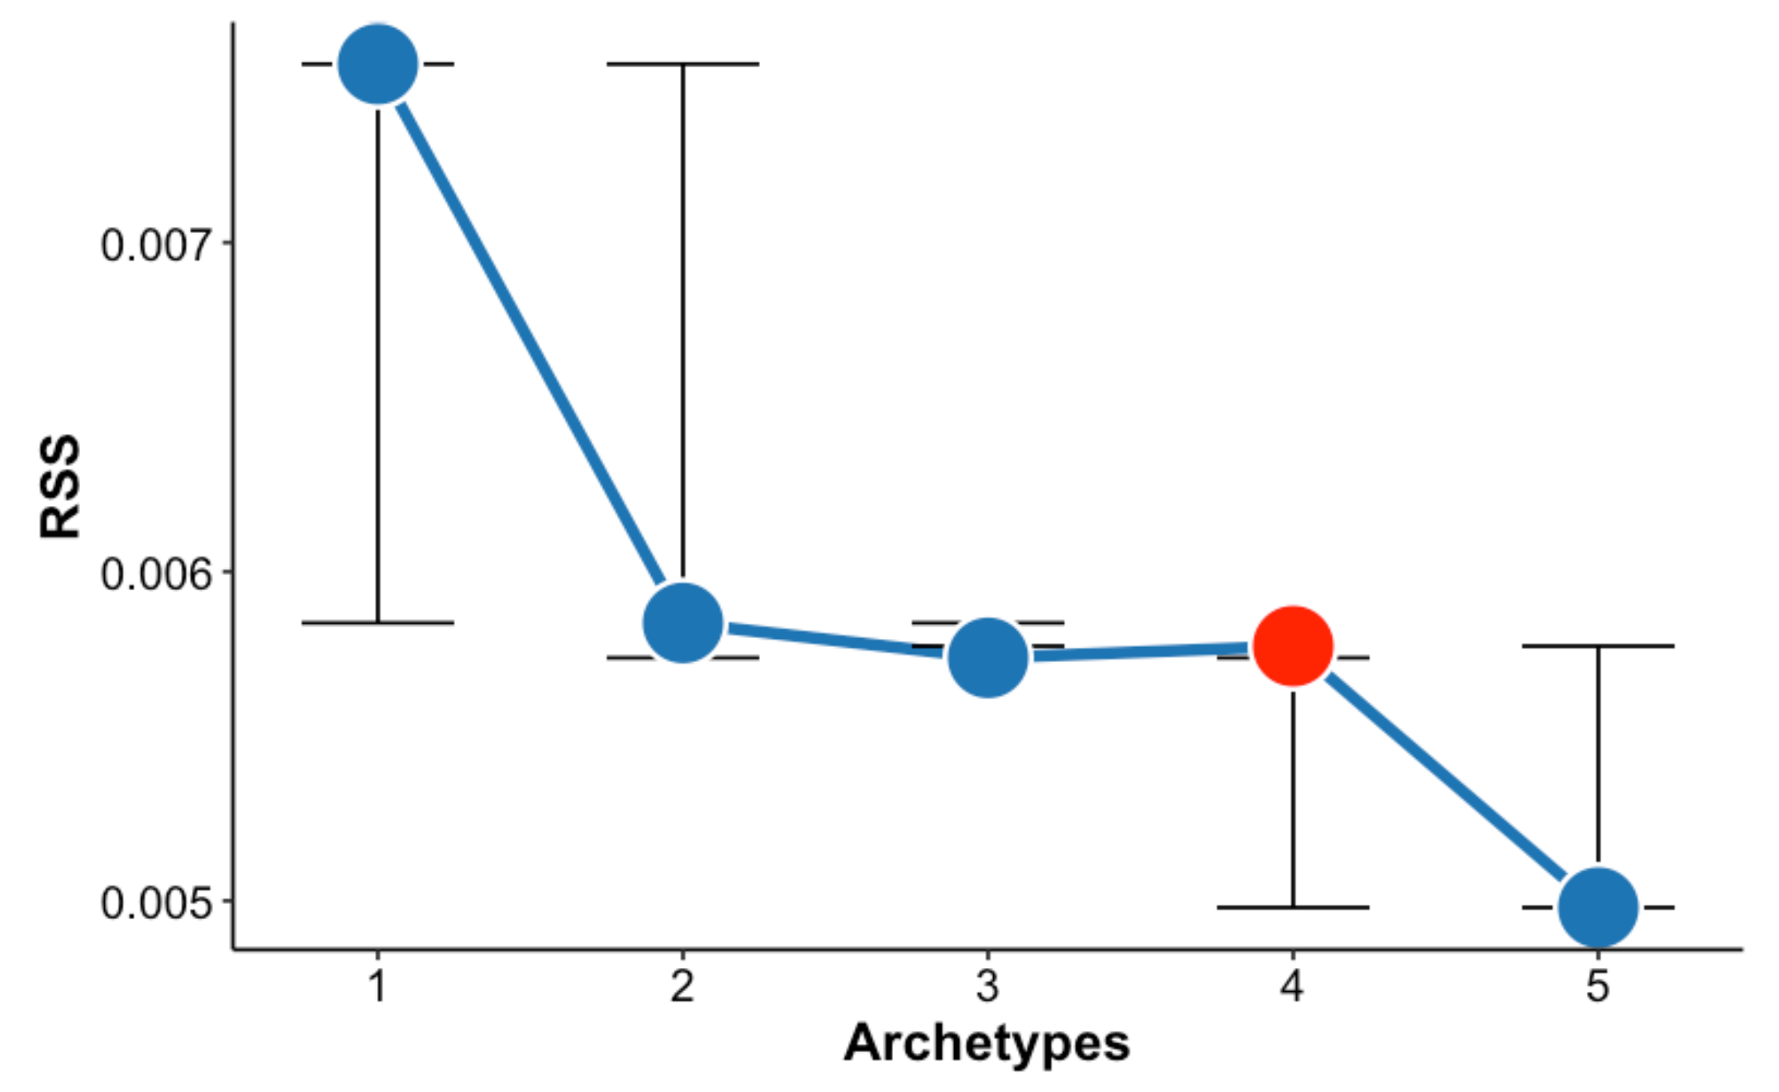
Fig. A1 Screeplot of the residual sum of squares (RSS) of Humanities. The red dot represents the value chosen for the analysis.

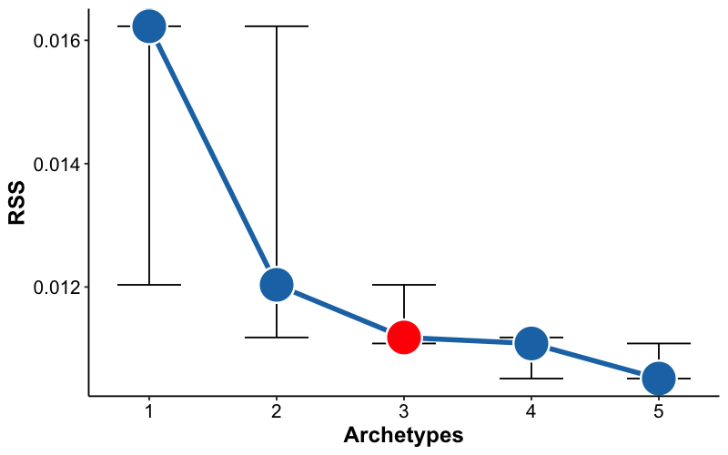
Fig. A2 Screeplot of the residual sum of squares (RSS) of History. The red dot represents the value chosen for the analysis.
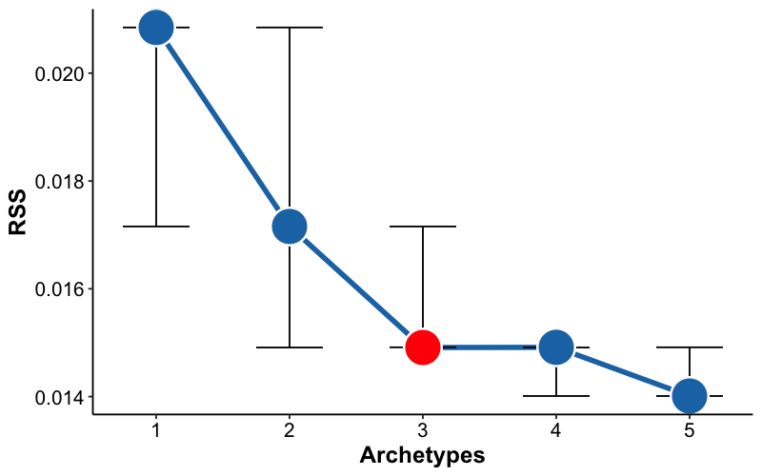
Fig. A3 Screeplot of the residual sum of squares (RSS) of Philosophy. The red dot represents the value chosen for the analysis.

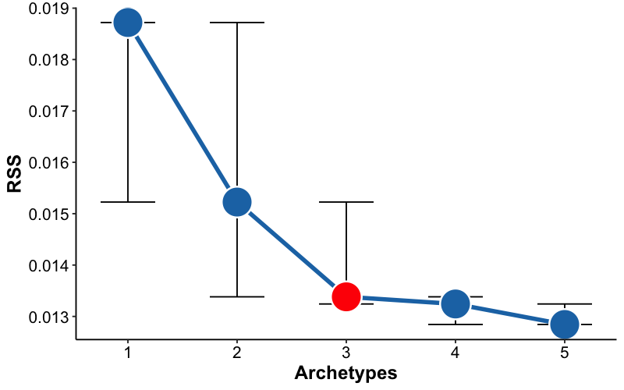
Fig. A4 Screeplot of the residual sum of squares (RSS) of Philology. The red dot represents the value chosen for the analysis.

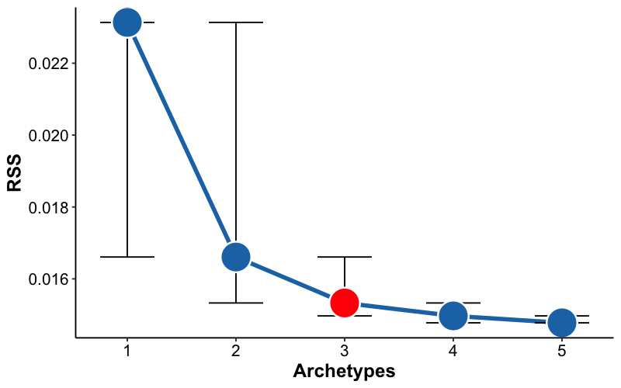
Fig. A5 Screeplot of the residual sum of squares (RSS) of Arts. The red dot represents the value chosen for the analysis.

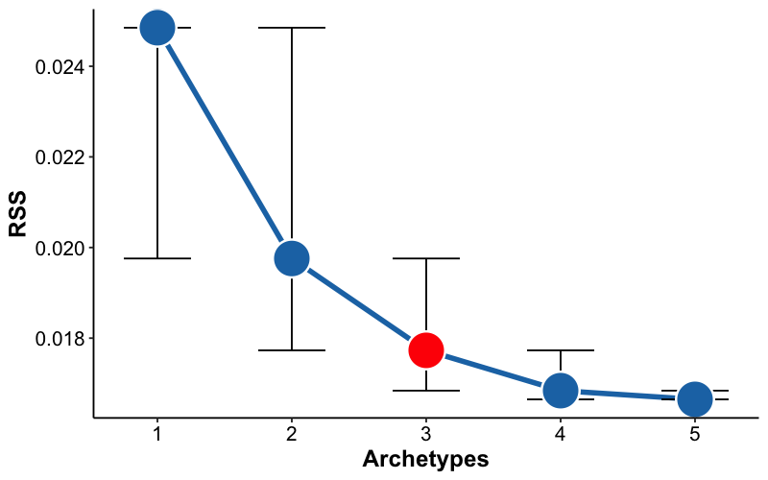
Fig. A6 Screeplot of the residual sum of squares (RSS) of Archaeology. The red dot represents the value chosen for the analysis.

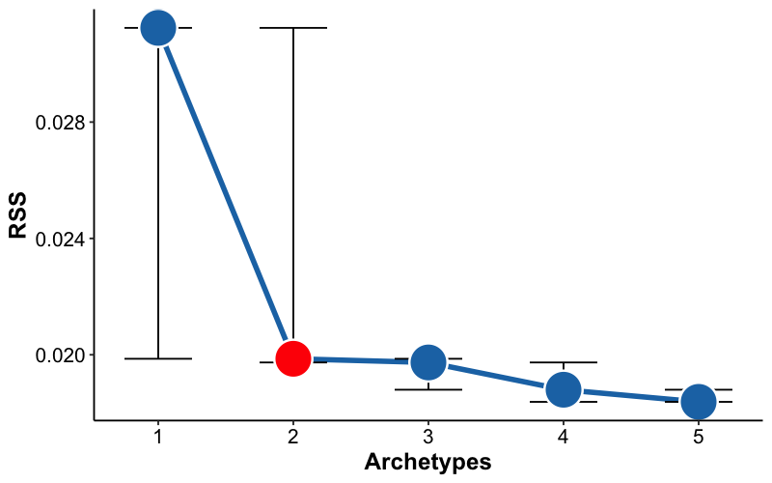
Fig. A7 Screeplot of the residual sum of squares (RSS) of Language & Linguistics. The red dot represents the value chosen for the analysis.

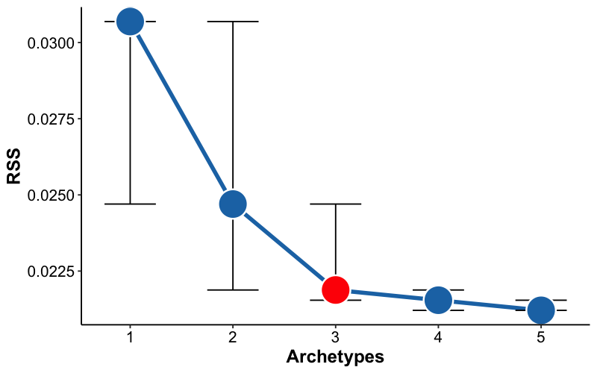
Fig. A8 Screeplot of the residual sum of squares (RSS) of Literature. The red dot represents the value chosen for the analysis.

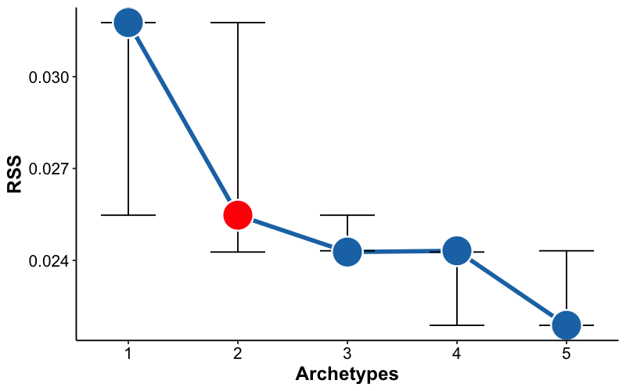
Fig. A9 Screeplot of the residual sum of squares (RSS) of Music. The red dot represents the value chosen for the analysis.

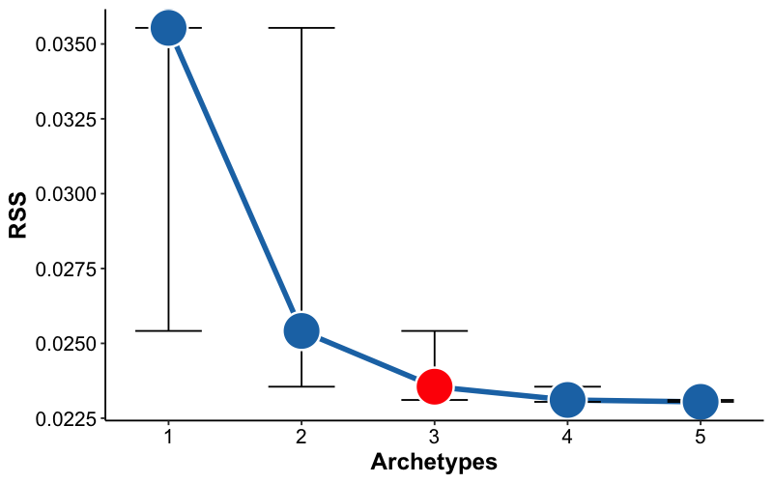
Fig. A10 Screeplot of the residual sum of squares (RSS) of Anthropology. The red dot represents the value chosen for the analysis.

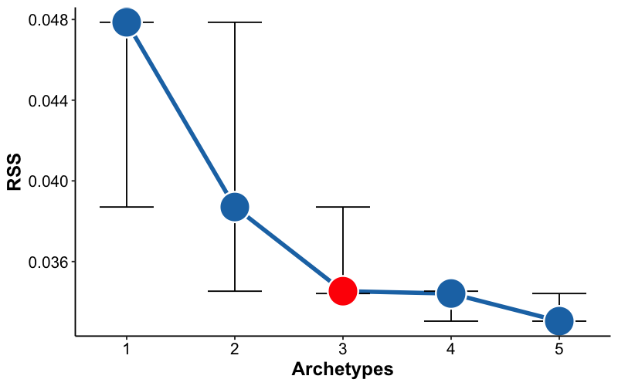
Fig. A11 Screeplot of the residual sum of squares (RSS) of Translation Studies. The red dot represents the value chosen for the analysis.

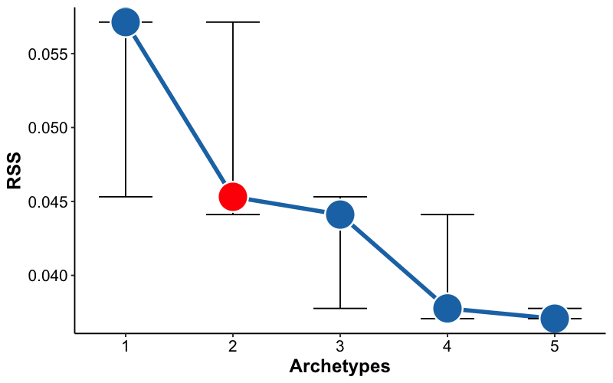
Fig. A12 Screeplot of the residual sum of squares (RSS) of Geography. The red dot represents the value chosen for the analysis.

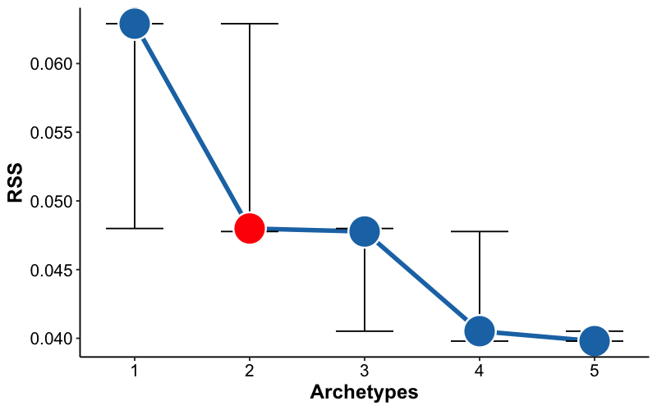
Fig. A13 Screeplot of the residual sum of squares (RSS) of Paleontology. The red dot represents the value chosen for the analysis.

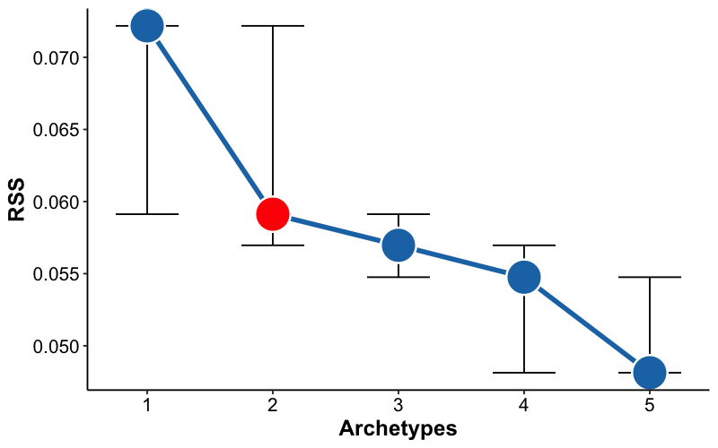
Fig. A14 Archetypes for the rest of fields not included and generational distribution. Colors are linked to archetypes. Red represents the Digital Chronicler; green the Traditionalist and blue the global scholar

Table A1 Jaccard distances matrices between thematic profiles of archetype-discipline combinations.
Archaeology | Anthropology
   | TLC | TCB | TCS
  TLC | 0
  TCB | 0,355 | 0
  TCS | 0,947 | 0,960 | 0
   | TLC | TCB | TCS
  TLC | 0
  TCB | 0,297 | 0
  TCS | 0,980 | 0,977 | 0
Arts | Cultural Studies
   | TCS | TCB | TLC
  TCS | 0
  TCB | 0,979 | 0
  TLC | 0,969 | 0,356 | 0
   | TLC | TCB
  TLC | 0
  TCB | 0,371 | 0
Geography | History
   | TLC | TCB
  TLC | 0
  TCB | 0,745 | 0
   | TLC | TCB | TCS
  TLC | 0
  TCB | 0,373 | 0
  TCS | 0,976 | 0,984 | 0
Language & Linguistics | Literature
   | TPM | TBG
  TPM | 0
  TBG | 0,867 | 0
   | TLC | TPM | TSG
  TLC | 0
  TPM | 0,750 | 0
  TSG | 0,589 | 0,890 | 0
Music | Paleontology
   | TLC | TCB
  TLC | 0
  TCB | 0,765 | 0
   | TBG | TCB
  TBG | 0
  TCB | 0,841 | 0
Philology | Philosophy
   | TCB | TLC | TCS
  TCB | 0
  TLC | 0,371 | 0
  TCS | 0,940 | 0,911 | 0
   | TCB | TLC | TCS
  TCB | 0
  TLC | 0,591 | 0
  TCS | 0,967 | 0,986 | 0
Translation Studies | Abbreviations  TBG – The Bridger  TCB – The Collaborator  TCS – The Cosmopolitan  TLC – The Local Chronicler  TPM – The Polymath  TSG – The Sage
 | TCS | TLC | TCB
TCS | 0
TLC | 0,882 | 0
TCB | 0,921 | 0,439 | 0

Table A2 Equivalence between disciplines and research fields.
Discipline | Field
Social Anthropology | Anthropology
Archaeology | Archaeology
Architectural Graphic Expression | Arts
Graphic Expression in Engineering | Arts
Art History | Arts
Painting | Arts
Arab and Islamic Studies | Cultural Studies
East Asian Studies | Cultural Studies
Hebrew and Aramaic Studies | Cultural Studies
German Philology | Philology
Catalan Philology | Philology
Slavic Philology | Philology
French Philology | Philology
Galician and Portuguese Philology | Philology
Greek Philology | Philology
English Philology | Philology
Italian Philology | Philology
Latin Philology | Philology
Romance Philology | Philology
Basque Philology | Philology
Philosophy | Philosophy
Moral Philosophy | Philosophy
Logic and Philosophy of Science | Philosophy
Human Geography | Geography
Historiographical Sciences and Techniques | History
Ancient History | History
Contemporary History | History
American History | History
History of Science | History
History of Thought and Movements | History
Medieval History | History
Modern History | History
Prehistory | History
Spanish Language | Language & Linguistics
General Linguistics | Language & Linguistics
Indo-European Linguistics | Language & Linguistics
Spanish Literature | Literature
Music | Music
Paleontology | Paleontology
Translation and Interpretation | Translation Studies

