Supplementary Information to: Demographic Decline and Resurgence in the Aging Century - Grid-level Population Tendency Grasped by Artificial Intelligence

Long-term Forecasting Framework

Dataset and Model Structure for Grid-level Population

Dataset for Grid-level Population
The main text mentions the basic composition of a piece of standard data. Here we simply draw a table to show the specific shape of this piece of data. The input vector has 142 elements, X for short, and output has 1 element, y for short, as shown in Table S1.
Table S1: Schematic Diagram of Single Data Structure for Fureco
 | X |  |  |  |  |  |  | y
Name | Neighbor Population counts | On land dummy | NTL | 32 City-level data | 32 City-level data | Location | Category | Certain population count
Period | current | -- | next-5-year | current | next-5-year | -- | -- | next-5-year
Element | 25 | 25 | 25 | 32 | 32 | 2 | 1 | 1
Here, the input vector, X, and output, y, could be expressed as:
$$X_{grid,category,t+5}= {NPC}_{grid,category,t}∪{OLD}_{grid}∪{NTL}_{grid,t+5}∪$$  $${CLD}_{grid,t}∪{CLD}_{grid,t+5}∪{Loc}_{grid}∪category$$ | (1)
$$y_{grid,category,t+5}= {CPC}_{grid,category,t+5}$$ | (2)
where $X_{grid,category,t+5}$ represents a vector with 142 elements for predicting the population count of $category$ in the $grid$ in the year $t+5$, ${NPC}_{grid,category,t}$ represents corresponding population counts of $category$ in the $grid$’s neighborhood in the year $t$, ${OLD}_{grid}$ represents the on-land dummy value of each grid in the $grid$’s neighborhood, ${NTL}_{grid,t+5}$ represents NTL values of each grid in the $grid$’s neighborhood in the year $t+5$, ${CLD}_{grid,t}$ represents the 32 city-level indicators of the city that $grid$ belongs to in the year $t$, ${CLD}_{grid,t+5}$ represents the 32 city-level indicators of the city that $grid$ belongs to in the year $t+5$, ${Loc}_{grid}$ represents the longitude and latitude of the $grid$, $category$ represents the population indicator, $y_{grid,category,t+5}$ represent the output data corresponding to $X_{grid,category,t+5}$, and ${CPC}_{grid,category,t+5}$ represents corresponding population counts of $category$ in the $grid$’s neighborhood in the year $t+5$. $t$’s values could be a number from 2000 to $year$. $year$ is a time cursor with an initial value of 2020. Subsequently, as each forecast period ends, $year$ increases by 5.
Each population indicator in each period has 1,553,024 data points, which is the total number of grids in Japan. We have four-period complete data, including both input and output. The first three periods have four indicators, and the last one has 25 indicators. Therefore, our basic dataset is 57,461,888 rows. We randomly divide the basic data into training and test datasets by an 8:2 ratio using a stratified method. Because the data quality before 2010 is relatively poor, we oversampled the data after 2010 in the training dataset. For TOTAL, MALE, FEMALE, and HOUSEHOLD, we adopt a sampling rate of 2.5 times, while for others, we employ a 2-time sampling rate. In this way, the training dataset size is 86,969,326, and the test dataset size is 11,492,385. It is worth mentioning that this is the scale of our initial training and test datasets.
The training and test datasets could be illustrated as follows:
$$X_{grid,category,t+5}^{training},X_{grid,category,t+5}^{test},y_{grid,category,t+5}^{training},$$  $$y_{grid,category,t+5}^{test}=τ(X_{grid,category,t+5},y_{grid,category,t+5})$$ | (3)
where $X_{grid,category,t+5}^{training}$ and $y_{grid,category,t+5}^{training}$ represent training dataset taking 80% data, $X_{grid,category,t+5}^{test}$ and $y_{grid,category,t+5}^{test}$ represent test dataset covering 20% data, and $τ$ represents the random dividing process. As new data is constantly predicted, the training data and test data sets are constantly updated.

Model Structure for Grid-level Population
Without good debugging and architecture design, such a deep network is difficult to converge because of the vanishing gradients problem. Fully residual connection networks are an effective technology to solve that problem. Originally, the fully residual connection networks are designed to classify the images based on conventional neural networks, which are called ResNet (He et al., 2016). Combined with our data structure, we employ the fully residual connections without conventional layers. Hence, we could name our model Fureco. Fureco is stacked with residual connection modules, as illustrated by Figure S1. A standard residual connection module in this study includes a fully connected layer, a dropout layer, and an adding layer. The number of nodes in the fully connected layer is the same as the input structure, and its activation function is “ReLU”. The dropout layer’s dropout rate is 0.1, and the input of this layer is the output of the fully connected layer. Here, dropout plays a regularization role, so that the training parameter is not too large (Srivastava et al., 2014). In this way, the input of the adding layer is the output of the dropout layer, and the original input of the module. The data structures of the module input and output are the same. There are five depths of ResNet: ResNet-18, ResNet-34, ResNet-50, ResNet-101, and ResNet-152. They have different numbers of residual connection modules, e.g., ResNet-18 has 18 modules. In our study, we test 50-module, 101-module, and 152-module versions, which are called Fureco-50, Fureco-101, and Fureco-152, respectively. We employ a virtual machine with four NVIDIA V100 GPUs to train Fureco models. The networks are built by TensorFlow 2.12.0 and Python 3.9.13. The loss function of Fureco models is based on mean squared error, and the optimizer is Adam. The initial training process could be expressed as follows:
$${Fureco152}_{year+5}=θ(Fureco152,X_{grid,category,t+5}^{training},y_{grid,category,t+5}^{training})$$ | (4)
where $Fureco152$ represents random initialized Fureco-152, and ${Fureco152}_{year+5}$ represents the trained Fureco-152 for predicting data in $year+5$.

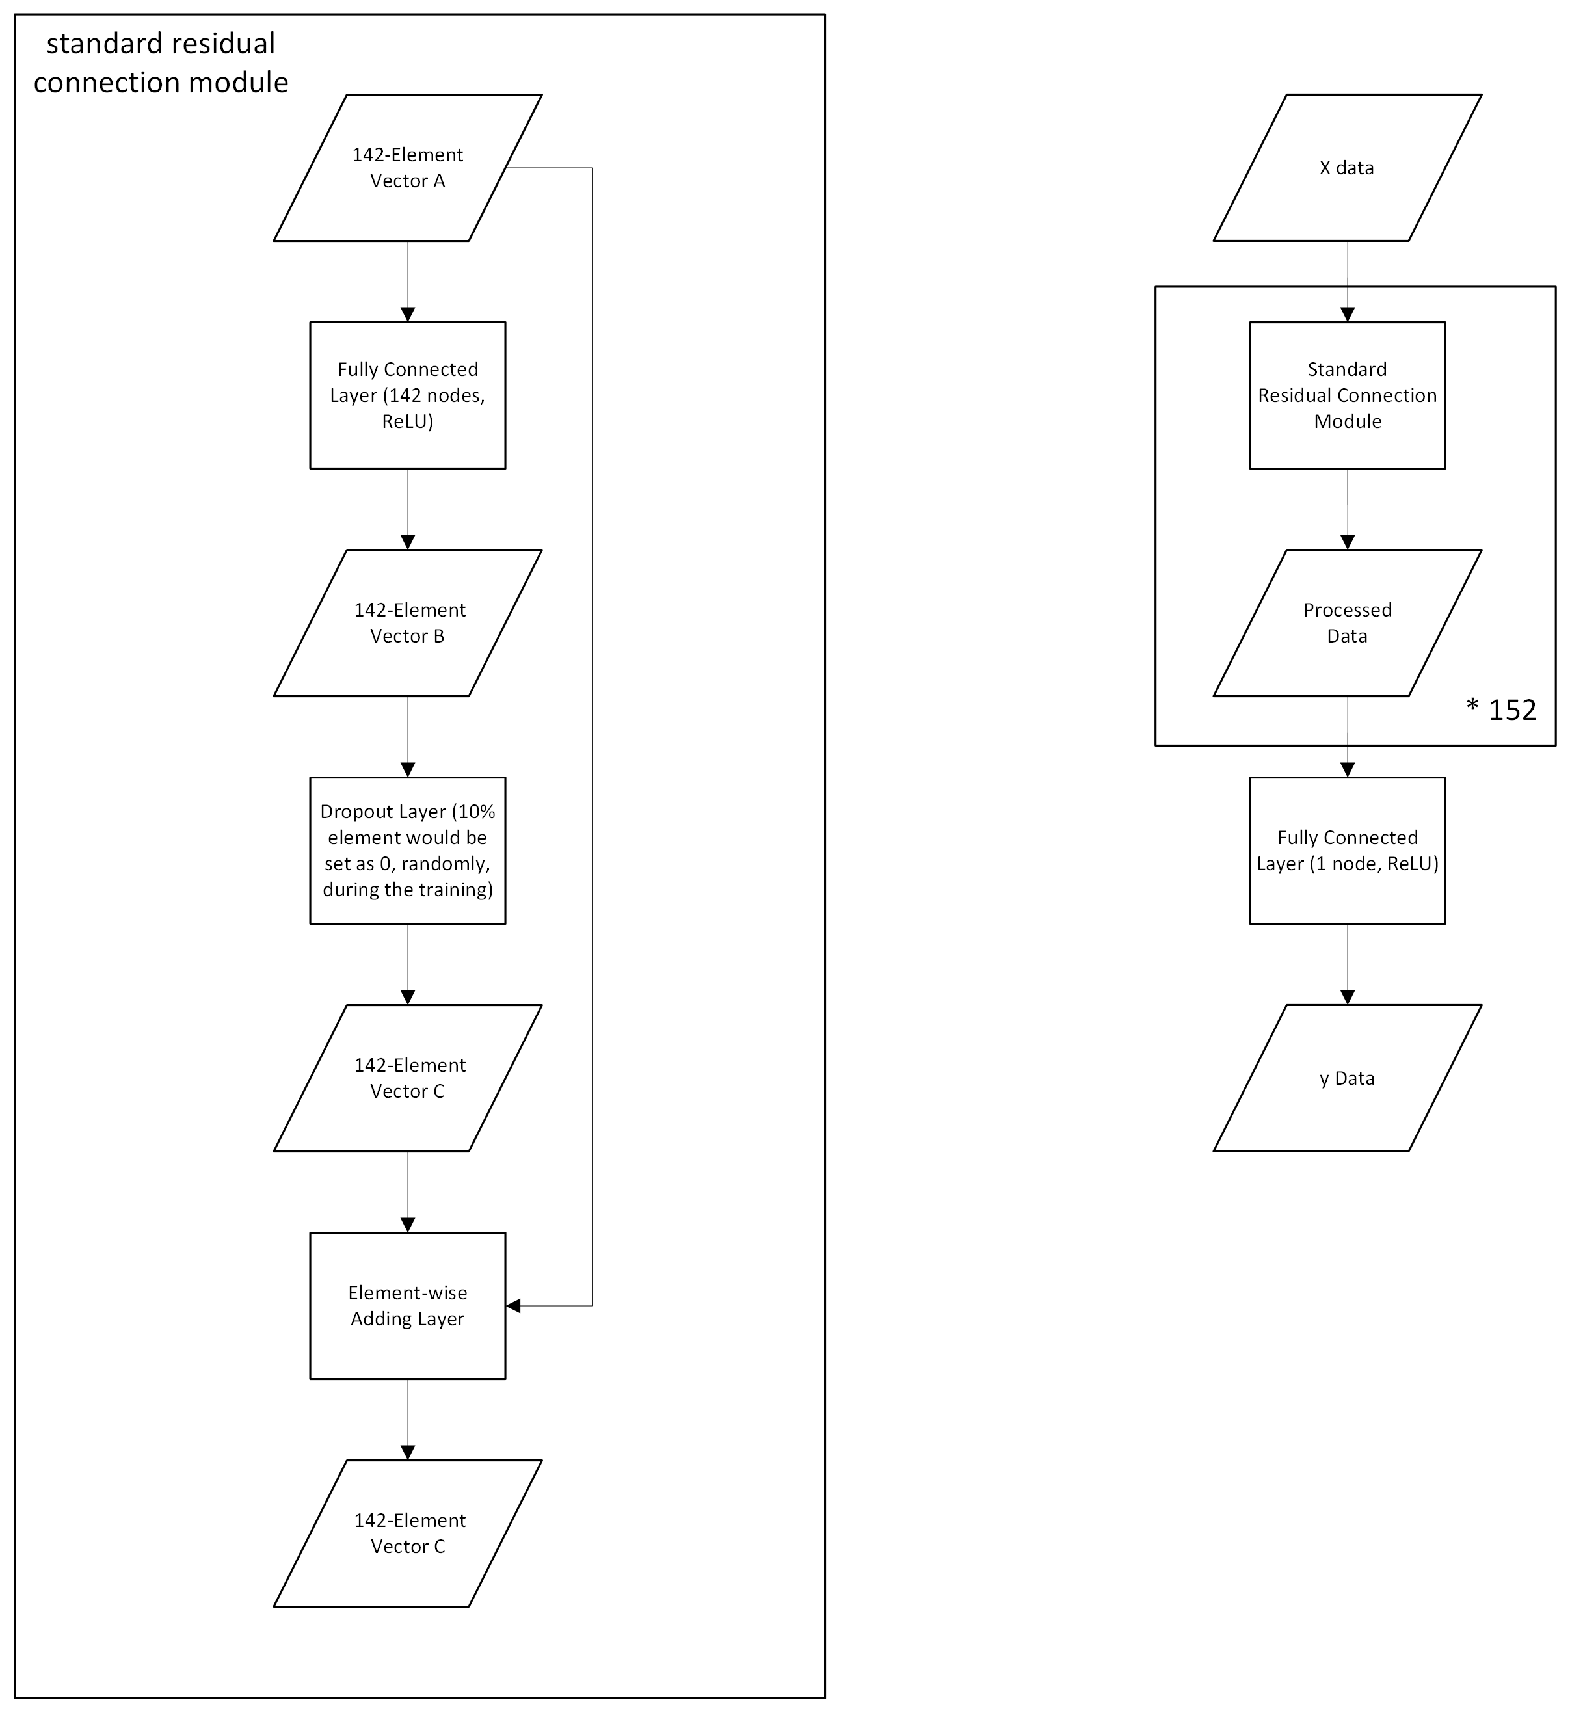
Figure S1: Standard Residual Connection Module and Fureco-152

Validation Assumption and Process
The 8:2 cross-validation is adopted to monitor the accuracy and reliability of predictions. The specific operation is as follows: 20% of the data in each period is reserved as test data, roughly 7.76 million data rows per period, as shown by Equations 3 and 4. This data is not used in training. In other words, the model parameter updates are not related to this test data. Before predicting the next period of data, the updated model will make predictions on the three most recent periods of held-out test data and then compare the predictions to the observed results. The validation metric is calculated based on this comparison. These validation metrics demonstrate the reliability of the predictions. A key assumption here is that if the same model can accurately predict the population recent years into the future, it should also be able to predict the population five years from now to a certain degree. After all, the probability of sudden changes in population patterns is low.
Four validation indicators, namely R² and mean absolute error (MAE), mean squared error (MSE), and root mean squared error (RMSE), are considered and computed as follows:
$${\hat{y}}_{grid,category,t+5}^{test}={Fureco152}_{year+5}(X_{grid,category,t+5}^{test})$$ | (5)
$$R_{grid,category,year+5}^{2}=1-\frac{\sum{{(y_{grid,category,t+5}^{test}-{\hat{y}}_{grid,category,t+5}^{test})}^{2}}}{\sum{{(y_{grid,category,t+5}^{test}-{\overline{y}}_{grid,category,t+5}^{test})}^{2}}}$$ | (6)
$${MAE}_{grid,category,year+5}=\frac{1}{n}\sum{\left|y_{grid,category,t+5}^{test}-{\hat{y}}_{grid,category,t+5}^{test}\right|}$$ | (7)
$${MSE}_{grid,category,year+5}=\frac{1}{n}\sum{{(y_{grid,category,t+5}^{test}-{\hat{y}}_{grid,category,t+5}^{test})}^{2}}$$ | (8)
$${RMAE}_{grid,category,year+5}=\sqrt{{MSE}_{grid,category,year+5}}$$ | (9)
where ${\hat{y}}_{grid,category,t+5}^{test}$ represents the predicted value based on $X_{grid,category,t+5}^{test}$ through the trained model ${Fureco152}_{year+5}$, $R_{grid,category,year+5}^{2}$ is the validation R² for predicting $variable$ in $year+5$, ${MAE}_{grid,category,year+5}$ is the validation MAE for predicting $variable$ in $year+5$, ${MSE}_{grid,category,year+5}$ is the validation MSE for predicting $variable$ in $year+5$, ${RMSE}_{grid,category,year+5}$ is the validation RMSE for predicting $variable$ in $year+5$, and $n$ is the data count in the test dataset. MSE and RMSE are sensitive to large errors, MAE reflects the average magnitude of errors in an intuitive way, and R² measures how well the model explains the variance in the observed data.
Since we are more concerned about whether the model can capture the population changes in each grid in the near future, in the actual test, we use the test data of the last three periods, which is about 22 million data rows.

Dataset and Model Structure for Grid-level NTL

Logic for Grid-level NTL
The basic logic is similar to the prediction of grid-level population. We use current-period grid-level population information of the grid’s neighborhood, current grid-level NTL value, city-level population data in the current and next periods, and grid location to predict NTL value in the next period. Figure S2 shows the relationship and prediction logic between grid-level population and NTL datasets. In this study, NTL is used as a proxy for grid-level urban development and population activity. This could be an interface, which is mainly designed to simulate the small-scale impact of localized investments or normal adjustments. Our current projections assume that current populations will influence urban development and population activity five years from now. Future urban development will further influence population dynamics. Simply, the interaction between population and cities determines the future distribution of population. As a small-scale ablation test, we retrain the Fureco-152 model without NTL inputs. The validation MAE increased by 0.368, which is 9.57% compared to the original experimental logic MAE. In this way, NTL contributes substantial predictive information rather than serving as a redundant auxiliary feature.
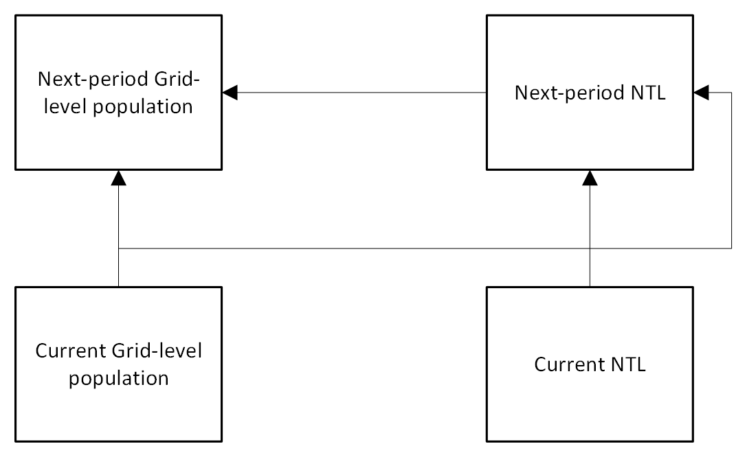
Figure S2: Relationship and Prediction Logic between Grid-level Population and NTL Datasets

Dataset for Grid-level NTL
Different from population prediction, the grid-level population information covers four indicators: TOTAL, MALE, FEMALE, and HOUSEHOLD. In this way, the input data includes 100 grid-level population elements, 25 on-land information elements, 25 NTL elements, 64 city-level population elements, and 2 grid location elements. In total, there are 216 elements as shown in Table S2. It should be noted that all NTL values used in this part are real values, rather than standardized values.
Table S2: Schematic Diagram of Single Data Structure for NTL-Fureco
 | X |  |  |  |  |  |  | y
Name | Neighbor Population counts (TOTAL, MALE, FEMALE, HOUSEHOLD) | On land dummy | NTL | 32 City-level data | 32 City-level data | Location | Category | NTL
Period | current | -- | current | current | next-5-year | -- | -- | next-5-year
Element | 25 * 4 | 25 | 25 | 32 | 32 | 2 | 0 | 1

Here, the input vector, X, and output, y, could be expressed as:
$$X_{grid,NTL,t+5}= {FPC}_{grid,t}∪{OLD}_{grid}∪{NTL}_{grid,t}∪$$  $${CLD}_{grid,t}∪{CLD}_{grid,t+5}∪{Loc}_{grid}$$ | (10)
$$y_{grid,NTL,t+5}= {NTL}_{grid,t+5}$$ | (11)
where $X_{grid,NTL,t+5}$ represents a vector with 216 elements for predicting the NTL in the $grid$ in the year $t+5$, ${FPC}_{grid,t}$ represents four-indicator population counts in the $grid$’s neighborhood in the year $t$, $y_{grid,NTL,t+5}$ represent the output data corresponding to $X_{grid,NTL,t+5}$, and ${NTL}_{grid,ct+5}$ represents the NTL in the $grid$’s neighborhood in the year $t+5$. $t$’s values could be a number from 2000 to $year$.
For the grid-level NTL dataset, we also use an 8:2 ratio to divide it into training and test datasets. In the training dataset, we oversampled the data after 2010 based on a 2.5-time rate. The training and test dataset sizes are 8,696,932 and 1,242,420 records, respectively. The training and test datasets could be illustrated as follows:
$$X_{grid,NTL,t+5}^{training},X_{grid,NTL,t+5}^{test},y_{grid,NTL,t+5}^{training},$$  $$y_{grid,NTL,t+5}^{test}=τ(X_{grid,NTL,t+5},y_{grid,NTL,t+5})$$ | (12)
where $X_{grid,NTL,t+5}^{training}$ and $y_{grid,NTL,t+5}^{training}$ represent training dataset taking 80% data, $X_{grid,NTL,t+5}^{test}$ and $y_{grid,NTL,t+5}^{test}$ represent test dataset covering 20% data, and $τ$ represents the random dividing process.

Model Structure for Grid-level NTL and Its Validation
The Fureco is the basic structure to predict NTL, named NTL-Fureco. We also adopt 152-layer networks. Figure S3 shows the structure of NTL-Fureco. Since the input data has more elements in each row, the NTL-Fureco-152 has more parameters, specifically, 7,262,623. Other settings are the same as the population Fureco models.
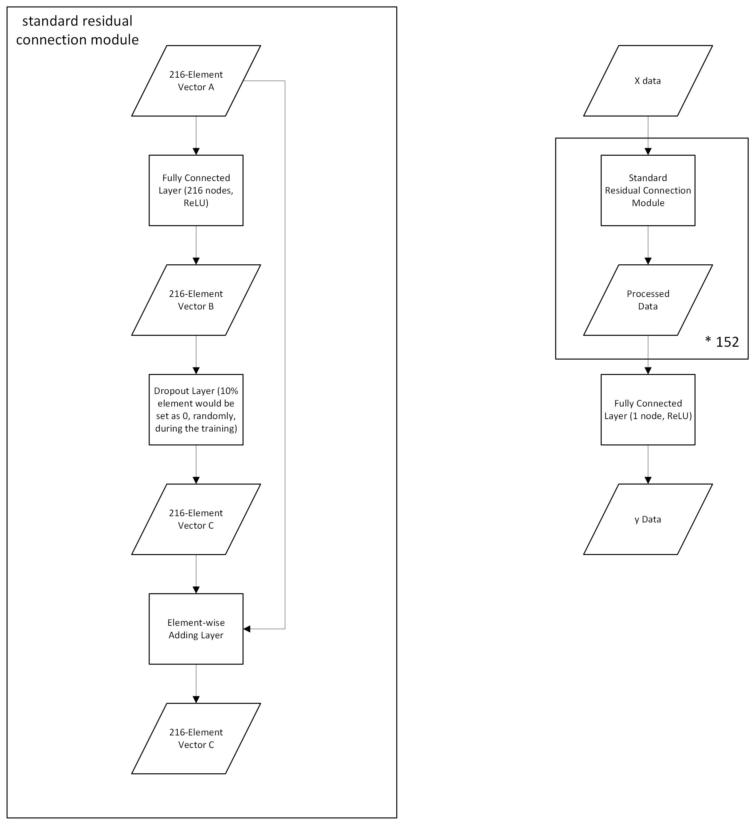
Figure S3: Standard Residual Connection Module and NTL-Fureco-152
The initial training process could be expressed as follows:
$${NTLFureco152}_{year+5}=θ(NTLFureco152,X_{grid,NTL,t+5}^{training},y_{grid,NTL,t+5}^{training})$$ | (13)
where $NTLFureco152$ represents random initialized NTL-Fureco-152, and ${NTLFureco152}_{year+5}$ represents the trained NTL-Fureco-152 for predicting data in $year+5$.
Four validation indicators, namely R², MAE, MSE, and RMSE, are considered and computed as follows:
$${\hat{y}}_{grid,NTL,t+5}^{test}={NTLFureco152}_{year+5}(X_{grid,NTL,t+5}^{test})$$ | (14)
$$R_{grid,NTL,year+5}^{2}=1-\frac{\sum{{(y_{grid,NTL,t+5}^{test}-{\hat{y}}_{grid,NTL,t+5}^{test})}^{2}}}{\sum{{(y_{grid,category,t+5}^{test}-{\overline{y}}_{grid,category,t+5}^{test})}^{2}}}$$ | (15)
$${MAE}_{grid,NTL,year+5}=\frac{1}{n}\sum{\left|y_{grid,NTL,t+5}^{test}-{\hat{y}}_{grid,NTL,t+5}^{test}\right|}$$ | (16)
$${MSE}_{grid,NTL,year+5}=\frac{1}{n}\sum{{(y_{grid,NTL,t+5}^{test}-{\hat{y}}_{grid,NTL,t+5}^{test})}^{2}}$$ | (17)
$${RMSE}_{grid,NTL,year+5}=\sqrt{{MSE}_{grid,NTL,year+5}}$$ | (18)
where ${\hat{y}}_{grid,NTL,t+5}^{test}$ represents the predicted value based on $X_{grid,NTL,t+5}^{test}$ through the trained model ${NTLFureco152}_{year+5}$, $R_{grid,NTL,year+5}^{2}$ is the validation R² for predicting $variable$ in $year+5$, ${MAE}_{grid,NTL,year+5}$ is the validation MAE for predicting $variable$ in $year+5$, ${MSE}_{grid,NTL,year+5}$ is the validation MSE for predicting $variable$ in $year+5$, ${RMSE}_{grid,NTL,year+5}$ is the validation RMSE for predicting $variable$ in $year+5$, and $n$ is the data count in the test dataset.

Dynamically Updated Deep Learning Models
The update strategy is as follows. First, we use grid-level input data in the period $year$ to predict the population in the period $year+5$. Second, we adjust the grid-level data in the period $year+5$ city by city based on city-level data. We compute the adjustment rates of each city by dividing city-level population data by the sums of all grids in the corresponding cities. The adjustment rate is then multiplied by the direct output of the model to obtain the adjusted grid-level prediction. Third, the adjusted grid-level prediction is taken as the output value of corresponding grid-level input data in the period $year$. We use this method to obtain a new complete dataset in the period $year$, which could be further divided into training and test datasets based on previous methods. Fourth, we create datasets by combining the new datasets in the period $year$ with datasets in period $year-5$ and $year-10$ to update the models. The models would be trained on that dataset for 10 epochs, and the model with the lowest validation loss is selected as the main model for the next-period prediction. Additionally, each period’s validation accuracy is computed based on a new test dataset covering the recent three-period data partially.
The step update method essentially converts a longer period prediction into several short period predictions. In each forecast, the model is updated with the latest data and only forecasts data for 5 years later. This processing method borrows the idea of ​​the recommendation system (Covington et al., 2016). The only difference is that the data we use for updating comes from past model predictions rather than real observations. It is a method of uncertainty control. Throughout the forecasting process, the model and data are changing. The model can be understood as an abstract description of the various relationships between variables and expressed in mathematics.
For each update, we only use the latest three periods of data instead of all the data. Three main reasons support this strategy. First, as the number of prediction iterations increases, the updated data level will become larger and larger if all data is used. This may result in newly added data not being taken seriously and being diluted by past data. This situation reduces the effectiveness of the update. Second, if outdated data is not removed, the models will actually learn them more times because it has to learn them several times each time the models are updated. This may cause the models to continue to reinforce their impression of them. Third, from an engineering perspective, the data is too large, resulting in insufficient memory. Although a simple solution is to break them up and write them back to disk, this will significantly increase the time cost. Not using all the data for updates makes sense both from a logical and engineering perspective. Furthermore, to validate the rationality of this design, we compared model performance when using the latest two, three, and four periods of data for updating. As shown in Table S3, the three-period scheme generally maintains the highest or near-highest R² values and the lowest or near-lowest MAE across forecast years from 2025 to 2060. Although the four-period configuration occasionally performs slightly better, the differences are marginal. Overall, the three-period updating provides a more stable and computationally efficient balance between retaining recent information and avoiding over-reliance on outdated data. Because of computational resource limitations, the test was extended to 2060 only, which is adequate to capture the performance trend.
Table S3: Comparison of Data Truncation for Model Updating
 | Two-period |  |  | Three-period |  |  | Four-period
Year | Epoch | R² | MAE | Epoch | R² | MAE | Epoch | R² | MAE
2025 | 10 | 99.53% | 2.11 | 10 | 99.62% | 1.92 | 8 | 99.63% | 1.89
2030 | 10 | 99.68% | 1.64 | 10 | 99.76% | 1.36 | 8 | 99.77% | 1.39
2035 | 10 | 99.79% | 1.17 | 9 | 99.95% | 0.57 | 8 | 99.94% | 0.59
2040 | 10 | 99.83% | 0.99 | 8 | 99.97% | 0.41 | 7 | 99.97% | 0.42
2045 | 10 | 99.91% | 0.73 | 8 | 99.98% | 0.33 | 5 | 99.99% | 0.32
2050 | 10 | 99.97% | 0.42 | 10 | 99.99% | 0.29 | 6 | 99.99% | 0.30
2055 | 9 | 99.98% | 0.33 | 10 | 99.99% | 0.29 | 6 | 99.99% | 0.29
2060 | 9 | 99.99% | 0.30 | 7 | 99.99% | 0.22 | 5 | 99.99% | 0.22

In order to ensure that the data does not deviate too far from the highly accurate city-level forecasts, we have adopted a strategy of forced adjustment of the forecast data. There are two situations during the adjustment process. First, the indicators exist in both grid-level and city-level datasets. In this case, we divide the city-level population value by the sum of the grid-level values ​​in that city, which is the adjustment rate in that city in that period:
$${AdjR}_{category,city,year}= \frac{{CP}_{category,city,year}}{sum({GP}_{grid,category,city,year})}$$ | (19)
where ${AdjR}_{category,city,year}$ represents the adjustment rate for indicator $category$ in the city $city$ during the period $year$, ${CP}_{category,city,year}$ represents the city-level population value for indicator $category$ in the city $city$ during the period $p$, ${GP}_{grid,category,city,year}$ represents the grid-level population value for indicator $category$ in the grid $grid$ belonging to the city $city$ during the period $year$, and $sum$ is the process to compute the sum. Here, if the centroid of a grid is included in the polygon of a city, we consider that the grid belongs to this city. Based on the city-level adjustment rate, the grid-level data are adjusted as follows:
${AdjGP}_{grid,category,city,year}={GP}_{grid,category,city,year} × {AdjR}_{category,city,year}$ | (20)
where ${AdjGP}_{grid,category,city,year}$ represents the adjusted values of the grid-level population. During the dynamic updating, the adjusted values are regarded as the real value to further train the models. Second, in the city-level data, there is no corresponding data for TOTAL_FOR, MALE_FOR, FEMALE_FOR, TOTAL_A20, MALE_A20, FEMALE_A20, TOTAL_A75, MALE_A75, and FEMALE_A75. We use stable data as the nearest substitute. In the details, we replace the adjustment rates of TOTAL_FOR, MALE_FOR, and FEMALE_FOR with TOTAL’s, MALE’s, and FEMALE’s; the adjustment rates of TOTAL_A20, MALE_A20, and FEMALE_A20 with TOTAL_A15’s, MALE_A15’s, FEMALE_A15’s; and the adjustment rates of TOTAL_A75, MALE_A75, and FEMALE_A75 with TOTAL_A65’s, MALE_A65’s, FEMALE_A65’s.
Essentially, to prevent cumulative drift, each five-year forecast is recalibrated using updated city-level totals before disaggregation to grids. This design constrains long-term residual accumulation and maintains temporal consistency across forecast iterations.

Model Performance
Table S4 records the performance indicators of the Fureco-152 after 100-epoch training in the validation. Four indicators, including MSE, R², MAE, and RMSE, are considered. MSE and RMSE are sensitive to outliers, while R² and MAE are easier to understand. R² is the indicator of how well the prediction variation explains the real variation, which can be used interchangeably with accuracy in this study. We randomly select 20% of the data for each population indicator in each period to build a validation data set. Therefore, in Table S4, each population indicator is tested for the initial state of the model. The data in the period of 2015 are more valuable, so we mainly focus on performance based on the validation in 2015. The overall performance of the Fureco-152 is excellent. Specifically, the accuracy in the TOTAL prediction is 99.61%, and the MSE is only 5.37 people/grid. In other words, in the most extreme case, where all grids are overestimated or underestimated, the error across the country is about 8.32 million, although this case would not happen. Compared with the total population of about 126 million, this total absolute error is acceptable. The randomness and richness of training data affect the performance of the model. For example, the performance of Fureco-152 in TOTAL_A75 is relatively poor because the randomness of death among the elderly is extremely high, and the population in this age group is also more sparse than that in other groups. For another instance, the indicator about foreign people is mainly influenced by its sparsity. Taking all validation data as a whole, the overall validation performance indicators, including MSE, R², MAE, and RMSE of the initial Fureco-152, are 297.37, 99.23%, 3.58, and 17.24, respectively. Figure S4 illustrates the variation of the model’s R² for each population indicator in the validation during the training process. After 100 epochs of training, the performance of almost all population indicators has converged and become stable. Hence, we use this 100-epoch-trained model as the initial model to predict 2025 data. Based on a similar validation process, the performance indicators of the NTL-Fureco-152 after the 100-epoch training are 1.94 of MSE, 92.51% of R², 0.29 of MAE, and 1.39 of RMSE. For the NTL-Fureco-152, 100-epoch training ensures the stable convergence of the entire network. Table S5 lists the performance of Fureco-152 in the dynamic updating process. With the ability gradually strengthened, the prediction accuracy is increasing. This reflects the effect of our city-level recalibration mechanism, which controls cumulative drift by anchoring each iteration to externally updated city-level totals.
Table S4: Performance of the Fureco-152 in the Validation as of 2020
Year | Indicator | Name | MSE | R² | MAE | RMSE
2015 | 1 | TOTAL | 569.20 | 99.61% | 5.37 | 23.86
2015 | 2 | MALE | 133.55 | 99.64% | 2.76 | 11.56
2015 | 3 | FEMALE | 137.92 | 99.65% | 2.88 | 11.74
2015 | 4 | TOTAL_U15 | 90.81 | 96.10% | 1.84 | 9.53
2015 | 5 | MALE_U15 | 24.66 | 95.95% | 1.04 | 4.97
2015 | 6 | FEMALE_U15 | 22.13 | 95.92% | 1.00 | 4.70
2015 | 7 | TOTAL_A15 | 314.11 | 99.70% | 4.52 | 17.72
2015 | 8 | MALE_A15 | 89.28 | 99.65% | 2.39 | 9.45
2015 | 9 | FEMALE_A15 | 104.06 | 99.65% | 2.60 | 10.20
2015 | 10 | TOTAL_1565 | 251.98 | 99.56% | 3.80 | 15.87
2015 | 11 | MALE_1565 | 87.34 | 99.41% | 2.16 | 9.35
2015 | 12 | FEMALE_1565 | 80.82 | 99.43% | 2.11 | 8.99
2015 | 13 | TOTAL_A20 | 273.19 | 99.73% | 4.23 | 16.53
2015 | 14 | MALE_A20 | 80.78 | 99.66% | 2.26 | 8.99
2015 | 15 | FEMALE_A20 | 87.76 | 99.68% | 2.42 | 9.37
2015 | 16 | TOTAL_A65 | 134.32 | 98.58% | 2.75 | 11.59
2015 | 17 | MALE_A65 | 23.62 | 98.67% | 1.33 | 4.86
2015 | 18 | FEMALE_A65 | 46.28 | 98.50% | 1.63 | 6.80
2015 | 19 | TOTAL_A75 | 832.34 | 68.70% | 8.26 | 28.85
2015 | 20 | MALE_A75 | 127.12 | 68.16% | 3.50 | 11.27
2015 | 21 | FEMALE_A75 | 301.73 | 69.18% | 5.10 | 17.37
2015 | 22 | TOTAL_FOR | 25.82 | 89.80% | 0.59 | 5.08
2015 | 23 | MALE_FOR | 6.41 | 87.72% | 0.33 | 2.53
2015 | 24 | FEMALE_FOR | 5.61 | 89.66% | 0.33 | 2.37
2015 | 25 | HOUSEHOLD | 137.36 | 99.63% | 2.26 | 11.72
2000 | 1 | TOTAL | 2015.55 | 98.53% | 13.22 | 44.89
2000 | 2 | MALE | 450.94 | 98.64% | 6.53 | 21.24
2000 | 3 | FEMALE | 464.72 | 98.66% | 6.78 | 21.56
2000 | 25 | HOUSEHOLD | 270.54 | 98.97% | 4.55 | 16.45
2005 | 1 | TOTAL | 1277.72 | 99.11% | 7.37 | 35.75
2005 | 2 | MALE | 314.11 | 99.06% | 3.80 | 17.72
2005 | 3 | FEMALE | 294.91 | 99.19% | 3.79 | 17.17
2005 | 25 | HOUSEHOLD | 223.58 | 99.25% | 2.74 | 14.95
2010 | 1 | TOTAL | 963.67 | 99.32% | 6.67 | 31.04
2010 | 2 | MALE | 217.77 | 99.37% | 3.36 | 14.76
2010 | 3 | FEMALE | 225.07 | 99.41% | 3.53 | 15.00
2010 | 25 | HOUSEHOLD | 179.49 | 99.46% | 2.58 | 13.40

Table S5: Fureco-152 Performance in Dynamic Updating
Year | Epoch | MSE | R² | MAE | RMSE
2025 | 10 | 114.63 | 99.62% | 1.92 | 10.71
2030 | 10 | 64.53 | 99.76% | 1.36 | 8.03
2035 | 9 | 13.40 | 99.95% | 0.57 | 3.66
2040 | 8 | 7.06 | 99.97% | 0.41 | 2.66
2045 | 8 | 4.46 | 99.98% | 0.33 | 2.11
2050 | 10 | 3.22 | 99.99% | 0.29 | 1.79
2055 | 10 | 2.63 | 99.99% | 0.29 | 1.62
2060 | 7 | 2.39 | 99.99% | 0.22 | 1.54
2065 | 10 | 2.33 | 99.99% | 0.28 | 1.53
2070 | 8 | 1.88 | 99.99% | 0.22 | 1.37
2075 | 6 | 1.65 | 99.99% | 0.19 | 1.28
2080 | 6 | 1.63 | 99.99% | 0.19 | 1.28
2085 | 7 | 1.55 | 99.99% | 0.22 | 1.25
2090 | 9 | 1.54 | 99.99% | 0.20 | 1.24
2095 | 3 | 1.55 | 99.99% | 0.18 | 1.24
2100 | 6 | 1.63 | 99.99% | 0.17 | 1.28

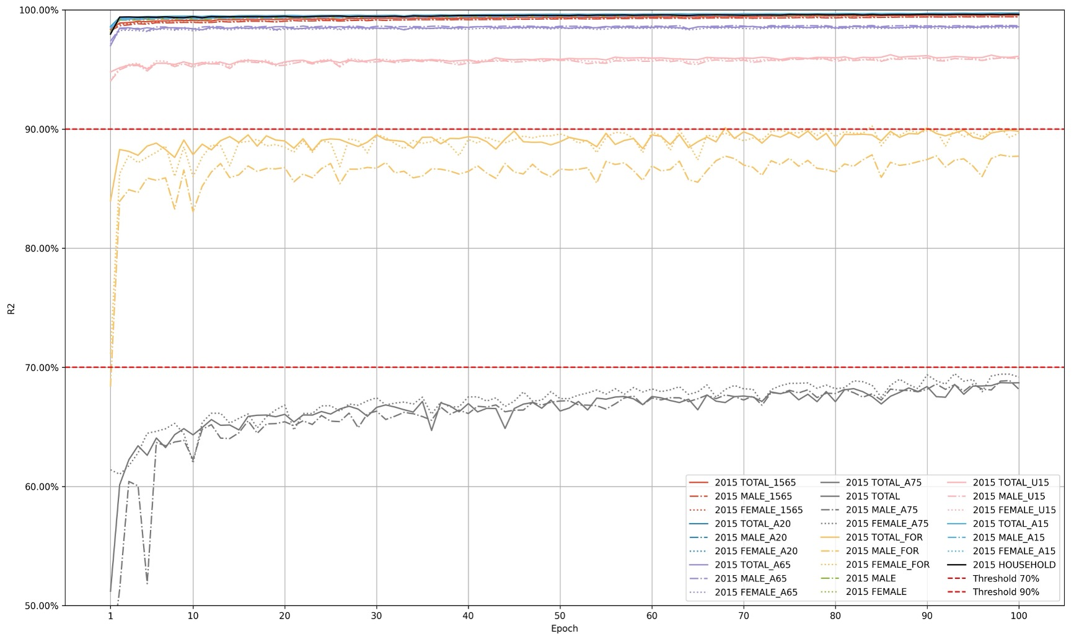
Figure S4: Fureco-152 Performance Variation during 100-Epoch Training

Temporal verification of the Fureco-152 structure
To assess temporal generalization, we reinitialize the Fureco-152 model and trained it on 2000-2015 data to forecast 2015-2020 outcomes. The model achieved its best performance at 63 epochs with an R² above 99.22% for all indicators, as shown in Table S6, comparable to results from the standard 8:2 spatial cross-validation, based on another reinitialized Fureco-152 model with 98-epoch training. This confirms that the model generalizes well across time.
Table S6: Temporal Validation and its 8:2 Cross-validation Reference
Validation Method | Indicator | Name | MSE | R2 | MAE | RMSE
Temporal Validation | 1 | TOTAL | 1183.79 | 99.22% | 6.18 | 34.41
Temporal Validation | 2 | MALE | 298.81 | 99.17% | 3.21 | 17.29
Temporal Validation | 3 | FEMALE | 318.02 | 99.21% | 3.35 | 17.83
Temporal Validation | 25 | HOUSEHOLD | 275.07 | 99.26% | 2.57 | 16.59
8:2 Cross Validation | 1 | TOTAL | 1123.68 | 99.21% | 8.19 | 33.52
8:2 Cross Validation | 2 | MALE | 320.04 | 99.07% | 4.25 | 17.89
8:2 Cross Validation | 3 | FEMALE | 316.26 | 99.15% | 4.39 | 17.78
8:2 Cross Validation | 25 | HOUSEHOLD | 211.10 | 99.33% | 3.03 | 14.53

Sensitivity Analysis
To quantify model uncertainty, we train ten independent Fureco-152 models with different random seeds and training epoch to check variation. Because each five-year forecast step incorporates updated city-level inputs, large-scale drift is suppressed, and ensemble variability remains small. These results suggest that model-induced uncertainty is minor compared with potential scenario uncertainty at the policy level.
To evaluate the robustness of the long-term projections, we conduct a series of sensitivity tests on three core input variables: migration inflow to Tokyo, number of newborns, and number of foreign residents. For the adjustment of migration inflow to Tokyo, we increase or decrease the city-level internal migration population count by 5% or 10% for the following five-year period. The adjusted city-level data are then disaggregated to generate grid-level predictions of total population, household number, and foreign population for the same period, which are subsequently aggregated to compute indicators for Tokyo. In total, Tokyo contains 8,357 grids in our dataset. For the adjustments of newborns and foreign residents, we apply two similar perturbation strategies. For newborns, we modify the city-level data by increasing or decreasing the number of newborns by 1% or 2% for the next five-year period before generating grid-level predictions. Because the city-level dataset does not include variables related to foreign residents, we directly adjust the grid-level data by increasing or decreasing the number of foreigners by 1% or 2%. Each of the three adjustment methods therefore includes five scenarios. The resulting changes in total population, household size, and foreigner ratio from 2025 to 2100 are summarized in Tables S7-S9.
The results indicate that, although minor numerical variations occur, the overall population trajectories and structural patterns remain nearly unchanged. These findings suggest that the Fureco-152 framework is resilient to plausible fluctuations in key demographic inputs, and that moderate policy or behavioral changes at the city level are unlikely to alter the long-term population trend. Regarding total population indicators, the model demonstrates strong stability: increases in migration inflow, number of newborns, or number of foreign residents all lead to corresponding increases in total population. We also observe some interesting patterns. An increase in the domestic migration rate leads to a relative decrease in the proportion of foreigners, as shown in Table S7, suggesting that domestic and foreign migrants are partially substitutable given the relatively stable number of job opportunities. In addition, an increase in the number of newborns slightly raises the average household size as shown in Table S8, reflecting the demographic structure’s internal consistency.

Table S7: Simulation Based on Migration Adjustment in Tokyo
 | Total Population (Thousand People) |  |  |  |  |  | Household Size |  |  |  |  |  | Foreigner Ratio
Year |  | Original | Migration +10% | Migration +5% | Migration -5% | Migration -10% | Original | Migration +10% | Migration +5% | Migration -5% | Migration -10% | Original |  | Migration +10% | Migration +5% | Migration -5% | Migration -10%
2025 |  | 14128.72 | 37.33 | 19.87 | -22.62 | -48.28 | 1.897 | 1.899 | 1.898 | 1.896 | 1.895 | 3.58% |  | 3.48% | 3.53% | 3.63% | 3.69%
2030 |  | 14360.52 | 90.84 | 47.41 | -51.13 | -105.63 | 1.842 | 1.844 | 1.843 | 1.841 | 1.840 | 3.95% |  | 3.84% | 3.89% | 4.00% | 4.05%
2035 |  | 14401.39 | 76.90 | 40.76 | -44.60 | -92.32 | 1.816 | 1.816 | 1.816 | 1.816 | 1.816 | 4.38% |  | 4.29% | 4.33% | 4.42% | 4.46%
2040 |  | 14383.66 | 97.92 | 50.78 | -53.66 | -109.89 | 1.813 | 1.811 | 1.812 | 1.813 | 1.814 | 4.71% |  | 4.65% | 4.68% | 4.75% | 4.78%
2045 |  | 14746.63 | 95.04 | 48.20 | -48.50 | -96.98 | 1.779 | 1.781 | 1.780 | 1.779 | 1.778 | 5.31% |  | 5.25% | 5.28% | 5.33% | 5.36%
2050 |  | 14393.43 | 82.06 | 41.13 | -40.96 | -81.83 | 1.767 | 1.766 | 1.767 | 1.767 | 1.767 | 6.09% |  | 6.04% | 6.07% | 6.11% | 6.13%
2055 |  | 14287.93 | 62.18 | 30.98 | -30.74 | -61.37 | 1.725 | 1.723 | 1.724 | 1.726 | 1.726 | 6.40% |  | 6.36% | 6.38% | 6.42% | 6.43%
2060 |  | 14397.67 | 63.58 | 32.01 | -32.46 | -65.32 | 1.709 | 1.709 | 1.709 | 1.709 | 1.710 | 6.86% |  | 6.81% | 6.84% | 6.88% | 6.90%
2065 |  | 14371.52 | 56.55 | 28.34 | -28.72 | -57.34 | 1.657 | 1.657 | 1.657 | 1.657 | 1.657 | 7.28% |  | 7.24% | 7.26% | 7.29% | 7.31%
2070 |  | 14262.43 | 46.37 | 23.31 | -23.33 | -46.33 | 1.615 | 1.615 | 1.615 | 1.615 | 1.616 | 7.72% |  | 7.69% | 7.71% | 7.74% | 7.75%
2075 |  | 14276.97 | 49.90 | 24.93 | -24.70 | -49.26 | 1.591 | 1.592 | 1.592 | 1.590 | 1.590 | 7.77% |  | 7.73% | 7.75% | 7.79% | 7.80%
2080 |  | 14366.43 | 44.47 | 22.29 | -22.47 | -45.31 | 1.576 | 1.578 | 1.577 | 1.576 | 1.575 | 8.01% |  | 7.97% | 7.99% | 8.02% | 8.04%
2085 |  | 14455.97 | 37.93 | 18.97 | -18.83 | -38.20 | 1.573 | 1.575 | 1.574 | 1.572 | 1.571 | 8.18% |  | 8.15% | 8.17% | 8.20% | 8.22%
2090 |  | 14528.55 | 45.36 | 23.15 | -23.59 | -46.83 | 1.561 | 1.564 | 1.563 | 1.560 | 1.558 | 8.30% |  | 8.27% | 8.28% | 8.31% | 8.33%
2095 |  | 14748.08 | 38.62 | 19.44 | -19.55 | -39.34 | 1.552 | 1.555 | 1.554 | 1.551 | 1.549 | 8.58% |  | 8.55% | 8.57% | 8.60% | 8.62%
2100 |  | 14840.84 | 48.88 | 24.70 | -24.69 | -49.24 | 1.549 | 1.553 | 1.551 | 1.548 | 1.546 | 8.61% |  | 8.57% | 8.59% | 8.62% | 8.64%

Table S8: Simulation Based on Newborn Adjustment in Tokyo
 | Total Population (Thousand People) |  |  |  |  | Household Size |  |  |  |  | Foreigner Ratio
Year | Original | Newborns +2% | Newborns +1% | Newborns -1% | Newborns -2% | Original | Newborns +2% | Newborns +1% | Newborns -1% | Newborns -2% | Original | Newborns +2% | Newborns +1% | Newborns -1% | Newborns -2%
2025 | 14128.72 | 6.60 | 3.28 | -3.25 | -6.48 | 1.897 | 1.897 | 1.897 | 1.896 | 1.896 | 3.58% | 3.57% | 3.57% | 3.59% | 3.59%
2030 | 14274.53 | 6.04 | 3.01 | -2.98 | -5.92 | 1.850 | 1.850 | 1.850 | 1.849 | 1.849 | 3.98% | 3.96% | 3.97% | 3.99% | 4.00%
2035 | 14391.72 | 5.39 | 2.68 | -2.65 | -5.26 | 1.804 | 1.805 | 1.805 | 1.804 | 1.804 | 4.50% | 4.47% | 4.48% | 4.51% | 4.52%
2040 | 14474.13 | 4.67 | 2.32 | -2.28 | -4.53 | 1.777 | 1.778 | 1.777 | 1.777 | 1.776 | 5.03% | 5.01% | 5.02% | 5.04% | 5.05%
2045 | 14503.11 | 4.27 | 2.12 | -2.10 | -4.18 | 1.747 | 1.747 | 1.747 | 1.746 | 1.746 | 5.74% | 5.71% | 5.72% | 5.75% | 5.76%
2050 | 14499.91 | 3.93 | 1.96 | -1.93 | -3.84 | 1.719 | 1.719 | 1.719 | 1.718 | 1.718 | 6.37% | 6.34% | 6.35% | 6.38% | 6.40%
2055 | 14507.20 | 3.49 | 1.73 | -1.71 | -3.41 | 1.692 | 1.693 | 1.693 | 1.692 | 1.692 | 7.02% | 6.99% | 7.00% | 7.03% | 7.05%
2060 | 14499.01 | 3.26 | 1.62 | -1.60 | -3.19 | 1.663 | 1.664 | 1.664 | 1.663 | 1.663 | 7.67% | 7.64% | 7.65% | 7.68% | 7.70%
2065 | 14464.93 | 3.04 | 1.52 | -1.50 | -2.98 | 1.628 | 1.629 | 1.628 | 1.628 | 1.628 | 8.29% | 8.26% | 8.27% | 8.30% | 8.32%
2070 | 14367.61 | 2.63 | 1.31 | -1.30 | -2.57 | 1.580 | 1.581 | 1.581 | 1.580 | 1.580 | 8.82% | 8.79% | 8.81% | 8.83% | 8.85%
2075 | 14315.61 | 2.38 | 1.18 | -1.17 | -2.33 | 1.549 | 1.550 | 1.550 | 1.549 | 1.549 | 9.22% | 9.20% | 9.21% | 9.24% | 9.25%
2080 | 14300.64 | 2.22 | 1.10 | -1.08 | -2.15 | 1.530 | 1.531 | 1.530 | 1.530 | 1.530 | 9.58% | 9.56% | 9.57% | 9.59% | 9.61%
2085 | 14404.11 | 2.05 | 1.02 | -1.00 | -1.99 | 1.519 | 1.520 | 1.519 | 1.519 | 1.519 | 9.90% | 9.88% | 9.89% | 9.91% | 9.92%
2090 | 14477.59 | 1.91 | 0.95 | -0.94 | -1.86 | 1.507 | 1.507 | 1.507 | 1.506 | 1.506 | 10.15% | 10.13% | 10.14% | 10.16% | 10.17%
2095 | 14587.01 | 1.85 | 0.92 | -0.90 | -1.79 | 1.501 | 1.502 | 1.502 | 1.501 | 1.501 | 10.43% | 10.41% | 10.42% | 10.44% | 10.45%
2100 | 14719.86 | 1.77 | 0.88 | -0.86 | -1.70 | 1.498 | 1.498 | 1.498 | 1.498 | 1.498 | 10.66% | 10.64% | 10.65% | 10.67% | 10.68%

Table S9: Simulation Based on Foreigner Adjustment in Tokyo
 | Total Population (Thousand People) |  |  |  |  | Household Size |  |  |  |  | Foreigner Ratio
Year | Original | Foreigner +2% | Foreigner +1% | Foreigner -1% | Foreigner -2% | Original | Foreigner +2% | Foreigner +1% | Foreigner -1% | Foreigner -2% | Original | Foreigner +2% | Foreigner +1% | Foreigner -1% | Foreigner -2%
2025 | 14128.72 | 9.79 | 4.90 | -4.90 | -9.80 | 1.897 | 1.895 | 1.896 | 1.897 | 1.898 | 3.58% | 3.65% | 3.61% | 3.54% | 3.51%
2030 | 14360.52 | 10.93 | 5.46 | -5.47 | -10.93 | 1.842 | 1.841 | 1.841 | 1.843 | 1.843 | 3.95% | 4.03% | 3.99% | 3.91% | 3.87%
2035 | 14401.39 | 12.17 | 6.09 | -6.09 | -12.17 | 1.816 | 1.815 | 1.815 | 1.817 | 1.818 | 4.38% | 4.46% | 4.42% | 4.33% | 4.29%
2040 | 14383.66 | 13.89 | 6.95 | -6.95 | -13.90 | 1.813 | 1.811 | 1.812 | 1.814 | 1.814 | 4.71% | 4.81% | 4.76% | 4.67% | 4.62%
2045 | 14746.63 | 15.45 | 7.73 | -7.73 | -15.46 | 1.779 | 1.778 | 1.779 | 1.780 | 1.781 | 5.31% | 5.41% | 5.36% | 5.25% | 5.20%
2050 | 14393.43 | 16.93 | 8.47 | -8.47 | -16.93 | 1.767 | 1.766 | 1.766 | 1.768 | 1.769 | 6.09% | 6.20% | 6.15% | 6.03% | 5.98%
2055 | 14287.93 | 18.09 | 9.05 | -9.05 | -18.09 | 1.725 | 1.723 | 1.724 | 1.726 | 1.727 | 6.40% | 6.52% | 6.46% | 6.34% | 6.28%
2060 | 14397.67 | 19.41 | 9.70 | -9.70 | -19.40 | 1.709 | 1.707 | 1.708 | 1.710 | 1.711 | 6.86% | 6.98% | 6.92% | 6.80% | 6.73%
2065 | 14371.52 | 20.40 | 10.20 | -10.20 | -20.40 | 1.657 | 1.656 | 1.656 | 1.658 | 1.659 | 7.28% | 7.41% | 7.34% | 7.21% | 7.15%
2070 | 14262.43 | 21.03 | 10.51 | -10.51 | -21.02 | 1.615 | 1.614 | 1.614 | 1.616 | 1.617 | 7.72% | 7.86% | 7.79% | 7.66% | 7.59%
2075 | 14276.97 | 21.68 | 10.84 | -10.84 | -21.68 | 1.591 | 1.589 | 1.590 | 1.592 | 1.592 | 7.77% | 7.91% | 7.84% | 7.70% | 7.63%
2080 | 14366.43 | 22.56 | 11.28 | -11.28 | -22.56 | 1.576 | 1.575 | 1.576 | 1.577 | 1.578 | 8.01% | 8.14% | 8.08% | 7.94% | 7.87%
2085 | 14455.97 | 23.18 | 11.59 | -11.59 | -23.17 | 1.573 | 1.571 | 1.572 | 1.574 | 1.574 | 8.18% | 8.32% | 8.25% | 8.11% | 8.04%
2090 | 14528.55 | 23.81 | 11.90 | -11.90 | -23.80 | 1.561 | 1.560 | 1.560 | 1.562 | 1.563 | 8.30% | 8.44% | 8.37% | 8.23% | 8.16%
2095 | 14748.08 | 24.37 | 12.18 | -12.17 | -24.34 | 1.552 | 1.551 | 1.551 | 1.553 | 1.554 | 8.58% | 8.73% | 8.66% | 8.51% | 8.44%
2100 | 14840.84 | 24.87 | 12.43 | -12.41 | -24.82 | 1.549 | 1.548 | 1.549 | 1.550 | 1.551 | 8.61% | 8.75% | 8.68% | 8.53% | 8.46%

Reference:
Covington, P., Adams, J., & Sargin, E. (2016). Deep neural networks for youtube recommendations. Proceedings of the 10th ACM conference on recommender systems,
He, K., Zhang, X., Ren, S., & Sun, J. (2016). Deep residual learning for image recognition. Proceedings of the IEEE conference on computer vision and pattern recognition,
Srivastava, N., Hinton, G., Krizhevsky, A., Sutskever, I., & Salakhutdinov, R. (2014). Dropout: a simple way to prevent neural networks from overfitting. The Journal of Machine Learning Research, 15(1), 1929-1958.

