Supplementary Table S1: String Expressions Used for Significance Comparison among ‘Ru’ Terms

Supplementary Table S2: String Expressions Used for Data Collection in NV (Collocational and Dependency Words)

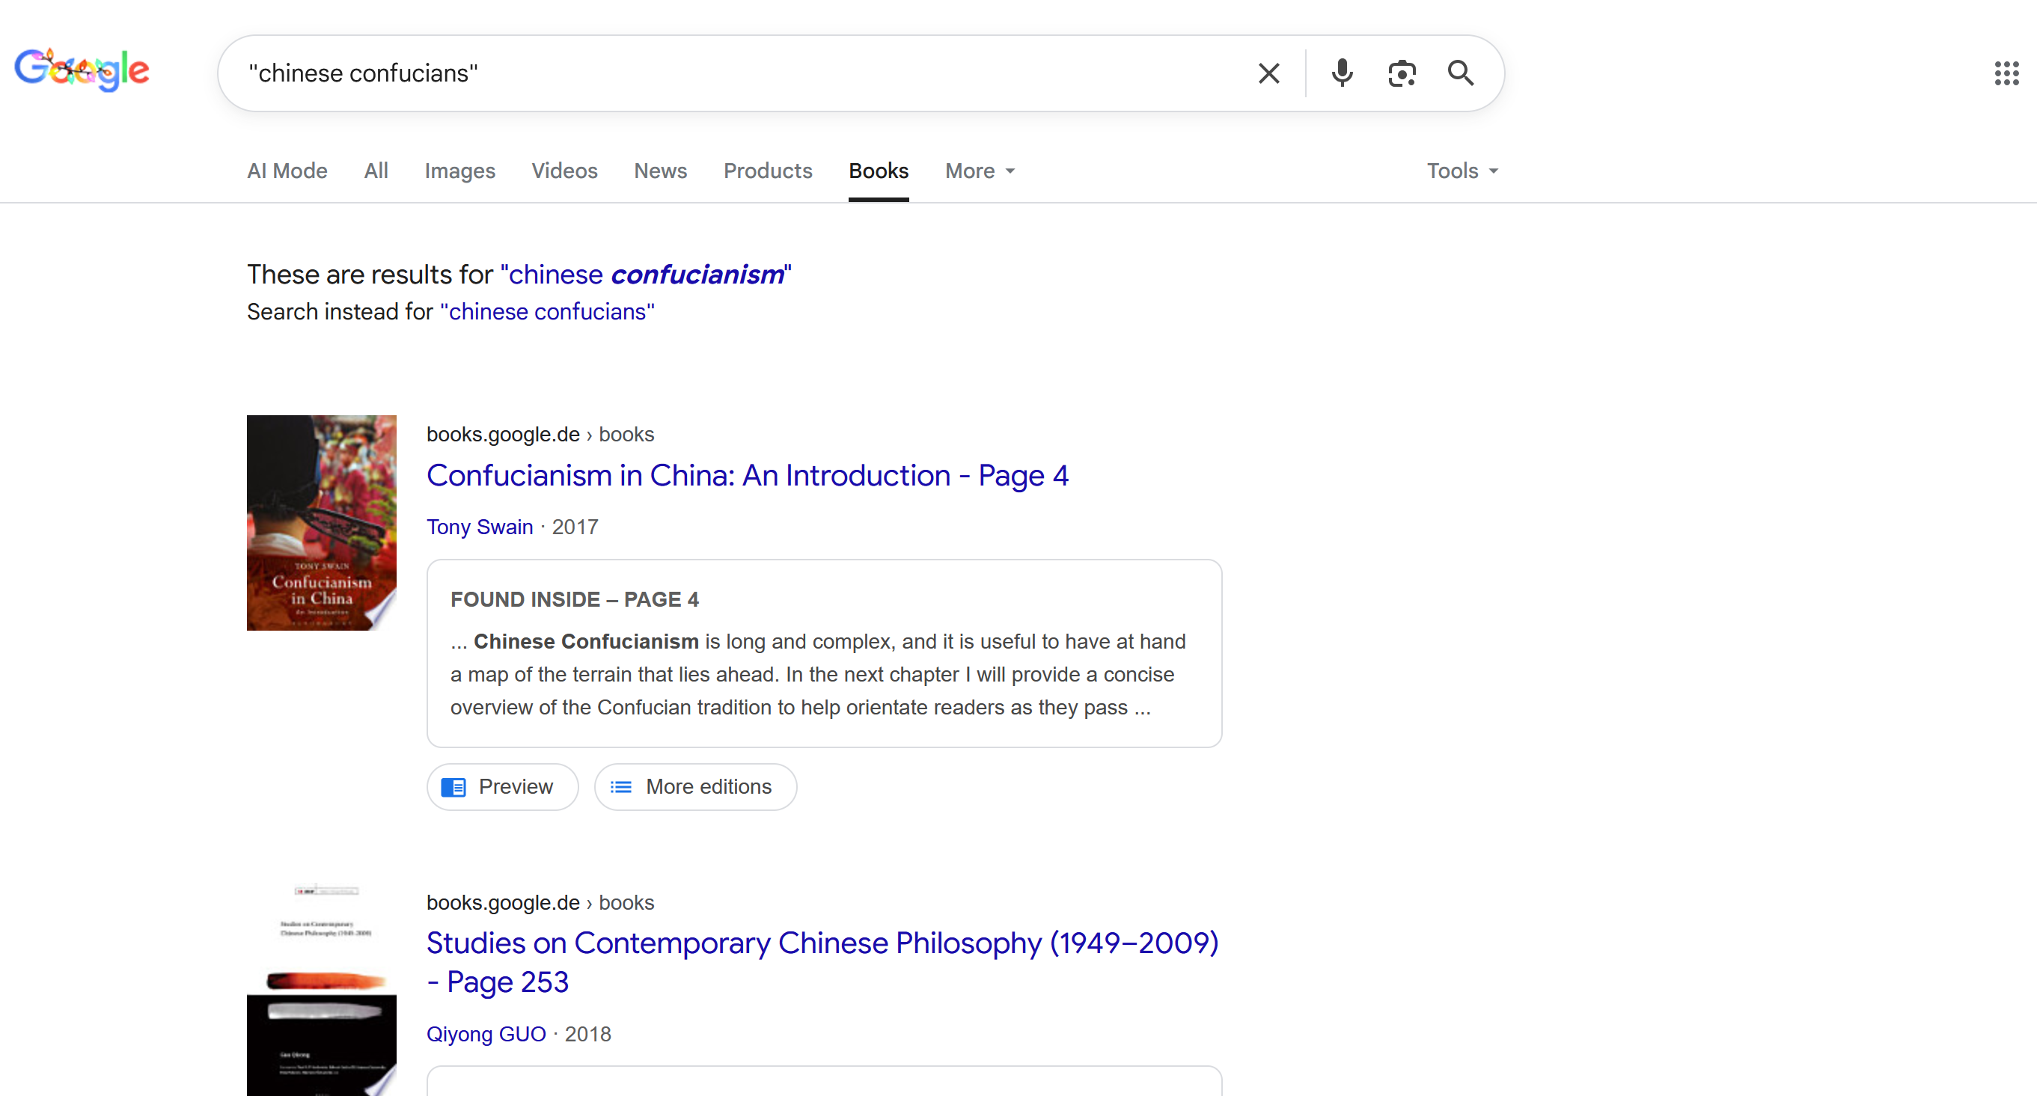
Supplementary Figure F1: Illustration of ‘Chinese Confucianism’ Returned When Searching for ‘Chinese Confucians’ in Google Books

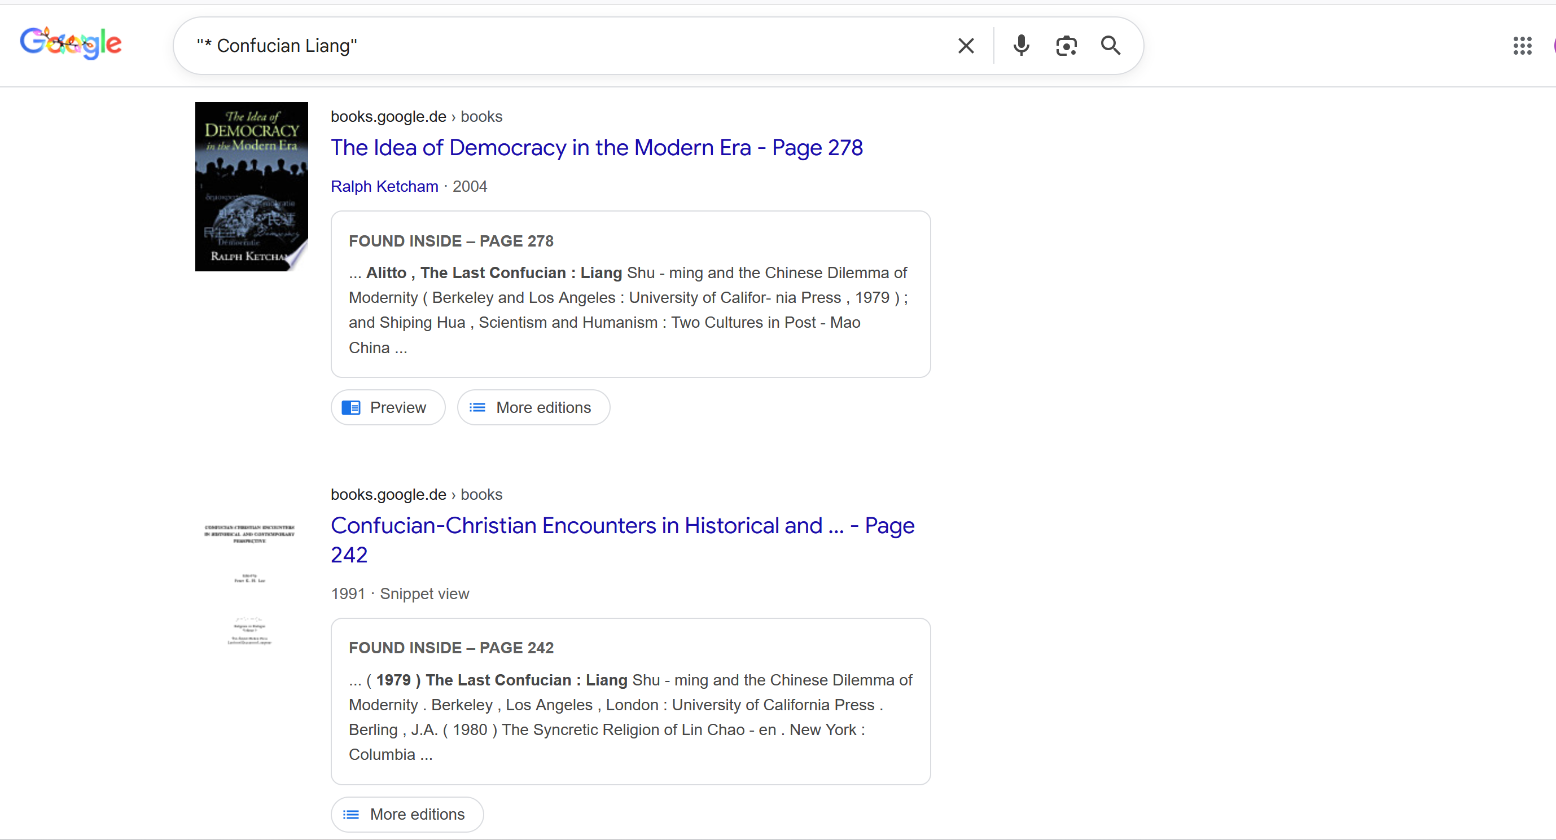
Supplementary Figure F2: Illustration of ‘The Last Confucian’ Returned When Searching for References to ‘Confucian Liang’ in Google Books

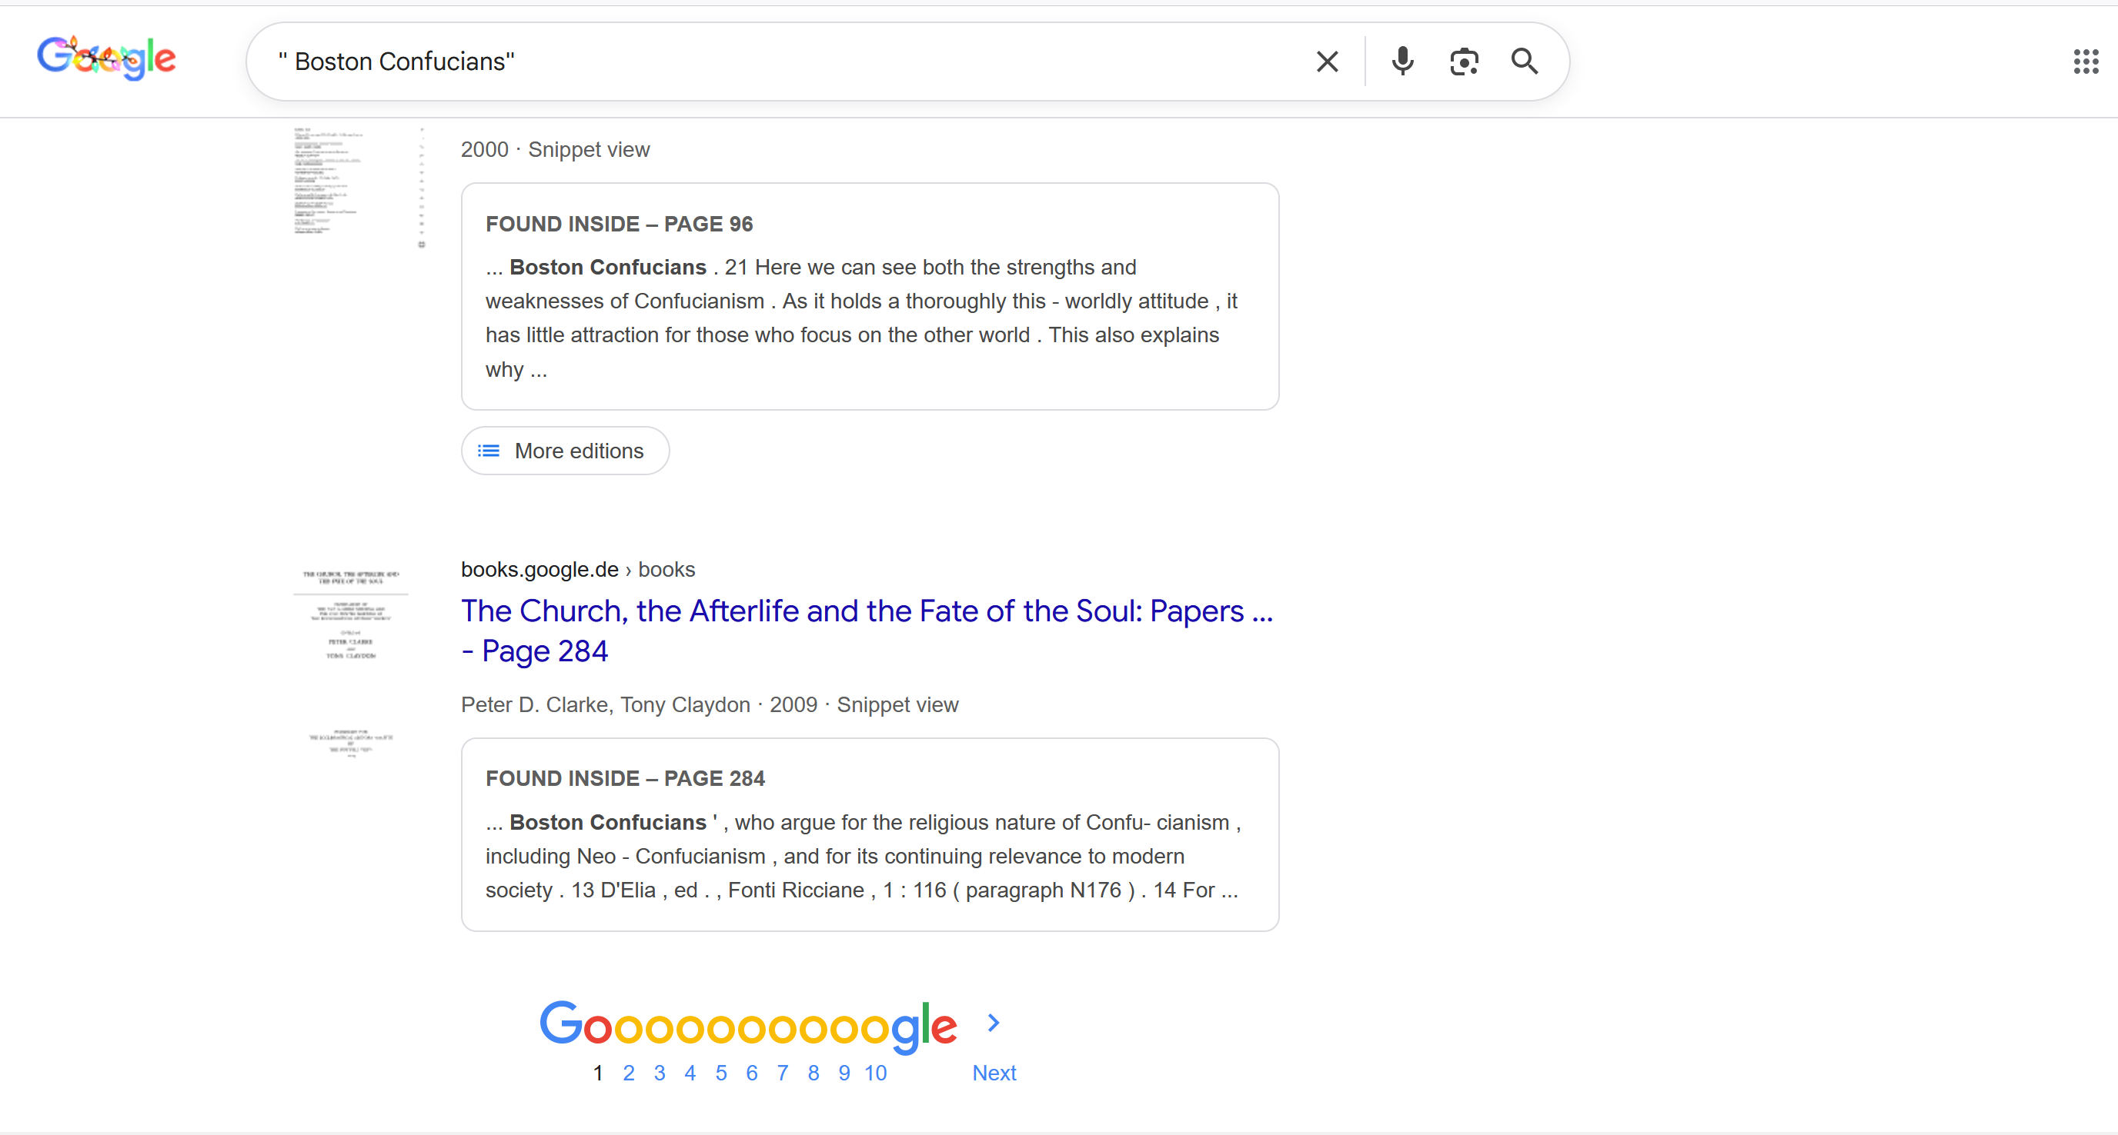
Supplementary Figure F3: Attribution of ‘Boston Confucian(s)’ to ‘Confucianism’ and ‘Religiosity’ in Google Books (Snippet View)

Notes on Supplementary Figures F1-F3:
All screenshots are taken from publicly accessible Google Books snippet views. The bibliographic information shown (titles, authors, publishers) constitutes part of the analysed digital knowledge representation. Therefore, bibliographic metadata (author names, publication details) are deliberately retained, as they form part of the classificatory and epistemic structure produced by the platform.

