Appendix
Section 1. Variable Importance
Variable importance in causal forests measures how much each covariate contributes to explaining differences in treatment effects (e.g., online vs. face-to-face learning). It is calculated based on:
- How often a variable is used to split trees.
- How much those splits improve prediction accuracy or reduce effect variability.
Unlike parametric models, causal forests use this nonparametric approach to detect key moderators of treatment effects. Table A1 reports the importance scores for all covariates in the analysis. The most important covariates are the ones whose importance is greater than 20% of the mean of all importances.

Table A1. Variable Importance
Variable | Gender | Residence Nablus | Residence North West Bank | Residence South West Bank | Residence Palestine1948 | Incomplete final exam, % | Teacher 1 | Teacher 2
Importance | 2.8% | 1.6% | 1.1% | 1.4% | 1.1% | 0.4% | 4.1% | 3.8%
Variable | Teacher 3 | Teacher 4 | Teacher 5 | Teacher 6 | Teacher 7 | Teacher 8 | Teacher 9 | Teacher 10
Importance | 2.1% | 1.2% | 1.3% | 1.5% | 0% | 1.2% | 1% | 0.2%
Variable | Teacher 11 | Teacher 12 | Teacher 13 | Teacher 14 | Civil or architecture | Computer Engineering | Industrial and Chemical Engineering | Physics
Importance | 0% | 7.3% | 0.9% | 0% | 1.1% | 2.9% | 1.3% | 0.7%
Variable | Information Technology | Mathematics | Other | Failed before, % | High school score | Absence (hours)
Importance | 3.3% | 1.6% | 1.7% | 4.2% | 44.6% | 5.8%

Section 2. Table format for subgroup analysis findings
Table A2 presents the detailed results corresponding to the main subgroup (GATE) analysis displayed in the forest plot in the main text (Figure 1). For each subgroup, the table reports its size, the estimated average treatment effect (GATE), and the lower and upper limits of the 95 % confidence interval. The final column indicates whether the subgroup effect is statistically different from the overall average effect (green) or not (red). This table provides full transparency and facilitating comparison across subgroups.

Table A2. Estimated Subgroup Treatment Effects (GATEs) With Confidence Intervals and Sample Sizes
subgroup | Size of the subgroup | Effect (GATE) | Lower limit of 95% CI | Upper limit of 95% CI | Is it different from Average?
population | 2210 | 2.56 | 1.23 | 3.9
male | 1205 | 4.82 | 2.89 | 6.75
female | 1005 | -0.14 | -1.94 | 1.66
Center | 1374 | 2.07 | 0.51 | 3.62
North | 728 | 3.27 | 0.88 | 5.66
South | 57 | 2.97 | -13.07 | 19.02
External | 51 | 5.44 | -5.30 | 16.17
Incomplete final exam,yes | 215 | 2.26 | -0.72 | 5.23
Teacher 1 | 79 | -5.77 | -10.81 | -0.73
Teacher 2 | 403 | 5.45 | 2.91 | 7.98
Teacher 3 | 131 | -0.62 | -6.91 | 5.67
Teacher 4 | 141 | 0.93 | -4.55 | 6.41
Teacher 5 | 97 | 1.52 | -3.82 | 6.86
Teacher 6 | 104 | -3.88 | -9.23 | 1.47
Teacher 7 | 157 | 6.07 | 0.46 | 11.68
Teacher 8 | 296 | -2.75 | -7.27 | 1.78
Teacher 9 | 157 | 1.12 | -3.22 | 5.47
Teacher 10 | 147 | 3.52 | -1.99 | 9.03
Teacher 11 | 187 | 4.09 | 0.50 | 7.69
Teacher 12 | 167 | 13.60 | 7.93 | 19.28
Teacher 13 | 86 | 0.94 | -6.21 | 8.09
Teacher 14 | 58 | 3.12 | -2.58 | 8.81
Civil or architecture | 330 | 2.68 | -0.78 | 6.13
Computer Engineering | 834 | -2.49 | -4.61 | -0.37
Industrial and Chemical Engineering | 152 | 3.54 | -1.61 | 8.69
Physics | 30 | -2.96 | -14.92 | 9.00
Information Technology | 742 | 7.45 | 5.16 | 9.74
Mathematics | 47 | 0.12 | -10.51 | 10.75
Other | 75 | 11.73 | 4.89 | 18.56
Failed before, Yes | 215 | 9.66 | 5.35 | 13.97
High school score 60 to69.99 | 132 | 15.56 | 11.47 | 19.65
High school score 70 to79.99 | 335 | 8.78 | 5.67 | 11.89
High school score 80 to 89.99 | 786 | 4.83 | 2.45 | 7.20
High school score 90 to 99.99 | 937 | -3.52 | -5.50 | -1.54

Section 3. Accounting for the Nested Structure: Teacher-Level Clustering
To explore the potential hierarchical nature of the data, particularly the influence of within-teacher dependence, we re-estimated the causal forest model with the teacher identifier specified as the clustering variable. This specification allows uncertainty to be computed at the teacher level and adjusts for potential intra-cluster correlation among students taught by the same instructor. The analysis examines the extent to which introducing teacher-level clustering influences the estimated average treatment effect (ATE), the distribution of individualized treatment effects (CATEs), and the pattern of subgroup effects (GATEs). The following tables and figures present these results and compare them with those from the original, unclustered specification as a sensitivity analysis.
Table A3 shows that the average treatment effect remained almost identical [2.58 (0.03, 5.13) vs. 2.56 (1.23, 3.90)] with slightly wider confidence intervals, as expected when clustering reduces the effective sample size.
Table A3. Comparison of Average Treatment Effects (ATE) With and Without Teacher-Level Clustering
Model Specification | Average Treatment Effect (ATE) | 95% Confidence Interval
Without clustering | 2.56 | (1.23 ; 3.90)
With teacher clustering | 2.58 | (0.033 ; 5.134)
On the individual student level, the distribution of estimated effects narrowed slightly (Range without clustering: –6.7–13.0; Range with clustering: –3.98 to 9.49). However, the overall heterogeneity pattern remained consistent, as illustrated in Figure A1, which displays the ranked individual treatment effects estimated by the causal forest with and without teacher-level clustering.
Figure A1. Distribution of individualized treatment effects (CATEs) with and without teacher clustering.
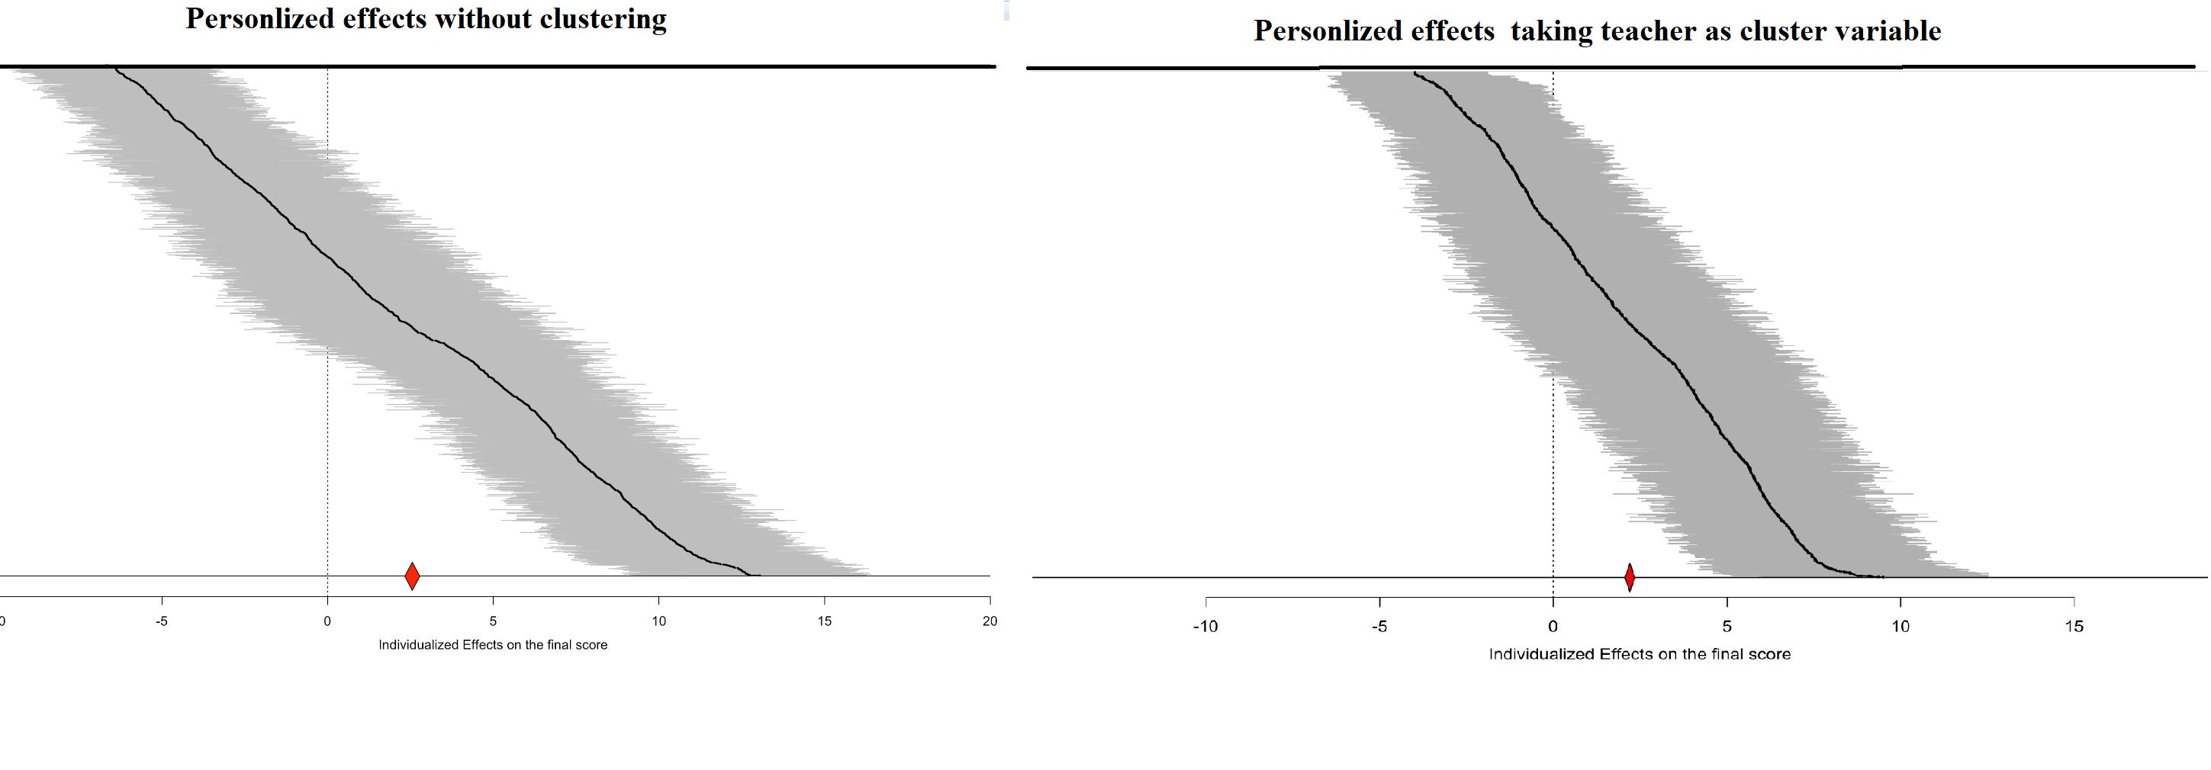
Moreover, Figure A2 shows that the pattern of heterogeneity across subgroups—particularly those defined by high school score, department, and gender—remained unchanged. Subgroup treatment effects are reported for the 21 categories that include at least two instructors, as teacher-specific subgroups were excluded because cluster-level variance cannot be computed for a single teacher. Overall, the heterogeneity patterns across student and department characteristics remain consistent under teacher-level clustering.
Figure A2. Subgroup (GATE) estimates from causal forest models with and without teacher clustering.
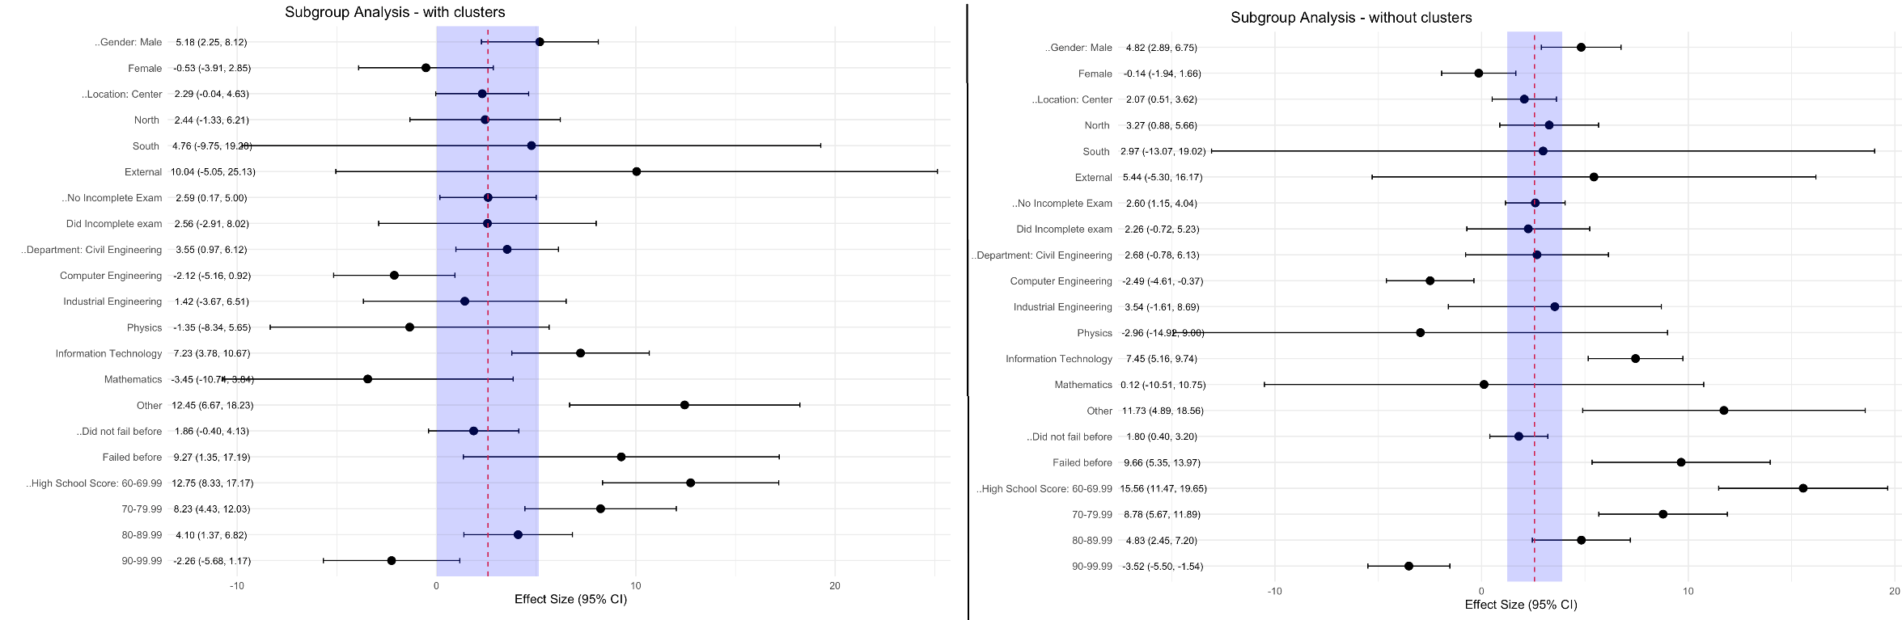
In summary, the inclusion of teacher-level clustering resulted in slightly wider confidence intervals but left the main conclusions unchanged, indicating that the estimated effects are not driven by within-teacher dependence. The preservation of heterogeneity patterns across departments and student characteristics demonstrates that the findings are robust to teacher-level clustering.
Section 4. Distribution of Outcome Scores
To explore whether the outcome variable was affected by potential ceiling or floor effects as may be guessed given the bounded outcome, we analyzed the distribution of final Calculus 1 scores across all students. The final score which is the outcome variable in all analyses and was measured on a 35–100-point scale. As shown in Figures A3 & A4, the distribution is approximately symmetric and broadly dispersed (mean = 65.6, SD = 17.0, median = 67.0), with scores covering nearly the entire grading range. Only a small proportion of observations lie near the upper boundary, mitigating the concern of ceiling effects and unlikely to bias treatment effect estimates.

Figure A3. Histogram of final Calculus 1 scores across all students.
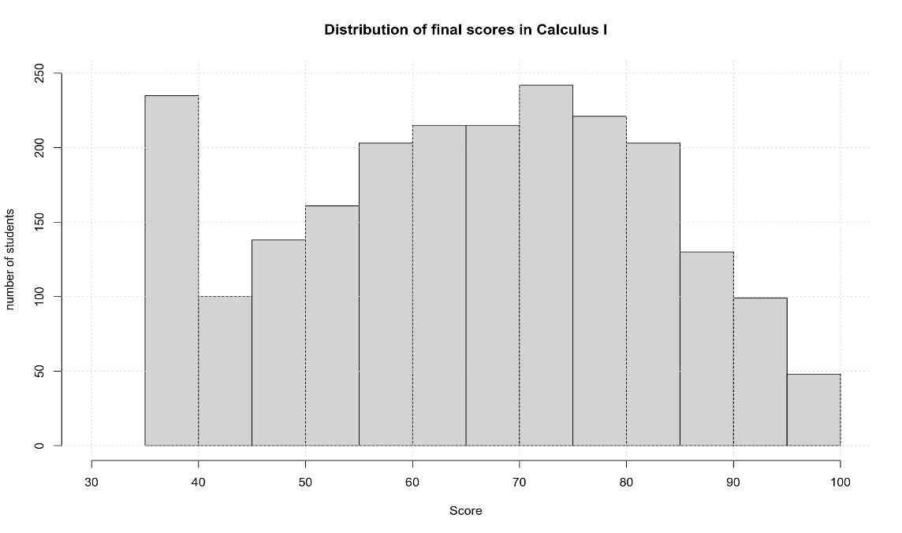
Figure A4. Boxplot of final Calculus 1 scores across all students.
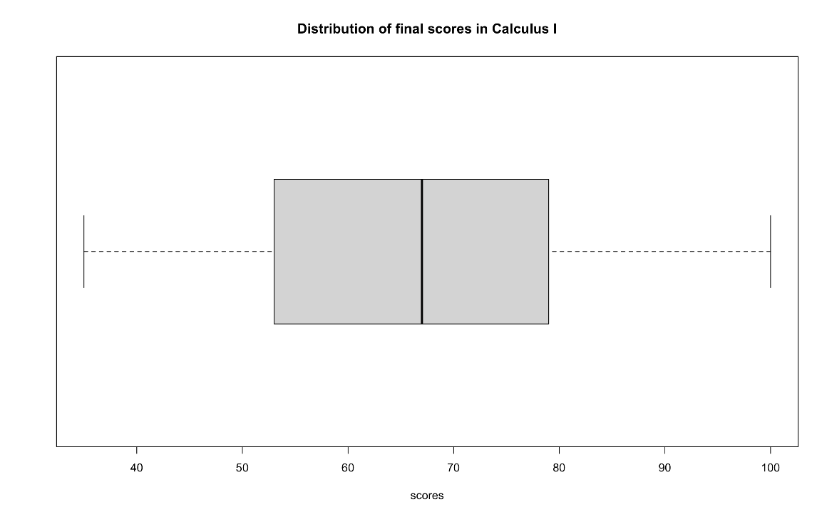

Section 5. Standardized Effects
For interpretability, all subgroup treatment effects are also presented in standardized units (i.e., as fractions of the outcome’s standard deviation, SD = 17.01) following Cohen (1988). Table A3 and Figure A5 below show that the pattern of heterogeneity remains the same.
Table A3. Estimated Standardized Subgroup Treatment Effects (GATEs) With Confidence Intervals and Sample Sizes
subgroup | Size of the subgroup | Standardized Effect (GATE) | Standardized  Lower limit of 95% CI | Standardized Upper limit of 95% CI | Is it different from Average?
population | 2210 | 0.15 | 0.072 | 0.229
male | 1205 | 0.283 | 0.17 | 0.397
female | 1005 | -0.008 | -0.114 | 0.098
Center | 1374 | 0.122 | 0.03 | 0.213
North | 728 | 0.192 | 0.052 | 0.333
South | 57 | 0.175 | -0.768 | 1.118
External | 51 | 0.32 | -0.312 | 0.951
Incomplete final exam, yes | 215 | 0.133 | -0.042 | 0.307
Teacher 1 | 79 | -0.339 | -0.636 | -0.043
Teacher 2 | 403 | 0.32 | 0.171 | 0.469
Teacher 3 | 131 | -0.036 | -0.406 | 0.333
Teacher 4 | 141 | 0.055 | -0.267 | 0.377
Teacher 5 | 97 | 0.089 | -0.225 | 0.403
Teacher 6 | 104 | -0.228 | -0.543 | 0.086
Teacher 7 | 157 | 0.357 | 0.027 | 0.687
Teacher 8 | 296 | -0.162 | -0.427 | 0.105
Teacher 9 | 157 | 0.066 | -0.189 | 0.322
Teacher 10 | 147 | 0.207 | -0.117 | 0.531
Teacher 11 | 187 | 0.24 | 0.029 | 0.452
Teacher 12 | 167 | 0.8 | 0.466 | 1.133
Teacher 13 | 86 | 0.055 | -0.365 | 0.476
Teacher 14 | 58 | 0.183 | -0.152 | 0.518
Civil or architecture | 330 | 0.158 | -0.046 | 0.36
Computer Engineering | 834 | -0.146 | -0.271 | -0.022
Industrial and Chemical Engineering | 152 | 0.208 | -0.095 | 0.511
Physics | 30 | -0.174 | -0.877 | 0.529
Information Technology | 742 | 0.438 | 0.303 | 0.573
Mathematics | 47 | 0.007 | -0.618 | 0.632
Other | 75 | 0.69 | 0.287 | 1.091
Failed before, Yes | 215 | 0.568 | 0.315 | 0.821
High school score 60 to69.99 | 132 | 0.915 | 0.674 | 1.155
High school score 70 to79.99 | 335 | 0.516 | 0.333 | 0.699
High school score 80 to 89.99 | 786 | 0.284 | 0.144 | 0.423
High school score 90 to 99.99 | 937 | -0.207 | -0.323 | -0.091

Figure A5. Standardized Subgroups effects of online versus face-to-face education. The blue area represents the overall population average effect (Standardized) with its 95% confidence interval.
