Appendix A. Self-paced reading. X-axis: Region; Y-axis: (a) Residual reading time, (b−d) Surprisal. Error bars indicate 95% confidence intervals.
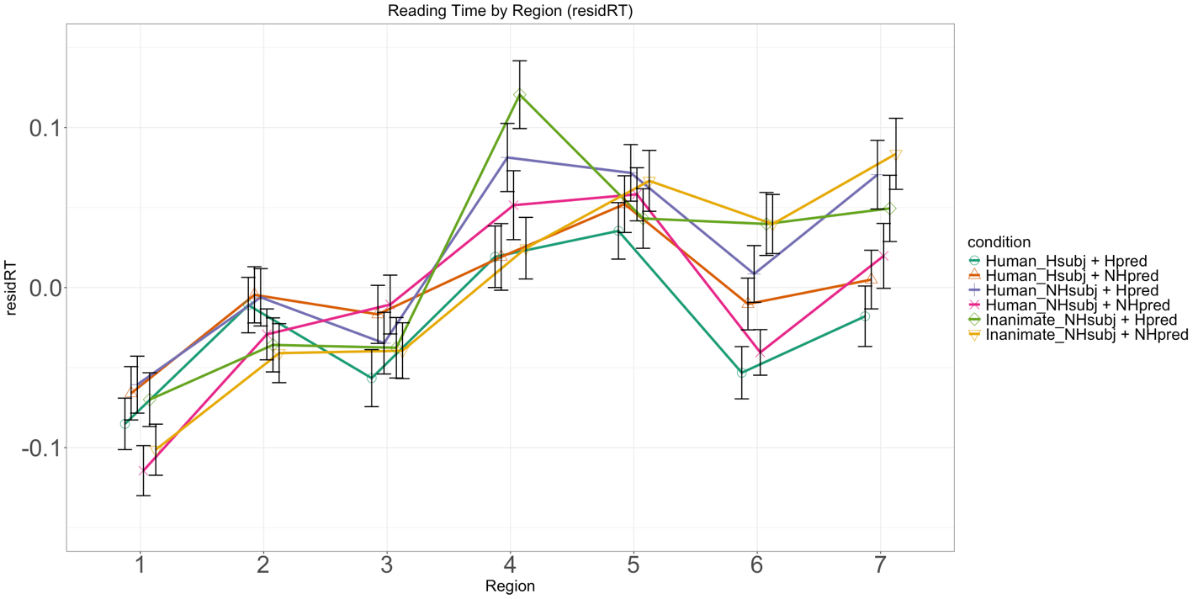
(a) Human reading time
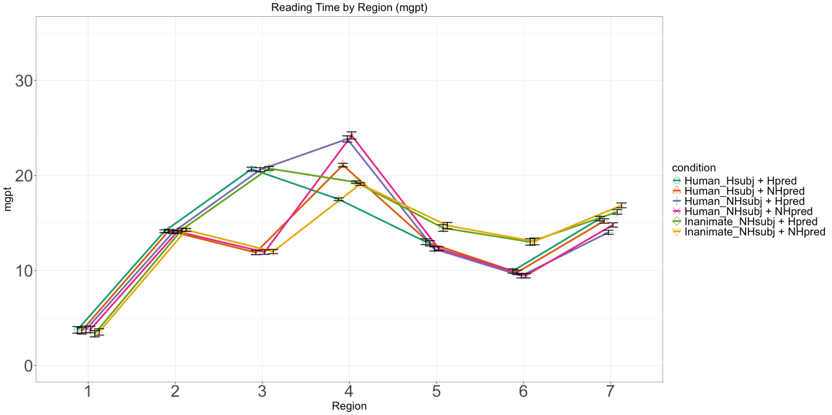
(b) KoGPT-2 surprisal
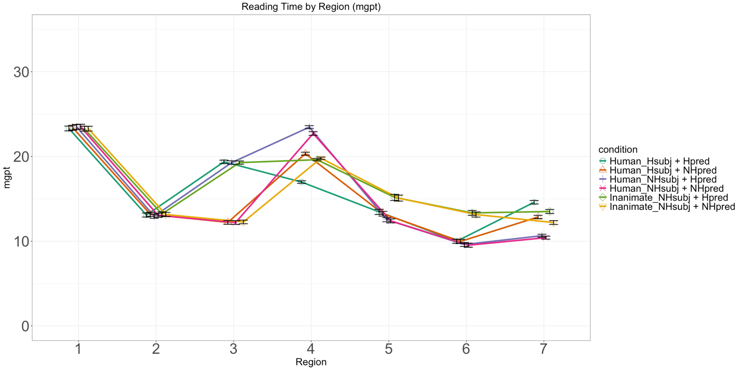
(c) Ko-GPT-Trinity surprisal
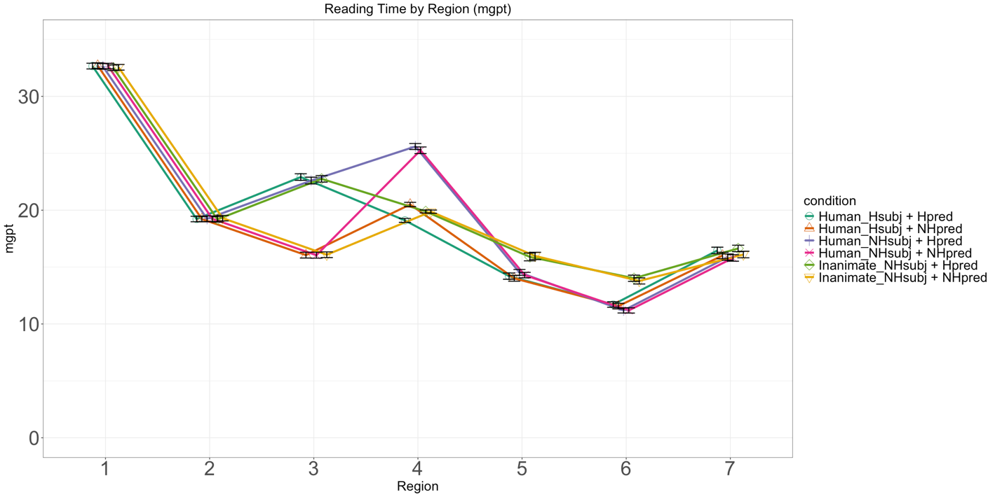
(d) mGPT surprisal

Appendix B. Eye-tracking reading. X-axis: Region; Y-axis: (a) Eye-gaze time (log-transformed), (b−d) Surprisal. Error bars indicate 95% confidence intervals.
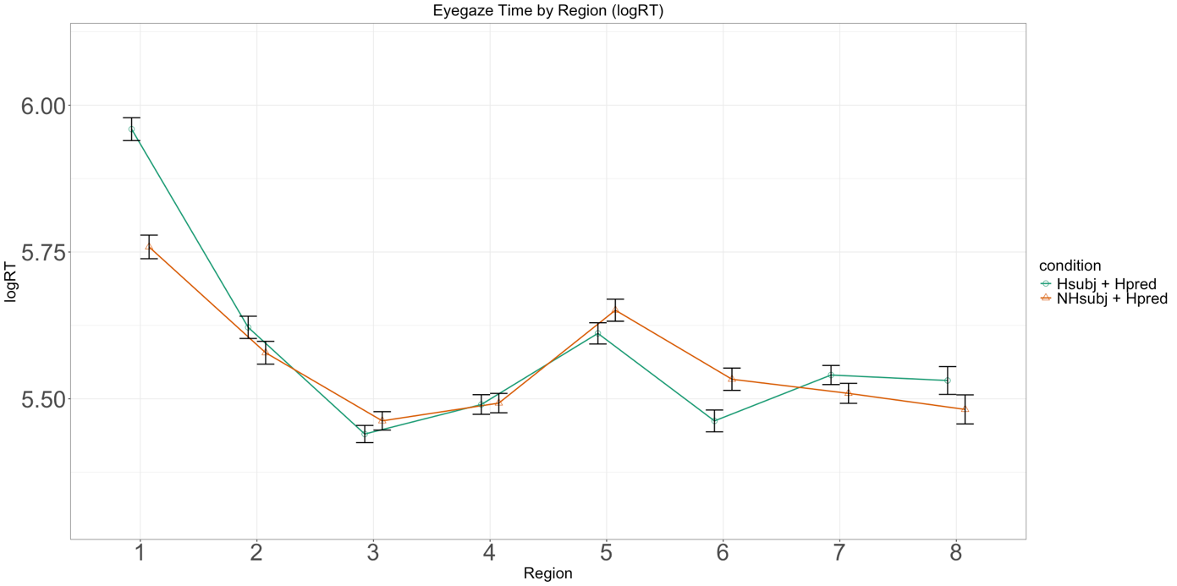
(a) Human eye gaze time
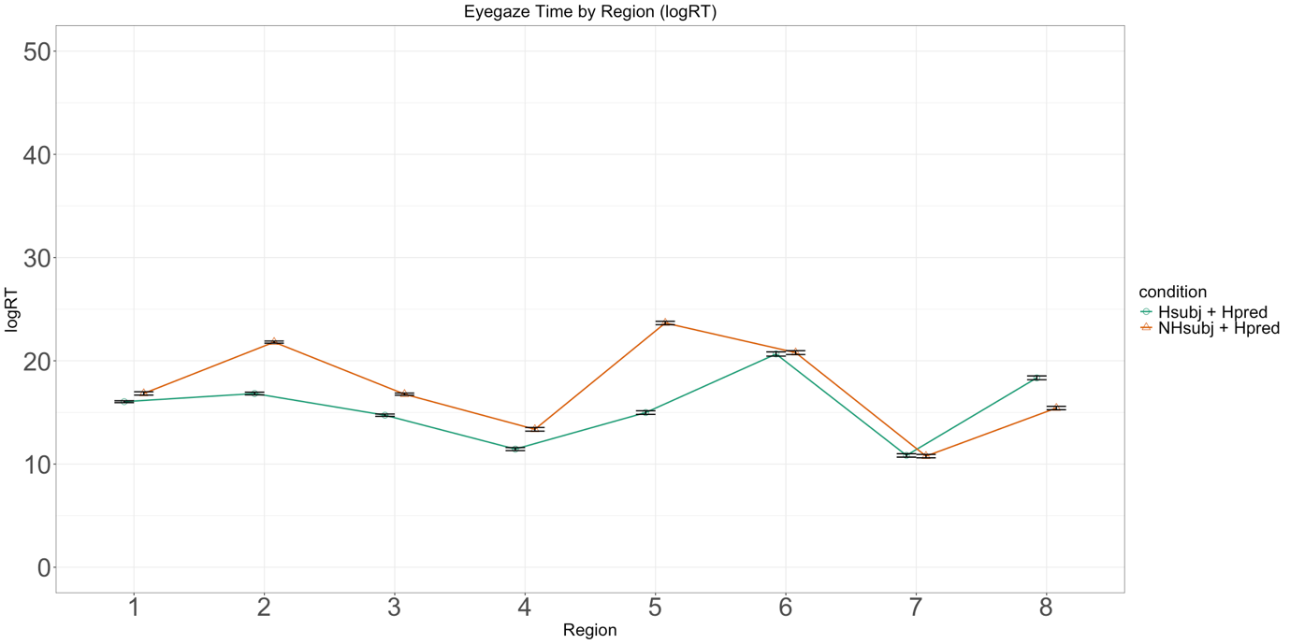
(b) KoGPT-2 surprisal
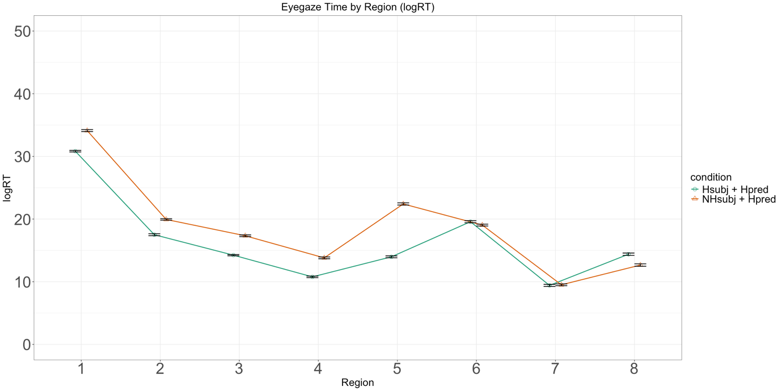
(c) Ko-GPT-Trinity surprisal
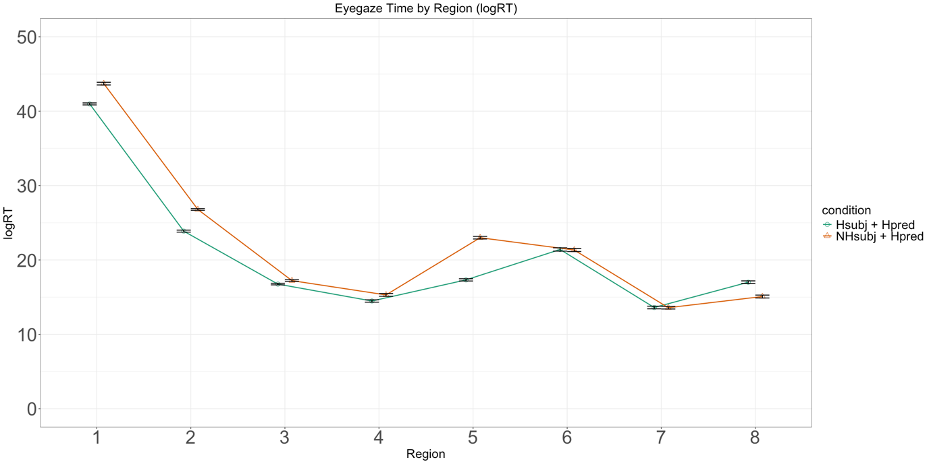
(d) mGPT surprisal

