Appendix 1

Fig 1. The description length of women is systematically longer than that of men, with a tailed length distribution and a meaningful median, implying that very few Discord users write long prompts (including duplicates).
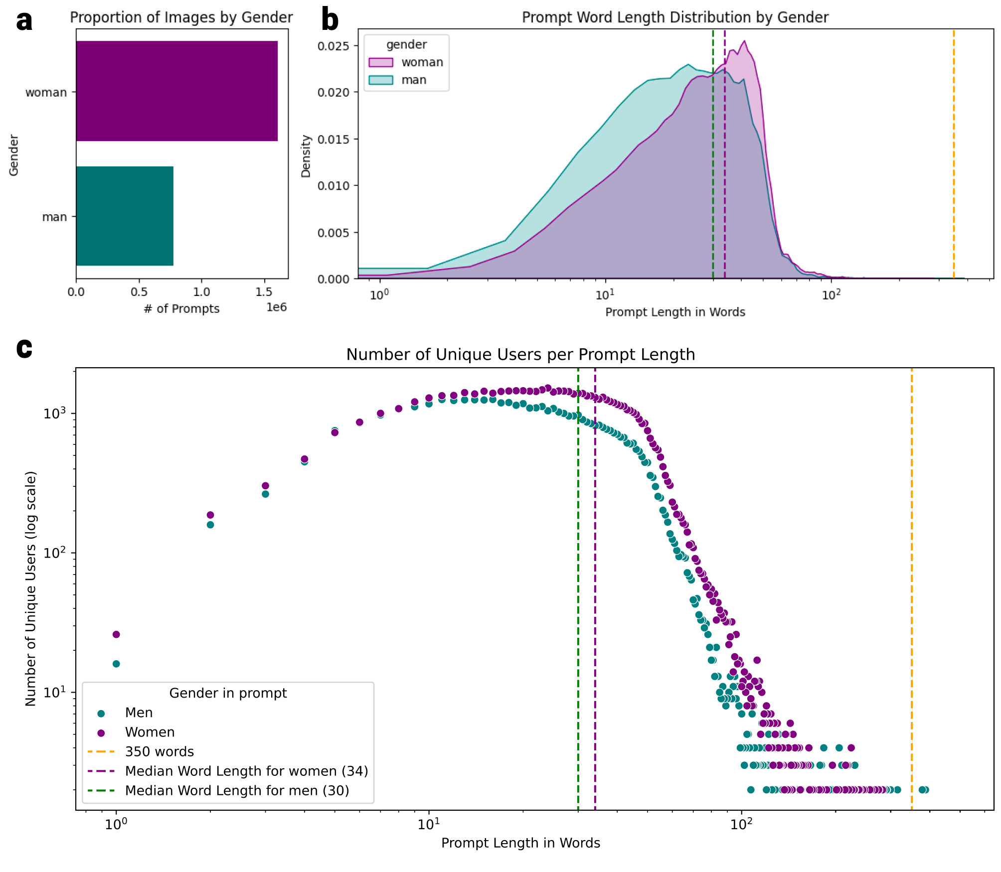
A. Images of women are similarly overrepresented (1,606,013 vs 779,200) in prompts when including duplicates in the analysis.
B. Images of men are described in fewer words than those of women across all prompts, including duplicates. As shown in the main paper, this holds true even after removing duplicates from the dataset. As the length of the prompt increases, the distributions exhibit a sharp decline, ranging from 50 to 80 words in length, which highlights an optimal prompt length. The orange dashed line indicates the approximate prompt length limit of 350 words or 2000 characters as specified by the Discord platform (hence, two prompts appear as outliers, while still being within the character length limit). C. Similarly, the distribution of unique users by prompt length is similar to the one we observe in the data that only contains unique prompts.

Fig. 2. Top words predicting men and women show existence of strong stereotypical gendered topics within prompts (including duplicates)
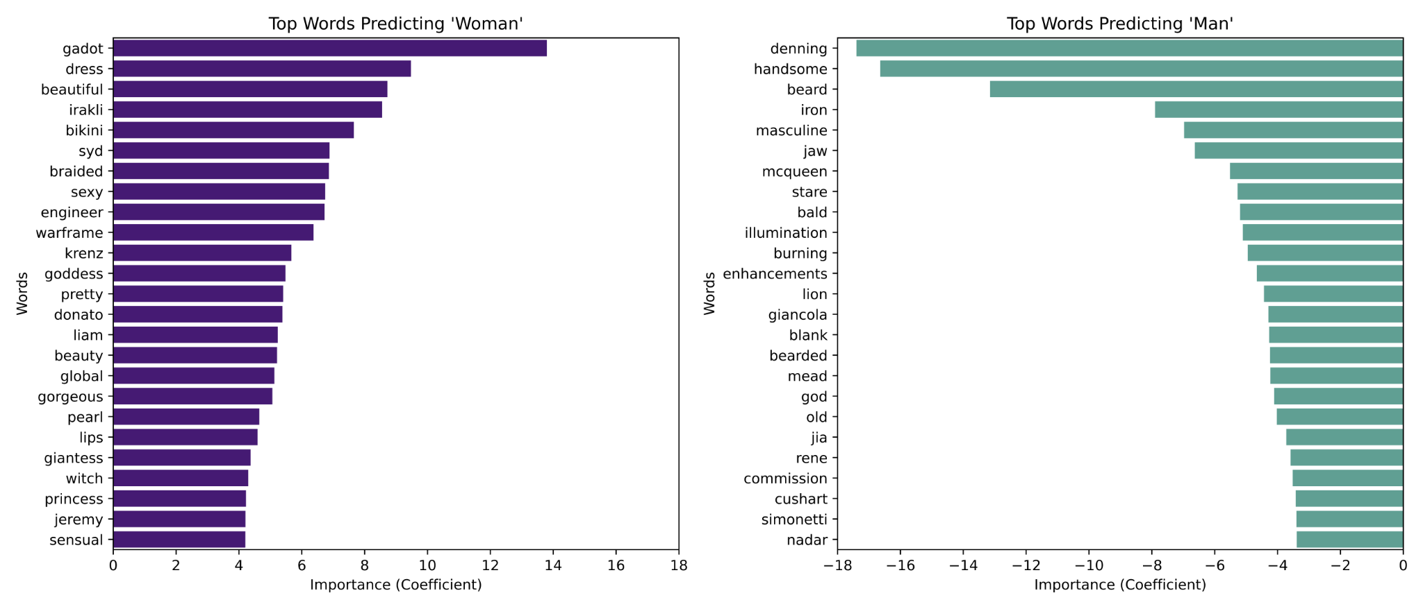
If we don't remove the duplicates, we also see words indicating occupations, roles, or professions among the top words to prompt women. Such terms indicate the depicted person’s involvement in certain professions or activities, such as 'engineer', 'witch', or 'princess', as found and indicated to the left for women. This finding is particularly interesting in light of the previous work by Gorska and Jemielniak (2023), who found that engineers were underrepresented in images of women. Notably, there is no mention of men's professions among the top 25 terms, which, subject to further investigation, may perhaps be rooted in ‘faceism’—a practice of focusing on a man's face without providing much context regarding the occupation or status of the depicted person (Archer et al., 1983). After the removal of the duplicates in the main paper, however, we don't see terms indicating occupations among the top terms anymore.

