Appendix
Table S1. The impact of birth intervals on educational attainment in 3-child families 2
Table S2. The impact of birth intervals on educational attainment in 4-child families 3
Table S3. The impact of birth intervals on educational attainment in 5-child families 4
Table S4. The impact of birth intervals on educational attainment in families with 6 or more children 5
Table S5. The impact of birth intervals on educational attainment by Hukou type. 6
Table S6. The impact of continuous birth intervals on educational attainment 8
Table S7. The impact of birth intervals on educational attainment using fixed-effects ordered logit models 9
Table S8. The impact of birth interval on educational attainment when the sample was restricted to individuals born before 1979 11
Table S9. The impact of birth interval on educational attainment when the sample was restricted to individuals born before 1971 12
Table S10. The impact of birth interval on educational attainment when controlled for the earlier average birth intervals within family 13
Figure S1 Predicted effect on educational attainment by preceding and subsequent birth intervals restricting the sample to individuals born before the one-child policy 14

Table S1. The impact of birth intervals on educational attainment in 3-child families
 | Preceding birth interval |  | Subsequent birth interval
 | Beta | SE | Beta | SE
Birth Interval Length
1 | -0.063 | 0.038 | 0.066 | 0.039
2(ref) | 0.000 |  | 0.000
3 | 0.005 | 0.027 | 0.025 | 0.027
4 | -0.019 | 0.034 | 0.000 | 0.035
5 | 0.019 | 0.043 | -0.015 | 0.042
6 | 0.033 | 0.054 | -0.118* | 0.053
7 | -0.049 | 0.061 | -0.050 | 0.061
8 | -0.040 | 0.077 | -0.008 | 0.073
9 | -0.029 | 0.088 | 0.017 | 0.078
>=10 | -0.002 | 0.075 | 0.031 | 0.067
Gender (ref: Female) | 0.218*** | 0.018 | 0.307 | 0.019
Birth order
1 |  |  | 0.043*** | 0.036
2(ref) | 0.000 |  | 0.000
3 | 0.012 | 0.034
Maternal Age
15-19 | -0.061 | 0.111 | -0.008 | 0.064
20-24 | -0.010 | 0.035 | 0.012 | 0.035
25-29(ref) | 0.000 |  | 0.000
30-34 | -0.041 | 0.039 | 0.041 | 0.048
35-39 | -0.091 | 0.074 | -0.046 | 0.097
40-44 | -0.097 | 0.116 | -0.069 | 0.165
45-49 | -0.065 | 0.180 | -0.076 | 0.300
Birth year fixed | Yes |  | Yes
R-squared | 0.055 |  | 0.063
N | 13,402 |  | 13,338
Note. SE = standard errors. The sample includes 6,701 families. All regressions included family fixed effects. * p < 0.05, ** p < 0.01, *** p < 0.001.

Table S2. The impact of birth intervals on educational attainment in 4-child families
 | Preceding birth interval |  | Subsequent birth interval
 | Beta | SE | Beta | SE
Birth Interval Length
1 | 0.012 | 0.028 | 0.039 | 0.029
2(ref) | 0.000 |  | 0.000
3 | 0.049* | 0.019 | -0.029 | 0.020
4 | 0.088*** | 0.024 | 0.008 | 0.025
5 | 0.100*** | 0.031 | -0.029 | 0.032
6 | 0.092* | 0.036 | 0.002 | 0.038
7 | 0.139** | 0.045 | -0.024 | 0.046
8 | 0.105 | 0.057 | -0.069 | 0.057
9 | 0.134 | 0.070 | 0.104 | 0.069
>=10 | 0.143* | 0.057 | 0.034 | 0.050
Gender (ref: Female) | 0.299*** | 0.014 | 0.386*** | 0.015
Birth order
1 |  |  | 0.093*** | 0.024
2(ref) | 0.000 |  | 0.000
3 | -0.001 | 0.024 | -0.033 | 0.025
4 | 0.046 | 0.041
Maternal Age
15-19 | -0.052 | 0.076 | -0.024 | 0.049
20-24 | -0.026 | 0.028 | 0.009 | 0.026
25-29(ref) | 0.000 |  | 0.000
30-34 | -0.021 | 0.027 | -0.004 | 0.030
35-39 | -0.032 | 0.050 | -0.098 | 0.060
40-44 | -0.031 | 0.078 | -0.106 | 0.106
45-49 | 0.022 | 0.120 | 0.136 | 0.190
Birth year fixed | Yes |  | Yes
R-squared | 0.077 |  | 0.091
N | 18,372 |  | 18,372
Note. SE = standard errors. The sample includes 6,124 families. All regressions included family fixed effects. * p < 0.05, ** p < 0.01, *** p < 0.001.

Table S3. The impact of birth intervals on educational attainment in 5-child families
 | Preceding birth interval |  | Subsequent birth interval
 | Beta | SE | Beta | SE
Birth Interval Length
1 | 0.006 | 0.026 | 0.030 | 0.030
2(ref) | 0.000 |  | 0.000
3 | 0.029 | 0.017 | -0.006 | 0.017
4 | 0.067** | 0.022 | -0.029 | 0.022
5 | 0.131*** | 0.029 | -0.027 | 0.028
6 | 0.160*** | 0.038 | -0.066 | 0.035
7 | 0.099* | 0.047 | -0.047 | 0.047
8 | 0.124* | 0.053 | 0.007 | 0.056
9 | 0.227** | 0.076 | -0.030 | 0.079
>=10 | 0.077 | 0.071 | 0.026 | 0.067
Gender (ref: Female) | 0.359*** | 0.014 | 0.468*** | 0.014
Birth order
1 |  |  | 0.091*** | 0.024
2(ref) | 0.000 |  | 0.000
3 | 0.048* | 0.023 | 0.011 | 0.023
4 | 0.096** | 0.037 | 0.027 | 0.039
5 | 0.189*** | 0.052
Maternal Age
15-19 | -0.002 | 0.071 | 0.035 | 0.048
20-24 | -0.025 | 0.027 | -0.006 | 0.026
25-29(ref) | 0.000 |  | 0.000
30-34 | -0.025 | 0.025 | -0.008 | 0.027
35-39 | -0.055 | 0.046 | -0.030 | 0.051
40-44 | -0.039 | 0.069 | -0.046 | 0.088
45-49 | -0.209 | 0.104 | -0.300 | 0.151
Birth year fixed | Yes |  | Yes
R-squared | 0.101 |  | 0.124
N | 19,440 |  | 19,440
Note. SE = standard errors. The sample includes 4,860 families. All regressions included family fixed effects. * p < 0.05, ** p < 0.01, *** p < 0.001.

Table S4. The impact of birth intervals on educational attainment in families with 6 or more children
 | Preceding birth interval |  | Subsequent birth interval
 | Beta | SE | Beta | SE
Birth Interval Length
1 | -0.005 | 0.021 | -0.006 | 0.022
2(ref) | 0.000 |  | 0.000
3 | 0.031* | 0.015 | -0.018 | 0.015
4 | 0.060*** | 0.019 | 0.008 | 0.019
5 | 0.044 | 0.025 | -0.039 | 0.027
6 | 0.095** | 0.034 | -0.018 | 0.033
7 | 0.104* | 0.053 | 0.001 | 0.048
8 | 0.123 | 0.064 | -0.072 | 0.065
9 | 0.014 | 0.086 | 0.040 | 0.101
>=10 | 0.139 | 0.081 | 0.033 | 0.078
Gender (ref: Female) | 0.457*** | 0.012 | 0.542*** | 0.013
Birth order
1 |  |  | 0.072*** | 0.022
2(ref) | 0.000 |  | 0.000
3 | 0.057* | 0.023 | 0.021 | 0.021
4 | 0.092** | 0.033 | 0.032 | 0.030
5 | 0.125** | 0.043 | 0.049 | 0.041
6 | 0.207*** | 0.053 | 0.101 | 0.053
7 | 0.248*** | 0.065 | 0.100 | 0.067
8 | 0.261*** | 0.078 | 0.064 | 0.110
9 | 0.461*** | 0.119
Maternal Age
15-19 | 0.030 | 0.073 | -0.034 | 0.043
20-24 | -0.028 | 0.025 | -0.018 | 0.024
25-29(ref) | 0.000 |  | 0.000
30-34 | 0.014 | 0.022 | 0.000 | 0.023
35-39 | 0.067 | 0.038 | 0.012 | 0.041
40-44 | 0.092 | 0.056 | 0.031 | 0.065
45-49 | 0.067 | 0.085 | -0.067 | 0.106
Birth year fixed | Yes |  | Yes
R-squared | 0.123 |  | 0.148
N | 25,808 |  | 25,808
Note. SE = standard errors. The sample includes 4,645 families. All regressions included family fixed effects. * p < 0.05, ** p < 0.01, *** p < 0.001.

Table S5. The impact of birth intervals on educational attainment by Hukou type.
 | Rural Hukou |  |  |  |  |  | Urban Hukou
 | Preceding birth interval |  | Subsequent birth interval |  |  | Preceding birth interval |  |  | Subsequent birth interval
 | Beta | SE | Beta | SE |  | Beta |  | SE | Beta | SE
Birth Interval Length
1 | -0.030 | 0.025 | 0.012 | 0.026 |  | 0.063 |  | 0.051 | 0.020 | 0.059
2(ref) | 0.000 |  | 0.000 |  |  | 0.000 |  |  | 0.000
3 | 0.041* | 0.016 | -0.023 | 0.016 |  | 0.013 |  | 0.042 | 0.034 | 0.040
4 | 0.046* | 0.021 | -0.023 | 0.021 |  | 0.100 |  | 0.054 | 0.077 | 0.053
5 | 0.085*** | 0.027 | -0.040 | 0.028 |  | -0.006 |  | 0.072 | 0.008 | 0.069
6 | 0.106** | 0.035 | -0.052 | 0.033 |  | 0.042 |  | 0.094 | 0.048 | 0.092
7 | 0.086 | 0.046 | -0.065 | 0.045 |  | -0.016 |  | 0.130 | -0.022 | 0.139
8 | 0.161** | 0.058 | 0.018 | 0.055 |  | -0.120 |  | 0.169 | 0.034 | 0.143
9 | 0.209** | 0.068 | -0.016 | 0.067 |  | -0.089 |  | 0.235 | 0.013 | 0.121
>=10 | 0.166** | 0.060 | -0.043 | 0.054 |  | -0.148 |  | 0.220 | -0.177 | 0.213
Gender (ref: Female) | 0.380*** | 0.013 | 0.482*** | 0.014 |  | 0.062* |  | 0.031 | 0.096** | 0.033
Birth order
1 |  |  | 0.083*** | 0.023 |  |  |  |  | 0.097 | 0.056
2(ref) | 0.000 |  | 0.000 |  |  | 0.000 |  |  | 0.000
3 | 0.018 | 0.023 | -0.030 | 0.023 |  | 0.019 |  | 0.060 | -0.005 | 0.054
4 | 0.074 | 0.038 | -0.012 | 0.037 |  | -0.061 |  | 0.108 | -0.069 | 0.091
5 | 0.123* | 0.053 | 0.004 | 0.052 |  | -0.098 |  | 0.147 | -0.146 | 0.132
6 | 0.209** | 0.069 | 0.085 | 0.071 |  | -0.166 |  | 0.189 | -0.119 | 0.191
7 | 0.225** | 0.083 | 0.059 | 0.097 |  | -0.257 |  | 0.243 | -0.027 | 0.238
8 | 0.225* | 0.114 | -0.004 | 0.172 |  | -0.217 |  | 0.267 | -0.154 | 0.227
9 | 0.505** | 0.188 |  |  |  | -0.226 |  | 0.296
Maternal Age
15-19 | -0.016 | 0.082 | -0.043 | 0.045 |  | 0.236 |  | 0.149 | 0.029 | 0.114
20-24 | -0.022 | 0.025 | -0.017 | 0.024 |  | -0.049 |  | 0.062 | 0.018 | 0.060
25-29(ref) | 0.000 |  | 0.000 |  |  | 0.000 |  |  | 0.000
30-34 | -0.019 | 0.024 | -0.003 | 0.026 |  | -0.020 |  | 0.061 | 0.062 | 0.064
35-39 | 0.005 | 0.044 | -0.028 | 0.049 |  | -0.039 |  | 0.121 | 0.093 | 0.153
40-44 | 0.032 | 0.067 | -0.039 | 0.087 |  | -0.080 |  | 0.189 | -0.099 | 0.231
45+ | -0.109 | 0.104 | -0.118 | 0.158 |  | 0.163 |  | 0.454 | -0.132 | 0.579
Birth year fixed | Yes |  | Yes |  |  | Yes |  |  | Yes
R-squared | 0.099 |  | 0.118 |  |  | 0.049 |  |  | 0.050
N | 23,506 |  | 23,506 |  |  | 3,539 |  |  | 3,539
Note. SE = standard errors. The sample includes 8,183 families from CFPS. All regressions included family fixed effects. * p < 0.05, ** p < 0.01, *** p < 0.001.

Table S6. The impact of continuous birth intervals on educational attainment
 | Preceding birth interval |  | Subsequent birth interval
 | Beta | SE | Beta | SE
Birth Interval Length | 0.017*** | 0.002 | -0.003 | 0.002
Gender (ref: Female) | 0.363*** | 0.007 | 0.457*** | 0.007
Birth order
1 |  |  | 0.072*** | 0.012
2(ref) | 0.000 |  | 0.000
3 | 0.037** | 0.012 | -0.011 | 0.012
4 | 0.073*** | 0.020 | -0.010 | 0.019
5 | 0.115*** | 0.028 | -0.014 | 0.027
6 | 0.161*** | 0.036 | 0.026 | 0.036
7 | 0.194*** | 0.044 | 0.018 | 0.049
8 | 0.191** | 0.056 | -0.035 | 0.099
9 | 0.377*** | 0.102
Maternal Age
15-19 | -0.012 | 0.040 | -0.014 | 0.025
20-24 | -0.025 | 0.014 | -0.007 | 0.013
25-29(ref) | 0.000 |  | 0.000
30-34 | -0.011 | 0.013 | -0.001 | 0.014
35-39 | 0.001 | 0.024 | -0.022 | 0.026
40-44 | 0.013 | 0.036 | -0.026 | 0.044
45+ | -0.051 | 0.054 | -0.120 | 0.074
Constant | 1.995*** | 0.146 | 1.850*** | 0.059
Birth year fixed | Yes |  | Yes
R-squared | 0.093 |  | 0.114
N | 77,022 |  | 77,022
Note. SE = standard errors. The sample includes 22,330 families. All regressions included family fixed effects. * p < 0.05, ** p < 0.01, *** p < 0.001.

Table S7. The impact of birth intervals on educational attainment using fixed-effects ordered logit models
 | Preceding birth interval |  | Subsequent birth interval
 | Beta | SE | Beta | SE
Birth Interval Length
1 | -0.028 | 0.042 | 0.063 | 0.042
2(ref) | 0.000 |  | 0.000
3 | 0.108*** | 0.028 | -0.035 | 0.027
4 | 0.195*** | 0.035 | -0.031 | 0.034
5 | 0.261*** | 0.045 | -0.108* | 0.044
6 | 0.319*** | 0.056 | -0.121* | 0.053
7 | 0.289*** | 0.075 | -0.095 | 0.071
8 | 0.314*** | 0.092 | -0.134 | 0.088
9 | 0.378*** | 0.114 | 0.094 | 0.118
>=10 | 0.336*** | 0.100 | 0.075 | 0.089
Gender (ref: Female) | 1.067*** | 0.021 | 1.283*** | 0.022
Birth order
1 |  |  | 0.189*** | 0.036
2(ref) | 0.000 |  | 0.000
3 | 0.141*** | 0.038 | 0.013 | 0.035
4 | 0.276*** | 0.062 | 0.033 | 0.057
5 | 0.423*** | 0.086 | 0.052 | 0.079
6 | 0.575*** | 0.109 | 0.161 | 0.104
7 | 0.663*** | 0.133 | 0.162 | 0.138
8 | 0.657*** | 0.166 | -0.065 | 0.249
9 | 1.035*** | 0.249
Maternal Age
15-19 | -0.008 | 0.128 | -0.016 | 0.073
20-24 | -0.063 | 0.043 | 0.000 | 0.040
25-29(ref) | 0.000 |  | 0.000
30-34 | -0.049 | 0.040 | -0.015 | 0.041
35-39 | -0.008 | 0.071 | -0.060 | 0.075
40-44 | 0.024 | 0.106 | -0.047 | 0.126
45-49 | -0.170 | 0.161 | -0.295 | 0.213
Birth year fixed | Yes |  | Yes
R-squared | 0.123 |  | 0.144
N | 56,440 |  | 58,758
Note. SE = standard errors. For fitting the model parameters, only panel units with variation in their dependent variables are informative. The fixed-effects ordered logit models would exclude families where siblings have the same education level, as their log-likelihood contribution is zero. This condition resulted in 56,440 observations from 15,235 families for examining the impact of preceding birth intervals on educational attainment and 58,758 observations from 15,938 families for examining the impact of subsequent birth intervals on educational attainment. * p < 0.05, ** p < 0.01, *** p < 0.001.

Table S8. The impact of birth interval on educational attainment when the sample was restricted to individuals born before 1979
 | Preceding birth interval |  | Subsequent birth interval
 | Beta | SE | Beta | SE
Birth Interval Length
1 | 0.002 | 0.014 | 0.023 | 0.015
2(ref) | 0.000 |  | 0.000
3 | 0.034*** | 0.010 | -0.011 | 0.010
4 | 0.064*** | 0.012 | -0.004 | 0.012
5 | 0.088*** | 0.016 | -0.033* | 0.016
6 | 0.115*** | 0.020 | -0.037 | 0.020
7 | 0.088*** | 0.027 | -0.027 | 0.026
8 | 0.088** | 0.032 | -0.024 | 0.033
9 | 0.118** | 0.043 | 0.031 | 0.044
>=10 | 0.107** | 0.038 | 0.048 | 0.037
Gender (ref: Female) | 0.367*** | 0.007 | 0.462*** | 0.008
Birth order
1 |  |  | 0.071*** | 0.013
2(ref) | 0.000 |  | 0.000
3 | 0.037** | 0.013 | -0.011 | 0.013
4 | 0.066*** | 0.021 | -0.012 | 0.021
5 | 0.107*** | 0.029 | -0.013 | 0.029
6 | 0.143 *** | 0.037 | 0.014 | 0.039
7 | 0.176*** | 0.046 | 0.015 | 0.053
8 | 0.178** | 0.058 | 0.009 | 0.105
9 | 0.368*** | 0.104
Maternal Age
15-19 | 0.011 | 0.043 | -0.009 | 0.026
20-24 | -0.011 | 0.015 | -0.006 | 0.014
25-29(ref) | 0.000 |  | 0.000
30-34 | -0.013 | 0.014 | 0.006 | 0.015
35-39 | -0.006 | 0.025 | -0.008 | 0.028
40-44 | 0.006 | 0.037 | -0.012 | 0.046
45-49 | -0.047 | 0.057 | -0.136 | 0.079
Birth year fixed | Yes |  | Yes
R-squared | 0.123 |  | 0.118
N | 68,931 |  | 68,931
Note. SE = standard errors. The sample includes 19,628 families. All regressions included family fixed effects. * p < 0.05, ** p < 0.01, *** p < 0.001.

Table S9. The impact of birth interval on educational attainment when the sample was restricted to individuals born before 1971
 | Preceding birth interval |  | Subsequent birth interval
 | Beta | SE | Beta | SE
Birth Interval Length
1 | 0.009 | 0.018 | 0.024 | 0.020
2(ref) | 0.000 |  | 0.000
3 | 0.030* | 0.013 | 0.005 | 0.013
4 | 0.058*** | 0.017 | -0.007 | 0.017
5 | 0.072*** | 0.021 | -0.039 | 0.022
6 | 0.119*** | 0.028 | -0.026 | 0.027
7 | 0.092* | 0.037 | -0.031 | 0.035
8 | 0.091* | 0.043 | -0.022 | 0.046
9 | 0.123* | 0.055 | 0.054 | 0.056
>=10 | 0.114* | 0.054 | 0.049 | 0.052
Gender (ref: Female) | 0.372*** | 0.010 | 0.468*** | 0.010
Birth order
1 |  |  | 0.074*** | 0.017
2(ref) | 0.000 |  | 0.000
3 | 0.037* | 0.017 | -0.019 | 0.017
4 | 0.055 | 0.029 | -0.024 | 0.028
5 | 0.082* | 0.040 | -0.040 | 0.040
6 | 0.125* | 0.051 | -0.012 | 0.053
7 | 0.110 | 0.062 | -0.031 | 0.076
8 | 0.147 | 0.080 | -0.129 | 0.163
9 | 0.377* | 0.160
Maternal Age
15-19 | -0.013 | 0.053 | -0.018 | 0.035
20-24 | -0.023 | 0.020 | -0.015 | 0.019
25-29(ref) | 0.000 |  | 0.000
30-34 | -0.002 | 0.018 | 0.018 | 0.020
35-39 | 0.016 | 0.033 | 0.009 | 0.037
40-44 | 0.043 | 0.049 | 0.052 | 0.062
45-49 | -0.001 | 0.079 | -0.026 | 0.116
Birth year fixed | Yes |  | Yes
R-squared | 0.106 |  | 0.135
N | 38,434 |  | 38,434
Note. SE = standard errors. The sample includes 11,020 families. All regressions included family fixed effects. * p < 0.05, ** p < 0.01, *** p < 0.001.

Table S10. The impact of birth interval on educational attainment when controlled for the earlier average birth intervals within family
 | Preceding birth interval |  | Subsequent birth interval
 | Beta | SE | Beta | SE
Birth Interval Length
1 | -0.015 | 0.014 | 0.021 | 0.014
2(ref) | 0.000 |  | 0.000
3 | 0.043*** | 0.010 | -0.012 | 0.009
4 | 0.082*** | 0.015 | -0.002 | 0.012
5 | 0.116*** | 0.021 | -0.031 | 0.015
6 | 0.153*** | 0.027 | -0.043* | 0.019
7 | 0.153*** | 0.035 | -0.027 | 0.024
8 | 0.166*** | 0.042 | -0.035 | 0.030
9 | 0.199*** | 0.052 | 0.031 | 0.039
>=10 | 0.215*** | 0.055 | 0.029 | 0.031
Gender (ref: Female) | 0.363*** | 0.007 | 0.457*** | 0.007
Earlier Average Birth Interval | 0.035* | 0.015 | -0.048*** | 0.008
Birth order
1 |  |  | 0.087*** | 0.012
2(ref) | 0.000 |  | 0.000
3 | 0.013** | 0.016 | 0.048** | 0.016
4 | 0.063*** | 0.020 | 0.055* | 0.022
5 | 0.126*** | 0.028 | 0.044 | 0.029
6 | 0.194*** | 0.038 | 0.074* | 0.037
7 | 0.248*** | 0.050 | 0.055 | 0.050
8 | 0.264*** | 0.064 | -0.008 | 0.099
9 | 0.471*** | 0.110
Maternal Age
15-19 | -0.008 | 0.040 | -0.010 | 0.025
20-24 | -0.023 | 0.014 | -0.003 | 0.013
25-29(ref) | 0.000 |  | 0.000
30-34 | -0.014 | 0.013 | 0.003 | 0.014
35-39 | -0.001 | 0.024 | -0.013 | 0.026
40-44 | 0.016 | 0.036 | -0.013 | 0.044
45-49 | -0.037 | 0.054 | -0.102 | 0.074
Birth year fixed | Yes |  | Yes
R-squared | 0.093 |  | 0.114
N | 77,022 |  | 77,022
Note. SE = standard errors. The sample includes 22,330 families. All regressions included family fixed effects. * p < 0.05, ** p < 0.01, *** p < 0.001

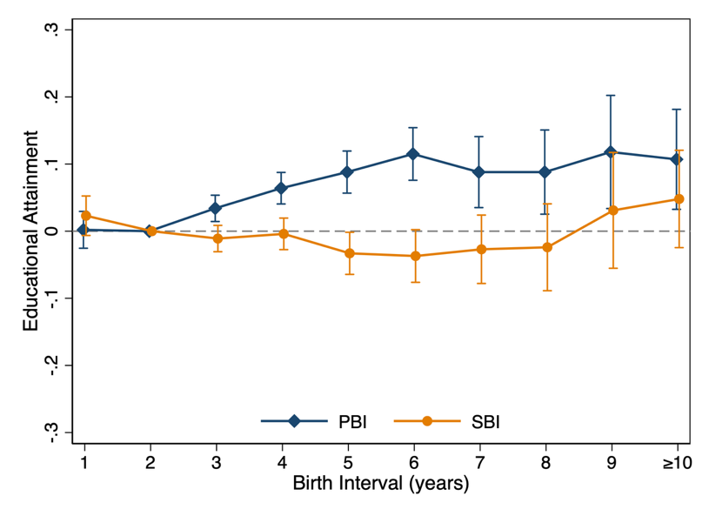

Figure S1 Predicted effect on educational attainment by preceding and subsequent birth intervals restricting the sample to individuals born before the one-child policy (birth year ≤ 1979)
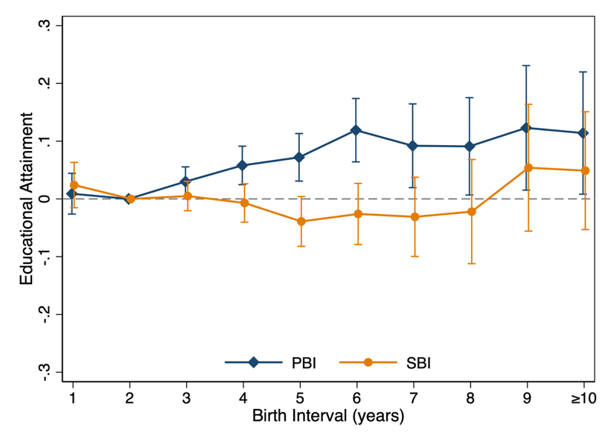
Figure S2 Predicted effect on educational attainment by preceding and subsequent birth intervals restricting the sample to individuals born before the family planning policy (birth year ≤ 1971)
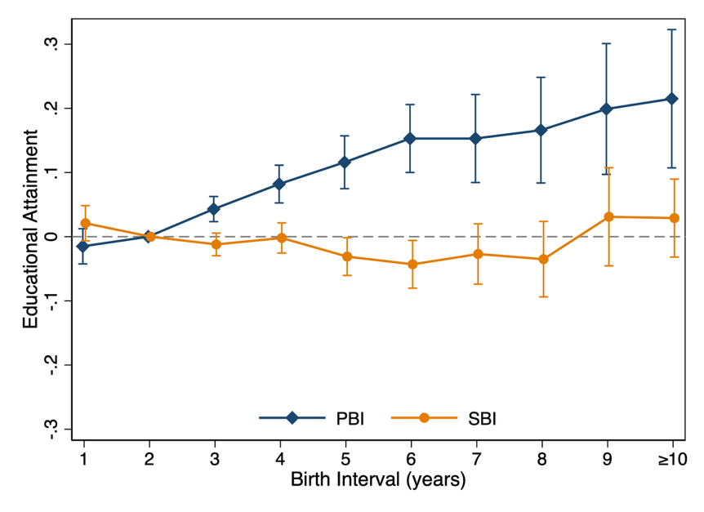
Figure S3 The impact of birth interval on educational attainment when controlled for the earlier average birth intervals within family

