Appendix
Table A1: Descriptive statistics of Traditional indices/ESG and DAX during Pre-Crisis Period (1st Jan 2021 to 31st Jan 2022)
 | Traditional Pre-Crisis |  |  |  | ESG Pre-Crisis
Country | Mean | Skewness | Kurtosis | Jarque-Bera | Mean | Skewness | Kurtosis | Jarque-Bera
Brazil | -0.0002 | -0.2583 | 3.2122 | 3.3270 | -0.0006 | 0.0700 | 2.9757 | 0.2153
China | -0.0004 | -0.2843 | 3.7568 | 9.3714***` | -0.0003 | -0.4035 | 3.7390 | 12.5239***
India | 0.0010 | -0.8025 | 5.9179 | 115.0605*** | 0.0010 | -0.8742 | 5.9083 | 119.4708***
Indonesia | 0.0001 | -0.0853 | 3.4940 | 2.9025 | -0.0004 | 0.2471 | 3.3954 | 4.2563***
Korea | -0.0008 | -0.1313 | 3.3792 | 2.2609 | -0.0006 | 0.1907 | 3.8984 | 10.1209***
Mena | 0.0013 | -1.3534 | 12.9185 | 1211.1900*** | 0.0011 | -0.9917 | 10.9610 | 743.2938***
Mexico | 0.0002 | -0.5430 | 3.6634 | 17.7459*** | 0.0000 | -0.4273 | 3.9703 | 18.0430***
Taiwan | 0.0008 | -0.1874 | 6.1759 | 107.8080*** | 0.0008 | -0.2866 | 7.5343 | 220.2034***
Thailand | 0.0000 | -0.2797 | 3.9316 | 11.8080*** | 0.0000 | 0.1206 | 4.9421 | 38.2982***
Turkey | -0.0015 | -0.0674 | 18.9858 | 2736.6580*** | -0.0012 | -0.1020 | 18.4190 | 2546.3110**
DAX | 0.0001 | -0.5172 | 4.0273 | 24.3516***
***, ** & * represent significance at 1%, 5% and 10% respectively

Table A2: Descriptive statistics of Traditional indices/ESG and DAX during Core-Crisis Period (1st Feb 2022 to 31st Oct 2022)
 | Traditional Core-Crisis |  |  |  | ESG Core-Crisis
Country | Mean | Skewness | Kurtosis | Jarque-Bera | Mean | Skewness | Kurtosis | Jarque-Bera
Brazil | 0.0007 | 0.3884 | 5.1172 | 38.3562 | 0.0006 | 0.3584 | 4.5036 | 20.9243***
China | -0.0023 | -0.3311 | 4.5298 | 19.7982*** | -0.0024 | -0.4256 | 4.6859 | 25.4129***
India | -0.0001 | -0.6153 | 6.1214 | 81.6201*** | -0.0002 | -0.5262 | 5.6133 | 57.5406***
Indonesia | -0.0002 | -0.6797 | 4.6094 | 31.8093*** | 0.0003 | -0.4222 | 3.6929 | 8.5506***
Korea | -0.0020 | -0.2503 | 3.1561 | 1.9591 | -0.0020 | -0.1660 | 2.7435 | 1.2539
Mena | -0.0002 | -1.0743 | 7.1544 | 175.0030*** | -0.0001 | -1.1033 | 7.0288 | 164.4073***
Mexico | -0.0002 | 0.0911 | 2.7680 | 0.66714 | -0.0005 | -0.3439 | 3.4415 | 5.1206*
Taiwan | -0.0025 | -0.0045 | 2.6564 | 0.8615 | -0.0022 | 0.0025 | 2.6477 | 0.9051
Thailand | -0.0011 | -0.4616 | 3.9422 | 11.9622*** | -0.0018 | -0.4916 | 4.3816 | 19.7688***
Turkey | 0.0019 | -0.7460 | 8.2122 | 219.2198*** | 0.0015 | -0.4814 | 7.2503 | 141.6475***
DAX | -0.0015 | 0.4443 | 5.3142 | 49.1612***
***, ** & * represent significance at 1%, 5% and 10% respectively

Table A3: Descriptive statistics of Traditional indices/ESG and DAX during Extended-Crisis Period (1st Nov 2022 to 31st Oct 2025)
 | Traditional Extended-Crisis |  |  |  | ESG Extended-Crisis
Country | Mean | Skewness | Kurtosis | Jarque-Bera | Mean | Skewness | Kurtosis | Jarque-Bera
Brazil | 0.0004 | -0.1969 | 4.4162 | 65.5394*** | -0.0001 | -0.3552 | 4.6841 | 100.6499***
India | 0.0004 | -1.0447 | 12.2493 | 2603.7940*** | 0.0004 | 0.5505 | 9.8167 | 1374.7480***
Indonesia | 0.0003 | -0.0439 | 5.1812 | 135.8129*** | 0.0004 | -0.4821 | 8.1359 | 785.0829***
Korea | 0.0007 | -0.2170 | 8.2846 | 812.9904*** | -0.0001 | 0.3458 | 5.7457 | 226.8253***
Mena | 0.0003 | -1.1161 | 15.2700 | 4899.3830*** | 0.0007 | -0.1020 | 6.8397 | 424.4465***
Mexico | 0.0001 | -1.0143 | 9.3006 | 1323.5310*** | 0.0002 | -0.9537 | 13.3944 | 3438.8930***
Taiwan | 0.0014 | 0.0587 | 9.5055 | 1211.8460*** | 0.0001 | -0.9100 | 10.6473 | 1848.6620***
Thailand | -0.0001 | 0.2265 | 4.8373 | 101.16330*** | 0.0013 | 0.1548 | 8.5371 | 875.2303***
Turkey | 0.0000 | -0.6370 | 7.0493 | 539.8583***` | -0.0002 | 0.1218 | 4.3927 | 56.05432***
China | 0.0004 | 0.5620 | 10.3787 | 1617.8630*** | 0.0002 | -0.5694 | 7.1566 | 554.1239***
DAX | 0.0010 | -0.0177 | 6.5613 | 404.3036***
***, ** & * represent significance at 1%, 5% and 10% respectively

Table A4: ESG indices Diebold Yilmaz Total Connectedness Table (Pre-Crisis Period)
 | DAX | China | Indonesia | Brazil | Turkey | Mexico | Korea | MENA | Thailand | Taiwan | India | FROM
DAX | 51.63 | 1.46 | 1.10 | 7.48 | 6.45 | 15.31 | 2.53 | 1.10 | 1.67 | 3.45 | 7.83 | 48.37
China | 2.10 | 68.88 | 3.67 | 2.54 | 1.58 | 2.37 | 7.55 | 1.49 | 1.54 | 6.06 | 2.22 | 31.12
Indonesia | 2.09 | 2.66 | 55.47 | 1.25 | 2.94 | 1.97 | 12.15 | 2.60 | 4.22 | 5.77 | 8.89 | 44.53
Brazil | 8.34 | 1.16 | 1.56 | 57.08 | 3.95 | 11.34 | 2.51 | 2.65 | 3.90 | 2.28 | 5.23 | 42.92
Turkey | 8.32 | 1.72 | 3.12 | 4.89 | 61.75 | 5.54 | 2.70 | 1.74 | 1.95 | 1.14 | 7.11 | 38.25
Mexico | 17.15 | 1.53 | 3.09 | 9.65 | 4.97 | 51.30 | 1.13 | 2.18 | 1.23 | 2.50 | 5.26 | 48.70
Korea | 6.00 | 3.68 | 8.58 | 2.69 | 2.37 | 2.55 | 41.53 | 1.24 | 8.51 | 13.80 | 9.05 | 58.47
MENA | 3.35 | 1.30 | 4.06 | 1.82 | 3.96 | 2.98 | 4.41 | 68.11 | 3.58 | 2.56 | 3.86 | 31.89
Thailand | 2.81 | 1.41 | 4.03 | 4.22 | 2.91 | 1.37 | 11.04 | 2.37 | 53.14 | 4.61 | 12.10 | 46.86
Taiwan | 6.09 | 3.61 | 5.25 | 2.10 | 1.44 | 3.46 | 16.05 | 1.11 | 4.60 | 49.29 | 7.01 | 50.71
India | 7.48 | 0.80 | 8.12 | 4.16 | 4.54 | 5.10 | 9.06 | 1.72 | 9.69 | 4.98 | 44.36 | 55.64
TO | 63.72 | 19.34 | 42.59 | 40.79 | 35.10 | 52.00 | 69.13 | 18.21 | 40.89 | 47.15 | 68.57 | 497.48
cTCI/TCI
49.75/45.23

Table A5: ESG indices Diebold Yilmaz Total Connectedness Table (Core-Crisis Period)
 | DAX | China | Indonesia | Brazil | Turkey | Mexico | Korea | MENA | Thailand | Taiwan | India | FROM
DAX | 32.61 | 2.43 | 3.68 | 10.79 | 5.49 | 15.86 | 3.45 | 1.52 | 11.77 | 3.03 | 9.37 | 67.39
China | 3.56 | 45.73 | 2.25 | 4.11 | 2.02 | 7.39 | 8.17 | 4.82 | 8.09 | 8.73 | 5.12 | 54.27
Indonesia | 4.80 | 4.42 | 40.56 | 3.80 | 7.77 | 6.09 | 5.34 | 4.91 | 6.67 | 8.85 | 6.80 | 59.44
Brazil | 13.33 | 3.00 | 2.08 | 41.93 | 3.61 | 17.75 | 2.15 | 2.04 | 7.64 | 1.73 | 4.74 | 58.07
Turkey | 6.62 | 3.31 | 9.29 | 3.28 | 40.23 | 9.74 | 5.82 | 4.93 | 6.49 | 4.22 | 6.08 | 59.77
Mexico | 14.20 | 3.31 | 4.59 | 10.47 | 7.04 | 31.97 | 5.36 | 2.36 | 9.71 | 4.39 | 6.61 | 68.03
Korea | 10.82 | 5.59 | 4.33 | 7.66 | 4.22 | 12.74 | 21.03 | 5.30 | 10.12 | 11.63 | 6.55 | 78.97
MENA | 1.79 | 5.93 | 7.76 | 2.09 | 5.66 | 5.12 | 9.78 | 43.78 | 4.55 | 8.69 | 4.86 | 56.22
Thailand | 11.56 | 4.81 | 4.81 | 7.38 | 4.27 | 10.90 | 6.86 | 2.72 | 27.69 | 8.32 | 10.69 | 72.31
Taiwan | 9.12 | 5.35 | 5.52 | 7.50 | 3.69 | 11.02 | 12.03 | 4.89 | 11.27 | 22.04 | 7.57 | 77.96
India | 10.47 | 4.22 | 6.19 | 5.55 | 4.56 | 9.12 | 5.30 | 3.78 | 12.02 | 8.44 | 30.36 | 69.64
TO | 86.27 | 42.35 | 50.50 | 62.63 | 48.33 | 105.73 | 64.27 | 37.28 | 88.30 | 68.02 | 68.39 | 722.07
cTCI/TCI
72.21/65.64

Table A6: ESG indices Diebold Yilmaz Total Connectedness Table (Extended-Crisis Period)
 | DAX | China | Indonesia | Brazil | Turkey | Mexico | Korea | MENA | Thailand | Taiwan | India | FROM
DAX | 49.82 | 2.80 | 2.68 | 4.43 | 2.75 | 12.06 | 4.38 | 3.61 | 7.41 | 6.14 | 3.92 | 50.18
China | 6.19 | 67.17 | 1.25 | 1.51 | 0.81 | 4.59 | 4.89 | 2.27 | 4.93 | 4.87 | 1.52 | 32.83
Indonesia | 5.73 | 1.03 | 57.73 | 3.55 | 2.58 | 4.46 | 5.71 | 4.33 | 6.95 | 4.57 | 3.36 | 42.27
Brazil | 6.57 | 1.15 | 1.41 | 69.15 | 2.10 | 11.50 | 2.19 | 1.27 | 2.49 | 0.83 | 1.33 | 30.85
Turkey | 3.67 | 1.18 | 2.92 | 1.91 | 78.88 | 2.19 | 1.41 | 2.38 | 1.25 | 1.52 | 2.70 | 21.12
Mexico | 13.10 | 2.13 | 1.46 | 9.54 | 0.94 | 60.89 | 1.38 | 1.44 | 4.62 | 0.79 | 3.74 | 39.11
Korea | 11.39 | 3.19 | 4.05 | 4.97 | 1.64 | 8.08 | 39.21 | 4.12 | 6.87 | 12.48 | 3.99 | 60.79
MENA | 6.55 | 1.67 | 4.85 | 2.43 | 2.37 | 4.27 | 5.59 | 57.46 | 3.13 | 4.97 | 6.71 | 42.54
Thailand | 9.41 | 3.85 | 5.23 | 3.55 | 1.28 | 7.49 | 5.70 | 3.03 | 52.92 | 4.13 | 3.40 | 47.08
Taiwan | 11.91 | 3.57 | 3.60 | 3.54 | 1.27 | 7.52 | 13.88 | 4.27 | 5.44 | 42.47 | 2.53 | 57.53
India | 6.29 | 1.09 | 3.37 | 1.82 | 2.30 | 8.50 | 5.33 | 5.30 | 5.14 | 2.74 | 58.11 | 41.89
TO | 80.80 | 21.67 | 30.82 | 37.26 | 18.05 | 70.68 | 50.46 | 32.01 | 48.22 | 43.03 | 33.21 | 466.20
cTCI/TCI
46.62/42.38

Table A7: Traditional indices Diebold Yilmaz Total Connectedness Table (Pre-Crisis Period)
 | DAX | China | Indonesia | Brazil | Turkey | Mexico | Korea | MENA | Thailand | Taiwan | India | FROM
DAX | 49.83 | 1.40 | 4.34 | 7.58 | 5.66 | 10.50 | 3.77 | 1.42 | 3.27 | 3.02 | 9.22 | 50.17
China | 1.01 | 67.68 | 1.97 | 3.25 | 2.20 | 3.50 | 7.04 | 2.16 | 2.64 | 6.80 | 1.75 | 32.32
Indonesia | 3.09 | 1.49 | 44.04 | 3.79 | 4.92 | 4.04 | 9.99 | 2.68 | 8.21 | 6.89 | 10.87 | 55.96
Brazil | 7.31 | 2.12 | 4.22 | 51.93 | 3.51 | 12.48 | 5.86 | 1.84 | 4.23 | 2.00 | 4.50 | 48.07
Turkey | 6.79 | 2.62 | 4.81 | 3.89 | 60.16 | 5.98 | 3.02 | 1.67 | 2.46 | 1.50 | 7.11 | 39.84
Mexico | 10.23 | 2.46 | 5.29 | 11.11 | 5.65 | 47.32 | 4.48 | 2.15 | 4.39 | 2.78 | 4.13 | 52.68
Korea | 3.73 | 4.16 | 8.40 | 4.89 | 3.49 | 4.30 | 39.20 | 1.23 | 8.25 | 14.15 | 8.19 | 60.80
MENA | 3.83 | 1.25 | 4.89 | 2.07 | 2.88 | 3.17 | 5.80 | 57.79 | 7.91 | 2.49 | 7.91 | 42.21
Thailand | 3.36 | 2.09 | 8.21 | 3.69 | 4.48 | 3.00 | 8.71 | 6.39 | 43.84 | 6.06 | 10.16 | 56.16
Taiwan | 4.66 | 4.21 | 8.16 | 3.40 | 2.54 | 4.99 | 15.07 | 1.99 | 5.99 | 42.86 | 6.14 | 57.14
India | 6.97 | 0.96 | 11.57 | 4.26 | 4.94 | 5.89 | 8.99 | 3.15 | 8.62 | 4.85 | 39.80 | 60.20
TO | 50.98 | 22.74 | 61.86 | 47.93 | 40.27 | 57.86 | 72.73 | 24.68 | 55.96 | 50.54 | 69.99 | 555.55
cTCI/TCI
55.55/50.50

Table A8: Traditional indices Diebold Yilmaz Total Connectedness Table (Core-Crisis Period)
 | DAX | China | Indonesia | Brazil | Turkey | Mexico | Korea | MENA | Thailand | Taiwan | India | FROM
DAX | 30.06 | 2.99 | 5.15 | 10.24 | 7.29 | 11.30 | 4.22 | 2.44 | 11.63 | 4.23 | 10.45 | 69.94
China | 2.89 | 45.78 | 4.17 | 4.88 | 2.56 | 3.69 | 6.41 | 3.50 | 9.72 | 10.09 | 6.32 | 54.22
Indonesia | 4.85 | 3.25 | 37.04 | 4.57 | 7.51 | 4.80 | 6.63 | 5.27 | 8.33 | 9.35 | 8.39 | 62.96
Brazil | 11.11 | 3.12 | 4.41 | 37.55 | 4.32 | 17.61 | 5.07 | 3.59 | 7.26 | 2.49 | 3.47 | 62.45
Turkey | 8.99 | 2.51 | 8.40 | 4.99 | 36.70 | 6.14 | 2.93 | 7.44 | 7.32 | 4.22 | 10.36 | 63.30
Mexico | 11.70 | 2.80 | 6.54 | 14.29 | 6.15 | 34.80 | 3.90 | 2.95 | 7.73 | 3.15 | 6.00 | 65.20
Korea | 4.61 | 4.68 | 6.77 | 7.43 | 2.68 | 6.53 | 33.16 | 4.17 | 10.84 | 14.66 | 4.46 | 66.84
MENA | 2.97 | 3.71 | 7.90 | 4.02 | 8.37 | 3.45 | 5.32 | 42.31 | 5.13 | 8.19 | 8.64 | 57.69
Thailand | 9.68 | 6.47 | 8.16 | 6.71 | 4.91 | 6.76 | 9.69 | 3.33 | 24.78 | 9.30 | 10.20 | 75.22
Taiwan | 7.92 | 7.04 | 6.93 | 7.92 | 3.05 | 8.88 | 12.73 | 4.93 | 11.06 | 23.64 | 5.90 | 76.36
India | 10.85 | 5.08 | 7.79 | 4.45 | 7.26 | 5.21 | 6.04 | 6.17 | 11.03 | 8.19 | 27.93 | 72.07
TO | 75.56 | 41.64 | 66.22 | 69.50 | 54.09 | 74.37 | 62.95 | 43.80 | 90.04 | 73.87 | 74.20 | 726.25
cTCI/TCI
72.62/66.02

Table A9: Traditional indices Diebold Yilmaz Total Connectedness Table (Extended-Crisis Period)
 | DAX | China | Indonesia | Brazil | Turkey | Mexico | Korea | MENA | Thailand | Taiwan | India | FROM
DAX | 39.65 | 7.04 | 5.50 | 5.54 | 2.12 | 10.27 | 9.17 | 2.42 | 8.06 | 6.19 | 4.04 | 60.35
China | 7.92 | 57.73 | 2.53 | 3.32 | 0.89 | 3.67 | 7.23 | 2.12 | 6.22 | 6.07 | 2.29 | 42.27
Indonesia | 7.14 | 3.26 | 49.81 | 3.62 | 1.64 | 3.98 | 9.00 | 3.18 | 8.94 | 6.32 | 3.11 | 50.19
Brazil | 8.29 | 4.90 | 2.83 | 55.37 | 0.92 | 12.64 | 5.24 | 1.42 | 3.71 | 2.95 | 1.73 | 44.63
Turkey | 4.19 | 2.15 | 2.62 | 1.15 | 75.38 | 2.40 | 2.76 | 2.11 | 2.39 | 2.30 | 2.54 | 24.62
Mexico | 13.55 | 4.13 | 3.49 | 10.80 | 1.00 | 47.69 | 4.79 | 1.96 | 6.39 | 2.78 | 3.43 | 52.31
Korea | 10.38 | 5.63 | 6.45 | 5.76 | 1.60 | 6.19 | 35.61 | 3.15 | 8.68 | 12.56 | 3.98 | 64.39
MENA | 6.05 | 3.55 | 5.26 | 3.98 | 1.68 | 5.52 | 6.26 | 53.09 | 4.07 | 4.59 | 5.94 | 46.91
Thailand | 8.99 | 6.10 | 7.54 | 4.23 | 1.51 | 6.55 | 9.45 | 2.42 | 43.60 | 6.02 | 3.60 | 56.40
Taiwan | 10.26 | 5.72 | 4.78 | 4.60 | 1.63 | 6.09 | 15.17 | 2.71 | 7.14 | 38.78 | 3.13 | 61.22
India | 6.53 | 2.89 | 3.10 | 2.26 | 2.06 | 6.78 | 6.53 | 4.50 | 5.63 | 4.25 | 55.46 | 44.54
TO | 83.30 | 45.36 | 44.10 | 45.26 | 15.04 | 64.09 | 75.60 | 26.00 | 61.23 | 54.04 | 33.80 | 547.82
cTCI/TCI
54.78/49.80

Figure 1: Spillover from the respective sample country’s ESG index to all other indices for the pre-crisis period.

X-axis: Time
Y-axis: Directional Connectedness (%)
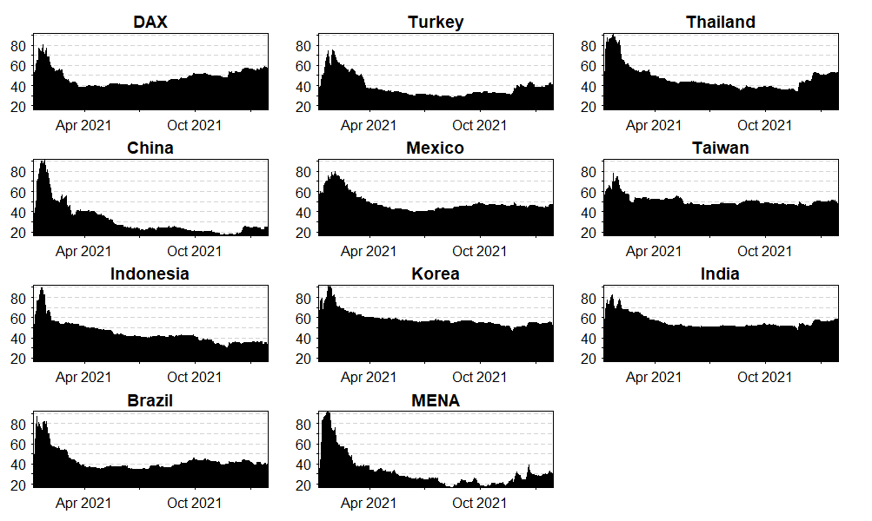

Figure 2: Spillover to the respective sample country’s ESG index from all other indices for the pre-crisis period.

X-axis: Time
Y-axis: Directional Connectedness (%)
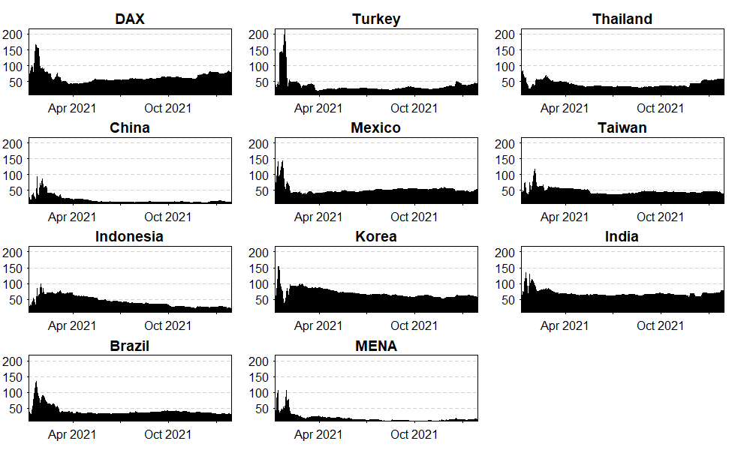

Figure 3: Spillover from the respective sample country’s ESG index to all other indices for the core-crisis period.

X-axis: Time
Y-axis: Directional Connectedness (%)

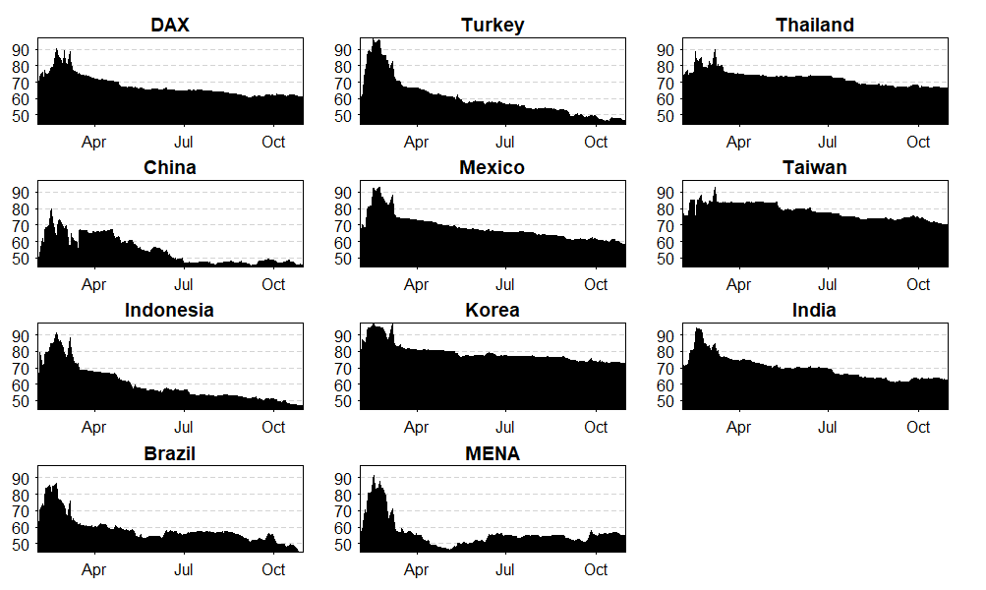

Figure 4: Spillover to the respective sample country’s ESG index from all other indices for the core-crisis period.

X-axis: Time
Y-axis: Directional Connectedness (%)
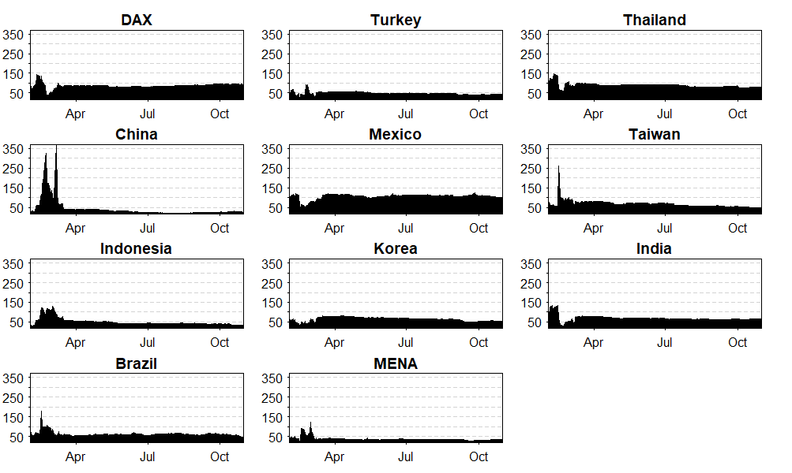

Figure 5: Spillover from the respective sample country’s ESG index to all other indices for the extended-crisis period.

X-axis: Time
Y-axis: Directional Connectedness (%)

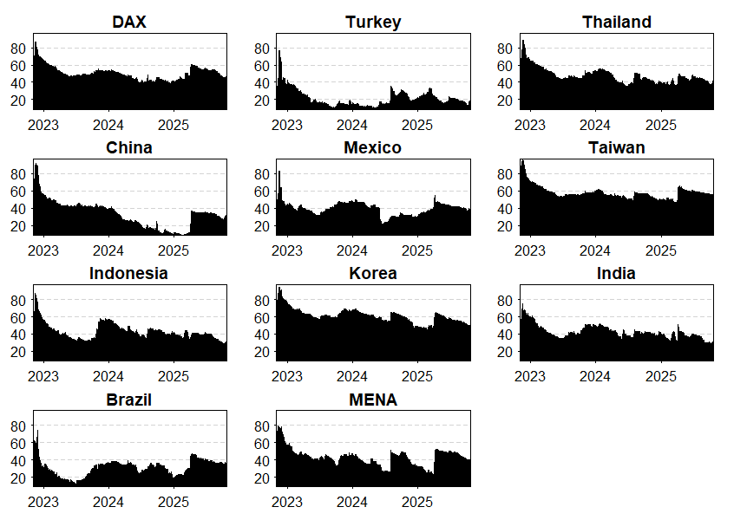

Figure 6: Spillover to the respective sample country’s ESG index from all other indices for the extended-crisis period.

X-axis: Time
Y-axis: Directional Connectedness (%)

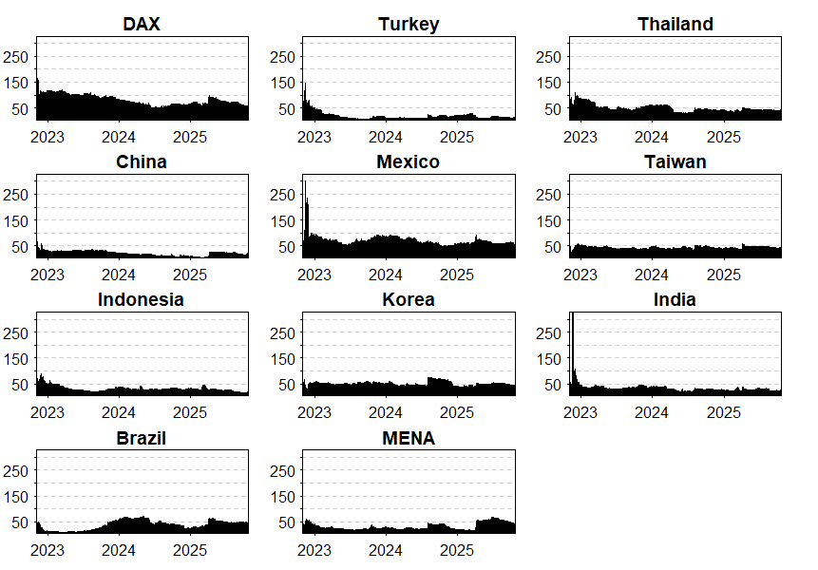

Figure 7: Spillover from the respective sample country’s traditional index to all other indices for the pre-crisis period.

X-axis: Time
Y-axis: Directional Connectedness (%)

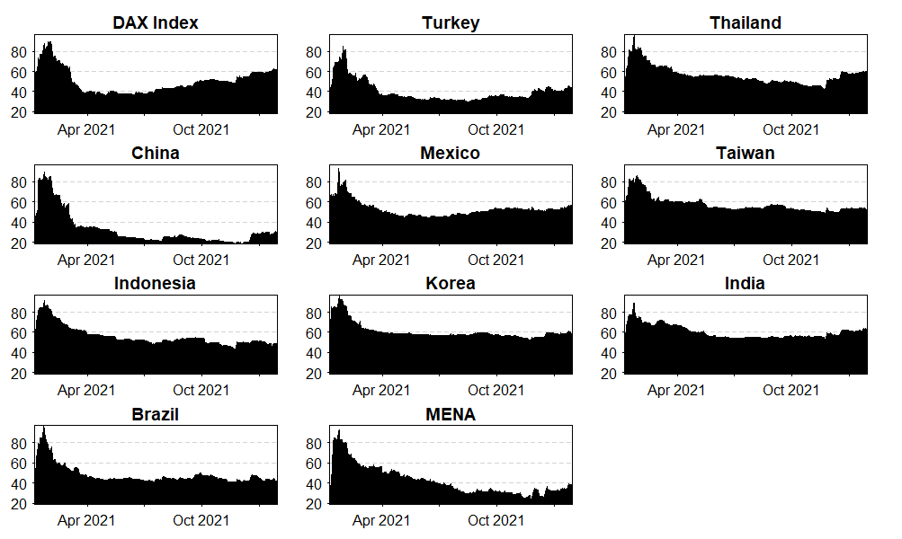

Figure 8: Spillover to the respective sample country’s traditional index from all other indices for the pre-crisis period.
X-axis: Time
Y-axis: Directional Connectedness (%)

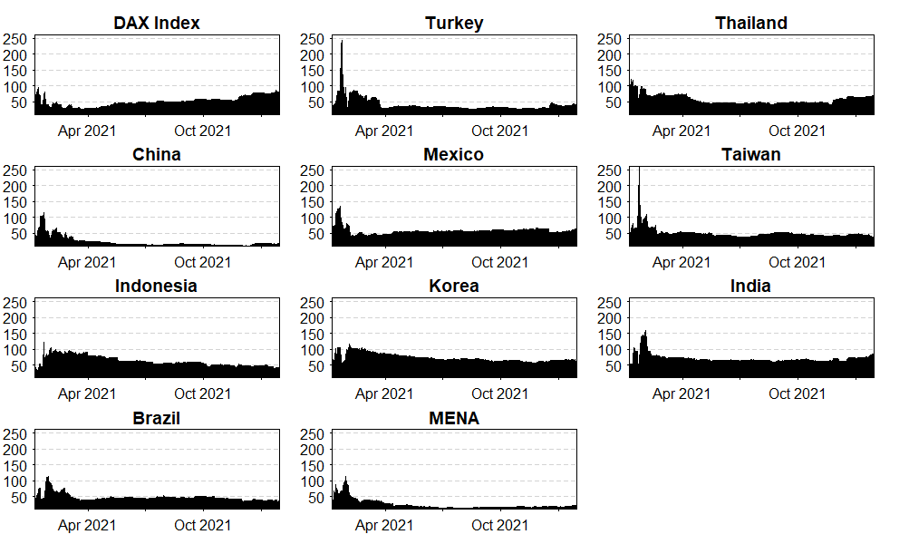

Figure 9: Spillover from the respective sample country’s traditional index to all other indices for the core-crisis period.

X-axis: Time
Y-axis: Directional Connectedness (%)

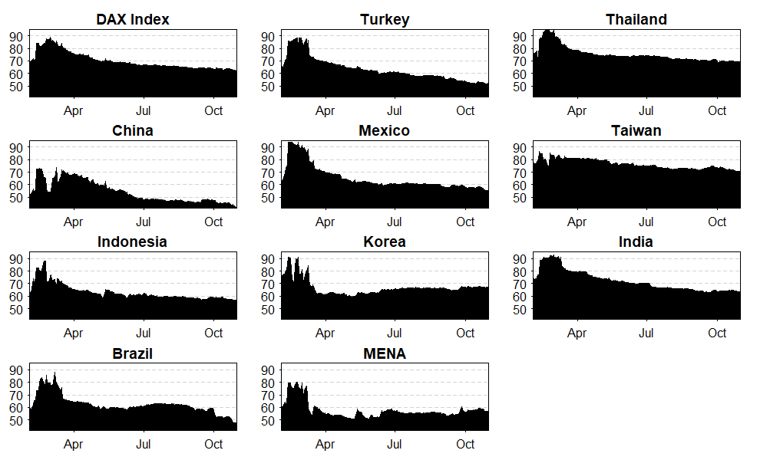

Figure 10: Spillover to the respective sample country’s traditional index from all other indices for the core-crisis period.

X-axis: Time
Y-axis: Directional Connectedness (%)

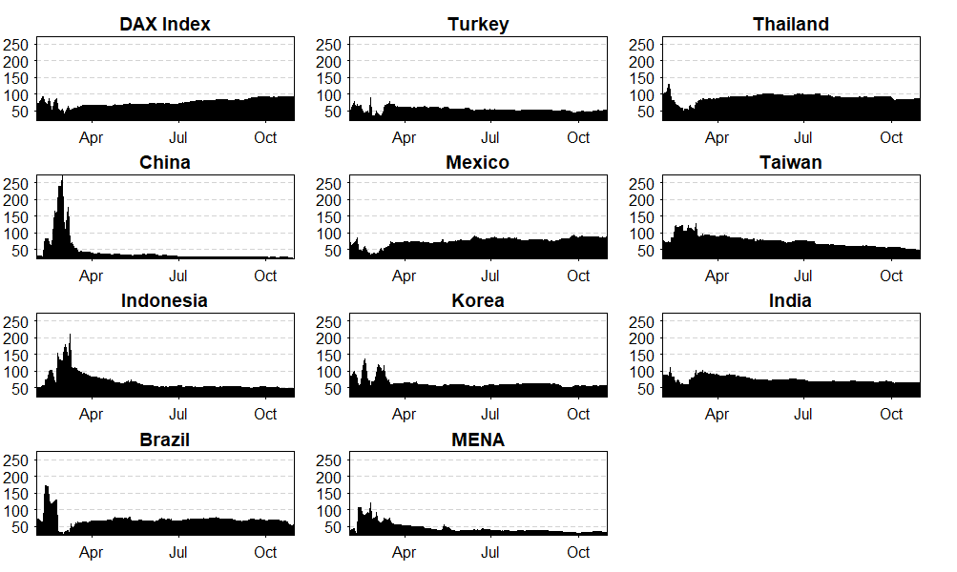

Figure 11: Spillover from the respective sample country’s traditional index to all other indices for the extended-crisis period.

X-axis: Time
Y-axis: Directional Connectedness (%)

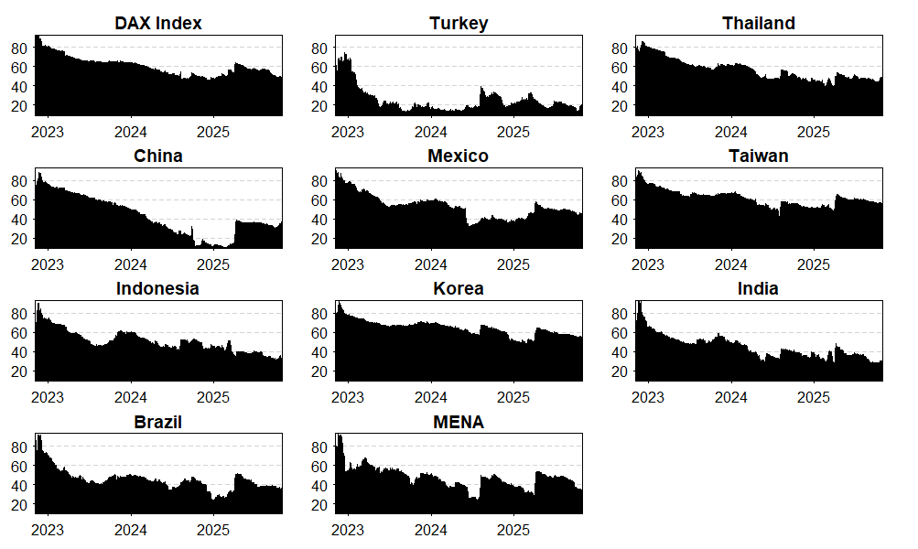

Figure 12: Spillover to the respective sample country’s traditional index from all other indices for the extended-crisis period.

X-axis: Time
Y-axis: Directional Connectedness (%)

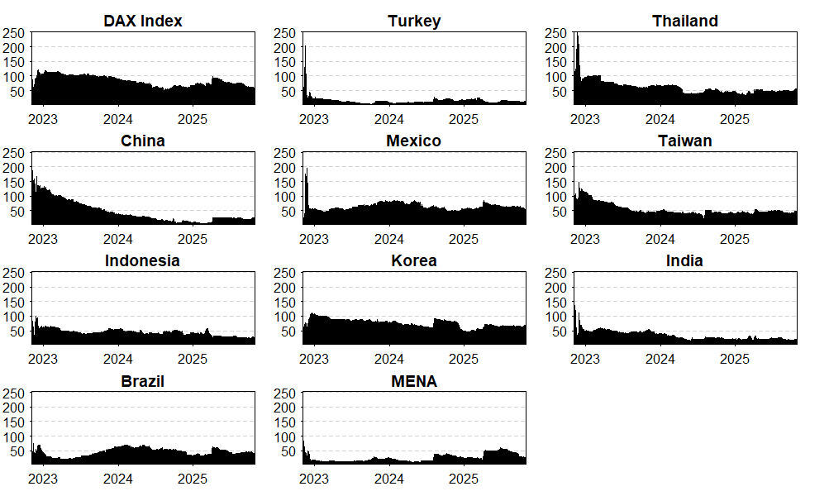

Figure 13: Network Diagram of the spillovers, node in-degree and node out-degree for the ESG indices during the pre-crisis period.
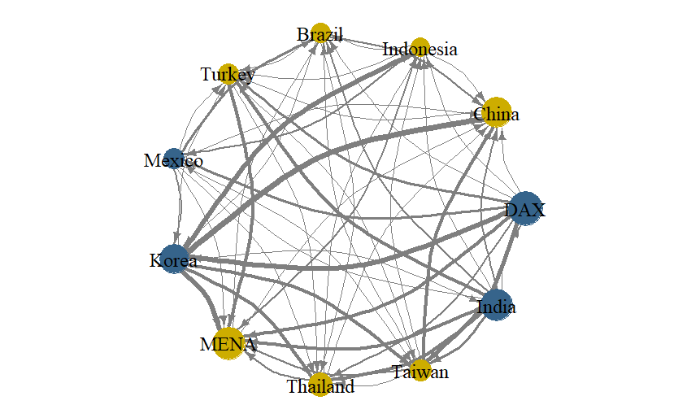

Figure 14: Network Diagram of the spillovers, node in-degree and node out-degree for the ESG indices during the core-crisis period.
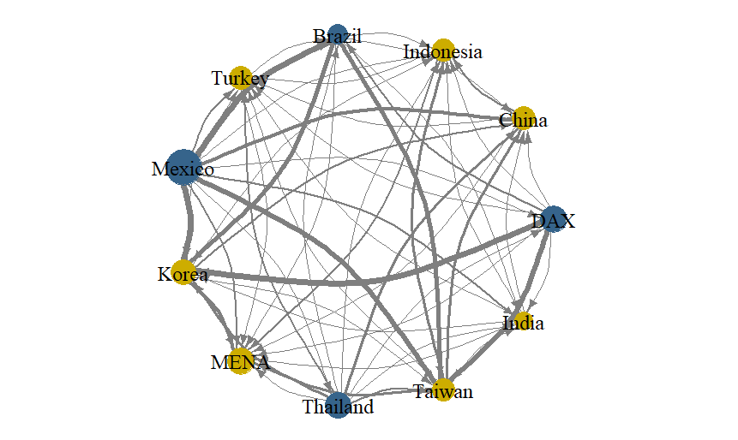

Figure 15: Network Diagram of the spillovers, node in-degree and node out-degree for the ESG indices during the extended-crisis period.
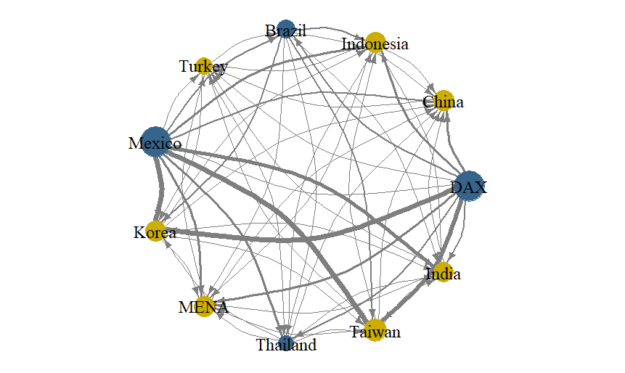

Figure 16: Network Diagram of the spillovers, node in-degree and node out-degree for the traditional indices during the pre-crisis period.
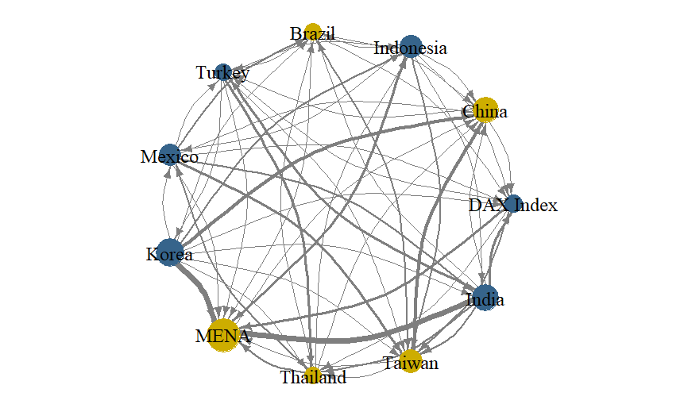

Figure 17: Network Diagram of the spillovers, node in-degree and node out-degree for the traditional indices during the core-crisis period.
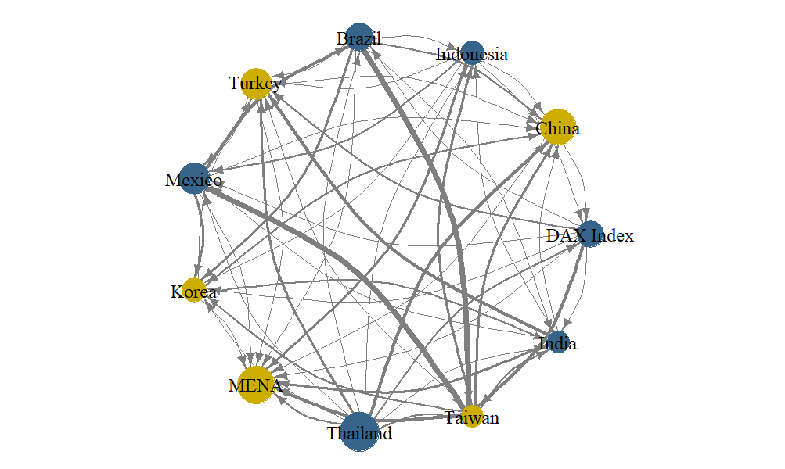

Figure 18: Network Diagram of the spillovers, node in-degree and node out-degree for the ESG indices during the extended-crisis period.
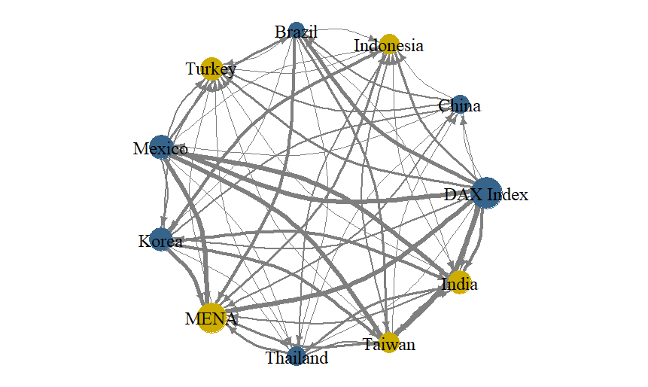

Missing-value audit before log-return construction
Period | Type | Country | Original_Rows | Missing_DAX_Percent | Missing_Country_Before_Fill | Missing_Country_Percent | Non_Positive_Rows_Removed
Pre_Crisis | ESG | China | 276.0000 | 0.0000 | 18.0000 | 6.5217 | 0.0000
Pre_Crisis | ESG | Indonesia | 276.0000 | 0.0000 | 11.0000 | 3.9855 | 0.0000
Pre_Crisis | ESG | Brazil | 276.0000 | 0.0000 | 10.0000 | 3.6232 | 0.0000
Pre_Crisis | ESG | Turkey | 276.0000 | 0.0000 | 11.0000 | 3.9855 | 0.0000
Pre_Crisis | ESG | Mexico | 276.0000 | 0.0000 | 8.0000 | 2.8986 | 0.0000
Pre_Crisis | ESG | Korea | 276.0000 | 0.0000 | 12.0000 | 4.3478 | 0.0000
Pre_Crisis | ESG | MENA | 276.0000 | 0.0000 | 6.0000 | 2.1739 | 0.0000
Pre_Crisis | ESG | Thailand | 276.0000 | 0.0000 | 19.0000 | 6.8841 | 0.0000
Pre_Crisis | ESG | Taiwan | 276.0000 | 0.0000 | 16.0000 | 5.7971 | 0.0000
Pre_Crisis | ESG | India | 276.0000 | 0.0000 | 13.0000 | 4.7101 | 0.0000
Crisis | ESG | China | 193.0000 | 0.0000 | 16.0000 | 8.2902 | 0.0000
Crisis | ESG | Indonesia | 193.0000 | 0.0000 | 13.0000 | 6.7358 | 0.0000
Crisis | ESG | Brazil | 193.0000 | 0.0000 | 6.0000 | 3.1088 | 0.0000
Crisis | ESG | Turkey | 193.0000 | 0.0000 | 8.0000 | 4.1451 | 0.0000
Crisis | ESG | Mexico | 193.0000 | 0.0000 | 4.0000 | 2.0725 | 0.0000
Crisis | ESG | Korea | 193.0000 | 0.0000 | 12.0000 | 6.2176 | 0.0000
Crisis | ESG | MENA | 193.0000 | 0.0000 | 3.0000 | 1.5544 | 0.0000
Crisis | ESG | Thailand | 193.0000 | 0.0000 | 15.0000 | 7.7720 | 0.0000
Crisis | ESG | Taiwan | 193.0000 | 0.0000 | 11.0000 | 5.6995 | 0.0000
Crisis | ESG | India | 193.0000 | 0.0000 | 9.0000 | 4.6632 | 0.0000
Post_Crisis | ESG | China | 761.0000 | 0.0000 | 51.0000 | 6.7017 | 0.0000
Post_Crisis | ESG | Indonesia | 761.0000 | 0.0000 | 55.0000 | 7.2273 | 0.0000
Post_Crisis | ESG | Brazil | 761.0000 | 0.0000 | 20.0000 | 2.6281 | 0.0000
Post_Crisis | ESG | Turkey | 761.0000 | 0.0000 | 28.0000 | 3.6794 | 0.0000
Post_Crisis | ESG | Mexico | 761.0000 | 0.0000 | 21.0000 | 2.7595 | 0.0000
Post_Crisis | ESG | Korea | 761.0000 | 0.0000 | 43.0000 | 5.6505 | 0.0000
Post_Crisis | ESG | MENA | 761.0000 | 0.0000 | 13.0000 | 1.7083 | 0.0000
Post_Crisis | ESG | Thailand | 761.0000 | 0.0000 | 47.0000 | 6.1761 | 0.0000
Post_Crisis | ESG | Taiwan | 761.0000 | 0.0000 | 53.0000 | 6.9645 | 0.0000
Post_Crisis | ESG | India | 761.0000 | 0.0000 | 35.0000 | 4.5992 | 0.0000
Pre_Crisis | Traditional | China | 276.0000 | 0.0000 | 18.0000 | 6.5217 | 0.0000
Pre_Crisis | Traditional | Indonesia | 276.0000 | 0.0000 | 11.0000 | 3.9855 | 0.0000
Pre_Crisis | Traditional | Brazil | 276.0000 | 0.0000 | 10.0000 | 3.6232 | 0.0000
Pre_Crisis | Traditional | Turkey | 276.0000 | 0.0000 | 11.0000 | 3.9855 | 0.0000
Pre_Crisis | Traditional | Mexico | 276.0000 | 0.0000 | 6.0000 | 2.1739 | 0.0000
Pre_Crisis | Traditional | Korea | 276.0000 | 0.0000 | 12.0000 | 4.3478 | 0.0000
Pre_Crisis | Traditional | MENA | 276.0000 | 0.0000 | 0.0000 | 0.0000 | 0.0000
Pre_Crisis | Traditional | Thailand | 276.0000 | 0.0000 | 19.0000 | 6.8841 | 0.0000
Pre_Crisis | Traditional | Taiwan | 276.0000 | 0.0000 | 16.0000 | 5.7971 | 0.0000
Pre_Crisis | Traditional | India | 276.0000 | 0.0000 | 13.0000 | 4.7101 | 0.0000
Crisis | Traditional | China | 193.0000 | 0.0000 | 16.0000 | 8.2902 | 0.0000
Crisis | Traditional | Indonesia | 193.0000 | 0.0000 | 13.0000 | 6.7358 | 0.0000
Crisis | Traditional | Brazil | 193.0000 | 0.0000 | 6.0000 | 3.1088 | 0.0000
Crisis | Traditional | Turkey | 193.0000 | 0.0000 | 8.0000 | 4.1451 | 0.0000
Crisis | Traditional | Mexico | 193.0000 | 0.0000 | 4.0000 | 2.0725 | 0.0000
Crisis | Traditional | Korea | 193.0000 | 0.0000 | 12.0000 | 6.2176 | 0.0000
Crisis | Traditional | MENA | 193.0000 | 0.0000 | 0.0000 | 0.0000 | 0.0000
Crisis | Traditional | Thailand | 193.0000 | 0.0000 | 15.0000 | 7.7720 | 0.0000
Crisis | Traditional | Taiwan | 193.0000 | 0.0000 | 11.0000 | 5.6995 | 0.0000
Crisis | Traditional | India | 193.0000 | 0.0000 | 9.0000 | 4.6632 | 0.0000
Post_Crisis | Traditional | China | 766.0000 | 0.0000 | 51.0000 | 6.6580 | 0.0000
Post_Crisis | Traditional | Indonesia | 766.0000 | 0.0000 | 55.0000 | 7.1802 | 0.0000
Post_Crisis | Traditional | Brazil | 766.0000 | 0.0000 | 20.0000 | 2.6110 | 0.0000
Post_Crisis | Traditional | Turkey | 766.0000 | 0.0000 | 29.0000 | 3.7859 | 0.0000
Post_Crisis | Traditional | Mexico | 766.0000 | 0.0000 | 20.0000 | 2.6110 | 0.0000
Post_Crisis | Traditional | Korea | 766.0000 | 0.0000 | 43.0000 | 5.6136 | 0.0000
Post_Crisis | Traditional | MENA | 766.0000 | 0.0000 | 5.0000 | 0.6527 | 0.0000
Post_Crisis | Traditional | Thailand | 766.0000 | 0.0000 | 47.0000 | 6.1358 | 0.0000
Post_Crisis | Traditional | Taiwan | 766.0000 | 0.0000 | 53.0000 | 6.9191 | 0.0000
Post_Crisis | Traditional | India | 766.0000 | 0.0000 | 35.0000 | 4.5692 | 0.0000

Key Statistics
Metric | Value
Overall missing rate | 4.3% (approximately)
Range across countries | 1.79% (MENA) to 6.91% (China)
Stability across sub-periods | 4.12% - 4.42% (no systematic difference)
Countries most affected | China, Thailand, Taiwan, Indonesia, Korea (Asian holidays)

