Appendix A. Research landscape
Publication trend. Fig. A1 illustrates the annual publication trend in the field of open innovation and knowledge transfer. Overall, the field exhibits a clear evolutionary trajectory, progressing from an initial emergence phase to gradual development and, more recently, rapid growth. The earliest publications appeared in 2003 (Chesbrough, 2003); however, during the subsequent five years (2003-2007), the field developed relatively slowly, with fewer than five articles published annually. This suggests that the topic had not yet attracted widespread scholarly attention, and the corresponding theoretical framework was still in its formative stage (Inkpen & Tsang, 2005; Laursen & Salter, 2006; Lichtenthaler, 2005).
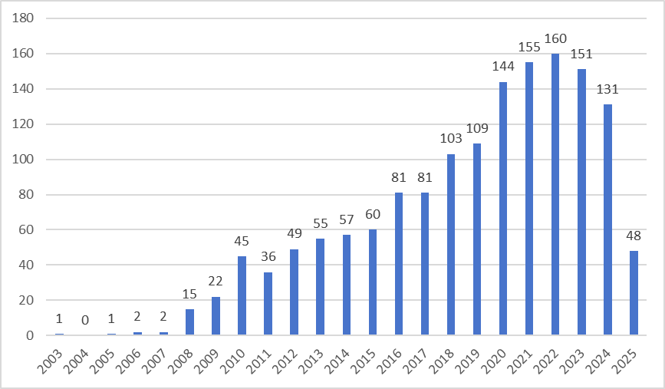
Fig. A1 Number of publications over years.
Beginning in 2008, the number of publications began to rise significantly, exceeding 40 articles in 2010. During this period, research began to shift from scattered exploratory efforts to more systematic investigation. This marked the field’s transition into a stage of steady development (Dahlander & Gann, 2010; Mahr et al., 2014; Perkmann et al., 2013).
From 2015 onward, publication volume surged sharply and has remained at a high level in recent years, indicating the onset of a rapid growth phase. Notably, nearly half of all identified publications were produced in recent years (2019-2024). Although there is a slight decline in publication numbers for 2024 and 2025, this can be attributed to incomplete data collection for 2025 and does not indicate a decrease in research interest. On the whole, the upward trend remains evident.

Journal analysis. A total of 1,508 publications on open innovation and knowledge transfer were distributed across 200 academic journals. Table A1 presents the top ten journals in terms of publication volume. Although the overall journal distribution is broad, approximately 26% of the articles were published in these top ten journals, indicating a certain degree of concentration within the field. These journals primarily focus on themes such as innovation, knowledge management, and technology transfer (Albats et al., 2022; Alvarez-Meaza et al., 2020; Battistella et al., 2016; Ferraris et al., 2017; Frishammar et al., 2015). Notably, few studies in this field appear in top-tier general management journals such as the Academy of Management Journal. This phenomenon largely reflects differences in research orientation and journal positioning. Studies on open innovation and knowledge transfer are predominantly practice-oriented, addressing issues in innovation and technology management (Bacon et al., 2019; Secundo et al., 2019), and are therefore more aligned with the audiences and scope of specialized journals. In contrast, general management journals emphasize theoretical advancement and cross-contextual generalizability, and thus impose stricter requirements on conceptual originality and theoretical contribution (DeCelles et al., 2019). Future research could enhance its theoretical impact by strengthening the articulation of theoretical propositions and improving the logical coherence across different contexts.

Table A1 top 10 most productive journals.
Rank | Journals | Publications | Proportion
1 | Journal of Knowledge Management | 50 | 3.32
2 | Sustainability | 50 | 3.32
3 | Journal of Technology Transfer | 46 | 3.05
4 | Technological Forecasting and Social Change | 43 | 2.85
5 | Technovation | 36 | 2.39
6 | European Journal of Innovation Management | 35 | 2.32
7 | Research Policy | 35 | 2.32
8 | Technology Analysis Strategic Management | 32 | 2.12
9 | International Journal of Innovation Management | 31 | 2.06
10 | International Journal of Technology Management | 30 | 1.99

Author contribution and co-authorship analysis. To identify highly productive authors and visualize the co-authorship network, this study conducted a bibliometric visualization analysis of the refined dataset using VOSviewer (version 1.6.20). The co-authorship network was constructed using the full counting method. Accordingly, a minimum threshold of five publications per author was applied to focus on scholars with sufficient publication volume for meaningful network representation. Under this criterion, 34 authors were included in the co-authorship network analysis. Table A2 presents the top ten most productive authors, while Fig. A2 presents the co-authorship network among them. The results indicate that Ulrich Lichtenthaler stands out as one of the most prolific and influential scholars in this domain, with 17 publications and over 1,000 citations. Pia Hurmelinna-Laukkanen and Alberto Di Minin follow closely, with 10 and 9 publications respectively, both demonstrating relatively high total link strength, suggesting strong connectivity within the collaboration network. Notably, although Gabriele Santoro has a slightly lower publication count, he has the highest citations among the listed authors, highlighting his significant academic impact. Overall, the co-authorship network in this field appears relatively fragmented. Highly productive scholars such as Ulrich Lichtenthaler show minimal collaborative link strength, indicating a tendency toward independent research. In contrast, researchers like Pia Hurmelinna-Laukkanen and Alberto Di Minin exhibit more active collaboration patterns, suggesting the gradual emergence of small-scale collaborative clusters. In summary, while the scholarly output of leading authors has demonstrated substantial influence, the overall collaboration network remains loosely connected. This phenomenon is closely related to the characteristics of the research domain. Studies on open innovation and knowledge transfer span multiple disciplines, including innovation management and knowledge management (Alavi & Leidner, 2001; Huizingh, 2011). The topical and methodological heterogeneity of this research often leads scholars to cluster in their own academic communities, thereby limiting cross-disciplinary collaboration. Furthermore, methodological and data-related differences across research fields (Huvila & Sinnamon, 2024) have constrained broader collaboration among scholars to some extent. Future research could foster greater synergy through special issues, joint research projects, and data-sharing platforms, thereby promoting stronger theoretical and methodological integration within the field.

Table A2 Top 10 most productive authors.
Rank | Authors | publications | Citations | Total link  strength
1 | Lichtenthaler, Ulrich | 17 | 1006 | 0
2 | Hurmelinna-Laukkanen, Pia | 10 | 757 | 6
3 | Di Minin, Alberto | 9 | 433 | 6
4 | Roper, Stephen | 9 | 416 | 0
5 | Belitski, Maksim | 8 | 256 | 0
6 | Bogers, Marcel | 7 | 785 | 0
7 | Papa, Armando | 7 | 480 | 4
8 | Santoro, Gabriele | 7 | 1075 | 5
9 | Spithoven, Andre | 7 | 807 | 0
10 | Chen, Jin | 6 | 92 | 2

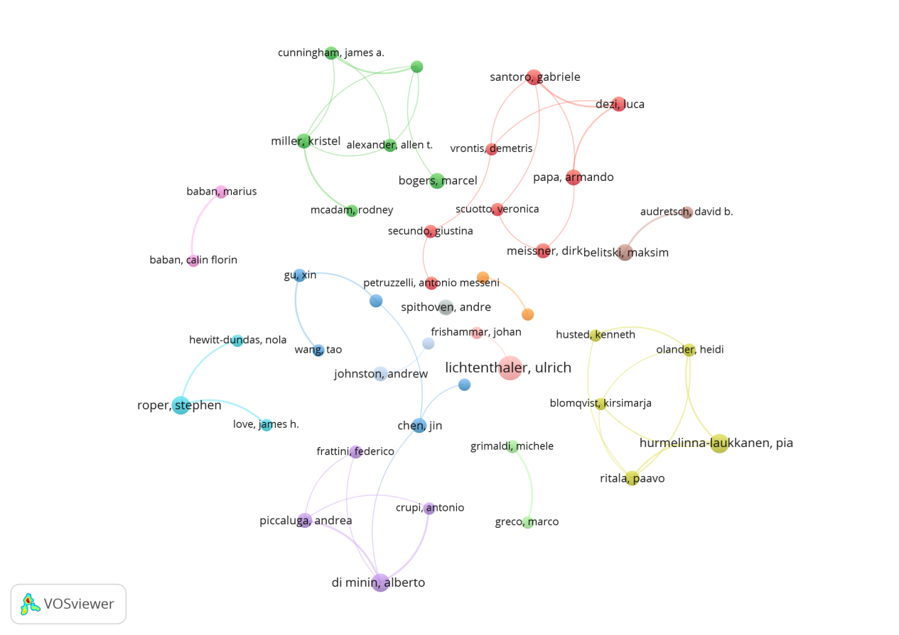
Fig. A2 Network of authors.

Affiliation statistics. This study utilized CiteSpace (version 6.3.R1) to analyze the institutional affiliations of the contributing authors. The analysis covered 2003 to 2025 using one-year time slices, with node selection based on the g-index (k = 25). To prevent excessive network density, link reduction parameters were set to LRF = 3.0, L/N = 10, and e = 1.0. In addition, the label year span was set to LBY = 5, restricting label extraction to the most recent five years. No pruning was applied during network construction to preserve the original structure of institutional collaboration links to the greatest extent possible. Table A2 lists the top ten institutions by publication volume. The results show that the University of Turin (Italy) ranks first in terms of publication volume, followed closely by the Chinese Academy of Sciences (China) and Copenhagen Business School (Denmark), indicating a high level of research activity in both Europe and China. From the perspective of the collaboration network, Copenhagen Business School emerges as a central hub, with key contributors such as Marcel Bogers. Other institutions, including the Swiss Federal Institutes of Technology Domain (Switzerland) and Tsinghua University (China), also exhibit high centrality, further underscoring the strategic position of several European and Chinese universities in this field. Overall, the institutional landscape of this research domain demonstrates a pattern characterized by regional concentration, core institutional leadership, and multinational collaboration. This pattern is closely related to policy orientation and research system structures. In Europe, regional innovation policies and transnational funding mechanisms have facilitated network-based collaborative models (Georghiou, 2001). In China, the innovation-driven development strategy has strengthened industry-university-research collaboration and accelerated the commercialization of research outputs, thereby sustaining the dynamism of the research ecosystem (Li et al., 2020). In general, the concentration of regional resources and supportive policy environments has enabled a few research centers to play a leading role in agenda-setting and network coordination, while international projects and academic mobility have further promoted transnational collaboration, thereby forming a pattern of regional concentration, core institutional leadership, and multinational collaboration.

Table A2 Top 10 most productive institutions.
Rank | Institution | publications | Degree | Centrality
1 | University of Turin | 25 | 13 | 0.08
2 | Chinese Academy of Sciences | 23 | 9 | 0.03
3 | Copenhagen Business School | 15 | 29 | 0.11
4 | Tsinghua University | 15 | 10 | 0.1
5 | Lappeenranta-Lahti University of Technology LUT | 13 | 5 | 0.02
6 | Swiss Federal Institutes of Technology Domain | 12 | 16 | 0.11
7 | Ku Leuven | 12 | 13 | 0.08
8 | HSE University | 12 | 6 | 0.01
9 | Harbin Engineering University | 12 | 3 | 0.01
10 | University of London | 11 | 12 | 0.06

Country distribution. This study employed VOSviewer to analyze the country distribution. This study adopted the full counting method to measure national publication output, with a minimum threshold of five publications per country, resulting in a total of 54 countries included in the international collaboration network. Table A3 lists the top ten countries by publication volume, while Fig. A3 visualizes the international collaboration network. The results indicate that China ranks first in terms of publication count, followed by the United Kingdom, Italy, the United States, and Germany. These countries constitute the primary centers of knowledge production in this domain. Collectively, the top five countries account for 95% of the total sample, further highlighting the high level of concentration and the dominance of developed economies in this research area. Nevertheless, the wide geographical distribution of countries shown in Fig. A3 suggests that the field is gaining increasing global attention, with a growing trend toward the internationalization of research efforts. In terms of collaboration networks, the field exhibits a multi-centric and regionally distributed pattern of international cooperation. European countries perform strongly in both research output and regional collaboration, with the United Kingdom, Italy, and Germany occupying central positions in the network. Meanwhile, China and the United States have emerged as core research hubs in the Eastern and Western regions, respectively, establishing dense collaborative links with multiple countries. The distribution of countries follows a similar logic to that of institutions, being largely shaped by policy orientation and research system structures. In Europe, regional funding programs and transnational collaborations have fostered dense research networks, enabling countries such as the United Kingdom, Italy, and Germany to remain at the core of these networks through robust research infrastructure and longstanding collaborative traditions (Georghiou, 2001). In China, the national innovation strategy has sustained a high level of research activity, whereas the United States has served as a bridge through international collaboration and academic mobility (Leydesdorff & Wagner, 2008; Li et al., 2020). Consequently, at the country level, the field exhibits a multi-centric and regionally distributed pattern of international cooperation.

Table A3 Top 10 most productive countries.
Rank | Country | Publications | Citations | Total link  strength
1 | China | 349 | 5621 | 137
2 | England | 199 | 8313 | 263
3 | Italy | 182 | 7690 | 166
4 | USA | 172 | 7061 | 191
5 | Germany | 156 | 5253 | 164
6 | Spain | 94 | 3548 | 114
7 | Netherlands | 87 | 3738 | 130
8 | France | 74 | 2379 | 125
9 | Australia | 61 | 1956 | 84
10 | Sweden | 58 | 1689 | 73

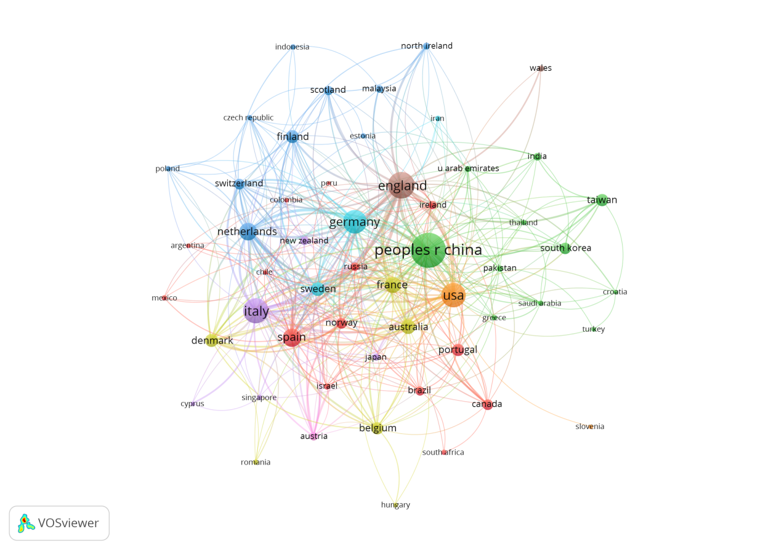
Fig. A3 Network of countries.

References
Alavi M, Leidner DE (2001) Review: knowledge management and knowledge management systems: conceptual foundations and research issues. MIS Q 25(1):107-136. https://doi.org/10.2307/3250961
Albats E, Alexander AT, Cunningham JA (2022) Traditional, virtual, and digital intermediaries in university-industry collaboration: exploring institutional logics and bounded rationality. Technol Forecast Soc Change 177:121470. https://doi.org/10.1016/j.techfore.2022.121470
Alvarez-Meaza I, Pikatza-Gorrotxategi N, Rio-Belver RM (2020) Sustainable business mo-del based on open innovation: case study of Iberdrola. Sustainability 12(24):10645. https://doi.org/10.3390/su122410645
Bacon E, Williams MD, Davies GH (2019) Recipes for success: conditions for knowledge transfer across open innovation ecosystems. Int J Inf Manag 49:377-387. https://doi.org/10.1016/j.ijinfomgt.2019.07.012
Battistella C, De Toni AF, Pillon R (2016) Inter-organisational technology/knowledge trans-fer: a framework from critical literature review. J Technol Transf 41(5):1195-1234. https://doi.org/10.1007/s10961-015-9418-7
Chesbrough HW (2003) Open Innovation: The New Imperative for Creating and Profiting from Technology. Harvard Business Press, Boston.
Dahlander L, Gann DM (2010) How open is innovation? Res Policy 39(6):699-709. https://doi.org/10.1016/j.respol.2010.01.013
DeCelles KA, Leslie LM, Shaw JD (2019) From the editors-disciplinary code switching at AMJ: the tale of Goldilocks and the three journals. Acad Manag J 62(3):635-640. https://doi.org/10.5465/amj.2019.4003
Ferraris A, Santoro G, Dezi L (2017) How MNC’s subsidiaries may improve their innovative performance? the role of external sources and knowledge management capabilities. J Knowl Manag 21(3):540-552. https://doi.org/10.1108/JKM-09-2016-0411
Frishammar J, Ericsson K, Patel PC (2015) The dark side of knowledge transfer: explorin-g knowledge leakage in joint R&D projects. Technovation 41–42:75-88. https://doi.org/10.1016/j.technovation.2015.01.001
Georghiou L (2001) Evolving frameworks for European collaboration in research and technology. Res Policy 30(6):891-903. https://doi.org/ 10.1016/s0048-7333(00)00163-3
Huizingh EKRE (2011) Open innovation: state of the art and future perspectives. Technovation 31(1):2-9. https://doi.org/10.1016/j.technovation.2010.10.002
Huvila I, Sinnamon LS (2024) When data sharing is an answer and when (often) it is not: acknowledging data-driven, non-data, and data-decentered cultures. J Assoc Inf Sci Technol 75(13):1515-1530. https://doi.org/10.1002/asi.24957
Inkpen AC, Tsang EWK (2005) Social capital, networks, and knowledge transfer. Acad Manag Rev 30(1):146-165. https://doi.org/10.5465/amr.2005.15281445
Laursen K, Salter A (2006) Open for innovation: the role of openness in explaining inno-vation performance among U.K. manufacturing firms. Strat Manag J 27(2):131-150. https://doi.org/10.1002/smj.507
Leydesdorff L, Wagner CS (2008) International collaboration in science and the formation of a core group. J Informetr 2(4):317-325. https://doi.org/10.1016/j.joi.2008.07.003
Li Y, Ji Q, Zhang D (2020) Technological catching up and innovation policies in China: what is behind this largely successful story? Technol Forecast Soc Change 153:119918. https://doi.org/10.1016/j.techfore.2020.119918
Lichtenthaler U (2005) External commercialization of knowledge: review and research agenda. Int J Manag Rev 7(4):231-255. https://doi.org/10.1111/j.1468-2370.2005.00115.x
Mahr D, Lievens A, Blazevic V (2014) The value of customer co-created knowledge during the innovation process. J Prod Innov Manag 31(3):599-615. https://doi.org/10.1111/jpim.12116
Perkmann M, Tartari V, McKelvey M, Autio E, Broström A, D’Este P, Fini R, Geuna A, Grimaldi R, Hughes A, Krabel S, Kitson M, Llerena P, Lissoni F, Salter A, Sobrero M (2013) Academic engagement and commercialisation: a review of the literature on university-industry relations. Res Policy 42(2):423-442. https://doi.org/10.1016/j.respol.2012.09.007
Secundo G, Toma A, Schiuma G, Passiante G (2019) Knowledge transfer in open innovation: a classification framework for healthcare ecosystems. Bus Process Manag J 25(1):144-163. https://doi.org/10.1108/BPMJ-06-2017-0173

