Table1: Sex, educational, occupation, salary and level office characteristics of respondents
Variables | Respondents
Sex | Freq. | Percent
Male | 283 | 77.5
Female | 82 | 22.5
Educational Level
Diploma | 29 | 7.9
Bachelor Degree | 288 | 78.9
Master Degree and above | 48 | 13.2
Work Experience
Below 5 year | 23 | 6.3
5 to 10 year | 132 | 36.2
11 to 15 year | 103 | 28.2
Above 15 years | 103 | 28.2
None Response | 4 | 1.1
Salary Below and Above the Mean
Below 7184 Birr | 195 | 53.4
Above 7184 Birr | 154 | 42.2
None Response | 16 | 4.4
Level of office
Regional Bureau | 175 | 47.9
Metekel Zonal Office | 36 | 9.9
Assosa Zone office | 41 | 11.2
Kemashi Zone office | 24 | 6.6
Mengie Woreda office | 33 | 9.0
Kemashi Woreda office | 26 | 7.1
Dangur Woreda office | 20 | 5.5
G/Bless Town Administration office | 10 | 2.7

Table 2: Regional Development Plan Implementation Performance by sector
Plan Components | Success |  | Fall |  | Std. Deviation
Plan Components | Freq. | % | Freq. | % | Std. Deviation
Implementation of Agricultural Plan | 275 | 75.3 | 90 | 24.7 | 0 .435
Implementation of Manufacturing Industry Plan | 90 | 24.7 | 275 | 75.3 | 0.431
Implementation of Tourism Service Plan | 87 | 23.8 | 278 | 76.2 | 0.427
Implementation of Urban Development Plan | 90 | 24.7 | 275 | 75.3 | 0.432
Implementation of Educational Service Plan | 85 | 23.3 | 280 | 76.7 | 0.423
Implementation of Health service Plan | 89 | 24.4 | 276 | 75.6 | 0.429
Implementation of Road Transport service | 94 | 25.8 | 271 | 74.2 | 0.437
Implementation of Energy Service Plan I | 89 | 24.4 | 276 | 75.6 | 0.429
Implementation of the Water Service Plan | 85 | 23.3 | 280 | 76.7 | 0.423
Over all Development plan Implementation | 89 | 24.4 | 276 | 75.6 | 0.432

Table 3: Factors that Affect development Implementation Aggregated
Factors | High |  | Low
Factors | Freq. | % | Freq. | %
Lake of skilled labor/manpower | 143 | 39.2 | 222 | 60.8
Inaccessibility to infrastructure | 295 | 80.8 | 70 | 19.2
Insufficient Finance allocation to implement plans | 270 | 74.0 | 95 | 26.0
Absence of Stakeholder Participation | 283 | 77.5 | 82 | 22.5
Political Instability in the region | 286 | 78.4 | 79 | 21.6
Lack of Innovation | 279 | 76.4 | 86 | 23.6
Physical Barriers | 219 | 60.0 | 146 | 40.0

Fig.1. Factors that Affect the Development Implementation aggregated

Table 4. Detailed of factors affecting the regional development plan
Manpower Skill | High |  | Low
Manpower Skill | Freq. | % | Freq. | %
Lack of qualified Planers | 104 | 28.4 | 262 | 71.6
Shortage of Qualified Implementers | 172 | 47.0 | 194 | 53.0
Lack of Experienced Planners | 100 | 27.3 | 266 | 72.7
Shortage of Experienced Implementers | 112 | 30.6 | 254 | 69.4
Inaccessibility to Infrastructure
Weak Transportation Network | 211 | 57.7 | 155 | 42.3
Communication Barriers | 202 | 55.2 | 164 | 44.8
Insufficient Finance allocation
Lack Of Public Funding | 207 | 56.6 | 156 | 42.6
Inadequate Privet investors’ Support | 204 | 55.7 | 162 | 44.3
Insufficient Government Grant | 199 | 54.4 | 167 | 45.6
Participation
Weak Public Participation | 209 | 57.1 | 157 | 42.9
Weak Stakeholder Participation | 188 | 51.4 | 178 | 48.6
Political Instability
Incidence of Conflicts | 270 | 73.8 | 96 | 26.2
Frequent Protests | 244 | 66.7 | 122 | 33.3
Weak Political Party Engagement | 203 | 55.5 | 163 | 44.5
Frequent Leadership Changes | 234 | 63.9 | 132 | 36.1
Incidence of Corruption | 271 | 74.0 | 94 | 25.7
Lack Of Accountability of Sectors | 244 | 66.7 | 122 | 33.3
Resistance To Political System | 190 | 51.9 | 176 | 48.1
Weak Innovative Capacity
Weak Support for Local Firms | 197 | 53.8 | 169 | 46.2
Weak firm ties to innovative institutions | 199 | 54.4 | 197 | 53.8
weak external innovation links | 55.5 | 55.5 | 44.5 | 44.5
Limited local financial institutions | 161 | 44.0 | 204 | 55.7
Weak Regulation Of Financing Innovation | 158 | 43.2 | 206 | 56.3
Lack of Research Support | 223 | 60.9 | 143 | 39.1
Weak Skill Building System | 191 | 52.2 | 172 | 47.0
Weak new market creation | 195 | 53.3 | 168 | 45.9
Weak Organizational Innovation of Sectors | 206 | 56.3 | 157 | 42.9
Physical Factors
Harsh Climatic Condition | 165 | 45.1 | 199 | 54.4
Topographic Challenges | 154 | 42.1 | 210 | 57.4
Settlement Pattern | 153 | 41.8 | 211 | 57.7

Assumptions
- Multicollinearity was checked using Variable inflation factor
Variable | VIF | 1/VIF
2.ManP | 1.24 | 0.804142
2.Infra2 | 1.40 | 0.711946
1.Finance | 1.41 | 0.707775
2.Particip~3 | 1.21 | 0.827989
2.Poitical1 | 1.36 | 0.735531
2.phy2 | 1.59 | 0.629492
2.Inove2 | 1.36 | 0.734999
Mean VIF | 1.37

Fitness of the model
1.Hosmer _lemeshow test
estat gof, group (7)
Logistic model for AllPlanPrePerform, goodness-of-fit test
(Table collapsed on quantiles of estimated probabilities)
(There are only 6 distinct quantiles because of ties)
number of observations = 365
number of groups = 6
Hosmer-Lemeshow chi2(4) = 8.82
Prob > chi2 = 0.0659
Person chi-square test conducted
. estat gof
Logistic model for AllPlanPrePerform, | goodness-of-fit | test
number of observations = | 365
number of covariate patterns = | 33
Pearson chi2(25) = | 31.32
Prob > chi2 = | 0.1785

Predictive efficiency
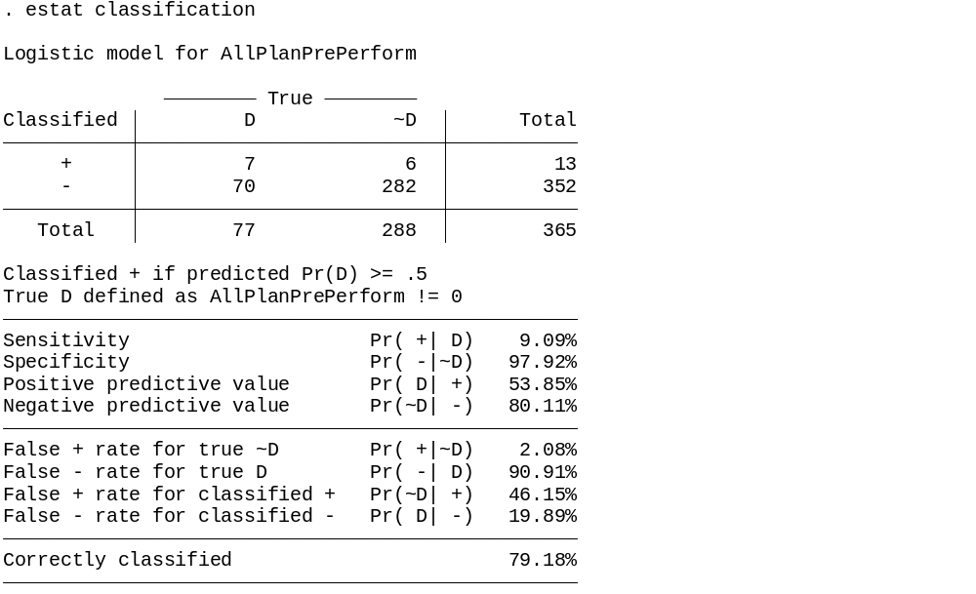
Logistic Regression Model Summary
Number of obs = 365
LR chi2(7) = 67.41
Prob > chi2 = 0.0000
Log likelihood = -169.0366
Pseudo R2 = 0.1663
Table7. Overall development plan implementation-logistic regression
Development Plan Implementation | Odds Ratio | Std. Err | Z | P >/Z/ | (95% conf. Interval
Lack of Skilled Manpower | 1.116 | 0.374 | 0.33 | 0.744 | 0.578 | 2.154
Inaccessibility of Infrastructure | 10.510 | 6.969 | 3.55 | 0.000 | 2.865 | 38.549
Insufficient Finance allocation | 7.921 | 3.625 | 4.52 | 0.000 | 3.230 | 19.424
Lack of Stakeholder participation | 7.496 | 3.879 | 3.89 | 0.000 | 2.719 | 20.667
Political Instability in the region | 2.458 | 1.114 | 1.98 | 0.047 | 1.011 | 5.977
Limited innovative capacity | 6.896 | 3.527 | 3.78 | 0.000 | 2.531 | 18.790
Physical Factors | 0.722 | 0.246 | -0.96 | 0.339 | 0.370 | 1.407
Const. | 0.0005 | 0.0006 | -6.53 | 0.000 | 0.0001 | 0.0048

Table8.: Determinants of Agriculture, Manufacturing and Industry, Tourism, Urban Development, Education service, Health Service, Road transport, Energy and Water Service Development Plans Implementation,
Agriculture plan Implementation | Odds Ratio | Std. Err | Z | P >/Z/ | (95% conf. Interval
Lack of Skilled Manpower | 0.875 | 0.268 | -0.44 | 0.662 | 0.480 | 1.595
Inaccessibility of Infrastructure | 0.419 | 0.188 | -1.94 | 0.053 | 0.174 | 1.010
Insufficient Finance allocation | 0.198 | 0.074 | -4.35 | 0.000 | 0.096 | 0.411
Lack of Stakeholder participation | 0.196 | 0.089 | -3.57 | 0.000 | 0.080 | 0.479
Political Instability in the region | 0.294 | 0.127 | -2.84 | 0.005 | 0.127 | 0.685
Physical Factors | 0.247 | 0.102 | -3.39 | 0.001 | 0.110 | 0.554
Limited innovative capacity | 1.087 | 0.353 | 0.26 | 0.796 | 0.576 | 2.054
Const. | 273.43 | 243.935 | 6.29 | 0.000 | 47.588 | 1571.159
Manufacturing Industry plan Implementation
Lack of Skilled Manpower | 1.258 | 0.409 | 0.71 | 0.480 | 0.665 | 2.381
Inaccessibility of Infrastructure | 6.273 | 3.572 | 3.23 | 0.001 | 2.055 | 19.147
Insufficient Finance allocation | 6.970 | 3.063 | 4.42 | 0.000 | 2.946 | 16.491
Lack of Stakeholder participation | 8.006 | 4.113 | 4.05 | 0.000 | 2.925 | 21.911
Political Instability in the region | 2.354 | 1.056 | 1.91 | 0.056 | 0.978 | 5.671
Limited innovative capacity | 8.748 | 4.444 | 4.27 | 0.000 | 3.232 | 23.678
Physical Factors | 0.778 | 0.265 | -0.74 | 0.462 | 0.398 | 1.519
Const. | 0.0006 | 0.0007 | -6.64 | 0.000 | .00007 | 0.0054
Tourism Service plan Implementation
Lack of Skilled Manpower | 1.325 | 0.432 | 0.86 | 0.388 | 0.699 | 2.510
Inaccessibility of Infrastructure | 1.258 | 0.409 | 0.71 | 0.480 | 0.665 | 2.381
Insufficient Finance allocation | 6.970 | 3.063 | 4.42 | 0.000 | 2.946 | 16.491
Lack of Stakeholder participation | 8.006 | 4.112 | 4.05 | 0.000 | 2.925 | 21.911
Political Instability in the region | 2.354 | 1.056 | 1.91 | 0.056 | 0.9776 | 5.671
Physical Factors | 0.778 | 0.266 | -0.74 | 0.462 | 0.398 | 1.519
Limited innovative capacity | 8.748 | 4.444 | 4.27 | 0.000 | 3.232 | 23.678
Const. | 0.0006 | .0007 | -6.64 | 0.000 | 0.0001 | 0.005
Urban Development Plan Implementation
Lack of Skilled Manpower | 1.085 | 0.355 | 0.25 | 0.802 | 0.572 | 2.059
Inaccessibility of Infrastructure | 6.154 | 3.518 | 3.18 | 0.001 | 2.007 | 18.869
Insufficient Finance allocation | 6.942 | 3.026 | 4.45 | 0.000 | 2.955 | 16.315
Lack of Stakeholder participation | 8.456 | 4.466 | 4.04 | 0.000 | 3.001 | 23.810
Political Instability in the region | 2.379 | 1.059 | 1.95 | 0.051 | 0.995 | 5.691
Physical Factors | 0.766 | 0.261 | -0.78 | 0.434 | 0.394 | 1.493
Limited innovative capacity | 6.957 | 3.430 | 3.93 | 0.000 | 2.647 | 18.286
Const. | 0.0008 | .0008 | -6.51 | 0.000 | 0.0001 | 0.0065
Educational Service Plan Implementation
Lack of Skilled Manpower | 0.994 | 0.343 | -0.02 | 0.986 | 0.506 | 1.953
Inaccessibility of Infrastructure | 5.576 | 3.306 | 2.90 | 0.004 | 1.745 | 17.821
Insufficient Finance allocation | 8.710 | 3.998 | 4.72 | 0.000 | 3.542 | 21.414
Lack of Stakeholder participation | 8.309 | 4.610 | 3.82 | 0.000 | 2.804 | 24.623
Political Instability in the region | 3.103 | 1.507 | 2.33 | 0.020 | 1.197 | 8.040
Limited innovative capacity | 10.321 | 5.451 | 4.42 | 0.000 | 3.665 | 29.061
Physical Factors | 0.757 | 0.265 | -0.80 | 0.425 | 0.381 | 1.502
Const. | 0.0004 | 0.0005 | -6.54 | 0.000 | 0.00004 | 0.0043
Health Service Plan Implementation
Lack of Skilled Manpower | 1.242 | 0.403 | 0.67 | 0.505 | 0.658 | 2.344
Inaccessibility of Infrastructure | 5.383 | 3.041 | 2.98 | 0.003 | 1.779 | 16.291
Insufficient Finance allocation | 6.618 | 2.882 | 4.34 | 0.000 | 2.819 | 15.537
Lack of Stakeholder participation | 8.654 | 4.574 | 4.08 | 0.000 | 3.071 | 24.383
Political Instability in the region | 2.139 | 0.953 | 1.71 | 0.088 | 0.893 | 5.123
Physical Factors | 0.951 | 0.328 | -0.15 | 0.885 | 0.484 | 1.869
Limited innovative capacity | 6.582 | 3.245 | 3.82 | 0.000 | 2.504 | 17.300
Const. | 0.0008 | .0009 | -6.48 | 0.000 | .0001 | 0.0068
Road Transport Plan Implementation
Lack of Skilled Manpower | 1.363 | 0.384 | 1.10 | 0.273 | 0.784 | 2.368
Inaccessibility of Infrastructure | 3.042 | 1.311 | 2.58 | 0.010 | 1.307 | 7.080
Insufficient Finance allocation | 1.536 | 0.533 | 1.24 | 0.216 | 0.778 | 3.034
Lack of Stakeholder participation | 3.406 | 1.316 | 3.17 | 0.002 | 1.597 | 7.266
Political Instability in the region | 1.241 | 0.459 | 0.58 | 0.559 | 0.601 | 2.564
Physical Factors | 0.894 | 0.284 | -0.35 | 0.726 | 0.481 | 1.666
Limited innovative capacity | 1.753 | 0.656 | 1.50 | 0.133 | 0.842 | 3.651
Const. | 0.023 | 0.0164 | -5.27 | 0.000 | 0.0056 | 0.0930
Energy Sector Plan Implementation
Lack of Skilled Manpower | 1.400 | 0.419 | 1.12 | 0.261 | 0.778 | 2.517
Inaccessibility of Infrastructure | 2.627 | 1.161 | 2.19 | 0.029 | 1.105 | 6.248
Insufficient Finance allocation | 3.698 | 1.368 | 3.53 | 0.000 | 1.790 | 7.640
Lack of Stakeholder participation | 6.957 | 3.391 | 3.98 | 0.000 | 2.676 | 18.082
Political Instability in the region | 2.240 | .0927 | 1.95 | 0.051 | 0.995 | 5.045
Physical Factors | 0.700 | 0.232 | -1.08 | 0.282 | 0.365 | 1.340
Limited innovative capacity | 3.567 | 1.476 | 3.07 | 0.002 | 1.583 | 8.029
Const. | 0.0040 | .0036 | -6.16 | 0.000 | 0.0007 | .0232
Water Service Provision Plan Implementation
Lack of Skilled Manpower | 1.061 | 0.350 | 0.18 | 0.859 | 0.555 | 2.0253
Inaccessibility of Infrastructure | 3.069644 | 1.526 | 2.26 | 0.024 | 1.159 | 8.131
Insufficient Finance allocation | 7.190235 | 2.845 | 4.99 | 0.000 | 3.311 | 15.615
Lack of Stakeholder participation | 4.70941 | 2.320 | 3.15 | 0.002 | 1.793 | 12.368
Political Instability in the region | 4.457243 | 2.106 | 3.16 | 0.002 | 1.765 | 11.253
Physical Factors | .5588754 | 0.189 | -1.72 | 0.086 | 0.2877 | 1.085
Limited innovative capacity | 4.411442 | 1.934 | 3.38 | 0.001 | 1.867 | 10.421
Const. | .0022367 | 0.0021 | -6.28 | 0.000 | 0.0003 | 0.0150

Statistical scripts
