Supplementary Material

Appendix Tables

Table 1 Descriptive statistics of variables
Variable | Description | Mean | SD | Obs.
UWESV | Ecosystem value of Urban wetland, Ln,Numeric | 8.79 | 2.79 | 669
Service type
Providing
Material production | Dummy, preference for service type | 0.10 | 0.30 | 65
Water supply | Dummy, Service type | 0.05 | 0.22 | 35
Regulating
Carbon fixation and oxygen release | Dummy, Service type | 0.06 | 0.25 | 43
Water conservation | Dummy, Service type | 0.04 | 0.19 | 26
Purifying water quality | Dummy, Service type | 0.08 | 0.28 | 58
Hydrological regulation | Dummy, Service type | 0.08 | 0.27 | 55
Gas regulation | Dummy, Service type | 0.05 | 0.22 | 35
Climate regulation | Dummy, Service type | 0.09 | 0.28 | 58
Supporting
Material cycle | Dummy, Service type | 0.03 | 0.17 | 19
Biological habitat | Dummy, Service type | 0.03 | 0.18 | 23
Biological conservation | Dummy, Service type | 0.08 | 0.27 | 54
Maintain soil | Dummy, Service type | 0.04 | 0.20 | 28
Cultural
Tourism and leisure | Dummy, Service type | 0.10 | 0.30 | 65
Scientific research | Dummy, Service type | 0.08 | 0.28 | 56
Existence | Dummy, Service type | 0.03 | 0.18 | 23
Environment improvement | Dummy, Service type | 0.05 | 0.21 | 32
Valuation method
Market Value | Dummy, Preference for valuation method | 0.15 | 0.36 | 103
Substitution cost | Dummy, Valuation method | 0.09 | 0.28 | 58
Shadow engineering | Dummy, Valuation method | 0.20 | 0.40 | 135
Achievement reference | Dummy, Valuation method | 0.32 | 0.47 | 215
Carbon Tax Law | Dummy, Valuation method | 0.05 | 0.21 | 31
Expense cost | Dummy, Valuation method | 0.09 | 0.29 | 61
Equivalent benefit substitution | Dummy, Valuation method | 0.03 | 0.17 | 19
Stated Preference | Dummy, Valuation method | 0.04 | 0.21 | 30
Analytic Hierarchy Process | Dummy, Valuation method | 0.03 | 0.16 | 17
City type
City1 | Dummy, City type | 0.17 | 0.38 | 116
City_new1 | Dummy, Preference City type | 0.54 | 0.50 | 361
City2 | Dummy, City type | 0.13 | 0.33 | 84
City3 | Dummy, City type | 0.05 | 0.22 | 35
City4 | Dummy, City type | 0.06 | 0.23 | 39
City5 | Dummy, City type | 0.05 | 0.22 | 34
Wetland type
Composite wetland | Dummy, Wetland type | 0.44 | 0.50 | 295
River Wetland | Dummy, Wetland type | 0.14 | 0.34 | 92
Lake wetland | Dummy, Preference for wetland type | 0.42 | 0.49 | 282
Numeric variable
GDP | Ln, Ten thousand CNY in 2015 prices | 8.70 | 1.17 | 669
Population | Ln, Ten thousand | 6.50 | 0.52 | 669
Precipitation | Ln, Numeric, Average annual precipitation | 7.17 | 0.39 | 669
Biodiversity | Ln, Numeric, Birds observation | 2.77 | 0.41 | 669
NDVI | Normalized difference vegetation index, Numeric | 0.70 | 0.07 | 669
Temperature | Ln, Numeric, Mean annual temperature | 2.84 | 0.24 | 669
Bulit-up area | Ln, Numeric, Urban built-up area | 6.01 | 0.93 | 669
Road area pc | Ln, Numeric, Urban per capita road area | 2.62 | 0.33 | 669
Green area pc | Ln, Numeric, Urban per capita green area | 2.50 | 0.32 | 669

Table 2 Complete regression results
Variable | Total |  | Before 2015 |  | After 2015 |  | Non-use
Variable | Est | Se | Est | Se | Est | Se | Est | Se
Intercept | -3.368 | 4.384 | -10.51 | 13.86 | 64.48 | 18.43
Service Type
Supporting | -0.080 | 0.205 | -0.602* | 0.299 | 0.584* | 0.297
Regulating | 0.804*** | 0.207 | 0.496 | 0.309 | 0.733* | 0.296
Cultural | 1.005*** | 0.214 | 0.652* | 0.321 | 1.041*** | 0.303
City Type
City1 | 1.541*** | 0.438 | -0.150 | 1.841 | 8.456*** | 1.646
City_new1 |  |  |  |  |  |  | 16.093 | 112.37
City2 | -1.414*** | 0.385 | 10.365*** | 2.039 | 6.267*** | 1.445 | -9.852 | 167.38
City3 | -1.957* | 0.789 | -4.462 | 3.577 | 2.948 | 3.509 | -9.454 | 172.33
City4 | -0.348 | 0.841 | -1.271 | 2.603 | 4.711 | 3.462 | -214.75 | 206.67
City5 | 0.282 | 0.997 | 3.223 | 3.451 | 11.179** | 3.908 | -144.86 | 268.51
Wetland Type
Lake |  |  |  |  |  |  | -62.891 | 62.592
Composite | -0.028 | 0.221 | 1.719* | 0.758 | -2.269 | 1.183
River | -0.753* | 0.317 | 6.458* | 2.583 | -1.979 | 1.257 | 42.158 | 136.67
Valuation Method
AR | -1.979*** | 0.216 | -1.582*** | 0.322 | -2.435*** | 0.309
AHP | -1.422* | 0.619 |  |  | 6.855*** | 1.520
CT | -1.385*** | 0.281 | -1.123** | 0.400 | -1.247** | 0.422
EBS | -0.086 | 0.316 | -0.314 | 0.426 | -0.082 | 0.517
EC | 0.218 | 0.249 | 0.124 | 0.376 | 0.418 | 0.344
SE | -1.046*** | 0.219 | -1.275*** | 0.324 | -0.693* | 0.313
SP | 0.553 | 0.292 | 0.392 | 0.416 | 0.350 | 0.447
SC | -2.360*** | 0.249 | -1.995*** | 0.379 | -2.228*** | 0.350
Numeric Variable
GDP | -0.247 | 0.207 | 2.678*** | 0.452 | -3.227* | 1.462 | -48.01 | 122.57
Population | -0.000 | 0.414 | -15.985*** | 2.320 | 6.654*** | 1.409 | -88.62 | 66.73
Bulit-up area | -0.480 | 0.382 | 6.524** | 2.119 | 1.843 | 1.910 | 45.18 | 128.51
Road area pc | 1.386** | 0.429 | 4.338* | 1.796 | 0.158 | 1.720 | 40.03 | 104.50
Green area pc | 1.336** | 0.509 | -12.438*** | 2.713 | -4.212*** | 1.124 | 45.769 | 181.54
Precipitation | -0.190 | 0.380 | 5.183*** | 1.186 | -0.099 | 1.246 | -176.98 | 128.37
Temperature | 2.335*** | 0.459 | -14.939*** | 3.440 | 3.945* | 1.987 | 98.34 | 85.56
Biodiversity | 1.134*** | 0.240 | 0.955* | 0.430 | -2.718 | 1.446 | -14.254 | 94.25
NDVI | 3.510 | 2.027 | 11.648 | 9.129 | -1.719 | 9.024 | -90.32 | 508.83
Notes: AR: Achievement reference, AHP: Analytic Hierarchy Process,CT:Carbon tax,EBS:Equivalent benefit substitution,EC:Expense cost,SE:Shadow engineering,SP:Stated preference,SC:Substitution cost.

Table 3 SSPs Scenario Introduction and Data Sources
The SSP-RCP path covers development characteristics such as social economic growth, technological progress, and climate change adaptation strategies, and is a global scenario framework based on socio-economic assumptions, including 5 different future socio-economic development models. The details are as follows:
SSP1 (Sustainable Development - Green Path): A sustainable development scenario, emphasizing a shift from rapid economic expansion to prioritizing human well-being in the future.
SSP2 (Moderate Development Path): A medium-level development scenario, with most economies maintaining political stability and following historical development patterns.
SSP3 (Regional Competition - Difficult Path): A regional competition scenario, with slow economic growth and urbanization rates.
SSP4 (Inequality - Divergence Path): An inequality development scenario, with rapid urbanization in low-income regions and a decline in urbanization rates in high-income regions.
SSP5 (Fossil Fuel-driven Development - High-Speed Path): A global economic rapid development scenario, with high growth at the cost of extensive use of fossil fuels.

The data sources used in the XGBoost model for predicting the value of urban wetland ecosystem services in China for the years 2030 and 2060
Data | Unit | Source
GDP | 100 million yuan | https://doi.org/10.57760/sciencedb.01683
Population | Thousands of people | https://doi.org/10.57760/sciencedb.01683
Temperature | Degree centigrade | https://www.globio.info/globio-data-downloads
Precipitation | mm | https://www.globio.info/globio-data-downloads
Built-up area | km² | https://data.tpdc.ac.cn/
Green area pc | m² | Calculated by linear regression
Road area pc | m² | Calculated by linear regression
Biodiversity | - | Calculated by linear regression
NDVI | - | Calculated by linear regression

XGBoost is an ensemble learning algorithm based on gradient boosting decision trees (GBDT). Its core idea is to continuously add decision trees and perform feature splitting. Each time a new tree is added, a new function is learned, using the residuals of the previous round's prediction to fit the current round's prediction. Based on sample features, the sample score can be predicted, and after training, n trees are obtained. The sample will fall on the leaf node corresponding to each tree, and each leaf node corresponds to a score. Finally, the corresponding scores of all trees are added together to obtain the prediction value of the sample.
SHAP (Shapley Additive Explanations) is an interpretable machine learning method for explaining model prediction results, based on the shap value theory to quantify the contribution of each feature to the model output (Lundberg and Lee, 2017). Coupling the XGBoost model with the SHAP method (XGBoost-SHAP) can identify the nonlinear relationship between ecosystem services and each variable, and separate the independent influence of each variable on the value of ecosystem services from the interaction of variables.

Table 4 The literature included in the meta-analysis database
Meta Database
Chen, C., Liu, X., Yan, L., Wang, J., & Peng, P. (2018). Evaluation on ecosystem service values of sichuan nanhe national wetland park. Wetl. Sci, 16, 238-244.
Chen, C., Shao, C., & Shi, Y. (2020). Dynamic evaluation of ecological service function value of Qilihai Wetland in Tianjin. International Journal of Environmental Research and Public Health, 17, 7108.
Chen, J. (2016). Research on the Changes in the Ecosystem Service Value of Urban Wetlands in Changsha City and the Driving Forces. Unpublished Master, Hunan Normal University.
Chen, T. (2023). Research on the Evaluation of Ecosystem Service Value of Urban Wetlands. Unpublished Master
China University of Mining and Technology.
Dai, X. (2010). Evaluation Study on Wetland Ecological Service Functions in Changsha City. Unpublished Doctor, Central South University of Forestry and Technology.
Du, J., Shrestha, R. P., Nitivattananon, V., Nguyen, T. P. L., & Razzaq, A. (2023). Unveiling the value of nature: a comprehensive analysis of the ecosystem services and ecological compensation in Wuhan city’s urban lake wetlands. Water, 15, 2257.
Gan, D., Zeng, L., Jiang, T., & Zhou, Z. (2010). Research on the Changes in the Ecosystem Service Value of Urban Wetlands in Changsha City and the Driving Forces. Wetland Science and Management, 6, 16-20.
Gan, Y., Luo, J., Zhu, Y., Luo, M., & Tian, L. (2023). Urban Spatial Ecological Asset Assessment and Its Connotations of Human-Environment Relationship - Taking Fuzhou River Wetland in Wuhan City as an Example. Journal of Natural Resources, 38, 1756-1770.
Guo, Y., Zhou, Y., Liu, W., & Pei, F. (2019). Evaluation of the Ecological Restoration Service Value of Urban River Wetlands in Haikou. Green science and technology, 22-26.
Jing, L., & Liao, K. (2010). Evaluation of the Service Function Value of the Urban Wetland System in Changsha City. Hunan Forestry Technology, 37, 15-17+25.
Ke, N., Zhou, S., Zhu, Z., Wang, J., & Ye, S. (2023). Accounting of the Total Ecological Product Value of Small and Medium-sized Wetland Systems in Southern Zhejiang Province - Taking Songyin River Wetland as an Example. Lishui University Journal, 45, 69-81.
Li, F., Peng, L., Liu, K., & Li, Q. (2018). Research on the Ecological Service Value of Urban Wetlands in Guangzhou City. Land and Natural Resources Research, 45-48.
Li, J. (2006). Research on the Ecosystem Service Functions of Xixi Wetland in Hangzhou. Unpublished Master, Southwest University.
Li, N. (2020). Evaluation of the Ecosystem Service Value of Pan'an Lake Wetland in Xuzhou City. In The 2020 Conference of the Chinese Society of Landscape Architecture (pp. 6).
Li, T., & Gao, X. (2016). Ecosystem services valuation of lakeside wetland park beside Chaohu Lake in China. Water, 8, 301.
Li, Y. (2023). Evaluation of Ecosystem Service Value in National-level Nature Reserves. Unpublished Master, Shanghai University of Finance and Economics.
Liang, M. (2023). Research on Dynamic Assessment and Trade-off Relationship of Key Ecosystem Services of Urban Wetlands. Unpublished Master, Zhongkai University of Agriculture and Engineering.
Liu, D. (2019). Evaluation of the Ecosystem Service Function Value of Guangzhou Haizhu National Wetland Park. Unpublished Master, Guangzhou University.
Liu, F. (2009). Evaluation on ecosystem services in Nanhu Wetland of Huaibei City. Journal of Natural Resources, 24, 1818-1828.
Liu, G., Wang, B., Li, Z., & Wu, M. (2016). Evaluation of the Ecological Engineering Benefits of Urban Wetlands Based on Ecosystem Services: A Case Study of Xixi National Wetland Park. Zhejiang Forestry Technology, 36, 77-81.
Liu, H., & Gu, X. (2022). Research on the Characteristics and Value of Urban Micro-Wetlands - Taking the Central Urban Area of Nanchang as an Example. classical Chinese garden, 38, 101-105.
Liu, W. (2015). Value assessment of the ecosystem service functions of Binfen Wetland Park in Suining City. Unpublished Master, Sichuan Agricultural University.
Liu, Z. (2023). Evaluation of the ecosystem service value of urban lakes and wetlands. Unpublished Master, Jiangxi University of Finance and Economics.
Lv, L. Y., Li, H. Y., & Yang, J. N. (2014). The value assessment of ecosystem service function in Lingang Wetland Park. Applied Mechanics and Materials, 675, 1067-1071.
Man, J. (2023). Evaluation of the ecosystem service value of constructed wetlands. Unpublished Master, Yunnan University of Finance and Economics（YNUFE）.
Mu, H. (2022). Research on the Value Calculation of Urban Wetland Ecological Products and Ecological Compensation Capacity Based on GIS. Unpublished Master, Shandong University of Architecture and Engineering.
Ren, M. (2008). Urban Wetland Ecosystem Service Functions and Their Value Assessment - Taking Wetlands in Kaifeng City as an Example. Anhui Agricultural Sciences, 6935-6938+6942.
Sun, Z., Kang, D., Peng, Z., & Fan, Z. J. (2024a). Research on the Dynamic Changes of Ecosystem Service Values of Urban Lake Wetlands - Taking Donghu Lake in Wuhan as an Example. In 2024 China Urban Planning Annual Conference (pp. 12).
Sun, Z., Xue, W., Kang, D., & Peng, Z. (2024b). Assessment of ecosystem service values of urban wetland: taking East Lake scenic area in Wuhan as an example. Land, 13, 1013.
Tang, X. (2017). Evaluation and Trade-off/Coordination Research on the Ecosystem Service Value of Urban Wetlands. Unpublished Doctor, Nanjing University.
Tong, J. (2011). Analysis of the Value of Wetland Ecosystem Services in Changsha City. Unpublished Master, Central South University of Forestry and Technology.
Wang, F. (2010a). Evaluation of the Ecological Service Value of Urban Lake Wetlands. Unpublished Doctor, Huazhong Agricultural University.
Wang, G. (2010b). Evaluation of Changes in Urban Wetlands in Hangzhou and Their Service Functions. Unpublished Doctor, Central South University of Forestry and Technology.
Wang, K., Zhang, Y., Ning, Y., Jiang, N., & Yang, Y. (2024). Research on the Evaluation of Wetland Ecosystem Service Value in Xuzhou City. Science and technology innovation and application, 14, 121-124.
Wang, L., Wang, L., Yin, P., Cui, H., Liang, L., & Wang, Z. (2017). Value assessment of artificial wetland derived from mining subsided lake: a case study of Jiuli Lake Wetland in Xuzhou. Sustainability, 9, 1860.
Wang, Y., He, C., Wang, L., Liu, Y., Ye, K., Yang, X., Kong, Z., & Su, Y. (2019). Framework for Valuating Urban Wetland Park Ecosystem Services Based on the Cascade Approach. Polish Journal of Environmental Studies, 28.
Wu, J., Liu, T., & Li, L. (2024). Evaluation of Wetland Resources Assets Value in the Core Area of Megacities and Strategies for Enhancement - A Case Study of Nanshan District, Shenzhen City. In 2024 China Urban Planning Annual Conference (pp. 11).
Xiao, S., Wu, C., Chu, J., & She, Y. (2012). Evaluation of the Dominant Ecosystem Service Functions and Value of Urban Wetlands - A Case Study of Zhenjiang City, Jiangsu Province. Soil and Water Conservation Bulletin, 32, 194-199+205.
Xiao, T., & Shi, Q. (2022). The Impact of Management Approaches on the Ecosystem Service Value of Urban Wetlands: A Case Study of Xixi Wetland and Hemei Wetland in Hangzhou. Wetland Science and Management, 18, 51-55.
Xie, H., & Guo, C. (2018). Evaluation of the Ecosystem Service Value of the Haizhu Wetland in Guangzhou. Tropical landform, 39, 26-33.
Xu, H. (2013). Evaluation of Urban Wetland Resources and Research on Ecosystem Service Value. Unpublished Doctor, China University of Geosciences.
Yang, L., Zhang, Z., Zhang, W., Zhang, T., Meng, H., Yan, H., Shen, Y., Li, Z., & Ma, X. (2023). Wetland park planning and management based on the valuation of ecosystem services: A case study of the Tieling lotus lake national wetland park (LLNWP), China. International Journal of Environmental Research and Public Health, 20, 2939.
Yu, H., Shao, C., Wang, X., & Hao, C. (2022). Transformation path of ecological product value and efficiency evaluation: The case of the Qilihai Wetland in Tianjin. International Journal of Environmental Research and Public Health, 19, 14575.
Zhang, B., Shi, Y.-t., Liu, J.-h., Xu, J., & Xie, G.-d. (2017). Economic values and dominant providers of key ecosystem services of wetlands in Beijing, China. Ecological Indicators, 77, 48-58.
Zhang, H., & Li, H. (2011). Evaluation of the Ecosystem Service Function Value of Quanzhou Xihu Urban Wetland Park. China Water Resources, 59-61.
Zhang, S., Cheng, Z., Liang, W., & Ding, L. (2023). For the better protection of wetland resources: net value of ecosystem services after protective development of Xixi Wetland in Hangzhou, China. Sustainability, 15, 5913.
Zhang, Y. (2021). Evaluation of the Ecosystem Service Value of Typical Urban Wetlands in Qinghai and Study on Their Spatial Pattern. Unpublished Master, Qinghai Normal University.
Zhong, Z. (2022). Evaluation and Protection of Urban Wetland Ecological Service Value in Haikou City. Unpublished Master, Hainan Normal University.
Zhou, W., Shi, Y., Pan, L., Fu, T., & Zheng, L. (2019). Evaluation of the Final Service Value of the Donghu Wetland Ecosystem in Wuhan in 2017. Wetland Science, 17, 318-323.
Zhuang, D., & Yang, Q. (2009). Evaluation of the Ecosystem Service Value of Urban Wetlands in Guangzhou City. Geography of tropics, 29, 407-411.
Zhuang, H. (2020). Ecosystem Service Value Assessment Based on Analytic Hierarchy Process - Taking Suzhou Wetlands as an Example. Rural Economy and Technology, 31, 49-50.
Dai, P., Zhang, S., Gong, Y., Zhou, Y., & Hou, H. (2022). A crowd-sourced valuation of recreational ecosystem services using mobile signal data applied to a restored wetland in China. Ecological Economics, 192, 107249.
Tong, C., Feagin, R. A., Lu, J., Zhang, X., Zhu, X., Wang, W., & He, W. (2007). Ecosystem service values and restoration in the urban Sanyang wetland of Wenzhou, China. Ecological Engineering, 29, 249-258.
Xiang, L., Yao, S., Hua, W., Zhang, H., Jiang, J., Chen, Q., Chen, C., Chen, P., & Sang, K. (2025). FUZZY-SET QUALITATIVE COMPARATIVE ANALYSIS OF WETLAND GROSS ECOSYSTEM PRODUCT: THE CASE OF HUADUHU WETLAND PARK IN CHINA. Applied Ecology & Environmental Research, 23.

Table 5 variance inflation factor
Variable | VIF | Variable | VIF
GDP | 3.549066986 | Precipitation | 1.922717109
Populaiton | 2.733000409 | Temperature | 1.678631062
Built-up area | 4.005164974 | Biodiversity | 1.213290357
Road area pc | 1.837182662 | NDVI | 1.617122535
Green area pc | 1.927812952 | City_type | 1.639337584
Wetland_type | 1.354228273 | Service_type | 1.336783288
Valuation_method | 1.175548182

Table 6 Ordered Nested Meta-regression
 | Model 1 | Model 2 | Model 3 | Model 4 | Model 5 | Model 6 | Model 7
intercept | 10.731*** | 16.978*** | 0.826 | 1.364 | -1.149 | -1.110 | -3.368
 | (0.517) | (1.038) | (2.469) | (2.466) | (2.567) | (4.016) | (4.384)
GDP | -0.217*** | 0.202* | -0.200 | -0.213 | -0.452* | -0.316 | -0.247
 | (0.056) | (0.083) | (0.187) | (0.187) | (0.189) | (0.204) | (0.207)
Popultion |  | -1.533*** | -0.593* | -0.629* | -0.509 | -0.118 | -0.000
 |  | (0.221) | (0.277) | (0.276) | (0.281) | (0.403) | (0.414)
Precipitation |  |  | -0.487 | -0.360 | -0.148 | -0.286 | -0.190
 |  |  | (0.303) | (0.303) | (0.306) | (0.364) | (0.380)
Temperature |  |  | 1.690*** | 1.508*** | 1.678*** | 2.235*** | 2.335***
 |  |  | (0.361) | (0.362) | (0.364) | (0.453) | (0.459)
Biodiversity |  |  | 1.514*** | 1.474*** | 1.362*** | 1.130*** | 1.134***
 |  |  | (0.207) | (0.206) | (0.208) | (0.233) | (0.240)
NDVI |  |  | 3.649* | 3.218* | 2.807 | 2.589 | 3.510
 |  |  | (1.572) | (1.570) | (1.805) | (1.971) | (2.027)
Built-up area |  |  | 0.076 | 0.095 | 0.426 | -0.445 | -0.480
 |  |  | (0.265) | (0.265) | (0.284) | (0.371) | (0.382)
Road area pc |  |  | 0.134 | 0.104 | -0.011 | 1.290** | 1.386**
 |  |  | (0.283) | (0.283) | (0.286) | (0.419) | (0.429)
Green area pc |  |  | 1.882*** | 1.874*** | 2.236*** | 1.623*** | 1.336**
 |  |  | (0.351) | (0.351) | (0.370) | (0.486) | (0.509)
Supporting |  |  |  | -1.299*** | -0.040 | -0.080 | -0.080
 |  |  |  | (0.138) | (0.204) | (0.205) | (0.205)
Regulating |  |  |  | -0.278* | 0.822*** | 0.808*** | 0.804***
 |  |  |  | (0.120) | (0.206) | (0.206) | (0.207)
Cultural |  |  |  | 0.546*** | 1.004*** | 1.006*** | 1.005***
 |  |  |  | (0.129) | (0.213) | (0.214) | (0.214)
Achievement reference |  |  |  |  | -1.897*** | -1.973*** | -1.979***
 |  |  |  |  | (0.215) | (0.216) | (0.216)
Analytic Hierarchy Process |  |  |  |  | -0.309 | -1.503* | -1.422*
 |  |  |  |  | (0.552) | (0.613) | (0.619)
Carbon Tax |  |  |  |  | -1.412*** | -1.379*** | -1.385***
 |  |  |  |  | (0.280) | (0.281) | (0.281)
Equivalent benefit substitution |  |  |  |  | -0.090 | -0.095 | -0.086
 |  |  |  |  | (0.315) | (0.315) | (0.316)
Expense cost |  |  |  |  | 0.285 | 0.204 | 0.218
 |  |  |  |  | (0.247) | (0.248) | (0.249)
Shadow engineering |  |  |  |  | -1.056*** | -1.060*** | -1.046***
 |  |  |  |  | (0.218) | (0.219) | (0.219)
Stated Preference |  |  |  |  | 0.571* | 0.549 | 0.553
 |  |  |  |  | (0.291) | (0.292) | (0.292)
Substitution cost |  |  |  |  | -2.446*** | -2.384*** | -2.360***
 |  |  |  |  | (0.246) | (0.248) | (0.249)
City1 |  |  |  |  |  | 1.450*** | 1.541***
 |  |  |  |  |  | (0.420) | (0.438)
City2 |  |  |  |  |  | -1.363*** | -1.414***
 |  |  |  |  |  | (0.374) | (0.385)
City3 |  |  |  |  |  | -1.976* | -1.957*
 |  |  |  |  |  | (0.775) | (0.789)
City4 |  |  |  |  |  | -0.619 | -0.348
 |  |  |  |  |  | (0.810) | (0.841)
City5 |  |  |  |  |  | -0.237 | 0.282
 |  |  |  |  |  | (0.918) | (0.997)
Composite wetland |  |  |  |  |  |  | -0.028
 |  |  |  |  |  |  | (0.221)
River Wetland |  |  |  |  |  |  | -0.753*
 |  |  |  |  |  |  | (0.317)
Num.Obs. | 669 | 669 | 669 | 669 | 669 | 669 | 669
AIC | 5558.8 | 5512.7 | 5386.3 | 5160.5 | 4842.3 | 4796.3 | 4794.6
BIC | 5572.3 | 5530.7 | 5435.8 | 5223.5 | 4941.5 | 4918.0 | 4925.2
 | Model 1 | Model 2 | Model 3 | Model 4 | Model 5 | Model 6 | Model 7
intercept | 10.731*** | 16.978*** | 0.826 | 1.364 | -1.149 | -1.110 | -3.368
 | (0.517) | (1.038) | (2.469) | (2.466) | (2.567) | (4.016) | (4.384)
Gdp | -0.217*** | 0.202* | -0.200 | -0.213 | -0.452* | -0.316 | -0.247
 | (0.056) | (0.083) | (0.187) | (0.187) | (0.189) | (0.204) | (0.207)
People |  | -1.533*** | -0.593* | -0.629* | -0.509 | -0.118 | -0.000
 |  | (0.221) | (0.277) | (0.276) | (0.281) | (0.403) | (0.414)
Precipitation |  |  | -0.487 | -0.360 | -0.148 | -0.286 | -0.190
 |  |  | (0.303) | (0.303) | (0.306) | (0.364) | (0.380)
temperature |  |  | 1.690*** | 1.508*** | 1.678*** | 2.235*** | 2.335***
 |  |  | (0.361) | (0.362) | (0.364) | (0.453) | (0.459)
Biological_diversity |  |  | 1.514*** | 1.474*** | 1.362*** | 1.130*** | 1.134***
 |  |  | (0.207) | (0.206) | (0.208) | (0.233) | (0.240)
NDVI |  |  | 3.649* | 3.218* | 2.807 | 2.589 | 3.510
 |  |  | (1.572) | (1.570) | (1.805) | (1.971) | (2.027)
jiancheng_area |  |  | 0.076 | 0.095 | 0.426 | -0.445 | -0.480
 |  |  | (0.265) | (0.265) | (0.284) | (0.371) | (0.382)
renjundaolu_area |  |  | 0.134 | 0.104 | -0.011 | 1.290** | 1.386**
 |  |  | (0.283) | (0.283) | (0.286) | (0.419) | (0.429)
renjungongyaunlvdi_area |  |  | 1.882*** | 1.874*** | 2.236*** | 1.623*** | 1.336**
 |  |  | (0.351) | (0.351) | (0.370) | (0.486) | (0.509)
service_typeSupporting |  |  |  | -1.299*** | -0.040 | -0.080 | -0.080
 |  |  |  | (0.138) | (0.204) | (0.205) | (0.205)
service_typeRegulating |  |  |  | -0.278* | 0.822*** | 0.808*** | 0.804***
 |  |  |  | (0.120) | (0.206) | (0.206) | (0.207)
service_typeCultural |  |  |  | 0.546*** | 1.004*** | 1.006*** | 1.005***
 |  |  |  | (0.129) | (0.213) | (0.214) | (0.214)
valuation_methodAchievement_reference |  |  |  |  | -1.897*** | -1.973*** | -1.979***
 |  |  |  |  | (0.215) | (0.216) | (0.216)
valuation_methodAnalytic_Hierarchy_Process |  |  |  |  | -0.309 | -1.503* | -1.422*
 |  |  |  |  | (0.552) | (0.613) | (0.619)
valuation_methodCarbon_Tax |  |  |  |  | -1.412*** | -1.379*** | -1.385***
 |  |  |  |  | (0.280) | (0.281) | (0.281)
valuation_methodEquivalent_benefit_substitution |  |  |  |  | -0.090 | -0.095 | -0.086
 |  |  |  |  | (0.315) | (0.315) | (0.316)
valuation_methodExpense_cost |  |  |  |  | 0.285 | 0.204 | 0.218
 |  |  |  |  | (0.247) | (0.248) | (0.249)
valuation_methodShadow_engineering |  |  |  |  | -1.056*** | -1.060*** | -1.046***
 |  |  |  |  | (0.218) | (0.219) | (0.219)
valuation_methodStated_Preference |  |  |  |  | 0.571* | 0.549 | 0.553
 |  |  |  |  | (0.291) | (0.292) | (0.292)
valuation_methodSubstitution_cost |  |  |  |  | -2.446*** | -2.384*** | -2.360***
 |  |  |  |  | (0.246) | (0.248) | (0.249)
city_typeCity1 |  |  |  |  |  | 1.450*** | 1.541***
 |  |  |  |  |  | (0.420) | (0.438)
city_typeCity2 |  |  |  |  |  | -1.363*** | -1.414***
 |  |  |  |  |  | (0.374) | (0.385)
city_typeCity3 |  |  |  |  |  | -1.976* | -1.957*
 |  |  |  |  |  | (0.775) | (0.789)
city_typeCity4 |  |  |  |  |  | -0.619 | -0.348
 |  |  |  |  |  | (0.810) | (0.841)
city_typeCity5 |  |  |  |  |  | -0.237 | 0.282
 |  |  |  |  |  | (0.918) | (0.997)
wetland_typeComposite_wetland |  |  |  |  |  |  | -0.028
 |  |  |  |  |  |  | (0.221)
wetland_typeRiver_Wetland |  |  |  |  |  |  | -0.753*
 |  |  |  |  |  |  | (0.317)
Num.Obs. | 669 | 669 | 669 | 669 | 669 | 669 | 669
AIC | 5558.8 | 5512.7 | 5386.3 | 5160.5 | 4842.3 | 4796.3 | 4794.6
BIC | 5572.3 | 5530.7 | 5435.8 | 5223.5 | 4941.5 | 4918.0 | 4925.2

Appendix Figures

Figure 1.The complete adjustment effect results are presented in the form of bubble charts.
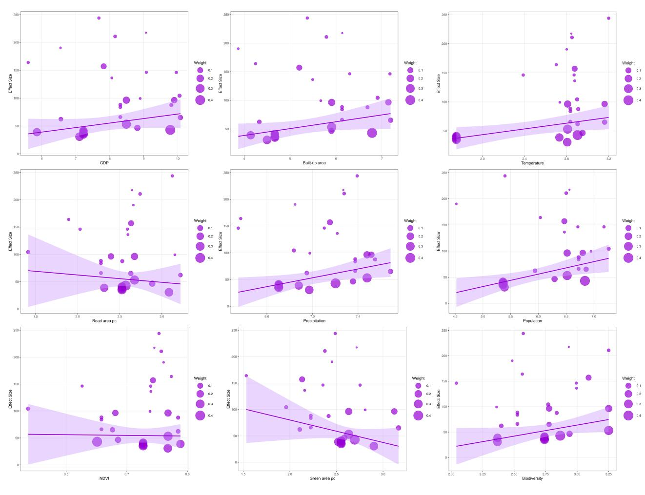

Figure 2. The contribution rates of each factor to the SHAP value
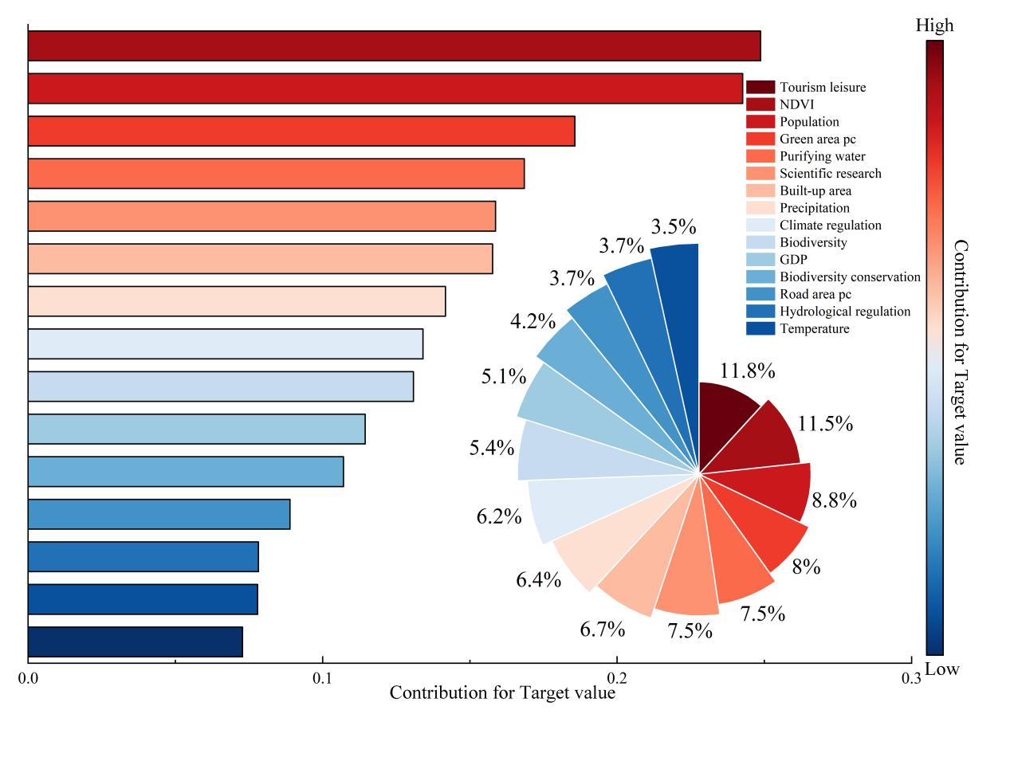

Figure 3. The fitting error of the XGBoost model
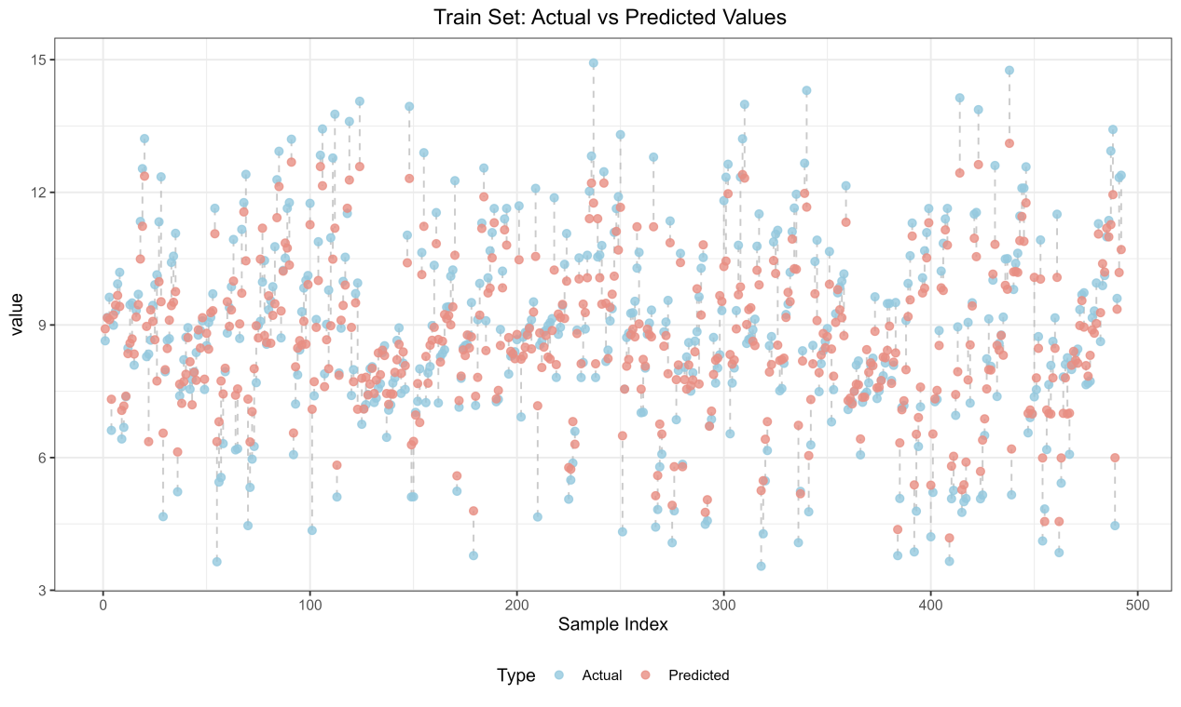
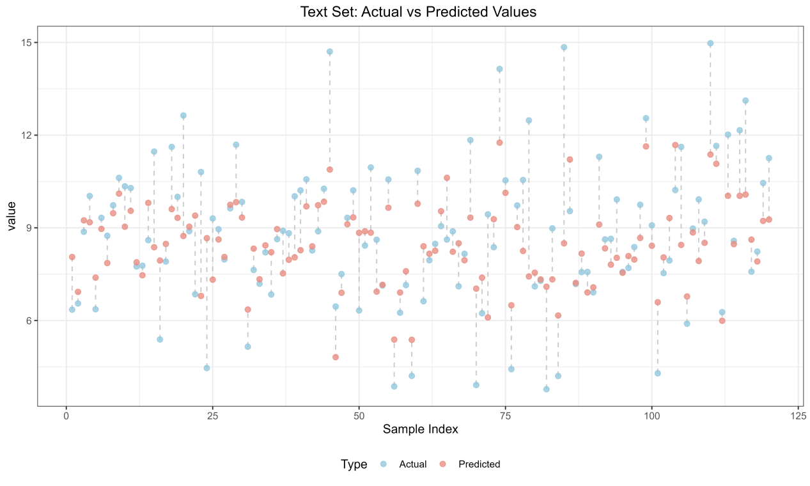

Figure 4. The unit area value of urban wetland ecosystem services in China under the SSP-RCP scenarios in 2030 and 2060
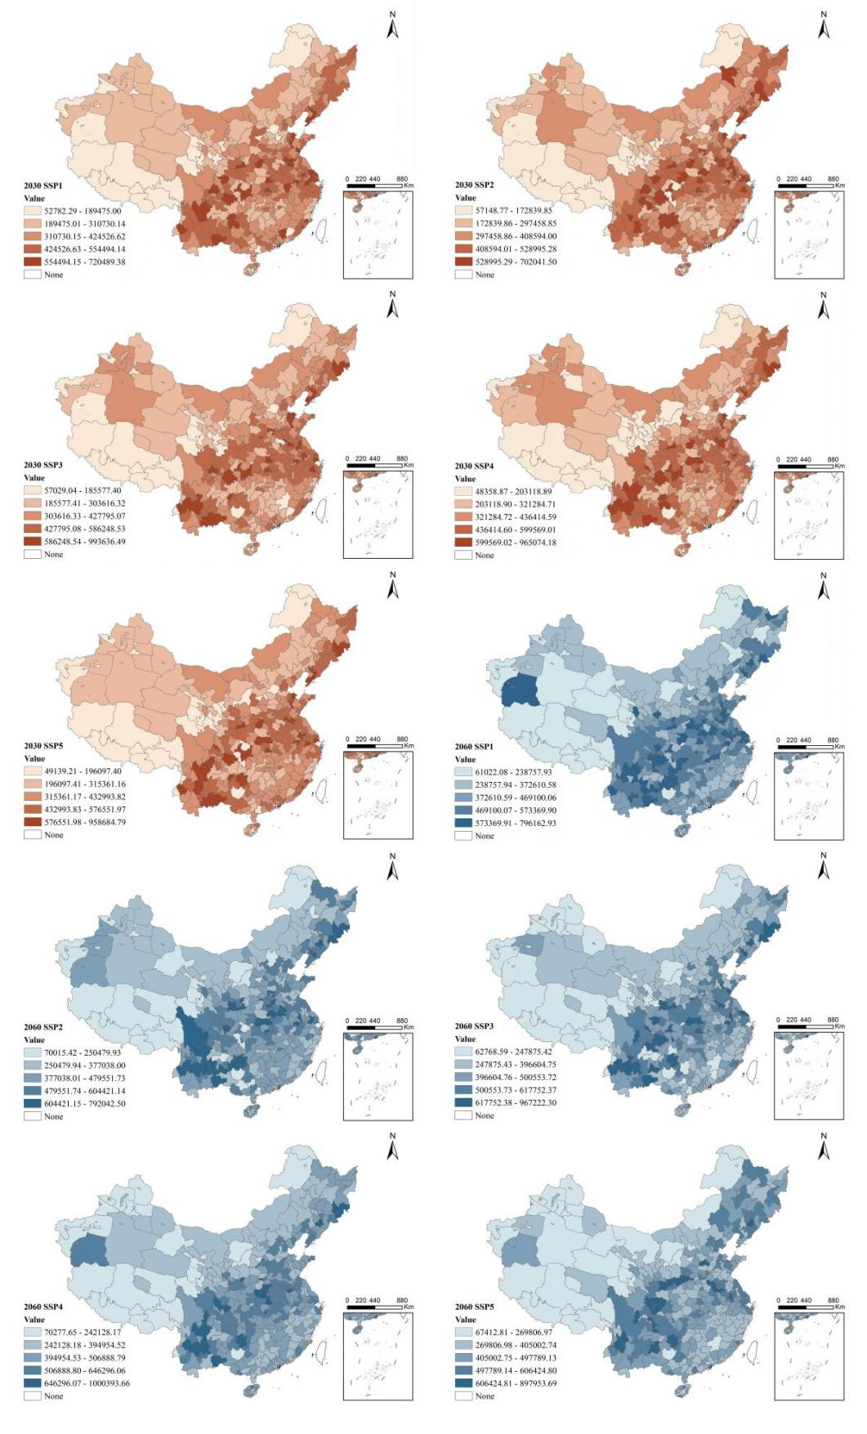

Figure 5. The non-use value of WTP decreases as the area increases
The survey on the average willingness to pay based on the survey is generally conducted on individual wetlands rather than individual areas, so there are some extreme outliers. The plotted data is a simple scatter plot based on the trimmed data. The red line represents the fitting result based on linear regression, and the green line represents the local smoothing fitting result based on LOESS.

Figure 6.SHAP summary plot of UWESV drivers.Each point represents one observation for a given feature, and its position on the x-axis indicates the SHAP value, or the feature’s contribution to the model prediction.

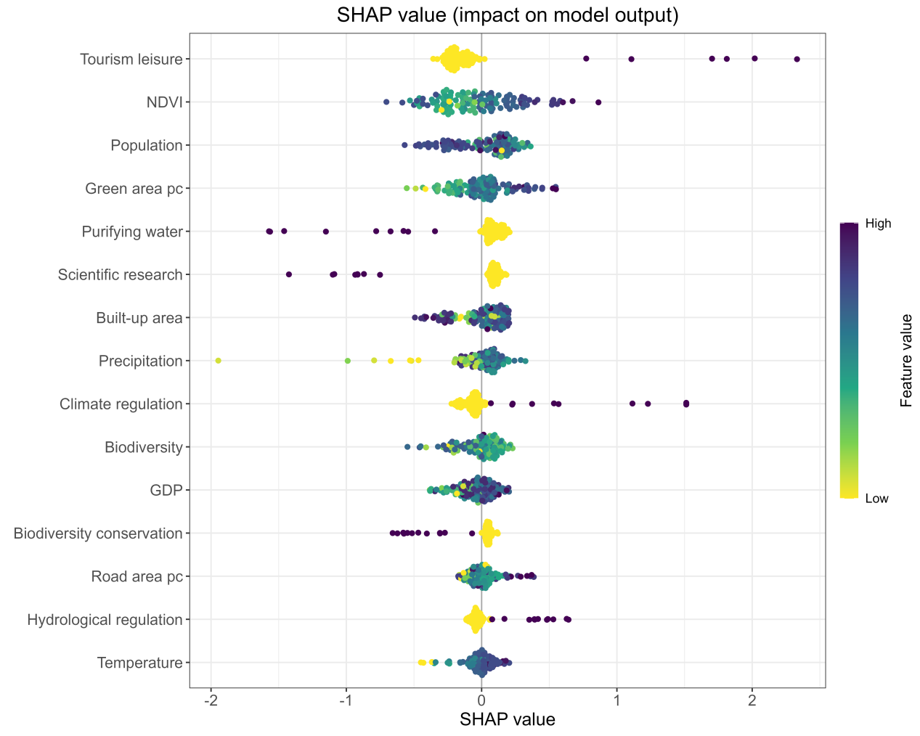
Purple and yellow dots represent high and low feature values, respectively. A SHAP value greater than 0 indicates a positive effect, while less than 0 signifies a negative one. The results indicate that Recreation and tourism is the most influential feature, followed by NDVI, while Temperature has the smallest effect. In terms of effect direction, features such as Recreation and tourism, NDVI, and Population positively influence UWESV predictions, whereas Water purification, Precipitation, and Climate regulation show negative effects.

Figure 7.Correlation matrix plot of continuous variables

