Supplementary Information

Supporting Materials for

Haji Bushra of Gata and the Making of Islamic Education in Nineteenth-Century South Wollo, Ethiopia: Institutional Formation and Community Agency

1. Interview Guide

Oral evidence comprises 12 semi-structured interviews conducted during fieldwork in June 2025. Participants were purposively selected from among religious scholars, manuscript custodians, community elders, and local residents on the basis of their knowledge of Gata Majlis, its educational traditions and manuscripts, and the wider social and historical context of South Wollo.

The interviews were guided by the following questions:
- What is remembered about Haji Bushra and his role in Islamic education at Gata?
- How is Haji Bushra's scholarly authority and educational contribution remembered within the local community?
- What forms of Islamic learning and teaching were associated with Haji Bushra and the Gata Majlis?
- How were students taught and trained within the Gata educational tradition?
- What types of Islamic texts and manuscripts were used in teaching and scholarly practice?
- How were manuscripts produced, copied, transmitted, preserved, and passed between generations?
- What is known about Haji Bushra's teachers, students, and wider scholarly connections?
- How did the Gata Majlis relate to the surrounding Muslim community?
- What local traditions explain the claim concerning the large number of manuscripts attributed to Haji Bushra?
- How do community members distinguish between historical memories, oral traditions, and hagiographical accounts concerning Haji Bushra?
- What changes have affected the preservation of manuscripts and the continuity of Islamic education at Gata?
- Are there additional manuscripts, oral traditions, institutional records, or other sources that may help reconstruct the history of Haji Bushra and the Gata Majlis?

Follow-up questions were used where necessary to clarify chronology, provenance, terminology, relationships, and the evidentiary basis of particular claims.

2. Focus Group Discussion Guide

Two focus group discussions were conducted during the June 2025 fieldwork, with six participants in each discussion. The FGDs complemented the individual interviews by examining shared community memories and interpretations concerning Haji Bushra, the Gata Majlis, manuscripts, and the development of Islamic education.

The discussions focused on the following themes:
- Collective memories of Haji Bushra and his scholarly reputation.
- The origins and development of Islamic learning at Gata.
- The organization of teaching and scholarly activities within the Gata Majlis.
- The roles of scholars, teachers, students, custodians, and the wider community.
- Manuscript production, circulation, use, and preservation.
- The transmission of Islamic knowledge across generations.
- Scholarly connections between Gata and other centres of learning.
- Community interpretations of the reported number of manuscripts attributed to Haji Bushra.
- Differences between historical memory, oral tradition, and hagiographical narratives.
- Contemporary challenges affecting manuscript preservation and the continuity of Islamic education.

Participants were encouraged to express different memories and interpretations. Where accounts differed, these differences were retained for source-critical comparison rather than treated as evidence of a single uncontested historical narrative.

3. Anonymised Participant/Source Table
Code | Source Type | Participant Category | Principal Contribution
Interviewees 01-12 | Semi-structured interview | Religious scholars, manuscript custodians, community elders, and local residents | Oral history, educational traditions, manuscript knowledge, scholarly authority, and institutional development
FGD Member-01-06 | Focus group discussion | Six purposively selected participants | Collective memory, educational traditions, manuscripts, and community agency
FGD Member-07-12 | Focus group discussion | Six purposively selected participants | Collective memory, educational traditions, manuscripts, and community agency

Note: Participants were purposively selected on the basis of their knowledge of Gata Majlis, its educational traditions and manuscripts, and the wider social and historical context of South Wollo. Personal names and other identifying information are withheld to protect confidentiality.

4. Thematic Analytical Framework
The oral, manuscript, and documentary materials were examined thematically and interpreted through historical source criticism, textual analysis, and comparison across different categories of evidence. The analysis focused on the following interconnected themes:
Analytical Theme | Focus of Analysis
 | Development and organization of Islamic learning
  Islamic education
 | Teaching methods, learning processes, and scholarly training
  Pedagogy
 | Formation and transmission of religious and scholarly authority
  Scholarly authority
 | Development and organization of the Gata Majlis
  Institutional formation
 | Community participation, support, and institutional continuity
  Community agency
 | Production, copying, use, circulation, and preservation
  Manuscripts
 | Contents, annotations, and transmission of texts
  Textual transmission
 | Connections among scholars, students, and centres of learning
  Scholarly networks
 | Oral traditions and collective remembrance
  Historical memory
 | Miraculous and exemplary narratives concerning Haji Bushra
  Hagiographical tradition
 | Transformation and preservation of the educational tradition
  Continuity and change

These themes were not treated as isolated categories. Rather, they were examined in relation to one another and compared across interviews, focus group discussions, manuscripts, oral traditions, and documentary sources. Where accounts differed, the differences were considered through source criticism, contextual comparison, and assessment of the provenance and evidentiary value of each source.

5. Source and Manuscript Documentation

The main article already identifies and discusses the principal manuscripts used in the study, including their titles, contents, and relevant material and textual characteristics. To avoid unnecessary duplication, this supplementary section does not reproduce the full manuscript inventory. The manuscript evidence comprised approximately 20 preserved manuscripts associated with the Gata scholarly tradition, selected and examined according to their provenance, historical relevance, accessibility, and evidentiary value. Particular attention was given to their material characteristics, textual contents, scribal and copying practices, marginal annotations, evidence of pedagogical use, transmission and preservation, and references to scholarly and regional networks.

6. Selected Anonymised Manuscript Evidence

The following three photographs provide selected visual evidence from the handwritten manuscript materials examined during the research. They are included as documentary examples supporting the manuscript-based analysis presented in the main article. They do not constitute a complete reproduction of the manuscript collection.

Figure S1. Selected Manuscript Page

Selected page from a handwritten Islamic manuscript preserved within the Gata scholarly tradition. The image provides visual evidence of the handwritten textual materials examined in reconstructing the history of Islamic learning at Gata.

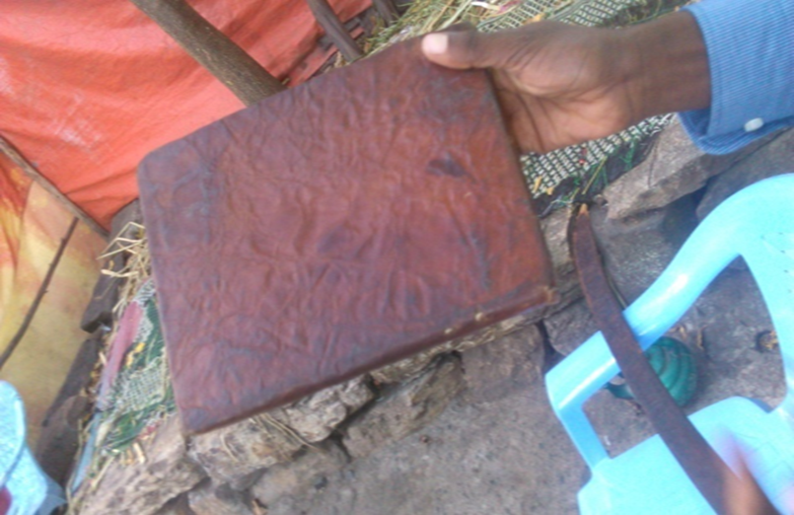

Figure S2. Selected Manuscript Page

Selected page from a handwritten Islamic manuscript associated with the Gata scholarly tradition, illustrating features of the textual materials examined in relation to Islamic learning, textual transmission, and manuscript preservation.

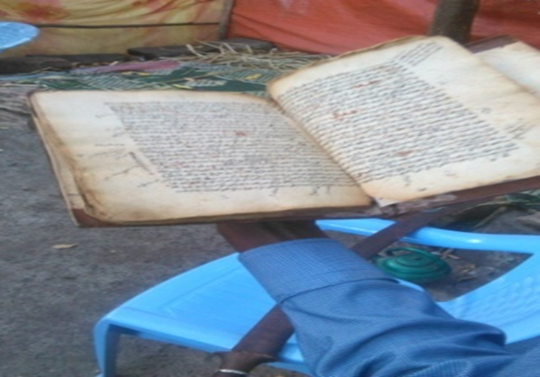

Figure S3. Selected Manuscript Page

Selected page from a handwritten manuscript preserved within the Gata scholarly tradition. The photograph provides additional documentary evidence for the manuscript-based reconstruction of Islamic educational practices and scholarly transmission.

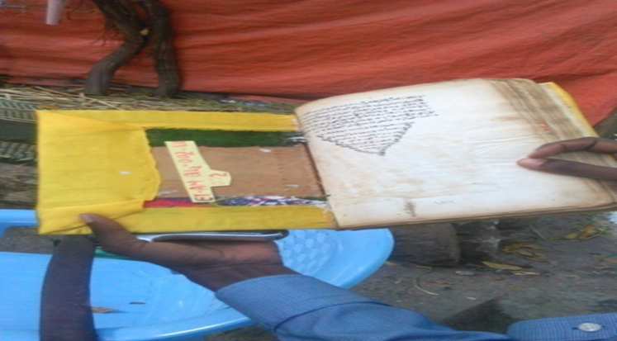

Note: The photographs are provided as selected documentary evidence for scholarly purposes. Identifying information concerning private custodians or other individuals is not disclosed. The images should be read together with the manuscript descriptions and source-critical discussion in the main article.

7. Data Availability Statement

The primary materials underlying this study comprise historical manuscripts, oral accounts, interviews, focus group discussions, and institutional and documentary sources. Because some materials are privately held, locally preserved, or subject to custodial and ethical restrictions, the complete underlying materials cannot be made publicly available. Selected anonymised evidence and supporting research materials are provided in this Supplementary Information. Further information concerning the sources may be obtained from the corresponding author, subject to appropriate ethical, custodial, and access considerations.

8. Ethical and Confidentiality Note
The research was conducted independently and without external sponsorship. Oral evidence was collected during fieldwork in June 2025 from participants purposively selected for their knowledge of Gata Majlis, its educational traditions and manuscripts, and the wider historical and social context of South Wollo. Participant identities and other potentially identifying information are not disclosed in this supplementary material. Oral accounts and manuscript materials are presented in accordance with the ethical and confidentiality procedures described in the main article.

