S1. Supplementary information

Sustainability of bio-based polyethylene: the influence of biomass sourcing and end-of-life
Linda Ritzen*, Benjamin Sprecher, Conny A. Bakker, and A. Ruud Balkenende
Department of Sustainable Design Engineering, Delft University of Technology. Landbergstraat 15, 2628CE, Delft, the Netherlands.
S1.1 | Biogenic carbon calculations | Page 1
S1.2 | Ethanol production process descriptions | Page 2-3
Table S1.1 | Overview of biomass types and the allocation of by-products from the ethanol production process. | Page 3
Table S1.2 | Lifecycle inventory of petrochemical-based HDPE scenarios. | Page 3
Table S1.3 | Lifecycle inventory of the ethylene conversion process. | Page 3
Table S1.4 | Lifecycle inventory of bio-based HDPE scenario’s. *Data from the Global Feed LCA database. | Page 4-12
Table S1.5 | Overview of the transport distances. | Page 13-16
Table S1.6 | Process contributions to GWP100 in %. | Page 17
Table S1.7 | Process contributions to terrestrial acidification in %. | Page 18
Table S1.8 | Process contributions to land use in %. | Page 19
Table S1.9 | Process contributions to particulate matter formation in %. | Page 20
Table S1.10 | Process contributions to water use in %. | Page 21
Figure S1.1 | Comparison of the environmental impact of petro-HDPE and bio-HDPE from various resources according to the ReCiPe impact categories. | Page 22-24
Figure S1.2 | Contribution of production stages to the environmental impact of bio-HDPE. | Page 25-30
Figure S1.3 | Comparison of the environmental impact of three end-of-life treatment options for bio-HDPE and petro-HDPE. | Page 31-36
 | References | Page 37

S1.1 Biogenic carbon calculations
The amount of biogenic CO₂ stored in 1 kg of bio-HDPE was calculated according to the following equation:
$$m_{BCstored}=\frac{m_{BC}}{m_{HDPE}}⋅\frac{m_{CO_{2}}}{m_{C}}⋅m_{polymer}=\frac{12.0096}{12.0096+2⋅1.00784}⋅\frac{12.0096+2⋅15.99903}{12.0096}⋅1=3.14 kg$$
In this equation, $m_{BCstored}$ is the atmospheric CO₂ stored in the polymer in kg. $M_{BC}$ is the molecular weight of biogenic carbon in 1 repeating unit of the polymer. The molecular structure of polyethylene is (CH₂)_{n}, so it equals the molecular weight of one carbon atom in our case. $m_{HDPE}$ is the molecular weight of one repeating unit of the polymer, $m_{CO_{2}}$ is the molecular weight of one carbon dioxide molecule, and $m_{c}$ is the atomic weight of carbon. Finally, $m_{polymer}$ is the mass for which the contained CO₂ is to be calculated, 1 kg in this case. The equation first calculates fraction of the weight of a polymer is biogenic carbon. Every kg polyethylene contains of 0.85 kg of carbon atoms. Next, the relation between CO₂ and atomic carbon is used to compute the weight of the corresponding CO₂, amounting to 3.14 kg for bio-HDPE.

S1.2 Ethanol production process descriptions

Sugarcane-based ethanol
The process for producing ethanol from sugarcane is described in (Jungbluth & Chudacoff, 2007) and is summarised below. During the production of ethanol from sugarcane, the sugarcane is washed and cut into small pieces. The sugarcane pieces are milled in multiple steps in order to break the structure of the sugarcane and subsequently grind the sugarcane. During some steps, water is added to enhance the juice extraction. The resulting juice is collected and sterilised, and the remaining by-product is called bagasse and can be incinerated for electricity. Yeast is added to the juice which will convert the sugars into ethanol within a few days.

Maize-based ethanol
The process for producing ethanol from maize is described in (Bothast & Schlicher, 2005) and is summarised below. The ethanol from maize process in the ecoinvent database is the combination of two processes: wet-milling (80%) and dry-grinding (20%) (Jungbluth & Chudacoff, 2007; Wernet et al., 2016). During the wet-milling process, the germ is removed from the corn kernel. The remaining starch solution is separated from the by-products (solids, oils and gluten). This starch solution is liquified and converted into fermentable sugars using enzymes. Yeast is added to the glucose solution to yield ethanol. The remaining products are used as animal feed.
In the dry grind process, the corn is ground and water is added. The resulting mash is cooked and the starch in the mash is converted into sugar using enzymes. Yeast is subsequently added to ferment the sugars and the resulting mixture is distilled and dehydrated to yield ethanol. The remaining products are sold as animal feed.

Sugar beet-based ethanol
The process for ethanol production from sugar beets is described in (Jungbluth & Chudacoff, 2007) and is summarised below. Pre-processing of sugar beets for ethanol involves rock/residue removal and washing. Next, the beets are cut into smaller pieces and transferred into a diffuser. Here, sugar is extracted by continues diffusion in hot water. The sugar solution and pulps are collected and the pulps are processed further and sold as animal feed. The sugar solution is purified through precipitation of the non-sugars using a solution of lime and CO₂. The remaining purified juice is concentrated by boiling off excess water until it reaches a 60% sugar concentration. Crystals from during this process and are separated from the juice in a centrifuge. The remaining juice (sugar beet molasses) is combined with yeast to ferment into ethanol in 30-35 hours.

Potato-based ethanol
The process for ethanol production from potatoes is described in (Jungbluth & Chudacoff, 2007) and is summarised below. Pre-processing of potatoes is similar to that of sugar beets: residues are removed, and the crops are washed. The potatoes are then grated into a pulp. The pulp is heated and liquefied after which the starch in the pulp is hydrolysed using enzymes at elevated temperatures. The resulting sugars are fermented using yeast, and the ethanol is extratected and purified. The remaining by-products (vinasse) are sold as animal feed.

Wood-based ethanol
The process for ethanol production from potatoes is described in (Jungbluth & Chudacoff, 2007) and is summarised below. Pre-treatment of wood involves heating it to 160-190 °C in a sulphuric acid solution in order to catalyse hemicellulose removal and expose the cellulose. The process also releases sugars from the wood. The liquid is removed from the product and is neutralised with lime. Additional lime is used to raise the pH and remove toxic downstream biological steps. The liquid is recombined with the solids before fermentation. A small fraction of the resulting mixture is used to produce cellulase enzyme that is used in the fermentation of the remainder of the mixture. Additionally, a liquid hydrolysate is added and a yeast to ferment the sugars released from the cellulose into ethanol. The ethanol is then purified and distilled while the solids are concentrated and burned to generate steam and electricity that is used within the ethanol production plant. Wastewater is treated by anaerobic digestion to produce biogas that is also used within the plant.
Table S1.1: Overview of biomass types and the allocation of by-products from the ethanol production process.

Biomass type | Source | By- or wasterpoducts | Allocation
Sugarcane | Wernet et al., 2016, Jungbluth & Chudacoff, 2007 | Vinasse | 0% of impacts
Sugarcane | Wernet et al., 2016, Jungbluth & Chudacoff, 2007 | Filtercake | 0% of impacts
Sugarcane | Wernet et al., 2016, Jungbluth & Chudacoff, 2007 | Bagasse | Economic allocation: 0.55%  Mass allocation: 21.09%
Maize | Wernet et al., 2016, Jungbluth & Chudacoff, 2007 | Distiller's dried grains with solubles (DDGS) | Economic allocation: 2.4%  Mass allocation: 51.14%
Sugar beet | Wernet et al., 2016, Jungbluth & Chudacoff, 2007 | Beets chips | Economic allocation: 4.9%  Mass allocation: 18.75%
Sugar beet | Wernet et al., 2016, Jungbluth & Chudacoff, 2007 | Vinasse | Economic allocation: 0%  Mass allocation: 71.27%
Potato | Wernet et al., 2016, Jungbluth & Chudacoff, 2007 | DDGS | Economic allocation: 4.4%.  Mass allocation: 52.89%
Wood | Wernet et al., 2016, Jungbluth & Chudacoff, 2007 | Electricity | Economic allocation: 0.3%  Mass allocation not applicable

Table S1.2: Lifecycle inventory of petrochemical-based HDPE scenarios.
Scenario | amount | Activity | Adjustments
Petro-RoW | 1 kg | Polyethylene, high density, granulate [RoW]
Petro-RER | 1 kg | Polyethylene, high density, granulate [RER]

Table S1.3: Lifecycle inventory of the ethylene conversion process.
Amount | Activity | Location
0.0672 kg | nitrogen, liquid | RoW or RER
0.00011 kg | zeolite, powder | RoW or RER
0.0266 kg | sodium bicarbonate | RoW or RER
2.57 kg | tap water | Specific country
0.0372 kg | nitrogen, liquid | RoW or RER
0.0035 kg | propylene | RoW or RER
0.47 kWh | electricity, medium voltage | Specific country
4.84 MJ | heat, district or industrial | Specific country

Table S1.4: Lifecycle inventory of bio-based HDPE scenario’s. *Data from the Global Feed LCA database.
Scenario | Amount | Activity | Adjustments
SC-BR | 18.57 kg | Sugarcane [BR]
SC-BR | 2.084 kg | ethanol, without water, in 99.7% solution state, from fermentation [BR]
SC-BR | 1.002 kg | Ethylene [RoW] | Adjusted energy and tap water to [BR]
SC-BR | 1 kg | polyethylene, high density, granulate [RoW] | Adjusted energy to [BR}
SC-BR | 0.93 t km | Transport, freight, lorry >32 metric ton, EURO3 [BR]
SC-BR | 1.43 t km | Transport, freight train [RoW]
SC-BR | 11.31 t km | Transport, freight, sea, container ship [GLO]
SC-CN | 18.57 kg | Sugarcane [CN]*
SC-CN | 2.084 kg | ethanol, without water, in 99.7% solution state, from fermentation [BR] | Adjusted energy to [CN]
SC-CN | 1.002 kg | Ethylene [RoW] | Adjusted energy and tap water to [CN]
SC-CN | 1 kg | polyethylene, high density, granulate [RoW] | Adjusted energy to [CN]
SC-CN | 1.52 t km | Transport, freight, lorry >32 metric ton, EURO3 [RoW]
SC-CN | 0.61 t km | Transport, freight train [CN]
SC-CN | 18.22 t km | Transport, freight, sea, container ship [GLO]
SC-CO | 18.57 kg | Sugarcane [CO]
SC-CO | 2.08 kg | ethanol, without water, in 99.7% solution state, from fermentation [BR] | Adjusted energy to [CO]
SC-CO | 1.002 kg | Ethylene [RoW] | Adjusted energy and tap water to [CO]
SC-CO | 1.0 kg | polyethylene, high density, granulate [RoW] | Adjusted energy to [CO]
SC-CO | 1.52 t km | Transport, freight, lorry >32 metric ton, EURO3 [RoW]
SC-CO | 8.62 t km | Transport, freight, sea, container ship [GLO]
SC-IN | 18.57 kg | Sugarcane [IN]
SC-IN | 2.084 kg | ethanol, without water, in 99.7% solution state, from fermentation [BR] | Adjusted energy to [IN]
SC-IN | 1.002 kg | Ethylene [RoW] | Adjusted energy and tap water to [IN]
SC-IN | 1 kg | polyethylene, high density, granulate [RoW] | Adjusted energy to [IN]
SC-IN | 0.93 t km | Transport, freight, lorry >32 metric ton, EURO3 [RoW]
SC-IN | 1.33 t km | Transport, freight train [IN]
SC-IN | 11.55 t km | Transport, freight, sea, container ship [GLO]

Table S1.4: continued
Scenario | Amount | Activity | Adjustments
SC-US | 18.57 kg | Sugarcane [US]*
SC-US | 2.084 kg | ethanol, without water, in 99.7% solution state, from fermentation [US] | Adjusted energy to [US]
SC-US | 1.002 kg | Ethylene [RoW] | Adjusted energy and tap water to [US]
SC-US | 1 kg | polyethylene, high density, granulate [RoW] | Adjusted energy to [US]
SC-US | 1.02 t km | Transport, freight, lorry >32 metric ton, EURO3 [RoW]
SC-US | 7.5 t km | Transport, freight, sea, container ship [GLO]
M-BR | 6.72 kg | maize grain [BR]
M-BR | 2.08 kg | ethanol, without water, in 95% solution state, from fermentation [US] | Adjusted energy and tap water to [BR]
M-BR | 2.08 kg | ethanol, without water, in 99.7% solution state, from fermentation [US] | Adjusted energy to [BR]
M-BR | 1.002 kg | Ethylene [RoW] | Adjusted energy and tap water to Brazil
M-BR | 1.0 kg | polyethylene, high density, granulate [RoW] | Adjusted energy to Brazil
M-BR | 0.34 t km | Transport, freight, lorry >32 metric ton, EURO3 [BR]
M-BR | 3.25 t km | Transport, freight train [RoW]
M-BR | 1.31 t km | Transport, freight, sea, container ship [GLO]
M-CA-QC | 6.72 kg | maize grain [CA-QC]
M-CA-QC | 2.08 kg | ethanol, without water, in 95% solution state, from fermentation [US] | Adjusted energy and tap water to [CA-QC]
M-CA-QC | 2.08 kg | ethanol, without water, in 99.7% solution state, from fermentation [US] | Adjusted energy to [CA-QC]
M-CA-QC | 1.002 kg | Ethylene [RoW] | Adjusted energy and tap water to [CA-QC]
M-CA-QC | 1.0 kg | polyethylene, high density, granulate [RoW] | Adjusted energy to [CA-QC]
M-CA-QC | 0.34 t km | Transport, freight, lorry >32 metric ton, EURO3 [RoW]
M-CA-QC | 0.45 t km | Transport, freight train [RoW]
M-CA-QC | 5.85 t km | Transport, freight, sea, container ship [GLO]

Table S1.4: continued
Scenario | Amount | Activity | Adjustments
M-CN | 6.72 kg | maize grain [CN]*
M-CN | 2.08 kg | ethanol, without water, in 95% solution state, from fermentation [US] | Adjusted energy and tap water to [CN]
M-CN | 2.08 kg | ethanol, without water, in 99.7% solution state, from fermentation [US] | Adjusted energy to [CN]
M-CN | 1.002 kg | Ethylene [RoW] | Adjusted energy and tap water to [CN]
M-CN | 1.0 kg | polyethylene, high density, granulate [RoW] | Adjusted energy to [CN]
M-CN | 0.34 t km | Transport, freight, lorry >32 metric ton, EURO3 [RoW]
M-CN | 0.37 t km | Transport, freight train [CN]
M-CN | 20.48 t km | Transport, freight, sea, container ship [GLO]
M-IN | 6.72 kg | maize grain [IN]
M-IN | 2.08 kg | ethanol, without water, in 95% solution state, from fermentation [US] | Adjusted energy and tap water to [IN]
M-IN | 2.08 kg | ethanol, without water, in 99.7% solution state, from fermentation [US] | Adjusted energy to [IN]
M-IN | 1.002 kg | Ethylene [RoW] | Adjusted energy and tap water to [IN]
M-IN | 1.0 kg | polyethylene, high density, granulate [RoW] | Adjusted energy to [IN]
M-IN | 0.34 t km | Transport, freight, lorry >32 metric ton, EURO3 [RoW]
M-IN | 1.33 t km | Transport, freight train [IN]
M-IN | 11.55 t km | Transport, freight, sea, container ship [GLO]
M-US | 6.72 kg | maize grain [US]
M-US | 2.08 kg | ethanol, without water, in 95% solution state, from fermentation [US]
M-US | 2.08 kg | ethanol, without water, in 99.7% solution state, from fermentation [US]
M-US | 1.002 kg | Ethylene [RoW] | Adjusted energy and tap water to [US]
M-US | 1.0 kg | polyethylene, high density, granulate [RoW] | Adjusted energy to [US]
M-US | 0.34 t km | Transport, freight, lorry >32 metric ton, EURO3 [RoW]
M-US | 0.5 t km | Transport, freight train [US]
M-US | 8.10 t km | Transport, freight, sea, container ship [GLO]
M-ZA | 6.72 kg | maize grain [ZA]
M-ZA | 2.08 kg | ethanol, without water, in 95% solution state, from fermentation [US] | Adjusted energy and tap water to [ZA]
M-ZA | 2.08 kg | ethanol, without water, in 99.7% solution state, from fermentation [US] | Adjusted energy to [ZA]
M-ZA | 1.002 kg | Ethylene [RoW] | Adjusted energy and tap water to [ZA]
M-ZA | 1.0 kg | polyethylene, high density, granulate [RoW] | Adjusted energy to [ZA]
M-ZA | 0.44 t km | Transport, freight, lorry >32 metric ton, EURO3 [RoW]
M-ZA | 11.42 t km | Transport, freight, sea, container ship [GLO]
Table S1.4: continued
Scenario | Amount | Activity | Adjustments
M-CH | 6.72 kg | maize grain [CH]
M-CH | 2.08 kg | ethanol, without water, in 95% solution state, from fermentation [US] | Adjusted energy and tap water to [CH]
M-CH | 2.08 kg | ethanol, without water, in 99.7% solution state, from fermentation [US] | Adjusted energy to [CH]
M-CH | 1.002 kg | Ethylene [RER] | Adjusted energy and tap water to [CH]
M-CH | 1.0 kg | polyethylene, high density, granulate [RER] | Adjusted energy to [CH]
M-CH | 0.34 t km | Transport, freight, lorry >32 metric ton, EURO3 [RER]
M-CH | 0.76 t km | Transport, freight train [FR]
M-CH | 0.47 t km | Transport, freight, sea, container ship [GLO]
M-DE | 6.72 kg | maize grain [DE]*
M-DE | 2.08 kg | ethanol, without water, in 95% solution state, from fermentation [US] | Adjusted energy and tap water to [DE]
M-DE | 2.08 kg | ethanol, without water, in 99.7% solution state, from fermentation [US] | Adjusted energy to [DE]
M-DE | 1.002 kg | Ethylene [RER] | Adjusted energy and tap water to [DE]
M-DE | 1.0 kg | polyethylene, high density, granulate [RER] | Adjusted energy to [DE]
M-DE | 0.34 t km | Transport, freight, lorry >32 metric ton, EURO3 [RER]
M-DE | 0.76 t km | Transport, freight train [DE]
M-DE | 0.75 t km | Transport, freight, sea, container ship [GLO]
M-FR | 6.72 kg | maize grain [FR]*
M-FR | 2.08 kg | ethanol, without water, in 95% solution state, from fermentation [US] | Adjusted energy and tap water to [FR]
M-FR | 2.08 kg | ethanol, without water, in 99.7% solution state, from fermentation [US] | Adjusted energy to [FR]
M-FR | 1.002 kg | Ethylene [RER] | Adjusted energy and tap water to [FR]
M-FR | 1.0 kg | polyethylene, high density, granulate [RER] | Adjusted energy to [FR]
M-FR | 0.34 t km | Transport, freight, lorry >32 metric ton, EURO3 [RER]
M-FR | 0.52 t km | Transport, freight train [FR]
M-FR | 0.47 t km | Transport, freight, sea, container ship [GLO]

Table S1.4: continued
SB-US | 13.56 kg | sugar beet [ US]
SB-US | 2.08 kg | ethanol, without water, in 95% solution state, from fermentation [CH] | Adjusted energy and tap water to [US]
SB-US | 2.08 kg | ethanol, without water, in 99.7% solution state, from fermentation [CH] | Adjusted energy to [US]
SB-US | 1.002 kg | Ethylene [RoW] | Adjusted energy and tap water to [US]
SB-US | 1.0 kg | polyethylene, high density, granulate [RoW] | Adjusted energy to [US]
SB-US | 0.68 t km | Transport, freight, lorry >32 metric ton, EURO3 [RoW]
SB-US | 0.24 t km | Transport, freight train [US]
SB-US | 8.25 t km | Transport, freight, sea, container ship [GLO]
SB-CH | 13.56 kg | sugar beet [CH]
SB-CH | 2.08 kg | ethanol, without water, in 95% solution state, from fermentation [CH]
SB-CH | 2.08 kg | ethanol, without water, in 99.7% solution state, from fermentation [CH]
SB-CH | 1.002 kg | Ethylene [RER] | Adjusted energy and tap water to [CH]
SB-CH | 1.0 kg | polyethylene, high density, granulate [RER] | Adjusted energy to [CH]
SB-CH | 0.68 t km | Transport, freight, lorry >32 metric ton, EURO3 [RER]
SB-CH | 0.76 t km | Transport, freight train [FR]
SB-CH | 0.47 t km | Transport, freight, sea, container ship [GLO]
SB-DE | 13.56 kg | sugar beet [DE]
SB-DE | 2.08 kg | ethanol, without water, in 95% solution state, from fermentation [CH] | Adjusted energy and tap water to [DE]
SB-DE | 2.08 kg | ethanol, without water, in 99.7% solution state, from fermentation [CH] | Adjusted energy to [DE]
SB-DE | 1.002 kg | Ethylene [RER] | Adjusted energy and tap water to [DE]
SB-DE | 1.0 kg | polyethylene, high density, granulate [RER] | Adjusted energy to [DE]
SB-DE | 0.78 t km | Transport, freight, lorry >32 metric ton, EURO3 [RER]
SB-DE | 0.90 t km | Transport, freight train [DE]
SB-DE | 0.75 t km | Transport, freight, sea, container ship [GLO]
SB-FR | 13.56 kg | sugar beet [FR]
SB-FR | 2.08 kg | ethanol, without water, in 95% solution state, from fermentation [CH] | Adjusted energy and tap water to [FR]
SB-FR | 2.08 kg | ethanol, without water, in 99.7% solution state, from fermentation [CH] | Adjusted energy to [FR]
SB-FR | 1.002 kg | Ethylene [RER] | Adjusted energy and tap water to [FR]
SB-FR | 1.0 kg | polyethylene, high density, granulate [RER] | Adjusted energy to [FR]
SB-FR | 0.68 t km | Transport, freight, lorry >32 metric ton, EURO3 [RER]
SB-FR | 0.52 t km | Transport, freight train [FR]
SB-FR | 0.47 t km | Transport, freight, sea, container ship [GLO]
Table S1.4: continued
Scenario | Amount | Activity | Adjustments
SB-SE | 13.56 kg | sugar beet [SE]*
SB-SE | 2.08 kg | ethanol, without water, in 95% solution state, from fermentation [CH] | Adjusted energy and tap water to [SE]
SB-SE | 2.08 kg | ethanol, without water, in 99.7% solution state, from fermentation [CH] | Adjusted energy to [SE]
SB-SE | 1.002 kg | Ethylene [RER] | Adjusted energy and tap water to [SE]
SB-SE | 1.0 kg | polyethylene, high density, granulate [RER] | Adjusted energy to [SE]
SB-SE | 0.73 t km | Transport, freight, lorry >32 metric ton, EURO3 [RER]
SB-SE | 1.32 t km | Transport, freight, sea, container ship [GLO]
P-CA | 29.63 kg | Potato [CA-QC]
P-CA | 2.08 kg | ethanol, without water, in 95% solution state, from fermentation [CH] | Adjusted energy and tap water to [CA-QC]
P-CA | 2.08 kg | ethanol, without water, in 99.7% solution state, from fermentation [CH] | Adjusted energy to [CA-QC]
P-CA | 1.002 kg | Ethylene [RoW] | Adjusted energy and tap water to [CA-QC]
P-CA | 1.0 kg | polyethylene, high density, granulate [RoW] | Adjusted energy to [CA-QC]
P-CA | 1.48 t km | Transport, freight, lorry >32 metric ton, EURO3 [RoW]
P-CA | 0.45 t km | Transport, freight train [RoW]
P-CA | 5.85 t km | Transport, freight, sea, container ship [GLO]
P-CN | 29.63 kg | Potato [CN]
P-CN | 2.08 kg | ethanol, without water, in 95% solution state, from fermentation [CH] | Adjusted energy and tap water to [CN]
P-CN | 2.08 kg | ethanol, without water, in 99.7% solution state, from fermentation [CH] | Adjusted energy to [CN]
P-CN | 1.002 kg | Ethylene [RoW] | Adjusted energy and tap water to [CN]
P-CN | 1.0 kg | polyethylene, high density, granulate [RoW] | Adjusted energy to [CN]
P-CN | 1.48 t km | Transport, freight, lorry >32 metric ton, EURO3 [RoW] | 0.34 t km
P-CN | 0.37 t km | Transport, freight train [CN] | 0.37 t km
P-CN | 20.48 t km | Transport, freight, sea, container ship [GLO] | 20.48 t km
P-IN | 29.63 kg | Potato [IN]
P-IN | 2.08 kg | ethanol, without water, in 95% solution state, from fermentation [CH] | Adjusted energy and tap water to [IN]
P-IN | 2.08 kg | ethanol, without water, in 99.7% solution state, from fermentation [CH] | Adjusted energy to [IN]
P-IN | 1.002 kg | Ethylene [RoW] | Adjusted energy and tap water to [IN]
P-IN | 1.0 kg | polyethylene, high density, granulate [RoW] | Adjusted energy to [IN]
P-IN | 1.48 t km | Transport, freight, lorry >32 metric ton, EURO3 [RoW]
P-IN | 1.33 t km | Transport, freight train [IN]
P-IN | 11.55 t km | Transport, freight, sea, container ship [GLO]

Table S1.4: continued
Scenario | Amount | Activity | Adjustments
P-US | 29.63 kg | Potato [US]
P-US | 2.08 kg | ethanol, without water, in 95% solution state, from fermentation [CH] | Adjusted energy and tap water to [US]
P-US | 2.08 kg | ethanol, without water, in 99.7% solution state, from fermentation [CH] | Adjusted energy to [US]
P-US | 1.002 kg | Ethylene [RoW] | Adjusted energy and tap water to [US]
P-US | 1.0 kg | polyethylene, high density, granulate [RoW] | Adjusted energy to [US]
P-US | 1.48 t km | Transport, freight, lorry >32 metric ton, EURO3 [RoW]
P-US | 1.22 t km | Transport, freight train [US]
P-US | 15.682 t km | Transport, freight, sea, container ship [GLO]
P-CH | 29.63 kg | Potato [CH]
P-CH | 2.08 kg | ethanol, without water, in 95% solution state, from fermentation [CH]
P-CH | 2.08 kg | ethanol, without water, in 99.7% solution state, from fermentation [CH]
P-CH | 1.002 kg | Ethylene [RER] | Adjusted energy and tap water to [CH]
P-CH | 1.0 kg | polyethylene, high density, granulate [RER] | Adjusted energy to [CH]
P-CH | 1.48 t km | Transport, freight, lorry >32 metric ton, EURO3 [RER]
P-CH | 0.76 t km | Transport, freight train [FR]
P-CH | 0.47 t km | Transport, freight, sea, container ship [GLO]
P-DE | 29.63 kg | Potato [DE]*
P-DE | 2.08 kg | ethanol, without water, in 95% solution state, from fermentation [CH] |  | Adjusted energy and tap water to [DE]
P-DE | 2.08 kg | ethanol, without water, in 99.7% solution state, from fermentation [CH] |  | Adjusted energy to [DE]
P-DE | 1.002 kg | Ethylene [RER] |  | Adjusted energy and tap water to [DE]
P-DE | 1.0 kg | polyethylene, high density, granulate [RER] |  | Adjusted energy to [DE]
P-DE | 1.48 t km | Transport, freight, lorry >32 metric ton, EURO3 [RER]
P-DE | 0.90 t km | Transport, freight train [DE]
P-DE | 0.75 t km | Transport, freight, sea, container ship [GLO]
P-FR | 29.63 kg | Potato [FR]*
P-FR | 2.08 kg | ethanol, without water, in 95% solution state, from fermentation [CH] |  | Adjusted energy and tap water to [FR]
P-FR | 2.08 kg | ethanol, without water, in 99.7% solution state, from fermentation [CH] |  | Adjusted energy to [FR]
P-FR | 1.002 kg | Ethylene [RER] |  | Adjusted energy and tap water to [FR]
P-FR | 1.0 kg | polyethylene, high density, granulate [RER] |  | Adjusted energy to [FR]
P-FR | 1.48 t km | Transport, freight, lorry >32 metric ton, EURO3 [RER]
P-FR | 0.52 t km | Transport, freight train [FR]
P-FR | 0.47 t km | Transport, freight, sea, container ship [GLO]
Table S1.4: continued
Scenario | Amount | Activity | Adjustments
P-SE | 29.63 kg | Potato [SE]*
P-SE | 2.08 kg | ethanol, without water, in 95% solution state, from fermentation [CH] | Adjusted energy and tap water to [SE]
P-SE | 2.08 kg | ethanol, without water, in 99.7% solution state, from fermentation [CH] | Adjusted energy to [SE]
P-SE | 1.002 kg | Ethylene [RER] | Adjusted energy and tap water to [SE]
P-SE | 1.0 kg | polyethylene, high density, granulate [RER] | Adjusted energy to [SE]
P-SE | 1.53 t km | Transport, freight, lorry >32 metric ton, EURO3 [RER]
P-SE | 1.32 t km | Transport, freight, sea, container ship [GLO]
WO-CA | 7.93 kg | wood chips, wet, measured as dry mass [CA-QC]
WO-CA | 2.08 kg | ethanol, without water, in 95% solution state, from fermentation [CH] | Adjusted energy and tap water to [CA-QC]
WO-CA | 2.08 kg | ethanol, without water, in 99.7% solution state, from fermentation [CH] | Adjusted energy to [CA-QC]
WO-CA | 1.002 kg | Ethylene [RoW] | Adjusted energy and tap water to [CA-QC]
WO-CA | 1.0 kg | polyethylene, high density, granulate [RoW] | Adjusted energy to [CA-QC]
WO-CA | 0.45 t km | Transport, freight train [RoW]
WO-CA | 5.85 t km | Transport, freight, sea, container ship [GLO]
WO-CH | 7.93 kg | wood chips, wet, measured as dry mass [CH]
WO-CH | 2.08 kg | ethanol, without water, in 95% solution state, from fermentation [CH]
WO-CH | 2.08 kg | ethanol, without water, in 99.7% solution state, from fermentation [CH]
WO-CH | 1.002 kg | Ethylene [RER] | Adjusted energy and tap water to [CH]
WO-CH | 1.0 kg | polyethylene, high density, granulate [RER] | Adjusted energy to [CH]
WO-CH | 0.40 t km | Transport, freight, lorry >32 metric ton, EURO3 [RER]
WO-CH | 0.76 t km | Transport, freight train [FR]
WO-CH | 0.47 t km | Transport, freight, sea, container ship [GLO]
WO-DE | 7.93 kg | wood chips, wet, measured as dry mass [DE]
WO-DE | 2.08 kg | ethanol, without water, in 95% solution state, from fermentation [CH] | Adjusted energy and tap water to [DE]
WO-DE | 2.08 kg | ethanol, without water, in 99.7% solution state, from fermentation [CH] | Adjusted energy to [DE]
WO-DE | 1.002 kg | Ethylene [RER] | Adjusted energy and tap water to [DE]
WO-DE | 1.0 kg | polyethylene, high density, granulate [RER] | Adjusted energy to [DE]
WO-DE | 0.40 t km | Transport, freight, lorry >32 metric ton, EURO3 [RER]
WO-DE | 0.90 t km | Transport, freight train [DE]
WO-DE | 0.75 t km | Transport, freight, sea, container ship [GLO]

Table S1.4: continued
Scenario | Amount | Activity | Adjustments
WO-SE | 7.93 kg | wood chips, wet, measured as dry mass [SE]
WO-SE | 2.08 kg | ethanol, without water, in 95% solution state, from fermentation [CH] | Adjusted energy and tap water to [SE]
WO-SE | 2.08 kg | ethanol, without water, in 99.7% solution state, from fermentation [CH] | Adjusted energy to [SE]
WO-SE | 1.002 kg | Ethylene [RER] | Adjusted energy and tap water to [SE]
WO-SE | 1.0 kg | polyethylene, high density, granulate [RER] | Adjusted energy to [SE]
WO-SE | 0.45 t km | Transport, freight, lorry >32 metric ton, EURO3 [RER]
WO-SE | 1.32 t km | Transport, freight, sea, container ship [GLO]

Table S1.5: Overview of the transport distances.
Scenario | Mode of transportation | Journey | t-km | References
SC-BR | Truck | To chemical plant | 0.9284 t-km
SC-BR | Train | To Porto Alegre [BR] | 1.429 t-km | (Google, n.d.; Wernet et al., 2016)
SC-BR | Freight ship | Porto Alegre [BR] → Port of Antwerp [BE] | 11.216 t-km | (Sea Distances, n.d.)
SC-CN | Truck | To chemical plant | 0.9284 t-km
SC-CN | Train | Gianxi [CN] → Guangzhou [CN] | 0.609 t-km | (Google, n.d.; Peng, 2023; M. Zhang & Govindaraju, 2018)
SC-CN | Freight ship | Guangzhou [CN] → Port of Antwerp [BE] | 18.216 t-km | (Sea Distances, n.d.)
SC-CO | Truck | To chemical plant | 0.9284 t-km
SC-CO | Truck | Rio Cauca [CO] → Covenas [CO] | 0.594 t-km | (Google, n.d.; Peng, 2023; M. Zhang & Govindaraju, 2018)
SC-CO | Freight ship | Covenas [CO] → Port of Antwerp [BE] | 17.96 t-km | (Sea Distances, n.d.)
SC-IN | Truck | To chemical plant | 0.9284 t-km
SC-IN | Train | Rattipur [IN] → Kandla port [IN] | 1.333 t-km | (Google, n.d.; Indian Railways, n.d.; Wernet et al., 2016)
SC-IN | Freight ship | Kandla port [IN] → Port of Antwerp [BE] | 11.308 t-km | (Sea Distances, n.d.)
SC-US | Truck | To chemical plant | 0.9284 t-km
SC-US | Truck | Lake Okeechobee [US] → Port of Palm Beach [US] | 0.09 t-km | (Google, n.d.; U.S. Department of Transportation, 2022; United States Department of Agriculture, 2022; Wernet et al., 2016)
SC-US | Freight ship | Port of Palm Beach [US] → Port of Antwerp [BE] | 7.5 t-km | (Sea Distances, n.d.)
M-BR | Truck | To ethylene plant | 0.3361 t-km
M-BR | Train | To Porto Alegre [BR] | 3.25 t-km | (Braskem, 2022; Google, n.d.; Wernet et al., 2016)
M-BR | Freight ship | Porto Alegre [BR] → Port of Antwerp [BE] | 11.308 t-km | (Sea Distances, n.d.)
M-CA | Truck | To ethylene plant | 0.3361 t-km
M-CA | Train | Ottowa [CA] → Quebec Port [CA] | 0.445 t-km | (Aberdeen Carolina & Western Railway Company, n.d.-a; Google, n.d.; Wernet et al., 2016)
M-CA | Freight ship | Quebec Port [CA] → Porto Alegre [BR] | 5.845 t-km | (Sea Distances, n.d.)
M-CA | Freight ship | Quebec Port [CA] → Port of Antwerp [BE] | 12.18 t-km | (Sea Distances, n.d.)

Table S1.5: continued.
Scenario | Mode of transportation | Journey | t-km | References
M-CN | Truck | To chemical plant | 0.3361 t-km
M-CN | Train | Hebei [CN] → Tianjin port [CN] | 0.371 t-km | (Google, n.d.; Peng, 2023; Y. Zhang et al., 2019)
M-CN | Freight ship | Tianjin port [CN] → Port of Antwerp [BE] | 20.477 t-km | (Sea Distances, n.d.)
M-IN | Truck | To chemical plant | 0.3361 t-km
M-IN | Train | Rattipur [IN] → Kandla port [IN] | 1.333 t-km | (Google, n.d.; Indian Railways, n.d.; Wernet et al., 2016)
M-IN | Freight ship | Kandla port [IN] → Port of Antwerp [BE] | 11.547 t-km | (Sea Distances, n.d.)
M-US | Truck | To chemical plant | 0.3361 t-km
M-US | Train | Iowa [US] → Chicago port [US] | 0.5 t-km | (Aberdeen Carolina & Western Railway Company, n.d.-b; Google, n.d.; United States Department of Agriculture, n.d.)
M-US | Freight ship | Chicago port [US] → Port of Antwerp [BE] | 8.096 t-km | (Sea Distances, n.d.)
M-ZA | Truck | To chemical plant | 0.3361 t-km
M-ZA | Truck | Farm to Cape Town port (estimate) [ZA] | 0.1 t-km | (Google, n.d.)
M-ZA | Freight ship | Cape Town port [ZA] → Port of Antwerp [BE] | 11.423 t-km | (Sea Distances, n.d.)
M-CH | Truck | To chemical plant | 0.3361 t-km
M-CH | Train | Bern [CH] → Le Havre [FR] | 0.762 t-km | (Google, n.d.; Wernet et al., 2016)
M-CH | Freight ship | Le Havre [FR] → Port of Antwerp [BE] | 0.466 t-km | (Sea Distances, n.d.)
M-DE | Truck | To chemical plant | 0.3361 t-km
M-DE | Train | Central Germany [DE] → Port of Hamburg [DE] | 0.902 t-km | (Google, n.d.)
M-DE | Freight ship | Port of Hamburg [DE] → Port of Antwerp [BE] | 0.75 t-km | (Sea Distances, n.d.)
M-FR | Truck | To chemical plant | 0.3361 t-km
M-FR | Train | Central France [FR] → Le Havre [FR] | 0.521 t-km | (Google, n.d.)
M-FR | Freight ship | Le Havre [FR] → Port of Antwerp [BE] | 0.466 t-km | (Sea Distances, n.d.)
SB-US | Truck | To chemical plant | 0.6781 t-km
SB-US | Train | Minesota [US] → Port Duluth [US] | 0.243 t-km | (Aberdeen Carolina & Western Railway Company, n.d.-b; Google, n.d.; United States Department of Agriculture, 2022)
SB-US | Freight ship | Port Duluth [US] → Port of Antwerp [BE] | 8.248 t-km | (Sea Distances, n.d.)

Table S1.5: continued.
Scenario | Mode of transportation | Journey | t-km | References
SB-CH | Truck | To chemical plant | 0.6781 t-km
SB-CH | Train | Bern [CH] → Le Havre [FR] | 0.762 t-km | (Google, n.d.; Wernet et al., 2016)
SB-CH | Freight ship | Le Havre [FR] → Port of Antwerp [BE] | 0.466 t-km | (Sea Distances, n.d.)
SB-DE | Truck | To chemical plant | 0.6781 t-km
SB-DE | Train | Central Germany [DE] → Port of Hamburg [DE] | 0.902 t-km | (Google, n.d.)
SB-DE | Freight ship | Port of Hamburg [DE] → Port of Antwerp [BE] | 0.75 t-km | (Sea Distances, n.d.)
SB-FR | Truck | To chemical plant | 0.6781 t-km
SB-FR | Train | Central France [FR] → Le Havre [FR] | 0.521 t-km | (Google, n.d.)
SB-FR | Freight ship | Le Havre [FR] → Port of Antwerp [BE] | 0.466 t-km | (Sea Distances, n.d.)
SB-SE | Truck | To chemical plant | 0.6781 t-km
SB-SE | Truck | Southern Sweden → Malmo Port [SE] (estimate) | 0.10 t-km | (Google, n.d.)
SB-SE | Freight ship | Malmo Port [SE] → Port of Antwerp [BE] | 1.316 t-km | (Sea Distances, n.d.)
P-CA | Truck | To chemical plant | 1.4815 t-km
P-CA | Train | Ottowa [CA] → Quebec Port [CA] | 0.445 t-km | (Aberdeen Carolina & Western Railway Company, n.d.-a; Google, n.d.; Wernet et al., 2016)
P-CA | Freight ship | Quebec Port [CA] → Port of Antwerp [BE] | 5.845 t-km | (Sea Distances, n.d.)
P-CN | Truck | To chemical plant | 1.4815 t-km
P-CN | Train | Hebei [CN] → Tianjin port [CN] | 0.371 t-km | (Google, n.d.; Peng, 2023; Y. Zhang et al., 2019)
P-CN | Freight ship | Tianjin port [CN] → Port of Antwerp [BE] | 20.477 t-km | (Sea Distances, n.d.)
P-IN | Truck | To chemical plant | 1.4815 t-km
P-IN | Train | Rattipur [IN] → Kandla port [IN] | 1.333 t-km | (Google, n.d.; Indian Railways, n.d.; Wernet et al., 2016)
P-IN | Freight ship | Kandla port [IN] → Port of Antwerp [BE] | 11.547 t-km | (Sea Distances, n.d.)
P-US | Truck | To chemical plant | 1.4815 t-km
P-US | Train | Idaho [US] → Coos Bay Port [US] | 1.224 t-km | (Google, n.d.; Statista, 2023)
P-US | Freight ship | Coos Bay port [US] → Port of Antwerp [BE] | 15.682 t-km | (Sea Distances, n.d.)
P-CH | Truck | To chemical plant | 1.4815 t-km
P-CH | Train | Bern [CH] → Le Havre [FR] | 0.762 t-km | (Google, n.d.; Wernet et al., 2016)
P-CH | Freight ship | Le Havre [FR] → Port of Antwerp [BE] | 0.466 t-km | (Sea Distances, n.d.)
Table S1.5: continued.
Scenario | Mode of transportation | Journey | t-km | References
P-DE | Truck | To chemical plant | 1.4815 t-km
P-DE | Train | Central Germany [DE] → Port of Hamburg [DE] | 0.902 t-km | (Google, n.d.)
P-DE | Freight ship | Port of Hamburg [DE] → Port of Antwerp [BE] | 0.75 t-km | (Sea Distances, n.d.)
P-FR | Truck | To chemical plant | 1.4815 t-km
P-FR | Train | Central France [FR] → Le Havre [FR] | 0.521 t-km | (Google, n.d.)
P-FR | Freight ship | Le Havre [FR] → Port of Antwerp [BE] | 0.466 t-km | (Sea Distances, n.d.)
P-SE | Truck | To chemical plant | 1.4815 t-km
P-SE | Truck | Southern Sweden → Malmo Port [SE] (estimate) | 0.05 t-km | (Google, n.d.)
P-SE | Freight ship | Malmo port [SE] → Port of Antwerp [BE] | 1.316 t-km | (Sea Distances, n.d.)
WO-CA | Truck | To chemical plant | 0.3963 t-km
WO-CA | Train | Ottowa [CA] → Quebec Port [CA] | 0.445 t-km | (Aberdeen Carolina & Western Railway Company, n.d.-a; Google, n.d.; Wernet et al., 2016)
WO-CA | Freight ship | Quebec port [CA] → Port of Antwerp [BE] | 5.845 t-km | (Sea Distances, n.d.)
WO-CH | Truck | To chemical plant | 0.3963 t-km
WO-CH | Train | Bern [CH] → Le Havre [FR] | 0.762 t-km | (Google, n.d.; Wernet et al., 2016)
WO-CH | Freight ship | Le Havre [FR] → Port of Antwerp [BE] | 0.466 t-km | (Sea Distances, n.d.)
WO-DE | Truck | To chemical plant | 0.3963 t-km
WO-DE | Train | Central Germany [DE] → Port of Hamburg [DE] | 0.902 t-km | (Google, n.d.; Wernet et al., 2016)
WO-DE | Freight ship | Port of Hamburg [DE] → Port of Antwerp [BE] | 0.75 t-km | (Sea Distances, n.d.)
WO-SE | Truck | To chemical plant | 0.3963 t-km
WO-SE | Truck | Southern Sweden → Malmo Port [SE] (estimate) | 0.05 t-km | (Google, n.d.; Wernet et al., 2016)
WO-SE | Freight ship | Malmo Port[SE] → Port of Antwerp [BE] | 1.316 t-km | (Sea Distances, n.d.)

 | electricity | land use change | transport | heat | land tenure | ethanol | sugarcane | maize | sugar beet | potato | wood | diesel
SC-BR | 19.4 | 0.1 | 13.3 | 11.1 | 7.3 | 3.7 | 25.4 | 0.0 | 0.0 | 0.0 | 0.0 | 1.6
SC-CN | 58.7 | 0.0 | 1.2 | 10.7 | 0.0 | 4.7 | 0.3 | 0.0 | 0.0 | 0.0 | 0.0 | 0.4
SC-CO | 29.9 | 0.0 | 1.9 | 15.1 | 0.0 | 4.0 | 26.4 | 0.0 | 0.0 | 0.0 | 0.0 | 1.1
SC-IN | 46.9 | 0.0 | 2.4 | 10.7 | 0.0 | 2.7 | 10.6 | 0.0 | 0.0 | 0.0 | 0.3 | 4.0
SC-US | 52.9 | 0.0 | 1.4 | 14.7 | 0.0 | 6.7 | 0.5 | 0.0 | 0.0 | 0.0 | 0.0 | 0.6
M-BR | 5.2 | 16.2 | 1.2 | 11.4 | 47.2 | 0.0 | 0.0 | 11.3 | 0.0 | 0.0 | 0.0 | 0.6
M-CA | 6.7 | 0.0 | 2.7 | 32.6 | 0.0 | 0.0 | 0.0 | 36.2 | 0.0 | 0.0 | 0.0 | 0.8
M-CN | 40.2 | 0.0 | 1.6 | 33.2 | 0.0 | 0.0 | 0.1 | 0.0 | 0.0 | 0.0 | 0.0 | 0.5
M-IN | 31.4 | 2.1 | 2.6 | 19.7 | 0.5 | 0.0 | 0.1 | 23.9 | 0.0 | 0.0 | 0.0 | 2.5
M-US | 22.2 | 0.0 | 2.7 | 35.9 | 0.0 | 0.0 | 0.0 | 13.6 | 0.0 | 0.0 | 0.0 | 1.3
M-ZA | 30.7 | 0.0 | 5.8 | 21.7 | 0.0 | 0.0 | 0.0 | 16.0 | 0.0 | 0.0 | 0.0 | 1.5
M-CH | 9.0 | 0.0 | 2.8 | 32.5 | 0.0 | 0.0 | 0.0 | 20.9 | 0.0 | 0.0 | 0.0 | 0.7
SB-US | 31.6 | 0.0 | 2.4 | 24.8 | 0.0 | 0.0 | 0.0 | 0.0 | 16.1 | 0.0 | 0.0 | 1.6
SB-CH | 17.1 | 0.0 | 2.8 | 27.3 | 0.0 | 0.0 | 0.0 | 0.0 | 17.7 | 0.0 | 0.0 | 0.7
SB-DE | 28.0 | 0.0 | 3.8 | 24.1 | 0.0 | 0.0 | 0.0 | 0.0 | 17.9 | 0.0 | 0.0 | 1.1
SB-FR | 18.1 | 0.0 | 3.5 | 31.4 | 0.0 | 0.0 | 0.0 | 0.0 | 19.5 | 0.0 | 0.0 | 5.4
P-CA | 8.4 | 0.0 | 7.1 | 30.9 | 0.0 | 0.0 | 0.0 | 0.0 | 0.0 | 31.6 | 0.0 | 1.3
P-IN | 31.1 | 7.4 | 5.7 | 9.3 | 1.7 | 0.0 | 0.0 | 0.0 | 0.0 | 23.4 | 0.2 | 1.9
P-US | 23.4 | 0.0 | 8.3 | 22.0 | 0.0 | 0.0 | 0.0 | 0.0 | 0.0 | 15.7 | 0.0 | 2.1
P-CH | 10.6 | 0.0 | 9.4 | 26.9 | 0.0 | 0.0 | 0.0 | 0.0 | 0.0 | 15.8 | 0.0 | 1.5
WO-CA | 11.2 | 0.1 | 14.6 | 23.5 | 0.2 | 10.5 | 0.0 | 0.5 | 0.0 | 0.0 | 0.0 | 6.4
WO-CH | 14.8 | 0.1 | 9.6 | 19.0 | 0.4 | 12.0 | 0.0 | 0.5 | 0.0 | 0.0 | 2.8 | 4.9
WO-DE | 30.2 | 0.0 | 6.7 | 35.8 | 0.1 | 0.0 | 0.0 | 0.0 | 0.0 | 0.0 | 2.2 | 3.7
WO-SE | 15.0 | 0.1 | 12.6 | 16.6 | 0.3 | 10.4 | 0.0 | 0.4 | 0.0 | 0.0 | 4.8 | 7.5
Table S1.6: Process contributions to GWP100 in %.

 | electricity | transport | diesel | heat | maize | sugarcane | sugar beet | potato | wood | gypsum | ethanol | sulfur
SC-BR | 6.3 | 15.3 | 0.8 | 4.2 | 0.0 | 60.5 | 0.0 | 0.0 | 0.0 | 0.2 | 5.0 | 1.1
SC-CN | 55.1 | 2.4 | 0.5 | 10.7 | 0.0 | 0.8 | 0.0 | 0.0 | 0.0 | 0.7 | 15.6 | 1.4
SC-CO | 12.7 | 1.4 | 0.4 | 5.4 | 0.0 | 65.2 | 0.0 | 0.0 | 0.0 | 0.4 | 5.1 | 1.3
SC-IN | 15.1 | 2.3 | 2.3 | 4.7 | 0.0 | 59.3 | 0.0 | 0.0 | 0.0 | 0.2 | 4.5 | 1.1
SC-US | 29.3 | 3.0 | 0.8 | 16.5 | 0.0 | 1.3 | 0.0 | 0.0 | 0.0 | 1.1 | 24.9 | 2.2
M-BR | 3.9 | 1.7 | 0.7 | 3.5 | 75.2 | 0.2 | 0.0 | 0.0 | 0.0 | 0.1 | 0.0 | 2.3
M-CA | 2.1 | 1.7 | 0.4 | 2.2 | 85.5 | 0.0 | 0.0 | 0.0 | 0.0 | 0.1 | 0.0 | 1.2
M-CN | 57.1 | 4.5 | 0.9 | 13.6 | 0.0 | 0.5 | 0.0 | 0.0 | 0.0 | 0.4 | 0.0 | 5.1
M-IN | 6.4 | 1.4 | 0.8 | 2.3 | 83.3 | 0.0 | 0.0 | 0.0 | 0.0 | 0.0 | 0.0 | 0.8
M-US | 10.6 | 3.7 | 1.1 | 19.5 | 47.9 | 0.0 | 0.0 | 0.0 | 0.0 | 0.3 | 0.0 | 2.3
M-ZA | 37.9 | 4.8 | 1.1 | 4.1 | 35.7 | 0.0 | 0.0 | 0.0 | 0.0 | 0.1 | 0.0 | 1.3
M-CH | 3.9 | 1.8 | 0.4 | 2.9 | 73.1 | 0.0 | 0.0 | 0.0 | 0.0 | 0.9 | 0.0 | 2.6
SB-US | 6.3 | 1.5 | 0.5 | 3.9 | 0.0 | 0.0 | 77.3 | 0.0 | 0.0 | 0.4 | 0.0 | 2.5
SB-CH | 9.1 | 2.2 | 0.6 | 5.6 | 0.0 | 0.0 | 57.5 | 0.0 | 0.0 | 1.2 | 0.0 | 5.9
SB-DE | 1.4 | 0.4 | 0.1 | 1.0 | 0.0 | 0.0 | 93.4 | 0.0 | 0.0 | 0.2 | 0.0 | 0.8
SB-FR | 1.5 | 0.5 | 0.7 | 1.2 | 0.0 | 0.0 | 92.3 | 0.0 | 0.0 | 0.4 | 0.0 | 1.3
P-CA | 3.1 | 4.9 | 0.8 | 2.2 | 0.0 | 0.0 | 0.0 | 78.5 | 0.0 | 0.1 | 0.0 | 1.7
P-IN | 5.3 | 2.8 | 0.4 | 2.6 | 0.0 | 0.0 | 0.0 | 82.8 | 0.0 | 0.0 | 0.0 | 0.8
P-US | 9.7 | 12.6 | 1.5 | 4.3 | 0.0 | 0.0 | 0.0 | 49.5 | 0.0 | 0.3 | 0.0 | 3.1
P-CH | 4.3 | 4.0 | 0.9 | 3.4 | 0.0 | 0.0 | 0.0 | 70.4 | 0.0 | 0.5 | 0.0 | 2.4
WO-CA | 8.2 | 19.6 | 7.6 | 8.8 | 2.0 | 0.0 | 0.0 | 0.0 | 0.0 | 9.1 | 18.3 | 13.7
WO-CH | 10.5 | 7.5 | 3.2 | 4.9 | 2.2 | 0.0 | 0.0 | 0.0 | 0.8 | 17.8 | 19.9 | 19.7
WO-DE | 24.8 | 12.9 | 5.6 | 12.4 | 0.0 | 0.0 | 0.0 | 0.0 | 1.4 | 3.6 | 0.0 | 11.3
WO-SE | 9.4 | 8.8 | 4.7 | 3.6 | 1.6 | 0.0 | 0.0 | 0.0 | 1.1 | 29.9 | 15.4 | 15.2
Table S1.7: Process contributions to terrestrial acidification in %.

 | sugarcane | maize | sugar beet | potato | wood | manure | road | coal
SC-BR | 83.6 | 0.0 | 0.0 | 0.0 | 0.8 | 0.0 | 0.5 | 0.1
SC-CN | 28.0 | 0.0 | 0.0 | 0.0 | 36.2 | 0.0 | 1.5 | 19.3
SC-CO | 98.3 | 0.0 | 0.0 | 0.0 | 0.9 | 0.0 | 0.1 | 0.2
SC-IN | 86.7 | 0.0 | 0.0 | 0.0 | 6.5 | 0.0 | 0.1 | 0.3
SC-US | 24.3 | 0.0 | 0.0 | 0.0 | 56.4 | 0.0 | 1.1 | 5.9
M-BR | 0.2 | 20.7 | 0.0 | 0.0 | 0.5 | 0.0 | 0.1 | 0.0
M-CA | 0.0 | 98.6 | 0.0 | 0.0 | 0.6 | 0.0 | 0.1 | 0.0
M-CN | 18.4 | 0.0 | 0.0 | 0.0 | 38.4 | 0.0 | 2.5 | 20.9
M-IN | 0.3 | 94.7 | 0.0 | 0.0 | 1.3 | 0.0 | 0.2 | 0.3
M-US | 0.0 | 96.9 | 0.0 | 0.0 | 2.1 | 0.0 | 0.1 | 0.2
M-ZA | 0.1 | 17.3 | 0.0 | 0.0 | 32.5 | 0.0 | 11.6 | 11.1
M-CH | 0.0 | 41.5 | 0.0 | 0.0 | 0.5 | 57.1 | 0.0 | 0.0
SB-US | 0.0 | 0.0 | 95.4 | 0.0 | 2.6 | 0.1 | 0.2 | 0.3
SB-CH | 0.0 | 0.0 | 50.3 | 0.0 | 1.6 | 46.9 | 0.1 | 0.0
SB-DE | 0.0 | 0.0 | 95.4 | 0.0 | 2.5 | 0.1 | 0.3 | 0.2
SB-FR | 0.0 | 0.0 | 94.8 | 0.0 | 2.6 | 0.0 | 0.2 | 0.2
P-CA | 0.0 | 0.0 | 0.0 | 97.7 | 0.9 | 0.0 | 0.3 | 0.1
P-IN | 0.1 | 0.0 | 0.0 | 63.2 | 18.9 | 10.5 | 0.4 | 0.3
P-US | 0.0 | 0.0 | 0.0 | 97.5 | 1.2 | 0.0 | 0.3 | 0.1
P-CH | 0.0 | 0.0 | 0.0 | 41.6 | 0.7 | 56.2 | 0.3 | 0.0
WO-CA | 0.0 | 0.2 | 0.0 | 0.0 | 99.3 | 0.0 | 0.2 | 0.0
WO-CH | 0.0 | 0.5 | 0.0 | 0.0 | 98.6 | 0.0 | 0.3 | 0.0
WO-DE | 0.0 | 0.0 | 0.0 | 0.0 | 99.5 | 0.0 | 0.1 | 0.0
WO-SE | 0.0 | 0.2 | 0.0 | 0.0 | 99.4 | 0.0 | 0.2 | 0.0
Table S1.8: Process contributions to land use in %.

 | ethanol | sugarcane | maize | sugar beet | potato | wood | transport | tenure | electricity
SC-BR | 24.3 | 27.3 | 0.0 | 0.0 | 0.0 | 0.3 | 14.7 | 4.4 | 11.4
SC-CN | 38.7 | 0.3 | 0.0 | 0.0 | 0.0 | 0.1 | 1.3 | 0.0 | 40.0
SC-CO | 12.9 | 66.6 | 0.0 | 0.0 | 0.0 | 0.0 | 0.7 | 0.0 | 8.7
SC-IN | 20.0 | 21.5 | 0.0 | 0.0 | 0.0 | 0.1 | 2.1 | 0.0 | 33.0
SC-US | 48.0 | 0.3 | 0.0 | 0.0 | 0.0 | 0.1 | 1.2 | 0.0 | 26.2
M-BR | 0.0 | 0.1 | 26.0 | 0.0 | 0.0 | 0.2 | 1.7 | 53.4 | 6.6
M-CA | 0.0 | 0.0 | 65.1 | 0.0 | 0.0 | 0.1 | 3.8 | 0.0 | 8.6
M-CN | 0.0 | 0.2 | 0.0 | 0.0 | 0.0 | 0.1 | 3.9 | 0.0 | 61.6
M-IN | 0.0 | 0.0 | 54.3 | 0.0 | 0.0 | 0.1 | 2.3 | 0.0 | 26.9
M-US | 0.0 | 0.0 | 19.9 | 0.0 | 0.0 | 0.2 | 4.3 | 0.0 | 30.9
M-ZA | 0.0 | 0.0 | 16.2 | 0.0 | 0.0 | 0.1 | 6.4 | 0.0 | 47.1
M-CH | 0.0 | 0.0 | 47.3 | 0.0 | 0.0 | 0.1 | 3.6 | 0.0 | 10.7
SB-US | 0.0 | 0.0 | 0.0 | 45.0 | 0.0 | 0.1 | 2.3 | 0.0 | 28.2
SB-CH | 0.0 | 0.0 | 0.0 | 29.6 | 0.0 | 0.1 | 3.2 | 0.0 | 17.9
SB-DE | 0.0 | 0.0 | 0.0 | 82.2 | 0.0 | 0.0 | 1.1 | 0.0 | 5.2
SB-FR | 0.0 | 0.0 | 0.0 | 79.9 | 0.0 | 0.0 | 1.2 | 0.0 | 5.2
P-CA | 0.0 | 0.0 | 0.0 | 0.0 | 54.1 | 0.1 | 9.8 | 0.0 | 11.1
P-IN | 0.0 | 0.0 | 0.0 | 0.0 | 53.6 | 0.1 | 4.9 | 0.0 | 22.8
P-US | 0.0 | 0.0 | 0.0 | 0.0 | 21.2 | 0.2 | 14.4 | 0.0 | 30.9
P-CH | 0.0 | 0.0 | 0.0 | 0.0 | 42.7 | 0.1 | 7.3 | 0.0 | 11.7
WO-CA | 14.5 | 0.0 | 0.7 | 0.0 | 0.0 | 1.3 | 18.1 | 0.2 | 15.2
WO-CH | 17.4 | 0.0 | 0.8 | 0.0 | 0.0 | 1.0 | 8.1 | 0.4 | 15.6
WO-DE | 0.0 | 0.0 | 0.0 | 0.0 | 0.0 | 1.6 | 14.0 | 0.2 | 30.7
WO-SE | 13.4 | 0.0 | 0.6 | 0.0 | 0.0 | 1.3 | 9.2 | 0.3 | 13.9
Table S1.9: Process contributions to particulate matter formation in %.

 | electricity | sugarcane | maize | sugar beet | potato | wood | polyethylene | ethanol | heat | ammonia | nitrogen
SC-BR | 55.6 | 0.6 | 0.0 | 0.0 | 0.0 | 0.0 | 12.5 | 0.0 | 0.1 | 4.0 | 4.7
SC-CN | 16.4 | 9.9 | 0.0 | 0.0 | 0.0 | 0.1 | 33.0 | 0.1 | 0.1 | 0.8 | 12.5
SC-CO | 0.8 | 96.1 | 0.0 | 0.0 | 0.0 | 0.0 | 0.9 | 0.0 | 0.0 | 0.3 | 0.4
SC-IN | 4.2 | 82.5 | 0.0 | 0.0 | 0.0 | 0.9 | 3.1 | 0.0 | 0.0 | 2.0 | 1.2
SC-US | 19.3 | 10.2 | 0.0 | 0.0 | 0.0 | 0.1 | 34.1 | 0.1 | 0.1 | 0.8 | 12.9
M-BR | 3.9 | 0.0 | 91.3 | 0.0 | 0.0 | 0.0 | 0.5 | 0.6 | 0.1 | 0.8 | 0.2
M-CA | 3.5 | 0.0 | 92.5 | 0.0 | 0.0 | 0.0 | 0.4 | 0.6 | 0.1 | 1.0 | 0.2
M-CN | 13.5 | 5.0 | 0.0 | 0.0 | 0.0 | 0.1 | 16.5 | 21.5 | 4.3 | 5.7 | 6.2
M-IN | 0.9 | 0.1 | 93.4 | 0.0 | 0.0 | 0.0 | 0.3 | 0.5 | 0.1 | 1.5 | 0.1
M-US | 0.5 | 0.0 | 96.3 | 0.0 | 0.0 | 0.0 | 0.4 | 0.5 | 0.1 | 0.8 | 0.1
M-ZA | 5.2 | 0.0 | 70.0 | 0.0 | 0.0 | 0.0 | 2.5 | 3.2 | 0.7 | 5.5 | 0.9
M-CH | 12.9 | 0.0 | 68.2 | 0.0 | 0.0 | 0.0 | 2.9 | 3.8 | 0.7 | 3.7 | 1.1
SB-US | 0.5 | 0.0 | 0.0 | 97.0 | 0.0 | 0.0 | 0.6 | 0.0 | 0.1 | 0.3 | 0.2
SB-CH | 22.0 | 0.0 | 0.0 | 52.8 | 0.0 | 0.0 | 9.2 | 0.0 | 0.1 | 1.2 | 3.5
SB-DE | 9.7 | 0.0 | 0.0 | 57.9 | 0.0 | 0.0 | 9.0 | 0.0 | 0.7 | 4.8 | 3.4
SB-FR | 15.0 | 0.0 | 0.0 | 43.6 | 0.0 | 0.0 | 12.3 | 0.0 | 1.3 | 3.4 | 4.7
P-CA | 13.2 | 0.0 | 0.0 | 0.0 | 72.7 | 0.0 | 1.2 | 0.3 | 0.0 | 4.0 | 0.5
P-IN | 0.9 | 0.1 | 0.0 | 0.0 | 95.7 | 0.0 | 0.2 | 0.0 | 0.1 | 1.0 | 0.1
P-US | 0.4 | 0.0 | 0.0 | 0.0 | 97.2 | 0.0 | 0.2 | 0.1 | 0.1 | 0.6 | 0.1
P-CH | 17.1 | 0.0 | 0.0 | 0.0 | 66.6 | 0.0 | 3.0 | 0.8 | 0.0 | 2.7 | 1.1
WO-CA | 37.5 | 0.0 | 8.7 | 0.0 | 0.0 | 0.2 | 6.9 | 23.1 | 0.1 | 11.8 | 2.6
WO-CH | 18.7 | 0.0 | 10.9 | 0.0 | 0.0 | 0.0 | 8.6 | 28.9 | 0.1 | 14.6 | 3.3
WO-DE | 25.3 | 0.0 | 0.0 | 0.0 | 0.0 | 0.1 | 17.1 | 4.4 | 5.9 | 7.4 | 6.5
WO-SE | 13.4 | 0.0 | 11.5 | 0.0 | 0.0 | 0.0 | 9.1 | 30.5 | 0.5 | 15.4 | 3.5
Table S1.10: Process contributions to water use in %.

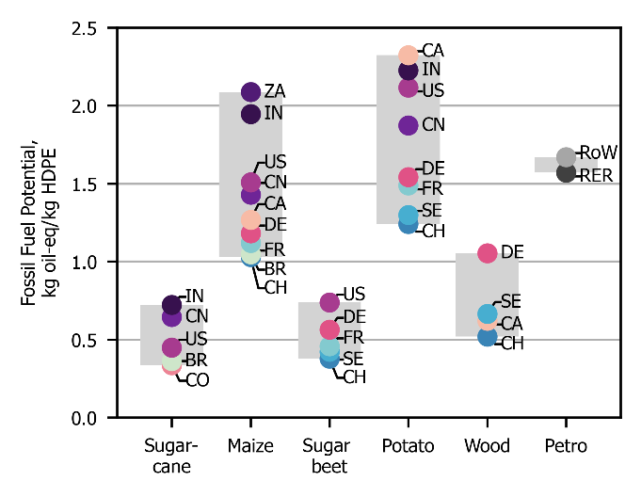 | 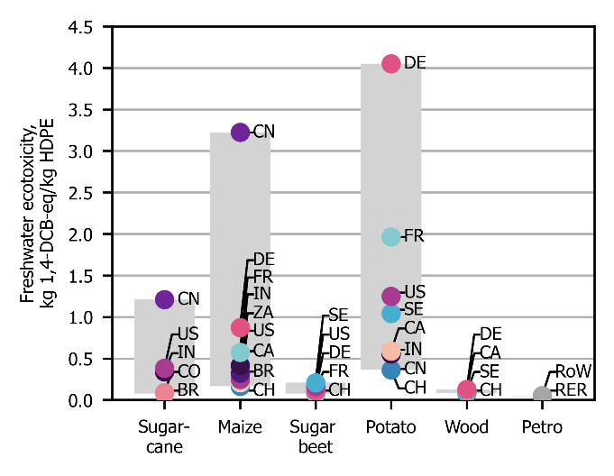
(a) Fossil fuel potential. | (b) Freshwater ecotoxicity.
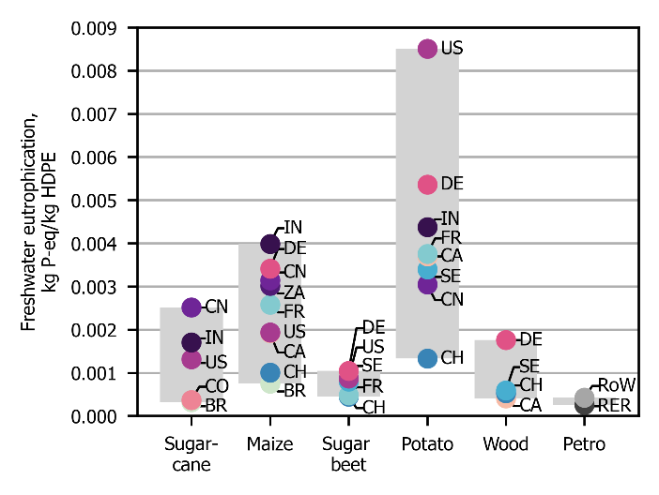 | 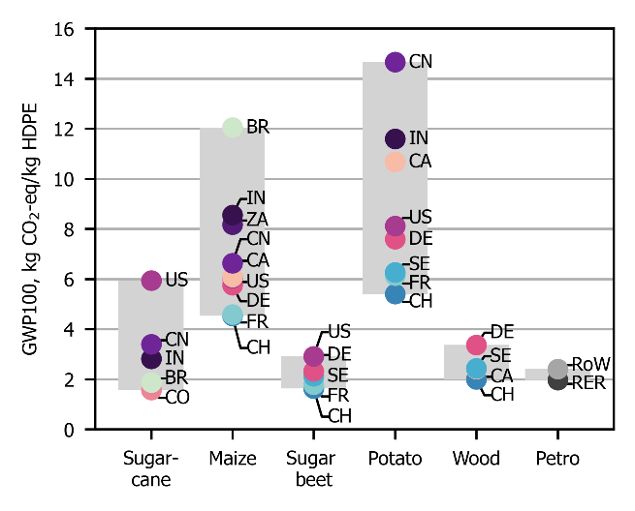
(c) Freshwater eutrophication. | (d) Global warming potential (GWP100).
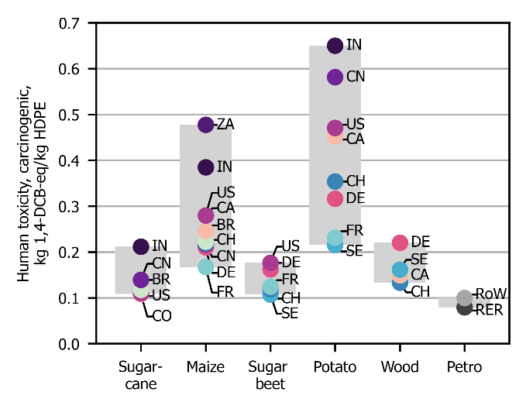 | 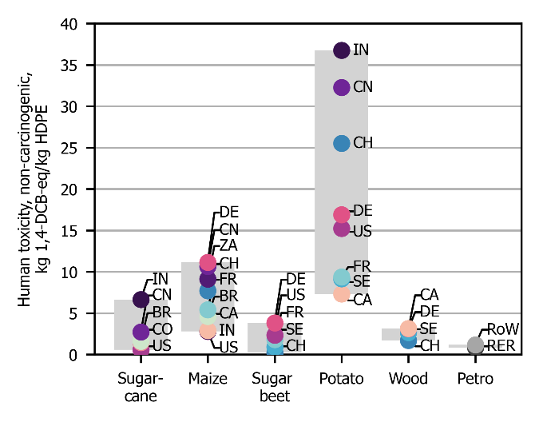
(e) Human toxicity, carcinogenic. | (f) Human toxicity, non-carcinogenic.
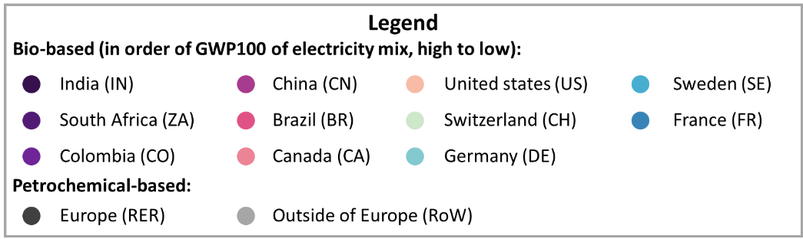

Figure S1.1: Comparison of the environmental impact of petro-HDPE and bio-HDPE from various resources according to the ReCiPe impact categories.
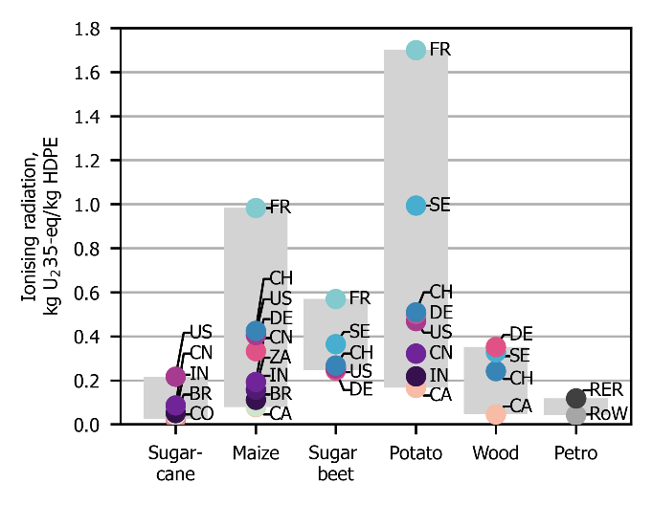 | 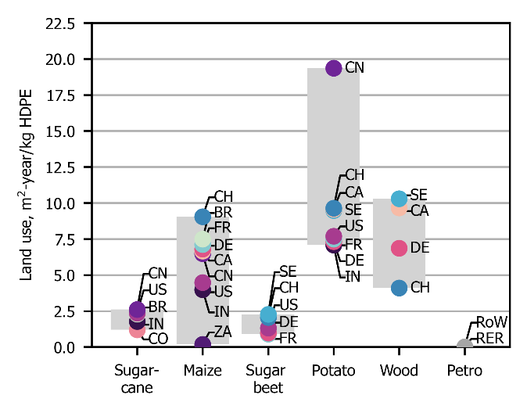
(g) Ionising radiation. | (h) Land use.
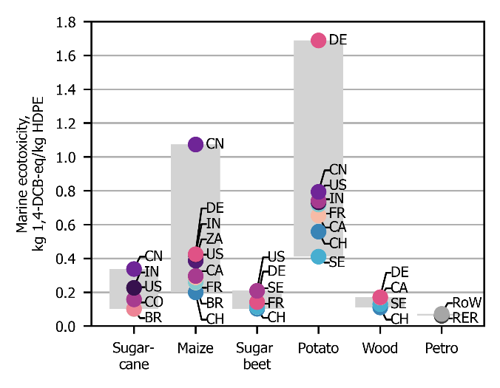 | 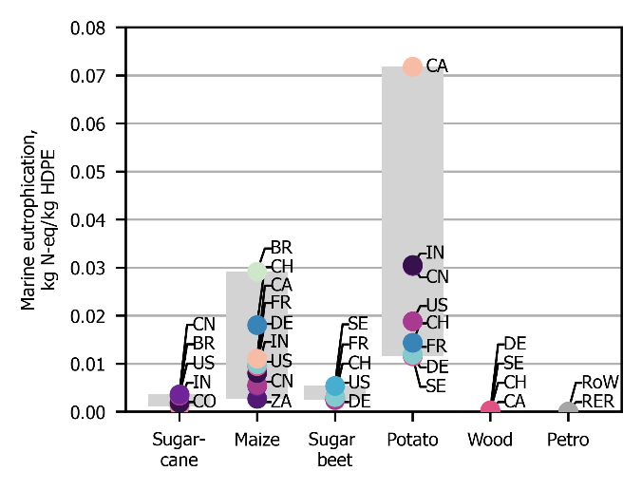
(i) Marine ecotoxicity. | (j) Marine eutrophication.
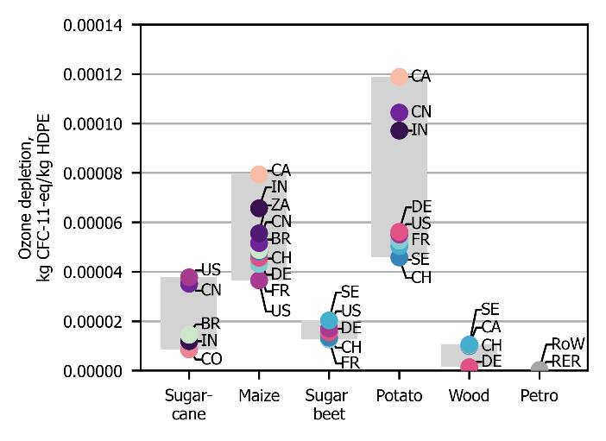 | 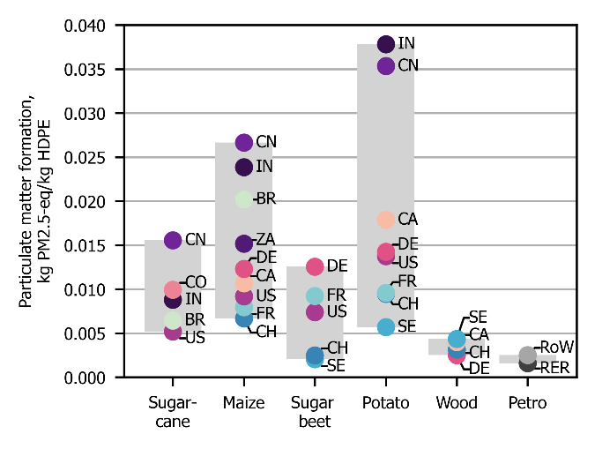
(k) Ozone depletion. | (l) Particulate matter formation.
Figure S1.1: Continued.
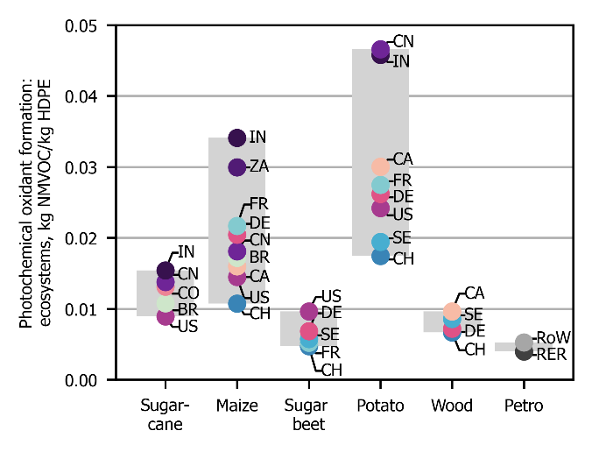 | 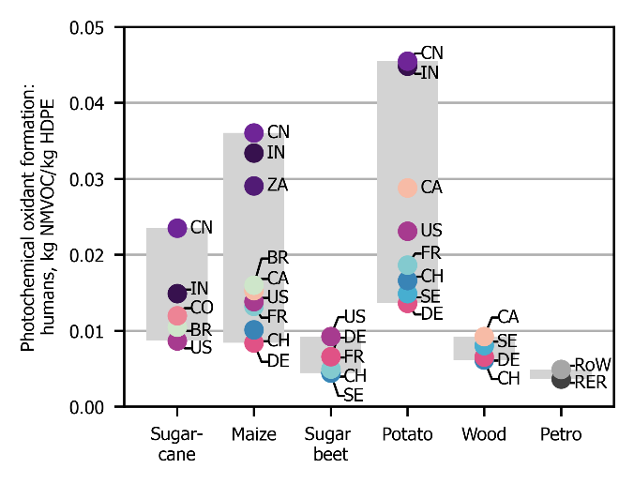
(m) Photochemical oxidant formation: ecosystems. | (n) Photochemical oxidant formation: humans.
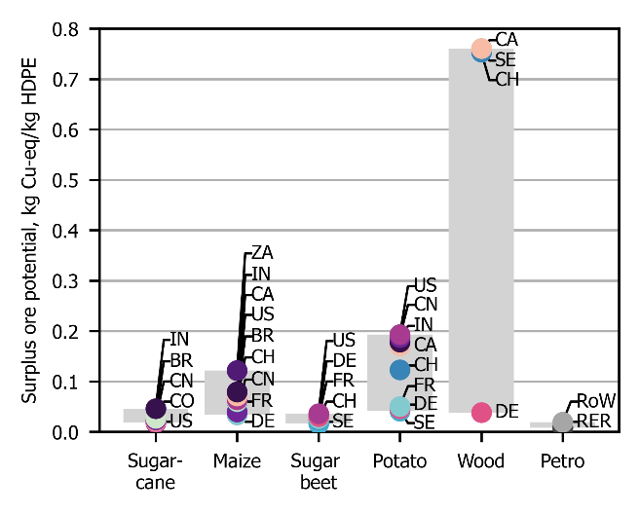 | 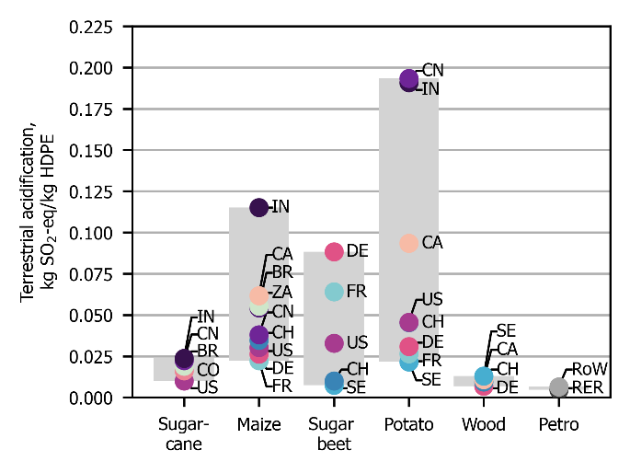
(o) Surplus oil potential. | (p) Terrestrial acidification.
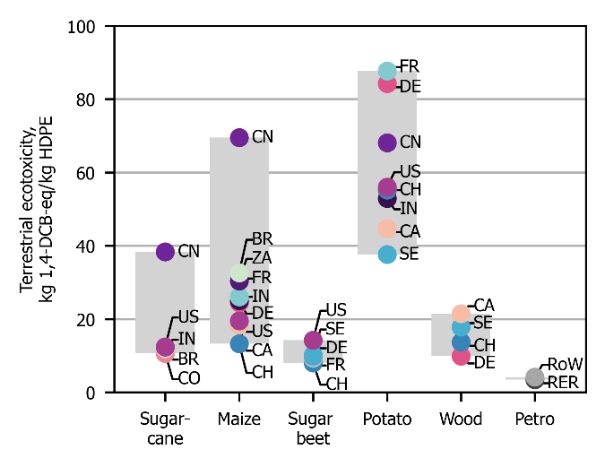 | 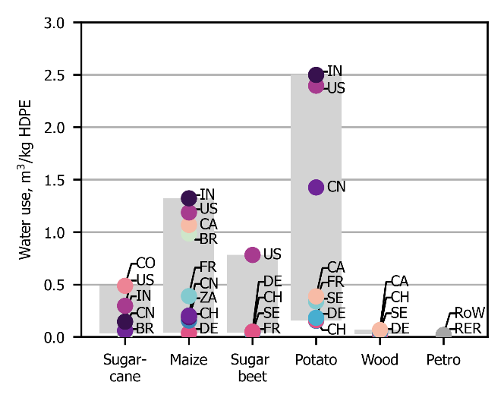
(q) Terrestrial ecotoxicity. | (r) Water use.
Figure S1.1: Continued.

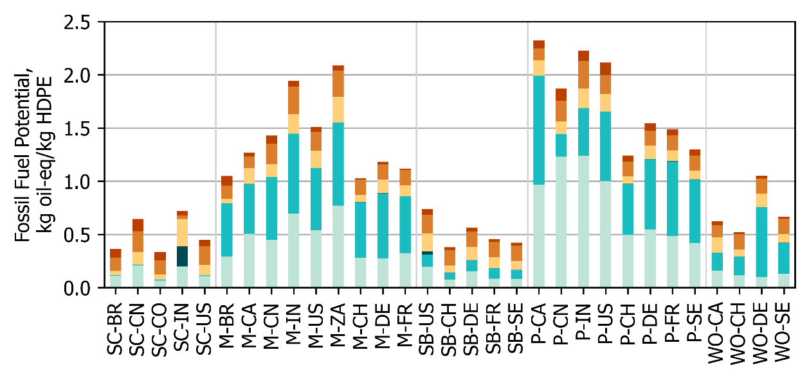
(a) Fossil fuel potential.
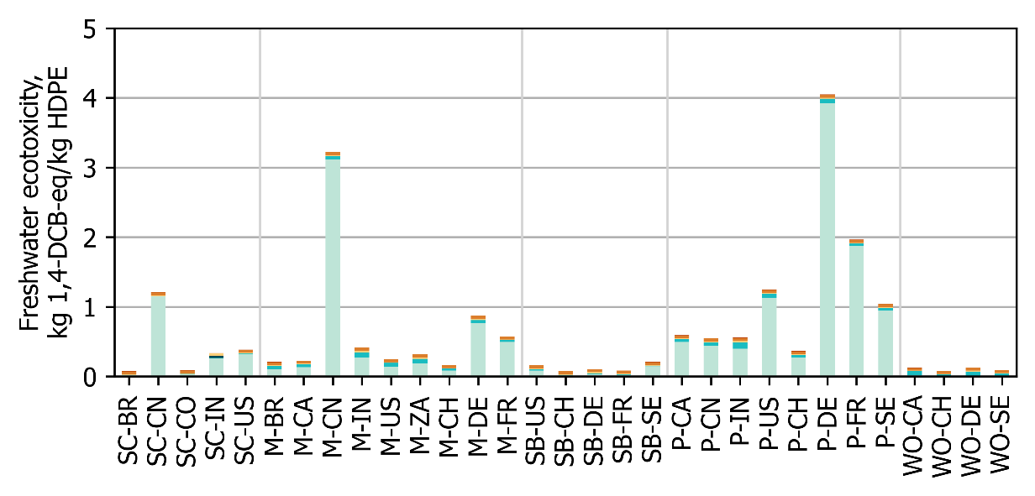
(b) Freshwater ecotoxicity.
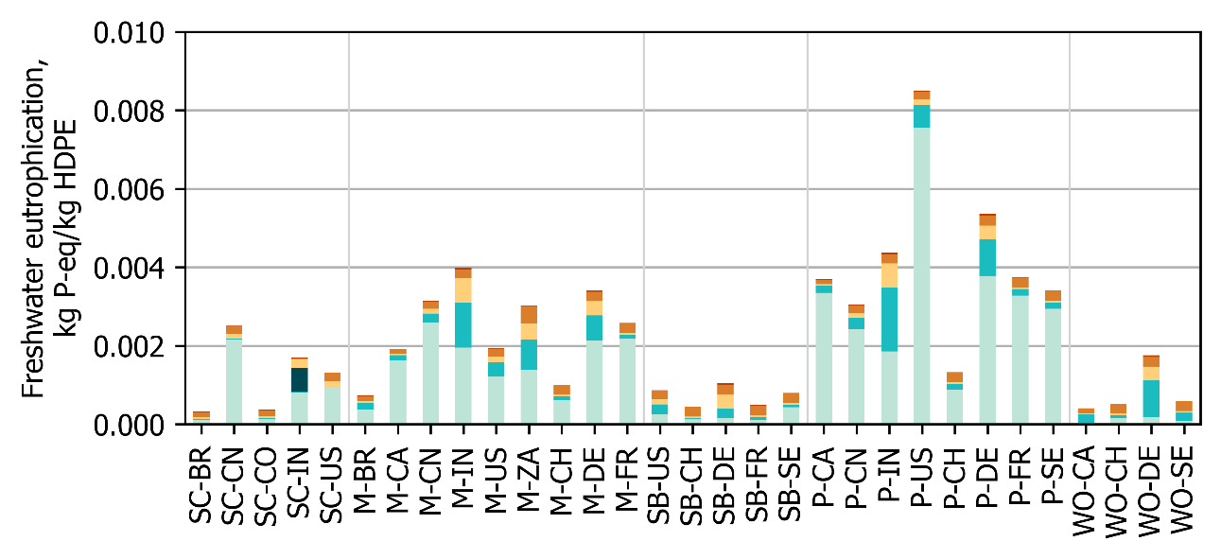
(c) Freshwater eutrophication.
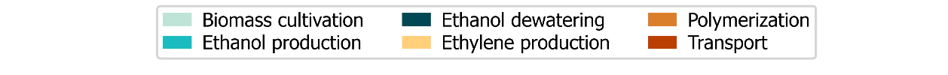
Figure S1.2: Contribution of production stages to the environmental impact of bio-HDPE.
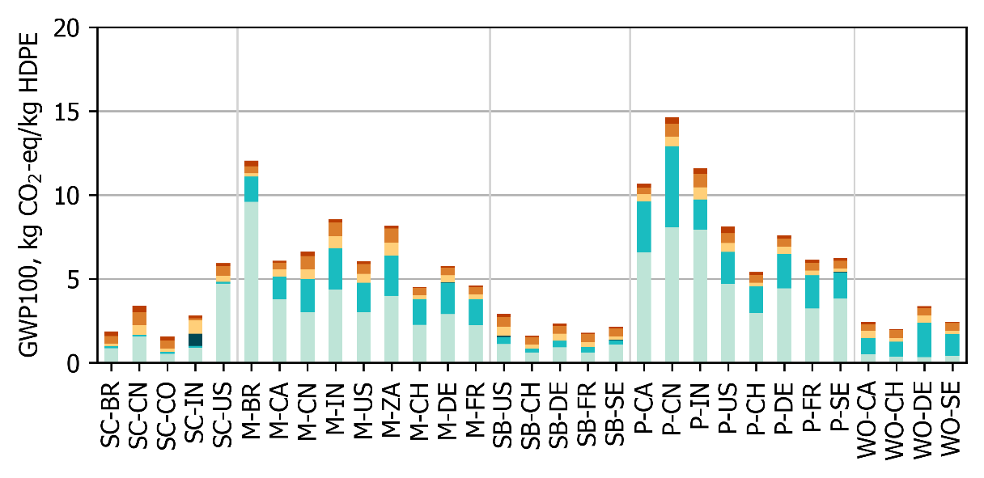
(d) Global warming potential (GWP100).
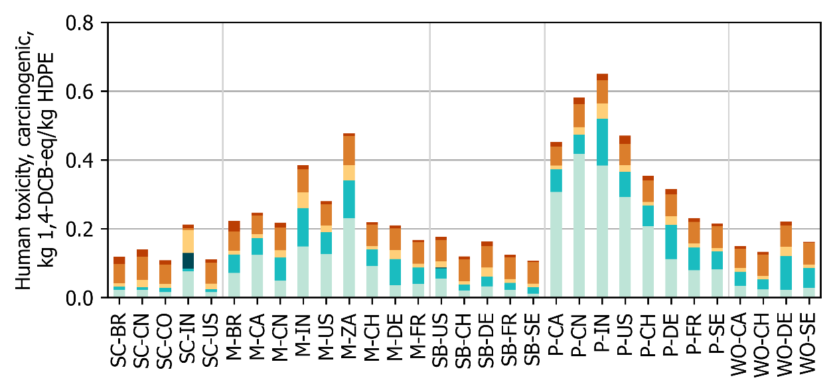
(e) Human toxicity, carcinogenic.
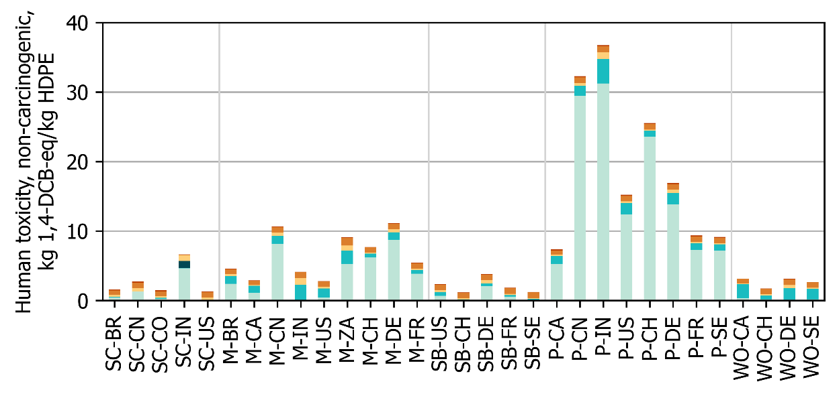
(f) Human toxicity, non-carcinogenic.
Figure S1.2: Continued.

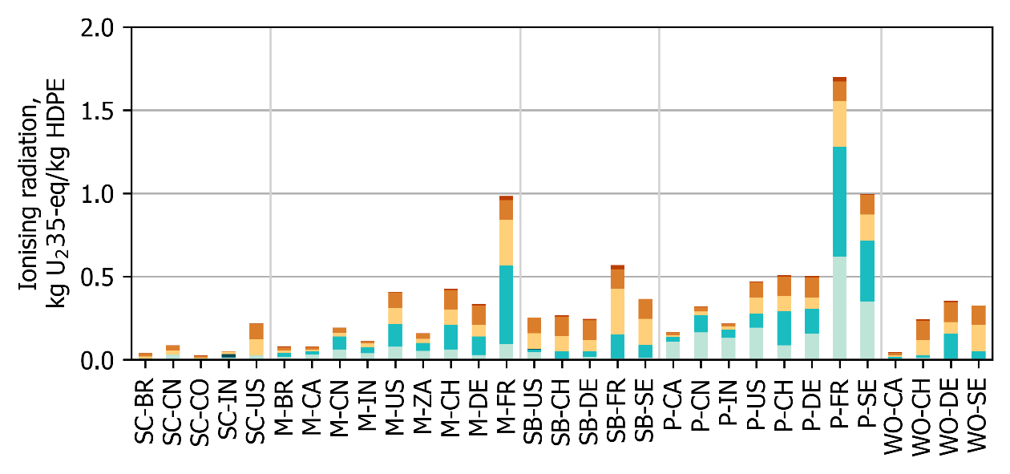
(g) Ionising radiation.
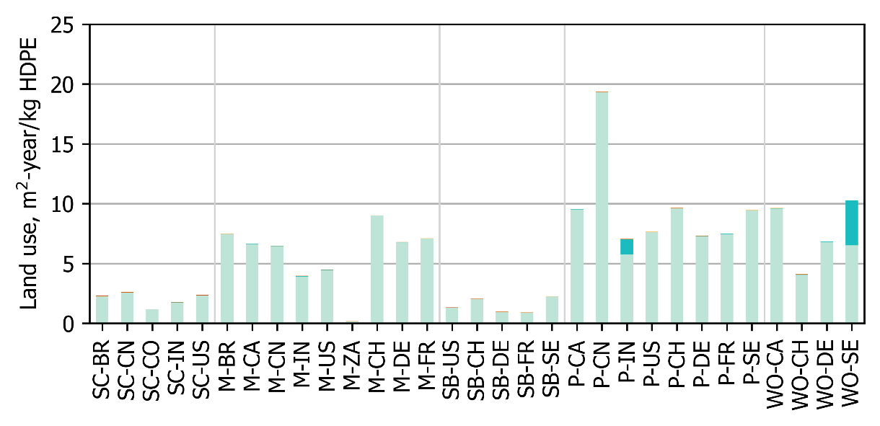
(h) Land use.
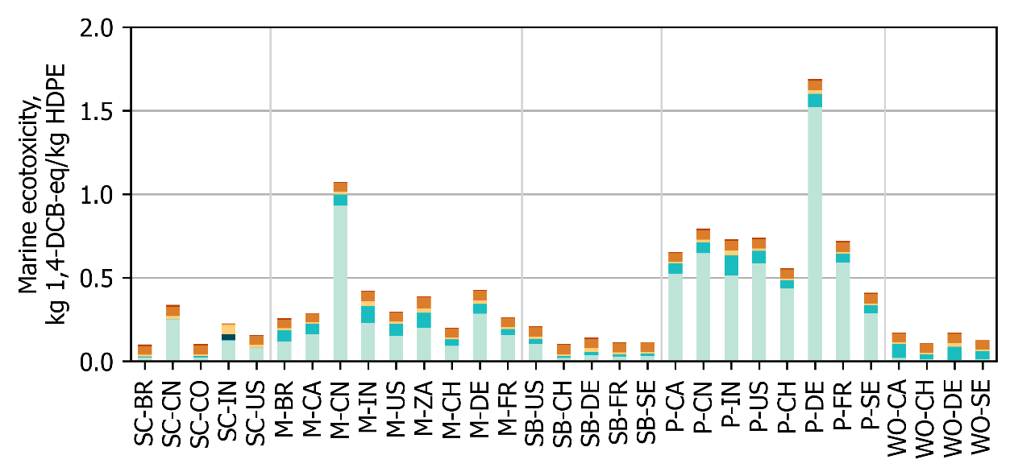
(i) Marine ecotoxicity.
Figure S1.2: Continued.

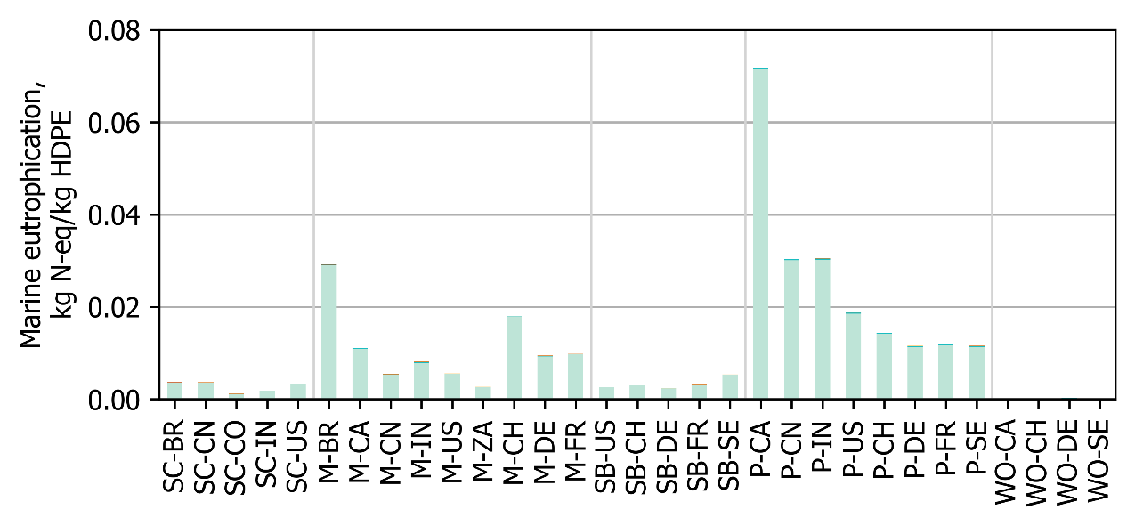
(j) Marine eutrophication.
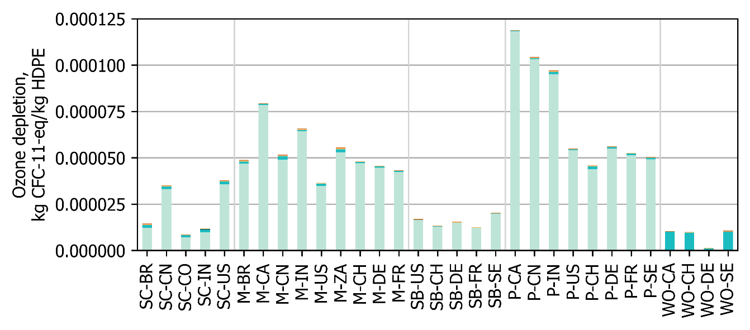
(k) Ozone depletion.
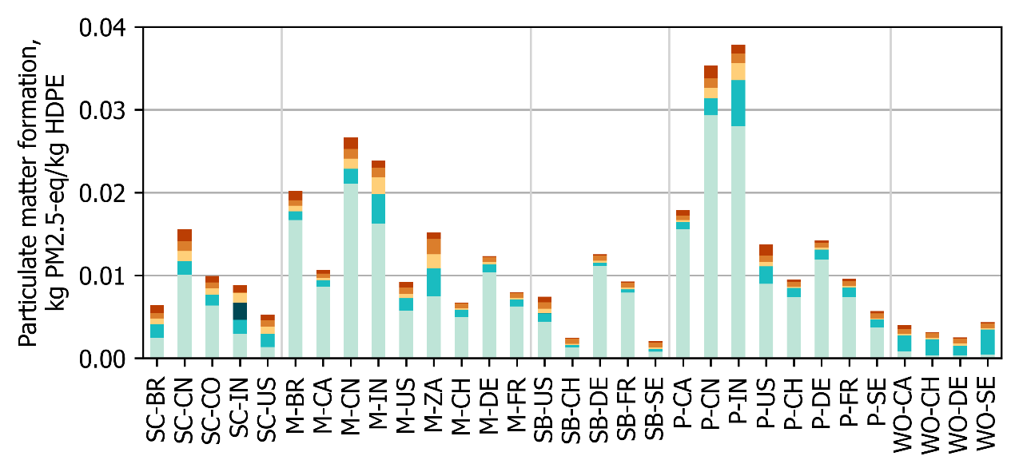
(l) Particulate matter formation.
Figure S1.2: Continued.

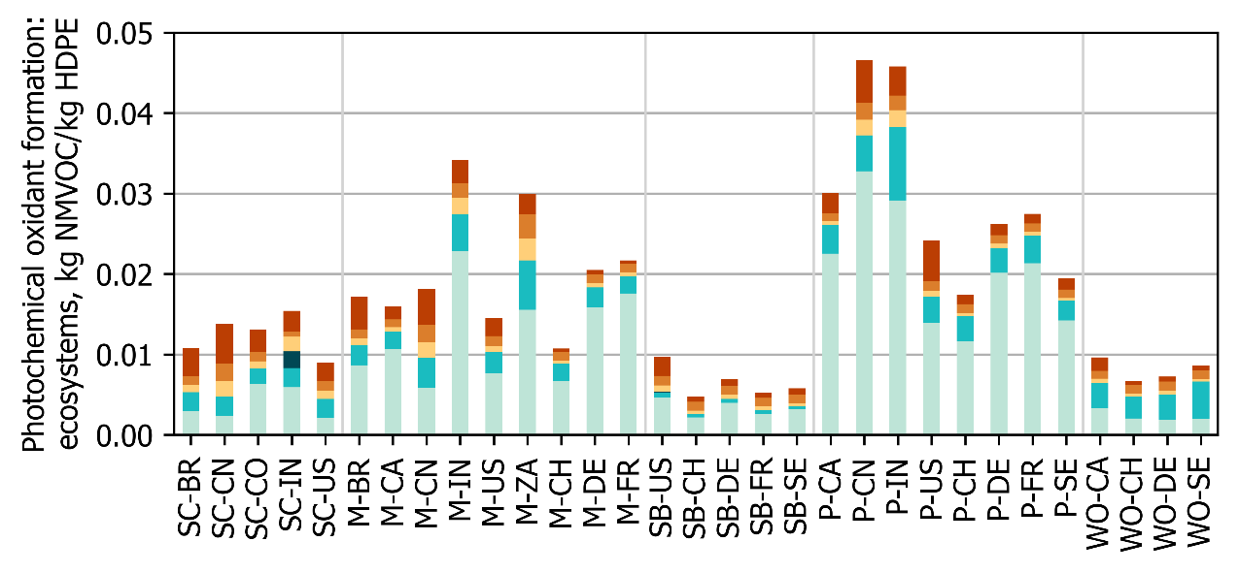
(m) Photochemical oxidant formation: ecosystems.
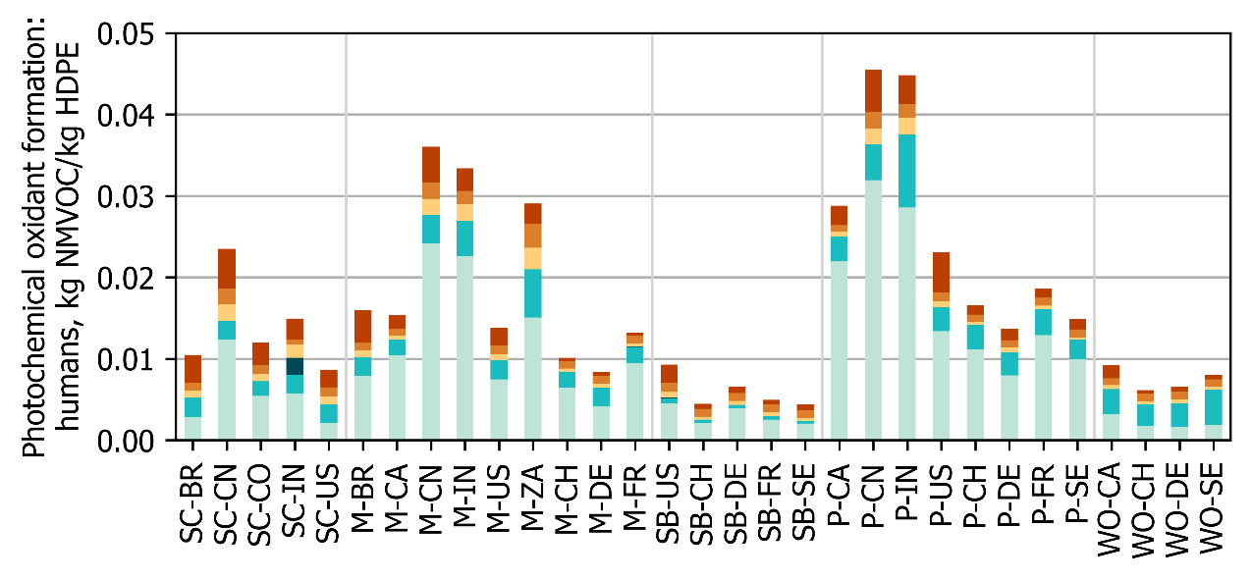
(n) Photochemical oxidant formation: humans.
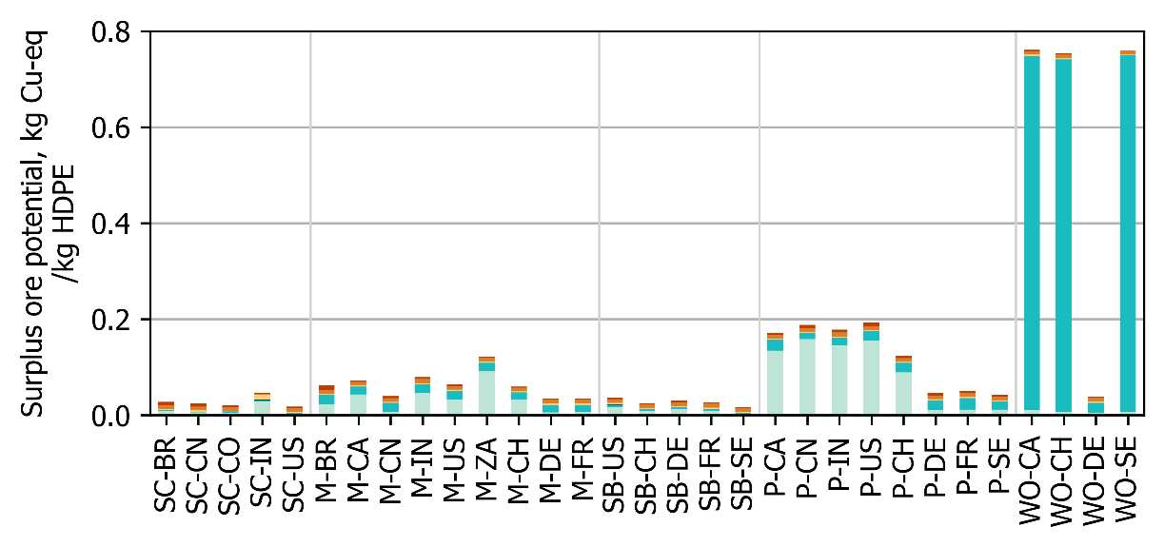
(o) Surplus ore potential.
Figure S1.2: Continued.
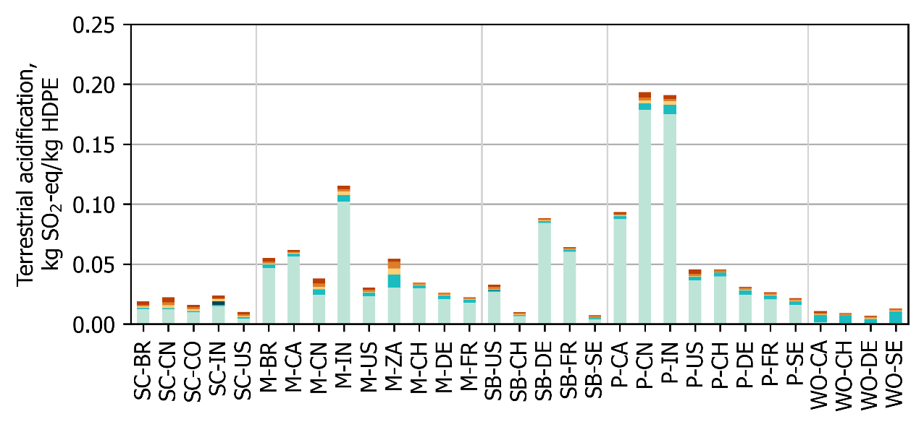
(p) Terrestrial acidification.
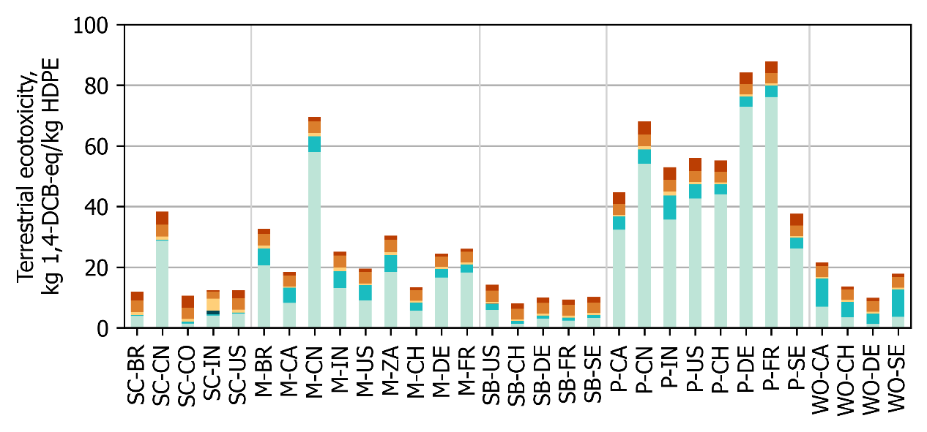
(q) Terrestrial ecotoxicity.
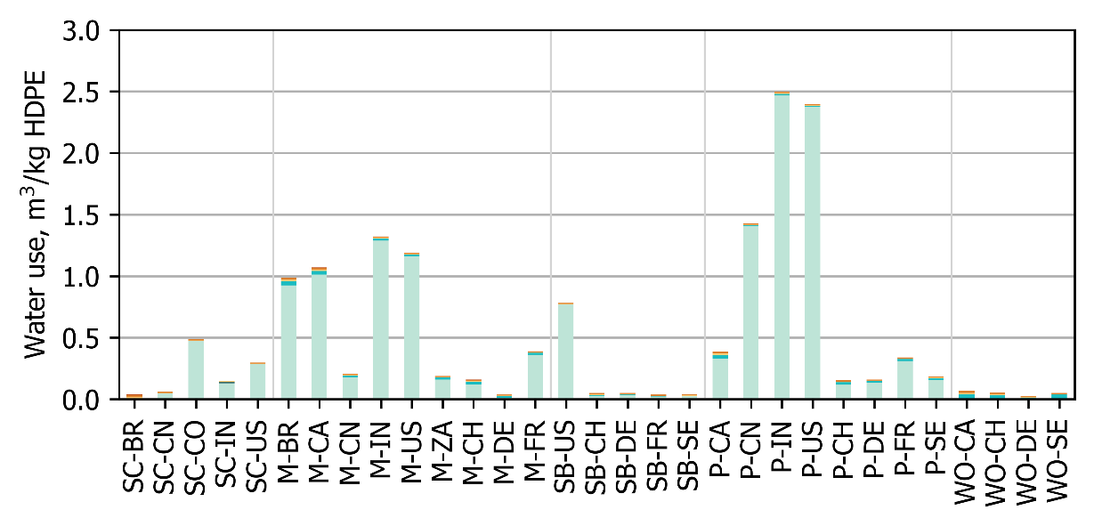
(r) Water use.
Figure S1.2: Continued.

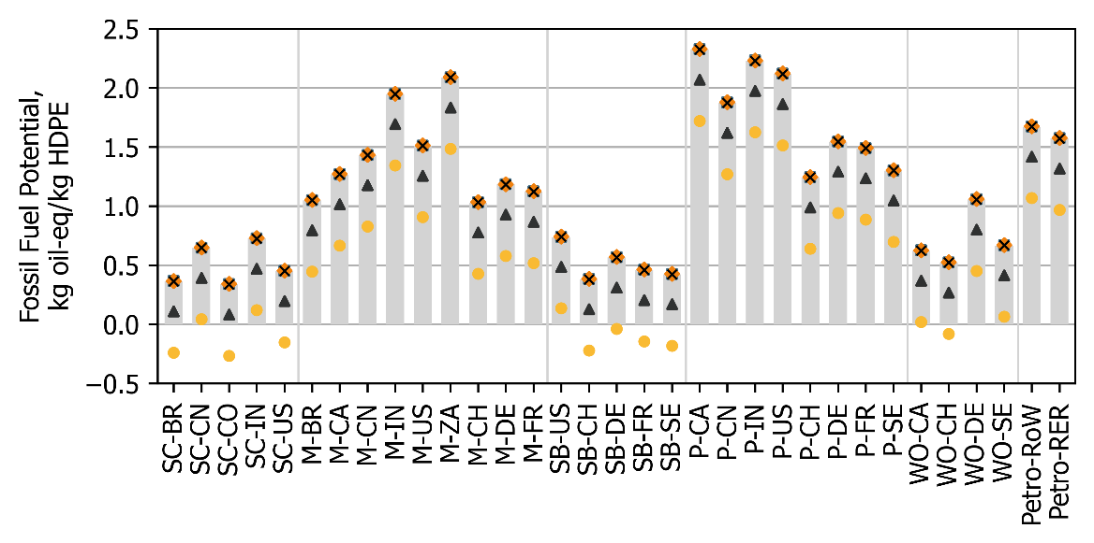
(a) Fossil fuel potential.
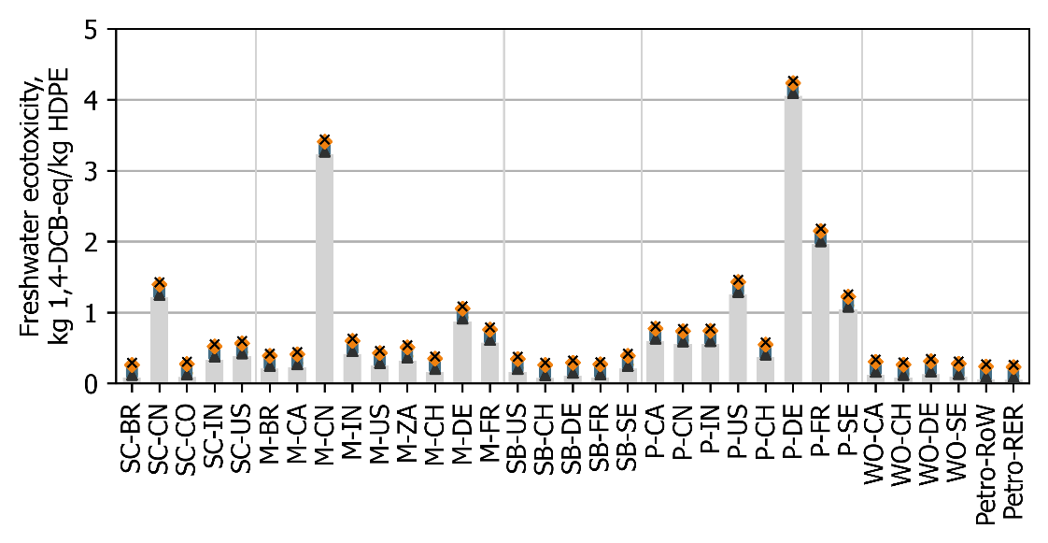
(b) Freshwater ecotoxicity.
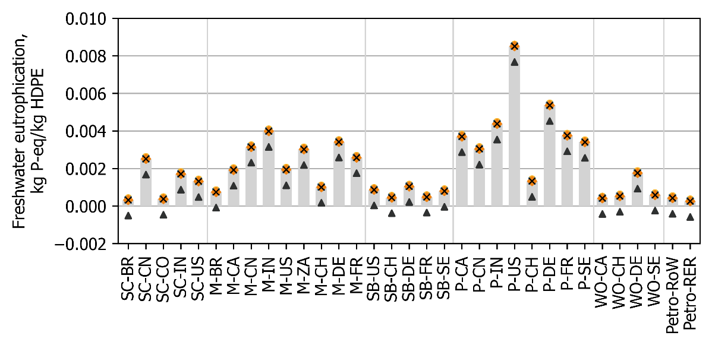
(c) Freshwater eutrophication.
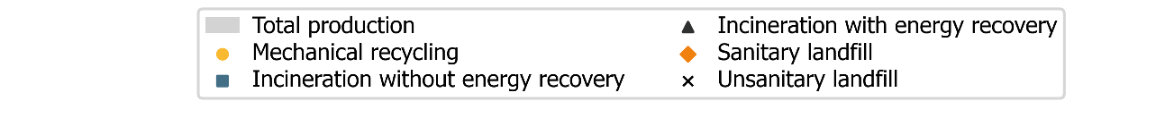
Figure S1.3: Comparison of the environmental impact of three end-of-life treatment options for bio-HDPE and petro-HDPE.
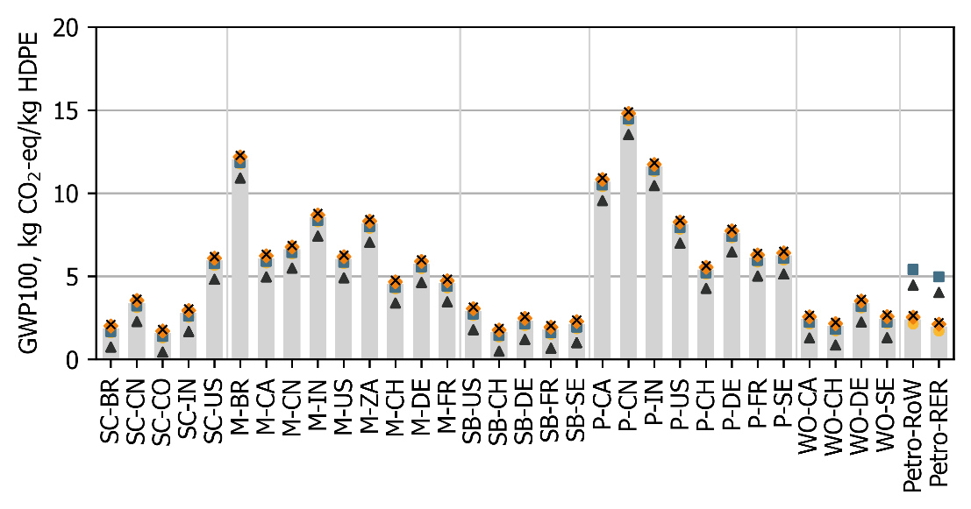
(d) Global warming potential (GWP100).
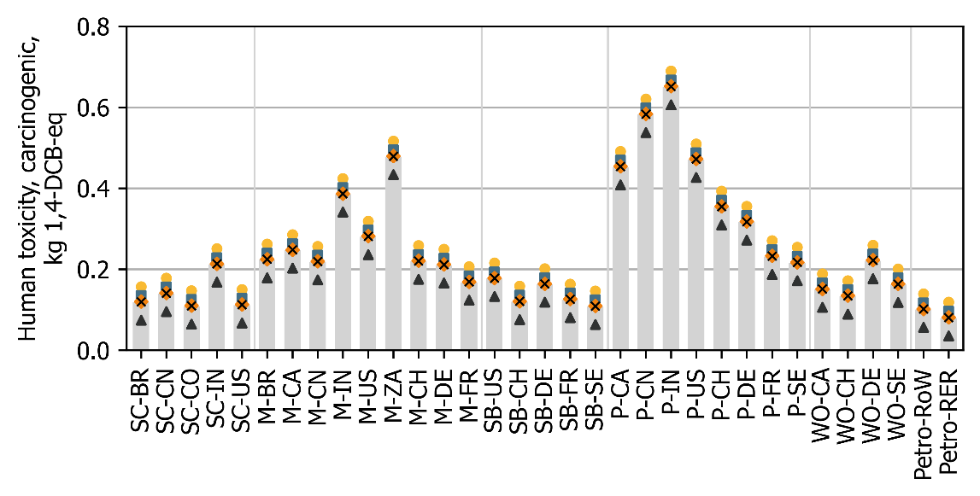
(e) Human toxicity, carginogenic.
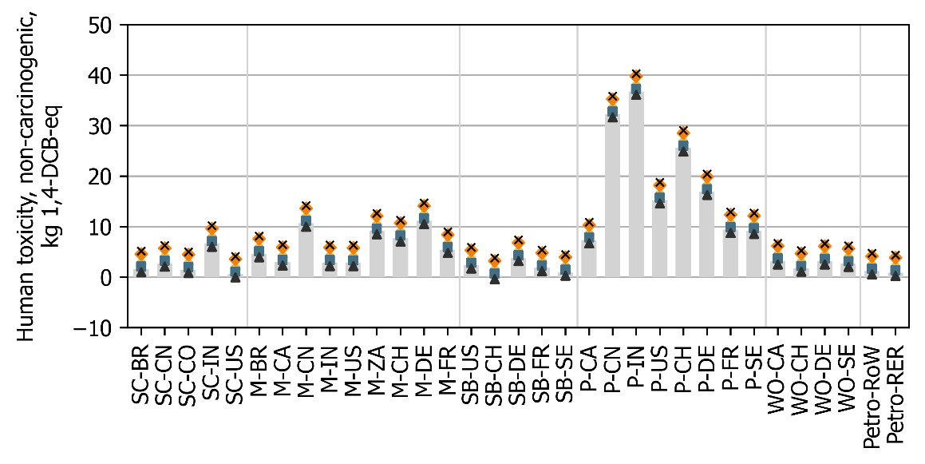
(f) Human toxicity, non-carcinogenic.
Figure S1.3: Continued.

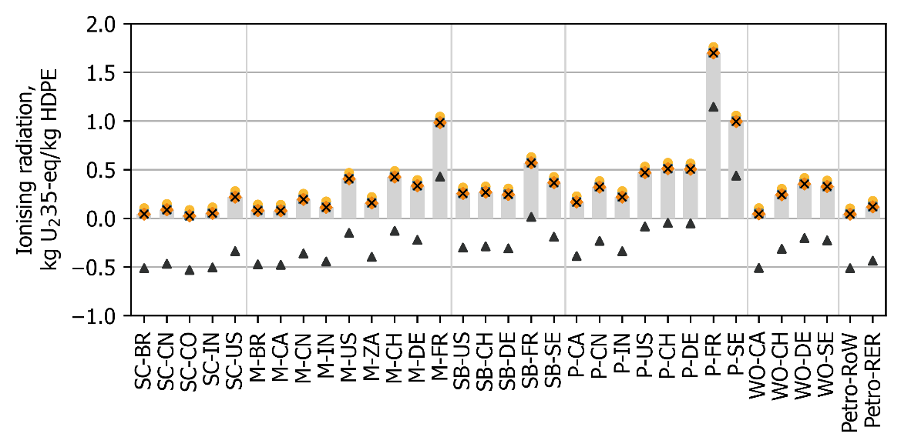
(g) Ionising radiation.
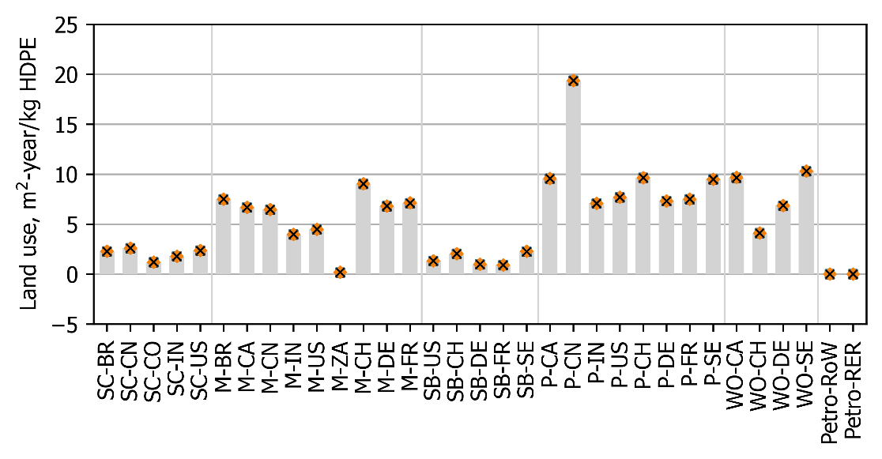
(h) Land use.
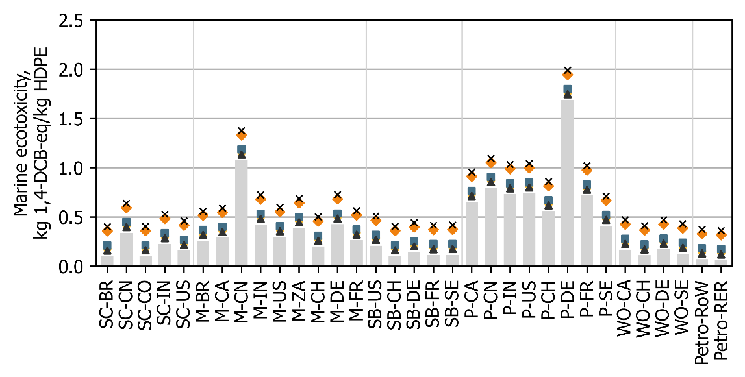
(i) Marine ecotoxicity.
Figure S1.3: Continued.

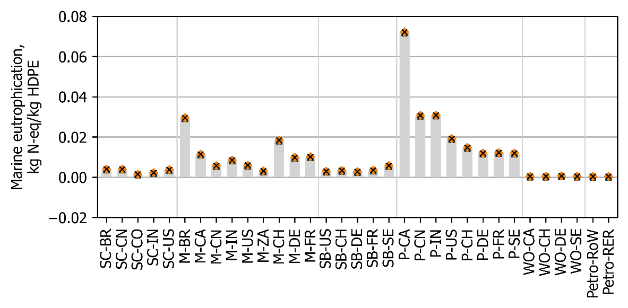
(j) Marine eutrophication.
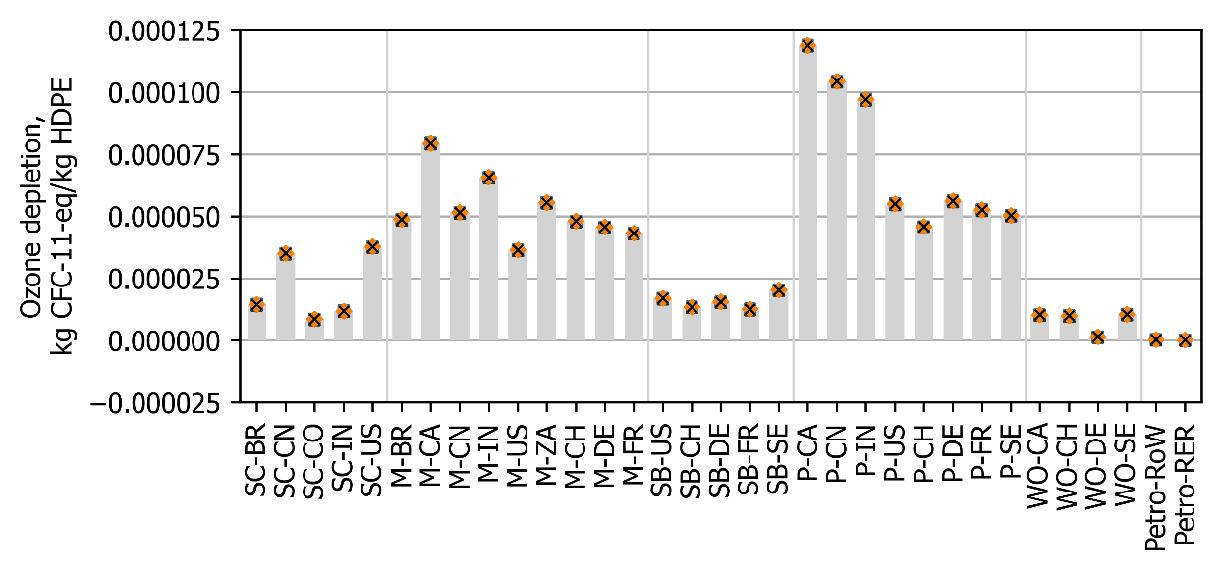
(k) Ozone depletion.
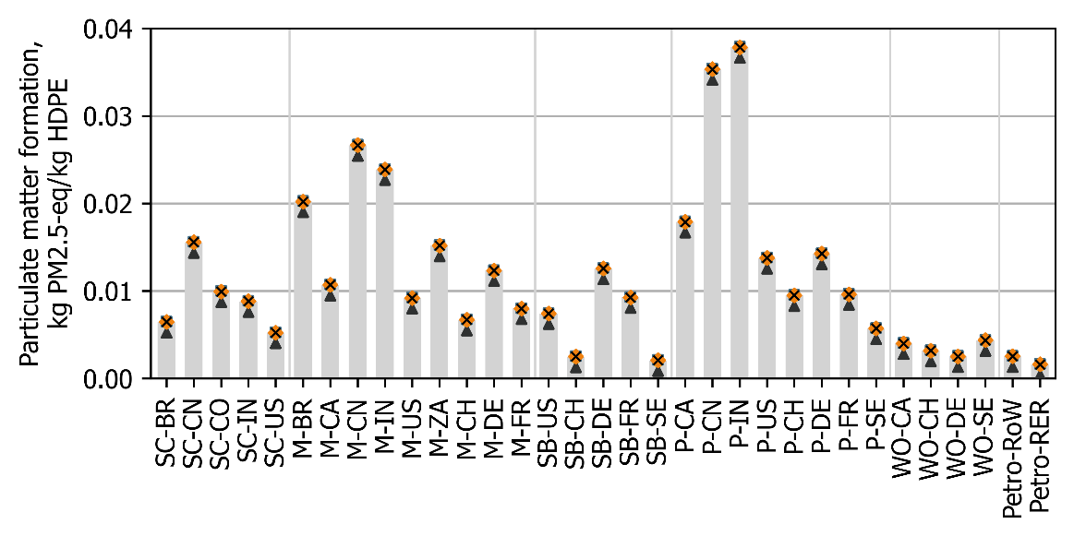
(l) Particulate matter formation.
Figure S1.3: Continued.
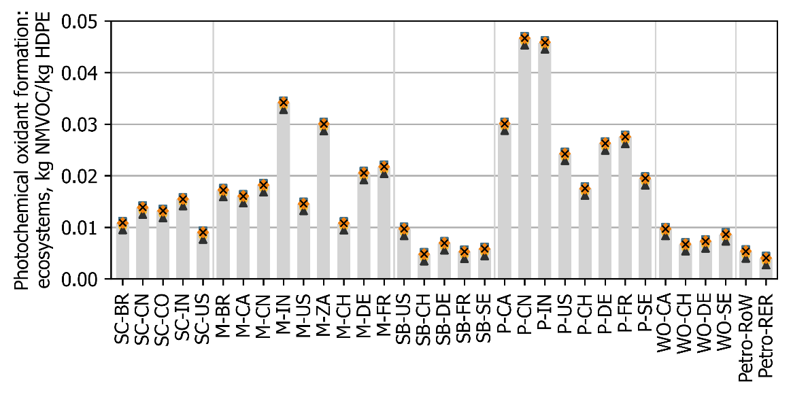
(m) Photochemical oxidant formation: ecosystems.
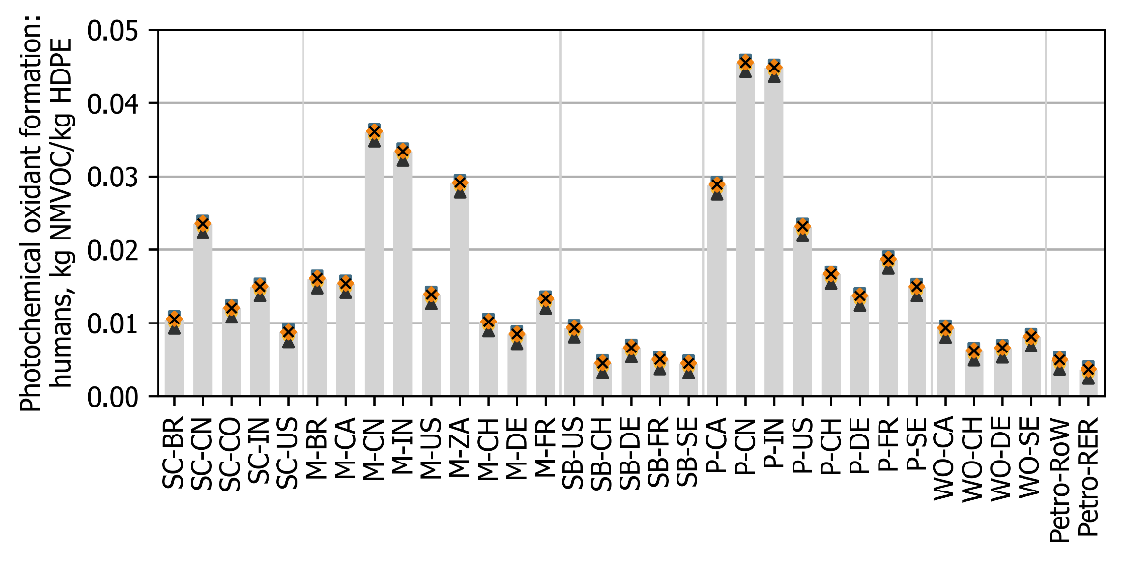
(n) Photochemical oxidant formation: humans.
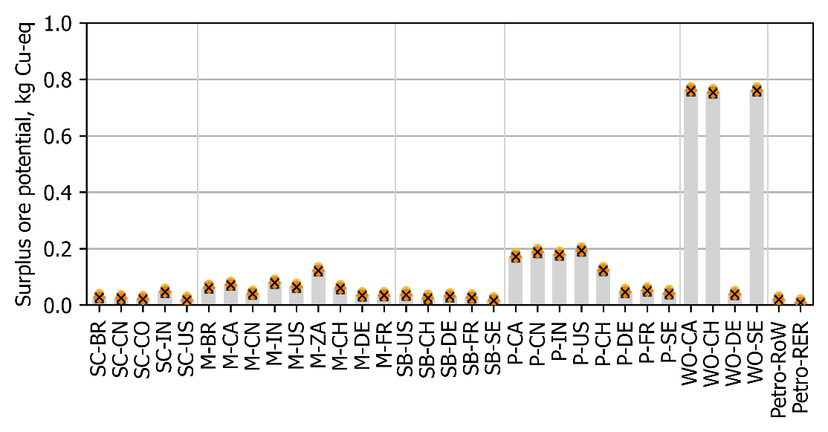
(o) Surplus ore potential.
Figure S1.3: Continued.
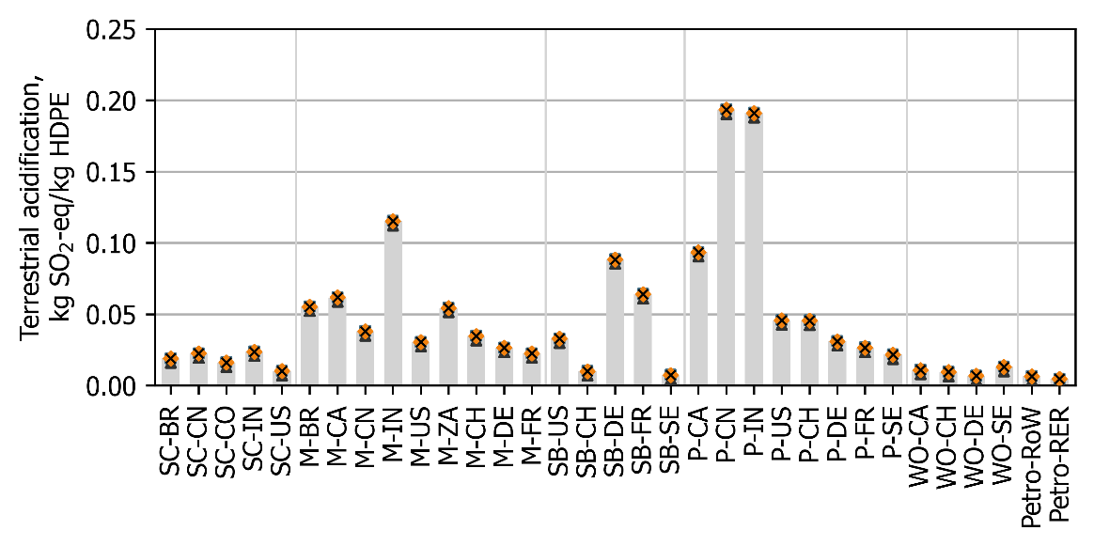
(p) Terrestrial acidification.
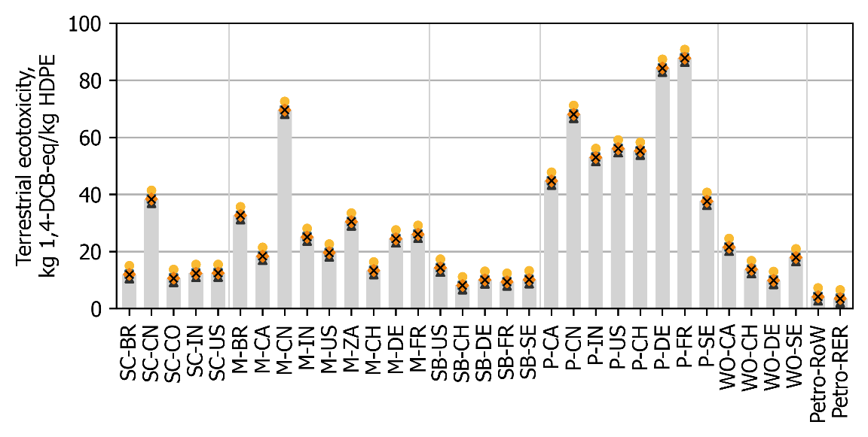
(q) Terrestrial ecotoxicity.
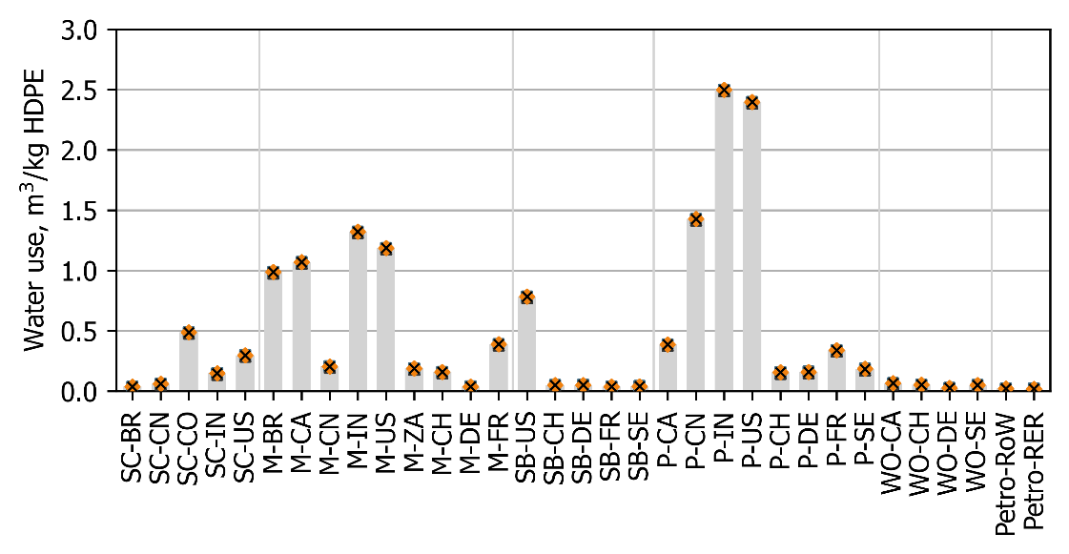
(r) Water use.
Figure S1.3: Continued.
References
Aberdeen Carolina & Western Railway Company. (n.d.-a). Canadian National Railway Map. Retrieved September 25, 2023, from https://www.acwr.com/economic-development/rail-maps/canadian-national
Aberdeen Carolina & Western Railway Company. (n.d.-b). Interactive maps of U.S. Freight railroads. Retrieved September 25, 2023, from https://www.acwr.com/economic-development/rail-maps
Bothast, R. J., & Schlicher, M. A. (2005). Biotechnological processes for conversion of corn into ethanol. Applied Microbiology and Biotechnology, 67(1), 19–25. https://doi.org/10.1007/s00253-004-1819-8
Braskem. (2022). I’m greenTM bio-based PE Life Cycle Assessment.
Google. (n.d.). Maps. Retrieved August 31, 2023, from https://www.google.com/maps
Indian Railways. (n.d.). Indian Railways - Freight terminals dashboard. Retrieved August 31, 2023, from https://www.fois.indianrail.gov.in/RailSAHAY/index.jsp
Jungbluth, N., & Chudacoff, M. (2007). Life cycle inventories of bioenergy. Final Report Ecoinvent …, 17, pp143-157. http://www.researchgate.net/publication/230725648_Life_Cycle_Inventories_of_Bioenergy._ecoinvent_report_No._17/file/9c96051b76e2fb8dce.pdf
Peng, K. (2023). China Railway Map. http://cnrail.geogv.org/enus/about
Sea Distances. (n.d.). Sea Distances / Port Distances. Retrieved August 31, 2023, from https://sea-distances.org/
Statista. (2023). Potato production in the United States in 2022, by state. https://www.statista.com/statistics/382166/us-potato-production-by-state/
U.S. Department of Transportation. (2022). Rail system map. https://gis-fdot.opendata.arcgis.com/apps/rail-system-map-3/explore
United States Department of Agriculture. (n.d.). Quick Stats. Retrieved August 31, 2023, from https://quickstats.nass.usda.gov/
United States Department of Agriculture. (2022). Sugar and sweeteners outlook: September 2023 (Issue October).
Wernet, G., Bauer, C., Steubing, B., Reinhard, J., Moreno-Ruiz, E., & Weidema, B. (2016). The ecoinvent database version 3 (part I): overview and methodology. The International Journal of Life Cycle Assessment, 21, 1218–1230. https://doi.org/10.1007/s11367-016-1087-8
Zhang, M., & Govindaraju, M. (2018). Sugarcane Production in China. In A. De Olivera (Ed.), Sugarcane - Technology and Research. InTechOpen. https://doi.org/10.5772/intechopen.73113
Zhang, Y., Qi, Y., Shen, Y., Wang, H., & Pan, X. (2019). Mapping the agricultural land use of the North China Plain in 2002 and 2012. Journal of Geographical Sciences, 29(6), 909–921. https://doi.org/10.1007/s11442-019-1636-8

