1
SUPPORTING INFORMATION FOR:

Hellmann, A. J. G., Barke, A., Heinze, W., Heimbs, S. & Spengler, T. S. (2024). Using lightweight airframe materials in aircraft structures and investigating potential reinforcement effects with sustainable aviation fuels: An analysis of environmental and economic impacts. Journal of Industrial Ecology.
This Supporting Information S1 provides (1) detailed information on the airframe materials studied, (2) LCA and LCC, (3) further information on the aircraft design process using PrADO and the SHAC studied, (4) assumptions on the airframe production, (5) assumptions on fossil fuel and SAFs, and (6) assumptions on the flight operations.

Contents

1. Airframe materials 2
1.1. Trend toward using carbon fiber reinforced polymer in airframe components 2
1.2. Aluminum alloys 2
1.3. Carbon fiber reinforced polymer 3
2. Life cycle assessment and life cycle costing 4
3. Short- and medium-haul aircraft specifications 6
3.1. PrADO 6
3.2. Aircraft configuration and structural design specifications 9
4. Assumptions concerning airframe production 13
4.1. Airframe component breakdown 13
4.2. Airframe production network 16
4.3. Raw materials 17
4.4. Energy requirement 19
4.5. Transports 20
4.6. Production costs 20
5. Assumptions concerning fossil kerosene and sustainable aviation fuels 22
6. Assumptions concerning flight operations 23
6.1. Flight operations 23
6.2. Maintenance 23
6.3. Reference flight 26
7. References 28

Airframe materials
This section gives further information on the increasing importance of carbon fiber reinforced polymer (CFRP) and its significance as a substitute for aluminum alloy (Al) in aircraft structures (Section S1-1.1). In addition, the compositions of the Al considered in the study are described (Section S1-1.2), and the properties and production process of the lightweight material CFRP are explained in more detail (Section S1-1.3).

Trend toward using carbon fiber reinforced polymer in airframe components
The study focuses on the materials Al and CFRP and their proportions in the airframe, as this proportion has significantly changed in recent years. A trend toward using CFRP in aircraft structures can be observed, which is attributed to the material properties of CFRP (Breuer, 2016). The material has a density of 1,500-2,000 kg per m³, which is significantly lower compared to Al, which has a density of 2,600-2,800 kg per m³. This lower density of CFRP, along with its good stiffness and strength, allows aircraft structures to achieve the same load-bearing capacity as Al structures while reducing the structural weight (Huang, 2003; Ren et al., 2017).
This material shift from Al to CFRP can be observed in the difference in material composition between the Airbus A320 and A350 XWB. The Airbus A320 had its maiden flight in 1987, and its airframe is composed of 72% Al and only 10% CFRP (Airbus S.A.S., 2022b). In contrast, the A350 XWB, which had its first flight in 2015, comprises just 19% Al and 53% CFRP in the airframe (Airbus S.A.S., 2013a). Despite being generally more costly, composites have become popular in high-performance products that require lightweight materials that can withstand high loads, such as aerospace structures (Soutis, 2005). The material was first used in the mid-1950s for secondary structures, which include non-structural applications. Initially restricted to these structures, the first primary structures for the civil aerospace sector incorporating CFRP were implemented in the 1980’s. Primary structures are essential, load-bearing components of an aircraft, such as the wing or fuselage (Baker & Scott, 2016). The good performance and low maintenance of the material have led to its increased use in primary structures in subsequent aircraft models (Boyer et al., 2015; Hünecke, 2004).

Aluminum alloys
As a structural material in aircraft construction, aluminum is almost exclusively used as an alloy due to the low strength of pure aluminum (Roos et al., 2022). The study considered two aluminum wrought alloys, EN AW-2024-T6 and EN AW-7075-T6, for the structural design of the aircraft. Both alloys have a density of 2,854 kg per m³, as specified in the Preliminary Aircraft Design and Optimization program (PrADO) from the Institute of Flight Guidance at Technische Universität Braunschweig. They are solution-annealed, quenched, and artificially aged (Roos et al., 2022). EN AW-2024-T6 is an aluminum-copper-magnesium alloy (AlCuMg) consisting of 93.2% aluminum, 3.8% copper, and 1.2% magnesium. It also contains small amounts of silicon (0.5%), iron (0.5%), manganese (0.3%), zinc (0.15%), titanium (0.15%), and chromium (0.1%) (Deutsches Institut für Normung e.V., 2022). This heat-treatable alloy exhibits high strength in the age-hardened state but is prone to corrosion due to its copper content (Arnold, 2017; Roos et al., 2022). The EN AW-7075-T6 is an aluminum-zinc-magnesium alloy (AlZnMg) composed of 90.02% aluminum, 5.1% zinc, 2.1% magnesium, 1.2% copper, 0.5% iron, 0.4% silicon, 0.3% manganese, 0.2% titanium, and 0.18% chromium (Deutsches Institut für Normung e.V., 2022). This age-hardened aluminum alloy, based on the main alloying elements zinc and magnesium, is frequently used in aircraft construction due to its high strength. However, it is also susceptible to corrosion (Arnold, 2017; Roos et al., 2022).

Carbon fiber reinforced polymer
The second material to be analyzed in this study is CFRP, a fiber-plastic composite (Horst & Wolf, 2014). CFRP is an ideal lightweight construction material due to its high specific stiffness, strength, and low mass. It is considered a replacement for metals in lightweight construction, although it is associated with higher costs (Arnold, 2017; Horst & Wolf, 2014). The material mainly consists of carbon fibers, which are those with the most outstanding properties among reinforcing fibers (Schürmann, 2007). Carbon fibers used in the aerospace industry can withstand high temperatures and possess exceptional stiffness and strength. These kinds of fibers are also referred to as aerospace-grade carbon fiber. However, their cost is a disadvantage, which increases with the modulus of elasticity and the roving of the yarn (Horst & Wolf, 2014).
The most common precursor for carbon fibers is the textile fiber polyacrylonitrile (PAN), which accounts for over 90% of the market (Schürmann, 2007). The main monomer used to produce PAN is acrylonitrile, which is primarily produced through the Sohio process using propylene, ammonia, and oxygen. The precursor PAN is manufactured through the addition polymerization of acrylonitrile with 5% co-monomers, such as the vinyl ester methyl methacrylate in solution (Johnson & Sullivan, 2014; Morgan, 2005). After polymerization, PAN is spun into fibers for further processing (Johnson & Sullivan, 2014). Subsequently, carbon fibers are produced from the precursor PAN through several process steps. Initially, the PAN fibers are stabilized by oxidation at temperatures ranging from 180-350°C. In a subsequent step, the stabilized PAN fibers are carbonized at temperatures up to 1500°C (Khalil, 2017; Schürmann, 2007; Timmis et al., 2015).
The carbon fibers are treated and sized before being combined with the polymer. The sized carbon fibers are then used to produce carbon prepreg by combining them with a polymer matrix (Khalil, 2017). Prepregs are pre-impregnated, continuous, unidirectional fiber webs that offer superior strength and quality in fiber composite technology. They are commonly used in highly stressed structures in aircraft construction and are typically made from carbon fibers and epoxy resins (Horst & Wolf, 2014). Epoxy resins are generally the most widely used polymer matrix in aircraft construction due to their excellent adhesive and fatigue strength (Horst & Wolf, 2014). As is the case with all fiber composites, the arrangement of the fibers determines the mechanical properties (Arnold, 2017). The proportion of fiber volume in relation to the total volume is relevant for designing CFRP components. A standard ratio of 60% carbon fibers and 40% polymer matrix has been established. A higher fiber volume ratio is avoided due to the potential for a local lack of matrix, which can result in poor bonding between the fibers and matrix (Horst & Wolf, 2014). For operations with strongly changing forces and force directions, carbon prepreg is processed and arranged as an aircraft construction laminate with four fiber directions(Horst & Wolf, 2014). CFRP has exceptional fatigue strength due to its high-strength fibers, and crack propagation is inhibited by dividing the cross-section into numerous fibers. The fibers and polymer matrix also exhibit excellent corrosion resistance, reducing maintenance costs associated with corrosion problems (Horst & Wolf, 2014).
For the aircraft structural designs to be analyzed in this study, the use of different types of carbon composite laminate as airframe material is specified in PrADO, including T300 15k/976 and HTS40 12k/RTM6. T300 15k/976 is a carbon-epoxy unidirectional tape with a density of 1,620 kg per m³. It is made of the high-performance carbon fiber T300 with a roving of about 15.000 fibers per carbon fiber strand and the Fiberite 976 epoxy resin (SAE International, 2018). HTS40 12k/RTM6 has a density of 1,518 kg per m³ and consists of the high-performance carbon fiber HTS40 with a roving of around 12.000 fibers per carbon fiber strand. It is created through a resin transfer molding process with RTM6, a mono-component epoxy system specifically designed for this process (Hexcel Corporation, 2022). These materials are used to create aircraft construction laminates. The third CFRP is also a laminate with a density of 1,600 kg per m³, similar to the other two, and is only identified as such in PrADO.

Life cycle assessment and life cycle costing
Various methods for assessing environmental and economic aspects exist in science and industry, with life cycle assessment (LCA) and life cycle costing (LCC) being the most widespread. These methods enable detailed modeling and analysis of product systems along the life cycle or in individual life cycle phases.
The basic procedure of these sustainability assessment methods was initially developed for the LCA and is specified in the ISO 14040:2021-02 and 14044:2021-02 standards (Deutsches Institut für Normung e.V., 2021a, 2021b). This standardized procedure for applying LCA consists of four phases: 1.) Goal and scope definition, 2.) inventory analysis, 3.) impact assessment, and 4.) interpretation (see Figure S1-1). During the goal and scope definition, the subject of the study, the system boundaries, and the functional unit, which establishes the reference to which all energy and resource flows are normalized, are defined. In the subsequent inventory analysis, the inventory data, which describes exchanges between the unit processes within the system boundaries and the external environment along the life cycle, is collected. Afterward, the inventory data is assigned to environmental impact categories, and impact scores are calculated in the impact assessment phase. Here, the impact categories can be differentiated between midpoint and endpoint levels. Midpoint indicators are used to describe immediate environmental impacts with comparatively low uncertainty. Besides these midpoint indicators, endpoint indicators exist that describe more indirect consequences for different areas of protection with increased uncertainty (Finnveden et al., 2009; Goedkoop et al., 2013). In the interpretation phase, the environmental assessment results are evaluated and interpreted. In this phase, the results are validated, sensitivities are determined, and decision-makers preferences can be integrated. This step accompanies the other steps and should be carried out in an iterative procedure, as new findings, data limitations, or stakeholder preferences may lead to a redefinition of the study (Grubert, 2017; Thies et al., 2021; UNEP/SETAC, 2011).
The LCC method is used to analyze the economic aspects of product systems. LCC is typically divided into conventional LCC, environmental LCC, and societal LCC. The conventional LCC aims to estimate the costs associated with the existence of a product system, while environmental and societal LCC extend this estimation by considering further externalities that could be internalized in the future (Rebitzer & Hunkeler, 2003). To carry out the environmental and economic assessment of product systems within identical system boundaries and with the same functional unit, the environmental LCC is normally used (Hunkeler et al., 2008). For the application of environmental LCC, an economic value is assigned to each unit process within the system boundaries in the inventory analysis phase. In the subsequent impact assessment phase, these economic values are linked to economic indicators that should be analyzed and that are similar to midpoint indicators in the LCA (Heijungs et al., 2013; Moreau & Weidema, 2015). The interpretation phase is similar to the LCA, focusing on economic aspects.
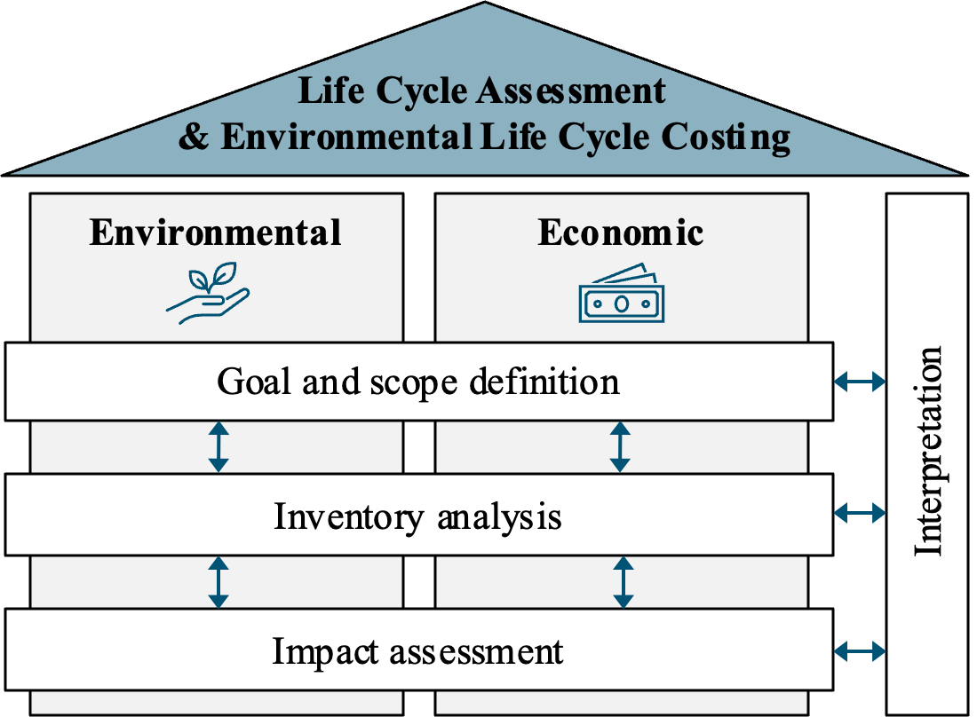

Figure S1-1: Framework for LCA and LCC adopted from Barke, Bley, et al. (2022)

Short- and medium-haul aircraft specifications
In this section, details on the aircraft design program PrADO and the underlying design procedure are described (Section S1-3.1). Furthermore, the aircraft configurations and the structural design specifications are presented (Section S1-3.2).

PrADO
For the overall assessment on an environmental and economic level, data is required for converged aircraft design that includes mass distributions down to the (sub)component level. For state-of-the-art aircraft, this data is not publicly available due to restrictions imposed by aircraft manufacturers. Therefore, integrated design procedures simulating the multidisciplinary design process can be used to obtain results for overall aircraft assessments of new aircraft concepts as part of public research activities. Such a design procedure enables the design tool PrADO (Preliminary Aircraft Design and Optimization) developed by the Institute of Aircraft Design and Lightweight Structures (IFL) at the Technische Universität Braunschweig with which the complete design process of a commercial aircraft can be simulated (Heinze et al., 2001). Figure S1-2 depicts the PrADO structure and data flows.
The various design modules (MDs) represent the contributions of the disciplines involved in the aircraft design process. These modules are linked by a database management system (DMS), in which all configuration data are stored and, therefore, are made accessible to all modules. They are run iteratively to return calculated results to modules already executed in the chain. The iterative feedback also simulates the resulting “snowball” effects initiated by technology changes (e.g., change from Al to CFRP for the wing structure) or due to new features of the aircraft configuration. This iteration is terminated if the deviations of central design parameters (e.g., maximum take-off mass or required engine thrust) from iteration step to iteration step are less than 1%. After completing this process, the data in the DMS describes a converged design, which can be used to evaluate the aircraft as well as to carry out additional post-design analyses.
As inputs for PrADO, numerous top-level requirements (e.g., payload, range, altitude, and Mach number during cruise flight), design constraints (e.g., allowed runway length and time to end of the climb), geometry inputs to describe the aircraft components (e.g., information on cabin layout, wing area, and wing aspect ratio), propulsion concept data (e.g., bypass ratio and total pressure ratio) and the regulations of the certification authorities (e.g., Federal Aviation Administration (FAA) and European Union Aviation Safety Agency (EASA)) are required. The PrADO design tool is characterized by the fact that physics-based methods are used for the calculations in the different MDs, which means that the accuracy of the results is very high.

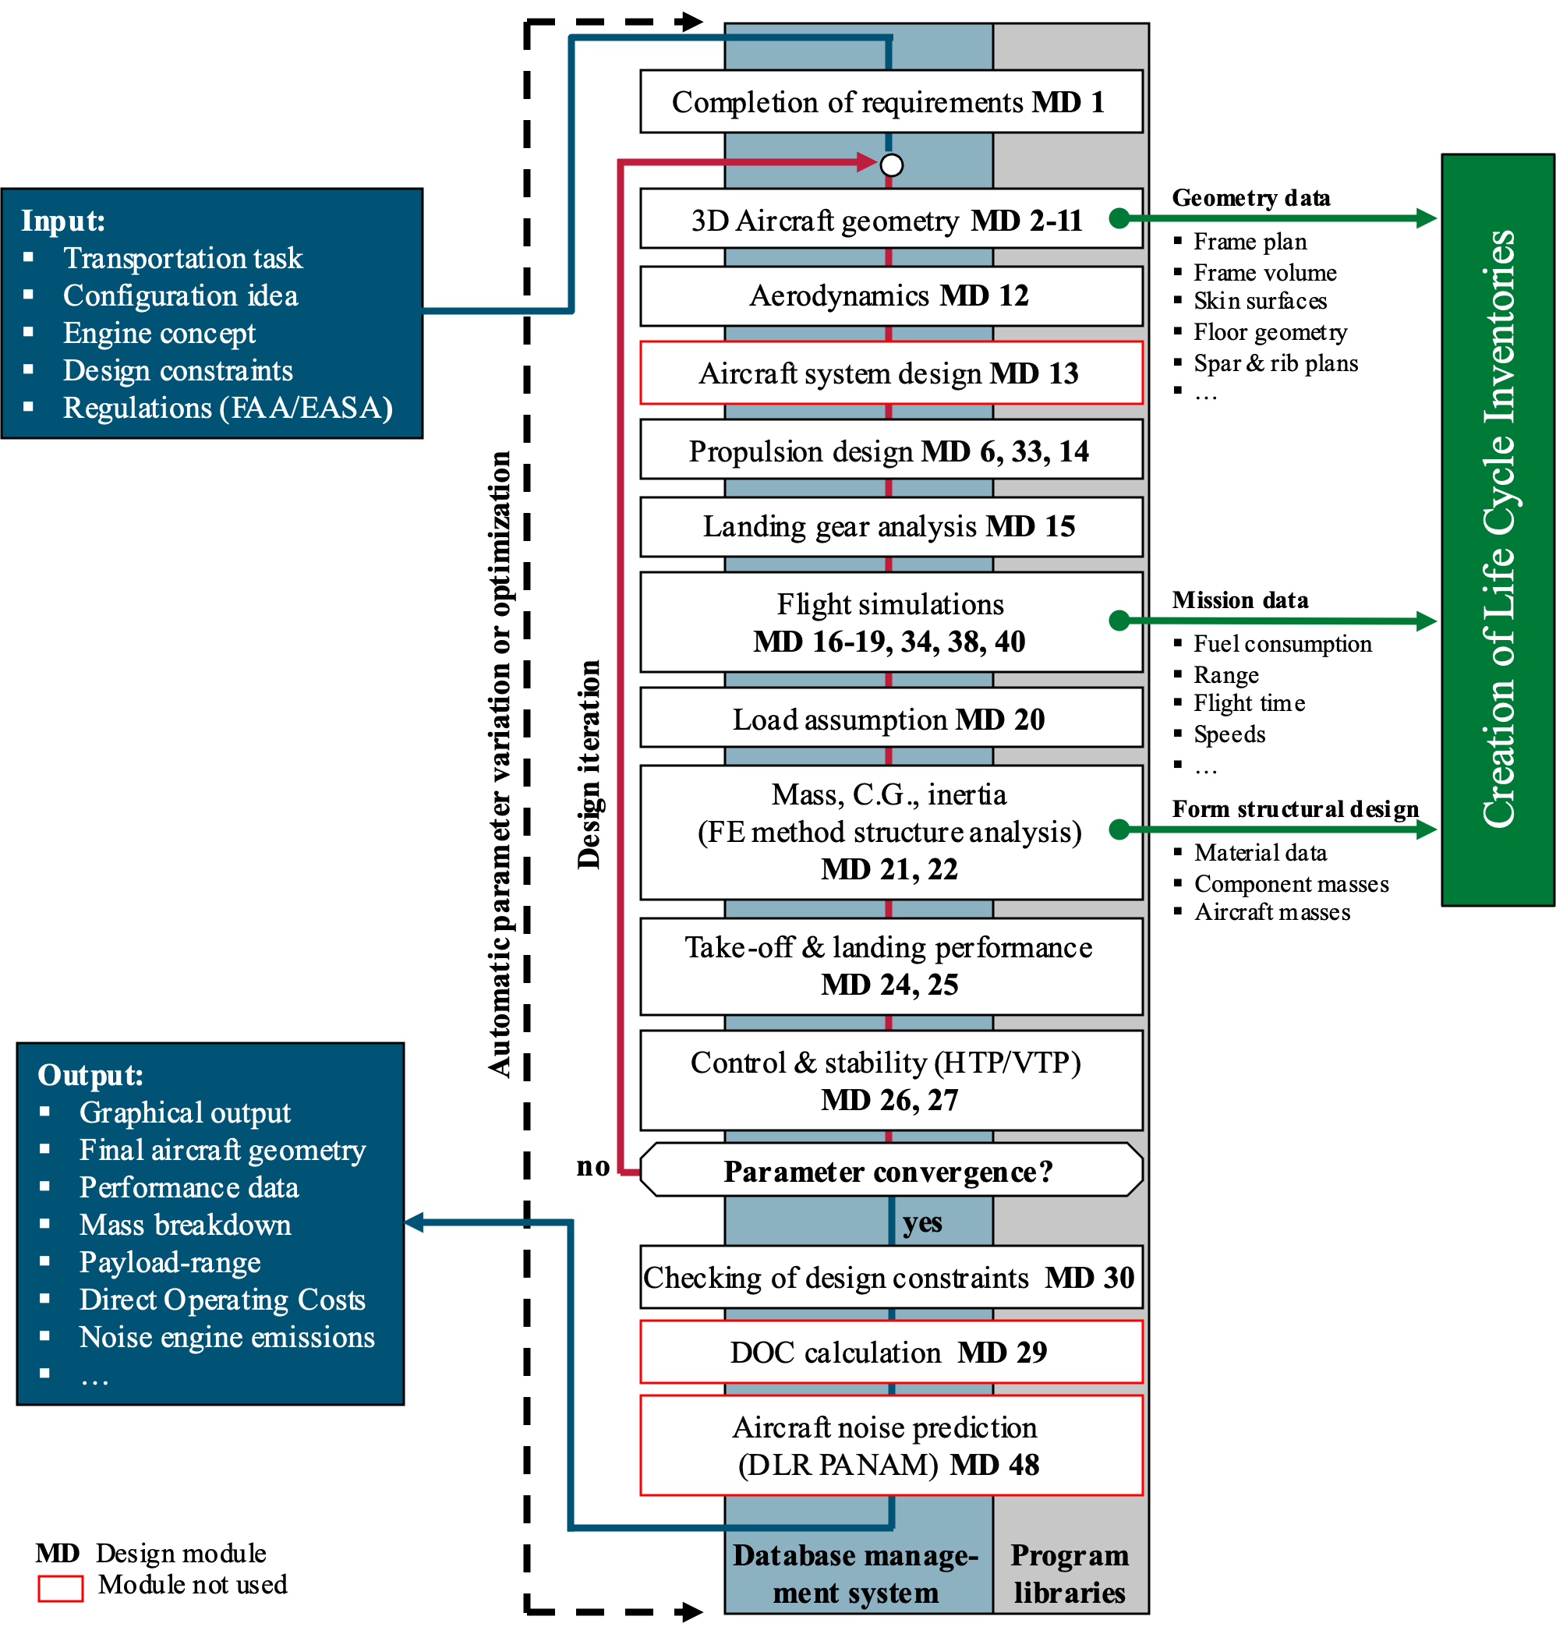
Figure S1-2: PrADO process chain

In detail, the following steps are performed:

- The design requirements of the configuration are summarized and completed (MD1).

- The design process begins with the geometry modules (MD2-MD11), which analyze the parametric component inputs and calculate the missing data to describe the aerodynamic surface, structural design, and internal arrangement of all aircraft components (e.g., galleries, restrooms, seats, and flight system elements). The result is a 3D model of the aircraft, whose data are available to all design modules that perform analyses for determining aircraft characteristics (e.g., mass calculations). Figure S1-3 shows the 3D model for the short- and medium-haul aircraft (SHAC) configuration of this article.

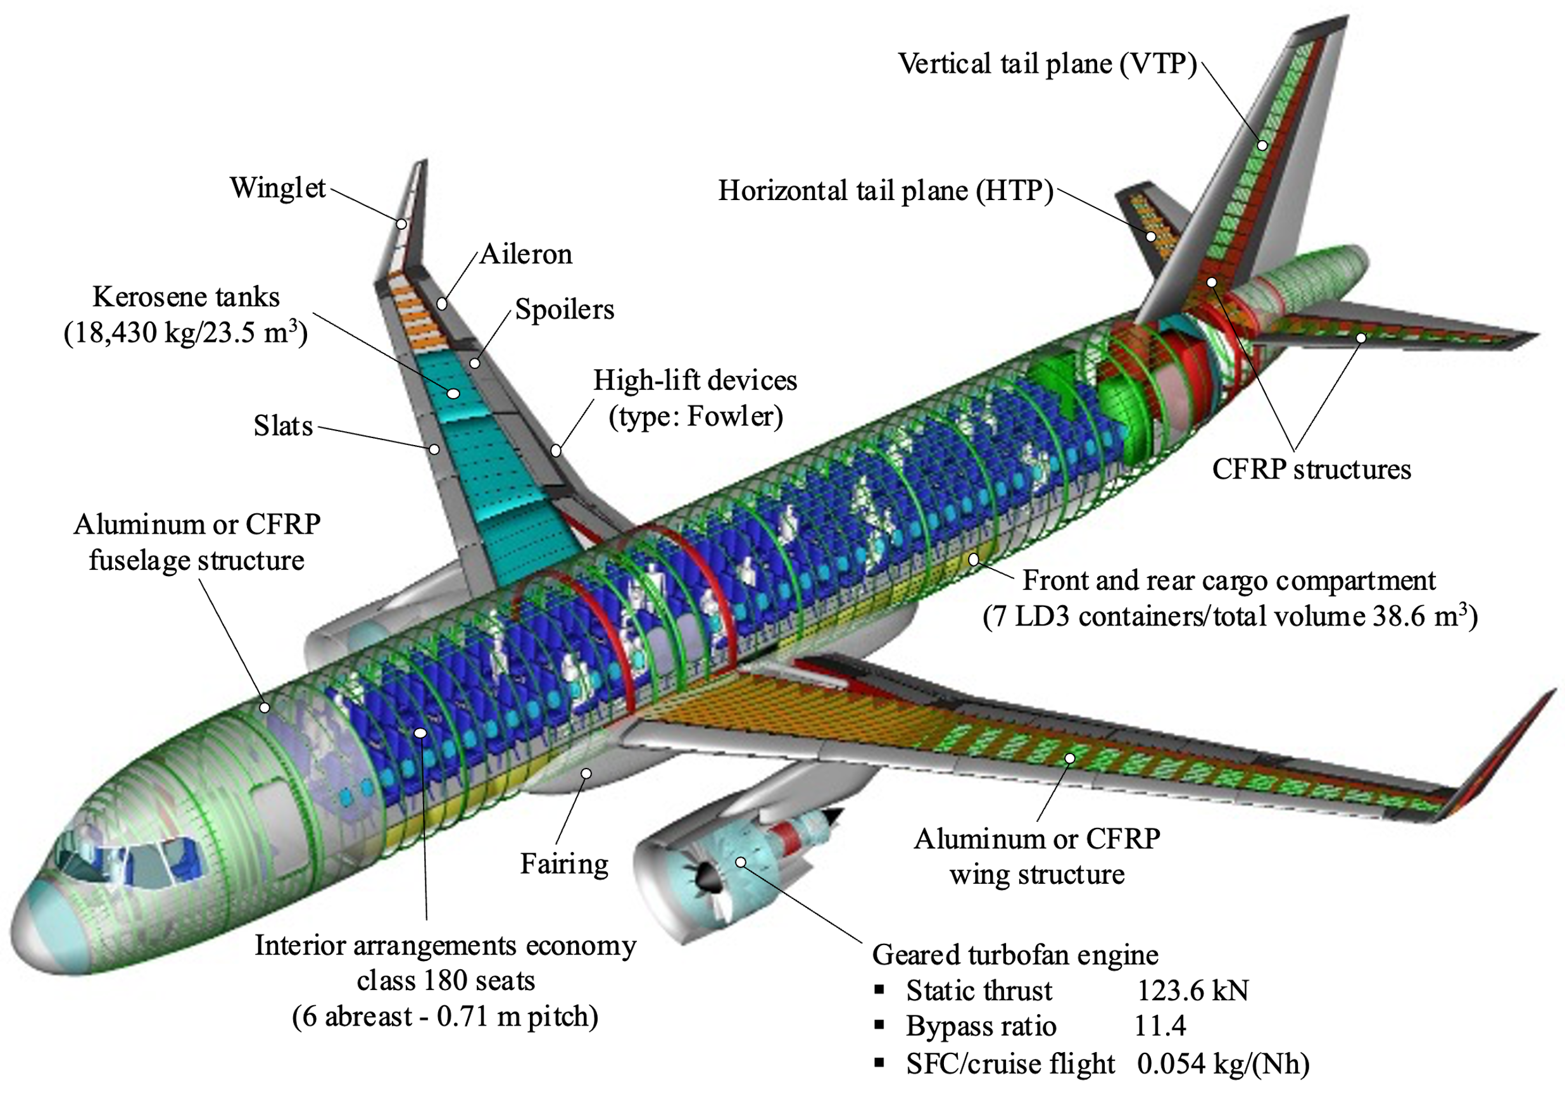
Figure S1-3: PrADO geometry model of the SHAC configuration

- The aerodynamic coefficients for the entire flight envelope of the aircraft are generated in the aerodynamics module (MD12). Various types of aerodynamic codes are available for this purpose (e.g., panel code HISSS (Fornasier, 1984)). The zero-lift drag of the aircraft is calculated using the drag area method according to Hoerner (1965). The results are required for the flight simulation (MD16-19) to determine the fuel demand, calculate the necessary take-off and landing runway lengths (MD24 and MD25), and check the control and stability characteristics of the vertical tail plane (VTP) and horizontal tail plane (HTP) (MD26 and MD27).

- In the propulsion module, the geometry and weight of the engine are designed, and the engine characteristics (e.g., thrust and specific fuel consumption maps as a function of altitude, Mach number, and power setting) are computed by simulating the thermodynamic cycle (Mattingly et al., 2018) for the planned engine concept (for this article: geared turbo-fan engine). These data are needed, in addition to the aerodynamic characteristics, to evaluate the flight physics of the aircraft configuration.

- In the landing gear module (MD15), the load classification number and the loads from the landing gear to the aircraft are calculated.

- Flight mission simulations (e.g., MD16-MD19) are carried out to determine performance data and the required fuel masses for the specified missions according to top-level requirements. These simulations cover all phases of a complete mission by determining the flight mechanical state (including trim) of the aircraft for defined time steps. The aerodynamic coefficients, as well as the thrust and fuel consumption data, are based on the maps created in the previous modules. The results of these modules are the fuel consumption for the defined missions, flight times, maximum cruise altitude, and the required maximum thrust to carry out the missions.

- The structural mass (MD21) can be calculated using several methods with varying degrees of accuracy, ranging from statistical methods via analytical beam models to a method based on the finite element (FE) method. The FE method, called SAM (Structural aerodynamic and Aeroelastic sizing Module), was developed by Österheld et al. (2000) and extended by Rieke et al. (2008) for the consideration of CFRP components. The structural sizing module includes a multi-model generator that creates an aerodynamic surface panel model for HISSS and an FE model (see Figure S1-4) simultaneously. The loads are predicted by the module MD20 according to the rules of the FAA/EASA (maneuver and gust cases) and applied to the structure. A dimensioning process based on the stress and deformation results is iteratively performed with the FE solver MSC Nastran. This process is described in more detail by Österheld et al. (2000).

- The structural mass is required in the following module (MD22) to determine a first or updated operating empty mass with the masses of aircraft systems, furnishings, and operational items (e.g., seats, service, water, and unused fuel). At the same time, the aircraft masses (such as maximum take-off and landing mass) are updated, affecting the necessary engine size, new fuel mass, and loads for the new structural sizing in the next iteration step.

- In the handling quality modules (MD26 and MD27), the HTP and VTP are examined concerning controllability and stability. Critical flight cases are simulated by flight mechanic models, the verification of which is also required by the regulations (e.g., landing with a crosswind, roll maneuvers, one-engine-inoperative case). Results are the necessary tail unit areas and rudder sizes. These values are only displayed to the user now, so he has to correct the inputs after his assessment. It is also possible to automatically adjust the control surfaces for the calculations in the next iteration step.
If the convergence check of the selected dependent parameters is positive, the iteration is aborted, and the last module (MD30) is called. It checks the defined design constraints. In the “Single configuration analysis” operating mode, the result of this check is only output, and the user has to modify the configuration by adjusting the first inputs after his evaluation. A new PrADO run must then be carried out. In “Configuration optimization” mode, the optimization method reacts to these results and automatically changes the independent parameters so that the violated constraints are corrected. The optimizer then also automatically starts a new PrADO calculation.

Aircraft configuration and structural design specifications
The structural design of the SHAC corresponds to the geometry of an Airbus A320neo with winglets and a geared turbofan. Literature for this aircraft is available from Airbus S.A.S. (1985, 2024), which allows the preparation of a PrADO model (see Figure S1-3). The SHAC is designed for a design mission corresponding to a flight with a maximum payload (19,256 kg/180 passengers) reaching a maximum range of 3,525 km (for further information on the design mission, see Section S1-6.3).
To ensure comparability of the three SHAC designs, the two complementary variants are identical regarding top-level requirements and use the same engine. The engine size and wing area have not been adapted to the reduced aircraft masses. In addition, identical systems (e.g., air conditioning and flight controls), furnishing (e.g., restrooms and cargo loading system), and operational equipment (e.g., galleys and passenger seats) are installed in all three aircraft. Identical material compositions are also assumed for the structural components, landing gear, pylons, and fairings.
The dimensioning of the different structure components was carried out under the assumption of a rigid aircraft structure. The structural components are made of aluminum and CFRP (see Section S1-4.3). The aluminum components of the aircraft structures are made of Al2024 (density 2864 kg/m³, ultimate stress 430 MPa), while for the CFRP parts, the material combination HTS40/RTM6 (density 1620 kg/m³, maximum tensile strength 1455-1620 MPa) is chosen. The layup [0/45/90/-45/0]/_{sym} produces a quasi-isotropic material behavior. The thickness of each layer is 0.2 mm at the beginning of the dimensioning process from SAM. The dimensioning of the CFRP components is carried out according to the Puck criterion (Puck & Schürmann, 2002), whose application in SAM is described in more detail in Rieke et al. (2008). The aluminum structures have been dimensioned according to v.Mises criteria. Minimum wall thicknesses of 1-2 mm are specified for these components. When dimensioning these parts, only about 35% of the ultimate material strength was allowed. The low value results from the demanded safety factor of 1.5 against failure of the structure and additional reductions of not-considered dynamic loads in SAM. In addition to dimensioning according to sufficient strength, buckling is also checked, and, if necessary, the wall thicknesses are further increased. Figure S1-4 shows the final wall thickness distributions of the sizing process from SAM for the three converged SHAC designs. The most crucial design data from PrADO’s multidisciplinary overall design analysis are summarized in Table S1-1.

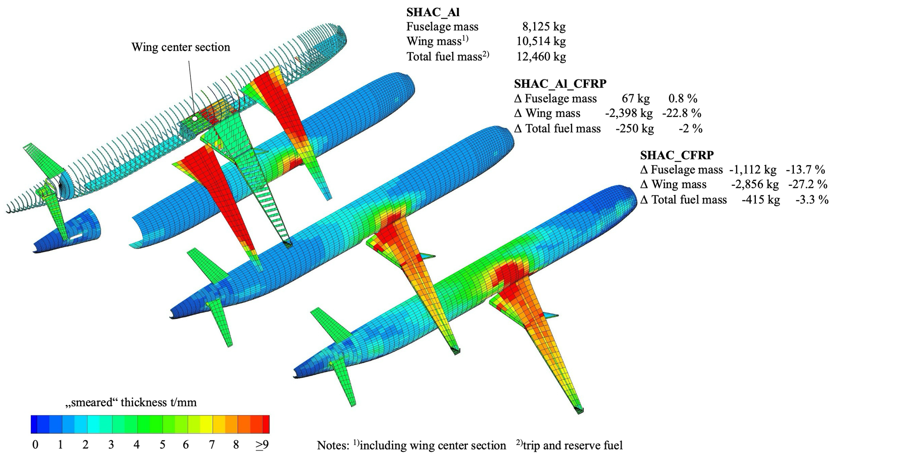
Figure S1-4: FE models showing the final thickness distributions for the three aircraft variants

Table S1-1: Aircraft data of the converged SHAC variants
Design and performance parameters | Variant
Design and performance parameters | SHAC_Al | SHAC_Al_CFRP | SHAC_CFRP
Design mission  - Payload  - Range | 19,256 kg  3,525 km
Geometry  - Fuselage length  - Fuselage diameter  - Wing reference area  - Wingspan | 37.570 m  4.141 m  122.600 m²  33.940 m
Flight point at beginning of cruise  - Altitude  - Mach number  - Lift coefficient  - Lift to drag | 10.5 km  0.76  0.585  17.25 | 10.5 km  0.76  0.564  17.049 | 10.5 km  0.76  0.549  16.848
Sea-level static thrust  - Take-off  - Beginning of cruise | 2 x 123.6 kN  0.0262 kg/(Nh)  0.0539 kg/(Nh) | 2 x 123.6 kN  0.0262 kg/(Nh)  0.05401 kg/(Nh) | 2 x 123.6 kN  0.0262 kg/(Nh)  0.0541 kg/(Nh)
Max. lift coefficient  - Take-off  - Landing | 2.7  3.3
Range  - With max. payload  - With max. fuel  - With max. fuel, without max. payload | 3,525 km  5,719 km  6,406 km | 3,525 km  5,854 km  6,534 km | 3,525 km  5,947 km  6,618 km
Runway length  - Take-off distance  - Landing distance | 1,954 m  1,400 m | 1,767 m  1,348 m | 1,658 m  1,312 m
Operating empty mass  Max. payload mass  Max. fuel mass  Max. take-off mass  Max. landing mass | 42,123 kg  19,256 kg  18,430 kg  73,839 kg  65,457 kg | 39,681 kg  19,256 kg  18,430 kg  71,147 kg  62,933 kg | 37,968 kg  19,256 kg  18,430 kg  69,268 kg  61,166 kg
Fuel for design mission  - Fuel mass for flight  - Reserve fuel mass  - Total fuel mass | 9,658 kg  2,802 kg  12,460 kg | 9,472 kg  2,737 kg  12,210 kg | 9,350 kg  2,695 kg  12,045 kg

The differences in the material configurations of the three SHAC are explained below, and the differences in component weights can be found in Table 1 in the manuscript:
- The SHAC_Al has an Al construction and serves as a reference for a current aircraft in the analysis. Similar to the Airbus A320neo, the VTP and HTP are primarily made of CFRP, while the wing and fuselage are mainly made of Al. As a result, the airframe is composed of 79% Al and 6% CFRP. The structural weight is 22,888 kg, and the operating empty weight is 42,123 kg.
- The SHAC_Al_CFRP has the same material composition as the SHAC_Al for the empennage. However, the proportion of CFRP in the wing has been increased, making it the primary material for this component. As a result, the airframe is composed of 50% Al and 34% CFRP, which is similar to the proportion of CFRP to that of aircraft models from the 2000s (Breuer, 2016). The change in material composition leads to a structural weight of 20,488 kg and an operating empty weight of 39,681 kg. The structural weight has been decreased by 10%, and the operating empty weight has been lowered by 6% compared to the reference aircraft.
- The SHAC_CFRP is designed to further increase the CFRP content in the airframe. In addition to the empennage and wing, which are mainly made from CFRP, the amount of CFRP in the center wing box and fuselage is also increased. As a result, the airframe is composed of 14% Al and 72% CFRP, which is a higher proportion of CFRP than the latest aircraft models on the market, where the amount of CFRP accounts for about 50% (Breuer, 2016). The change in material composition leads to a structural weight of 18,805 kg and an operating empty weight of 37,968 kg. The structural weight has been decreased by 18%, and the operating empty weight has been lowered by 10% compared to the reference aircraft.

Assumptions concerning airframe production
In this section, the assumptions concerning the modeling of the airframe production are provided. The assumed airframe component breakdown (Section S1-4.1) and production network (Section S1-4.2) of the SHAC are explained in more detail. In addition, more information on the modeling of the raw materials (Section S1-4.3), the energy requirement (Section S1-4.4), the transport of the airframe components (Section S1-4.5), as well as the modeling of production costs (Section S1-4.6) is provided.

Airframe component breakdown
To create a comprehensive Life Cycle Inventory (LCI) of an aircraft’s production phase, a detailed breakdown of weight and materials at the component level is required. However, this information is considered proprietary and is not published by the aircraft manufacturers. In general, an Airbus A320 aircraft is composed of about 340,000 parts (Airbus S.A.S., 2022a). Therefore, simplifications are necessary when modeling aircraft production. This study only considers the production of the airframe. The production of systems, equipment, and operational equipment are not taken into consideration. The respective weights and materials of the production steps are identical for all three SHAC and do not influence the object of the study, as explained in Section 2.
The component breakdown is derived primarily from the component breakdown of the Airbus A350 XWB long-haul aircraft (Airbus S.A.S., 2013a). More information has been published by Airbus on this, allowing a more accurate recreation of the production processes compared to the information available on the A320 family. Some assumptions are supplemented by available data on the Airbus A321XLR (Airbus S.A.S, 2021). The derived breakdown of the airframe components and subcomponents is depicted in Figure S1-5. All airframe components not listed in Figure S1-5 are assumed not to have their own production step, and their weight is solely added to a respective component.

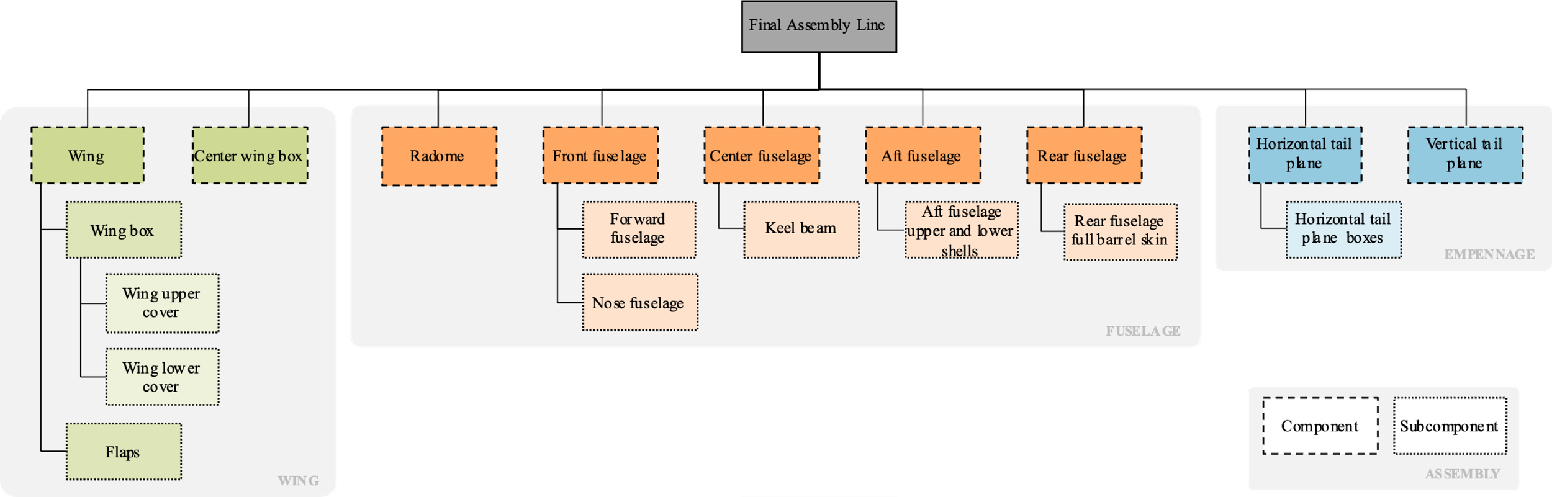
Figure S1-5: Component breakdown of the SHAC with (sub)components within the production network

The weights and materials used to produce the (sub)components are determined by assigning data on part weights and materials from the structural designs of the SHAC from PrADO to each corresponding (sub)component. The material allocation is determined via material IDs assigned in PrADO. However, this is a simplification of the material compositions since the parts are not made up of only one material in reality. Parts, such as rivets and screws, are assigned to the material IDs of the parts in which they are installed. The following tables list the quantities of raw materials allocated to each (sub)component for the SHAC_Al (see Table S1-2), the SHAC_Al_CFRP (see Table S1-3), and the SHAC_CFRP (see Table S1-4).

Table S1-2: Material allocation to each subcomponent of the SHAC_Al
(Sub)component | Weight [kg]
(Sub)component | AlCuMg | AlZnMg | CFRP | GFRP | Titanium | Steel
Final assembly | 190 | 0 | 297 | 0 | 991 | 1832
Center wing box | 1425 | 0 | 0 | 0 | 0 | 0
Wing assembly | 349 | 0 | 0 | 0 | 0 | 0
Flaps | 638 | 0 | 0 | 0 | 0 | 0
Wing box | 3366 | 0 | 0 | 0 | 0 | 0
Wing upper cover | 0 | 1637 | 0 | 0 | 0 | 0
Wing lower cover | 2993 | 0 | 0 | 0 | 0 | 0
Radome | 26 | 0 | 0 | 0 | 0 | 0
Front fuselage | 0 | 0 | 0 | 0 | 0 | 0
Nose fuselage | 1194 | 0 | 47 | 90 | 0 | 0
Forward fuselage | 894 | 0 | 32 | 143 | 0 | 0
Center fuselage | 1325 | 0 | 50 | 114 | 0 | 0
Keel beam | 232 | 0 | 0 | 0 | 0 | 0
Aft fuselage | 663 | 0 | 47 | 217 | 0 | 0
Aft fuselage upper/lower shell | 684 | 0 | 0 | 0 | 0 | 0
Rear fuselage | 1770 | 0 | 56 | 52 | 0 | 0
Rear fuselage full barrel skin | 488 | 0 | 0 | 0 | 0 | 0
Horizontal tail plane | 0 | 0 | 336 | 0 | 0 | 0
Horizontal tail plane boxes | 98 | 0 | 175 | 0 | 0 | 0
Vertical tail plane | 61 | 0 | 375 | 0 | 0 | 0

Table S1-3: Material allocation to each subcomponent of the SHAC_Al_CFRP
(Sub)component | Weight [kg]
(Sub)component | AlCuMg | AlZnMg | CFRP | GFRP | Titanium | Steel
Final assembly | 190 | 0 | 297 | 0 | 991 | 1763
Center wing box | 1421 | 0 | 0 | 0 | 0 | 0
Wing assembly | 349 | 0 | 0 | 0 | 0 | 0
Flaps | 638 | 0 | 0 | 0 | 0 | 0
Wing box | 65 | 0 | 2770 | 0 | 0 | 0
Wing upper cover | 0 | 0 | 1037 | 0 | 0 | 0
Wing lower cover | 0 | 0 | 1730 | 0 | 0 | 0
Radome | 27 | 0 | 0 | 0 | 0 | 0
Front fuselage | 0 | 0 | 0 | 0 | 0 | 0
Nose fuselage | 1204 | 0 | 47 | 90 | 0 | 0
Forward fuselage | 905 | 0 | 32 | 143 | 0 | 0
Center fuselage | 1337 | 0 | 50 | 114 | 0 | 0
Keel beam | 238 | 0 | 0 | 0 | 0 | 0
Aft fuselage | 666 | 0 | 47 | 217 | 0 | 0
Aft fuselage upper/lower shell | 697 | 0 | 0 | 0 | 0 | 0
Rear fuselage | 1773 | 0 | 56 | 52 | 0 | 0
Rear fuselage full barrel skin | 497 | 0 | 0 | 0 | 0 | 0
Horizontal tail plane | 0 | 0 | 337 | 0 | 0 | 0
Horizontal tail plane boxes | 98 | 0 | 176 | 0 | 0 | 0
Vertical tail plane | 61 | 0 | 375 | 0 | 0 | 0

Table S1-4: Material allocation to each subcomponent of the SHAC_CFRP
(Sub)component | Weight [kg]
(Sub)component | AlCuMg | AlZnMg | CFRP | GFRP | Titanium | Steel
Final assembly | 190 | 0 | 297 | 0 | 991 | 1716
Center wing box | 0 | 0 | 1022 | 0 | 0 | 0
Wing assembly | 349 | 0 | 0 | 0 | 0 | 0
Flaps | 638 | 0 | 0 | 0 | 0 | 0
Wing box | 65 | 0 | 2775 | 0 | 0 | 0
Wing upper cover | 0 | 0 | 1016 | 0 | 0 | 0
Wing lower cover | 0 | 0 | 1685 | 0 | 0 | 0
Radome | 0 | 0 | 24 | 0 | 0 | 0
Front fuselage | 0 | 0 | 0 | 0 | 0 | 0
Nose fuselage | 346 | 0 | 828 | 0 | 0 | 0
Forward fuselage | 54 | 0 | 867 | 0 | 0 | 0
Center fuselage | 376 | 0 | 938 | 0 | 0 | 0
Keel beam | 0 | 0 | 182 | 0 | 0 | 0
Aft fuselage | 83 | 0 | 681 | 0 | 0 | 0
Aft fuselage upper/lower shell | 0 | 0 | 625 | 0 | 0 | 0
Rear fuselage | 337 | 0 | 1226 | 0 | 0 | 0
Rear fuselage full barrel skin | 0 | 0 | 446 | 0 | 0 | 0
Horizontal tail plane | 0 | 0 | 337 | 0 | 0 | 0
Horizontal tail plane boxes | 98 | 0 | 176 | 0 | 0 | 0
Vertical tail plane | 61 | 0 | 375 | 0 | 0 | 0

Airframe production network
The production network for the airframe of the SHAC is based on that of the Airbus A350 XWB and A321XLR due to the higher availability of information (Airbus S.A.S., 2013a). Each component is produced separately, with defined inputs and outputs, as well as quantities as outlined in the LCIs of the airframe production of the three SHAC (see Supporting Information S2-S4). Figure S1-6 presents the distribution of production steps to individual sites, the processes at each site, and the transport routes of the (sub)components to the next production site.
The final assembly line (FAL) is situated in Toulouse, France. All prefabricated components are transported to Toulouse and assembled into the aircraft (Airbus S.A.S., 2013a). The production steps for each of the (sub)components of the considered aircraft structures wing, fuselage, and empennage are described below:

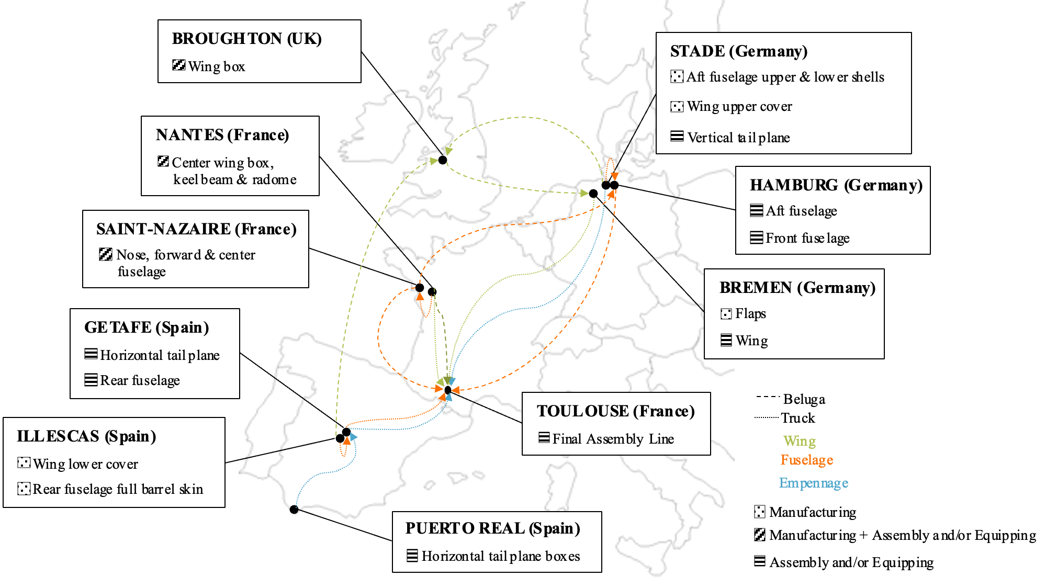
Figure S1-6: Airframe production network of the SHAC

Wing
The center wing box component is manufactured and assembled in Nantes, France (Airbus S.A.S., 2013a; Airbus S.A.S, 2021) and transported to the FAL via air. The wing is assembled in Bremen, Germany (Airbus S.A.S., 2013a) and transported to the FAL by air. During this production step, the subcomponent’s wing box and flaps are assembled (Jacob, 2011). The flaps are manufactured in Bremen, Germany (Airbus S.A.S., 2013a). The wing box is being transported to Bremen via air after being manufactured and assembled in Broughton, UK (Airbus S.A.S., 2013a; Airbus S.A.S, 2021). During this production step, the subcomponents wing upper and lower cover are fitted onto the wing (Jacob, 2011). The wing’s lower cover is manufactured in Illescas, Spain, and the wing’s upper cover is manufactured in Stade, Germany (Airbus S.A.S., 2013a). Both wing covers are transported to Broughton by air.

Fuselage
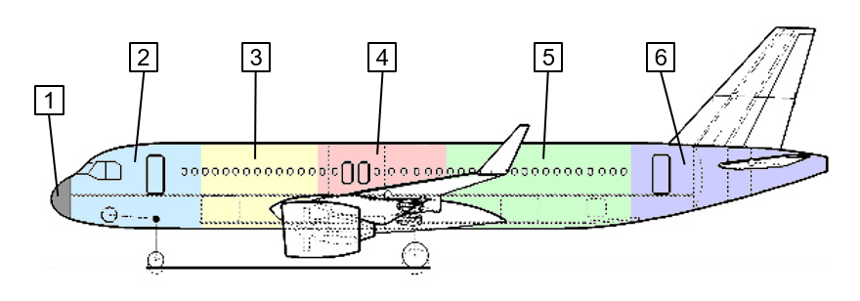
The fuselage of the SHAC consists of the radome (1) and the five subsections: nose fuselage (2), forward fuselage (3), center fuselage (4), aft fuselage (5), and rear fuselage (6) (Airbus S.A.S., 2021; Räckers, 2001). Figure S1-7 illustrates the division of these subsections. The subsections are manufactured and assembled at different production sites before being fitted together at the FAL. The radome component is manufactured in Nantes, France (Airbus S.A.S., 2013b, 2021) and transported to the FAL by lorry. The front fuselage component is assembled in Hamburg, Germany (Airbus S.A.S., 2013b) and transported to the FAL via air. During this production step, the two subcomponents, the forward fuselage and nose fuselage, are fitted together. Both subcomponents are manufactured and assembled in Saint-Nazaire, France (Airbus S.A.S., 2021) and transported to Hamburg by air. The center fuselage component is assembled in Saint-Nazaire, France (Airbus S.A.S., 2013b) and transported to the FAL via air. Its subcomponent keel beam, manufactured and assembled in Nantes, France (Airbus S.A.S., 2013b, 2021), is transported to Saint-Nazaire by lorry. The aft fuselage subsection is assembled in Hamburg, Germany (Airbus S.A.S., 2013b, 2021) and transported to the FAL by air. For the assembly of the aft fuselage, the aft fuselage upper and lower shells are required. These are manufactured in Stade, Germany (Airbus S.A.S., 2013b) and transported to Hamburg by lorry. The rearmost subsection of the fuselage is the component rear fuselage, which is assembled in Getafe, Spain (Airbus S.A.S., 2013b) and transported to the FAL by lorry. The rear fuselage full barrel skin, which is required to assemble the rear fuselage, is manufactured in Illescas, Spain (Airbus S.A.S., 2013b) and transported to Getafe by lorry.
Figure S1-7: SHAC fuselage subsection division

Empennage
The aircraft’s empennage consists of two components: the HTP and VTP. Both components are assembled into the aircraft at the FAL. The HTP is assembled in Getafe, Spain (Airbus S.A.S., 2013b, 2021) and transported to the FAL by lorry. The HTP boxes, which are required as subcomponents for assembly of the HTP, are assembled in Puerto Real, Spain (Airbus S.A.S., 2013b) and transported to Getafe by lorry. The VTP is assembled in Stade, Germany (Airbus S.A.S., 2013b, 2021) and then transported to the FAL by lorry.

Raw materials
The raw materials in the airframe of the SHAC include Al, CFRP, titanium, steel, and glass fiber reinforced plastic. Most of these are modeled according to the ecoinvent database version 3.9.1 (Wernet et al., 2016) and are sourced from countries that account for the largest share of global production, according to the U.S. Geological Survey (2023).
The two alloys, AlCuMg and AlZnMg, as mentioned in Section S1-1.2, are used as Al. The production of both alloys is based on the ecoinvent database version 3.9.1 activity “aluminum alloy production, AlMg3, RoW”, which was adapted to the percentage compositions defined in Section S1-1.2. It is assumed that the alloys are processed into sheets. Therefore, the activity “sheet rolling, aluminum, RoW” from the ecoinvent database version 3.9.1 is added to the processes of alloy production. The alloying elements are assumed to be sourced from countries that account for the largest share of global production, according to the U.S. Geological Survey (2023). The production site for both AlCuMg and AlZnMg is assumed to be the same as that for their main alloying element, aluminum.
Modeling CFRP proved to be challenging due to the lack of applicable data in the ecoinvent database version 3.9.1 for CFRP made from PAN-based carbon fibers. There are also no activities for carbon fibers or PAN precursor in the ecoinvent database version 3.9.1. Therefore, scientific literature is used to model material and energy flows for CFRP. However, this proved to be difficult, as the data provided by scientific literature significantly differed from one another. Due to these challenges, it is assumed that all CFRP used for the airframe is of the same kind and only one type of CFRP is modeled. The CFRP is modeled by assuming PAN precursor production, according to Johnson and Sullivan (2014), with the monomer acrylonitrile and co-monomer methyl methacrylate (see Table S1-5). Both of these activities are included in the ecoinvent database version 3.9.1. The PAN precursor is further processed into carbon fibers before being processed into carbon prepreg. The production steps follow the model of Khalil (2017). This data source has been selected for its comprehensive and reproducible LCI, as well as its focus on the aviation industry, which makes it particularly suitable for use in assessments of entire aircraft and aircraft components (e.g., Atescan-Yuksek et al. (2024)). For prepreg production, however, epoxy resin is used as the polymer matrix in a 2:3 ratio, as recommended by Horst and Wolf (2014). The PAN precursor, carbon fiber, and carbon prepreg production sites are all assumed to be in the US, as Hexcel is one of Airbus’ CFRP suppliers (Hexcel Corporation, 2023a, 2023b).

Table S1-5: Material and energy flows of CFRP production
Process step | Inputs |  | Outputs |  | Data source
PAN precursor production | Acrylonitrile  Methyl methacrylate  Energy | 0.95 kg  0.05 kg  13.92 kWh | PAN precursor | 1.00 kg | Johnson and Sullivan (2014)
Carbon fiber production | PAN precursor  Nitrogen  Energy | 1.82 kg  0.94 kg  2.29 kWh | Carbon fiber  CO₂  CO  Water vapor  NO₂  H₂  NH₃  N  C₂H₆  C₂H₄  CH₄ | 1.00 kg  1.10 kg  0.04 kg  0.67 kg  0.00 kg  0.00 kg  0.02 kg  1.18 kg  0.01 kg  0.01 kg  0.04 kg | Khalil (2017)
CFRP production | Carbon fiber  Epoxy resin  Energy | 0.60 kg  0.40 kg  12.39 kWh | Carbon prepreg | 1.0 kg | Horst and Wolf (2014)  Khalil (2017)

In general, the manufacturing process of CFRP is distinguished by a considerable degree of uncertainty. Notable discrepancies are evident in the data obtained from disparate sources, which can be attributed to variations in material properties, production scales, and study objectives. For instance, Groetsch et al. (2021) conducted a comparative analysis of the energy demand of various sources, with the majority falling within a range of 50-80 kWh per kg of carbon fiber. However, it is not evident from the analysis of the sources in question which processes are included, and some of the sources are not publicly accessible. A highly comprehensive LCI was created by Benitez et al. (2021) and made publicly accessible. In some instances, the energy demand and conversion rate of this LCI diverge significantly from the data assumed in this study. The energy demand associated with PAN production is comparable to that reported by Johnson and Sullivan (2014). The discrepancy is only 2.4 kWh per kg of PAN precursor. However, Benitez et al. (2021) assume methyl acrylate and acrylic acid as co-monomers rather than methyl methacrylate. In contrast, the production of carbon fiber differs considerably from the data presented by Khalil (2017). The production of 1 kg of carbon fiber requires approximately 1 kg more of PAN precursor and an energy demand that is 37 kWh higher. However, the LCI of Benitez et al. (2021) is mainly based on sources that are not publicly available. Furthermore, a discrepancy was identified between the stated energy demand for production and the LCI, which prompted the decision not to utilize this detailed LCI. In general, the data from Khalil (2017) employed in this study represent the lower range regarding energy demand in scientific literature. This was deemed acceptable for this study, given the focus on mass production.
Given the considerable uncertainty surrounding the manufacturing process of CFRP and its significance in the life cycle of CFRP components, a sensitivity analysis is conducted to assess the impact of varying energy demands for the process steps of carbon fiber production and carbon prepreg production. To investigate the impact of varying energy demands, a reduction of 5% and a doubling of the energy demand used in the study has been analyzed. The results of the sensitivity analysis are presented in Table S1-6. They demonstrate that the modest reduction of 5% of energy demand only slightly influences the individual impact scores. Conversely, the doubling of energy demand intensifies impacts, particularly in the case of the impact categories CC and HT. Nevertheless, there is a greater margin of difference between the CFRP impact score of HT and that of Al, whereas the impact score of CC exceeds that of Al when the energy demand is doubled. Accordingly, an energy demand that is, in fact, higher than that assumed in this study can result in a different outcome regarding the impact of airframe production of the SHAC_CFRP. However, this only marginally affects the impact of flight operations, as even with an increased energy demand for CFRP production, airframe production remains insignificant due to its very small share of the impact score.

Table S1-6: Sensitivity analysis of changing energy demand of carbon prepreg production compared to production of Al
Impact category | Unit | Production of 1 kg Al | Production of 1 kg carbon prepreg
Impact category | Unit | Production of 1 kg Al | - | -5% | +100%
CC | kg CO₂-eq | 25.66 | 23.41 | 23.06 | 30.29
POF | kg NO_{x}-eq | 0.07 | 0.04 | 0.04 | 0.04
TE | kg 1,4-DCB-eq | 26.25 | 40.42 | 40.11 | 46.66
HT | kg 1,4-DCB-eq | 4.48 | 0.90 | 0.88 | 1.20
FRS | kg oil-eq | 5.03 | 7.16 | 7.06 | 9.05

Energy requirement
The analysis includes the quantity of raw materials used for each production step (Section S1-4.2) and the energy required to process them. Information on the specific production processes and the resulting energy consumption is not publicly available by aircraft manufacturers, as it is proprietary information. To remain within the scope of this study, average values from Bohlender (2010, as cited in Rahn et al. (2022)) and Rahn et al. (2022) are used to model the energy flows in airframe production. It is also assumed that the required energy is supplied by the current electricity mix of the country where the respective production site is located.
The energy consumption of material-specific processing and joining methods for production processes is approximated without considering component-specific processes. In aircraft production, a distinction is made between material manufacturing and assembly (Hinsch, 2019). The production steps listed in Section S1-4.2 indicate the type of material processing. It is assumed that during a manufacturing process, the component is manufactured from raw materials assigned to the respective component. In an assembly process, the materials of the component and its subcomponents are assumed to be assembled. Additionally, there are production steps where the component is manufactured and then assembled with the subcomponents.
The components manufactured from Al are assumed to consume an average of 24.81 kWh per kg Al processed, including processes such as shaping and heat treatments for hardening. To manufacture components from CFRP, processes such as tape laying are used, with an average energy consumption of 11.17 kWh per kg CFRP (Bohlender, 2010, as cited in Rahn et al. (2022)). The energy consumption of assembling components also varies depending on the materials used. When assembling metals, material-specific joining methods such as rivets or screws are employed, resulting in an energy consumption of 6.61 kWh per kg metal. For CFRP assembly, adhesive bonding is often used. The energy consumption for assembling is 3.94 kWh per kg CFRP (Rahn et al., 2022). Since GFRP is used in the fuselage of two of the SHAC, it is also necessary to estimate the energy required for processing this material. According to scientific literature, glass fibers have lower strength compared to carbon fibers (AVK - Industrievereinigung Verstärkte Kunststoffe e.V., 2014). Therefore, it could be inferred that the energy required for manufacturing and assembling should be lower. However, the scientific literature does not provide any data on corresponding values for GFRP. As the density of the GFRP used for the airframe (1,600 kg per m³) is similar to that of the CFRP, the energy consumption for manufacturing and assembling of CFRP is assumed for GFRP.

Transports
Given that the production sites of the assumed production network are located throughout Europe (see Figure S1-6), it is crucial to consider the transportation of (sub)components between these sites. Therefore, the transportation of (sub)components to their next production step is included in the modeling of aircraft production, specifying the transports starting from the country of origin. This requires information on the mode of transport and distance. The distances for all transports are determined via the Google Maps and SeaRates website. Since no reliable information is available on the mode of transport, it is assumed that all (sub)components with dimensions smaller than 13.6 x 2.45 x 4 m (length x width x height) are transported by a lorry. For this purpose, the ecoinvent database version 3.9.1 activity “transport, freight, lorry 16-32 metric ton, EURO5” is used (Wernet et al., 2016). All (sub)components with slightly larger dimensions but that need to travel 500 km or less are assumed to be transported by a heavy lorry, for which the ecoinvent database version 3.9.1 activity “transport, freight, lorry >32 metric ton, EURO5” is used. For all other (sub)components, transport by air is assumed. For air transportation, the ecoinvent database version 3.9.1 activity “transport, freight, aircraft, long haul“ is used as an approximation of the Airbus Beluga, which Airbus uses to transport aircraft components. Additionally, the transport of the raw materials includes their extraction, further processing, and delivery to the airframe component production site using different modes of transport.

Production costs
Monetary flows are recorded in the marketsphere for the economic analysis. The marketsphere is defined as a collection of economic resources exchanged with the object of investigation within the system boundaries and thus represents the economic environment (Thies et al., 2021). To determine airframe production costs for the three SHAC, the focus is on the materials used in the airframe. A price is assigned to each raw material based on current procurement prices. The price for AlCuMg and AlZnMg is determined by the costs of the alloying elements, transports, sheet rolling, and energy consumption during production. Similarly, for the carbon prepreg, it is assumed that the raw materials mainly contribute to its price (MarketsandMarkets, 2023). Transports and energy consumption also contribute to the incurring costs. The price for the epoxy resin is taken from the ecoinvent database version 3.9.1. The market prices for carbon fibers vary greatly depending on the type of fiber. Carbon fibers for automotive applications or sporting goods are currently available, priced at USD 4-9 per kg. However, aerospace-grade carbon fiber is much more expensive, ranging from USD 180-260 per kg (MarketsandMarkets, 2022). The mean value of this price range of USD 220 per kg is used for the cost modeling. To achieve this value in carbon fiber cost modeling, all other process costs are deducted, including the cost of PAN precursor, which amounts to USD 90 per kg (Visiongain Reports Ltd, 2023). In addition to the costs of the materials, the energy and transportation costs are included for airframe production. The energy costs result from the energy consumption of the individual production steps and the transportation costs from transporting airframe components and raw materials to the corresponding production sites. Further costs incurred within the production processes, such as personnel costs, are not analyzed. These were excluded from the analysis because the modeling based on the components from the PrADO simulation did not yield any results regarding the production processes of the designed aircraft. Similarly, an approximation of the personnel costs using generic values from the literature, as was done for the energy costs, proved to be an ineffective approach due to the dependence of the personnel costs on component-specific processes, such as the degree of automation. To achieve a more accurate and comparable analysis of the three configurations, the costs were excluded from the data set.

Assumptions concerning fossil kerosene and sustainable aviation fuels
To determine the full reduction potential of the environmental and economic impacts of currently available technologies and to investigate potential reinforcement effects, the use of SAFs in SHAC with an increased CFRP content is analyzed in the study. The SAFs are based on prior work by (Barke et al., 2022), and the LCIs for their production have been updated and adapted to the ecoinvent database version 3.9.1 with the system model “allocation, cut-off by classification (FitzGerald & Sonderegger, 2022; Wernet et al., 2016). In total, five types of fuel are considered: fossil kerosene and four SAFs produced through X-to-Liquid pathways, specifically Biomass-to-Liquid and Power-to-Liquid, both using the Fischer-Tropsch synthesis process.
Fossil kerosene is produced from crude oil extracted in Tyumen, Russia, and refined in Hamburg, Germany (Raffinerie Heide, 2017). The Biomass-to-Liquid fuel is a second-generation biokerosene derived from miscanthus, cultivated in Saxony, Germany. The biomass is converted into biomethane and processed into hydrogen using steam methane reforming (SMR) for subsequent conversion to kerosene via Fisher-Tropsch synthesis (3N Centre of Experts for Renewable Resources Lower Saxony, 2014; Doliente et al., 2020; Raffinerie Heide, 2017).
Furthermore, three Power-to-Liquid fuels are considered, which differ in the production of hydrogen as feedstock for the Fisher-Tropsch synthesis. In the first production pathway, SMR with natural gas, electricity, and water as inputs are used (Rutkowski et al., 2018). The other two production pathways use electrolysis. Through polymer electrolyte membrane (PEM) electrolysis, hydrogen is produced from water and electricity. Here, 55 kWh of electricity is required per kg of hydrogen (DeSantis et al., 2019). An alternative is solid oxide electrolysis (SOEC), which requires water, electricity, and a small amount of natural gas. Compared to PEM electrolysis, 36.8 kWh of electricity per kg of hydrogen is required (James et al., 2018). All hydrogen is processed into SAF in Hamburg, Germany, via Fisher-Tropsch synthesis (Raffinerie Heide, 2017).
In the Biomass-to-Liquid pathway, hydrogen production is assumed to occur close to miscanthus cultivation and processing. The European pipeline network is used for transportation to the refinery (ECSPP, 2006), while trucks are used to transport the fuel to the airport. The distances are determined via the Searates website (www.searates.com).
The energy demands for producing fossil kerosene and the SAFs are based on data from scientific literature and industry reports (DeSantis et al., 2019; Doliente et al., 2020; James et al., 2018; Rutkowski et al., 2018). Production costs are calculated from the energy inputs, electricity prices specific to each country, and SAF production cost data from relevant studies (DeSantis et al., 2019; James et al., 2018; Rutkowski et al., 2018; Rye & Batten, 2011; Schmidt et al., 2018).

Assumptions concerning flight operations
In this section, the assumptions concerning the modeling of the flight operations are described (Section S1-6.1). In addition, more detailed information on the maintenance unit processes (Section S1- 6.2) and reference flight (Section S1-6.3) are provided.

Flight operations
For the analysis of aircraft manufacturing and use, flight operations are analyzed for a functional unit of 100 pkm traveled. They are modeled by including airframe wear (Section S1-3), maintenance (Section S1-6.2), fuel consumption (Section S1-6.3), and emissions resulting from fuel combustion. Both airframe and maintenance are specific to each SHAC and have a unit of measure that refers to a total value over the service life of the SHAC. Therefore, they are normalized to the functional unit of 100 pkm traveled. For the normalization, the environmental and economic impact of an airframe and maintenance item is divided by the total number of 8.42870E9 pkm and multiplied by 100 to correspond to the functional unit (per 100 pkm traveled). The total number of pkm is derived from the number of passengers, the range of the reference flight (see Section 4.3), and a total of 13,284 flights over the service life of 60,000 FH. The calculation is presented in equation (1):

$$Total number of pkm$$ | $$=Number of passenger per flight$$ | (1)
 | $$*Distance per flight*Number of flights$$ | (1)
 | $$=180 passenger *3,525 km*13,284 flights$$ | (1)
 | $$=8.42870E9 pkm$$ | (1)

The fuel consumption results from the selected reference flight and differs for the three SHAC, as explained in more detail in Section S1-6.3. The emissions resulting from the fuel combustion of each SHAC are adjusted based on the respective fuel used, as shown by Barke, Bley, et al. (2022). No additional costs are assumed besides those associated with airframe wear, maintenance, and fuel consumption for flight operations. The LCIs of the three SHAC for flight operations with fossil kerosene, as well as the LCIs for flight operations of the SHAC_CFRP with SAFs can be found in Supporting Information S10-S16.

Maintenance
Maintenance is defined as the “combination of all technical, administrative and managerial actions during the life cycle of an item intended to retain it in, or restore it to, a state in which it can perform the required function” (Deutsches Institut für Normung e.V., 2018). In aviation, this includes regular examinations and maintenance of safety-critical structures to ensure the airworthiness of the aircraft (Hinsch, 2019). Studies have shown that the environmental impact of aircraft maintenance has a relatively small share of the total environmental impact and can be neglected (Krieg et al., 2012). However, this study considers the maintenance implications of using CFRP in aircraft structures, as a reduction in maintenance is predicted (Hale, 2006).
When examining the environmental and economic impact of aircraft maintenance, the study focuses on scheduled maintenance, which includes routine tasks that are consistent throughout the operation phase (Ackert, 2012). The study neglects unscheduled maintenance, which includes non-routine tasks occurring due to malfunctions or damages due to its unpredictability. Scheduled maintenance activities in aviation can be planned well in advance since aircraft have components and systems that require inspection or preventive replacement at specific intervals. The intervals and scope of routine maintenance measures vary between different aircraft models and are recommended by the aircraft manufacturer but can be adjusted by the operator (Hinsch, 2019).
In aircraft maintenance, a distinction can be made between line, base, and shop maintenance. Complex components, such as the auxiliary power unit, engine, and landing gear, have independent maintenance programs and require special shop visits for overhaul during the aircraft’s use phase (Aircraft Commerce, 2006; Rahn et al., 2022). Since these components are not affected by the airframe structure materials studied, these shop visits are not considered. To analyze the line and base maintenance processes, a check-level approach is used for which preventive maintenance activities are aggregated into letter checks.
Line maintenance takes place within the framework of operational flight operations and comprises activities towards preserving the intended conditions of the aircraft. The line and ramp checks can be carried out quickly and are mainly limited to visual inspections, system checks, oil changes, and minor repairs (Aircraft Commerce, 2006; Hinsch, 2019; Klußmann & Malik, 2018). These include the pre-flight check, transit check, daily check, and weekly check (Klußmann & Malik, 2018; Rahn et al., 2022). All of these have a high frequency and low workload, which is why no change in downtimes and costs is assumed by a change of airframe material, and they are therefore not examined in this study. The A check, also referred to as light check in revision 41 of the Airbus A320 Maintenance Planning Document (Aircraft Commerce, 2006), is considered in this study. The basic interval of this check is 750 FH, and items such as all systems relevant to flight operations and the structure are checked (Aircraft Commerce, 2006; Klußmann & Malik, 2018).
Base maintenance, also referred to as heavy maintenance, involves extensive disassembly and requires the aircraft to be taken out of operation for several days to weeks (Hinsch, 2019; Klußmann & Malik, 2018). In revision 41 of the A320 Maintenance Planning Document, this includes C checks, as well as 6- and 12-year structural checks. The C check is required every 7,500 FH. The 6- and 12-year structural check is performed at intervals of 22,500 FH and 45,000 FH, respectively (Aircraft Commerce, 2006). These heavy checks are performed in the hangar and involve a thorough inspection of all safety-relevant aircraft structures and systems, as well as an overhaul of the cabin (Klußmann & Malik, 2018). The duration of the checks varies depending on the tasks to be performed and the aging of the aircraft (Aircraft Commerce, 2006).
Regarding the influence of airframe materials on the maintenance effort, it can be stated that at the beginning of the 21st century, it was assumed that there were no particular advantages or disadvantages between the use of Al and CFRP in the airframe in terms of manufacturing and repair (Achternbosch et al., 2002). Using CFRP offers advantages such as good corrosion resistance and lack of fatigue behavior (Achternbosch et al., 2002; Hale, 2006). However, detecting damages can be challenging because damages mainly occur internally (Soutis, 2005). Despite this, experience to date has shown that maintenance can be significantly reduced, mainly through the use of composites in the highly tension-loaded environment of the fuselage (Hale, 2006). According to Hale (2006), the Boeing 787-8, which has a composite share of 50% and 20% Al, is expected to have a 30% lower airframe maintenance cost compared to other similar aircraft. Similarly, maintenance costs for the Airbus A350 XWB are expected to be reduced by at least 20% (Ebner, 2020). This is due to the need for approximately 50% fewer structure maintenance tasks (Soutis, 2005).
To assess the environmental and economic impact of the three SHAC, it is assumed that the reference aircraft corresponds to the Airbus A320 maintenance program. As the other two aircraft have a higher proportion of CFRP in their airframes, a reduction in maintenance, including duration, person-hours, and material costs, is assumed to be proportional to the proportion of CFRP in their airframe using the proportional relation by Hale (2006). This results in a reduction in maintenance of 19% and 44% for the SHAC_Al_CFRP and SHAC_CFRP, respectively, compared to the reference SHAC. Assuming that the maintenance check intervals remain the same for the two modified SHAC, this results in the downtimes and total costs as presented in Table S1-7.

Table S1-7: Routine maintenance of the three SHAC (merged from Aircraft Commerce, 2006, 2017; Rahn et al., 2022)
Maintenance Item | Interval [FH] | SHAC_Al |  | SHAC_Al_CFRP |  | SHAC_CFRP
Maintenance Item | Interval [FH] | Duration [h] | Total cost* [USD] | Duration [h] | Total cost* [USD] |  | Duration [h] | Total cost* [USD]
A | 750 | 10 | 16,000 | 8 | 12,945 |  | 6 | 9,018
C1 | 7,500 | 72 | 195,000 | 58 | 157,773 |  | 41 | 109,909
C2 | 15,000 | 89 | 240,500 | 72 | 194,586 |  | 50 | 135,555
C3 + 6 year | 22,500 | 396 | 435,000 | 320 | 351,955 |  | 223 | 245,182
C4 | 30,000 | 101 | 273,000 | 82 | 220,882 |  | 57 | 153,873
C5 | 37,500 | 82 | 221,000 | 66 | 178,809 |  | 46 | 124,564
C6 + 12 year | 45,000 | 504 | 675,000 | 408 | 546,136 |  | 284 | 380,455
C7 | 52,500 | 86 | 270,000 | 70 | 218,455 |  | 49 | 152,182
*includes costs for personnel and materials
In addition to the expenses for personnel and materials, which are important for the economic assessment, the energy demand of maintenance equipment and facilities is a crucial factor for the environmental assessment of maintenance activities (Rahn et al., 2022). The duration of the maintenance checks is a determining factor influencing the energy consumption, allowing for a proportional reduction by the proportion of CFRP in the modified SHAC. This allows for a meaningful comparison of the environmental impact of the maintenance checks under consideration. Other factors that are significant in the environmental assessment include the manufacturing and transportation of spare parts (Rahn et al., 2022). However, these factors are not included in the assessment, as no proportional relationship with the CFRP content in the airframe can be assumed, and the generation of specific data on the modified SHAC is beyond the scope of this study.
Analyzing individual maintenance activities for each check is challenging due to the lack of data provided by manufacturers, airlines, and maintenance providers. The Maintenance Planning Document, which contains more detailed information, cannot be used for an in-depth analysis of single tasks of the checks as this document is not publicly available. As a result, maintenance checks are assumed to have an energy expenditure proportional to their time or cost. For all light and heavy checks, the maintenance equipment’s energy consumption is approximately 6.94 kWh per USD (Chester & Horvath, 2009). The energy consumption of the maintenance facility is approximated at 246 kWh per m² (Ekoplan Energieberatung, 2023). The impact of the facilities’ operation on the SHAC maintenance is calculated based on aircraft size and proportional use. The SHAC has a wing surface of 100 m², an HTP surface of 24 m², and a base area of 148 m² of the fuselage. Therefore, the SHAC occupies an area of 272 m², which results in an energy consumption of 66,667 kWh per hour for the facility.
In this study, it is assumed that all maintenance checks are conducted in Germany and that the required energy is supplied by the current electricity mix. It is known that the energy sources in the electricity mix and the resulting environmental as well as economic impacts change dynamically over time during the long use of the aircraft (over 20 years). However, a static electricity mix is assumed for the sake of simplicity. Additionally, it is assumed that the checks will be performed as needed until the end of the 60,000 FH service life. When a heavy check is performed, it is assumed that the tasks of the A check are included. Therefore, the A check is not performed at the same time but is suspended and executed at its following scheduled interval. Table S1-8 lists the resulting duration, costs, and energy consumption of maintenance for the three SHAC.
Table S1-8: Total duration, costs, and energy consumption of maintenance
 | SHAC_Al | SHAC_Al_CFRP | SHAC_CFRP
Total duration light checks [d] | 30.00 | 24.27 | 16.91
Total duration heavy checks [d] | 55.40 | 44.82 | 31.23
Total duration maintenance [d] | 85.40 | 69.10 | 48.13
Total costs light checks [USDM] | 1.15 | 0.93 | 0.65
Total costs heavy checks [USDM] | 2.31 | 1.87 | 1.30
Total maintenance costs [USDM] | 3.46 | 2.80 | 1.95
Total energy consumption equipment [TJ] | 86.54 | 70.02 | 48.78
Total energy consumption facilities [TJ] | 319.10 | 258.18 | 179.86
Total energy consumption [TJ] | 405.64 | 328.20 | 228.63

Reference flight
The reference flight is a unit process of flight operations and is used to determine the fuel consumption and associated environmental and economic impacts during flight operations. To ensure comparability between the three SHAC, a reference flight over maximum range with maximum payload is selected. All three SHAC were initially designed for the identical maximum range and payload. With a maximum range of 3,525 km and a flight time of 271 minutes, this corresponds to a medium-haul flight. Such a range is also possible with an Airbus A320, which is commonly referred to as a short- and medium-haul aircraft and is suitable for short- and medium-haul flights. The medium-haul flight is computed through a flight simulation for each of the three SHAC in PrADO. Each mission section is divided into different analysis points for solving the flight mechanics equations. The first step is determining the necessary angle of attack and setting the horizontal tail unit and trim. Using these state variables, the existing aerodynamic drag at the flight point is calculated. This leads directly to the required engine thrust to maintain flight conditions. In conjunction with the maximum available thrust at the flight point, this results in the engine throttling. With these calculated values, the current fuel consumption is determined from the engine maps. The delta fuel requirement is obtained by a time integration to the subsequent analysis point. Lastly, the values for the fuel consumption are obtained by a parent integrating over all simulated flight sections.
The selected reference flight mission consists of the following flight sections: climb to cruising altitude, cruising flight, and descent. The aircraft takes off in Germany and takes 13 minutes to take off and climb. The descent takes 30 minutes. The cruising altitude of the reference flight is 10,500 km, and the cruising Mach number is 0.76. In addition, the flight sections diversion flight and holding flight are added, which are necessary to determine the fuel reserves. To reach the maximum payload of 19,256 kg, a passenger count of 180 passengers and a corresponding passenger and baggage mass of 16,200 kg are used. In addition, a cargo mass of 3,056 kg is added.
The fuel consumption of the three SHAC during the medium-haul flight differs due to the reduced structural weight of the two modified SHAC. Accordingly, the fuel mass has been adjusted for each SHAC. At the beginning of the reference flight, each SHAC is loaded with the fuel mass required to perform the reference flight and an additional fuel reserve to perform an evasive flight, a waiting flight, as well as an additional 10% mandatory fuel mass. The computed fuel masses for each SHAC of the three SHAC are listed in Table S1-9. For the functional unit of 100 pkm traveled, the SHAC_Al consumes 1.522 kg of fuel. The two modified SHAC SHAC_Al_CFRP and SHAC_CFRP have a reduced fuel consumption of 1.492 kg and 1.474 kg per 100 pkm traveled.
Table S1-9: Fuel masses for reference medium-haul flight
 | SHAC_Al | SHAC_Al_CFRP | SHAC_CFRP
Fuel mass for flight [kg] | 9,658 | 9,472 | 9,350
Reserve fuel mass [kg] | 2,802 | 2,737 | 2,695
Total fuel mass [kg] | 12,460 | 12,210 | 12,045

Nevertheless, the accuracy of the results is very high. For the SHAC_Al, Airbus specifies a fuel requirement of approximately 13,000 kg on the design mission (flight with a maximum payload over a range of 3,525 km, 180 passengers with baggage, and 3,056 kg of additional air freight). The overall design analysis using the PrADO program resulted in a value of 12,460 kg, which means a deviation of only -4%.

References
3N Centre of Experts for Renewable Resources Lower Saxony. (2014). Biogas in Lower Saxony.
Achternbosch, M., Bräutigam, K. R., Kupsch, C., Reßler, B., & Sardemann, G. (2002). Material flow analysis - A comparison of manufacturing, use and fate of CFRP - Fuselage components versus aluminium-components for commercial airliners. https://www.dlr.de/fa/Portaldata/17/Resources/dokumente/institut/srw_10.pdf
Ackert, S. (2012). Basics of Aircraft Maintenance Reserve Development and Management: A Lessor’s Perspective of Maintenance Reserve Theory and Best Practices (Aircraft Monitor, Ed.). https://www.turbocash.net/pages/delphidreams/scripts/basics_of_aircraft_maintenance_reserves___v1.pdf
Airbus S.A.S. (1985). Airbus A320-Facility Planning Manual, Maintenance Facility Planning (MFP).
Airbus S.A.S. (2013a). FAST (Flight Airworthiness Support Technology) - Special Edition A350XWB. https://aircraft.airbus.com/sites/g/files/jlcbta126/files/2022-04/FAST_specialA350.pdf
Airbus S.A.S. (2013b). FAST (Flight Airworthiness Support Technology) - Special Edition A350XWB. https://aircraft.airbus.com/sites/g/files/jlcbta126/files/2022-04/FAST_specialA350.pdf
Airbus S.A.S. (2021). Wettbewerb und Wirtschaft: Jetzt kommt die A321XLR: Ein Meilenstein der Luftfahrt. https://www.airbus.com/de/who-we-are/our-worldwide-presence/germany/willkommen-im-airbus-hubberlin/wettbewerb-und-wirtschaft
Airbus S.A.S. (2021). Wettbewerb und Wirtschaft: Jetzt kommt die A321XLR: Ein Meilenstein der Luftfahrt. https://www.airbus.com/de/who-we-are/our-worldwide-presence/germany/willkommen-im-airbus-hubberlin/wettbewerb-und-wirtschaft
Airbus S.A.S. (2022a). A320 FAMILY: the most successful aircraft family ever: Facts & Figures. https://www.airbus.com/sites/g/files/jlcbta136/files/2022-01/EN-Airbus-A320-Facts-and-Figures-January-2022.pdf
Airbus S.A.S. (2022b). End-of-life Reusing, recycling, rethinking. https://aircraft.airbus.com/en/newsroom/news/2022-11-end-of-life-reusing-recycling-rethinking
Airbus S.A.S. (2024). Airbus A320-Aircraft Characteristics: Airport and Maintenance Planning (AC).
Aircraft Commerce. (2006). Aircraft Owner’s & Operator’s Guide: A320 family maintenance analysis & budget. Aircraft Commerce, 44, 18–31.
Arnold, B. (2017). Werkstofftechnik für Wirtschaftsingenieure (2nd ed.). Springer Vieweg. https://doi.org/10.1007/978-3-662-54548-5
Atescan-Yuksek, Y., Mills, A., Ayre, D., Koziol, K., & Salonitis, K. (2024). Comparative life cycle assessment of aluminium and CFRP composites: the case of aerospace manufacturing. International Journal of Advanced Manufacturing Technology, 131(7–8), 4345–4357. https://doi.org/10.1007/s00170-024-13241-3
AVK - Industrievereinigung Verstärkte Kunststoffe e.V. (2014). Handbuch Faserverbundkunststoffe/ Composites: Grundlagen, Verarbeitung, Anwendungen (4th ed.). Springer Vieweg. https://doi.org/10.1007/978-3-658-02755-1
Baker, A. A., & Scott, M. L. (2016). Composite Materials for Aircraft Structures (3rd ed.). American Institute of Aeronautics and Astronautics. https://doi.org/10.2514/4.103261
Barke, A., Bley, T., Thies, C., Weckenborg, C., & Spengler, T. S. (2022). Are Sustainable Aviation Fuels a Viable Option for Decarbonizing Air Transport in Europe? An Environmental and Economic Sustainability Assessment. Applied Sciences, 12(2), 597. https://doi.org/10.3390/APP12020597
Benitez, A., Wulf, C., de Palmenaer, A., Lengersdorf, M., Röding, T., Grube, T., Robinius, M., Stolten, D., & Kuckshinrichs, W. (2021). Ecological assessment of fuel cell electric vehicles with special focus on type IV carbon fiber hydrogen tank. Journal of Cleaner Production, 278, 123277. https://doi.org/10.1016/j.jclepro.2020.123277
Boyer, R. R., Cotton, J. D., Mohaghegh, M., & Schafrik, R. E. (2015). Materials considerations for aerospace applications. MRS Bulletin, 40, 1055–1065. https://doi.org/10.1557/mrs.2015.278
Breuer, U. P. (2016). Commercial Aircraft Composite Technology. Springer International Publishing: Cham. https://doi.org/10.1007/978-3-319-31918-6
Chester, M. V, & Horvath, A. (2009). Environmental assessment of passenger transportation should include infrastructure and supply chains. Environmental Research Letters, 4(2), 1–9. https://doi.org/10.1088/1748-9326/4/2/024008
DeSantis, D., James, B., & Saur, G. (2019). Hydrogen Production from Central PEM Electrolysis: NREL. https://www.nrel.gov/hydrogen/assets/docs/current-central-pem-electrolysis-2019-v3-2018.xlsm
Deutsches Institut für Normung e.V. (2018). Maintenance - Maintenance terminology (Issues 13306:2018-02). Beuth Verlag GmbH. https://www.nautos.de/TJM/search/item-detail/DE30071738
Deutsches Institut für Normung e.V. (2021a). DIN EN ISO 14040: Umweltmanagement – Ökobilanz – Grundsätze und Rahmenbedingungen (ISO 14040:2006 + Amd 1:2020) (pp. 1–36).
Deutsches Institut für Normung e.V. (2021b). DIN EN ISO 14044: Umweltmanagement – Ökobilanz – Anforderungen und Anleitungen (ISO 14044:2006 + Amd 1:2017 + Amd 2:2020) (pp. 1–70).
Deutsches Institut für Normung e.V. (2022). DIN EN 573-3: Aluminium and aluminium alloys - Chemical composition and form of wrought products - Part 3: Chemical composition and form of products (EN 573-3:2019+A1:2022).
Doliente, S. S., Narayan, A., Tapia, J. F. D., Samsatli, N. J., Zhao, Y., & Samsatli, S. (2020). Bio-aviation Fuel: A Comprehensive Review and Analysis of the Supply Chain Components. Frontiers in Energy Research, 0, 110. https://doi.org/10.3389/FENRG.2020.00110
Ebner, U. (2020). A-Check, C-Check, D-Check: Das Instandhaltungs-ABC. https://www.flugrevue.de/flugzeugbau/wartung-nach-plan-instandhaltungs-abc/
ECSPP. (2006). An Overview of the Pipeline Networks of Europe. https://chemicalparks.eu/europe/pipeline-networks
Ekoplan Energieberatung. (2023). Energieberatung im Mittelstand. https://www.ekoplan.de/referenzen/energieberatung-mittelstand
Finnveden, G., Hauschild, M. Z., Ekvall, T., Guinée, J., Heijungs, R., Hellweg, S., Koehler, A., Pennington, D., & Suh, S. (2009). Recent developments in Life Cycle Assessment. Journal of Environmental Management, 91, 1–21. https://doi.org/10.1016/j.jenvman.2009.06.018
FitzGerald, D., & Sonderegger, T. (2022). Documentation of changes implemented in the ecoinvent database v3.9.1. https://ecoinvent.org/wp-content/uploads/2022/12/change-report-v3.9.1.pdf
Fornasier, L. (1984). HISSS - A Higher-Order Subsonic/Supersonic Singularity Method for Calculating Linearized Potential Flow. AIAA Paper, 1–17. https://doi.org/10.2514/6.1984-1646
Goedkoop, M., Heijungs, R., Huijbregts, M., Schryver, Struijs, J., & van Zelm, R. (2013). ReCiPe 2008: A life cycle impact assessment method which comprises harmonised category indicators at the midpoint and the endpoint level (Ministry of Housing Spatial Planning and Environment, Ed.; First edit).
Groetsch, T., Creighton, C., Varley, R., Kaluza, A., Dér, A., Cerdas, F., & Herrmann, C. (2021). A modular LCA/LCC-modelling concept for evaluating material and process innovations in carbon fibre manufacturing. Procedia CIRP, 98, 529–534. https://doi.org/10.1016/j.procir.2021.01.146
Grubert, E. (2017). The Need for a Preference-Based Multicriteria Prioritization Framework in Life Cycle Sustainability Assessment. Journal of Industrial Ecology, 21(6), 1522–1535. https://doi.org/10.1111/jiec.12631
Hale, J. (2006). Boeing 787 from the Ground Up. https://www.boeing.com/commercial/aeromagazine/articles/qtr_4_06/AERO_Q406_article4.pdf
Heijungs, R., Settanni, E., & Guinée, J. (2013). Toward a computational structure for life cycle sustainability analysis: unifying LCA and LCC. The International Journal of Life Cycle Assessment, 18(9), 1722–1733. https://doi.org/10.1007/s11367-012-0461-4
Heinze, W., Österheld, P., & Horst, P. (2001). Multidisziplinäres Flugzeugentwurfsverfahren PrADO-Programmentwurf und Anwendung im Rahmen von Flugzeug-Konzeptstudien. Deutscher Luft- Und Raumfahrtkongress 2001, 1–12.
Hexcel Corporation. (2022). HexFlow RTM6/RTM6-2: 180°C Epoxy System for Resin Transfer Molding and Infusion Technologies. https://www.hexcel.com/user_area/content_media/raw/RTM6_RTM62_HexFlow_DataSheet(1).pdf
Hexcel Corporation. (2023a). Hexcel Decatur. https://www.hexcel.com/About/Site-Locations/1444/hexcel-decatur
Hexcel Corporation. (2023b). Hexcel Salt Lake City. https://www.hexcel.com/About/Site-Locations/1455/hexcel-salt-lake-city
Hinsch, M. (2019). Industrial Aviation Management: A Primer in European Design, Production and Maintenance Organisations (1st ed.). Springer Berlin Heidelberg. https://doi.org/10.1007/978-3-662-54740-3
Hoerner, S. F. (1965). Fluid Dynamic Lift (H. V. Borst, Ed.; 2nd ed.). Liselotte A. Hoerner. https://archive.org/details/FluidDynamicLiftHoerner1985
Horst, P., & Wolf, K. (2014). Luftfahrzeugstrukturen. In C. C. Rossow, K. Wolf, & P. Horst (Eds.), Handbuch der Luftfahrzeugtechnik (pp. 310–443). Carl Hanser Verlag. https://doi.org/10.3139/9783446436046.004
Huang, C. K. (2003). Study on co-cured composite panels with blade-shaped stiffeners. Composites Part A: Applied Science and Manufacturing, 34(5), 403–410. https://doi.org/10.1016/S1359-835X(03)00081-2
Hünecke, K. (2004). Die Technik des modernen Verkehrsflugzeuges (3rd ed.). Motorbuchverlag.
Hunkeler, D., Lichtenvort, K., & Rebitzer, G. (2008). Environmental life cycle costing (D. Hunkeler, K. Lichtenvort, & G. Rebitzer, Eds.). CRC Press.
Jacob, A. (2011). First A350 XWB wing lower cover delivered. https://www.reinforcedplastics.com/content/news/first a350 xwb wing lower cover delivered/
James, B., DeSantis, D., Moton, J., & Saur, G. (2018). Current Central Hydrogen Production from Solid Oxide Electrolysis: NREL. https://www.nrel.gov/hydrogen/assets/docs/current-central-solid-oxide-electrolysis-v3-2018.xlsm
Johnson, M. C., & Sullivan, J. L. (2014). Lightweight Materials for Automotive Application: An Assessment of Material Production Data for Magnesium and Carbon Fiber (Argonne National Lab. (ANL), Argonne, IL (United States), Issue ANL/ESD-14/7). https://doi.org/10.2172/1172026
Khalil, Y. F. (2017). Eco-efficient lightweight carbon-fiber reinforced polymer for environmentally greener commercial aviation industry. Sustainable Production and Consumption, 12, 16–26. https://doi.org/10.1016/j.spc.2017.05.004
Klußmann, N., & Malik, A. (2018). Lexikon der Luftfahrt (Vol. 4). Springer Berlin Heidelberg. https://doi.org/10.1007/978-3-662-54040-4
Krieg, H., Ilg, R., Brethauer, L., & Loske, F. (2012). Environmental impact assessment of aircraft operation: A key for greening the aviation sector. The Journal of Aerospace Science, Technology and Systems, 91, 73–78. https://citeseerx.ist.psu.edu/document?repid=rep1&type=pdf&doi=01a2408460fe642291a50de5577b7b9e64dfe511
MarketsandMarkets. (2022). Carbon Fiber Market. https://www.marketsandmarkets.com/Market-Reports/carbon-fiber-396.html
MarketsandMarkets. (2023). Carbon Fiber Prepreg Market. https://www.marketsandmarkets.com/Market-Reports/carbon-fiber-prepreg-market-25864916.html
Mattingly, J. D., Heiser, W. H., Boyer, K. M., Haven, B. A., & Pratt, D. T. (2018). Aircraft Engine Design (3rd ed.). American Institute of Aeronautics and Astronautics.
Moreau, V., & Weidema, B. P. (2015). The computational structure of environmental life cycle costing. The International Journal of Life Cycle Assessment, 20(10), 1359–1363. https://doi.org/10.1007/s11367-015-0952-1
Morgan, P. (2005). Carbon Fibers and their Composites. Taylor & Francis. https://doi.org/10.1201/9781420028744
Österheld, C. M., Heinze, W., & Horst, P. (2000). Influence of Aeroelastic Effects on Preliminary Aircraft Design. 22nd Congress of International Council of the Aeronautical Sciences 2000, 1–10.
Puck, A., & Schürmann, H. (2002). Failure analysis of FRP laminates by means of physically based phenomenological models. Composites Science and Technology, 62, 1633–1662. www.elsevier.com/locate/compscitech
Räckers, B. (2001). The challenge for advanced composites to increase applications on commercial aircraft: A discussion on research and development in materials and processing. 13th International Conference on Composite Materials, 1–10. https://www.iccm-central.org/Proceedings/ICCM13proceedings/SITE/PAPERS/Paper-1691.pdf
Raffinerie Heide. (2017). Energising the North.
Rahn, A., Wicke, K., & Wende, G. (2022). Using Discrete-Event Simulation for a Holistic Aircraft Life Cycle Assessment. Sustainability, 14, 10598. https://doi.org/10.3390/su141710598
Rebitzer, G., & Hunkeler, D. (2003). Life cycle costing in LCM: ambitions, opportunities, and limitations. The International Journal of Life Cycle Assessment, 8, 253–256. https://doi.org/10.1007/BF02978913
Ren, H., Chen, X., & Chen, Y. (2017). Reliability Based Aircraft Maintenance Optimization and Applications. Academic Press.
Rieke, J., Heinze, W., & Horst, P. (2008). Benchmarking of CFRP Structures in the Preliminary Overall Design of Civil Transport Aircraft. Deutscher Luft- Und Raumfahrtkongress 2008, 1–10.
Roos, E., Maile, K., & Seidenfuß, M. (2022). Werkstoffkunde für Ingenieure: Grundlagen, Anwendung, Prüfung (7th ed., Vol. 7). Springer Vieweg. https://doi.org/10.1007/978-3-662-64732-5
Rutkowski, M., Penev, M., Saur, G., & Steward, D. (2018). Current Central Hydrogen from Natural Gas with CO2 Capture and Sequestration: NREL. https://www.nrel.gov/hydrogen/assets/docs/current-central-natural-gas-with-co2-sequestration-v3-2018.20210104.xlsm
Rye, L., & Batten, D. (2011). Alternative aviation fuel feedstock: the microalgae solution. ICAS 2012, 1–7.
SAE International. (2018). Composite Materials Handbook Volume 2: Polymer Matrix Composites: Materials Properties (Revision H R-484, Vol. 2). Society of Automotive Engineers. https://doi.org/10.4271/R-484
Schmidt, P., Batteiger, V., Roth, A., Weindorf, W., & Raksha, T. (2018). Power-to-Liquids as Renewable Fuel Option for Aviation: A Review. Chemie-Ingenieur-Technik, 90(1), 127–140. https://doi.org/10.1002/cite.201700129
Schürmann, H. (2007). Konstruieren mit Faser-Kunststoff-Verbunden (2nd ed.). Springer-Verlag Berlin Heidelberg. https://doi.org/10.1007/978-3-540-72190-1
Soutis, C. (2005). Carbon fiber reinforced plastics in aircraft construction. Materials Science and Engineering: A, 412, 171–176. https://doi.org/10.1016/j.msea.2005.08.064
Thies, C., Kieckhäfer, K., & Spengler, T. S. (2021). Activity analysis based modeling of global supply chains for sustainability assessment. Journal of Business Economics, 91(2), 215–252. https://doi.org/10.1007/s11573-020-01004-x
Timmis, A. J., Hodzic, A., Koh, L., Bonner, M., Soutis, C., Schäfer, A. W., & Dray, L. (2015). Environmental impact assessment of aviation emission reduction through the implementation of composite materials. The International Journal of Life Cycle Assessment, 20(2), 233–243.
UNEP/SETAC. (2011). Towards a Life Cycle Sustainability Assessment: Making informed choices on products.
U.S. Geological Survey. (2023). Mineral commodity summaries 2023. https://doi.org/10.3133/mcs2023
Visiongain Reports Ltd. (2023). Global Carbon Fibre Reinforced Plastic (CFRP) Composite Market is projected to reach a market value of US$ 26.88 Billion by 2031: Visiongain Research Inc. In Visiongain Reports Ltd. https://www.globenewswire.com/en/news-release/2022/02/09/2382083/0/en/Global-Carbon-Fibre-Reinforced-Plastic-CFRP-Composite-Market-is-projected-to-reach-a-market-value-of-US-26-88-Billion-by-2031-Visiongain-Research-Inc.html
Wernet, G., Bauer, C., Steubing, B., Reinhard, J., Moreno-Ruiz, E., & Weidema, B. (2016). The ecoinvent database version 3 (part I): overview and methodology. The International Journal of Life Cycle Assessment, 21(9), 1218–1230. https://doi.org/10.1007/S11367-016-1087-8

www.google.com/maps
www.searates.com

