SUPPLEMENT TO “NOBLE GASES, CARBON AND NITROGEN ISOTOPES IN DIFFERENT LITHOLOGIES OF PESYANOE: IRRADIATION HISTORY AND IMPACT PROCESSES ON THE AUBRITE PARENT BODY”
A.I. Buikin, A.B. Verchovsky, J. Hopp, C.A. Lorenz, E.V. Korochantseva,
M. Trieloff and U. Ott

As noted in the main text (section 5.1), the step combustion results deliver Ne data that appear, at first glance, puzzling. In particular, several data in Fig. 3 plot significantly below a mixing line between GCR-produced Ne and fractionated solar wind Ne (FSW-Ne) as seen / inferred from lunar data (Benkert et al., 1993; Wieler, 2002) or other meteorites, including such of lunar origin (Korochantseva et al. 2018, 2021, 2022). Inferring the ²⁰Ne/²²Ne of an “apparent” FSW-Ne by extending, in Fig. 3 of the manuscript, a mixing line between cosmogenic Ne and a low ²¹Ne/²²Ne ratio befitting FSW, leads to surprisingly low values, down to <6 (as compared to a value of 11.2 in the “classical” FSW; Wieler, 2002).
Exact modelling is beyond the scope of our manuscript, but we have, nevertheless, attempted some crude qualitative / semi-quantitative estimates in order to obtain an idea how variable erosion and cosmogenic contributions (either “early” on the parent body, or “late” during the common cosmic ray exposure experienced during transit to Earth) affect the outcome. The calculations are based on the range-energy relations of the SRIM Code (Ziegler, 2010), for energy of 1 keV/nucleon, typical of SW ions. Pure enstatite (MgSiO₃) with a density of 3.2 g/cm³ was assumed for the target composition. We take into account the effect of longitudinal straggling (assumed to conform to a Gaussian distribution around the mean value), but not those of lateral straggling or backscattering (for additional information see Fig S1). As will become obvious below, our crude modelling can provide some insights and some results are intriguing in comparison with our stepwise combustion. Nevertheless, it is clear that a more sophisticated approach is required in order for proper explanation of all available data.
Note further that in order to obtain the observed (modelled) effect on neon, the pyroxene grains had to be in conditions for a certain time (before the ejection event) in which any possible redistribution of components occurred within the individual grains – and not between different grains.
Figure S1 shows the “simple case” alluded to in the main text: irradiation with solar wind Ne followed by (later) loss of outer material, where we show the range from 0 to 147 nm loss. Two quantities are plotted vs. the ²¹Ne/²²Ne ratio in the remaining material: ²⁰Ne/²²Ne in the remaining material (linear scale on the left) and the remaining fraction of ²⁰Ne (logarithmic scale on the right).
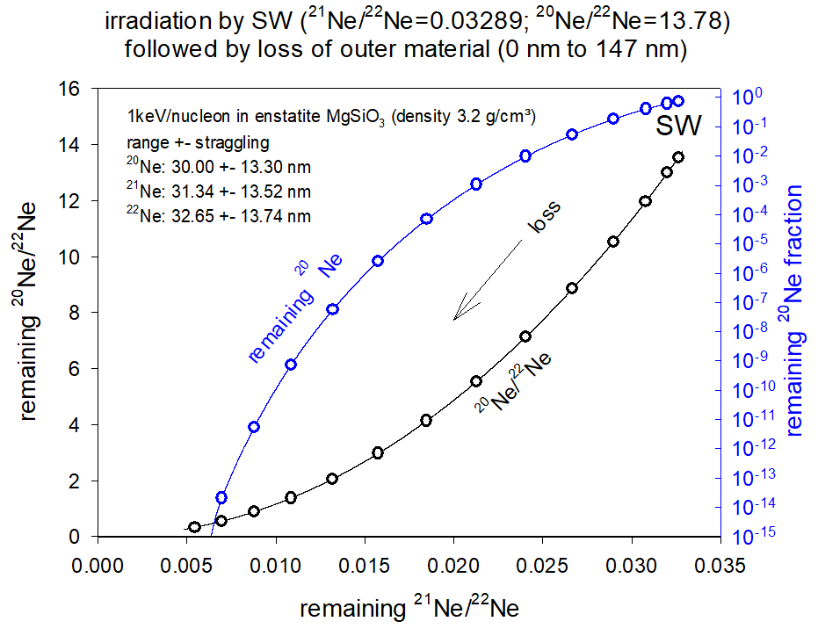
Fig. S1. The ratio ²⁰Ne//²²Ne and the remaining fraction of ²⁰Ne are plotted vs ²¹Ne/²²Ne for the case of SW irradiation followed by loss of outer material. The symbols mark the data in steps of 10 nm removed (10, 20, ….140 nm). The starting composition is the SW isotopic composition given by Heber et al. (2009): ²⁰Ne/²²Ne = 13.78, ²¹Ne/²²Ne = 0.03289.

Fig. S2 explores the effect of adding a cosmogenic component, with typical isotope ratios ²⁰Ne/²²Ne = 0.8, ²¹Ne/²²Ne = 0.9. Our simple approach assumes a fixed abundance of cosmogenic gas, and we show the results for three exemplary cases. These differ in the relative size (“r”) with respect to the SW component, where r (ranging between 10⁻⁵ and 10⁻⁷) is defined as the ratio of the cosmogenic ²²Ne abundance (assumed to be the constant over the whole range) to total SW ²²Ne. The abundance of the latter peaks at a depth of 32.65 nm, where ²²Ne_{cos}/²²Ne_{SW} is then ~8.6×10⁻³, 8.6×10⁻⁴ and 8.6×10⁻⁵ for the three cases. Also shown is (again) the case of zero cosmogenic contribution. Clearly, if, during stepwise gas release, data points that plot in the approximately linear range above ²¹Ne/²²Ne = 0.2 (as most combustion data in Fig. 3 do) are used to infer, by extrapolation, an “apparent” (²⁰Ne/²²Ne)_{FSW} ratio, this will be very low (e.g., less than ~6 for the r = 10⁻⁷ case). When the apparent “turn” of the curve to the right occurs, does not depend on the rate of erosion nor the rate of implantation. Also, in this simple case it does not matter when the cosmogenic component was added, either “early” (on the parent body) or “late” (during transfer to Earth).
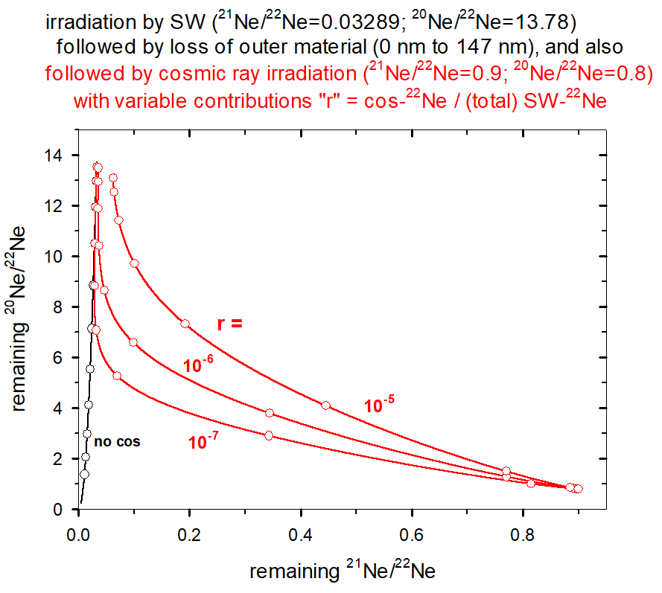
Fig. S2. Plot of ²⁰Ne//²²Ne vs ²¹Ne/²²Ne for the case of SW irradiation followed by loss of outer material, with a cosmogenic component added. The case “no cos” corresponds to the results shown in Fig. S1, while the three curves show the situation when various amounts of cosmogenic Ne (characterized by the parameter r) are added. See text for further explanation. The symbols mark the data in steps of 10 nm removed (10, 20, ….110 nm).

In Figs. S1 and S2 material loss is assumed to have taken place after the end of SW irradiation, so possible “early” (i.e., during SW irradiation) erosion has not been considered. We have done so in Fig. S3, but only in a crude approximation, where we assume several periods of solar wind irradiation, each followed by erosion – a series of distinct separate events, while in reality implantation and erosion more likely occur simultaneously. In detail, we have assumed to deal with 10 episodes of SW irradiation, each followed by material loss. One case assumes 2 nm loss of outer material during each episode, corresponding to a total loss of 20 nm, the other case assumes 5 nm erosion during each episode, for a total removal of the original outer 50 nm. In addition, for studying how the additional presence of cosmogenic gases affects the observed array of data points as a function of depth, we again have assumed a constant cosmogenic contribution throughout the considered grain volume. Again, we show also the case of no cosmogenic contribution.
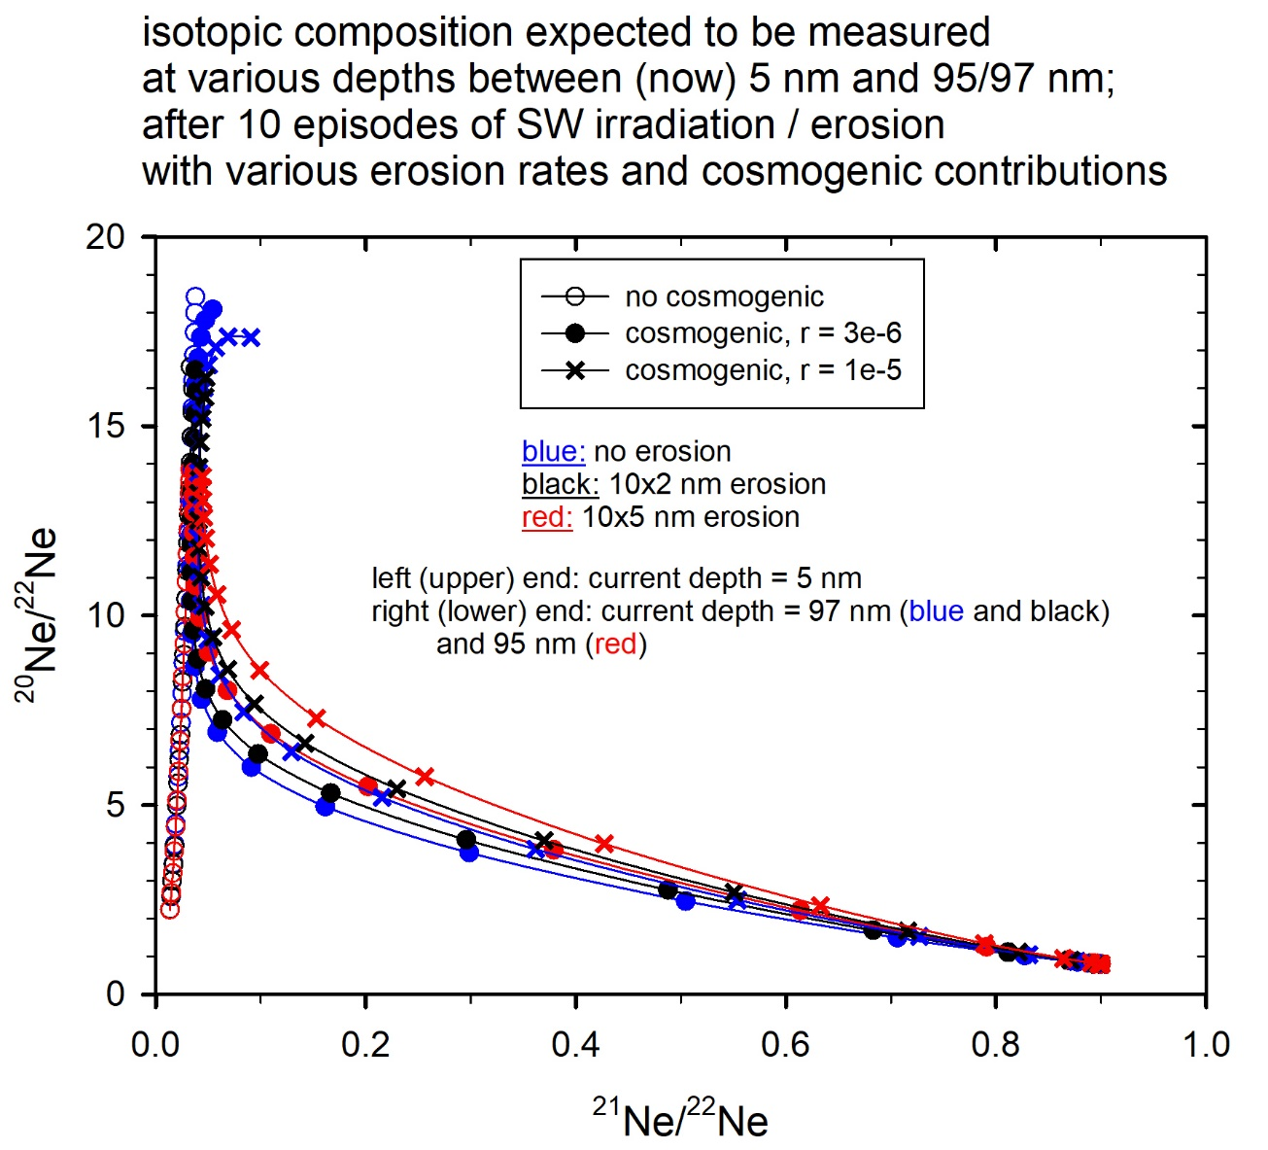
Fig. S3. Composition expected to be found, after 10 discrete episodes of SW irradiation followed each by erosion, as a function of (current) depth for different values of erosion rate and cosmogenic contribution as quantified by the parameter r (see text for explanation).

Fig. S3 shows then, in a standard Ne 3-isotope plot, the “expected” composition measured at various depths in the remaining material. The individual data points show what would be expected at (current) depths of 5, 9, 13…..97 nm in the “no erosion” and 10×2 nm erosion cases, and at 5, 10, 15, ….. 95 nm in the 10×5 nm erosion case. These values then correspond to what one should expect to find for the idealized case of onion-shell like removal during analysis by either, etching or combustion.
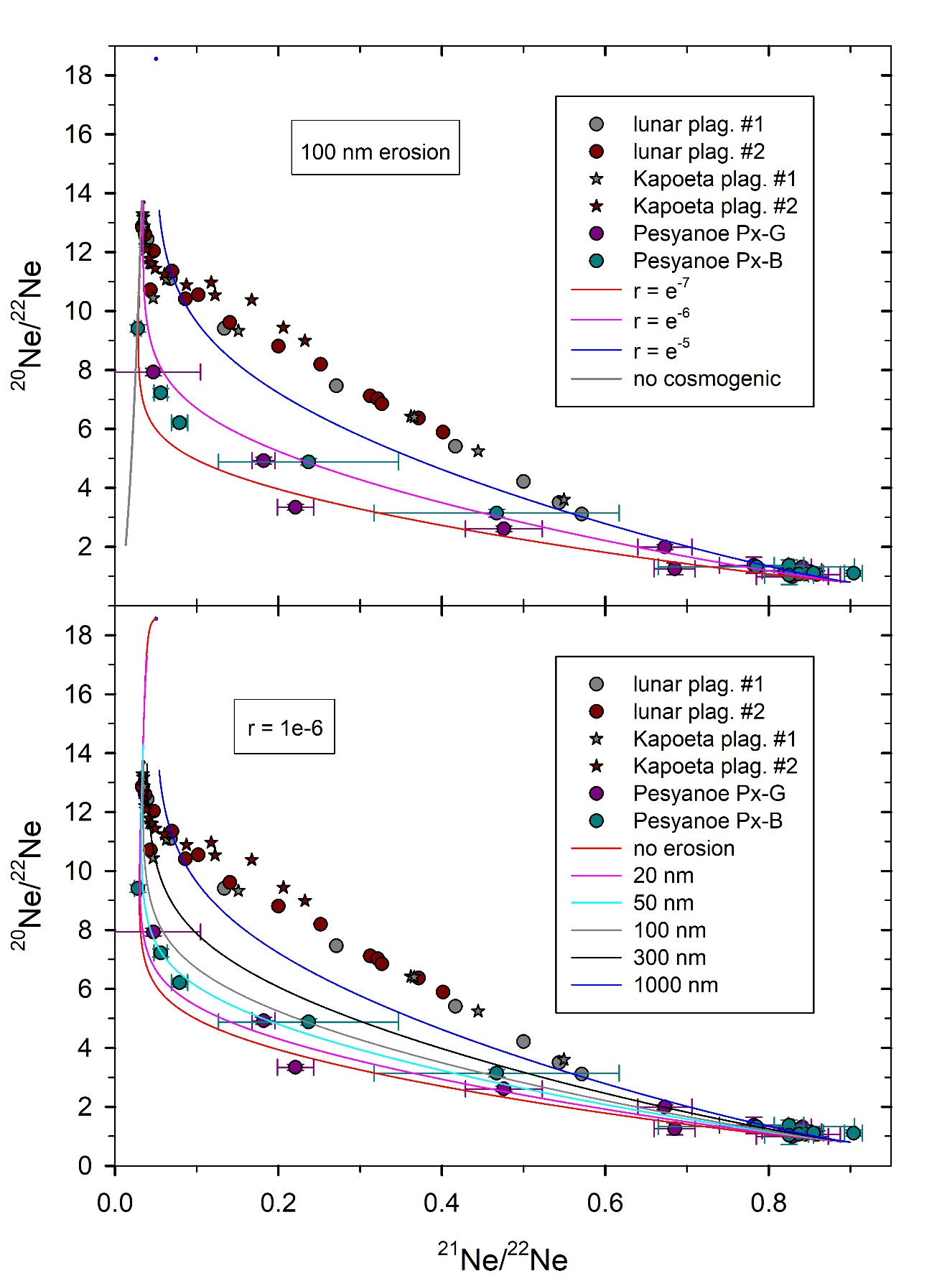
Fig. S4. In order to explore the influence of cosmogenic contribution plus erosion, model curves are compared to values measured by stepwise combustion of Pesyanoe Px-G and Px-B (Tables 5 and 6) and to lunar plagioclases (Wieler et al., 1986), as well as plagioclase separates from the Kapoeta howardite (Pedroni, 1989; Wieler et al., 2000). The top section shows, for the case of a fixed erosion (100 nm total, constant rate) taking place contemporaneous to SW irradiation, for three different relative cosmogenic contributions characterized by the parameter r (see text for definition). The bottom part explores the effect of different amounts of erosion for a fixed r value of cosmogenic contribution.
Fig. 4 compares model results to the data for our combustion analyses of Pesyanoe Px-B and Px-G. For comparison we also show data for two lunar plagioclases (Wieler et al., 1986) as well as plagioclase from the Kapoeta howardite (Pedroni, 1989; Wieler et al., 2000). The top part explores the influence of cosmogenic contribution for a fixed erosion value, while in the bottom section the effect of variable erosion is shown for a fixed value r of the cosmogenic contribution. Obviously, in order to match the Pesyanoe data, rather low values for erosion and/or cosmogenic contribution are required. Figs. 3 and 4 again show, as does Fig. 2, that due to the curved nature of the correlation, the composition derived from drawing a straight line through cosmogenic and measured data points, towards the expected ²¹Ne/²²Ne ratio, tends to underestimate the ²⁰Ne/²²Ne ratio in FSW.
The data points for lunar and Kapoeta plagioclases, also shown in Fig. 4, plot significantly higher and define an essentially straight line down to very low, SW-like, ²¹Ne/²²Ne. While an upward shift relative to the shown model lines can be achieved by choosing a significantly higher r value, a result of stronger cosmogenic contribution is also that the left-most ²¹Ne/²²Ne data points, close to that of unfractionated SW, are not reached. A possible / probable reason may lie in our stepwise rather than continuous approach, but clearly more sophisticated modelling is required.

Additional references
Benkert, J.-P., Baur, H., Signer, P., Wieler R., 1993. He, Ne, and Ar from the solar wind and solar energetic particles in lunar ilmenites and pyroxenes. J. Geophys. Res. 98, 13147-13162.
Pedroni, A., 1989. Die korpuskulare Bestrahlung der Oberflächen von Asteroiden; eine Studie der Edelgase in den Meteoriten Kapoeta und Fayetteville. PhD Diss. ETH No. 8880, ETH Zürich.
Wieler, R., Baur, H.,Signer, P., 1986. Noble gases from solar energetic particles revealed by closed system stepwise etching of lunar soil minerals. Geochim. Cosmochim. Acta. 50, 1997–2017.
Wieler, R., Pedroni, A., Leya, I., 2000. Cosmogenic neon in mineral separates from Kapoeta: No evidence for an irradiation of its parent body regolith by an early active Sun. Meteorit. Planet. Sci. 35, 251-257.
Ziegler, J.F., Ziegler, M.D., Biersack, J.P., 2010. SRIM - The stopping and range of ions in matter. Nuclear Instruments and Methods in Physics Research. 268, 1818-1823.

