Supplementary Information
Deeper insights into the photoluminescence properties and (photo)chemical reactivity of cadmium red (CdS_{1-x}Se_{x}) paints in renowned twentieth century paintings by state-of-the-art investigations at multiple length scales
Letizia Monico,^{1,2,3, *} Francesca Rosi¹, Riccardo Vivani⁴, Laura Cartechini¹, Koen Janssens,^{3,5} Nicolas Gauquelin,⁶ Dmitry Chezganov,⁶ Johan Verbeeck,⁶ Marine Cotte,^{7,8} Francesco d’Acapito,⁹ Lucrezia Barni,² Chiara Grazia,^{1,2} Luciano Pensabene Buemi,¹⁰ Jean-Louis Andral,¹¹ Costanza Miliani,¹² Aldo Romani^{1,2, *}
¹ SCITEC - Istituto di scienze e tecnologie chimiche "Giulio Natta", CNR, Via Elce di Sotto 8, 06123 Perugia, Italy
² Centre of Excellence SMAArt and Department of Chemistry, Biology and Biotechnology, University of Perugia, Via Elce di Sotto 8, 06123 Perugia, Italy
³ AXIS Research Group, NANOlab Centre of Excellence, Department of Physics, University of Antwerp, Groenenborgerlaan 171, 2020 Antwerp, Belgium
⁴ Pharmaceutical Science Department, University of Perugia, Via del Liceo 1, 06123 Perugia, Italy
⁵ Rijksmuseum, Conservation and Restoration—Scientific Research, Hobbemastraat 22, 1071 ZC Amsterdam, The Netherlands
⁶ Electron Microscopy for Materials Research (EMAT), Department of Physics, University of Antwerp, Groenenborgerlaan 171, 2020 Antwerp, Belgium
⁷ ESRF, Avenue des Martyrs 71, 38000 Grenoble, France
⁸ LAMS, CNRS UMR 8220, Sorbonne Université, UPMC Univ Paris 06, Place Jussieu 4, 75005 Paris, France
⁹ IOM-OGG, Istituto Officina dei Materiali, CNR, c/o ESRF, Avenue des Martyrs 71, 38000 Grenoble, France
¹⁰ Peggy Guggenheim Collection, Palazzo Venier dei Leoni, Dorsoduro 701, 30123 Venice, Italy
¹¹ Musée Picasso, Château Grimaldi, Place Mariejol, 06600 Antibes, France
¹² ISPC - Istituto di Scienze del Patrimonio Culturale, CNR, Via Cardinale Guglielmo Sanfelice 8, 80134 Napoli, Italy

*Corresponding authors: letizia.monico@cnr.it; aldo.romani@unipg.it

s1. Deep level emission (DLE) bands of cadmium red pigments: curve-fit results
Figure S1. Normalized emission vis-NIR spectra (black) of commercial CdS_{1-x}Se_{x} pigment powders (a) 21080_{Se=0.14} and (b) 21150_{Se=0.47} and corresponding curve-fit results (blue) by including two Gaussian functions (red and green) in the model (see Table S1 for details).

Table S1. Curve fit-results of the DLE bands obtained using Gaussian functions as components of the fit model (cf. Fig. S1).
Sample | Component | Wavelength (nm) | Width | Area | Reduced  chi-square | R-square
21080_{Se=0.14} | DLE₁ | 780 ± 1 | 66.7 ± 0.5 | 0.822 ± 0.009 | 4.80321×10⁻⁴ | 0.996
21080_{Se=0.14} | DLE₂ | 1006 ± 3 | 159 ± 3 | 0.546 ± 0.003 | 4.80321×10⁻⁴ | 0.996
21150_{Se=0.47} | DLE₁ | 880 ± 1 | 67.8 ± 0.8 | 0.76 ± 0.02 | 4.46889×10⁻⁴ | 0.997
21150_{Se=0.47} | DLE₂ | 1060 ± 5 | 140 ± 4 | 0.518 ± 0.007 | 4.46889×10⁻⁴ | 0.997

s2. Characterization of cadmium red paints in twentieth century paintings

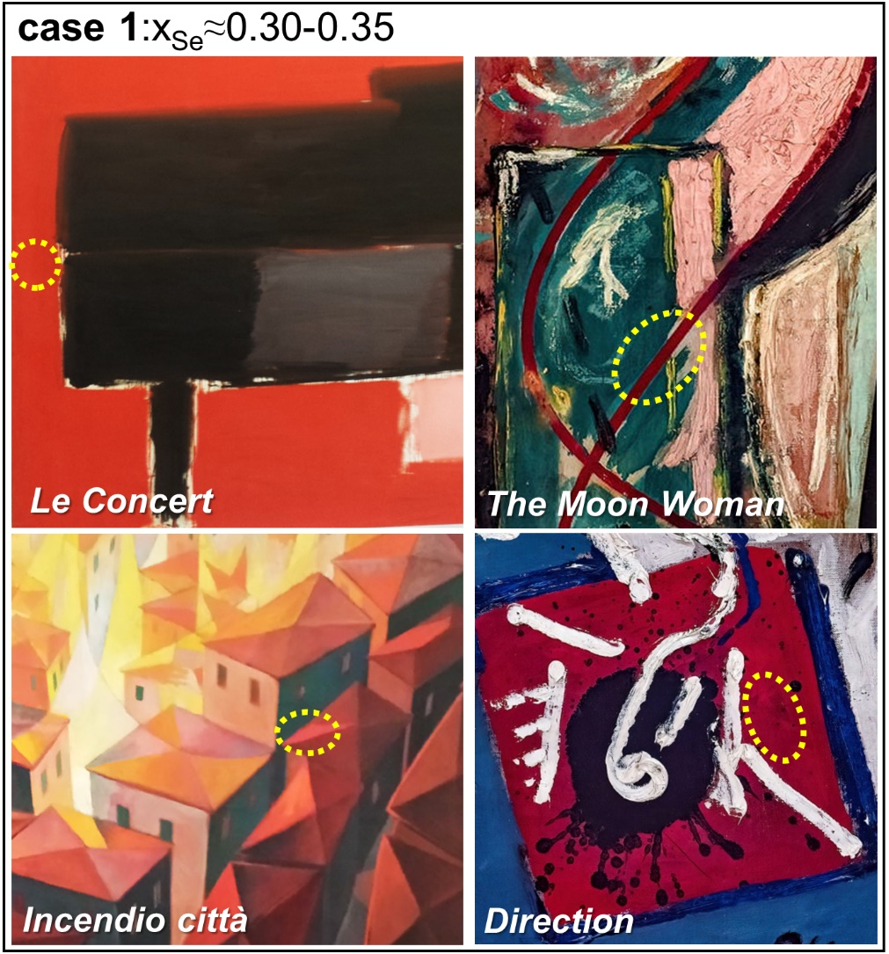
Figure S2. Case 1. Photographic details of the cadmium red-based paints of a series of oil paintings on canvas made up of CdS_{1-x}Se_{x} with x_{Se}≈0.30-0.35 and with a DLE₁ intensity much higher than that of DLE₂. From the upper-leftmost corner: Le Concert (Nicolas de Staël, 1955; Musée Picasso of Antibes, France); Incendio Città (Gerardo Dottori, 1926; Civic Museum of Palazzo della Penna of Perugia, Italy); The Moon Woman (1942) and Direction (1945) (Jackson Pollock; Peggy Guggenheim Collection of Venice, Italy). Spectra were recorded in the areas indicated by the dotted circles (see main paper: Fig. 1, case 1).

Figure S3. Photographic details of the cadmium red-based paints of the paintings where CdS_{1-x}Se_{x} pigments showing different photoluminescence properties were detected. (a,b) Case 2. Areas composed of CdS_{1-x}Se_{x} with (a) x_{Se}≈0.1 and (b) x_{Se}≈0.30-0.40 and featuring a DLE₂ band with an intensity much higher than that of DLE₁. From the upper-leftmost corner: Circumcision (1946; oil on canvas), Eyes in the Heat (1946; oil and alkyd enamel on canvas), Bird Effort (1946; oil on canvas) and Direction (1945; oil on canvas) (Jackson Pollock; Peggy Guggenheim Collection of Venice). (c) Case 3. Areas made up of CdS_{1-x}Se_{x} with x_{Se}≈0.30-0.40 and a DLE₁ intensity comparable than that of DLE₂. From top: The Moon Woman (1942; oil on canvas) and Alchemy (1947; oil, aluminum, alkyd enamel paint with sand, pebbles, fibres, and wood on commercially printed fabric) (Jackson Pollock; Peggy Guggenheim Collection of Venice); Lago Umbro (Gerardo Dottori, 1942, oil on panel; Civic Museum of Palazzo della Penna of Perugia). Dotted circles shows the regions where spectra were recorded (see main paper: Fig. 1, case 2 and case 3).

s3. Cadmium red pigment powders
s3.1 Additional vis-NIR spectra of historical CdS_{1-x}Se_{x} pigment powders
Figure S4. (a) Normalized fluorescence vis-NIR and (b) diffuse reflectance vis spectra of historical CdS_{1-x}Se_{x} pigment powders 440_{Se=0.47} and 442_{Se=0.40}.

s3.2 STEM-EDX: quantitative elemental analysis
Table S2. EDX quantitative elemental analysis (expressed in atomic %) of selected regions of commercial and historical CdS_{1-x}Se_{x} pigment powders reported in Fig. 2 (main paper).
Sample | Area number | at% Cd | at% S | at% Se | at% O | at% Ba
21080 | 1 | 50±8 | 38.3±0.9 | 8±1 | 4.3±0.2 | -
21080 | 2 | 51±8 | 36.8±0.8 | 10±1 | 1.5±0.1 | -
21080 | 3 | 55±8 | 37.0±0.9 | 7.6±0.9 | 0.8±0.1 | -
21080 | 4 | 48±8 | 40±1 | 10±1 | 2.7±0.2 | -
21080 | average | 51±8 | 38.0±0.9 | 9±1 | 2.3±0.2 | -
21150 | 1 | 57±8 | 18.8±0.5 | 25±2 | - | -
21150 | 2 | 54±8 | 20.0±0.6 | 26±3 | - | -
21150 | 3 | 57±8 | 16.5±0.8 | 24±3 | 2.8±0.3 | -
21150 | 4 | 59±8 | 14.5±0.5 | 25±3 | 1.8±0.2 | -
21150 | average | 57±8 | 17.5±0.6 | 25±3 | 1.1±0.2 | -
437 (BaSO₄ particles) | 1 | 2±1 | 22±1 | 0.8±0.6 | 48±1 | 28±9
437 (BaSO₄ particles) | 2 | 4±3 | 15±2 | 0 | 50±2 | 30±10
437 | 1 | 55±9 | 40±1 | 5.1±0.9 | - | -
437 | 2 | 55±8 | 40±1 | 5.7±0.9 | - | -
437 | 3 | 54±8 | 37±1 | 8±1 | 0.9±0.1 | -
437 | 4 | 54±8 | 41±1 | 4.2±0.7 | 0.8±0.1 | -
437 | average | 54±8 | 39±1 | 6±1 | 0.4±0.1 | -
442-I | 1 | 45±8 | 42±1 | 9±2 | 4.0±0.3 | -
442-I | 2 | 55±9 | 36±1 | 8±1 | 1.9±0.2 | -
442-I | 3 | 52±8 | 35±1 | 10±1 | 3.8±0.2 | -
442-I | 4 | 53±8 | 36.4±0.9 | 10±1 | - | -
442-I | average | 51±8 | 37±1 | 9±1 | 2.4±0.2 | -
442-II | 1 | 53±8 | 24.7±0.9 | 21±3 | 1.4±0.2 | -
442-II | 2 | 57±7 | 20.5±0.4 | 22±2 | 0.4±0.1 | -
442-II | 3 | 54±8 | 18.0±0.5 | 24±3 | 3.8±0.2 | -
442-II | 4 | 54±7 | 22.0±0.6 | 24±3 | 2.4±0.2 | -
 | average | 54±8 | 21.3±0.6 | 23±2 | 2.0±0.1 | -

s3.3 S K-edge XANES
Figure S5. S K-edge XANES spectra recorded from selected historical (top) and (bottom) commercial CdS_{1-x}Se_{x} pigment powders.

s3.4 Se K-edge XANES
The Se-K edge XANES spectra collected from CdS_{1-x}Se_{x} pigment powders with different Se content (Fig. S6) show not only differences in the post-edge absorption region (for details, see main paper: Fig. 5 and Table 2) but also a slight shift of the maximum of the white line (insets of Fig. S6 and Table S3). This observation is in agreement with earlier studies by Yu et al. [] where a similar shift has been observed for samples with higher Se content.
Figure S6. Se K-edge XANES spectra recorded from selected commercial (left) and historical (right) CdS_{1-x}Se_{x} pigment powders. Insets show the white line energy range indicated by the rectangles and arrows.

Table S3. Position of the maximum of the white line (WL) as determined by the zero of the δμ/δE derivative.
Sample | WL max position (eV)
21080_{Se=0.14} | 12661.85 ± 0.05
21150_{Se=0.47} | 12661.65 ± 0.05
437 _{Se=0.12} | 12661.86 ± 0.05
440_{Se=0.47} | 12661.72 ± 0.05

s4. UVA-vis aged (RH%~35%) and thermally aged paint mock-ups
s4.1 Vis-NIR spectroscopy
Figure S7. Diffuse reflectance vis spectra recorded from CdS_{1-x}Se_{x} oil paint mock-ups before (black) and after (a) exposure to UVA-vis light (RH~30%) (red) and (b) thermal aging (RH≥95%; T=40 °C) (grey).

Figure S8. Normalized emission vis-NIR spectra obtained from CdS_{1-x}Se_{x} oil paint mock-ups before (black) and after (a) exposure to UVA-vis light (RH~30%) (red) and (b) thermal aging (RH≥95%; T=40 °C) (grey).

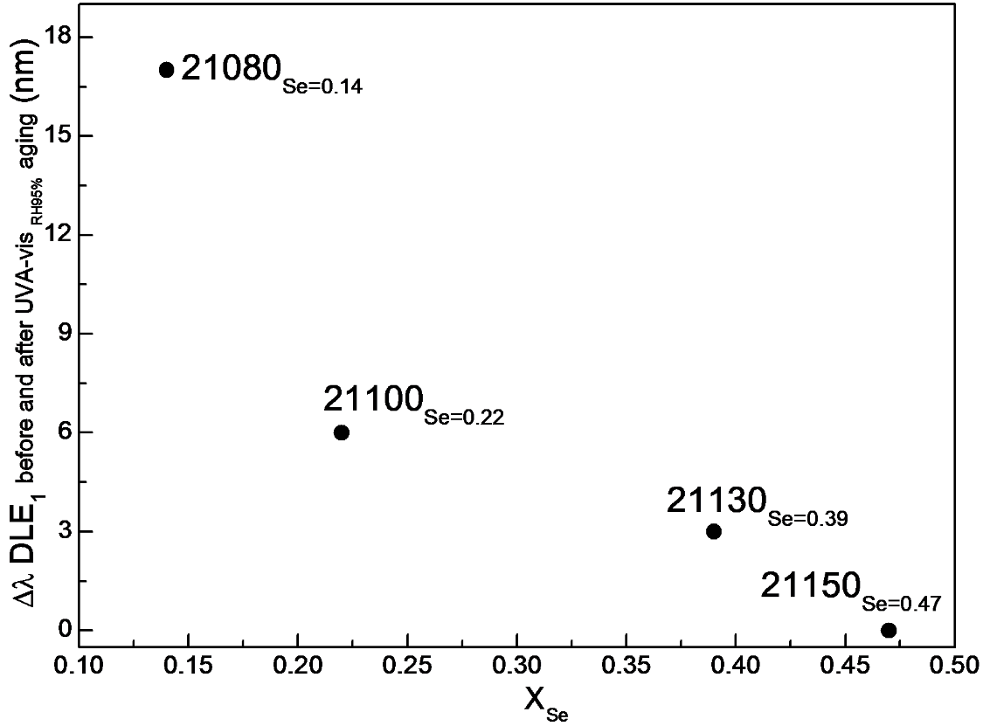
Figure S9. Shifting position of the DLE₁ band vs. the Se content in oil paint mock-ups before and after exposure to UVA-vis light and high moisture levels (RH≥95%) (for the corresponding spectra, see main paper: Fig. 6b).

s4.2 ATR mode FT-IR spectroscopy
The ATR mode FT-IR spectra recorded from the UVA-Vis aged samples at RH~30% (red lines in Fig. S10a) show changes of the CO ester asymmetric stretching mode [ν(CO)] of the triglycerides, along with the intensity increase of the band in the 1620-1635 cm⁻¹ range. Such modifications resemble the ones observed in the unpigmented linseed oil [,] and are attributable to the formation of secondary compounds with low molecular weight (e.g., alcohols, ketones, aldehydes, carboxylic acids…) due to the oxidation of the oil. The presence of a very weak band at 1320 cm⁻¹ is also visible and it can be assigned to oxalates. []
In all thermally aged samples (RH≥95%, T=40°C) (grey lines in Fig. S10b) the presence of Zn oxalate (ZnC₂O₄·2H₂O) as a degradation product was identified by XRPD (Table 3) and FT-IR spectroscopy via the presence of a weak characteristic IR bands at 1317 and 817 cm⁻¹. [4] The lower solubility of Zn oxalate compared to that of Cd oxalate (CdC₂O₄·3H₂O) [] provides a reasonable explanation of why the used aging conditions have triggered the formation of the former compound.
Characteristic IR signals due to BaSO₄ are present in the spectra of all samples before and after both aging treatments.
Figure S10. ATR-mode FT-IR spectra acquired from CdS_{1-x}Se_{x} oil paint mock-ups before (black) and after (a) exposure to UVA-vis light (RH~30%) (red) and (b) thermal aging (RH≥95%;
T=40 °C) (grey).
5. Calculation of band gap energies
Band gap energies ($E_{g}$; Table S4) were determined from the diffuse reflectance vis spectra (main paper: Figs. 1a and 6a) according to the method earlier proposed, [,,] based on eq. S1:
${(αhυ)}^{n}=A(hυ-E_{g})$ (eq. S1)
Where:
$α$ = absorption coefficient
$h$ = Planck's constant (eV*s)
$υ$ = is the frequency (eV)
$n$ = exponent related to the nature of the transition ($n=2$ for allowed direct transition). [8]
$A$ = proportionality constant
The recorded reflectance spectra were then converted into Kubelka–Munk values [F(R∞)], that are proportional to α. Thus, eq. S1 becomes:
${(F(R^{∞})hυ)}^{2}=A(hυ-E_{g})$ (eq. S2)
The $E_{g}$ values can be obtained by extrapolating a linear regression of ${(F(R^{∞})hυ)}^{2}$ against $hυ$ (expressed in eV) to zero. This line is tangent to the point of inflection on the spectral curve (found by taking the maximum of its first derivative).

Table S4. Band gap energy values of commercial and historical CdS_{1-x}Se_{x} compounds.
Sample | E_{g}/eV (nm)
21080_{Se=0.14} | 2.26 (514)
21100_{Se=0.22} | 2.19 (566)
21130 _{Se=0.36} | 2.06 (602)
21150-I_{Se=0.45}  21150-II_{Se=0.55} | 2.0 (603)  1.97 (629)
437 _{Se=0.12} | 2.29 (541)
439 _{Se=0.38} | 2.09 (593)
440 _{Se=0.47} | 2.03 (611)
442-I_{Se=0.19}  442-II_{Se=0.54} | 2.17 (571)  1.95 (636)

References

. Y. M. Yiu, M. W. Murphy, L. Liu, Y. Hu, T. K. Sham, AIP Conference Proceedings 1590, 26 (2014).
. M. Lazzari, O. Chiantore, Polym. Degrad. Stabil. 65, 303 (1999).
. J. Mallégol, J .L. Gardette, J. Lemaire, J. Am. Oil Chem. Soc. 77, 257 (2000).
. F. Rosi, L. Cartechini, L. Monico, F. Gabrieli, M. Vagnini, D. Buti, B. Doherty, C. Anselmi, B. G. Brunetti, C. Miliani, in Metal Soaps in Art, ed. By. F. Casadio, K. Keune, P. Noble, A. van Loon, E. Hendriks, S. Centeno, G. Osmond (Springer, Cham, 2019) p. 173.
. H. L. Clever, M. E. Derrick, S. A. Johnson, J. Phys. Chem. Ref. Data 21, 941 (1992).
. J. Tauc, R. Grigorovici, A. Vancu, Phys. Status Solidi B 15, 627 (1966).
. A. B. Murphy, Sol. Energy Mater. Sol. Cells 91, 1326 (2007).
. C. Grazia, F. Rosi, F. Gabrieli, A. Romani, M. Paolantoni, R. Vivani, B. G. Brunetti, P. Colomban, C. Miliani, Microchem. J. 125, 279 (2016).

