Supplementary material

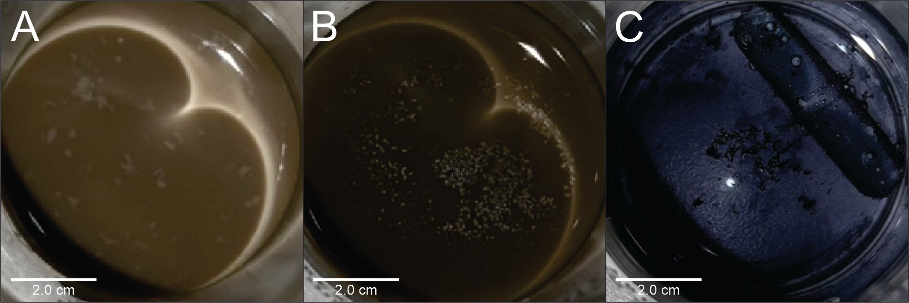
Figura S1. Synthesis of metal nanoparticles. A: C-Ag@HX, B: C-Au@HX (B) and C: C-Ag@Cit. Particle aggregation can be observed in the three cases.

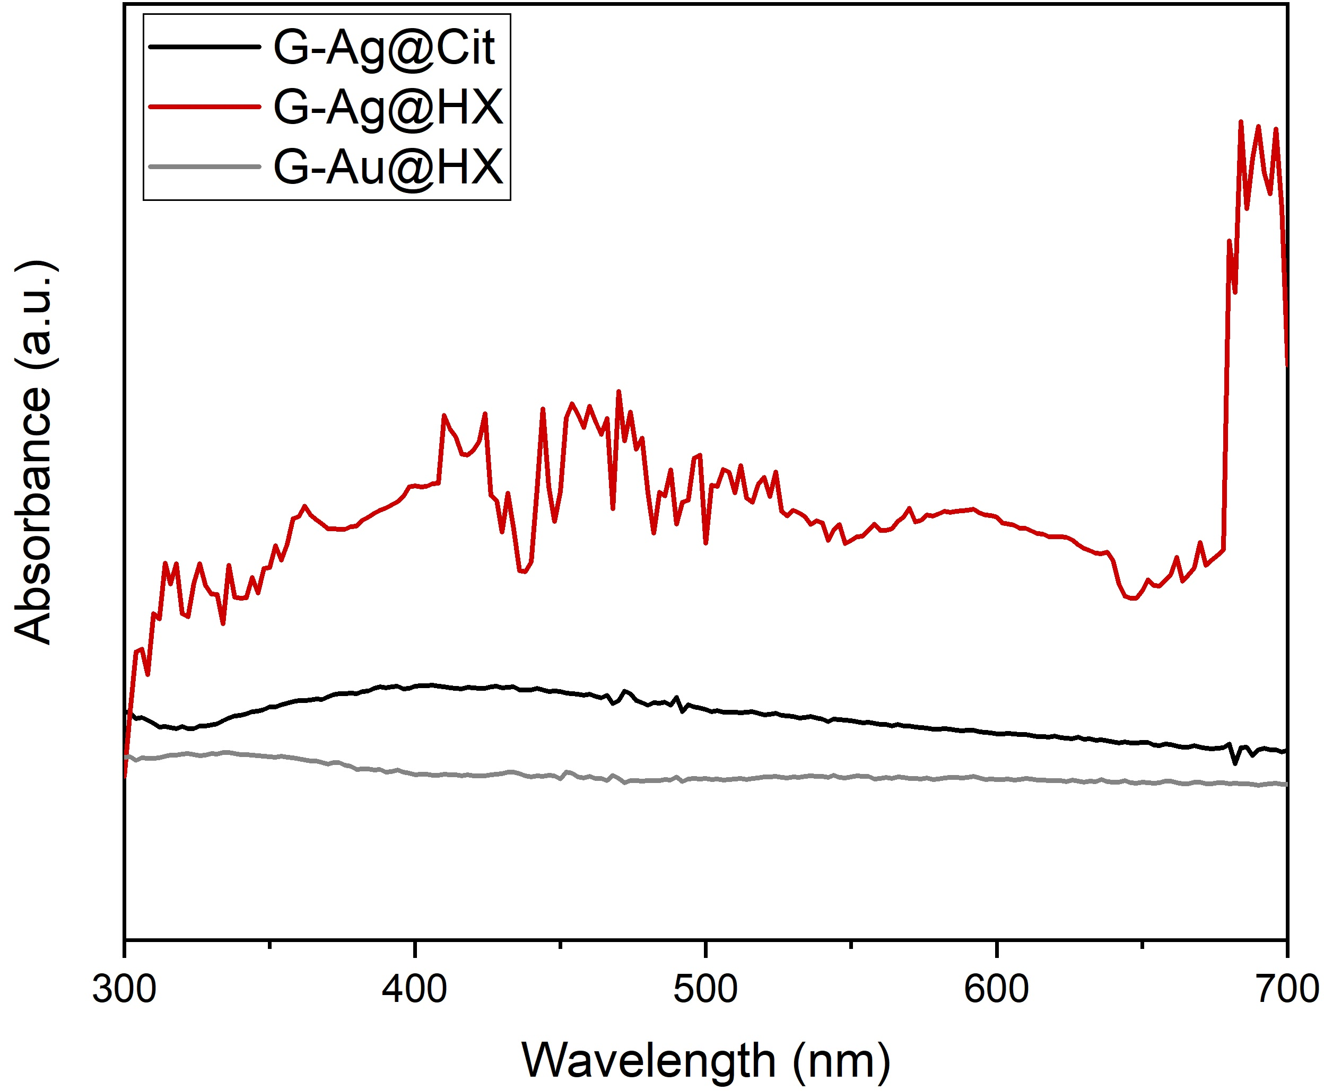
Figure S2 UV-Vis spectra of G-Ag@Cit, G-Ag@HX and G-Au@HX.

Figure S3. A: Direct Raman analysis without G-Au@Cit of the paint reference mock-up. B to D: SERS analysis with G-Au@Cit of orpiment (B), indigo (C) and pigment red 57 (D). Spectra were baseline-corrected using the automatic baseline option of the software OMNIC, and then smoothed via a Savitzky–Golay algorithm, using 15 points and a second-grade polynomial.

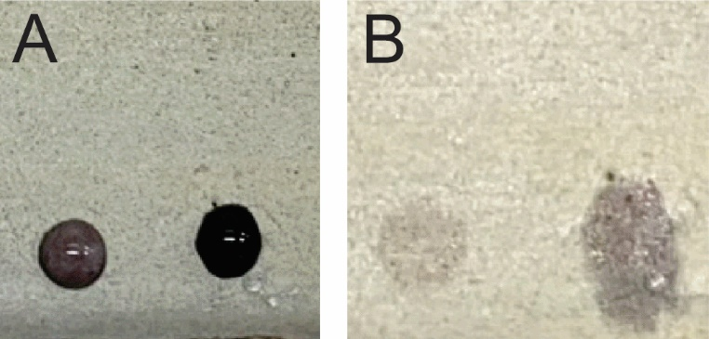
Figure S4. Image of a background area of the mock-up during the direct application (A) and after the removal (B) of an aliquot of a silver nanoparticles colloid.
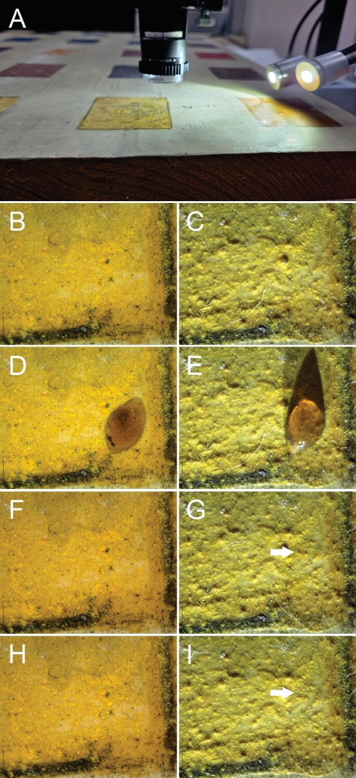
Figure S5. Gel removal test. A: Microscopic observation assemblage focused in the orpiment area of the mock-up; B-C: zenithal and grazing light illuminated images of orpiment before application; D-E: zenithal and grazing light illuminated images of orpiment during application; F-G: zenithal and grazing light illuminated images of orpiment after one cleaning step; H-I: zenithal and grazing light illuminated images of orpiment after two cleaning steps.

