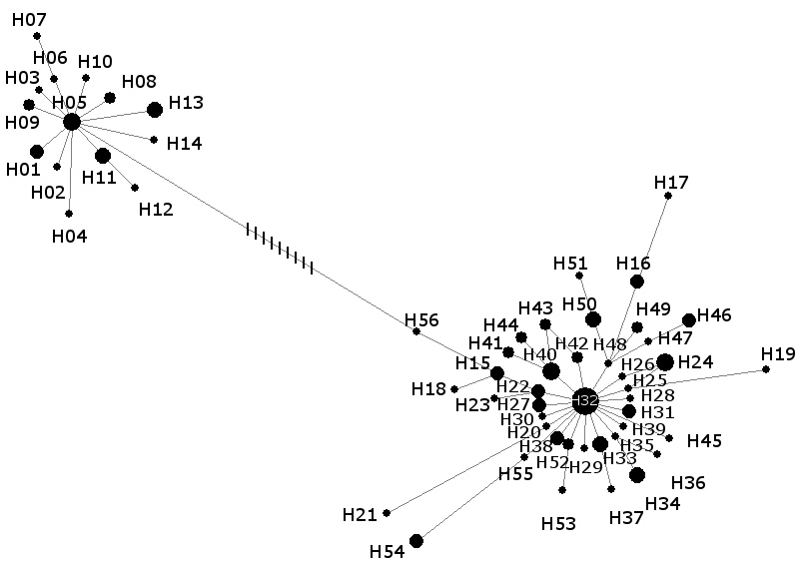

Additional file 6
Figure S3 Median-joining network (ε = 0) with molecular relationships between 56 haplotypes which cluster into two major ovine haplogroups: haplogroup A (H01-H14, on the left) and haplogroup B (H15-H56, on the right).

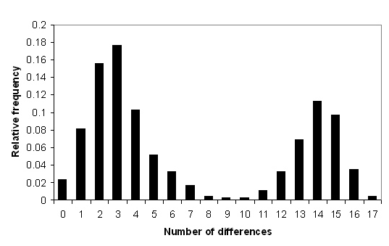

Additional file 6
Figure S4 Mismatch distribution of 120 modern and ancient domestic sheep indicating the existence of two divergent haplogroups in the data.

