Additional file 3: Enriched gene ontology classes for archetype 4

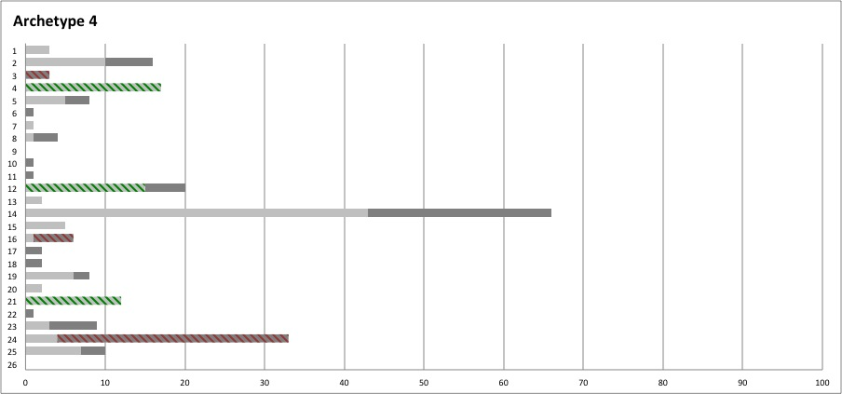
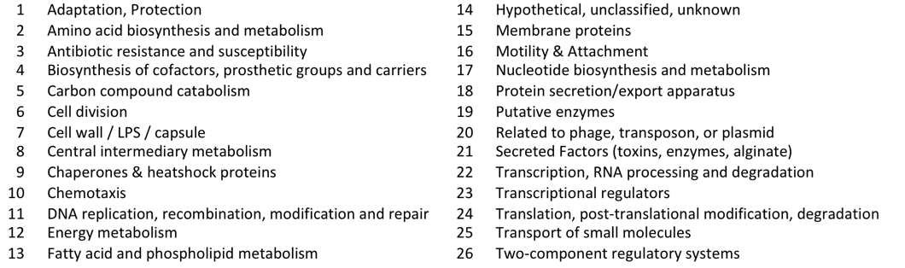 | 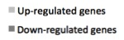

Figure S3-1. Characterization of Archetype 4.
Number of up- and down-regulated genes within 26 gene ontology classes for archetype 4. Enriched gene-ontology classes are high-lighted in green and red for up- and down-regulated genes respectively.

