Additional File 2. Scatterplots of PCA factor 1 (X Axis) against factors 3 through 6 (Y Axis), based on a PCA of microsatellite allele frequencies in all 97 newly typed populations. The additional factors further support several outlier populations as well as the uniqueness of several Pure Danubian populations (e.g ANR and BIS) and the differentiation between these and Bavarian populations. Several of these populations defining the Y – axis are labeled with the population code for reference. There is however no general pattern or inference that can be drawn from these additional vectors of variation.
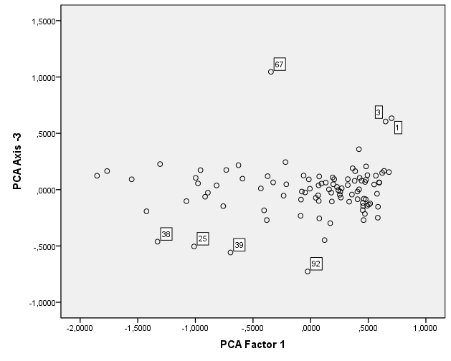
WOL
BIS
ANR
HM
THA
HAA
FOR

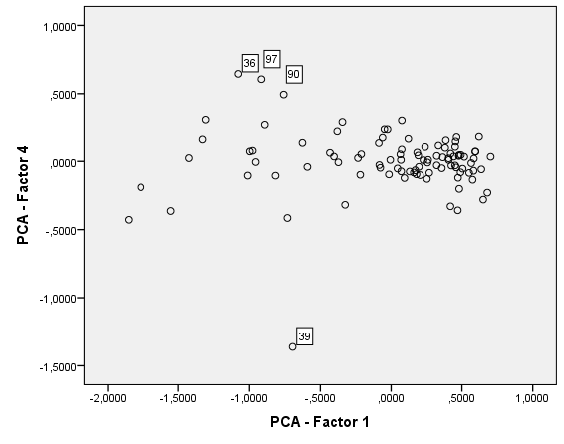
SWB
NIK
FUS
ANR

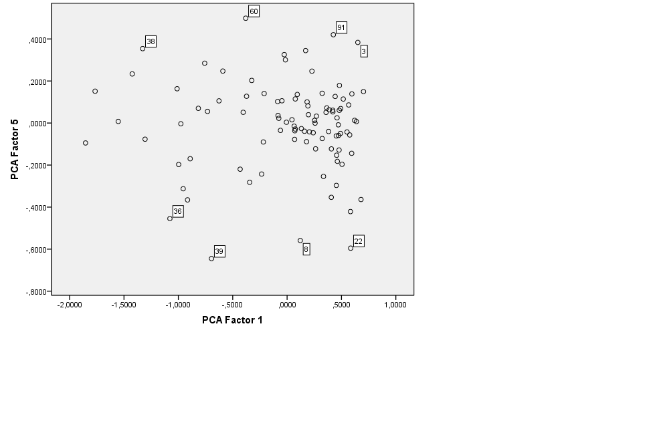
SHU
MUH
ANR
SWB
HAA
GAL
LOH
WOL

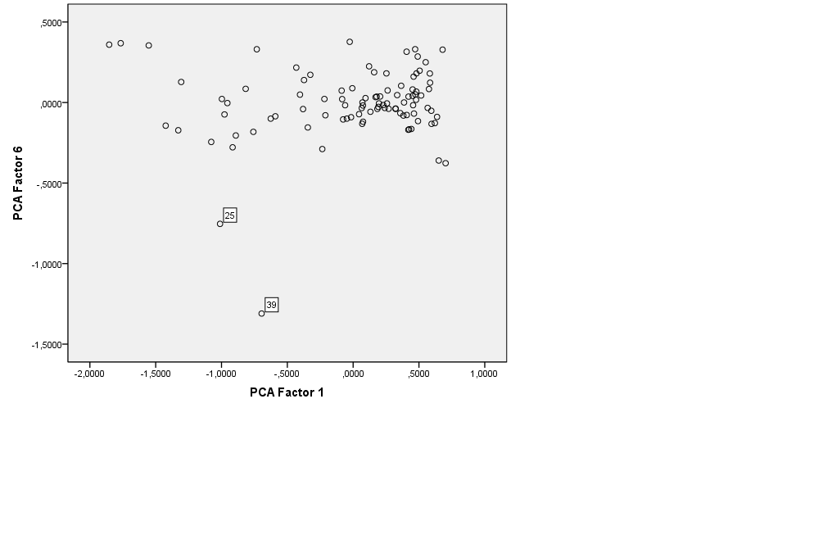
BIS
ANR

