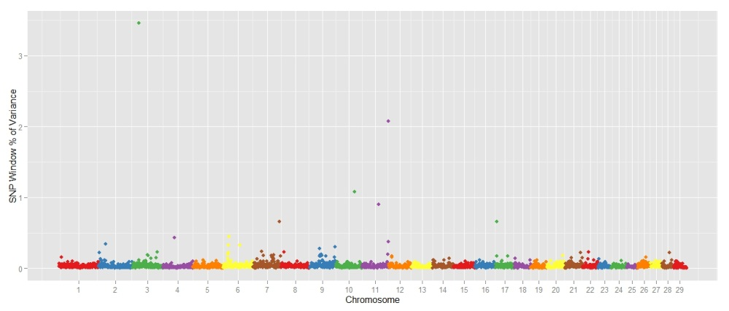
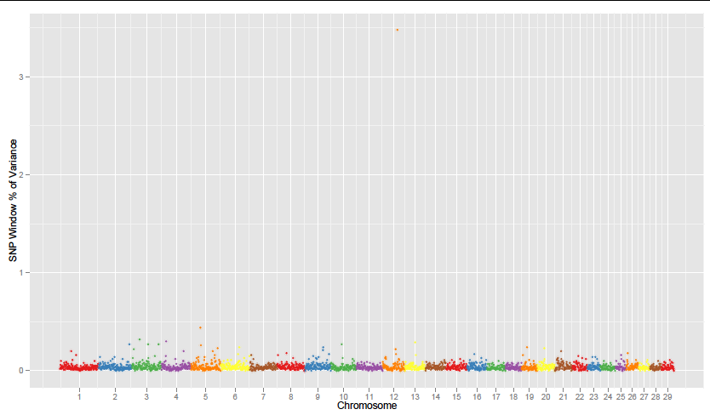
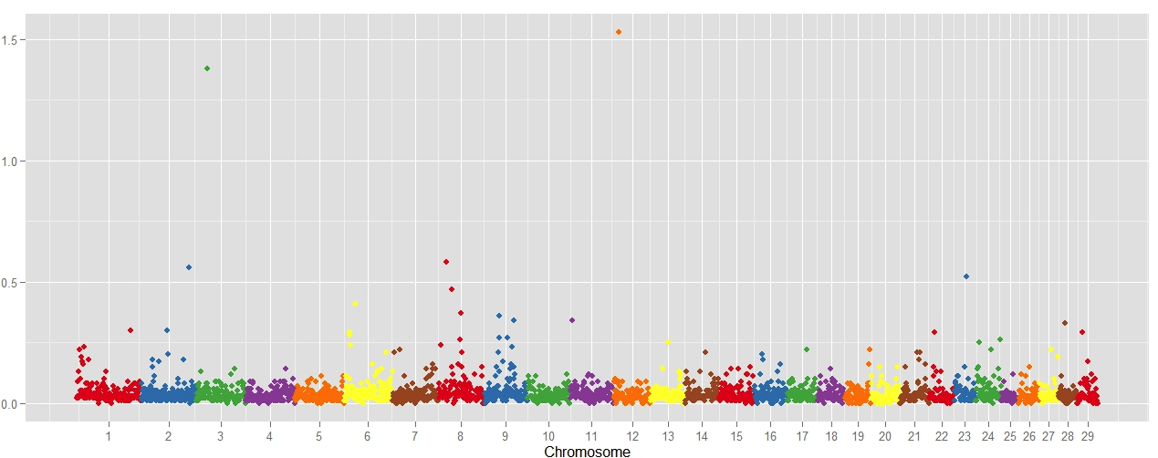
C
B
A
Additional file 2. Manhattan plot of the genome-wide association study result for A) C12:0 (lauric acid) B) C16:0 (palmitic acid) C) C18:0 (stearic acid) in Nellore. The X-axis represents the chromosomes, and the Y-axis shows the proportion of genetic variance explained by SNP window from Bayes B analysis.

