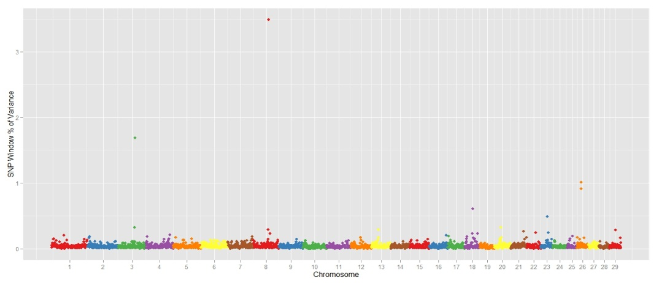
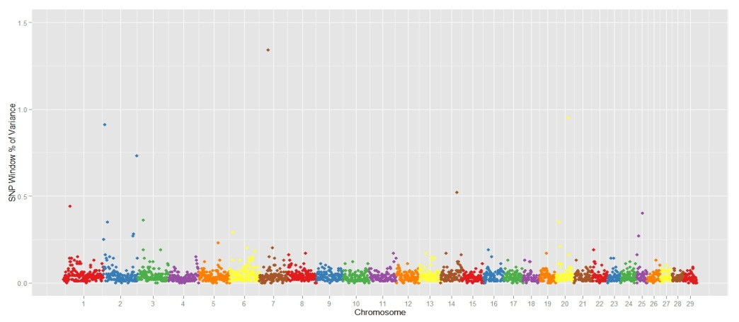
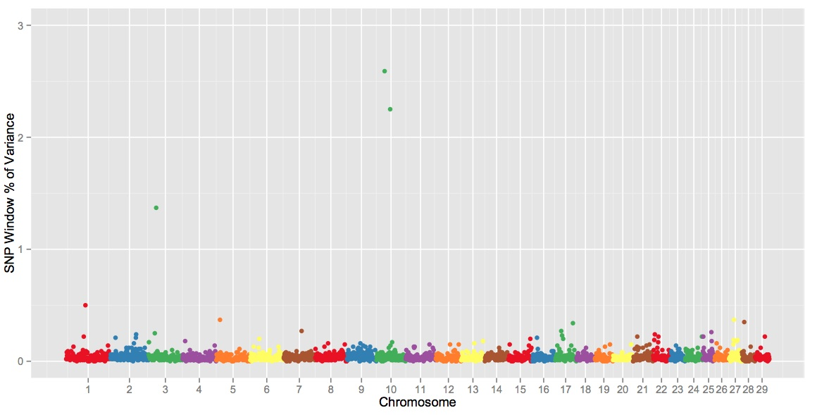
B
C
A
Additional file 3. Manhattan plot of the genome-wide association study result for A) C18:3 n-3 (γ-linolenic acid) B) C18:3 n-6 (α-linolenic acid) C) n-3 (total of n-3) in Nellore. The X-axis represents the chromosomes, and the Y-axis shows the proportion of genetic variance explained by SNP window from Bayes B analysis.

